Original Research Article
Effect Of Co-administration Of Methamphetamine And Vitamin E On The Hippocampus Of An Adult Male Wistar Rat.

ABSTRACT
Much attention has been drawn to the toxic effect of methamphetamine on humans. However, it is not clear whether or not the toxicity is related to the vital organs like the hippocampus, hence the present study is geared towards not only unraveling the toxic effect of methamphetamine (METH) on the hippocampus but more importantly investigating the protective effect of vitamin E against methamphetamine induced toxicity on this organ. Thirty-five adult Wistar rats (185-220g) were divided into seven groups of five animals each. Group A was given normal rat feed and water as the control; group B, C, D, E, F, G, was administered 5mg/kg body weight of METH, 10mg/kg body weight of METH, 500mg/kg body weight of vitamin E, 1000mg/kg body weight of vitamin E, 5mg/kg body weight of METH and 500mg/kg body weight of vitamin E, and 10mg/kg body weight of METH and 1000mg/kg body weight of vitamin E, respectively. All the treatments were administered orally daily for twenty-one day, 24hours after the last exposure, the animals were anesthetized using chloroform vapour. The brain tissues were harvested, weighed and some of the tissues was fixed in phosphate buffer formalin for biochemical analysis, while the rest was fixed in 10% neutral buffer formalin for histological studies. There was significant reduction in the body weight of animals in groups B, C, F and G which were administered with methamphetamine when compared with the control. The serum levels of Malondialdehyde (MAD) of groups B, C, F & G was the highest (P<0.05) in relative to the control group, while the serum levels of Gluthathione (GSH), and Superoxide dismutase (SOD) of group was significantly lower in groups B & C (P>0.05) than the control group. Histological observation showed that following administration of vitamin E there were no degenerated cells, instead, there was an increase in active granular cells in groups A, D & E, and mild regeneration, moderate / mild vacoulation and moderate increase in the number of active granular cell was shown in groups F & G, while severe degeneration and vacoulation and severe pyknotic granular cells were shown in groups B & C. The result of this study shows that no adverse biochemical alterations are associated with the use of vitamin E and no histopathological lesions were found in the hippocampus of adult male Wistar rats when treated with vitamin E. The drug vitamin E may contain antioxidant and chemoprotective properties against methamphetamine induced neurotoxicity.
Introduction
Background of the Study
Background of the Study
Methamphetamine is a potent and highly addictive psychostimulant that affects the central nervous system (National Institute on Drug Abuse, 2023). It is typically found as a white, odorless, bitter-tasting crystalline powder, which dissolves easily in alcohol or water. Methamphetamine induces euphoria and stimulant effects similar to those of cocaine (National Library of Medicine, 2023). It works by increasing the levels of naturally occurring neurotransmitters such as dopamine and norepinephrine in the brain. Compared to cocaine, the effects of methamphetamine last longer, and it is both cheaper and easier to produce using readily available ingredients. Street names for the drug include chalk, crank, crystal meth, and speed (Medical News Today, 2023), as well as "mkpuru mmiri" in southeastern Nigeria.
Developed in the early 20th century from its parent compound, amphetamine, methamphetamine was initially used in nasal decongestants and bronchial inhalers. It has a higher affinity and toxicity toward serotonergic neurons compared to amphetamine. Methamphetamine can be consumed by swallowing, inhalation, smoking, or injection. Smoking methamphetamine allows it to enter the bloodstream rapidly, with users feeling its effects almost immediately (National Institute on Drug Abuse, 2023).
Vitamin E, a vital lipid-soluble antioxidant, is obtained exclusively through the diet (Volker Bohm, 2018). This nutrient plays a crucial role in maintaining vision, reproduction, and the health of the blood, brain, and skin. As an antioxidant, vitamin E helps protect cells from damage caused by free radicals, which are molecules produced during food metabolism or when the body is exposed to tobacco smoke and radiation. Free radicals can contribute to various diseases, including heart disease and cancer. While vitamin E supplements may not provide the same benefits as naturally occurring antioxidants in food (Mayo Clinic, 2022), it is still considered essential for preventing oxidative damage in biological systems (Packer et al., 1991; Pryor et al., 2000; Traber et al., 2007; Niki et al., 2014). Beyond its antioxidant properties, vitamin E has been shown to influence cellular signaling, gene regulation, membrane functions, and nerve activity (Azzi et al., 2007; Brighelius-Flore et al., 2010; Galli et al., 2017). It is also effective in the prevention and treatment of various diseases such as cardiovascular disease, cancer, cataracts, Alzheimer's disease, and HIV/AIDS. A deficiency in vitamin E can result in neuropathy (Mayo Clinic, 2022).
Foods rich in vitamin E include canola oil, olive oil, margarine, almonds, peanuts, as well as meats, dairy products, leafy greens, and fortified cereals. Vitamin E supplements are also available in capsules or drops. The recommended daily intake for adolescents is 15 milligrams (Mayo Clinic, 2022).
The hippocampus, a key structure in the brain, is essential for memory consolidation and spatial navigation (Britannica, 2023). Part of the limbic system, the hippocampus is vulnerable to the toxic effects of environmental factors such as heavy metals, plant toxins, drug abuse, and cerebrovascular insufficiency. It is also affected by neurodegenerative diseases.
While methamphetamine and vitamin E have been studied for their individual pharmacological effects, their specific impact on the hippocampus remains largely unexplored. Previous research has focused on the effects of methamphetamine on the central nervous system and the antioxidant properties of vitamin E. However, the potential effects of these substances on the hippocampus—particularly in an animal model closely resembling human physiology—warrant further investigation.
The Wistar rat is a widely used model in histological and anatomical research due to its physiological similarities to humans. Studies involving Wistar rats have provided valuable insights into the toxicological and pharmacological effects of various substances, helping to enhance our understanding of their potential impacts on human health.
Given the limited scientific evidence on the combined effects of methamphetamine and vitamin E on the hippocampus, this study aims to contribute valuable knowledge regarding the potential impact of these substances on the hippocampus of adult male Wistar rats.

Methods
Ethical Approval
All the animals were treated following the approval of the ethical committee with the number FBMS/EA/1220, College of Health Sciences, Nnamdi Azikiwe University, Nnewi Campus, in line with the “Guide for the Care and Use of Laboratory Animals” (NRC 2011).
Experimental Animals
Thirty-five (35) adult Wistar rats were procured from Ela’s Animal Farm, Oko Anambra State. Perspex cages were used to house a group of seven (7) animals for the routine experiment. Each cage had wire gauze top for cross ventilation. The animals were allowed for a period of two weeks for acclimatization at the animal house of Anatomy Department, Nnamdi Azikiwe University, Nnewi Campus, before their weight was taken, under a controlled room temperature of about 25-28°C, relative humidity of about 60-80% and photo-periodicity of 12h day / 12h night. They were fed Ad libitum with water and guinea feed pallets from Agro feed mill Nigeria Ltd. All the animals were treated in accordance with the approval of ethical committee, College of Health Sciences, Nnamdi Azikiwe University, Nnewi Campus, in compliance with the “Guide for the Care and Use of Laboratory Animals” prepared by the National Academy of Sciences and published by the National Institute of Health Guide for the Care and Use of laboratory Animals (1985).
Methodology
Methamphetamine was obtained from National Drug Law Enforcement Agency of nigeria (NDLEA). All chemicals used in this study will be purchased at the highest available purity and quality.

Experimental Protocols
The thirty-five (35) adolescents male Wistar rats were gotten from Research enterprise farms, University of Ibadan, Oyo state. These rats were weighed and allocated into seven groups of five animals each. The groups were designated as groups A, B, C, D, E, F and G. Group A served as the control group and were administered distilled water and feed only. The experimental groups B, C, D, E, F and G were administered different doses of drugs as follows:
Group B ------------ 5mg/kg of methamphetamine (low)
Group C ------------ 10mg/kg of methamphetamine (high)
Group D ------------ 500mg/kg of Vitamin E (low)
Group E ------------ 1000mg/kg of Vitamin E (high)
Group F ------------ 5mg/kg of methamphetamine + 500mg/kg of vitamin E (low)
Group G ------------ 10mg/kg of methamphetamine + 1000mg/kg of Vitamin E (high)
Mode of Exposure
The drugs were administered once in a day between the hours of 12-3.30pm for a period of twenty-eight days. The drugs were administered orally using intubations method. After the twenty-eight day, the animals were weighed, and their weights recorded.

Behavioural Function Test
Morris Water Maze (Assessment of Spatial Learning and Memory)
The Morris water maze (MWM) task was used to assess the spatial learning and memory of the rats in the form of place navigation and probe test (Ishola et al, 2017) The MWM apparatus consisted of a circular water tank (110 cm diameter × 60 cm height) filled with water (26 ± 2 °C) to a depth of 30 cm. The pool was divided into four hypothetical quadrants, designated as: N (North), E (East), W (West), S (South). A black round platform of diameter 10 cm was placed 2 cm below the surface of the water in a constant position in the middle of the southwest quadrant in all trials. The MWM tasks were given for five consecutive days with 3 trials per day, the rats were given a maximum of 60 s (cutoff time) to locate the hidden platform and were allowed to stay on it for 30 s. The time taken for the rat to locate the escape platform was recorded using a stop watch. In the event that the animal was unable to locate the hidden platform within 60 s, it was gently guided to it and was allowed to stay on it for 30 s. Each rat was subjected to a daily session of 3 trials per day for 5 consecutive days. Escape latency time (ELT) (time to locate the hidden platform in the water maze) was used as an index of learning (Ishola et al, 2017;, Morris et al, 1982), on day 26 the platform was removed from the tank, and the rat underwent a spatial probe trial in which they were given 45 s to search for the platform. The time spent in a 2× (40 cm diameter) concentric area surrounding the platform (time in platform annulus) was recorded. The experimenter was blinded to the treatment groups.
Biomedical analysis
The brain tissues were analysed for oxidative stress markers namely; malondialdehyde (MDA) for lipid peroxidation and superoxide dismutase (SOD) and reduced glutathione for antioxidants (GSH) at the Department of Biochemistry, Nnamdi Azikiwe University, Nnewi Campus. One gram of each animal brain tissue was added to 10 mL of 0.9% normal saline and homogenized at room temperature. After this, each of the samples was centrifuged at 3,000 rpm for 20 min at room temperature. The supernatants were separated and stored for further analyses.
Tissue Processing
For easy study of sections under microscope, the tissues were passed through several processes of fixation, dehydration, clearing, infiltration, embedding, sectioning and staining. Fixation was carried out in 10% Neutral Buffered Formalin (Sodium Phosphate Monobasic 4.0gm, Sodium Phosphate Dibasic 6.5gm, Formaldehyde 37% 100.0ml, Distilled Water 900.0ml). The tissues remained in the fluid for 48 hours. After fixation, the tissues were washed overnight under a stream tap water so as to remove any surplus fixatives. Dehydration of the fixed tissues was done so as to remove water and other substances. This was carried out in different percentages of alcohol 50%, 70% and 95% absolute. In each grade of alcohol, tissues were changed twice for two (2) hours, and one (1) hour for each change. After dehydration, tissues were cleared in xylene for two (2) hours after which infiltration was done in molten paraffin wax at a temperature of 60oc for two (2) hours, each in two changes. When the paraffin wax cools, it sets as a hard block which allow for easy sectioning of the tissues.
Histological processing.
Tissue Processing: After weighing the organs, a small part of the Amygdala tissues were cut out and immediately fixed in 10% formal saline in order to preserve the various constituents of the cells in their normal micro anatomical position and to prevent autolysis and putrefaction. After fixation the tissues were dehydrated to remove water and other substances. This was carried out in different percentages of alcohol 50%, 70% and 95% absolute. In each grade of alcohol, tissues were changed twice for two (2) hours, one (1) hour for each change. After dehydration, tissues were cleared in xylene for two (2) hours after which infiltration was done in molten paraffin wax at a temperature of 60oc for two (2) hours, each in two changes. When the paraffin wax cools, it sets as a hard block which allows for easy sectioning of the tissues. The tissue sections were produced by normal histochemical methods of dehydration, clearing, impregnation, embedding, sectioning and staining (with H&E). The micrographs of the relevant stained sections were subsequently taken with the aid of a light microscope.
Termination of Treatment:
Twenty-four hours after the last exposure, following the behavioral test, the animals were weighed, then anaesthetized under chloroform vapor, and the animal skull dissected by occipitofrontal incision. Brain tissues were harvested from the animals and weighed. The brain tissues of some of the animals were prepared for biochemical analysis through the process of homogenization while the remaining tissues of some of the animals were fixed in 10% Neutral Buffered Formalin for 48hrs and grossed to isolate the brain tissue of interest for histological investigations. They were trimmed down to a size of 3mm x 3mm thick. The tissue slides were prepared in the histology laboratory, Anatomy Department, Nnamdi Azikiwe University, Nnewi, Anambra State. The oxidative stress test was determined using randox kit method.

3.13 Data Analysis
Data was analyzed using SPSS version 27.0.1 software package. Mean and standard deviation were obtained and one-way analysis of variance (ANOVA0 was used to compare values between groups. Data was expressed as Mean + Standard Deviation (SD) and then considered statistically significant when P <0.05.
RESULTS
Analysis of Body Weight

Table 1: Comparison of mean initial and final body weight and weight change in all the groups (A, B, C, D, E, F & G).

GROUPS | MEAN±SEM  (Initial weight)  (g) | MEAN±SEM  (Final weight)  (g) | WEIGHT CHANGE (g) | p-value
GROUP A | 210.05±0.8 | 235.33±1.76 | 25.28±0.96 | 0.044
GROUP B | 202.33±0.88 | 196.67±1.20 | -5.66±.0.32 | 0.001
GROUP C | 201.33±0.88 | 192.00±2.00 | -9.33±1.12 | 0.001
GROUP D | 202.33±0.88 | 218.00±2.00 | 15.67±1.12 | 0.001
GROUP E | 199.62±3.02 | 210.05±4.00 | 10.43±0.98 | 0.0001
GROUP F | 197.58±0.67 | 189.67±0.88 | -7.91±0.21 | 0.001
GROUP G | 200.34±0.88 | 192.76±1.20 | -7.58±0.32 | 0.001
Data was analyzed using Student dependent T-test and values were considered significant at P<0.05.

Figure 1: Chart showing the Comparison of mean initial and final body weight and weight change in all the groups (A, B, C, D, E, F & G).

The result obtained from calculation of initial, final and weight change of the various groups is presented in table 2. The final body weight of group D and E showed a statistically significant increase (P<0.05) relative to the control group A. The final body weight for group B & C treated with just methamphetamine was significantly lower (P>0.05) than the control animals and showed a statistically decrease compared with the control (P>0.05). The final body weight for group F & G treated with methamphetamine and vitamin E showed a significant decrease (P>0.05) relative to control group.

Morris Water Maze Test- Escape Latency (Seconds).
Table 2: Result of Morris water maze test- Escape latency
 | Groups | Mean ± SEM | p-value | F-value
Morris Water Maze Test- Escape latency  (Seconds) | Group A | 16.16 ±2.93 |  | 6.369
Morris Water Maze Test- Escape latency  (Seconds) | Group B | 40.25 ±3.84 | 0.044
Morris Water Maze Test- Escape latency  (Seconds) | Group C | 43.50±11.23 | 0.002
Morris Water Maze Test- Escape latency  (Seconds) | Group D | 28.80±11.23 | 0.002*
 | Group E | 29.50 ±5.62 | 0.003
 | Group F | 25.20 ±4.54 | 0.341
 | Group G | 33.25 ±3.84 | 0.044*

Figure 2: Chart showing the result of Morris water maze test- escape latency.

Activities of Serum Levels of Malondialdehyde (MDA), Gluthathione (GSH), and Superoxide Dismutase (SOD).
Table 3 Activities of Serum Levels of Malondialdehyde (MDA), Gluthathione (GSH), And Superoxide Dismutase (SOD).
 | Groups | Mean± SEM | p-value | F-value
MDA (mm⁻¹) | Group A | 3.42 ± 0.01 |  | 44.160
MDA (mm⁻¹) | Group B | 3.64 ±0.02 | 0.000
MDA (mm⁻¹) | Group C | 3.72 ±0.06 | 0.000
MDA (mm⁻¹) | Group D | 3.42± 0.06 | 0.000
 | Group E | 3.40±0.06 | 0.000
 | Group F | 3.50 ± 0.01 | 0.003
 | Group G | 3.57 ± 0.02 | 0.000
GSH (mm⁻¹) | Group A | 1.44 ± 0.02 |  | 14.246
GSH (mm⁻¹) | Group B | 1.30 ± 0.03 | 0.031
GSH (mm⁻¹) | Group C | 1.25 ± 0.02 | 0.002
GSH (mm⁻¹) | Group D | 1.42 ± 0.02 | 0.002
 | Group E | 1.44 ± 0.02 | 0.002
 | Group F | 1.42 ± 0.01 | 0.890
 | Group G | 1.39 ± 0.03 | 0.031
SOD (mm⁻¹) | Group A | 8.56 ± 0.02 |  | 1336.758
SOD (mm⁻¹) | Group B | 7.54 ± 0.01 | 0.000
SOD (mm⁻¹) | Group C | 7.33 ± 0.03 | 0.000
SOD (mm⁻¹) | Group D | 8.53 ± 0.03 | 0.000
 | Group E | 8.54 ± 0.03 | 0.000
 | Group F | 8.29 ± 0.02 | 0.000
 | Group G | 7.90 ± 0.01 | 0.000
Data were analyzed using One-way ANOVA, followed by Post HOC Fisher’s LSD multiple comparison, and data was considered significant at P<0.05.

Figure 3: Chart showing the activities of Serum Levels of Malondialdehyde (MDA), Gluthathione (GSH), And Superoxide Dismutase (SOD).
MDA= Malondialdehyde, GSH= gluthathione, SOD= superoxide dismutase.
From the results obtained from the calculations of the results of Malondialdehyde (MDA), Gluthathione (GSH) and Superoxide dismutase (SOD), there was no significant difference in groups A, D & E in the MDA levels at all the doses of the drugs, except in group B & C which were treated with methamphetamine and vitamin E. The group B & C, MDA activity level statistically were higher (P<0.05) than in control (A) and groups D & E. The Gluthathione (GSH) activity levels showed a significant increase (P<0.05) in groups B, D & E in relative to the control except in group C which was treated with methamphetamine and vitamin E in a high dose. The superoxide dismutase (SOD) activity levels showed a significant increase (P<0.05) in groups B, D & E in relative to the control (A) except in group C.
5 Acute Toxicity Test (Ld₅₀) Result of Methamphetamine and Vitamin E:
The methamphetamine and vitamin E did not produce any mortality up to the oral dose level of 10mg/kg and 1000mg/kg body weight respectively in adult Wistar rats. There were also no changes in posture, nature and frequency of stooling but there were changes in behavior as the animals given only methamphetamine and vitamin E were more agile and aggressive.
6 Histopathological Findings of the Hippocampus.
Micrograph 1 of the microscopic examination of the hippocampal cells of the animal in group A (control) shows normal hippocampal architecture as its shows the presence of active granular cells.
Micrograph 2 is the histology/ microscopic examination of the hippocampal cells in group B (treated with methamphetamine and vitamin E in a low dose). It shows the presence of mild vacuolation with active granular cells, as this mild vacuolation may indicate a possible adaptive physiological response presumably for damage limitation.
Micrograph 3 is the histology/ microscopic examination of the hippocampal cells in group C (treated with methamphetamine and vitamin E in a high dose). The micrograph shows a normal and active hippocampal architecture as the granular cells are active and well outlined.
Micrograph 4 is the histology/ microscopic examination of the hippocampal cells in group D (treated with just vitamin E in a low dose). It shows a moderate regeneration of cells with mild vacuolation and a moderate increase in the number of active granular cells. It shows a slightly normal hippocampal architecture.
Micrograph 5 is the histology/ microscopic examination of the hippocampal cells in group E (treated with vitamin E in a high dose). It shows a mild regeneration with moderate vacuolation and moderate pyknotic (cell nuclei condensation) active granular cell.

HISTOLOGICAL FINDINGS
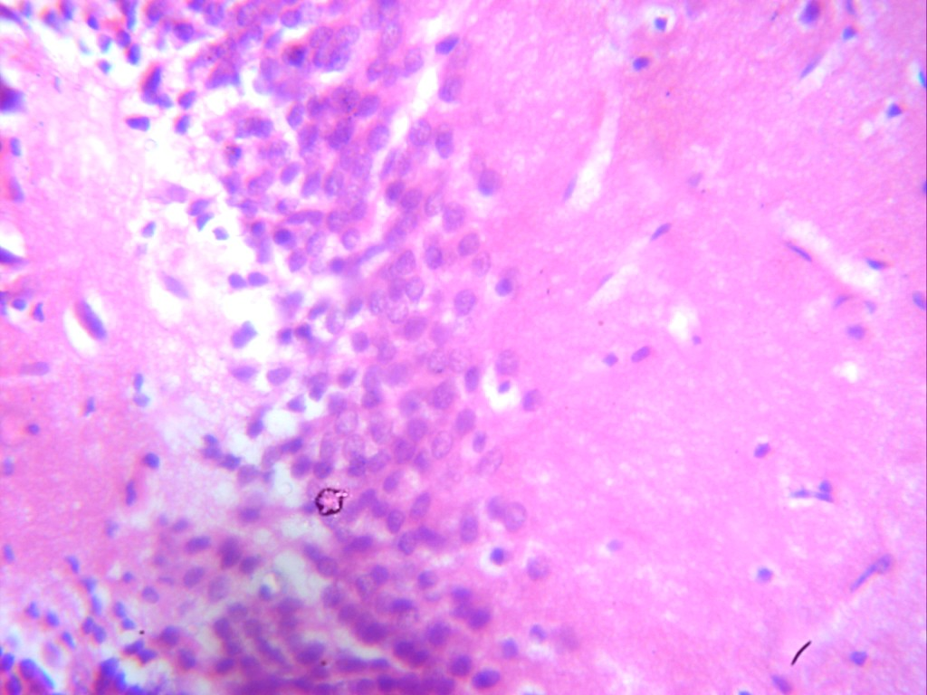
Plate 1: Photomicrograph of group A (control), a section of the hippocampus (x100(x400) (H/E) (CV) shows hippocampus with active granular cells (GC).
GC
GP A

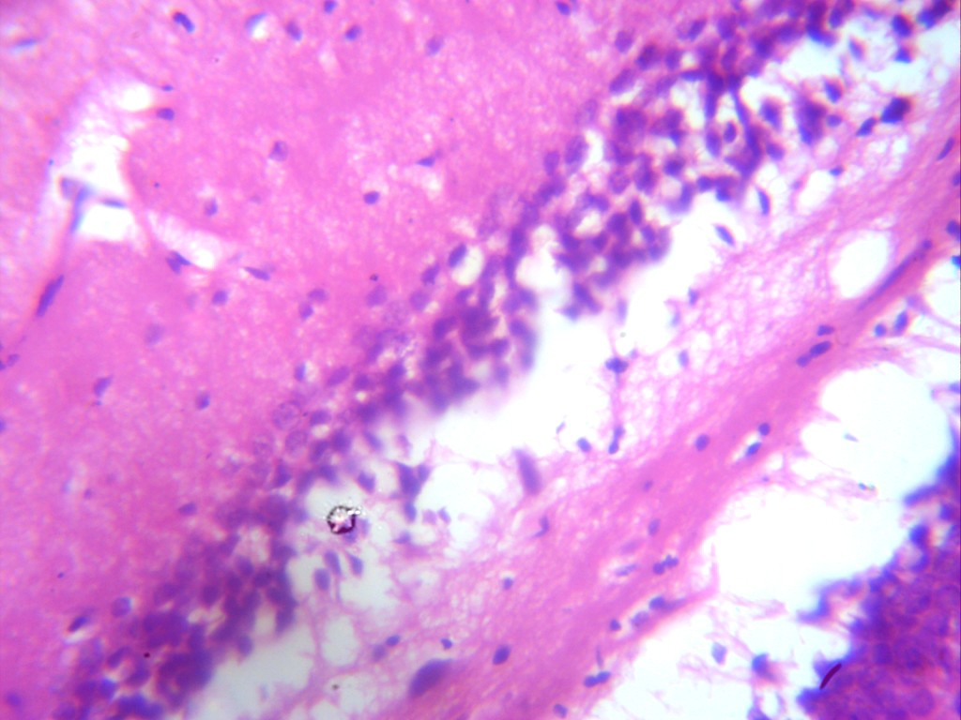

Plate 2: Photomicrograph of group B section of the hippocampus induced with 5mg/kg of methamphetamine(x100x400) (H/E) shows severe degeneration with severe vacuolation(v) and severe pyknotic(P) granular cells.
(P)
(v)
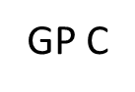
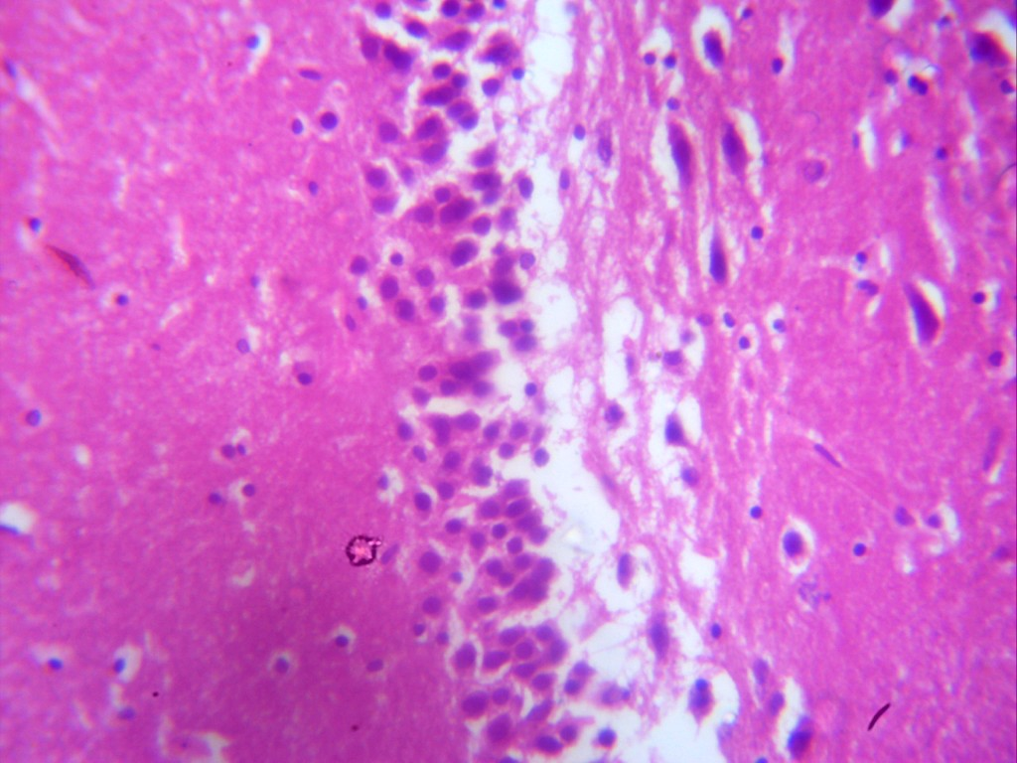

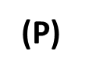

Plate 3: Photomicrograph of group C section of the hippocampus induced with 10mg/kg of methamphetamine(x100x400)(H/E) shows severe degeneration with severe vacuolation(v) and severe pyknotic(P) granular cells.
Plate 4: Photomicrograph of group D section of hippocampus administered with 500mg/kg of vitamin E only (x100x400) (H/E) shows mild vacoulation(v) with active granular cell (GC).

GC
GP D
V
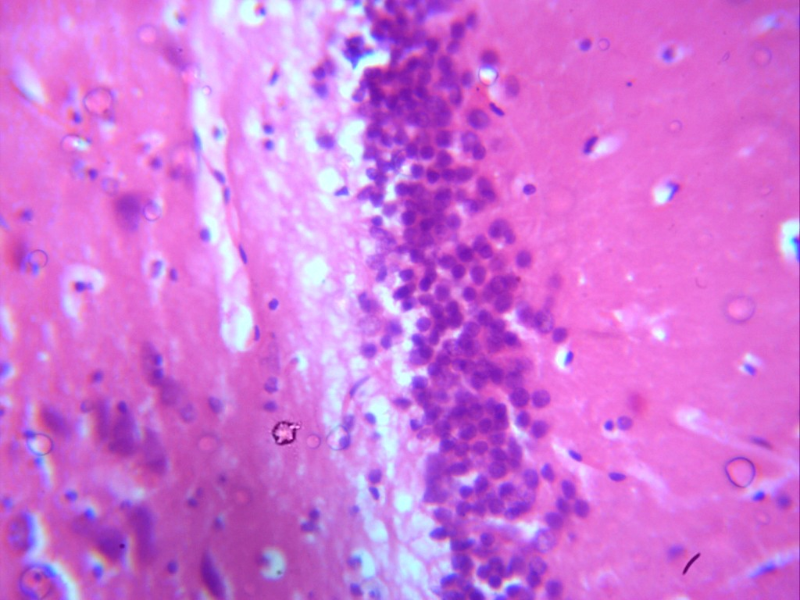
Plate 5: Photomicrograph of group E section of hippocampus administered with 1000mg/kg of vitamin E only (x100x400) (H/E) shows well outlined active granular cell (GC)
V
P
GC
GP E
GC
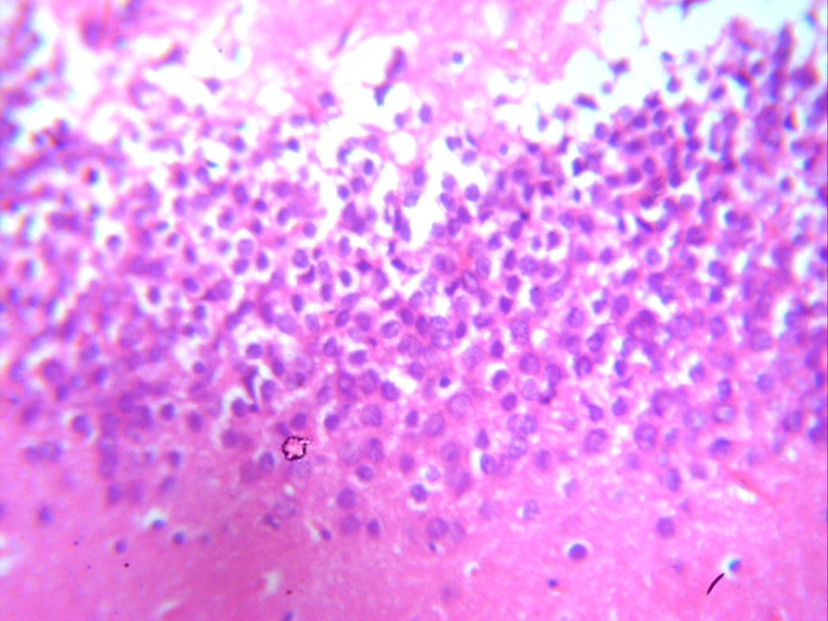
Plate 6: Photomicrograph of group F section of hippocampus induced with 5mg/kg of methamphetamine and 500mg/kg vitamin of E (x100x400) (H/E) shows moderate regeneration with mild vacoulation(v) and moderate increase in the number of active granular cell.
V
GC
GP F
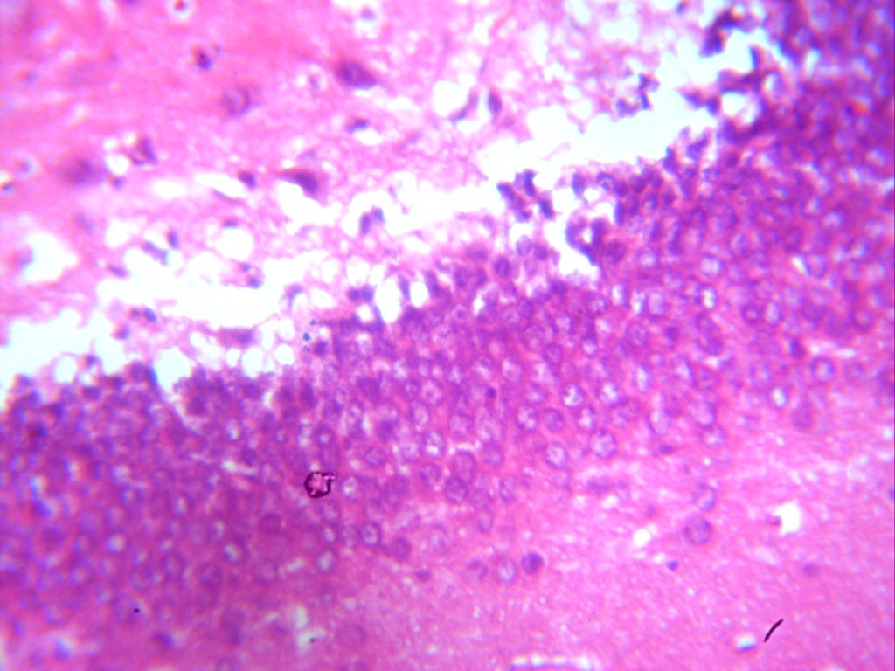
V
P
GP G
Plate 7: Photomicrograph of group G section of hippocampus induced with 10mg/kg of methamphetamine and 1000mg/kg of vitamin E (x100x400)(H/E) shows mild regeneration with moderate vacoulation(v) and moderate pyknotic(P) active granular cell.
P

Discussion
Methamphetamine is a powerful, highly addictive psychostimulant that affects the central nervous system (National Institute on Drug Abuse, 2023). It takes the form of a white, odorless, bitter tasting crystalline powder that easily dissolves in alcohol or water. It produces euphoria and stimulant effects like those from other r stimulants such as cocaine (National Library of Medicine, 2023). Methamphetamine increases the levels of naturally occurring dopamine and norepinephrine on the brain. The effects lasts longer than those of cocaine, and it is cheaper and easy to make with commonly available ingredients. While Vitamin E is a major lipid-soluble antioxidant in the cell antioxidant system, and it is exclusively obtained from the diet (Volker Bohm, 2018). Vitamin E is a nutrient that is important to vision, reproduction, and the health of your blood, brain, and skin. Vitamin E also has antioxidant properties. Antioxidants are substances that might protect your cells against the effects of free radicals — molecules produced when your body breaks down food or is exposed to tobacco smoke and radiation. Free radicals might play a role in heart disease, cancer, and other diseases. If you take vitamin E for its antioxidant properties, keep in mind that the supplement might not offer the same benefits as naturally occurring antioxidants in food (Mayo Clinic, 2022).
The result of this study reveals that intake of methamphetamine caused some characteristic physical changes in adult male Wistar rats as evident in the reduction of physical activity, while the intake of just vitamin E also caused some characteristic physical changes in adult male Wistar rat as evident in the increase in body weight of the animal.
Observation of the body weight difference in groups reveals increase in body weight of animals in group A. This could be physiological as the only substance they were exposed to was water and feed. The significant body weight increase was also observed in the experimental groups D & E that were treated with just vitamin E similar to the control group. This could have been caused by the increase in appetite caused by vitamin e. The increase in weight was mainly due to the increase in fat mass. It had been suggested that a decrease in the production of reactive oxygen species was able to prevent increases in the metabolic weight of animals (Bartke, Brown-Borg, Bode et al., 1998). This further suggests that vitamin E (an antioxidant) could result in slowing down of body metabolism and favor fat accumulation. This result agrees with the result by Ima-Nirwana (2000), who reported that increase in weight were seen in Wistar rats given vitamin E diets.
There was a significant decrease (P>0.05) in the body weight of animals in groups B, C, F & G which were administered methamphetamine, when compared to the control. This is probably as a result of the histological inflammation, degeneration and necrosis in fat tissue caused by Methamphetamine. This result agrees with the work of Jaafari-Sheybani, Hosseini et al., (2021), which says that METH use in Wistar rats resulted in a significant inflammation and necrosis in adipose tissue denoting to the dangers of METH use, when recreationally targeted for weight loss purposes.
The measurement of the activities of marker enzymes in tissues and body fluids can be used in assessing the degree of assault and the toxicity of a chemical compound on organ/tissues (Malamo, 2000; Yakubu et al., 2003). Measurement of enzyme activities can also be used to indicate tissue cellular damage caused by a chemical compound long before histological changes (Akanji, 1986). Enzyme activity levels in serum and tissues are often used as marker to ascertain toxic effects of administered foreign compounds to experimental animals (Coodley, 1970). MDA is a marker of oxidative stress while GSH and SOD are enzymatic antioxidants. These enzymes are highly concentrated in some brain tissues like hippocampus, pre-frontal cortex, e.t.c, are only found in serum in significant quantities when the cell membrane becomes leaky and even completely ruptured. A rise or fall in serum level or decrease in tissue level of these intracellular enzymes is an index of damage to the hippocampal cells.
In the present study, there was a significant increase(P<0.05) in the serum levels of MDA in group B, C, in relative to the control group A, as an increase in the serum levels of MDA indicates the increase in free radicals. This result indicated that the drug methamphetamine brought about cellular damages in the hippocampus during the experimental period. These results agree with Kita et al., (2003) and Escubedo et al., (2003) who reported that METH induced neurotoxicity by generating reactive oxygen species.
The antioxidative action and neuro protective behavior of vitamin E was observed following significant histopathological analysis and reduction of serum level of Malonaldehyde (MDA), and an increase in serum levels of Gluthathione (GSH), and Superoxide dismutase (SOD) in the groups that were treated with vitamin E (Groups D, E, F & G). In the present study, there was a slight increase (P<0.05) in serum levels of Gluthathione (GSH) in groups D & E animals that were treated with just vitamin E in relative to the control (group A). There was also a slight increase (P<0.05) in group F which was treated with methamphetamine and vitamin E in a low dose. This could also be as a result of the neuroprotective behavior and antioxidant properties of vitamin E. This result agrees with Pal et al., (2023) who reported that the decrease in serum levels of Gluthathione in a rat’s brain were reduced under acute stress conditions, however, the administration of vitamin E or vitamin C demonstrated promising effects in mitigating the oxidative stress induced by acute restraint stress. There was a significant decrease in the serum levels of GSH in group C when compared with the control in this present study. This is as a result of or can be attributed to the neurotoxic properties of methamphetamine which induces oxidative stress to the hippocampus of the animal. The low levels of GSH could be linked to the xenobiotic detoxification, or adaptive mechanism as reported by Dasari et al., (2018) and Laborde (2010). This result agrees with the work of Nwogueze et al., (2021), who reported that the serum levels of Gluthathione-related antioxidants in the brain tissue of stressed Wistar rats were reduced when exposed to stressors like RCT, MCT e.t.c, in this case the stressor agent was methamphetamine. This observation was supported by Feoli et al., (1971) who reported that gluthathione deficiency or reduction could increase the brains vulnerability to oxidative stress. GSH which is an enzymatic antioxidant when reduced in the hippocampal tissues or cell can lead to neurodegenerative diseases like Alzheimer’s disease and Parkinson’s disease. The serum levels of superoxide Dismutase (SOD) showed a slight decrease (P>0.05) in groups F, D & E when compared to the control group. While the serum level of SOD in group G showed a significant decrease (P>0.05) when compared with the control group. This decrease is as a result of the neurotoxic/neurodegenerative properties of methamphetamine which can cause oxidative stress in the brain. This result agrees with the work of Otitoju et al., (2008) which reports that an increase in the levels of SOD activity in the brain can reduce the possible neurobehavioural effects like body tremor or aggression which can be caused by an increase in oxidative stress levels.
Histopathological findings of the present study indicated normal hippocampal tissues in control group A. This could be physiological as the only substance they were exposed to was water and feed. The result of groups D & E as seen in photomicrograph 4 and 5, showed a normal hippocampal tissue with active granular cells. This is as a result of the vitamin E that was administered to the animals in these groups.
The groups B & C animals which were administered only methamphetamine showed severe damage to the hippocampal tissue architecture as seen in photomicrograph 2 and 3, here, there was severe degeneration with severe vacoulation and severe pyknotic granular cells. This could be as a result of decrease in antioxidant enzymes and biomarkers by methamphetamine. This result agrees with the work of Nwogueze et al., (2021). The groups F & G which were animals administered methamphetamine and vitamin E caused mild damage to the hippocampal tissue architecture as seen in photomicrograph 6 and 7, here, there was a moderate regeneration with mild vacoulation and moderate increase in the number of active granular cells was recorded in group F animals while, there was mild regeneration with moderate vacoulation and moderate pyknotic active granular cell in group G. This could also be as a result of decrease of the antioxidant enzymes and biomarkers by methamphetamine. This result also agrees with the work of Nwogueze et al., (2021). The animals in group F and G gives a particularly interesting observation about the dynamics of reactions to the presence of various substances in our systems. On administration of vitamin E to the groups, no toxicity changes were associated in physical and behavioral observation, there were body weight increase which were statistically similar with the control and few to no histological lesions were observed in the hippocampal tissues. By these observations, one may deduce that administration of vitamin E may boost the tolerance capacity for methamphetamine induced toxicity. Thus, the neuroprotective effect of vitamin E against methamphetamine induced hippocampus recorded in the present study is attributed to their antioxidant and chemo-protective properties.
CONCLUSION
The vitamin E did not induce adverse alterations in biochemical parameters of serum levels of Malondialdehyde (MAD), Gluthathione (GSH), and Superoxide dismutase (SOD) and very few histopathological lesions was observed in the hippocampus tissues of the rats given vitamin E. This study has demonstrated the potential ability of vitamin E to protect against methamphetamine induced neurotoxicity in the hippocampus of adult male Wistar rats. Rat’s tissues are very similar in many aspects to those of human. The findings of this study suggests that vitamin E administered to individuals exposed to methamphetamine poisoning could provide some slight protection against methamphetamine toxicity and perhaps ameliorate the effects of methamphetamine neurotoxicity on the hippocampus.
RECOMMENDATION
This study has opened a way for possible means of preventing damage to man tissues by methamphetamine. I recommend that vitamin E either from vitamin E rich foods or from dietary supplements should be administered to see if it is possible to demonstrate a possible counter effect on the hippocampus. However, further work is needed particularly on the effect of these drug on other organs like spleen, heart etc.
REFERENCES
Akanji, M. A., Nafiu, M. O. and *Yakubu, M. T., (2008). Enzyme Activities and Histopathology of Selected Tissues in Rats Treated with Potassium bromate. African Journal of Biomedical Research, Vol. 11, pp.87 – 95.
Alessio, A., Damasceno, B.P., Camargo, C.H.P., Kobayashi, E., Guerreiro, C.A.M. and Cendes, F., (2004). Differences in memory performance and other clinical characteristics in patients with mesial temporal lobe epilepsy with and without hippocampal atrophy. Epilepsy & Behavior, 5(1), pp.22-27.
Anglin, M.D., Burke, C., Perrochet, B., Stamper, E. and Dawud-Noursi, S., (2000). History of the methamphetamine problem. Journal of psychoactive drugs, 32(2), pp.137-141.
Bartke, A., Brown-Borg, H.M., Bode, A.M., Carlson, J., Hunter, W.S. and Bronson, R.T., (1998). Does growth hormone prevent or accelerate aging? Experimental gerontology, 33(7-8), pp.675-687.
Bast, T., (2011). The hippocampal learning-behavior translation and the functional significance of hippocampal dysfunction in schizophrenia. Current opinion in neurobiology, 21(3), pp.492-501.
Birenbaum, B., The Hippocampus: Definition, Function, & Anatomy.
Bonilha, L., Martz, G.U., Glazier, S.S. and Edwards, J.C., (2012). Subtypes of medial temporal lobe epilepsy: influence on temporal lobectomy outcomes?. Epilepsia, 53(1), pp.1-6.
Borel, P., Preveraud, D. and Desmarchelier, C., (2013). Bioavailability of vitamin E in humans: an update. Nutrition reviews, 71(6), pp.319-331.
Brecht, M.L., O'Brien, A., Von Mayrhauser, C. and Anglin, M.D., (2004). Methamphetamine use behaviors and gender differences. Addictive behaviors, 29(1), pp.89-106.
Brown KM, Morrice PC, Duthie GG., (1997). Erythrocyte vitamin E and plasma ascorbate concentrations in relation to erythrocyte peroxidation in smokers and non-smokers: Dose response to vitamin E supplementation. Am J Clin Nutr, 65, pp.496–502.
Burton GW, Joyce A, Ingold KU., (1983). Is vitamin E the only lipid-soluble, chain- breaking antioxidant in human blood plasma and erythrocyte membranes? Arch Biochem Biophys, 221, pp.281–90.
Canton, H., (2021). United Nations Office on drugs and crime—UNODC. In The Europa Directory of International Organizations 2021 (pp. 240-244). Routledge.
Cearley, C., Churchill, L. and Krueger, J.M., (2003). Time of day differences in IL1β and TNFα mRNA levels in specific regions of the rat brain. Neuroscience letters, 352(1), pp.61-63.
Cho, A.K., (1990). Ice: a new dosage form of an old drug. Science, 249(4969), pp.631-634.
Ciccarone, D., (2011). Stimulant abuse: pharmacology, cocaine, methamphetamine, treatment, attempts at pharmacotherapy. Primary Care: Clinics in Office Practice, 38(1), pp.41-58.
Coodley, E.L. (1970) Diagnosic Enzymology. (3rd ed.) W.B. Saunders Co. Philadelphia, USA.
Copes, H., Tchoula, W. and Ragland, J., (2019). Ethically representing drug use: Photographs and ethnographic research with people who use methamphetamine. Journal of Qualitative Criminal Justice and Criminology, 8(1), pp.21-36.
Cruickshank, C.C. and Dyer, K.R., (2009). A review of the clinical pharmacology of methamphetamine. Addiction, 104(7), pp.1085-1099.
Cumming, C., Troeung, L., Young, J.T., Kelty, E. and Preen, D.B., (2016). Barriers to accessing methamphetamine treatment: a systematic review and meta- analysis. Drug and alcohol dependence, 168, pp.263-273.
Degenhardt, L., Mathers, B., Guarinieri, M., Panda, S., Phillips, B., Strathdee, S.A., Tyndall, M., Wiessing, L., Wodak, A. and Howard, J., (2010). Meth/amphetamine use and associated HIV: Implications for global policy and public health. International Journal of Drug Policy, 21(5), pp.347-358.
Dhikav, V. and Anand, K., (2011). Potential predictors of hippocampal atrophy in Alzheimer’s disease. Drugs & aging, 28, pp.1-11.
Dhikav, V. and Anand, K.S., (2007). Is hippocampal atrophy a future drug target?. Medical hypotheses, 68(6), pp.1300-1306.
Dumbili, E. and Ebuenyi, I., (2022). Factors influencing methamphetamine (mkpulummiri) use in Eastern Nigeria. Available at SSRN 4020039.
Ellis, M.S., Kasper, Z.A. and Cicero, T.J., (2018). Twin epidemics: the surging rise of methamphetamine use in chronic opioid users. Drug and alcohol dependence, 193, pp.14-20.
Feoli, A.M., Siqueira, I.R., Almeida, L., Tramontina, A.C., Vanzella, C., Sbaraini, S., Schweigert, I.D., Netto, C.A., Perry, M.L. and Gonçalves, C.A., (2006). Effects of protein malnutrition on oxidative status in rat brain. Nutrition, 22(2), pp.160-165.
Fisher, D.G., Reynolds, G.L., Ware, M.R. and Napper, L.E., (2011). Methamphetamine and Viagra use: relationship to sexual risk behaviors. Archives of sexual behavior, 40, pp.273-279.
Grzywacz, A., Chmielowiec, J., Chmielowiec, K., Mroczek, B., Masiak, J., Suchanecka, A., Sipak-Szmigiel, O., Szumilas, K. and Trybek, G., (2019). The Ankyrin Repeat and Kinase Domain Containing 1 Gene Polymorphism (ANKK1 Taq1A) and Personality Traits in Addicted Subjects. International Journal of Environmental Research and Public Health, 16(15), p.2687.
Han, B., Compton, W.M., Jones, C.M., Einstein, E.B. and Volkow, N.D., (2021). Methamphetamine use, methamphetamine use disorder, and associated overdose deaths among US adults. JAMA psychiatry, 78(12), pp.1329-1342.
Hansen, E.R., Carvalho, S., McDonald, M. and Havens, J.R., (2021). A qualitative examination of recent increases in methamphetamine use in a cohort of rural people who use drugs. Drug and alcohol dependence, 229, p.109145.
Hanson, C., Lyden, E., Furtado, J., Van Ormer, M., Schumacher, M., Kamil, A., McGinn, E., Rilett, K., Elliott, E., Cave, C. and Johnson, R., (2019). Vitamin E status and associations in maternal-infant Dyads in the Midwestern United States. Clinical nutrition, 38(2), pp.934-939.
Ijomone MO, Nwoha PU, Olaibi OK, Obi AU, Alese MO., (2011). Effects of methamphetamine on the hippocampus of rats: Behavioural and morphological approach. J Neurosci Behav Health 3, pp.107-12.
Ima-Nirwana S, Khalid BAK, Azman A., (2001). The effects of vitamin E on bodyweight and fat mass intact and ovariectomized female rats. Med J Islam Academy sci, 14(4), pp.125-138.
Jaafari-sheybani F, Hoseini SE, Mehrabani D, Derakhshanfar A, Karimi-Busheri F., (2021). Histological changes in adipose tissue: An alarm when methamphetamine is targeted for weight loss purposes. Wrld J plas surg, 10(1), p.53.
Kamal‐Eldin, A. and Appelqvist, L.Å., (1996). The chemistry and antioxidant properties of tocopherols and tocotrienols. Lipids, 31(7), pp.671-701.
Kerr, K.M., Agster, K.L., Furtak, S.C. and Burwell, R.D., (2007). Functional neuroanatomy of the parahippocampal region: the lateral and medial entorhinal areas. Hippocampus, 17(9), pp.697-708.
Kita T, Wagner GC, Nakashima T., (2003). Current research on methamphetamine- induced neurotoxicity: animal models of monoamine disruption. Journal of pharmacological sciences, 92(3), pp.178-195.
Koehl, M. and Abrous, D.N., (2011). A new chapter in the field of memory: adult hippocampal neurogenesis. European Journal of Neuroscience, 33(6), pp.1101-1114.
Kuczenski, R., Segal, D.S., Cho, A.K. and Melega, W., (1995). Hippocampus norepinephrine, caudate dopamine and serotonin, and behavioral responses to the stereoisomers of amphetamine and methamphetamine. Journal of Neuroscience, 15(2), pp.1308-1317.
Lim, S.H., Akbar, M., Wickersham, J.A., Kamarulzaman, A. and Altice, F.L., (2018). The management of methamphetamine use in sexual settings among men who have sex with men in Malaysia. International Journal of Drug Policy, 55, pp.256-262.
Limanaqi F, Gambardella S, Biagioni F, Busceti CL, Fornai F., (2018). Epigenetic Effects Induced by Methamphetamine and Methamphetamine-Dependent Oxidative Stress. Oxid Med Cell Longev, 2018:4982453.
Maranella E, Mareri A, Nardi V, Di Natale C, Di Luca L, Conte E, Pannone V, Catalucci A, Di Fabio S., (2019). Severe neurologic and hepatic toxicity in a newborn prenatally exposed to methamphetamine. A case reports. Brain Dev, Feb;41(2):191-194.
McKetin, R., Kelly, E. and McLaren, J., (2006). The relationship between crystalline methamphetamine use and methamphetamine dependence. Drug and alcohol dependence, 85(3), pp.198-204.
Mielke, M.M., Okonkwo, O.C., Oishi, K., Mori, S., Tighe, S., Miller, M.I., Ceritoglu, C., Brown, T., Albert, M. and Lyketsos, C.G., (2012). Fornix integrity and hippocampal volume predict memory decline and progression to Alzheimer’s disease. Alzheimer's & Dementia, 8(2), pp.105-113.
Molnár, K. and Kéri, S., (2014). Bigger is better and worse: on the intricate relationship between hippocampal size and memory. Neuropsychologia, 56, pp.73-78.
Morgado-Bernal, I., (2011). Learning and memory consolidation: linking molecular and behavioral data. Neuroscience, 176, pp.12-19.
Mueller, S.G., Schuff, N., Yaffe, K., Madison, C., Miller, B. and Weiner, M.W., (2010). Hippocampal atrophy patterns in mild cognitive impairment and Alzheimer's disease. Human brain mapping, 31(9), pp.1339- 1347.
Niki E, Traber MG., (2012). A history of vitamin E. Ann Nutr Metab, 61, pp.207– 12.
Nwogueze BC, Ojieh AE, Aloamaka CP, Igweh JC, Onyesom I., (2021). Levels of gluthatione-related antioxidants in ssome tissues of stressed Wistar rats. Indian J Physiol Pharmacol, 65, pp.167-76.
Ohm, T.G., (2007). The dentate gyrus in Alzheimer's disease. Progress in brain research, 163, pp.723-740.
Onwurah IN, Otitoju O, Otitoju GT, Ugwu CE., (2008). Oxidative stress and superoxide dismutase activity in the brain of rats fed with diet containing permethrin. Biokemistri, 20(2), pp.93-98.
Palamar, J.J., Han, B.H. and Keyes, K.M., (2020). Trends in characteristics of individuals who use methamphetamine in the United States, 2015-2018. Drug and alcohol dependence, 213, p.108089.
Parsons, N.L., (2014). Meth Mania: A History of METH.
Pini, L., Pievani, M., Bocchetta, M., Altomare, D., Bosco, P., Cavedo, E., Galluzzi, S., Marizzoni, M. and Frisoni, G.B., (2016). Brain atrophy in Alzheimer’s disease and aging. Ageing research reviews, 30, pp.25-48.
Pubill, D., Canudas, A.M., Pallàs, M. et al., (2003). Different glial response to methamphetamine- and methylenedioxymethamphetamine-induced neurotoxicity. Naunyn-Schmiedeberg's Arch Pharmacol, 367, pp.490–499.
Raederstorff, D., Wyss, A., Calder, P.C., Weber, P. and Eggersdorfer, M., (2015). Vitamin E function and requirements in relation to PUFA. British Journal of Nutrition, 114(8), pp.1113-1122.
Rawson, R.A., Huber, A., Brethen, P., Obert, J., Gulati, V., Shoptaw, S. and Ling, W., (2001). Status of methamphetamine users 2–5 years after outpatient treatment. Journal of Addictive Diseases, 21(1), pp.107-119.
Sato, A., (2008). Methamphetamine use in Japan after the Second World War: Transformation of narratives. Contemporary Drug Problems, 35(4), pp.717- 746.
Schönheit, B., Glöckner, F. and Ohm, T.G., (2007). Apolipoprotein E polymorphism and dendritic shape in hippocampal interneurons. Neurobiology of Aging, 28(5), pp.677-686.
Scott, J.C., Woods, S.P., Matt, G.E., Meyer, R.A., Heaton, R.K., Atkinson, J.H. and Grant, I., 2007. Neurocognitive effects of methamphetamine: a critical review and meta-analysis. Neuropsychology review., 17, pp.275-297.
Sexton, R.L., Carlson, R.G., Leukefeld, C.G. and Booth, B.M., (2006). Methamphetamine use and adverse consequences in the rural southern United States: An ethnographic overview. Journal of psychoactive drugs, 38(3), pp.393-404.
Shoptaw, S. and Reback, C.J., (2007). Methamphetamine use and infectious disease‐ related behaviors in men who have sex with men: implications for interventions. Addiction, 102, pp.130-135.
Spallazzi, M., Dobisch, L., Becke, A., Berron, D., Stucht, D., Oeltze-Jafra, S., Caffarra, P., Speck, O. and Düzel, E., (2019). Hippocampal vascularization patterns: a high-resolution 7 Tesla time-of-flight magnetic resonance angiography study. NeuroImage: Clinical, 21, p.101609.
Suvvari TK, Pal G, Mishra HP, Tanwar A, Ghosh T, Verma P, Pal A, Mahapatra C, Amanullah NA, Shukoor SA, Kamal S, Rohil V., (2023). Oxidative stress in Wistar rats under acute stress and its modification by antioxidants and nitric oxide modulators. Cureus, 15(8): e43333.
Thiele, J.J., Hsieh, S.N. and Ekanayake‐Mudiyanselage, S., (2005). Vitamin E: critical review of its current use in cosmetic and clinical dermatology. Dermatologic surgery, 31, pp.805-813.
Thom, M., Eriksson, S., Martinian, L., Caboclo, L.O., McEvoy, A.W., Duncan, J.S. and Sisodiya, S.M., (2009). Temporal lobe sclerosis associated with hippocampal sclerosis in temporal lobe epilepsy: neuropathological features. Journal of Neuropathology & Experimental Neurology, 68(8), pp.928-938.
Traber, M.G., (2006). How much vitamin E?... Just enough!. American journal of clinical nutrition, 84(5), pp.959-960.
Traber, M.G., (2024). Human Vitamin E deficiency, and what is and is not Vitamin E?. Free Radical Biology and Medicine.
Violet, P.C., Ebenuwa, I.C., Wang, Y., Niyyati, M., Padayatty, S.J., Head, B., Wilkins, K., Chung, S., Thakur, V., Ulatowski, L. and Atkinson, J., (2020). Vitamin E sequestration by liver fat in humans. JCI insight, 5(1).
Wu, D. and Meydani, S.N., (2019). Vitamin E, immune function, and protection against infection. Vitamin E in human health, pp.371-384.
Yang X, Wang Y, Li Q, Zhong Y, Chen L, Du Y, He J, Liao L, Xiong K, Yi CX, Yan J., (2018). The Main Molecular Mechanisms Underlying Methamphetamine- Induced Neurotoxicity and Implications for Pharmacological Treatment. Front Mol Neurosci, 11, pp.186.
Zingg, J.M. and Azzi, A., (2004). Non-antioxidant activities of vitamin E. Current medicinal chemistry, 11(9), pp.1113-1133.

