## NEURO-RESTORATIVE EFFECTS OF SOURSOP SEED (ANNONA MURICATA) EXTRACT ON OPTIC CHIASM LESIONS AND TOXICITY IN ALUMINIUM CHLORIDE-INDUCED RAT MODEL OF ALZHEIMER'S DISEASE.

**ABSTRACT**

**Introduction:** Alzheimer's disease (AD) is a degenerative neural disease that disrupts connections between neurons in the optic chiasm due to an aberrant protein build-up that causes visual field loss and memory. Aluminum chloride accumulation has been linked to cholinergic dysfunction and neuronal death. Medicinal plants are plants that have medical value serving as building blocks for the creation of effective medications.

**Aim:** To investigate Neuro-Restorative Effects of Sour-sop Seed (Annona Muricata) Extract On Olfactory-Bulb Lesions and Toxicity In Aluminium-Chloride Induced Rat Model Of Alzheimer's Disease.

**Methods:** Thirty-five(35) male wister rats weighing 150 $±$ 200g were divided into 5 groups (n=7). Group A: received distilled water (orally). Group B (Alzheimer) received 100mg/kg of aluminum chloride (IP). Group C: received 200mg/kg of sour-sop seed extract (orally). Group D: received 100mg/kg of aluminum chloride and 200mg/kg of sour-sop seed extract. Group E: received 100mg/kg of aluminum chloride and 100mg/kg of standard drug for 21 days. The animals were sacrificed through cervical dislocation and organs were harvested for histological and biochemical analysis. Data obtained were analyzed using one-way ANOVA(p<0.05) subjected to graph pad prism.

**Results:** the body, brain and organ weight shows a significant decrease (P<0.0001) in Alzheimers group compared to control. The white blood cell count shows a significant decrease(p<0.0001) in the alzheimers group when compared to the control and treated group, TNF-alpha shows a significant increase in the alzheimers group (p<0.0001) when compared to the control and treated groups. Histological findings show that the optic chiasm of Alzheimer’s group has a degeneration of oligodendrocytes cells and loss of astrocytes while there is a regeneration of oligodendrocytes and gaining of astrocytes cells in the treatment group.

**Conclusion:** In summary,soursop seed extract has neuroprotective effects on the optic chiasm in aluminum chloride induced Alzheimer disease, providing a potential therapeutic benefit for AD treatment.

**Key word:** Alzheimer’s disease, Aluminium chloride,soursop,optic chiasm

# **1.0 INTRODUCTION**

# **1.1 ALZHEIMER’S DISEASE**

One of the most debilitating brain ailments that affect older people is Alzheimer's disease. .(Armstrong 2009). Alzheimer's disease (AD) is a degenerative neural disease that disrupts connections between neurons and kills cells in the brain due to an aberrant protein build-up. Initially, neurons and their connections in memory-related brain regions, such as the entorhinal cortex and hippocampus, are usually destroyed by Alzheimer's disease.(Armand *et al*., 2019)

Later on, it impacts parts of the cerebral cortex linked to logic, language, and social interaction. Numerous other brain regions eventually sustain injury. An individual suffering from Alzheimer's disease eventually loses the capacity to live and act on their own. In the end, the illness is lethal. (Kandimalla *et al.,*2017 ) . It is a condition that is underdiagnosed, undertreated, and rapidly becoming into a significant public health issue. Over the past ten years, there has been a consistent increase in the amount of work done to identify the disease's genesis and create pharmacological treatments. Improved clinical diagnostic guidelines and better behavioral and cognitive disturbance treatments are recent breakthroughs. (Kandimalla *et al.,*2017)

Randomized,double-blind, placebo-controlled, parallel-group studies assessing performance-based tests of cognitive function, activities of daily living, and behavior have clinically evaluated symptomatic treatment, mostly focusing on cholinergic therapy. Galantamine, donepezil, tacrine, rivastigmine, and other cholinesterase inhibitors are among the medications that are advised for treating cognitive impairment in Alzheimer's patients. (Armand *et al.,* 2019*).*

Early in the disease, there are deficits in the ability to encode and store new memories. The later stages are accompanied by gradual changes in cognition and behavior(Ashworth, 2020) Reduced synaptic strength, synaptic loss, and neurodegeneration are the results of altered amyloid precursor protein (APP) cleavage, the APP fragment beta-amyloid (Aβ), and hyperphosphorylated tau protein aggregation. Important elements of the disease process include concomitant diseases, alterations in metabolism, vascular function, and inflammation. (Ashworth, 2020)

The extracellular deposition of accumulated amyloid beta (Aβ) peptide (i.e., the 42 amino acid-long Aβ peptide (Aβ1–42) in the form of diffuse and neuritic Aβ plaques and the intraneuronal accumulation of neurofibrillary tangles (NFTs), consisting of aggregated hyperphosphorylated tau (p-tau) proteins, are the key pathophysiological hallmarks detected in AD brains.(Ashworth, 2020). Loss of synapses and selective neuronal cell death accompany these traits. A small but clinically significant improvement in cognition can be obtained with symptomatic treatment; nonetheless, disease-modifying treatments are badly needed. .(Armand *et al*., 2019)

In the population over 65, the disease is predicted to have a prevalence of 10-15% and an incidence of 1-3 percent. (Colin *et al.,* 2015). The sporadic form of Alzheimer's disease affects the majority of patients (>95%) and is characterized by a late onset (80–90 years of age). This is because the amyloid-β (Aβ) peptide cannot be cleared from the brain's interstitial spaces. (Colin *et al.,* 2015).

# **1.2 ALUMINUM CHLORIDE**

The neurotoxic material aluminum (Al) has been implicated in the pathophysiology, etiology, and progression of amyloid-β (Aβ) plaques. (Hesham Mustafa 2020). An abundance of aluminum in the environment has the potential to be neurotoxic and can cause oxidative damage to a variety of cellular indicators. Aluminum cookware utensils, food, medications, immunizations, and drinking water are among the possible sources of aluminum buildup in the body. (Hesham Mustafa 2020) .

The accumulation of aluminum in the brain is known to be connected with cholinergic dysfunction, oxidative stress and neuronal damage, which may ultimately cause Alzheimer's disease. (Dey *et al.,* 2022*).* According to epidemiological research, long-term aluminum intake has been linked to neurological damage and cognitive decline. The conditions associated with AD were formed in animals exposed to aluminum. . (Dey *et al.,* 2022*)* These conditions included elevated amounts of Aβ protein, hyperphosphorylated tau protein production, degeneration of cholinergic terminals in the cortex and hippocampus, development of oxidative stress, and neuronal death. Chronic exposure to aluminum has been demonstrated to cause accumulation in all areas of the rat brain, including the hippocampal synaptic plasticity, which is the site of learning and memory. (Kumar, 2019.)

# **1.3 MEDICINAL PLANTS.**

Medicinal plants are plants that have chemicals in one or more of its organs that have medical value or that serve as building blocks for the creation of effective medications. (Li, et al., 2023). A valuable and abundant source of plant-based medications and novel pharmaceuticals are medicinal plants. The secondary metabolites of medicinal plants are receiving more attention because of their distinct pharmacological action, high consumption value, and biological activity. (Li  *et al.,* 2023*).*

Throughout history, mankind have depended on the natural world to provide them with essential necessities such as food, clothes, housing, transportation, fertilizers, scents, and, last but not least, medicinal products. Plants have been the foundation of sophisticated traditional medical systems for thousands of years, and they still provide humans new ways to heal themselves. (Pourchez, 2017).

A number of studies have demonstrated the possible medical effects of soursop (Annona muricata), making it one of the fruits that has been the subject of the most research in recent years. The soursop is a versatile tropical and subtropical fruit that is highly susceptible to sharp temperature changes.(Gavamukulya *et al*., 2017).. Soursop has a wide range of medicinal uses due to its various phytochemicals; these include the inhibition of α-glucosidase and α-amylase enzymes, diabetes, tumors, cancer, oxidative stress, blood pressure, inducing apoptosis in tumor cells, hemorrhagic disease, and lowering cholesterol.(Gavamukulya *et al*., 2022). It can be used to generate pharmaceuticals and nutraceuticals because of its significant nutritional profile and therapeutic potential. The phytoconstituents and bioactive compounds of *Annona muricata* L. (medicinal herb) were examined and it was revealed that they possess medicinal properties.

The soursop leaf was identified to be useful in inhibiting the cancer cells by inducing apoptosis, improving immune response, decreasing glucose concentration in blood, reducing depression, stimulating digestion, and dilating blood vessels  (Afzaal *et al* ., 2022*)* The fruits of the soursop consist of 4% edible pulp by weight, 8% seeds, 20% skin, and 4% core. Protein, carbohydrates, water, nonreducing sugar, and vitamins B1, B2, and C are all abundant in their pulp. Refractive indices of 1.356 for the pulp and 1.335 for the seeds, pH values of 4.56 for the pulp and 8.34 for the seeds, and soluble solid contents of 151Brix for the pulp and 1.51Brix for the seeds were among the many physicochemical properties. . (Afzaal*et al .,* 2022*)*.

Sugars make up around 70% of the total solids in the soursop pulp, making them the second most abundant component after water. 93.6% of the sugar content was made up of fructose, glucose, and other reducing sugars. Gas-liquid chromatography was used to determine the soursop's fructose, D-glucose, and sucrose concentrations.(Pourchez, 2017 )

# **1.4 OPTIC CHIASM.**

The fundamental component of the visual pathway is the optic chiasm, also known as the optic chiasma, which is the area of the brain where the optic nerves intersect. (Ireland, 2017). It is situated in the suprasellar cistern near the base of the brain, 10 mm superior to the pituitary gland and inferior to the hypothalamus. (Carter *et al.,* 2023).

It forms a portion of the anterior floor of the third ventricle and shares significant anatomical links with the anterior communicating and anterior cerebral arteries. (Ireland *et al.,* 2017). Because of this, it is not surprising that neurodegeneration brought on by Alzheimer's disease affects the eye given its close relationship to the brain. Significant evidence suggests that ocular pathology occurs as part of AD, which has well-documented visual symptoms. This therefore offers a chance to use the transparent medium of the eye to investigate the diseased features in the brain using a minimally invasive technique.(Sadun, 1990*).*

When the optic nerves converge, the optic chiasm is created, which permits fibers from the nasal retina to cross over into the optic tract on the opposite side. This allows the occipital brain of the other eye to perceive images from one side of both eyes (Kidd. 2014). Particularly susceptible to neurodegeneration brought on by mitochondrial malfunction are the optic nerve and the retinal ganglion cells (RGCs), which give rise to the optic nerve's 1.2 million axons. (Valerio *et al.,* 2017*).* The two optic nerves unite at the optic chiasm, and the fibers from each eye either turn back and stay uncrossed or cross the midline. The fibers split into the two optic tracts after adopting their own paths. As the chiasm grows in a caudo-rostral orientation, the various ganglion cell classes cross the midline at different points along its length, representing their unique times of creation (Valerio *et al.,* 2017).

 According to morphometric study, the largest class of retinal ganglion cells (M-cells), which supply the optic nerve with large caliber fibers, were primarily lost in the optic nerve in many Alzheimer's disease cases. (Valerio *et al*., 2017) Certain visual functions are known to be mediated by the M-cell system, and many Alzheimer's patients experience clinically detectable neuro-ophthalmic and psychophysical deficits as a result of the M-cell population's selective involvement. (Alfredo *et al.,* 1990).

It is not surprising that Alzheimer's disease lead to neurodegeneration that affects vision. There is ample evidence to support the well-documented visual symptoms associated with AD, as well as the theory that the condition includes ocular pathology. As a result, this offers a chance to employ the transparent medium of the eye in a less invasive manner to investigate the diseased aspects in the brain. (Javaid *et al.,* 2016).

Changes in pupillary response to mydriatics, defects in fixation and smooth and saccadic eye movements, variations in contrast sensitivity and visual evoked potentials (VEP), and disruptions of complex visual functions like reading, visuospatial function, and object naming and identification are just a few of the visual issues that have been reported in patients with AD. (Armstrong *et al.,* 2009).

There is conflicting data in the literature about several of these changes, and no ocular or visual trait can be considered as particularly diagnostic of AD. Furthermore, it has been noted that pathological alterations in AD impact the eye, visual pathway, and visual brain. (Armstrong *et al.,* 2009).

# **2.0 METHODOLOGY**

## **2.1 PROCUREMENT OF RAT**

Thirty-five Wistar rats were purchased from the Babcock University Animal House in Ilishan, Ogun State, acclimatized at the Faculty of Basic Medical Sciences Animal House at Olabisi Onabanjo University, Sagamu campus, animal house using a temperature-controlled vehicle.  
They were maintained in a very sanitary and favorable environment with a 12-hour light/dark lighting cycle. The rats were given clean water to drink along with pelletized meal that was obtained in a sanitary and nutritionally sound manner. Their bedding was also changed every day.

**2.1.1 ETHICAL CONCERNS IN ANIMAL STUDY**

All animal experiments and protocols adhered to the guidelines and regulations set forth by the National Research Council in regards to laboratory animal care and utilization (2011). Following the conclusion of experiments, animal carcasses were buried, no less than two feet beneath the natural surface, and covered with lime, disinfectant, and soil.

## **2.1.2 PROCUREMENT OF ALUMINIUM CHLORIDE (AlCl₃)**

Aluminium Chloride(AlCl₃) was acquired using a methodical process to find reliable provider the AlCl₃ was acquired from a chemical laboratory retailer in sagamu's sabo market ogun state. it was verified and authenticated in the department of chemical sciences Olabisi Onabanjo University's

**2.1.3 PROCUREMENT OF SOURSOP SEED EXTRACT**

The sour-sop fruit was purchased from Sagamu's Sabo market. After allowing it to mature and extracting the seeds, it was placed in a room temperature drying cabinet in the laboratory, the seeds were grounded into powered form using a designated mechanical grinding mill. The Plant Science Department at Ago-Iwoye, Ogun State, verified and authenticated the le.

## **2.1.4 PROCUREMENT OF STANDARD DRUG**

The standard drugs was purchased from a pharmacy vendor in Sabo Market, Sagamu. The Olabisi Onabanjo University Department of Pharmacy verified and authenticated the standard medication.

**2.2 ANIMAL GROUPING**

**Control group** - Received distilled water orally.

**Aluminum chloride group** - Received 100mgof aluminum chloride for 3weeks.

**Aluminum + Sour-sop group** - Received 100mg of aluminum chloride and 200mg of

Sour-sop for 3weeks.

**Sour-sop only group** - Received 200mg of soursop for 3 weeks.

**Aluminum chloride + Standard drug group** - Received 100mg of aluminum chloride and 100mg

of standard drug for 3weeks.

**ANIMAL SACRIFICE AND DETERMINATION OF ORGAN WEIGHT**

The animals were subjected to cervical dislocation six hours subsequent to the expiration of research. The cerebellum was meticulously extracted and the weight of the organ was ascertained per 100 grams of body weight utilizing a kerroBL20001 weighing scale.

**2.3 HISTOLOGICAL AND HISTOCHEMICAL ANALYSIS**

The brain from all the rats were carefully removed using a brain forcep, weighed and the optic chiasm were preserved in 10% formal saline solution. After 24 hours of fixation, the optic chiasm of all the brain tissues were routinely processed for H&E stain and histochemical stains.

## **2.3.1 HISTOLOGICAL ANALYSIS**

## **2.3.2 Histological Procedure**

The optic chiasm was removed and fixed in 10% formal saline and processed through histological techniques at the Histology laboratory of the Department of Anatomy, Olabisi Onabanjo University, Sagamu Campus, Ogun State, Nigeria.

## **Fixation:**The optic chiasm tissue was fixed in 10% formal saline solution (which was prepared by

dissolving 0.85g of NaCl in 90ml of water and 10ml formaldehyde) for about 24 hours to prevent autolysis and to keep the tissue in life-like nature. **Dehydration:**Water was gradually removed from the optic chiasm tissue by placing them in ascending grades of alcohol (50%, 70%, 80%, 90% and 100%) at an interval of 1hour 30minutes andthen transferred into Absolute1 and Absolute2 grade of alcohol at an interval of 1 hour. **Clearing:** The tissue was taken through two (2) baths of Xylene at an interval of 1hours to remove the alcohol and to improve the refractive index. **Infiltration**: The tissue were infiltrated with molten paraffin wax at a temperature of 50℃ for two separate baths of 1hour each. **Embedding:** The optic chiasm tissue were placed into a cubed embedding mold, and molten paraffin wax was poured over them. The wax was then allowed to solidify, forming a tissue block around the optic chiasm tissues. Afterward, the excess wax was trimmed off, preparing the tissue block for sectioning. **Sectioning:** Using a rotary microtome, the tissue block was carefully trimmed to expose its surface before being sectioned at a thickness of 3 microns. The resulting sections were then floated in a water bath. They were subsequently picked up using an albuminized slide and placed on a hot plate to facilitate the adhesion of the tissue to the slide.

## **2.3.3 H&E STAINING METHOD**

## **2.3.3.1 H&E STAINING**

The labeled slides were dewaxed in xylene for I5 minutes, Hydration was done in descending grades of alcohol (100%, 90%, 80%, 70%,50%), Slides were stained in Harris Hematoxylin solution for 5 minutes, Slides were rinsed in running tap water for few minutes, Penetration in 1% acid alcohol (differentiation solution) for one to two dips for 30Seconds, Checking was done under the light microscope for a satisfactory effect of the stain, Sides were rinsed in running tap water, Differentiation was repeated on some for best result, which were checked microscopically., Slides were then immersed in the bluing solution for 5 minutes, Rinsing done in running tap water,, Sections were stained with Eosin solution for 30 seconds to 3 minutes, Rinsing done in running tap water done for 30 seconds, Stained sections were then dehydrated in 80% alcohol, 95% alcohol for 1 minute each and changed to 100% alcohol for 3 minutes, Clearing was done in two changes of xylene for 5 minutes, Mounting done with mounting medium -DPX and then air dried, Result: nuclei stained bright blue and cytoplasm pale pink.

# **2.4 PROCEDURE FOR HISTOCHEMICAL TECHNIQUE**

## **2.4.1 CRESYLECHT VIOLET FOR NISSL SUBSTANCE**

Formalin fixed tissues were the preferred choice and sectioned at a thickness of 6m.

**Technique**

The sections were cleared in xylene, followed by absolute alcohol, 95% alcohol and hydrated

in distilled water. Then, the sections were stained with cresyl echt violet solution for 3-5

minutes, rinsed with two changes of water, and briefly immersed in 95% alcohol and absolute

alcohol for 30 seconds each. The sections were immersed in a mixture of balsam and Xylene for 2 minutes, followed by

two changes of absolute alcohol for 30 seconds each. They were then rinsed in several

changes of Xylene and finally mounted in synthetic resin. The Nissl substance appeared blue

after staining.

## **2.4.2 FEULGEN STAIN**

The process involves two stages. Initially, the fixed material is exposed to a 1NHCL solution in a water bath or oven at 60°C for 8-10 minutes. Subsequently, the material is promptly placed in Schiffs reagent at room temperature for at least 30 minutes or until the tissue achieves a deep purple stain. Finally, the material is compressed using acetocarmine or aceto- orcein. It is advisable to analyze the material on the same day, but it can be stored at 4°C for several days if needed.

## **2.4.3 PERIODIC ACID SCHIFF STAIN**

Deparaffinize and hydrate the tissue sections, Treat the sections with periodic acid solution for about 5-10 minutes. This oxidizes the tissue, creating aldehydes, Rinse the sections thoroughly with distilled water to remove excess periodic acid, Apply Schiffs reagent to the sections for 15-30 minutes. This reacts with the aldehydes to form amagenta color, Wash the sections with sulfite water to remove unreacted Schiff&#39;s reagent. •Counterstain thesections with hematoxylin for 1-2 minutes, Wash the sections in running tap water to remove excess hematoxylin, Dehydrate, clear and mount the sections.

**2.5 TUMOR NECROTIC FACTOR (TNF-α)**

**REAGENT PREPARATION**

1. Bring all reagents to room temperature (18~25°C) before use. Follow the Microplate reader

manual for set-up and preheat it for 15 min before OD measurement.

2. **Wash Buffe**r: Dilute 30 mL of Concentrated Wash Buffer with 720 mL of deionized or distilled

water to prepare 750 mL of Wash Buffer.Note: if crystals have formed in the concentrate, warm it

in a 40°C water bath and mix it gently until the crystals have completely dissolved

3**. Standard working solution**: Centrifuge the standard at 10,000×g for 1 min. Add 1.0 mL of

Reference Standard &amp; Sample Diluent, let it stand for 10 min and invert it gently several times. After it dissolves fully, mix it thoroughly with a pipette. This reconstitution produces a working solution of 5000 pg/mL. Then make serial dilutions as needed. The recommended dilution

gradient is as follows: 5000, 2500, 1250, 625, 312.5, 156.25, 78.13, 0 pg/mL. Dilution method:

Take 7 EP tubes, add 500uL of Reference Standard &amp; Sample Diluent to each tube. Pipette

500uL of the 5000 pg/mL working solution to the first tube and mix up to produce a 2500 pg/mL

working solution. Pipette 500uL of the solution from the former tube into the latter one according

to these steps.

4**. Biotinylated Detection Ab working solution**: Calculate the required amount before the

experiment (100 μL/well). In preparation, slightly more than calculated should be prepared.

Centrifuge the stock tube before use, dilute the 100× Concentrated Biotinylated Detection Ab to

1×working solution with Biotinylated Detection Ab Diluent.

5**. Concentrated HRP Conjugate working solution**: Calculate the required amount before the

experiment (100 μL/well). In preparation, slightly more than calculated should be prepared.

Dilute the 100× concentrated HRP conjugate to 1× working solution with concentrated HRP

conjugate diluent.

**PROCEDURES**

1. Add 100 μL standard or sample to each well. Incubate for 90 min at 37°C.

2. Remove the liquid. Add 100 μL Biotinylated Detection Ab. Incubate for 1 hour at 37°C.

3. Aspirate and wash 3 times.

4. Add 100 μL HRP Conjugate. Incubate for 30 min at 37°C.

5. Aspirate and wash 5 times.

6. Add 90 μL Substrate Reagent. Incubate for 15 min at 37°C.

7. Add 50 μL Stop Solution. Read at 450 nm immediately.

8. Calculation of results.

# **2.6 PHOTOMICROGRAPHY**

Acquisition and processing of images: The photomicrographs were taken using a bright-field digital microscope with a 10–40x magnification objective.

**2.7 STATISTICAL ANALYSIS**

Using GraphPad Prism (version 9.5.1) software, data were analyzed statistically using both one-way (for weight analysis) and two-way analysis of variance (ANOVA) (acetaminophen consumption analysis). The average was used to express the results. Statistical significance and standard deviation were taken into account at a 95% confidence range (P<0.05).

# **3.0 RESULT AND ANALYSIS**

# **3.1 AVERAGE BODY WEIGHT**

The animals average body weight was measured and recorded. The result shows that A value was significantly decreased when compared to the control group. B value significantly increased when compared to Alzheimer group. AB value shows slight significant decreased when compared to Alzheimer group. AC value is significant when compared to Alzheimer group.(p<0.0001***)

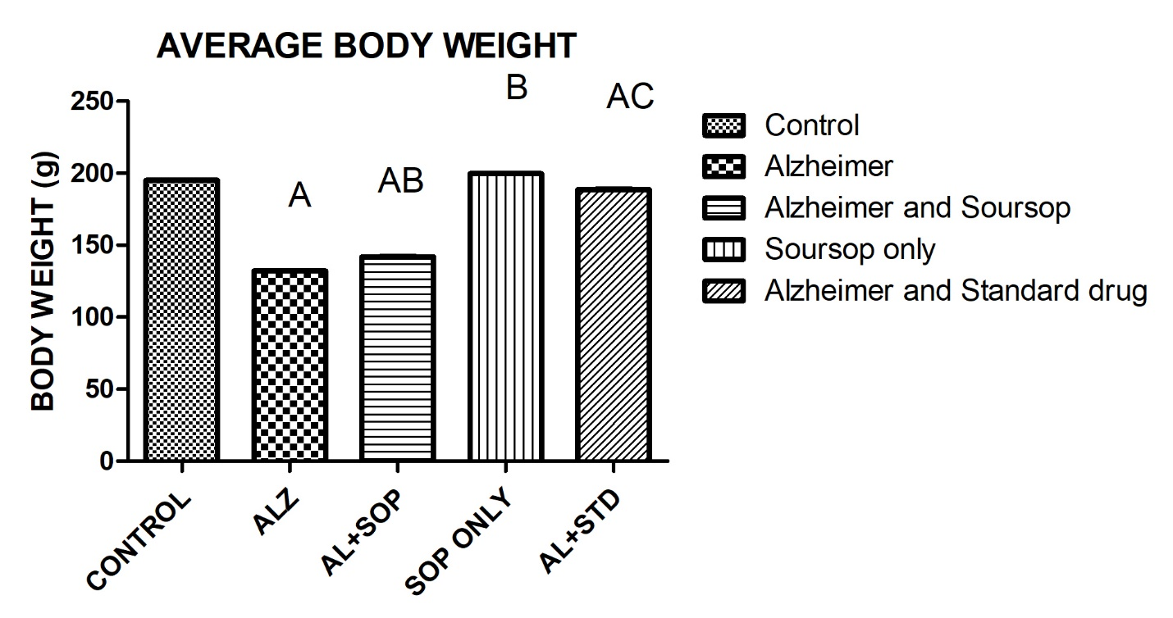

**FIG 1** Statistical analysis of rats’ body weight among five groups. All the values are expressed as mean $±$ standard error of mean SEM (P value < 0.05). Analysis of data was done using Graphpad Prism version 5 for windows . Differences between the groups were analyzed by one way ANOVA. Differences were considered significant (F=211700;P value <0.0001).

# **3.2 AVERAGE OLFACTORY BULB WEIGHT**

The olfactory bulb weight were measured and recorded for the five groups. The results shows that A value is significantly decreased when compared to control group. AB value was significantly increased when compared to Alzheimer group. B value was significantly increased when compared to Alzheimer group. AC value was significantly increased when compared to Alzheimer group.(p<0.0001***)

 **FIG 2** Statistical analysis of rats’ organ weight among five groups. All the values are expressed as mean $±$ standard error of mean SEM (P value < 0.05). Analysis of data was done using Graphpad Prism version 5 for windows 9. Differences between the groups were analyzed by one way ANOVA. Differences were considered significant (F= 28.98 ; P value <0.0001).

|  |  |  |  |
| --- | --- | --- | --- |
|  |  |  |  |

# **3.3 TUMOR NECROTIC FACTOR (TNF-α)**

The tumor necrotic factors alpha were measured (TNF-α) for the five groups. The results shows that A value was significantly increased when compared to the control group. AB value was significantly decreased when compared to Alzheimer group. Bvalue was significantly decrease when compared to Alzheimer group. AC value is significantly decreased when compared to Alzheimer group.(p<0.0001***)



**FIG 3**Statistical analysis of rats’ TNF-α among five groups. All the values are expressed as mean $±$ standard error of mean SEM (P value < 0.05) Analysis of data was done using Graphpad Prism version 5 for windows . Differences between the groups were analyzed by one way ANOVA. Differences were considered significant (F= 370300000; P value <0.0001).

# **3.4 WHITE BLOOD CELL (WBC)**

The animals white blood cell were analyzed and recorded for the five groups. The results shows that A value was significantly reduced when compared to control group. AB value was significantly increased when compared to Alzheimer group. B values is significant when compared to Alzheimer group. AC values is significant when compared to Alzheimer group.(p<0.0001***)



**FIG 4** Statistical analysis of rats’ WBC among five groups. All the values are expressed as mean $±$ standard error of mean SEM (P value < 0.05). Analysis of data was done using graphpad prism version 5 for windows . Differences between the groups were analyzed by one way ANOVA. Differences were considered significant (F= 332400 ; P value <0.0001).

# **3.5 PHOTOMICROGRAPHS**

## **3.5.1 H&E PHOTOMICROGRAPH OF OPTIC CHIASM**

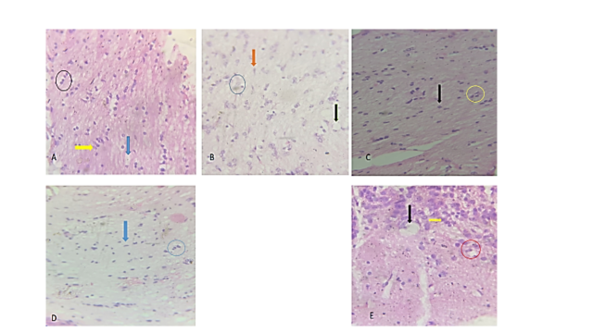

Plate 1: histology of the olfactory bulb stained with haematoxylin and Eosin

Sections of the optic chiasm showing; A-control group, shows well differentiated and normal astrocytes cells (Yellow arrow), a well and normal oligodendrocytes cells (Black circle) and a large number of vacuoles. B-Alzheimer group shows degeneration of oligodendrocytes cells (Blue circle), scarcity of astrocytes cells (Orange arrow). C-Soursop seed extract group shows well differentiated astrocytes (Black arrow) and normal oligodendrocytes cells (yellow circle).  D­-Alzheimer and soursop group shows regenerated oligodendrocyte cell (Blue circle) and normal astrocyte cells (blue arrow). E- Alzheimer and standard drug group shows a normal regenerated astrocytes (Yellow arrow) and and increased oligodendrocytes. **400X H&E.**

## **3.5.2 PAS PHOTOMICROGRAPH OF OPTIC CHIASM**

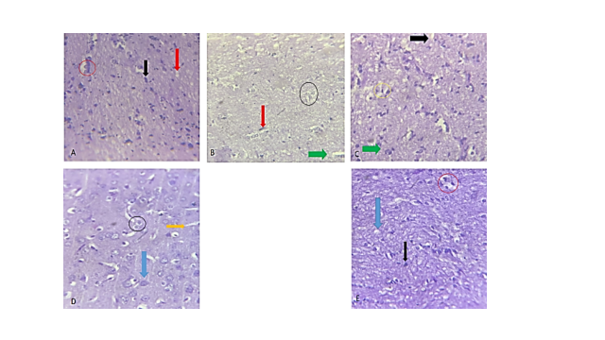

Plate 2: Histology of the olfactory bulb stained with Periodic Acid Sciff (PAS)

Section of the optic chiasm showing; A –control group shows normal and well differentiated astrocytes (Black arrow),a well and normal oligodendrocytes cell (Red circle),prescence of vacuoles (Red arrow). B- Alzheimer group shows tangled oligodendrocytes (Black circle),defected astrocytes cells (Red arrow),scarcity of vacuoles (Green arrow). C-Soursop group shows a normal astrocytes cells(Green arrow),presence of vacuoles (Black arrow),well and normal oligodendrocytes cell (Yellow circle). D-Alzheimer and soursop group shows a normal astrocyte cell (Blue arrow),regenerated oligodendrocyte cell (Black circle),presence of vacuoles (Yellow arrow). E- Alzheimer and standard group shows a normal astrocytes cell (Black arrow), a normal oligodendrocytes cells (Red arrow),presence vacuoles (Blue arrow). **400X PAS.**

## **3.5.3 CRESYL VIOLET PHOTOMICROGRAPH OF OPTIC CHIASM**

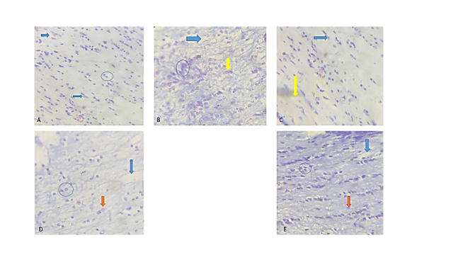

Plate 3: histology of the olfactory bulb stained with Cresyl Violet Stain

Section of the optic chiasm showing A-Control group well differentiated and normal oligodendrocytes cell (Blue circle),well and normal astrocytes cells (Blue arrow),presence of vacuoles(Blue arrow). B-Alzheimer group shows a distorted oligodendrocytes cell (Blue circle),defected astrocytes cell (Yellow arrow),defected and tangled vacuoles (Blue arrow).C-Soursop group shows a normal astrocyte cell (Blue arrow),well and normal oligodendrocyte cell (Yellow arrow),well and normal vacuole (Yellow arrow). D-Alzheimer and soursop group shows a regenerated astrocyte cells (Red arrow), regenerated oligodendrocyte cells (Blue arrow) ,normal vacuoles (Blue arrow). E-Alzheimer and standard group also show a normal regenerated astrocyte cells (Red arrow), well and normal oligodendrocyte cells (Blue circle), well and normal vacuoles(Blue arrow). **400X CRESYL VIOLET**

## **3.5.4 BIELSCHOWSKY STAIN PHOTOMICROGRAPH OF OPTIC CHIASM**

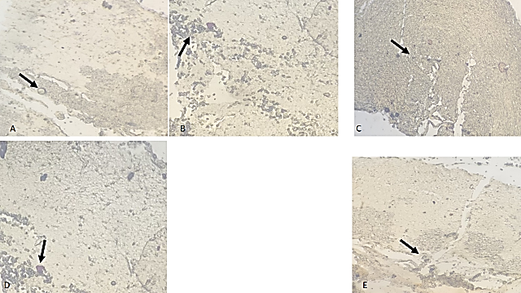

Plate 4: histology of the olfactory bulb stained with bielchowsky stain

Section of the optic chiasm showing A-Control group shows well differentiated fibers and normal neurons. B-Alzheimer group shows neurotic plaques and degeneration of fibers. C-Soursop group shows normal fibers. D-Alzheimer and soursop group shows degenerations of fibers . E-Alzheimer and standard group shows regeneration of neurons and fibers. **400X BIELSCHOWSKY STAIN**

# **4.0 DISCUSSION, CONCLUSION AND RECOMMENDATION**

# **4.1 DISCUSSION**

Alzheimer's disease (AD) is an irreversible neurological illness that is associated with progressive degradation of cognition and functional capability with age (Soria Lopez et al., 2019). . Alzheimer's disease (AD) is typified by memory deficiencies that worsen with time, along with cognitive and behavioral abnormalities that eventually result in dementia.(Chow *et al*., 2015)Soursop has a wide range of medicinal uses due to its various phytochemicals; these include the inhibition of α-glucosidase and α-amylase enzymes, diabetes, tumors, cancer, oxidative stress, blood pressure, inducing apoptosis in tumor cells, hemorrhagic disease, and lowering cholesterol.(Gavamukulya *et al*., 2022). Aluminum chloride is a strong neurotoxic that can cause oxidative stress, which is linked to illnesses of the nervous system. Aluminum chloride has the ability to cross-link amyloid β-protein, causing oligomerization that increases neurotoxicity.(Wang *et al*., 2023). As a result, this study, which assessed the effects of soursop seed extracts on optic chiasm in a rat model of Alzheimer's disease, thoroughly studied numerous parameters to totally grasp the ameliorative benefits of soursop consumption.

The average body weight was examined. Group B, the Alzheimer's only group, shows a significant decrease when compared to control, but the intervention group with soursop shows a mild significant increase when compared to the Alzheimer's group. The intervention with standard drug shows a more significant increase than the soursop intervention group which has also been reported by(Alosco *et al.,*2017) in previous research.

The Alzheimer's toxicity group has a much lower average organ weight than the other groups. The intervention with soursop results in a considerable rise when compared to the toxicity group. The soursop intervention group exhibits a more significant increase than the typical drug intervention group, which has been documented. (Sadun *et al.,*1990) found that patients with Alzheimer's disease exhibit visual difficulties due to degeneration of the optic chiasm.

The tumor necrosis factor revealed a significant increase in the tumor necrosis factor (TNF-apha) of the Alzheimer's group compared to the control and treatment groups. This reveals that TNF-apha, which is a crucial molecule in orchestrating chronic inflammation and can impact the synthesis of Alpha-beta plaques and the development of triangles, which can be ameliorated by soursop seed extracts which has also been reported by Kim *et al.,* 2017.

The white blood cell count shows a considerable decrease of White blood cell in alzheimers group when related to the control group

The results of the histological findings showed that aluminum chloride induced Alzheimer's toxicity shows degenerated and loss of oligodendrocytes and distorted astrocytes cells. Thus we reach the conclusion here that aluminium chloride induced alzheimers disease and attributed to neurotoxic and neuroinflammatory effect of aluminum chloride. In relation to all the the pathological effects it has on the olfactory bulb histology as reviewed by this study. It can be well stated that there is now a proof that further solidifies the findings credited and was reported by Sadun (1990).

# **4.2 CONCLUSION**

Finally, treatment with aluminum chloride generated oxidative stress, which resulted in cognitive impairment similar to the pathogenesis of Alzheimer disease. On the other hand, administering soursop seed extract resulted in a significant improvement in cognitive function as well as a decrease in oxidative stress markers. These results suggest to soursop seed extracts potential as a therapeutic agent for Alzheimer's disease mitigation, indicating the necessity for greater inquiry into the extracts' mechanisms of action and potential therapeutic uses.

**Ethical Approval:** Anatomical Sciences Research Ethics Committee of Olabisi Onabanjo University Sagamu Campus, Ogun State Nigeria

# **REFERENCES**

Afzaal, M., Saeed, F., Asghar, A., Shah, Y. A., Ikram, A., Ateeq, H., ... & Chacha, J. S. (2022). Nutritional and therapeutic potential of soursop. *Journal of Food Quality*, *2022*(1), 8828358.Murcia-Belmonte V, Ersk., Zuhrotun ine L (2019). Wiring the Binocular Visual Pathways. *Int J Mol Sci*.20(13)

Alosco, M. L., Duskin, J., Besser, L. M., Martin, B., Chaisson, C. E., Gunstad, J.,. & Tripodis, Y. (2017). Modeling the relationships among late-life body mass index, cerebrovascular disease, and Alzheimer’s disease neuropathology in an autopsy sample of 1,421 subjects from the National Alzheimer’s Coordinating Center Data Set. *Journal of Alzheimer's Disease*, *57*(3), 953-968.

Armand, E. F., Shantaram, M., Nico, N. F., Simon, F. N., & Paul, M. F. (2019). Potential of medicinal plant compounds to targeting Tau protein in the therapy of Alzheimer’s disease—A review. *Biomedicine*, *39*(2), 217-227

Armstrong, R. A. (2009). Alzheimer's disease and the eye. *Journal of Optometry*, *2*(3), 103-111.

Ashworth, R. M. (2020). Looking ahead to a future with Alzheimer's disease: coping with the unknown. *Ageing & Society*, *40*(8), 1647-1668.

Carter, C. J., France, J., Crean, Sand Singharo S.K.(2017), the porphyromonas gingivalis/host interactome shows enrichment in GWASdb genes related to Alzheimers disease, diabetes and cardiovascular disesse. Frontiers in aging neuroscience 9, 408

Chow, V. W., Savonenko, A. V., Melnikova, T., Kim, H., Price, D. L., Li, T., & Wong, P. C. (2010). Modeling an anti-amyloid combination therapy for Alzheimer’s disease. *Science translational medicine*, *2*(13), 13ra1-13ra1.

Dey, D., Srinivas, D., Panda, B., Suraneni, P., & Sitharam, T. G. (2022). Use of industrial waste materials for 3D printing of sustainable concrete: A review. *Journal of cleaner production*, *340*, 130749.

Gavamukulya, Y., Wamunyokoli, F., & El-Shemy, H. A. (2017). Annona muricata: Is the natural therapy to most disease conditions including cancer growing in our backyard? A systematic review of its research history and future prospects. *Asian Pacific journal of tropical medicine*, *10*(9), 835-848.

Ireland, A. C., & Carter, I. B. (2019). Neuroanatomy, optic chiasm.

Javaid, F. Z., Brenton, J., Guo, L., & Cordeiro, M. F. (2016). Visual and ocular manifestations of Alzheimer’s disease and their use as biomarkers for diagnosis and progression. *Frontiers in neurology*, *7*, 183500.

Kandimalla, R., Thirumala, V., & Reddy, P. H. (2017). Is Alzheimer's disease a type 3 diabetes? A critical appraisal. *Biochimica et Biophysica Acta (BBA)-Molecular Basis of Disease*, *1863*(5), 1078-1089.

Kidd, D. (2014). The optic chiasm. *Clinical Anatomy*, *27*(8), 1149-1158.

Kim, Y. S., Lee, K. J., & Kim, H. (2017). Serum tumour necrosis factor‐α and interleukin‐6 levels in Alzheimer's disease and mild cognitive impairment. *Psychogeriatrics*, *17*(4), 224-230.

Kumar, A., & Singh, A. (2015). A review on Alzheimer's disease pathophysiology and its management: an update. *Pharmacological reports*, *67*(2), 195-203.

Li, Z., Wang, Y., Xu, M., Liu, H., Li, L., & Xu, D. (2023). Molecular mechanism overview of metabolite biosynthesis in medicinal plants. *Plant Physiology and Biochemistry*, *204*, 108125.

Pourchez, L. (2017). *Women's knowledge: traditional medicine and nature; Mauritius, Reunion and Rodrigues*. UNESCO Publishing.

Sadun, A. A., & Bassi, C. J. (1990). Optic nerve damage in Alzheimer's disease. *Ophthalmology*, *97*(1), 9-17.

Soria Lopez, J.A Gonzalez, H.M and Leger, G.C(2019). Alzheimers disease. Hnadbook of Clinical Neurology, 167,231-255

Valerio Carell, Chiara la Morgia, Fred N. Ross- Cisneros, Alfred A. Sadun (2017) Human Molecular Genetics, 26: R139-R150

Wang, R. P. H., Huang, J., Chan, K. W. Y., Leung, W. K., Goto, T., Ho, Y. S., & Chang, R. C. C. (2023). IL-1β and TNF-α play an important role in modulating the risk of periodontitis and Alzheimer’s disease. *Journal of neuroinflammation*, *20*(1),71