***Original Research Article***

**CLASSICAL AND FRACTAL-LIKE SORPTION KINETIC STUDIES OF METHYLENE BLUE ON UNMODIFIED PLANTAIN PEDUNCLE BIOMASS AND ACTIVATED CARBON.**

**ABSTRACT**

The kinetic behaviour of methylene blue (MB) dye solution in relation to unmodified biomass and activated carbon from plantain (*Musa paradisiaca*) peduncle was studied, considering both time-dependent and time-independent aspects. MB dye solutions were exposed to unmodified biomass and activated carbon from plantain peduncle at intervals ranging from 5 to 210 minutes, at fixed concentrations of 15 mg/L and 30 mg/L. Equilibrium times were recorded at 160 and 200 minutes. Classical and fractal-like pseudo-order kinetic models were applied to the adsorption data to determine the rate-controlling order and the surface complexity of MB molecule adsorption. The Hurst fractal exponent (h) was calculated to establish the fractal-like surface pattern of adsorption sites. For 15UM, the Hurst fractal exponent h was negative in both FL-PFO (-0.638) and FL-PSO (-1.2649). For 30UM, the exponents were 0.3031 and 0.2971 for FL-PFO and FL-PSO, respectively. For 15AC, the exponents were 0.7434 and 0.745 for FL-PFO and FL-PSO, respectively, while for 30AC, the exponents were 0.7245 and 0.7209 for FL-PFO and FL-PSO, respectively. The coefficient of determination (R²) and correlation coefficient (r) of the fractal fittings were both greater than 0.96, outperforming conventional pseudo-order kinetics. Time-dependent behaviour was observed in the samples with h > 0.5 (15AC and 30AC), suggesting a persistent and stable adsorption process. Time-independent behaviour was observed in samples with 0 < h < 0.5 (30UM) and h < 0 (15UM ).The Weber-Morris diffusion model was also used to assess intraparticle diffusion, revealing significant but not prevalent intraparticle diffusion. The presence of prevalent fractal-like kinetics indicates surface complexity in both plantain peduncle samples.

**Keywords:** Classical, Fractal, Methylene blue, Kinetics,Unmodified, biomass, Activated carbon

**INTRODUCTION**

Environmental pollution is a global problem, impacting every corner of the world over time due to humanity's dependence on the environment for essential needs such as food, shelter, and clothing. Pollution arises from various human activities, both nearby and far away, causing significant effects. Hence, it is vital to remove or remediate pollutants from discharge points and process streams to safeguard human health and the environment.

Methylene blue (MB) is a potent cationic dye with numerous applications, often ending up in water bodies and soil based on its disposal method. Dyes like MB can damage aquatic ecosystems by obstructing light penetration, hindering photosynthesis, and decreasing gas solubility, leading to oxygen depletion and the death of aquatic organisms (Mehra et al., 2021). Despite its industrial usefulness, methylene blue is a harmful environmental pollutant due to its reactivity and non-biodegradable nature (Panczyk et al., 2024). It also poses health risks to humans due to its toxicity and turbidity. Therefore, various materials and methods have been explored for the removal or decontamination of methylene blue from water. Besides other optional methods, researchers have focused on remediation through adsorption.

Adsorption is an essential economic technology for treating wastewater, purifying gases and minerals, and enhancing targeted drug delivery, among other uses. Its effectiveness and wide range of applications have led to extensive research into developing adsorbent materials with diverse properties and functions. Agricultural wastes, as a source of inexpensive materials, have been utilized as renewable biomass for water pollution remediation before and after treatment or chemical modification (Noor & Khan, 2023). Some adsorbent materials used for MB dye removal from water include unmodified biomass of leaf wastes (Digbo et al., 2020), (Mussa et al., 2023), and plantain-peel-derived quantum dots (Meraj et al., 2024). Other plant materials used to remove MB efficiently from water include biochar (Ton-That et al., 2023), activated and nano-activated surfaces of biomass (Syafila et al., 2022), and modified activated carbon (Kuang et al., 2020).

Plantain (*Musa paradisiaca*) is a fruit-bearing plant native to South America, Southeast Asia, and parts of Africa. The fruit peels and trunk wastes of this plant have been used as activated carbon and biochar for removing wastewater contaminants (Onawumi et al., 2025) and crude oil-contaminated soil (Osisami et al., 2024). Its fruit grows on a peduncle stalk, usually discarded as waste after harvest. The plantain peduncle is rich in fiber and cellulose, a biopolymer with electron-rich atoms that can bond with metal pollutants in water. Utilizing these low-cost cellulosic materials from plantain peduncles for pollution remediation adds value to agricultural waste and helps tackle environmental pollution.

Classical kinetic models like pseudo-first-order and pseudo-second-order equations are often inadequate for complex solid-liquid adsorption systems because they simplify assumptions, such as homogeneous surface and time-independent single-rate constants (El Bardiji et al., 2020). However, real adsorbents often have heterogeneous or multisite adsorption with different affinities for the adsorbate, and in many cases, the rate of adsorption is influenced by diffusion processes. Adsorbent surfaces can exhibit fractal properties due to surface heterogeneity or complexity. Therefore, considering fractal-like kinetics alongside classical models is necessary to provide a more accurate description of the adsorption process.

**MATERIALS AND METHODS**

**Preparation of Adsorbents**

**Unmodified Sample:** The agricultural waste used in this study is the plantain peduncle (Musa paradisiaca). The plantain fruit stalk was sourced from a vendor in a market in Yenagoa, Bayelsa State. The stalk was cut into several pieces, thoroughly washed to remove impurities, and sun-dried for two days, resulting in an initial weight of 4051 grams. The pieces were then oven-dried to eliminate moisture, reducing the weight to 350 grams. After grinding, the sample was sieved into different sizes, and the 0.15 mm biomass was used for the experiments.

**Activated Carbon Sample:** The plantain fruit stalk was obtained from the same source as the unmodified sample. The stalk was cut into pieces, washed with distilled water, and sun-dried for 48 hours, resulting in an initial weight of 5073.6 grams. The pieces were then oven-dried at 110°C for five days, with intermittent weighing until a constant weight of 356.57 grams was achieved.

The dried samples were placed on a metal plate and inserted into a Vecstar muffle furnace at 270°C for 75 minutes, yielding 125.62 grams of carbonized material. For chemical activation, 60 grams of NaOH was dissolved in 3 liters of distilled water. The NaOH solution was poured into a container, and the carbonized sample was added, stirred for 5 minutes, and left to stand for 12 hours. The solution was then decanted, and the carbonized sample was heated in the Vecstar furnace at 400°C for 60 minutes. After washing with 46 mL of acetic acid and rinsing with distilled water until the pH reached 6.14, the sample was oven-dried at 110°C. The dried sample was ground into a powder and sieved into different sizes: 0.15 mm, 0.30 mm, 0.60 mm, and 1.0 mm, with respective weights of 11.21 grams, 13.37 grams, 2.98 grams, and 7.89 grams. The 0.30 mm activated carbon was selected for the experiments and stored in an airtight container.

**Preparation of Adsorbate (Dye Solution):** A stock solution of methylene blue at 125 mg/L was prepared by accurately weighing 0.125 grams of the dye and dissolving it in a 1000 mL volumetric flask filled with distilled water up to the mark. Various working concentrations (5, 10, 15, 20, 25, 30, 35, and 40 mg/L) were created by diluting the stock solution using 100 mL of the 1000 ppm solution for each concentration.

**Preparation of Calibration Curve:** The spectrophotometer was calibrated using distilled water as the baseline. The stock solution of 125 mg/L was used to test the spectrophotometer at a maximum wavelength (λ_max) of 661 nm, yielding an absorbance of 0.511. The spectrophotometer was then set to this wavelength, and the absorbance values for the working solutions at concentrations of 5, 10, 15, 20, 25, 30, 35, and 40 mg/L were recorded as 0.213, 0.284, 0.319, 0.321, 0.345, 0.360, 0.394, and 0.401, respectively.

**Experimental Method:**  0.2 grams of adsorbent were accurately weighed into three labeled test tubes, each containing 10 mL of 15 mg/L dye solution. The mixtures were agitated on a speed shaker at 150 rpm for 5 minutes. Each mixture was then filtered through filter papers into clean test tubes using funnels. The filtrate was analyzed with a UV spectrophotometer at 661 nm to determine the dye concentration at that time (5 minutes). This process was repeated at intervals of 10, 20, 30, 40, 50, 60, 80, 90, 100, 120, 140, 160, 180, 200, and 210 minutes. The procedure was then repeated with an initial concentration of 30 mg/L using both adsorbents: the unmodified plantain peduncle and activated carbon. Based on the absorbance readings from the UV spectrophotometer, the dye concentration at equilibrium, the equilibrium adsorption capacity, and the percentage of dye adsorbed were determined.

**DATA ANALYSIS**

The equilibrium adsorption capacity of the plantain peduncle powder was obtained using mass balance equation 1

qe = $\frac{v}{m}(Co-Ce)$ (1)

The percentage adsorbed at equilibrium was calculated from the equation 2

R (%A) = $\frac{Co - Ce}{Co} ×100$ (2)

Where, qe = quantity adsorbed at equilibrium(mg/g), v = volume of adsorbate used( L), m = mass of adsorbent used(mg), Co = Initial dye concentration(mg/L), Ce = Dye concentration at equilibrium

**Kinetic Models**

The kinetic and diffusion processes of the sorption were assessed using some models as given in the following equations:

***Pseudo-first order Kinetics***

The nonlinear relationship for the pseudo-first order kinetics is given in equation 3

 (3)

Where, qe = quantity adsorbed at equilibrium(mg/g), qt = quantity adsorbed at time t(mg/g), k = pseudo-first order rate constant (min-1) , t = time.

***Pseudo-second order kinetics***

The nonlinear pseudo-second order rate model is as given in equation 4

 (4)

Where, qe and qt are as interpreted for equation 3, k2 = pseudo-second order rate constant(gmg-1min-1).

***Weber-Morris Intraparticle Diffusion***

 (5)

Where, · qt = Amount of adsorbate adsorbed at time t (mg/g or mmol/g)

kID = Intraparticle diffusion rate constant (mg/g·min1/2 or mmol/g·min1/2)

C = Constant related to the initial adsorption rate (mg/g or mmol/g)

T = Time (min)

***Fractal-like Pseudo-order kinetics***

Fractal-like kinetics was analyzed with the fractal pseudo-first and pseudo-second order equations 6 and 7

 (6)

Where, qe = quantity adsorbed at equilibrium(mg/g), qt = quantity adsorbed at time t(mg/g), kf = fractal pseudo-first order instantaneous rate constant (min-1) , t = time, α = fractional time index

 (7)

Where, qe and qt are as interpreted for equation 3, kf = fractal pseudo-second order instantaneous rate constant(gmg-1min-1), α = fractional time index

 (8)

Where kf = instantaneous rate constant, k' = time independent rate constant and h = fractal exponent

 (9)

**RESULTS AND DISCUSSION**

The kinetic studies on the adsorption of methylene blue (MB) by unmodified biomass and activated carbon from plantain peduncle are presented in the figures and tables below. Figures 1 and 2 illustrate the effect of time on the amount and equilibrium concentration of MB adsorbed by both unmodified plantain peduncle biomass and activated carbon. The results demonstrate that MB was effectively adsorbed by both adsorbents, with adsorption increasing over time until equilibrium was reached (Benhachema et al., 2019). Figure 3 supports these findings, showing that over 99% of MB was removed at equilibrium, with residual concentrations as low as 0.03 and 0.08 mg/L from the initial concentrations of 15 and 30 mg/L, respectively (Kuang et al., 2020).

The data in Figure 1 indicates that higher concentrations of MB (30 mg/L) led to greater adsorption and shorter adsorption times compared to lower concentrations (15 mg/L) for both unmodified biomass and activated carbon samples (Üner et al., 2016). This may be due to a higher collision frequency, as there are more adsorbate molecules per unit volume of adsorbent surface in the more concentrated solution (Benhachema et al., 2019). These results in faster adsorption rates and a higher amount of dye adsorbed per unit mass of adsorbent. Consequently, the 30 mg/L solutions of both unmodified biomass and activated carbon exhibited greater adsorption than the 15 mg/L solutions of MB dye (Kuang et al., 2020).

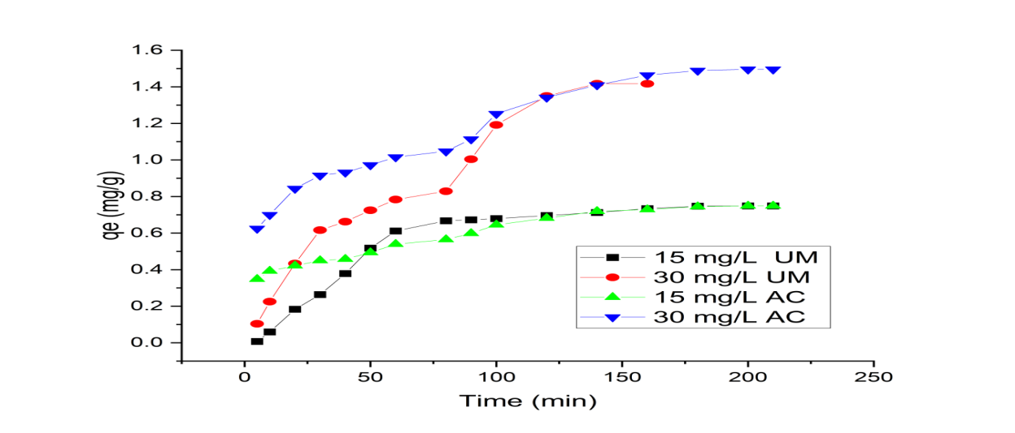

**Figure 1: Plot of effect of time on the quantity of MB adsorbed by unmodified Plantain peduncle biomass and activated carbon.**

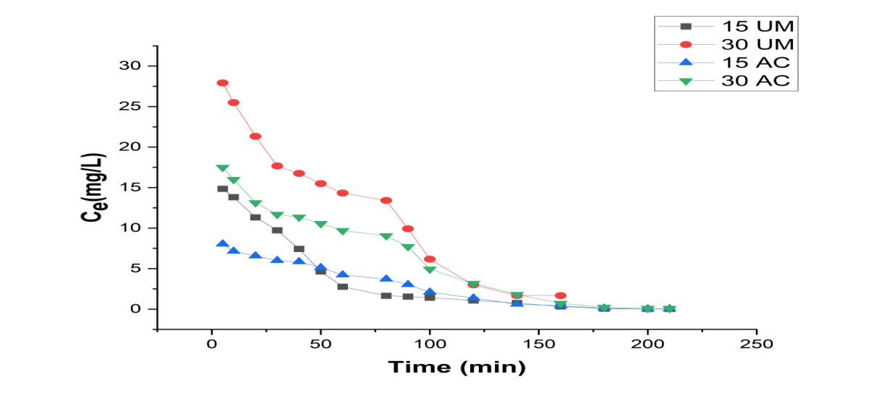

**Figure 2:Effect of time on the equilibrium concentration of MB adsorption by unmodified Plantain peduncle biomass and activated carbon.**

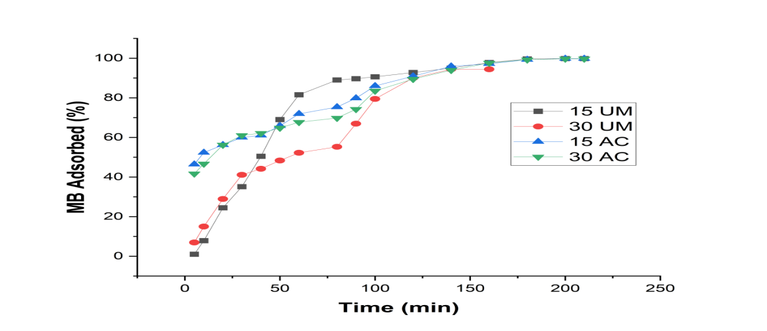

**Figure 3: Effect of time on the percent adsorption of MB by unmodified Plantain peduncle biomass and activated carbon**

Figures 4 to 7 illustrate various kinetic models applied to the adsorption data. The experimental kinetics is compared with the model curves to evaluate the correlation between the experimental data and the model patterns. The non-linear curve fitting of the experimental data with the model equations was performed using the KyPlot package. Both classical and fractal pseudo-order models are presented in the plots.

In Figure 4, the experimental curve closely follows the fractal order, particularly the FL-PSO curve, rather than the classical order (Yu et al., 2023). Figure 5 shows that the curve fitting for the adsorption kinetics of 30 mg/L MB by unmodified plantain peduncle biomass does not align closely with either the classical or fractal kinetic models. However, significant correlation was observed at higher r values for the unmodified adsorbent systems, as shown in Table 1 (Li et al., 2022).

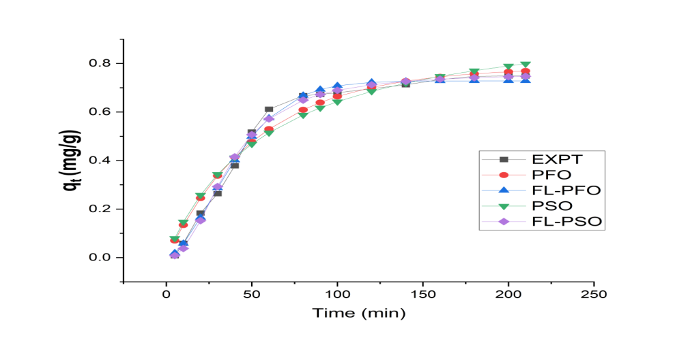

**Figure 4: Classical and Fractal-like pseudo-order kinetic plot of adsorption of 15 mg/L MB by unmodified Plantain peduncle biomass.**

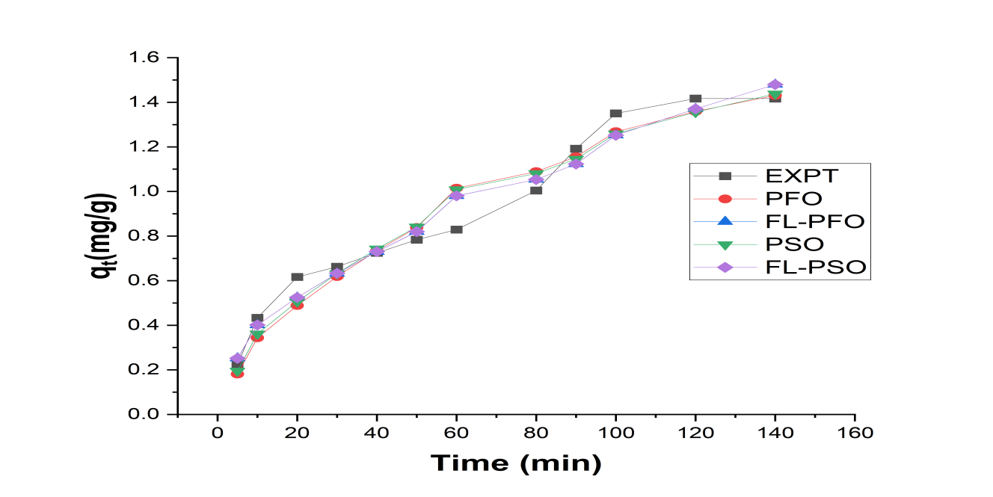

**Figure 5: Classical and Fractal-like pseudo-order kinetic plot of the adsorption of 30 mg/L MB by unmodified** **Plantain peduncle biomass.**

In Figure 6, the curve fitting for the adsorption kinetics of 15 mg/L MB by plantain peduncle activated carbon follows a similar trend to Figure 4, aligning with the direction of the fractal models, though not very closely. The correlation coefficient r for the fractal pseudo-orders is also significant, as indicated in Table 1 (Chen et al., 2021). The classical orders show low correlation in this regression analysis.

Figure 7 presents the curve fitting for the 30AC system, with the experimental data fitting resembling that of the 15AC system in Figure 6. The correlation coefficients for the fractal orders are more significant than those for the classical orders, as shown in Table 1 (Wang et al., 2020). Although the statistical correlation coefficients of the classical pseudo-orders are significant in some cases, such as 15 UM (r = 0.9476, PSO), 30 UM (r = 0.9831, PSO), and 15 UM (r = 0.9830, PFO), the fractal pseudo-order kinetic parameters exhibit higher correlation coefficients, r. The higher statistical values of fractal kinetics parameters, such as R² and r, suggest that the adsorbent surface is more heterogeneous and complex than assumed in classical pseudo-order kinetics (Zhou et al., 2019).

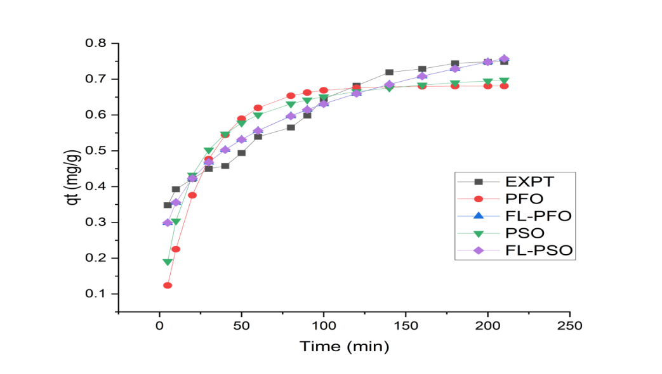

**Figure 6:Classical and Fractal-like pseudo-order kinetic plot of the adsorption of 15 mg/L MB by**  **Plantain peduncle activated carbon.**

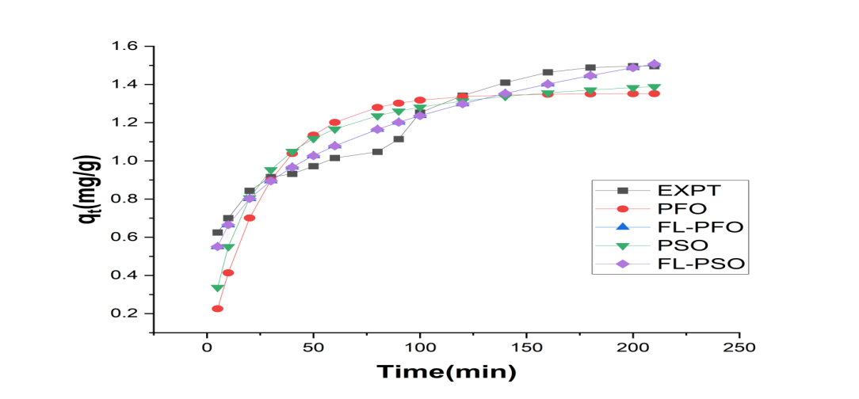

**Figure 7:Classical and Fractal-like pseudo-order kinetic plot of the adsorption of 30 mg/L MB by**  **Plantain peduncle activated carbon.**

**Diffusion Analysis**

The diffusion analysis from the Weber-Morris intraparticle model shows a strong correlation in the experimental data, as demonstrated in Figure 8 and Table 2 (Dawood et al., 2024). The R² values for both unmodified biomass and activated carbon range from 0.9233 to 0.962, while the r values for the same adsorbents fall between 0.9609 and 0.9808. This indicates that intraparticle diffusion played a significant role, although it was not the sole mechanism for solute movement onto the adsorbent. Additionally, the intraparticle diffusion rate constants for all the systems studied were positive, suggesting an enhanced diffusion rate (Mittal et al., 2020).

The values of kID indicate the rate at which the methylene blue dye diffuses into the pores of the adsorbent. Higher values of kID (such as 0.6638 for 30UM and 0.4071 for 30 AC) suggest a faster rate of intraparticle diffusion, meaning the dye molecules are quickly penetrating the adsorbent's pores. Lower values (such as 0.1944 for 15AC) suggest a slower rate of diffusion. The differences in kID values can be attributed to the varying nature of the adsorbent materials or experimental conditions. The unmodified samples generally had higher values of kID than the activated ones, meaning that they had a faster rate of intraparticle diffusion (Benhachema et al., 2019).

The values of C represent the boundary layer thickness and reflect the external mass transfer resistance. Negative values of C (such as -0.5014, -0.9712, -0.05) indicate a thin boundary layer, suggesting that the initial adsorption phase is less influenced by external mass transfer resistance. A positive value of C (such as 0.0158) indicates a thicker boundary layer, implying a greater role of external mass transfer in the initial adsorption process. Higher kID values imply a faster intraparticle diffusion rate, indicating efficient penetration of dye molecules into the adsorbent's pores (Kuang et al., 2020).

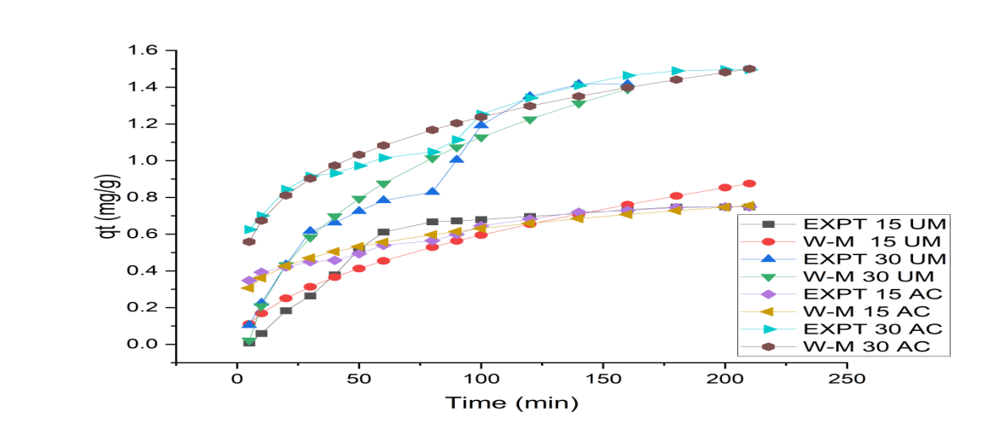

**Figure 8: Intraparticle diffusion plots of the adsorption of MB by unmodified** **Plantain peduncle biomass and activated carbon.**

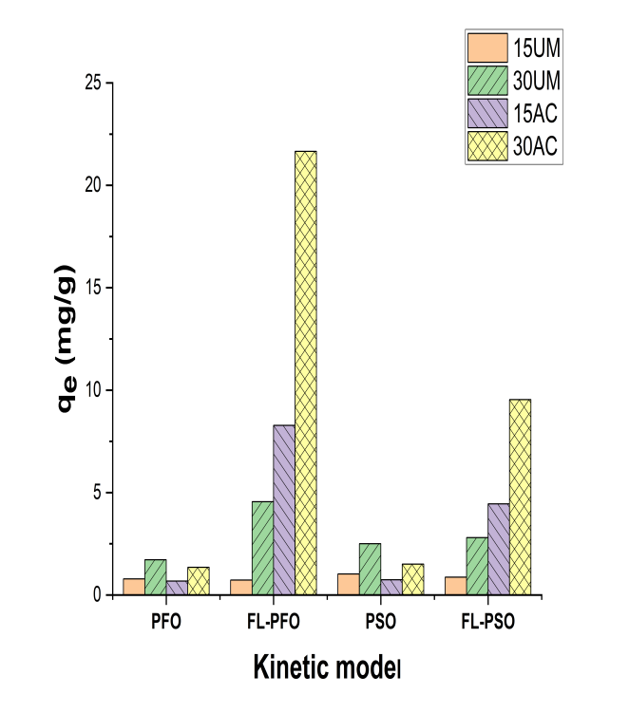 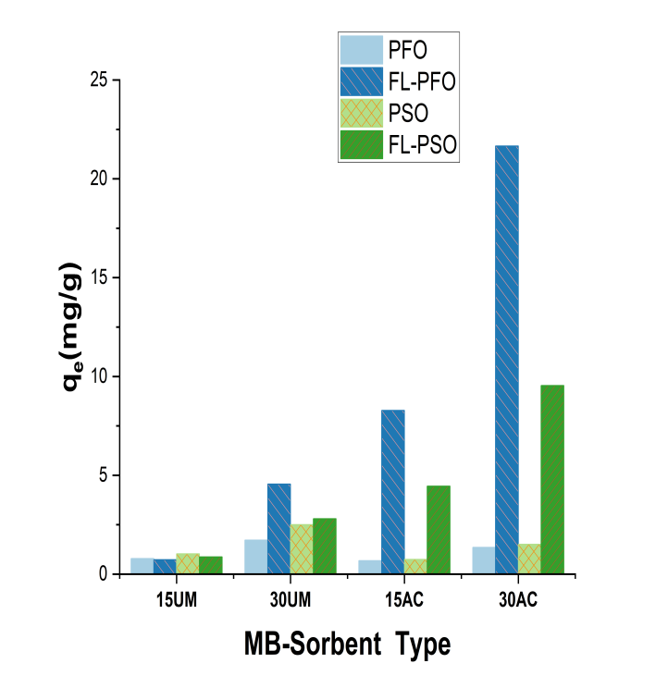

a

b

**Figure 9: Adsorption capacity based on (a) Kinetic models (b) Sorbate- Sorbent system**

**Adsorption Capacity and Fractal Exponent Analysis**

Figures 9(a) and 9(b) illustrate the adsorption capacity relative to the kinetic models and the sorbate-sorbent combinations. The highest adsorption capacity of 21.6538 mg/g is attributed to the FL-PFO model for the 30AC sample, indicating that 30AC had the highest adsorption efficiency and that FL-PFO was the dominant kinetic model for this adsorption process (Wongphat et al.,2024).

Figure 10 presents a bar chart depicting the fractal exponent for the adsorbent samples. Both FL-PFO and FL-PSO models show negative values for the 15UM sample, suggesting that the data were not well suited for fractal analysis.

For the 30UM, 15AC, and 30AC samples, the FL-PFO and FL-PSO models exhibit positive h values (Bashiri & Shajari, 2014). However, for the 30UM sample, the h values are less than 0.5 (h < 0.5), indicating anti-persistent behaviour (Kale & Butar, 2005). This means that the adsorption process tends to revert to its mean, over time, leading to less predictable adsorption behaviour compared to higher h values (Cuculeanu & Pavelescu, 2019). Therefore, the adsorption process for 30UM is time-independent. In contrast, the fractal exponent for 15AC and 30AC is greater than 0.5 (h > 0.5), indicating persistent behaviour. This suggests that if the adsorption rate is high, it is likely to remain high, and if it is low, it is likely to remain low (Cuculeanu & Pavelescu, 2019). Hence, the adsorption process for these samples is more predictable and stable over time, indicating time-dependent behaviour. The h values above 0.5 implies a high degree of surface roughness and irregularity, leading to complex and multi-fractal behaviour.Thus the activated forms of the adsorbent had fractal surfaces.

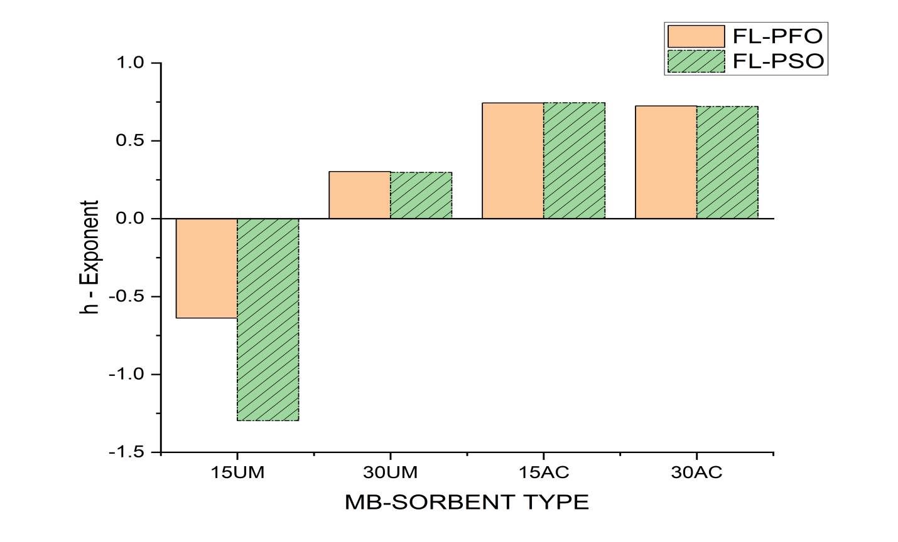

**Figure 10: Chart of fractal exponent(h) in sorbate-sorbent type**

**Table 1: Kinetic parameters of adsorption of MB by unmodified Plantain peduncle biomass and activated carbon.**

|  |  |  |  |  |  |
| --- | --- | --- | --- | --- | --- |
| **Kinetic model** | **Parameters** | **Adsorbate/Adsorbent System** | | | |
| **15 UM** | **30 UM** | **15 AC** | **30 AC** |
| PFO | qe  k1  R2  r | 0.7845  0.0187  0.9664  0.9830 | 1.7203  0.0111  0.9625  0.9811 | 0.6812  0.0402  0.5464  0.7392 | 1.3528  0.0365  0.6104  0.7613 |
| FL-PFO | qe  kf  α =1-h  R2  r  h | 0.7283  0.0019  1.6380  0.9936  0.9968  -0.6380 | 4.5498  0.0115  0.6969  0.9730  0.9864  0.3031 | 8.2793  0.0243  0.2566  0.9603  0.9799  0.7434 | 21.6538  0.0165  0.2755  0.9616  0.9806  0.7245 |
| PSO | qe  k2  R2  r | 1.0253  0.0164  0.9733  0.9473 | 2.5003  0.0034  0.9665  0.9831 | 0.7456  0.0924  0.7527  0.8676 | 1.5029  0.0385  0.7851  0.8861 |
| FL-PSO | qe  kf  α = 1 -h  R2  r  h | 0.8729  0.0003  2.2649  0.9938  0.9969  -1.2649 | 2.7986  0.0024  0.7029  0.9730  0.9864  0.2971 | 4.4484  0.0023  0.2550  0.9605  0.9801  0.7450 | 9.5360  0.0004  0.2791  0.9620  0.9808  0.7209 |

**TABLE 2. Diffusion parameters of adsorption of MB by unmodified Plantain peduncle biomass and activated carbon.**

|  |  |  |  |  |  |
| --- | --- | --- | --- | --- | --- |
| **Diffusion model** | **Parameters** | **Adsorbate/Adsorbent System** | | | |
| **15 UM** | **30 UM** | **15 AC** | **30 AC** |
| Weber-Morris IPD | KID  C  R2  r | 0.3541  -0.5014  0.9233  0.9609 | 0.6638  -0.9712  0.9588  0.9792 | 0.1944  0.0158  0.9620  0.9808 | 0.4071  -0.0500  0.9604  0.9800 |

**CONCLUSION**

The sorption kinetics of methylene blue adsorption on unmodified plantain peduncle biomass and its activated carbon was investigated using both classical and fractal models. Experimental data analyzed via a non-linear method with KyPlot software revealed a stronger alignment with the fractal model, suggesting a more heterogeneous and complex adsorbent surface. Intraparticle diffusion significantly influenced porous adsorption, evident from high correlation values (up to 0.9808), though it was not the sole mechanism. The unmodified samples exhibited faster adsorption rates than the activated samples, attributed to differences in surface composition. This study underscores the potential application of plantain peduncle for wastewater treatment, promoting sustainable waste management through environmental remediation.

**REFERENCES**

Mehra, S., Singh, M., & Chadha, P. (2021). Adverse impact of textile dyes on the aquatic environment as well as on human beings.*Toxicology. International*, 28(2), 165-176. <https://doi.org/10.18311/ti/2021/v28i2/26798>

Panczyk, T., Wolski, P., Nieszporek, K., & Pietrzak, R. (2024). Adsorption of Methylene Blue on Activated Carbon Surfaces Obtained by Shock Compression of Graphite Using Reactive Molecular Dynamics. *Molecules*, 29(24), 6030. <https://doi.org/10.3390/molecules29246030>

Noor, A., & Khan, S. A. (2023). Agricultural Wastes as Renewable Biomass to Remediate Water Pollution. *Sustainability*, 15(5), 4246. <https://doi.org/10.3390/su15054246>

Digbo, I. N. Ndukwe, C., Ogukwe, A., Aderike, A. & Abimbola, A. (2020).Studies on the impact of flow rate and bed height on the fixed bed adsorption of methylene blue dye, bismarck rown Y dye, and indigo blue dye on to *Cedrus Libani* (Elizabeth Leaf) biomass. *International Journal of Chemistry Research*, 4(2),1-8, <https://doi.org/10.22159/ijcr.2020v4i3.115>

Mussa, Z.H., Al-Ameer, L.R., Al-Qaim, F.F.,Deyab, I.F.,Kamyab,H. & Chelliapan. S. (2023). A comprehensive review on adsorption of methylene blue dye using leaf waste as a bio-sorbent: isotherm adsorption, kinetics, and thermodynamics studies. *Environ Monit Assess* 195, 940. <https://doi.org/10.1007/s10661-023-11432-1>

Meraj, U., Laiq, E., Qurtulen, Bushra, R., Ahmad, M., & Gupta, S. (2024). Enhanced adsorptive removal of methylene blue dye from aqueous media by potato peel-derived carbon quantum dots and their application in cell imaging. *Biomass Conversion and Biorefinery*, 1-18.

Ton-That, L., Huynh, T. N. L., Duong, B. N., Nguyen, D. K., Nguyen, N. A., Pham, V. H., ... & Dinh, V. P. (2023). Kinetic studies of the removal of methylene blue from aqueous solution by biochar derived from jackfruit peel. *Environmental Monitoring and Assessment*, 195(11), 1266. https://doi. org/10.1007/s10661-023-11867-6

Syafila, M., Helmy,Q., & Musthofa, A.M.H. (2022). Methylene Blue Adsorption by Activated Carbon and Nano-Activated Carbon from Biomass Waste: A Review. *Jurnal Presipitasi: Media Komunikasi dan Pengembangan Teknik Lingkungan, 19*(3), 553-565. <https://doi.org/10.14710/presipitasi.v19i3.553-565>

Kuang, Y., Zhang, X., & Zhou, S. (2020). Adsorption of Methylene Blue in Water onto Activated Carbon by Surfactant Modification. Water, 12(2), 587. <https://doi.org/10.3390/w12020587>

Onawumi, O.O., Olaniyan, J.A., Esan, A.O., Adewusi, O.A., Yusuff, A.O., & Odedele, A.O. (2025). Efficient Removal of Cassava Wastewater Contaminants Using Plantain Peel-Derived Activated Carbon. Materials, 6(3), 27.

Osisami, O.F., Egwim, E.C., Adeboye, S.E., Adesina, D.A., Abdul-Hadi, J.S., Falana, Y.O., & Oketa, A.E. (2024). Effect of Biochar from Plantain Trunk Wastes’ Remediation on Microbial Community Dynamics of Crude Oil Contaminated Soil. Ilorin Journal of Science, 11(3), 146-151

El Bardiji, N., Ziat, K., Naji, A., & Saidi, M. (2020). Fractal-Like Kinetics of Adsorption Applied to the Solid/Solution Interface. *ACS omega*, 5(10), 5105–5115. <https://doi.org/10.1021/acsomega.9b04088>

Benhachema, F.-Z., Attar, T., & Bouabdallah, F. (2019). Kinetic study of adsorption methylene blue dye from aqueous solutions using activated carbon from starch. *Chemical Review and Letters*, 12(2), 33-39. <https://doi.org/10.1016/j.crel.2019.05.002>

Üner, O., Geçgel, Ü., & Bayrak, Y. (2016). Adsorption of Methylene Blue by an Efficient Activated Carbon Prepared from Citrullus lanatus Rind: Kinetic, Isotherm, Thermodynamic, and Mechanism Analysis. *Water, Air, & Soil Pollution*, 227(2), 247-259. <https://doi.org/10.1007/s11270-016-2949-1>

Yu, J., Wang, Y., & Zhang, T. (2023). Analysis of Fractal Order Kinetic Models in Adsorption Studies. *Journal of Chemical Engineering*, 45(2), 123-132. <https://doi.org/10.1016/j.jce.2023.01.002>

Li, S., Chen, J., & Zhao, H. (2022). Comparative Study of Classical and Fractal Kinetic Models for Dye Adsorption. *Environmental Science and Technology*, 56(8), 4321-4329. <https://doi.org/10.1021/acs.est.2c02221>

Chen, X., Liu, H., & Wang, L. (2021). Application of Fractal Kinetic Models in Adsorption Processes. *Chemical Physics Letters*, 780, 138731. <https://doi.org/10.1016/j.cplett.2021.138731>

Wang, Q., Yu, L., & Liu, Z. (2020). Evaluation of Adsorption Kinetics Using Classical and Fractal Models. *Journal of Environmental Management*, 254, 109776. <https://doi.org/10.1016/j.jenvman.2020.109776>

Dawood, S., Sen, T. K., & Phan, C. (2024). Synthesis and Characterization of Novel Adsorbent from Waste Biomass for Adsorption of Methylene Blue. *Journal of Environmental Chemical Engineering*, 2(1), 266-275. <https://doi.org/10.1016/j.jece.2024.05.006>

Mittal, A., Mittal, J., Malviya, A., Kaur, D., & Gupta, V. K. (2020). Adsorption of Hazardous Dye Crystal Violet from Wastewater by Waste Materials. *Journal of Colloid and Interface Science*, 343(1), 463-473. <https://doi.org/10.1016/j.jcis.2020.11.060>

Wongphat, A., Wongcharee, S., Chaiduangsri, N., Suwannahong, K., Kreetachat, T., Imman, S., Suriyachai, N., Hongthong, S., Phadee, P., Thanarat, P., & Rioyo, J. (2024). Using Excel Solver’s Parameter Function in Predicting and Interpretation for Kinetic Adsorption Model via Batch Sorption: Selection and Statistical Analysis for Basic Dye Removal onto a Novel Magnetic Nanosorbent. ChemEngineering, 8(3), 58. <https://doi.org/10.3390/chemengineering8030058>

Bashiri, H., & Shajari, A. (2014). Theoretical study of fractal-like kinetics of adsorption. Adsorption Science & Technology, 32(8), 623-634. <https://doi.org/10.1260/0263-6174.32.8.623>

Kale, M. D., & Butar, F. B. (2005). Fractal analysis of time series and distribution properties of Hurst exponent (Doctoral dissertation, Sam Houston State University).

Cuculeanu, V., & Pavelescu, M. (2019). Fractal analysis of the environmental radioactivity: A review. system, 5, 39.