***Original Research Article***

**Response of Bird Species to Artificial Nests: Preferences, Challenges, and Conservation Potential**

**Abstract**

Nests are essential in the life cycle of birds, offering a safe and secure environment for egg-laying, incubation, and the rearing of young chicks. They safeguard eggs and hatchlings against predators, severe weather, and environmental dangers, providing the warmth and comfort crucial for their survival. Birds build nests with an assortment of materials, such as twigs, leaves, mud, and feathers, in various locations including trees, cliffs, and on the ground. Nonetheless, the escalating habitat destruction resulting from deforestation, urbanisation, and agricultural expansion poses significant challenges for numerous bird species in locating appropriate nesting sites. This study seeks to explore avian preferences for artificial nests constructed from diverse natural materials and assess their efficacy in offering appropriate nesting locations. A total of 118 artificial nests were constructed utilising different types of locally available materials. The design of these nests emulates natural habitats. Observations indicated that various bird species displayed distinct preferences influenced by factors such as nest size, material, and placement. Some species, including the Red Munia, Greater Coucal, House Sparrow, and Indian Robin, have shown a remarkable ability to adapt to artificial nests, whereas others still depend on natural nesting sites. The investigation emphasises the promise of artificial nests in aiding bird populations, particularly in regions experiencing habitat degradation. Additional investigation is essential to enhance nest designs and guarantee their successful application in avian conservation initiatives.

**Key Words:** Birds, Preferences, Man-made, Artificial Nests, Conservation Potential

**1. Introduction**

Nests are essential for birds as they provide a safe and secure place for laying eggs, incubating them, and raising their young. They protect eggs and chicks from predators, harsh weather, and environmental dangers. Nests also offer warmth and comfort, ensuring the survival of baby birds until they are ready to fly. Different bird species build nests in various locations, such as trees, cliffs, or even on the ground, using materials like twigs, leaves, mud, and feathers. Nesting is a crucial part of a bird’s life cycle, contributing to the continuation of their species. Man-made nests, such as birdhouses or artificial nesting platforms, play a crucial role in supporting bird populations, especially in urban or deforested areas where natural nesting sites are scarce. These nests provide birds with safe shelter, protection from predators, and a secure place to lay eggs and raise their young. Many bird species struggle to find suitable nesting spots due to habitat destruction caused by deforestation, urbanisation, and agriculture. Man-made nests offer birds a safe and protected environment, shielding them from extreme weather conditions like heavy rain, heat, or cold (Newton, 1998; Lambrechts et al., 2012). They also help keep eggs and chicks safe from predators such as snakes, cats, and larger birds. Several bird species face population decline due to habitat loss. Man-made nests can help endangered or vulnerable species by offering them a place to reproduce and maintain their populations (Sherley et al., 2012; Liu & Li, 2024). Conservation programs often install artificial nests to support species like owls, swallows, and eagles, ensuring their survival in the wild. Cities and towns often lack natural tree cavities, which many birds rely on for nesting (Kuranov, 2009; James Reynolds et al., 2019). Man-made birdhouses and nesting platforms allow birds to thrive even in human-populated areas. This contributes to urban biodiversity, helping maintain ecological balance by controlling pests like insects and rodents. Migratory birds travel long distances and often struggle to find safe nesting sites. Providing artificial nests along migration routes can help these birds rest, breed, and successfully raise their young before continuing their journey (Marzluff, 2008; Faaborg et al., 2010; Newton, 2023). Birds play a vital role in ecosystems by pollinating flowers, dispersing seeds, and controlling insect populations. By offering them nesting spaces, humans indirectly support the environment and maintain a balanced ecosystem (Wratten et al., 2012). Installing man-made nests attracts birds to gardens, parks, and forests, providing people with opportunities for bird watching and nature appreciation (Proctor, 1996; Idilfitri & Mohamad, 2012). This fosters environmental awareness and encourages conservation efforts.

Artificial nests serve as a straightforward and efficient method to support the flourishing of bird populations. Artificial nests play a crucial role in enhancing the well-being of bird species and the ecosystem by offering shelter, supporting conservation efforts, and improving biodiversity. Promoting the utilisation of these nests may have a beneficial influence on the relationship between wildlife and human engagement with the natural environment (Fuller, 2010; Cox, 2015; Putri et al., 2020). Some studies have indicated that utilising artificial materials for the construction of man-made bird nests can be advantageous, while other findings suggest that these materials may not be appropriate. This discussion has resulted in ambiguity concerning the optimal materials for nest building. The existing body of work on this topic is currently lacking in depth. Birds utilise an extensive range of both natural and synthetic materials in the construction of their nests. In forest environments, natural items such as twigs, leaves, and bark are typically collected to construct nests (Scott, 1977; Heinrich, 2013; Deeming, 2023). In instances where natural materials are limited or inaccessible, birds frequently turn to artificial materials present in their environment to finalise their nest building (James Reynolds et al., 2019). Furthermore, numerous avian species have evolved to occupy artificial habitats created by human constructions, highlighting their extraordinary ability to adjust to modified surroundings. The majority of the workers indicated that utilising artificial materials in the construction of bird nests negatively impacts the birds (Lambrechts et al., 2010; Suárez-Rodríguez et al., 2017; Jagiello et al., 2023; Zhang et al., 2023). Consequently, because of the distinctive features of this area, we solely employed natural materials for our investigation.

In order to tackle this issue, we carried out an experiment aimed at identifying the types of materials that birds preference when constructing their nests. This experiment seeks to investigate the preferences of birds for various types of man-made nests constructed from different natural materials. A total of 118 nests were constructed and positioned in trees to monitor the selection preferences of birds. This investigation aims to identify the optimal materials and designs for artificial bird nests. The results could enhance conservation initiatives for birds by refining nest designs tailored to various species. The study is aimed at expanding the knowledge of avian nesting behaviour in relation to anthropogenic structures.

**2. Materials and Methods**

**2.1 Study Area**

The study was conducted at Manikya Vihar Campus, located in Bhawanipatna, Kalahandi District, Southern Odisha. The site lies at approximately 19°55′09″N latitude and 83°10′27″E longitude. Bhawanipatna, situated at 19.9°N and 83.17°E, experiences a tropical wet and dry climate with an annual average rainfall of around 1300 mm. Kalahandi District, spanning between 19.3°N–21.5°N latitudes and 82.20°E–83.47°E longitudes, covers an area of 8,364.89 square kilometers. Its terrain consists of plains, hills, and mountains. The region has an extreme climate, remaining mostly dry except during the monsoon season. The campus hosts a rich diversity of flora and fauna.

**2.2 Materials**

For our experiment, we constructed a total of 118 nests using various natural materials. These nests were categorized into twelve types based on the materials used, which included dry and partially dried grasses, dry twigs, straw, paddy straw, coconut shells, dried coconut shells, bamboo, mud, coconut fibers, and cotton **(Figure 1 & Table 1)**. Each nest was carefully designed to resemble natural bird habitats, providing suitable shelter and nesting spaces.

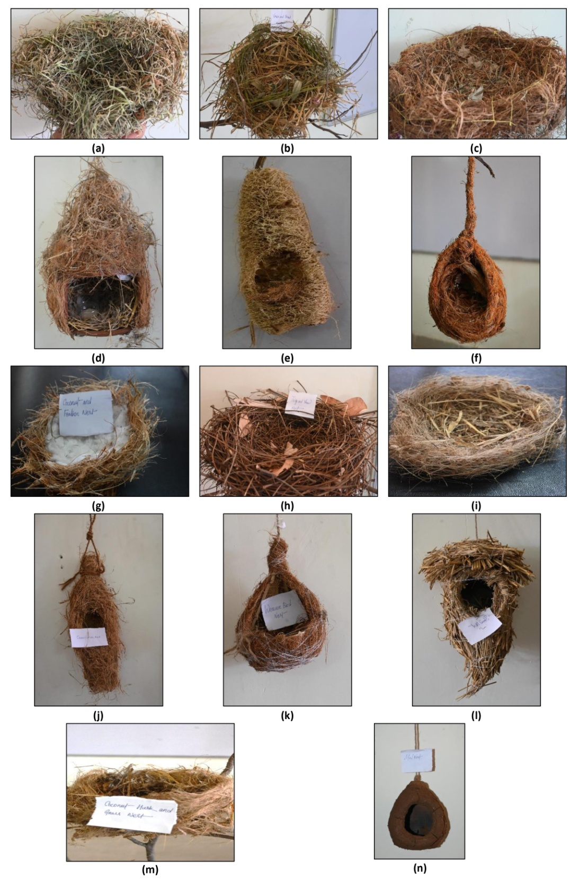

**Figure 1** Different man-made bird nests made from different natural materials, from (a) to (n)

**2.3 Methods**

After constructing the nests, we strategically placed them within the Maa Manikeshwari University campus areas to encourage bird habitation and study their nesting preferences. Some of the nests were securely positioned in the branches of trees, while others were suspended using ropes to replicate hanging nests often found in nature **(Figure 2)**. This initiative aims to support local bird populations, promote biodiversity, and contribute to environmental conservation efforts within the university campus.

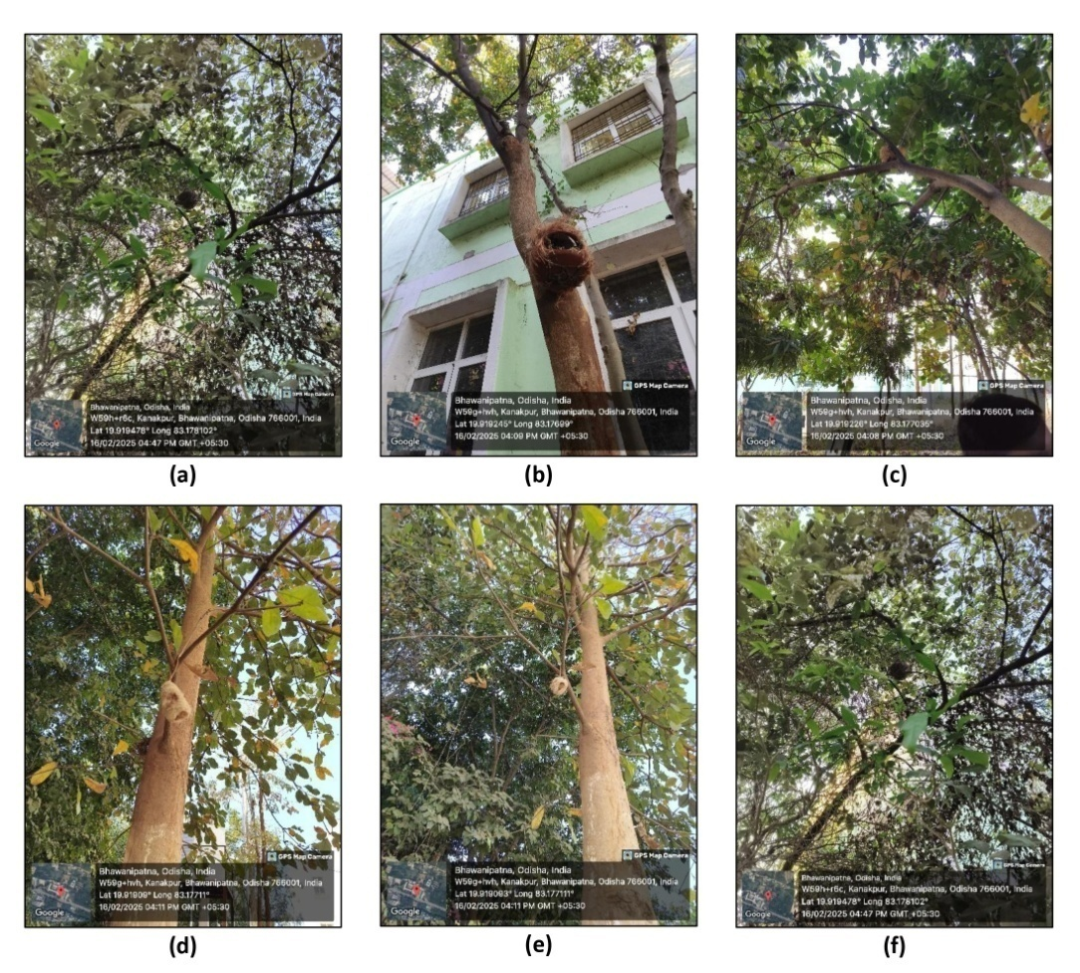

**Figure 2** Different man-made bird nest were installed in natural habitats like trees

**3. Result**

Out of twelve types of man-made nests, only four were chosen by four different bird species. However, one nest type, made from mixed natural materials, was used by both the Greater Coucal and the Indian Robin. The remaining eight nest types were not selected by any birds during the study **(Table 1)**.

**Table 1 Twelve nest types, their materials, and selected bird species are shown**

|  |  |  |  |  |
| --- | --- | --- | --- | --- |
| **Sl. No.** | **Materials used for construction of Nest** | **Number** | **Preferred by Birds** | **Scientific & common names of birds** |
|  | Dry and Partially Dried Grasses | 12 | + | *Amandava amandava* (Red Munia or Strawberry Finch) |
|  | Dry Twigs | 07 |  |  |
|  | Paddy Straw | 15 |  |  |
|  | Dried Coconut Shells | 14 |  |  |
|  | Paddy Straw with Coconut Shells | 07 |  |  |
|  | Paddy Straw with Coconut Fibers | 09 | + | *Centropus sinensis* (Greater Coucal) |
|  | Dried Coconut Shells with Bamboo | 07 |  |  |
|  | Dry Shell of Ridge Gourd with Coconut Fibers | 03 |  |  |
|  | Coconut Fibers With Dry Grasses | 10 | + | *Passer domesticus* (House Sparrow) |
|  | Coconut Fibers With Cotton | 10 |  |  |
|  | Mud | 04 |  |  |
|  | Different Mixed Natural Materials (Paddy straw, dry grasses, twigs, coconut fibers, dry leaves, bamboo sticks etc.) | 20 | + | *Centropus sinensis* (Greater Coucal) & *Copsychus fulicatus* (Indian Robin) |
| Total | | 118 |  | |

**4. Discussion**

In the early days following the placement of the nests, we noted that birds did not promptly choose them for habitation. They exhibited curiosity and conducted a careful examination of the artificial nests from a distance. Their behaviour evolved progressively over time. Initially, they approached the nests with caution but did not enter. Their increasing curiosity suggested a thorough evaluation process prior to the decision to occupy the nests (Steenhof & Newton, 2007; Breen et al., 2016). Over time, a notable change in behaviour was observed. The birds increased their proximity to the nests, conducting thorough inspections, and subsequently utilised them for shelter and nesting purposes. This transition highlighted their increasing confidence in the newly implemented structures. Continuous observation allowed for the identification of specific bird species that selected particular nests, indicating preferences related to material, placement, or design (Duncan & Kite, 1989; Healy et al., 2015; Biddle et al., 2018).

Capturing photographs of the birds presented significant challenges (Bibby et al., 1998; Martin, 2012; Schneider et al., 2024); however, we successfully photographed three distinct bird species. Nonetheless, we were unable to capture images of all the species we observed. Certain avian species, like the House Sparrow, exhibit remarkable speed and agility, which complicates efforts to observe them in their natural environments. Their incessant movement and rapid flight patterns hindered our ability to capture clear photographs. In light of this challenge, we successfully documented several species, marking a significant achievement. We carefully observed their interactions throughout this interesting adaptation process and effectively recorded multiple geo-tagged photographs **(Figure 3)**. These images act as important documentation of the birds' acceptance of the nests, offering insights into their nesting behaviour and habitat preferences.

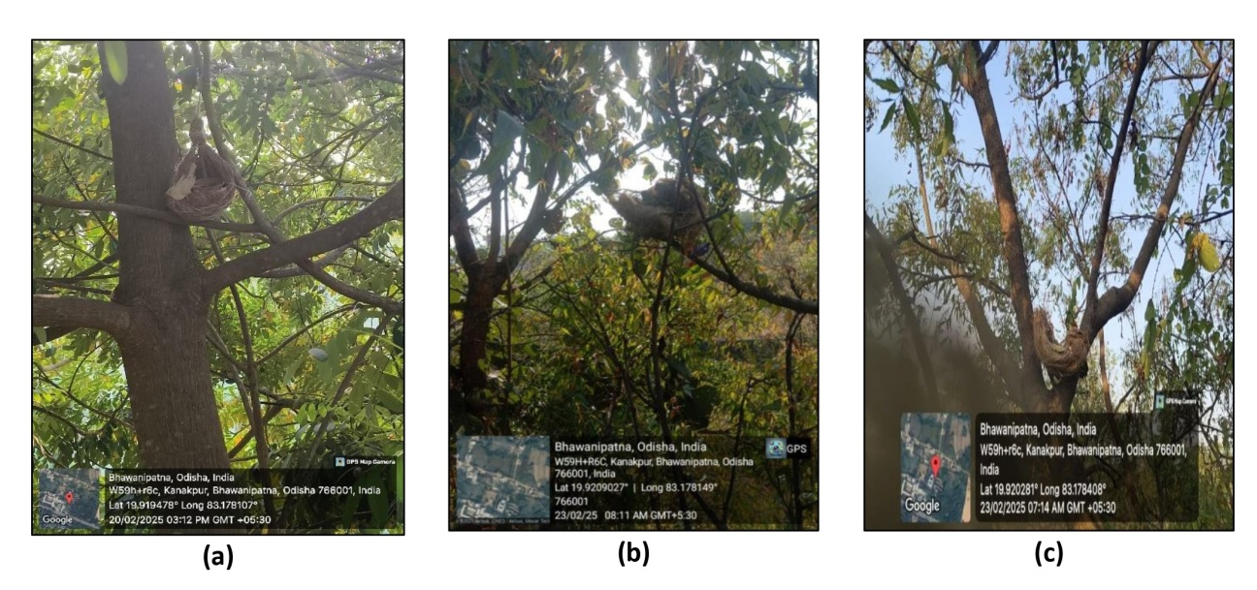

**Figure 3** Some birds preferred the man-made nest (a) Red Munia with artificial nest, (b) Indian Robin with artificial nest, and (c) Greater Coucal with artificial nest

Birds exhibit a significant level of intelligence and display a heightened sensitivity regarding their environment. Their instinct to safeguard their nests and offspring is pronounced, resulting in a demeanour that is both cautious and alert (Skutch, 1955; Sibley, 2020). When detecting the presence of any animal or human in proximity to their nesting area, they frequently exhibit caution and may opt to vacate their nest to prioritise their safety. This instinctive behaviour enables them avoid possible dangers and predators. This sensitivity presents challenges for researchers, photographers, and birdwatchers in their efforts to observe and document these subjects without causing disturbance. Interference in their habitat can result in stress and potentially lead to nest abandonment, thereby affecting their breeding and survival rates. Birds present intriguing subjects for observation; however, it is crucial to acknowledge the importance of respecting their space and reducing human interference. Practicing responsible bird watching and photography is essential for ensuring the safety and conservation of avian species.

Our observations revealed that four bird species—Red Munia, Greater Coucal, House Sparrow, and Indian Robin—exhibited a distinct preference for artificial, installed bird nests **(Table 1)**. The birds engaged with the artificial nests, employing them for both shelter and nesting activities. Their readiness to adjust to these frameworks indicates that such installations may prove advantageous for their living conditions, particularly in urban or altered settings. Conversely, various other bird species were noted in the vicinity; however, they did not utilise the artificial nests for habitation. Rather, they persisted in utilising their inherent nesting locations, including trees, shrubs, or concealed crevices. This suggests that although certain bird species easily adjust to anthropogenic environments, others continue to favour their conventional nesting practices. The installation of artificial bird nests serves to bolster specific species by offering them safe and secure locations for nesting. Further investigation is essential to comprehend the nesting preferences of various bird species and to evaluate how these interventions can aid in their conservation and the preservation of their habitats.

The Red Munia exhibits remarkable adaptability, favouring habitats characterised by dense vegetation, especially in grasslands and wetlands. However, they are abundantly found in the Kalahandi district of Odisha. The carefully constructed, dome-shaped nests offer protection and warmth for the young. In our study, it was observed that red munia preferred the dome-shaped nests we installed **(Figure 3 (a))**. Generally, a majority of avian species tend to construct nests that are dome-shaped or cylindrical, as these designs offer enhanced protection and security (Collias, 1987; Collias & Collias, 2014; Deeming, 2023). The dome-shaped nest, typically built using fine grass, leaves, twigs, and various natural materials, provides remarkable insulation, ensuring that the eggs and chicks remain warm in cooler temperatures while also offering shade and cooling in hotter conditions. The enclosed design serves to protect the nest from predators, strong winds, and heavy rain, thereby creating a secure environment for hatchlings to develop. In a similar vein, certain avian species exhibit a preference for cylindrical nests due to the secure and concealed environment they provide, frequently suspended from tree branches or nestled within dense foliage (Schmauss, 2019). This design effectively minimises the likelihood of predators accessing the nest, all while ensuring adequate ventilation is maintained.

The Greater Coucal, often known as the Crow Pheasant, is a sizable, non-parasitic species belonging to the cuckoo family, prevalent throughout South and Southeast Asia. Similar to many avian species, the Greater Coucal constructs large, hidden nests within thick vegetation (Claassen, 2004). The nest is typically constructed at a low level within shrubs, thickets, or dense bushes, frequently situated near the ground, though it can occasionally be found higher up in trees (Feijen & Feijen, 2008). Our findings indicate that the Greater Coucal exhibited a distinct preference for larger man-made nests **(Figure 3 (c))**. The nests were strategically placed at the tops of trees, offering the birds a heightened and safe habitat. The shape and placement of the nests probably played a significant role in their choice, as they provided a safeguard against terrestrial predators and disruptions. The materials utilised in the construction of these artificial nests were instrumental in determining their acceptance by the avian species. The construction of the nests involved the utilisation of paddy straw, fine coconut fibres, and a variety of plant materials, including twigs, leaves, grasses, and bamboo sticks. The materials closely mirrored the natural nesting components utilised by Greater Coucals in their natural habitat, enhancing the attractiveness of the artificial nests for them. Our findings indicate that well-designed and strategically positioned artificial nests can significantly enhance the nesting preferences of the Greater Coucal. This adaptation underscores the capacity of conservation initiatives to support specific bird species by offering appropriate nesting options, particularly in regions where natural nesting sites are scarce.

The House Sparrow is a small, social bird known for its strong connection to human habitats (Chamberlain et al., 2007; Shaw et al., 2008). It demonstrates remarkable adaptability and flourishes across diverse environments. House Sparrows inhabit diverse environments globally, especially in areas influenced by human presence (Anderson, 2006). House Sparrows exhibit opportunistic nesting behaviour, utilising a range of locations for nest construction (Von Post & Smith, 2015; Pegu et al., 2024). A nest was constructed by them within constructed environments, including edifices, illumination fixtures, ventilation openings, and ledges of windows. They also nest in tree hollows, dense underbrush, and beneath rooftops. When available, artificial nest boxes may also be used (Indykiewicz, 1991; Balaji, 2014; Pandian, 2023).The nests exhibit a loose construction, taking on either a dome or cup shape, influenced by their specific location (Collias & Collias, 2014). Nests are constructed from a variety of materials, including grass, straw, feathers, twigs, paper scraps, and other soft substances. Our observation revealed that the House Sparrow exhibited a distinct preference for small artificial nests. The nests were meticulously built with delicate coconut fibres and thoroughly dried grasses, creating a soft and inviting nesting habitat. The location of the nests was a crucial factor in their selection. The nests were positioned in trees adjacent to buildings, reflecting the House Sparrow’s inherent inclination to nest near human habitats. The existence of structures probably contributed to a feeling of safety, in addition to facilitating access to food resources. The trees provided shade and enhanced protection against predators and severe weather conditions. The results indicate that thoughtfully constructed and strategically positioned artificial nests can significantly enhance the nesting preferences of House Sparrows. In light of the decreasing numbers in certain urban regions attributed to habitat loss and environmental shifts, the implementation of artificial nests in appropriate sites presents a significant conservation approach (James Reynolds et al., 2019). By ensuring secure nesting locations, we can aid in the conservation of this small but ecologically significant bird species.

The Indian Robin is a small, dynamic bird recognised for its unique upright stance, elongated tail, and harmonious vocalisations (Clement, 2016). The Indian Robin demonstrates remarkable adaptability to diverse habitats, typically inhabiting regions characterised by a mix of trees, shrubs, and open areas conducive to foraging. It is often observed in dry grasslands, rocky terrains, and hilly landscapes, as well as in agricultural fields, village peripheries, and close to human dwellings. Cup-shaped nests were constructed using grass, twigs, leaves, and root fibres (Jahan, 2018). Our observation revealed that the Indian Robin showed a preference for nests constructed from natural materials, including grass, twigs, leaves, and coconut fibres **(Figure 3 (b))**. The installation of these nests in trees creates a secure and elevated habitat for the birds. The selected nesting materials closely mirrored those utilised by Indian Robins in their natural habitat, providing both comfort and protection for their eggs and chicks. Their choice for tree-installed nests underscores a natural tendency towards hidden and secure nesting locations, which provide protection from predators and environmental disruptions.

**5. Conclusion**

Our observations revealed that different bird species exhibited varying preferences for artificial nests based on factors such as size, material, and placement. While species like the Red Munia, Greater Coucal, House Sparrow, and Indian Robin successfully adapted to man-made nests, others continued to rely on natural nesting sites. The gradual acceptance of artificial nests highlights the potential of such installations in supporting bird populations, particularly in areas where natural habitats are declining. However, careful design, strategic placement, and minimal human interference are crucial for their successful adoption. Further studies are needed to refine artificial nest structures and enhance conservation efforts for diverse bird species.

**REFERENCE**

1. Anderson, T. R. (2006). *Biology of the ubiquitous house sparrow: from genes to populations*. Oxford University Press.
2. Balaji, S. (2014). Artificial nest box for house sparrow: An apt method to save the dwindling species in an urban environment. *International Journal of Biodiversity and Conservation*, *6*(3), 194-198.
3. Bibby, C. J., Jones, M., & Marsden, S. (1998). *Bird surveys* (pp. 1-137). London: Expedition Advisory Centre.
4. Biddle, L. E., Deeming, D. C., & Goodman, A. M. (2018). Birds use structural properties when selecting materials for different parts of their nests. *Journal of Ornithology*, *159*, 999-1008.
5. Breen, A. J., Guillette, L. M., & Healy, S. D. (2016). What can nest-building birds teach us?. *Comparative Cognition & Behavior Reviews*.
6. Chamberlain, D. E., Toms, M. P., Cleary-McHarg, R., & Banks, A. N. (2007). House sparrow (Passer domesticus) habitat use in urbanized landscapes. *Journal of Ornithology*, *148*(4), 453-462.
7. Claassen, A. H. (2004). Abundance, distribution, and reproductive success of sandbar nesting birds below the Yali Falls hydropower dam on the Sesan River, Northeastern Cambodia. *World Wildlife Fund for Nature Technical Report, Phnom Pehn, Cambodia*.
8. Clement, P. (2016). *Robins and chats*. Bloomsbury Publishing.
9. Collias, N. E. (1987). Evolution of nest building. In *The Natural History Reader in Animal Behavior* (pp. 85-96). Columbia University Press.
10. Collias, N. E., & Collias, E. C. (2014). *Nest building and bird behavior*. Princeton University Press.
11. Cox, D. T., & Gaston, K. J. (2018). Human–nature interactions and the consequences and drivers of provisioning wildlife. *Philosophical Transactions of the Royal Society B: Biological Sciences*, *373*(1745), 20170092.
12. Deeming, D. C. (2023). Nest construction in mammals: a review of the patterns of construction and functional roles. *Philosophical Transactions of the Royal Society B*, *378*(1884), 20220138.
13. Duncan, I. J. H., & Kite, V. G. (1989). Nest site selection and nest-building behaviour in domestic fowl. *Animal behaviour*, *37*, 215-231.
14. Faaborg, J., Holmes, R. T., Anders, A. D., Bildstein, K. L., Dugger, K. M., Gauthreaux Jr, S. A., ... & Warnock, N. (2010). Recent advances in understanding migration systems of New World land birds. *Ecological monographs*, *80*(1), 3-48.
15. Feijen, C. O. B. I., & Feijen, H. R. (2008). A review of the breeding birds of Bhutan. *Forktail*, *24*, 1-24.
16. Fuller, R. A., Irvine, K. N., & Gaston, K. J. (2010). Interactions between people and nature in urban environments. *Urban ecology*, 134-171.
17. Healy, S. D., Morgan, K. V., & Bailey, I. E. (2015). Nest construction behaviour. *Nests, eggs and incubation: new ideas about avian reproduction*, 16-28.
18. Heinrich, B. (2013). Why does a hawk build with green nesting material?. *Northeastern Naturalist*, *20*(2), 209-218.
19. Idilfitri, S., & Mohamad, N. H. N. (2012). Role of ornamental vegetation for birds’ habitats in urban parks: case study FRIM, Malaysia. *Procedia-Social and Behavioral Sciences*, *68*, 894-909.
20. Indykiewicz, P. (1991). Nests and nest-sites of the house sparrow Passer domesticus (Linnaeus, 1758) in urban, suburban and rural environments. *Acta zool. cracov*, *34*(2), 475-495.
21. Jagiello, Z., Reynolds, S. J., Nagy, J., Mainwaring, M. C., & Ibanez-Alamo, J. D. (2023). Why do some bird species incorporate more anthropogenic materials into their nests than others?. *Philosophical Transactions of the Royal Society B*, *378*(1884), 20220156.
22. Jahan, I., Begum, S., Feeroz, M. M., Das, D. K., & Datta, A. K. (2018). Nesting pattern of birds in Jahangirnagar University Campus, Bangladesh. *Journal of Threatened Taxa*, *10*(5), 11618-11635.
23. James Reynolds, S., Ibáñez-Álamo, J. D., Sumasgutner, P., & Mainwaring, M. C. (2019). Urbanisation and nest building in birds: a review of threats and opportunities. *Journal of Ornithology*, *160*(3), 841-860.
24. Kuranov, B. D. (2009). Nest biology of urban populations of cavity-nesting birds. *Contemporary Problems of Ecology*, *2*, 240-247.
25. Lambrechts, M. M., Adriaensen, F., Ardia, D. R., Artemyev, A. V., Atiénzar, F., Bańbura, J., ... & Ziane, N. (2010). The design of artificial nestboxes for the study of secondary hole-nesting birds: a review of methodological inconsistencies and potential biases. *Acta Ornithologica*, *45*(1), 1-26.
26. Lambrechts, M. M., Wiebe, K. L., Sunde, P., Solonen, T., Sergio, F., Roulin, A., ... & Korpimäki, E. (2012). Nest box design for the study of diurnal raptors and owls is still an overlooked point in ecological, evolutionary and conservation studies: a review. *Journal of Ornithology*, *153*, 23-34.
27. Liu, X. R., & Li, Z. Q. (2024). Urban bird nest building on man-made structures: A review. *Zoological Research: Diversity and Conservation*, *1*(4), 273-281.
28. Martin, G. R. (2012). Through birds’ eyes: insights into avian sensory ecology. *Journal of Ornithology*, *153*(Suppl 1), 23-48.
29. Marzluff, J., & Rodewald, A. (2008). Conserving biodiversity in urbanizing areas: nontraditional views from a bird’s perspective. *Cities and the Environment (CATE)*, *1*(2), 6.
30. Newton, I. (1998). *Population limitation in birds*. Academic press.
31. Newton, I. (2023). *The migration ecology of birds*. Elsevier.
32. Pandian, M. (2023). Studies on the response of House Sparrow Passer domesticus to artificial nest-boxes in rural Arakkonam and Nemili taluks, Vellore District, Tamil Nadu, India. *Journal of Threatened Taxa*, *15*(10), 24009-24015.
33. Pegu, S., Nag, S., Hasan, R., & Das, A. N. (2024). ROOSTING AND NESTING ECOLOGY OF HOUSE SPARROW (Passer domesticus) IN GUWAHATI CITY, ASSAM. *Journal of Biology/TẠp chí Sinh HỌc*, *46*(1).
34. Proctor, N. (1996). *Garden birds: how to attract birds to your garden*. Rodale.
35. Putri, I. A., Ansari, F., & Susilo, A. (2020). Response of bird community toward tourism activities in the karst area of Bantimurung Bulusaraung National Park. *Journal of Quality Assurance in Hospitality & Tourism*, *21*(2), 146-167.
36. Schmauss, A. (2019). *Birdhouses of the World*. Abrams.
37. Schneider, D., Lindner, K., Vogelbacher, M., Bellafkir, H., Farwig, N., & Freisleben, B. (2024). Recognition of European mammals and birds in camera trap images using deep neural networks. *IET Computer Vision*, *18*(8), 1162-1192.
38. Scott, V. E. (1977). *Cavity-nesting birds of North American forests* (No. 511). Forest Service, US Department of Agriculture.
39. Shaw, L. M., Chamberlain, D., & Evans, M. (2008). The House Sparrow Passer domesticus in urban areas: reviewing a possible link between post-decline distribution and human socioeconomic status. *Journal of Ornithology*, *149*(3), 293-299.
40. Sherley, R. B., Barham, B. J., Barham, P. J., Leshoro, T. M., & Underhill, L. G. (2012). Artificial nests enhance the breeding productivity of African Penguins (Spheniscus demersus) on Robben Island, South Africa. *Emu-Austral Ornithology*, *112*(2), 97-106.
41. Sibley, D. A. (2020). *What It's Like to be a Bird: From Flying to Nesting, Eating to Singing--what Birds are Doing, and why*. Knopf.
42. Skutch, A. F. (1955). The parental stratagems of birds. *Ibis*, *97*(1), 118-141.
43. Steenhof, K., & Newton, I. (2007). Assessing nesting success and productivity. Raptor research and management techniques, 181-192.
44. Suárez-Rodríguez, M., Montero-Montoya, R. D., & Macías Garcia, C. (2017). Anthropogenic nest materials may increase breeding costs for urban birds. *Frontiers in ecology and evolution*, *5*, 4.
45. Von Post, M., & Smith, H. G. (2015). Effects on rural House Sparrow and Tree Sparrow populations by experimental nest-site addition. *Journal of Ornithology*, *156*, 231-237.
46. Wratten, S. D., Gillespie, M., Decourtye, A., Mader, E., & Desneux, N. (2012). Pollinator habitat enhancement: benefits to other ecosystem services. *Agriculture, Ecosystems & Environment*, *159*, 112-122.
47. Zhang, L., Ma, X., Chen, Z., Wang, C., Liu, Z., Li, X., & Xing, X. (2023). Negative effects of artificial nest boxes on birds: A review. *Avian Research*, *14*, 100101.