**Novel distributional records for Asteraceae: Expanding the Flora of Maharashtra.**

**Abstract:**

This research records the first confirmed observations of *Acmella uliginosa* (Sw.) Cass. and *Gymnanthemum amygdalinum* (Dillile) Sch. Bip. (Asteraceae) in Maharashtra, India. Field surveys conducted in Jalgaon district of Maharashtra in 2024 discovered populations of many species, establishing new distributional records for the state's flora. Thorough morphological analyses and environmental evaluations were performed to confirm species identification and clarify the ecological context of these findings. The discovery of these species augments the acknowledged richness of Maharashtra and underscores the imperative for continuous floristic surveys to thoroughly catalogue and understand the region's plant diversity. This article addresses its taxonomy, phenology, and distribution, accompanied with colour photographs for easier identification.

**Keywords:** Asteraceae, New records, *Acmella, Gymnantemum*, Jalgaon, Maharashtra.

**Introduction:**

The Asteraceae family is among the largest families of flowering plants, comprising over 1,620 genera and over 23,600 species (Stevens, 2012). Members of this family exhibit significant vegetative variability, although can be identified by their capitulation and involucrate inflorescences, characterized by numerous little flowers that first emerge externally and are occasionally supported by bracts. The little, single-seeded fruits typically possess a plumose pappus and are often disseminated by wind (Stevens, 2012). The family holds economic significance, can serve as ornamental, and many family members possess therapeutic properties and are extensively cultivated for food and vegetables.

The species detailed in this research were gathered from the Chalisgaon tahsil in Jalgaon district. Jalgaon has diversity in both its climate and floral abundance. During the investigation of the flora in Jalgaon district in 2023-24, the authors encountered a collection of specimens of *Acmella* and *Gymnanthemum* from various localities. Thorough analysis of species with accessible literature in referencing the flora, critically examine the following works: Flora of Maharashtra (Almeida, 2001); Flora of Maharashtra: Dicotyledons (Singh, 2001); Flora of Marathwada (Naik, 1998); Flora of Jalgaon District, Maharashtra (Kshirsagar & Patil, 2008); and Flora of Dhule and Nandurbar Districts, Maharashtra (Patil, D. A., 2003) and analyses of research papers (Reshmi & Rajalakshmi (2016); J. Swamy (2015); Pavan Malav & et al (2020); Khan & Chaudhari (2023); Khan (2024); Undirwade. & Bhuktar (2024; 2025). Specimens were meticulously inspected and identified as *Acmella uliginosa* (Sw.) Cass. and *Gymnanthemum amygdalinum* (Dillile) Sch. Bip. Relates to the family Asteraceae.

**Taxonomic treatment:**

***Acmella uliginosa* (Sw.) Cass.** in G.-F. Cuvier, Dict. Sci. Nat., ed. 2. 24: 331. 1822; Jansen, Syst. Bot. Mongr. 8: 55. 1985; Chung et al. Taiwania 52: 276. 2007. *Spilanthes uliginosa* Sw. in Prodr. Veg. Ind. Occ.: 110. 1788. *Coreopsis acmella* var. *uliginosa* (Sw.) E.H.L. Krause in Beih. Bot. Centralbl. 32(2): 340. 1914. **(Fig.1).**

Annual herbs ranging from 10 to 35 cm in height. Stems vary from one to many at the base, displaying an upright, ascending, or occasionally decumbent orientation, and range in colour from green to purple, with a texture that is glabrous to moderately pilose. Petioles measure 0.6-1.7 cm in length, displaying sparse to moderate hairiness, and are either devoid of wings or possess narrow wings; leaf blades are lanceolate, narrowly ovate, or oval, measuring 1.5-5.2 cm by 0.4-2.7 cm, with an apex that is acute to acuminate, margins that are sinuate to dentate, sparsely ciliate, and a cuneate base, exhibiting a glabrous to sparsely pilose texture on both surfaces. Peduncles are around 1.2 to 4 cm in length and are sparsely adorned with hairs. Capitula are radiating, occurring alone or infrequently in pairs or triplets, terminal, oval, measuring 5-9 mm in length and 4-7 mm in diameter. Involucral bracts consist of 5 or 6, uniseriate, narrowly to broadly ovate, measuring 2-4 by 0.5-2 mm, sparsely to moderately ciliate; the receptacle measures 3-6 mm in length and 0.5-1 mm in diameter; the palea is stramineous or occasionally displays a purple-red hue during early flowering, measuring 2-3.5 by 0.5 mm; ray florets number 4-7, are bisexual, with corollas varying from yellow to orange-yellow, measuring 1.6-3.7 mm in length, the tube measuring 0.5-1.4 mm in length, and the limb is trifid, measuring 1-2 mm in length and 0.4-1.4 mm in width; disc florets are numerous, ranging from 70-150, bisexual, yellow to orange-yellow, and 4-merous. Achenes are black, ranging from 1.2 to 1.8 mm in length, and display moderate to dense ciliation with straight-tipped hairs; the pappus is pale brown, including two unequal bristles, with the bigger bristle measuring 0.2 to 0.7 mm and the shorter bristle measuring 0.1 to 0.5 mm.

**Flowering & Fruiting:** August-February

**Distribution:** In India the species is reported from Kerala, Rajasthan, Odissa, Assam, West Bengal and present report from Maharashtra.

**Occurrence:** Chalisgaon, Bilakhed, Kargaon.

**Status:** It is invasive, not indigenous.

**Ethnomedicinal uses:** Heads are chewed to cure the oral diseases, as well its given to sore throat. Can be used as alternative to *A. oleracea.*

***Gymnanthemum amygdalinum* (Delile) Sch. Bip** in W.G. Walpers, Repert. Bot. Syst. 2: 948. 1843. *Vernonia amygdalina*Delile in Cent. Pl. Afr. Voy. Méroé: 41. 1826; Bhattacharjee *et al.,* Zoo’s Print 28(5): 18. 2013. Bhattacharjee *et al.,* Zoo’s Print 28(5): 18. 2013. *Cacalia amygdalina*(Delile) Kuntze in Revis. Gen. Pl. 2: 969. 1891. *Decaneurum amygdalinum*(Delile) DC. in Prodr. 5: 68. 1836. *Keringa amygdalina*(Delile) Raf. in Sylva Tellur.: 144. 1838. **(Fig.2).**

Terete, glandular pubescent bushes or small trees 3-4 m high. Elliptic, elliptic-lanceolate, ovate, obovate, highly variable leaves, 8-22 by 3-7 cm, cuneately attenuate at base, acuminate, at apex, serrate or entire along margins, upper surface dark green, sparsely pubescent; lower surface pale green, glandular, densely pubescent, hairy along veins, very bitter in taste. Pubescent 4-4.5 cm petioles. Peduncles thickly puberulent and glandular; terminal corymbose panicles 22 by 16 cm. Heads homogamous, numerous, 1.4 by 1.2 cm; bracteoles 1 or 2, thickly puberulent. Phyllaries imbricate, 5-seriate, yellowish green with purple tip, outer most very short, inner ones longest, elliptic-oblong, obtuse or rounded at apex, hairy along margins, puberulent above, glabrous-puberulent below. Involucre campanulate, 6-8 by 6 mm. Flat, foveolate, brown receptacle. In each capitulum, 15-17, 2 cm-long flowers, creamy-white, tubular, 5-lobed, rounded corolla. Stamens 5, filaments glabrous, anthers sagittate at base, rounded to subacute at apex. Gynoecium 1 cm long; ovary hairy; style 5 mm with glabrous base and hairy apex; stigma subulate, uneven, hairy. Achenes, brown, 3 mm long, oblong, somewhat cuneate at base, 10-ribbed, very prominent, glandular between ribs, many spreading hairs on ribs; pappus white, persistent bristles, many in number.   
**Phenology:** Flowering and fruiting inNovember-March

**Distribution:** In India its reported from Bihar, Madhya Pradesh, Odisha, West Bengal and Telangana and present report from Maharashtra.

**Occurrence:** On the way to Wade-Gudhe, Planted near farm.

**Status:** It is invasive, not indigenous.

**Ethnomedicinal uses:** The leaves are commonly used as a treatment against nematodes in humans and chimpanzees as well as for other intestinal worms (Huffman and Seifu, 1989). It is a well-known traditional anti-diabetic plant known in Africa (Atangwho *et al*., 2011). Diabetes treatment: two spoonful of leaf powder in one glass of milk.

**Conservation and Sustainable Use:**

In addition to being invasive, both species possess therapeutic promise; they may be scarce and thus vulnerable to habitat destruction or over-exploitation. Measures must be instituted to safeguard these plants, ensuring that local communities obtain sustainable advantages from them without compromising their long-term sustainability. From an economic perspective, these plants may be farmed for commercial purposes, including the production of herbal products or medicinal formulations. This could offer new opportunities for local farmers and businesses to diversify their income sources.

**Disscussion:**

According to Jansen (1980), Jacquin described *Spilanthes* in 1760 and divided it into two sections-*Spilanthes* Jacq. and *Acmella* Rich. Later updated the description of section *Acmella* Rich. and stated that *Acmella* differentiates from *Spilanthes* only in possessing radiate heads, moving numerous radiate *Spilanthe*s species into *Acmella.* This categorization was followed by De Candolle (1836) and Moore (1907). Moore's revised *Spilanthes* section had 13 species, six varieties, and forms, whereas *Acmella* had 26 species, 18 variants, and forms. Jansen (1980) offered strong morphological and chromosomal evidence for *Acmella* and *Spilanthes* separate genera. It has 9 species and 2 variety in India (Reshmi & Rajalakshmi, 2016). To present, four species and one variety have been reported in Maharashtra. However, the reinstatement of *Acmella radicans* var. *debilis* (Jagtap & Buchalkar, 2015) to species status resulted in a total of four species. A species key is provided for every species, including the newly added one.

**Key to *Acmella* spp.**

1. Discoidal heads (without ray florets) …................................................................................ 3

3. Disc flowers pentamerous, pappus lacking, achene glabrous...................................... ***A. calva***

3. Achene ciliate, pappus 2-3...................................................................................................... 4

4. Disc flowers tetramerous, white ........................................................................... ***A. radicans***

4. Disc flowers 4-5-merous or 5-merous, yellow....................................................................... 5

5. Involucral bracts 3-seriate, disc flowers many, anthers black, capitula cylindric, more than1 cm broad ................................................................................................................... ***A. oleracea***

5. Involucral bracts 2-seriate, disc flowers numerous, anthers brown, capitula cone-shaped, less than 1 cm wide....................................................................................................... ***A. paniculata***

1. Radiate heads, (with ray florets) ............................................................................................ 2

2. Involucral bracts 5-6, uniseriate, disc flowers 4-merous, corollas yellow to orange ............. ..................................................................................................................................***A. uliginosa***

Upon reviewing the literature, the newly identified taxa *Acmella uliginosa* (Sw.) Cass. and *Gymnanthemum amygdalinum* (Dillile) Sch. Bip. provide novel distributional records for the Flora of Maharashtra. None of them have been previously documented or characterized from the state.

**Conclusion:**

The identification of newly documented taxa *Acmella uliginosa* (Sw.) Cass. and *Gymnanthemum amygdalinum* (Dillile) Sch. Bip. in Maharashtra's Flora signifies a significant enhancement of the region's botanical richness. The introduction of these taxa may augment the state's biodiversity, hence fostering a more robust ecology. These species may have therapeutic potential, enhancing the region's traditional medical expertise. Plants recognized for their medicinal properties may be especially valuable to local populations, offering a sustainable supply of plant-derived treatments for prevalent health issues.

**Conflict of interest:** Authors declare that they have no affiliation with or involvement in any organization or entity with any financial interest.

"I declare that the manuscript has not been published in any journal/book or proceedings or in any other publication, or offered for publication elsewhere in substantially the same or abbreviated form, either in print or electronically.”

**References:**

**Almeida, M. R. (2001).** *Flora of Maharashtra*, Orient Press, Mumbai, Vol. III A.

**Atangwho J, Ime F. A., Godwin E. E. and A. I. Mary (2011).** Changes in some liver lipids of non-diabetic and diabetic rats following administration of combined extracts of *Vernonia amygdalina* and *Azadirachta indica. Agric. Biol. J. N. Am.* 2 (7):1096-1100.

**De Candolle A. P. (1836).** *Spilanthes*. In: De Candolle AP (ed) Prodromus systematis naturalis regni vegetables. Treuttel and Wurtz, Paris, 620-626.

**Huffman M. A. and M. Seifu (1989).** Observations on illness and consumption of a possibly medicinal plant *Vernonia* *amygdalina* (Del.), by a wild Chimpanzee in the Mahale Mountains National Park, Tanzania. In: *Primates*. 30:51-63.

**Jagtap DG and M. Buchalkar (2015).** *Acmella radicans* var. *debilis* (Asteraceae): a new varietal record for Asia. *Rheedea,* 25(1): 39 – 43.

**Jansen R. K. and T. F. Stuessy (1980).** Chromosome counts of Compositae from Latin America. *American Journal of Botany*. 67:585-594.

**Khan T.A., R.Y. Chaudhari1 and M. Shaikh. (2023).** *Ficus lacor* Buch. -Ham. New distributional records for Maharashtra. *Indian Forester,* 149 (4): 469- 470.

**Khan T. A. (2024).** *Crotalaria clarkei* Gamble (Fabaceae), a new record for the Satpudarange of Jalgaon district, Maharashtra. *Ela Journal of Forestry and Wildlife.* 13 (1): 1541-1544.

**Kshirsagar, S. R. and D. A. Patil (2008).** *Flora of Jalgaon district, Maharashtra*. Bishen Singh Mahendra Pal Singh, Dehradun.

**Moore A. H. (1907).** Revision of the Genus *Spilanthes.* Proceedings of the American Academy of Arts andSciences; 42(20):521-569.

**Naik V. N. (1998).** *Flora of Marathwada*. Vol. I, Amrut Prakashan, Aurangabad. 1998.

**Patil, D. A. (2003).** *Flora of Dhule and Nandurbar District* (Maharashtra). Bishan Singh Mahendra Pal Singh Deharadun.

**Pavan Kumar Malav, R Bhardwaj, Anjula Pandey and Veena Gupta (2020).** African Bitter Leaf [*Vernonia amygdalina* Delile]: Study on Seasonal Variations in Total Phenols and Seed Germination in India. *Indian J. Plant Genet. Resour.* 33 (2): 187–191<https://doi.org/10.5958/0976-1926.2020.00027.3>

**Reshmi G. R. and R. Rajalakshmi (2016).** A new variety of *Acmella uliginosa* (Asteraceae) from Kerala, India. International Journal of Botany Studies1 (3): 11-13.

**Singh, N.P., Lakshminarasimhan, P., Karthikeyan, S. and P. Prasanna (2001).** *Flora of Maharashtra State,* *Dicotyledons*. Botanical Survey of India, Calcutta, Vol. 2.

**Swamy J., G. Prabhakar, L. Rasingam and P. Kamalakar (2015).** *Gymnanthemum amygdalinum* (Asteraceae) - A New Addition to the Flora of Peninsular India. *Int. J. Adv. Res. Sci. Technol*. 4(7):449-451.

**Stevens, P. F. (2012).** Angiosperm Phylogeny Website, <http://www.mobot.org/MOBOT/research/APweb/>

**Undirwade D.N. and A. S. Bhuktar (2024).** *Amaranthus saradhiana* (Amaranthaceae): new addition to flora of Maharashtra. *Bioinfolet*, **21(1):** 80-82.

<http://dx.doi.org/10.5958/0976-4755.2024.00027.0>

**Undirwade, D. N., and A. S. Bhuktar. (2025).** *Passiflora Foetida* Var. *Foetida* (Passifloraceae): A New Addition to the Flora of Maharashtra, India. Asian Journal of Biology 21 (1):26-30. <https://doi.org/10.9734/ajob/2025/v21i1473>

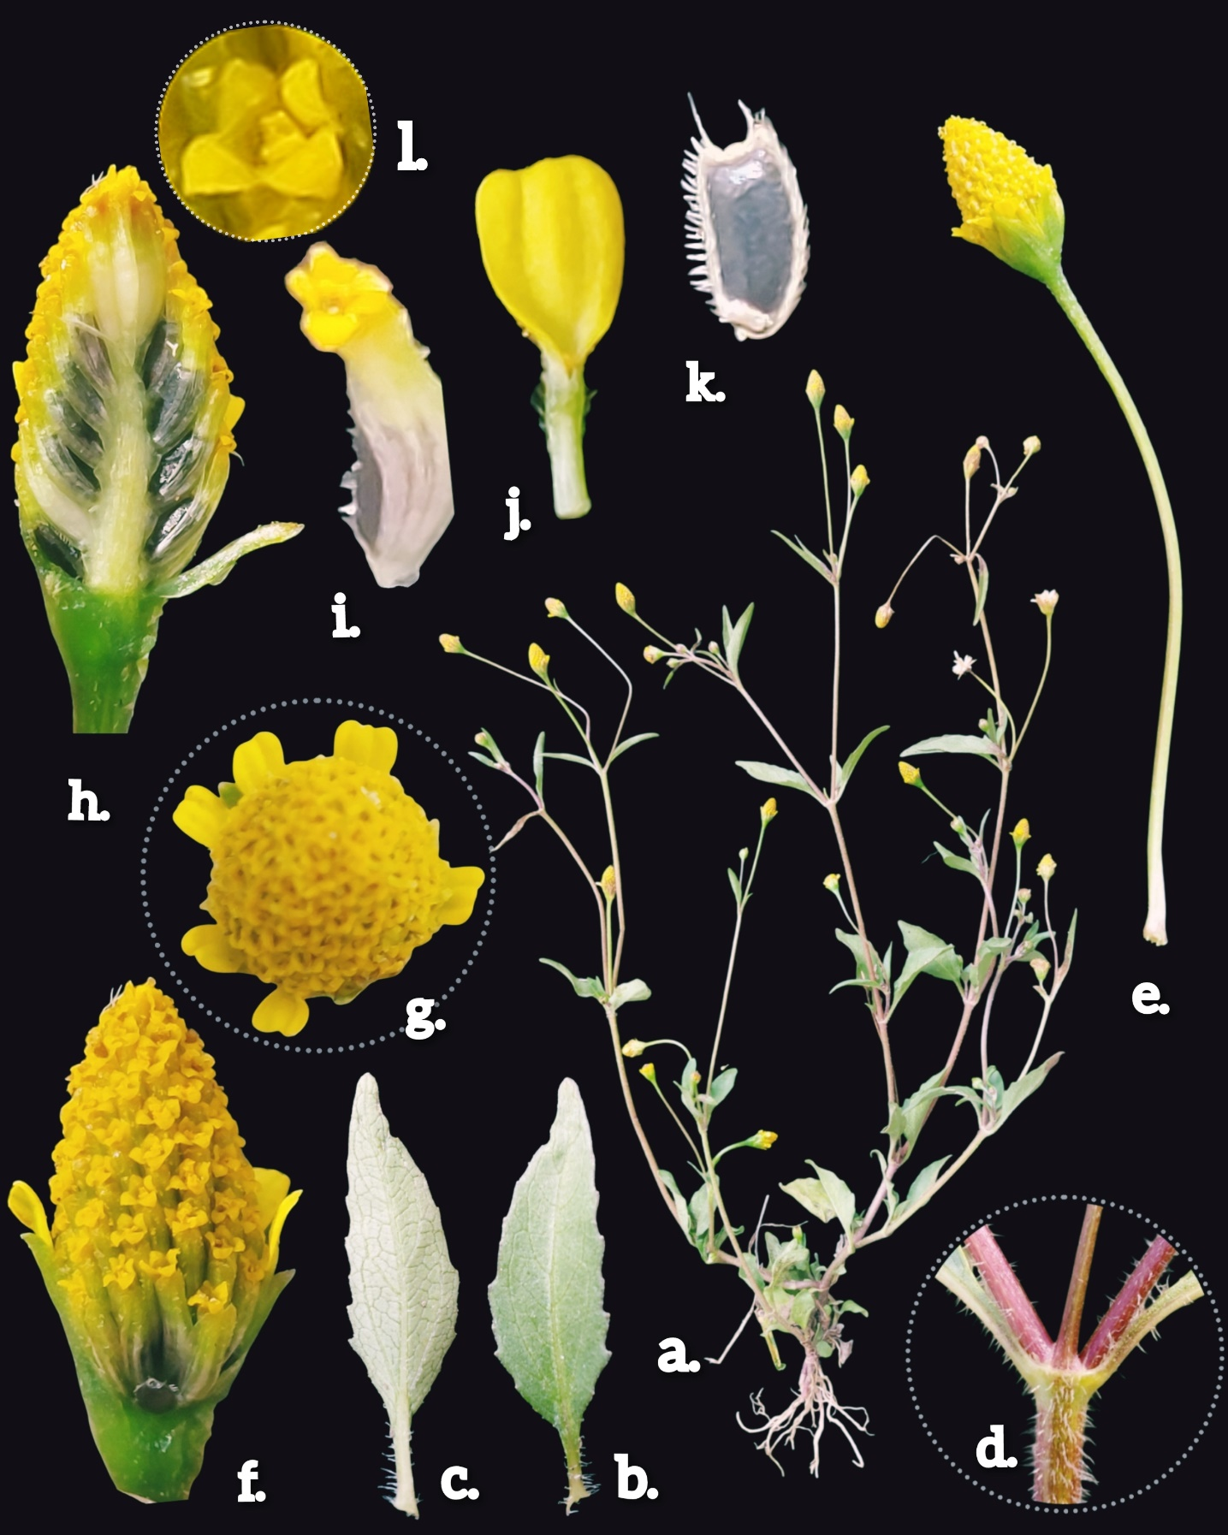

**Figure 1. Acmella uliginosa (Sw.) Cass.** **a.** Habit **b.** **& c.** Leaf dorsal ad ventral view respectively **d.** Pubescen Sem **e.** Head **f.** Head enlarged with phyllaries **g.** head top view **h.** Head dissected **i. & l.** Disc floret-tetramerous **j.** Ray floret **k.** Achene-ciliate

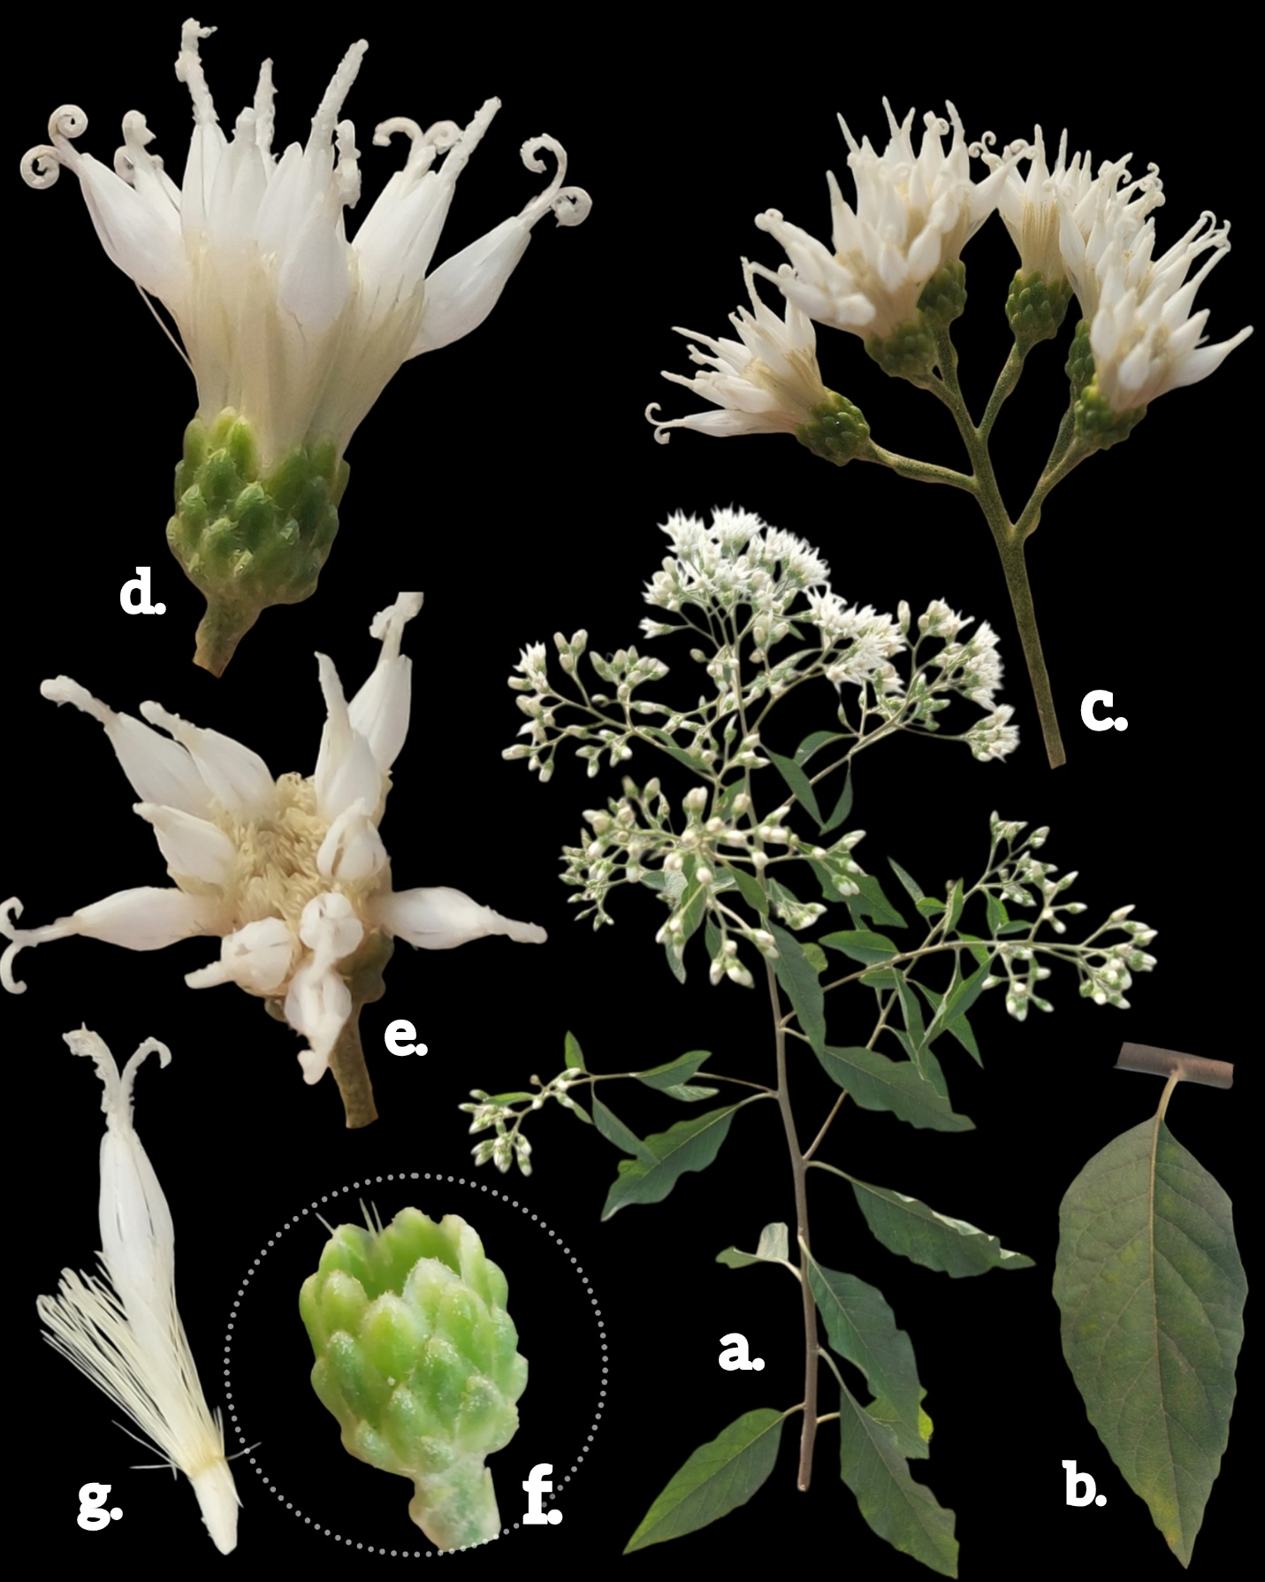

**Figure 2.** Gymnanthemum amygdalinum (Dillile) Sch. Bip. **a.** Habit, **b.** Leaf dorsal view **c.** Inflorescence pattern, **d.** Single head, **e.** Head top view, **f.** Phyllaries, **g.** Floret