**Evaluation of Multi-drugs Resistance Bacteria and high risk of Contaminated ready to eat fruit in Kano Metropolis**

**Abstract**

**Aim**

The study aimed to investigate the Prevalence of Multi-drug Resistance bacteria on ready to eat fruits in Kano Metropolis, and the associated risk factor.

**Methodology: -** The study used mixed methods design. Samples were collected from various street vendors and local markets. Questionnaire based survey was designed to collect data from vendors and consumers. A total of 33 organisms were recovered, the organisms were *Pseudomona aeruginosa Morganella morgani, Klebsiella spp, Streptococcus spp, Baccillus spp Citrobacter* *spp*, *Acinetobacter* *Baumanii*, *Cons* and *Macrococcus spp.*

**Result: -** The result shows the growth of micro-organisms in all the fruits, revealing 100% prevalence. It was revealed from the result that *Klebsiella spp* was the predominant isolate from the entire 33 isolated organism with 36.36% occurrences, followed by Baccillus spp and *Citrobacter* *spp* with 15.15%. *Pseudomona aeruginosa and Streptococcus spp* at 9.09%, while *Morganella morgana* has the occurrence rate of 6.06% and *Acinetobacter* *Baumanii, Macrococcus spp* and *Cons* with the least (3.03%). Furthermore, the result showed the growth of micro-organisms in all the fruits samples collected, revealing 100% prevalence. Making RTE fruits a potential source of infection. This is because all the organisms isolated are responsible for serious infections.

**Conclusion: -** The microbiological quality of RTE fruits served by street vendors in Kano metropolis was not within the acceptable limits, the result showed the growth of micro-organisms in all the fruits samples collected, revealing 100% prevalence. Making RTE fruits a potential source of infection to the general public and remains a threat to the public health.

**Keyword: Prevalence, Multi-drugs, Resistance, Bacteria, Kano**

**Introduction**

Vegetables and fruit are extremely important in human nutrition as sources of nutrients and non- nutritive food constituents as well as for the reduction in disease risks. While their importance as sources of nutrients and non-nutritive food constituents is generally accepted, there are still uncertainties regarding their relevance for the prevention of diseases (Boeing, Bechthold, Bub, & et al, 2012). Fruits particularly those eaten raw and without peeling can be agent of transmission of protozoa and helminthes (Bekele, Tefera, Biresaw, & Yohannes, 2017). Numerous research conducted throughout the world has revealed that foodstuffs eaten raw and uncooked such as fruits and vegetables, "play an important role in the transfer of these intestinal parasites to humans" (Li, Wang, Karim, & Zhang, 2020). These foods are frequently contaminated during cultivation, harvesting, transportation, processing, or marketing, with the soil, sewage, feces, and contaminated water serving as the primary sources of contamination (Alade & Adewuyi, 2020) Fruits are high in vitamins and minerals, and when consumed, they provide numerous health benefits to man (Olza, et al., 2017). Fruit intake has been advocated as a result of this fact, as well as the necessity for individuals to have a healthy and balanced diet. While fruits are important as a nutrient source, they can also serve as a potential source of several soil-transmitted helminths and intestinal protozoans when contaminated (Okwa, 2016). Fresh fruits and vegetables are widely available in various cities, towns, and villages in Nigeria (Keith, Ann, & Azadeh, 2009). Consumption of fresh fruits and vegetables is encouraged world-wide by both government and privately-owned health agencies or groups. Fresh vegetables and fruits play an important role in human nutrition due to their high nutrient content of water, dietary fiber, proteins, phytochemicals, vitamins and minerals such as calcium, potassium, and magnesium (Yahia, a-Sol, & Celis, 2019). Their high cellulose and fiber contents also help in the regulation of the digestive system (Mahapatra, Chaly, & Girija, 2015). International organizations including the World Health Organization (WHO), the Food and Agricultural Organization (FAO), and Centers for Disease Control and Prevention (CDC) have encouraged people to eat more fresh fruits and vegetables (Mahmoud, 2019). Fresh fruits and vegetables provide a healthy and balanced diet and can prevent chronic diseases such as heart diseases, cancer, diabetics, cardiovascular diseases, chronic obstructive pulmonary diseases, osteoporosis, and obesity including several micronutrient deficiencies especially in developing countries (Septembre-Malaterre, Remize, & Poucheret, 2018). In Nigeria, ready to-eat fruit and vegetables are becoming popular due to their high patronage (Eni, Oluwawemitan, & Oranusi, 2010), surprisingly, some of these fruits and vegetables are not washed before being consumed. Also, most vendors are not educated on personal and public hygiene because such products are exposed to contaminated air, unclean environments and packaging materials (Orji, Orinya, & Okonkwo, 2016). While there is an increase in global consumption of fresh fruits and vegetables. This is greatly threatened by an upsurge of microbial contamination (Snyder & Worobo, 2018). It has been reported that consumption of raw vegetables without proper washing is an important route in the transmission of diseases (Uga, Nathan, Thuan, & Noda, 2000). The study will point out the Prevalence of Multi-drug Resistance bacteria on ready to eat fruits in Kano Metropolis, and the associated risk factor.

**METHODOLOGY**

**Study area, population and design**

Kano state is a city situated in Northern Nigeria (Encyclopedia Britannica, 2021) , it is the second largest city in Nigeria after Lagos, with over ten million citizens living within 449 km (173 sq. mi) (Encyclopedia Britannica, 2021) lying between latitude 13 0 N and 11 0 N and longitude 8 0 W and 10’0’E (Isah, Muhammad, Sawyerr, & Olawale, 2020). Eight different types of fruit (apple, coconut, dates, garden egg, pineapple, pawpaw, orange and watermelon) ware obtained from the local fruit market located in Kano metropolis. A total of twenty-three (23) samples were randomly collected from different fruit sellers based on high patronage.

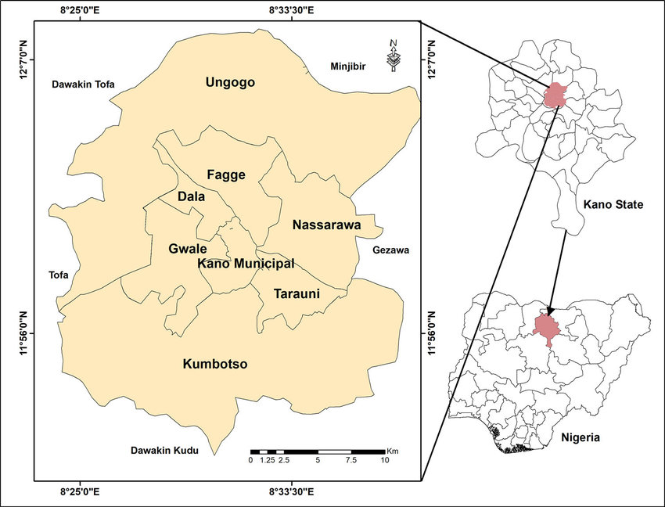

**MAP 1 SHOWING KANO METROPOLIS, KANO STATE, NIGERIA.** (Analysis and sustainability modelling of solid waste disposal sites in Kano metropolis,Nigeria, 2024)

This study was a mixed method design (descriptive and Experimental) studies. It was designed to evaluate the prevalence of multidrug resistant bacteria present on RTE fruits in Kano metropolis, Kano State. Samples were collected from various street vendors and local markets. Questionnaire based survey was designed where the questionnaires were been filled by the RTE vendors and consumers. Each sample collected was taken for bacteriological analysis to the Microbiology laboratory of Aminu Kano teaching hospital (AKTH) using standard methods.

**Data collection method, management and analysis**

**Isolation and Identification of Bacterial Isolates**

The samples were cultured immediately on Nutrient agar, Chocolate agar, and MacConkey agar mediums for Microbial examination n and frequency counts respectively. Cultures were then incubated at 37°C for 24 hours for microbial growth and isolation. The isolated colonies were examined and recorded based on the type of growth, elevation, size, colour, margin, edge, consistency, opacity, and change in medium (Cheesbrough, 2006). Gram staining technique was carried out as previously described (Cheesbrough, 2006). Catalase test was carried out on the Gram positive cocci to differentiate Staphylococcus spp from Streptococcus spp (Cheesbrough, 2006). Coagulase test was done to identify S. aureus which produces the enzyme coagulase. Oxidase test was done on the Gram-negative bacilli (GNB) to identify Psuedomonas species from other Gram -Negative bacilli (Cheesbrough, 2006). MICROBACT Biochemical Identification system was used to identify the species of the oxidase negative GNB. MICROBACT standardised micro-substrate systems was used for the rapid identification of Enterobacteriaceae and common miscellaneous Gram-negative bacilli (MGNB).

**Colonial Morphology**

The shape, size, pigmentation, elevation and marginal characteristics of the bacteria species were examined on agar plates after appropriate incubation periods.

**Gram stain**

Smears of 18-24 hours old cultures of bacteria isolates on clean glass slides were heat fixed and stained with crystal violet for about 30-60seconds. The dye was drained and specimen fixed with Lugol’s iodine for 30 seconds. The slides were rinsed with tap water, decolourised with 95% ethanol for about 10-15 seconds and again washed with tap water. The slides were counterstained with safranin for 30 seconds, then rinsed, air dried and examined under the microscope using the oil immersion lens for Gram reaction and cellular morphology. Gram positive organisms stained blue to purple while gram negative stained pink to red.

**Catalase Production**

Most aerobic microorganisms are capable of producing the enzyme catalase although to different extents. The principle of this test is that when organisms containing catalase enzyme are mixed with hydrogen peroxide (H2O2), gaseous oxygen is released. Suspensions of 18 hours old culture of the test organisms were made with distilled water on a clean glass slide. A few drops of hydrogen peroxide were added using a dropping pipette. The evolution of gas bubbles caused by the liberation of free oxygen indicated the presence of catalase enzyme.

**Coagulase Test**

Few drops of physiological saline was placed on two separate grease free slide and a loop of bacterial isolate was emulsified on the slide to make two suspensions. A drop of human plasma was collected with a sterile Pasteur pipette and mixed gently on the slides. The two slides were observed for clumping between 5-10 minutes for positive result.

**Oxidase Test**

This was carried to detect the presence of cytochrome oxidase in the microbes. Two (2) drops of oxidase reagent was placed onto what man filter paper and a smear of bacteria culture was made from a 24 hours old nutrient agar plate. The formation of Bubbles or effervescence was observed for positive result.

**Citrate Utilization**

Two (2) grams of Sodiun Citrate, 5 g Sodium Chloride, 1 g Dipotassium Phosphate, 1 g Ammonium Dihydrogen Phosphate, 0.08 g Bromothylmol Blue, 0.2 g Magnesium Sulphate and 15g agar was mixed together and 1000ml sterile distilled water was dispensed in the same mixture. The pH was adjusted to 6.9 and gentle heat was applied to dissolve agar. About 3-4 ml was collected in glass bottles and sterilized at 121 ℃ for 15 minutes in an autoclave. This was cooled in a slant bottles and inoculums was smeared onto the surface of the slant**.**

**Urease Activity**

Urea, a common organic nitrogen source for many microbes, can be hydrolysed to ammonia and carbon dioxide. The latter produces an alkaline condition in the medium, which is indicated by a color change of the pH indicator. Slants of Christensen’s urea agar medium were inoculated with the isolates and incubated at 350C for 5-7 days, watching daily for any colour changes. The development of color change from pink to red showed a positive urease activity.

**Preparation of Muller Hinton** **agar**

72g of Muller Hinton agar were measured into 1litre of distilled water, the conical flask containing the dissolved Muller Hinton agar was corked with cotton wool, wrapped with aluminum foil and it was then sterilized in the autoclave at 1210 for 15minutes.

**Antibiotic Susceptibility Test**

McFarland turbidity standards was used to compare culture of each bacterial isolate. Bacterial isolates (1.5 x 10⁸ cells/ml) was seeded into each sterile Mueller- Hinton agar and were allowed to stand at room temperature (27 ℃ ) for 30 minutes to allow inoculated organisms to pre- diffuse in the prepared media. The disc containing antibiotics (Ciprofloxacin (5µg), Augmentin (10µg), Gentamycin (10µg), ceftriazone(30µg), Erythromycin (15µg), Cloxacillin (1µg), ceftaxidine (30µg), Nitrofrantoin(300µg), Cefixime(5µg), Cefroxime(30µg), and Ofloxacin(5µg) were carefully placed aseptically on Mueller Hinton agar plates. All plates were placed in an incubator and allowed to stand for 24 hours at 37 ℃. Zone on inhibition was measured in millimeters to meet the guidelines set by the clinical standard laboratory institution (CLSI., 2020).

The statistical tools were used to analyze the data based on the laboratory samples collected. Firstly, the virtual displays of the data were described and the numerical results using the frequencies and percentages were tabulated in tables. Furthermore, the chi-square analysis was also employed for further analysis. All the analysis was done using the SPSS 21.

**Result**

**BIOCHEMICAL CHARACTERIZATION OF THE BACTERIAL ISOLATES FROM READY TO EAT FRUITS IN KANO (**Experimental analysis)

All the 23 samples of different 8 fruits collected show microbial contamination signifying 100% prevalence (figure 1). Apple shows 15.15% prevalence, Coconut shows 6.06% prevalence, Dates shows 15.15% prevalence, Garden eggs shows 15.15% prevalence, Orange shows 15.15% prevalence, Pawpaw shows 12.12% prevalence, and Pineapple shows 12.12% prevalence and Watermelon with 9.09% prevalence respectively. From fig. 2, Thirty-three microorganisms were recovered, 69.70% were gram negative and 30.30% were gram positive. The bacterial isolates were identified by standard biochemical tests (Table 1). The distribution of microorganisms recovered from all the Ready to Eat Fruits was given in figure 3 9.09% of the isolated organisms were *Pseudomona aeruginosa*, 9.09% were *Streptococcus spp*, 6.06% were *Morganella morgani*, 36.36% were *Klebsiella spp*, 15.15% were *Citrobacter* *spp*, 3.03% were *Acinetobacter* *Baumanii*, 15.15% were Baccillus spp, 3.03% were *Cons* and 3.03% were *Macrococcus spp.* This is an indication that *Klebsiella spp.* was the predominant isolate from the entire 33 isolated organism.

The results showcase that the isolated organisms were highly resistance and less susceptible to the selected antibiotics. The reasons being that, the isolated organisms show 70.71% full resistance, 7.07% intermediate resistance and 22.22% susceptible to the tested antibiotics. The chi-square result in table 1 shows that there is possible association between the isolated organisms and the rate at which they are resistance to the antibiotics. This means the resistance pattern of the organisms is high.

Similarly, the chi-square result indicated that the susceptibility pattern of the organisms is low. This is because the *p-value* is greater than 0.05.

**DESCRIPTIVE STATISTICS RESULTS OF QUESTIONNAIRE DISTRIBUTED**

This section shows the results of the tables and their percentage distributions.

All the 30 questionnaires indicated the risk factors associated with the contamination of ready-to-eat fruits with MDR bacteria, were 73.3% of the sellers has no any knowledge on MDR Bacteria and fruit handling process (Table 7), with only 13.3% properly wash their hands before handling fruit (Table 5) and Table 6 showed that the majority which is 33.3% display the fruit on an open shelve for sale.

Table 5 showed that 76.7% (23) of the sellers used water only, 13.3% (4) used soap and water, 6.7% (2) no washing and 3.3% (1) used hand sanitizer before handing fruits.

Table 6 showed that 10 of the sellers displayed there fruits on open shelve, 8 on a flat tray, 8 inside sole glass and 4 anyhow equivalent to 33.3%, 26.7%, 26.7% And 13.3% respectively.

Table 7 showed that 73.3% (22) has no knowledge on MDR Bacteria and fruit handling process while only 26.7% (8) has knowledge on it.

Table 8 showed that 73.3% (22) of the sellers doesn’t use hand gloves when handling fruits and 26.7% (8) used gloves.

**Discussion**

The increased awareness of nutrition has led to a rise in the consumption of fresh unprocessed fruits and vegetables. However, these foods are rich in essential nutrients, they can also harbor both beneficial and harmful microorganisms, resulting in a higher risk of foodborne illnesses. The link between RTE foods including fruits and MDR bacteria is a significant public health concern. The emergence and dissemination of MDR bacteria are challenging to control, and the evolution of new antibiotics is slow and costly. To investigate the prevalence of multi drug resistance bacteria on ready to eat fruits, the study was conducted by collecting 23 samples of 8 different fruits which are apple, pineapple, orange, watermelon, coconut, date, pawpaw and garden eggs within Kano State metropolis.

A total of 33 organisms were recovered, the organisms were *Pseudomona aeruginosa Morganella morgani, Klebsiella spp, Streptococcus spp, Baccillus spp Citrobacter* *spp*, *Acinetobacter* *Baumanii*, *Cons* and *Macrococcus spp.* The result shows the growth of micro-organisms in all the fruits, revealing 100% prevalence. It was revealed from the result that *Klebsiella spp* was the predominant isolate from the entire 33 isolated organism with 36.36% occurrences, followed by Baccillus spp and *Citrobacter* *spp* with 15.15%. *Pseudomona aeruginosa and Streptococcus spp* at 9.09%, while *Morganella morgana* has the occurrence rate of 6.06% and *Acinetobacter* *Baumanii, Macrococcus spp* and *Cons* with the least (3.03%).

The presence of Staphylococcus spp and Klebsiella spp. in the fruits highlights the need to safeguard the health of the consumers by proper washing and decontamination of these produce which are consumed without heat treatment. Klebsiella spp. was the most frequently isolated bacteria which is known to be one of the causative organisms of acute pneumonia. This is similar to the work of (Puspanadan, et al., 2022) which identified that consumption of fruits contaminated with Klebsiella sp. causes acute pneumonia especially in immunocompromised individuals thus, the need for serious public health concern.

*Pseudomonas spp*. and *Bacillus spp*. could be part of the natural flora and are among the most common fruit and vegetable spoilage bacteria, though some *Bacillus spp*. could cause food borne illness. Moreover, the result of this study is in line with the study of Gbolabo, Motunrayo, Nosakhare, & Titilope, (2023) from MDR bacteria associated with fresh fruits and vegetables sold in Lokoja markets, Kogi state, Nigeria.

Also, the antimicrobial susceptibility testing indicated that the isolated organisms were highly resistance and less susceptible to the selected antibiotics. Table 3 showed that the isolated organisms were 70.71% resistance, 7.07% intermediate and 22.22% susceptible to the eleven tested antibiotics. The chi-square result in table 4 shows that there is possible association between the isolated organisms and the rate at which they are resistance to the antibiotics, which means the resistance pattern of the organisms is high. This result is in line with the study of Neha, et al., (2020) which also identified high resistance in Microbes isolated from Street Fruit Drinks in Delhi, India.

The questionnaires indicated the level of awareness of sellers and risk factors associated with the contamination of ready-to-eat fruits with MDR bacteria, the result shows 73.3% of the respondent has no any knowledge on MDR Bacteria and fruit handling process, with only 13.3% of them properly wash their hands before handling fruit and 33.3% display the fruit on an open shelve for sale. This is also in line with the study of Neha, et al., (2020) which identified lack of awareness regarding hygiene practice among Street Fruit Drinks Vendors in Delhi, India.

**CONCLUSION**

The microbiological quality of RTE fruits served by street vendors in Kano metropolis was not within the acceptable limits, as reflected in our study. Furthermore, the result showed the growth of micro-organisms in all the fruits samples collected, revealing 100% prevalence. Making RTE fruits a potential source of infection. This is because all the organisms isolated are responsible for serious infections. It is very important to note that the outward appearance of fruits gave a wrong assessment of the microbial quality. Hence, awareness is to be created both for the consumers and the vendors. Also, it is clear from this study that antibiotic resistance pattern of the isolated organisms is far greater than their susceptibility pattern thus, making us conclude that the organisms are highly resistance to commonly used antibiotics. These multiple resistant bacteria isolated from RTE fruits shows that RTE fruits plays an important role in the transmission of multiple resistant bacteria in the community which is an indication that RTE fruits could be a threat to public health if adequate logistic measures are not put in place to ameliorate these levels of contaminations.

**RECOMMENDATIONS**

Consequently, with the continuous multiple antibiotic resistance role played by the isolated organisms from RTE Fruits based on the findings of this study, the following are therefore recommended:

* Hygienic measures such as thorough hand washing with soap before and after handling RTE fruits among the vendors should be encouraged in other to reduce the risk factors.
* There is need to increase surveillance of antibiotic resistant pathogen in ready to eat fruits.
* Public health surveillance is needed to monitor the fruit vendors.
* Display of RTE fruits in transparent containers with proper covering from environmental contaminants should be encouraged among vendors.
* Training of vendors or proper handling of RTE fruits to avoid direct or cross-contamination.
* Consumers should wash fruits with clean water before consumption.
* Vendors and consumers should be educated on the implication of foodborne pathogens in food and MDR Bacteria and its protection.

**References**

Alade, G. A., & Adewuyi, I. (2020). Prevalence of intestinal parasites in vegetables sold in Ilorin, Nigeria. *Am- Eurasian J Agric Environ Sci*, 13(9):1275-82.

Bekele, F., Tefera, T., Biresaw, G., & Yohannes, T. (2017). Parasitic contamination of raw vegetables and fruits collected from selected local markets in Arba Minch town, Southern Ethiopia. *Infect Dis Poverty.*, 6(1):19.

Boeing, H., Bechthold, A., Bub, A., & et al. (2012). Critical review: vegetables and fruit in the prevention of chronic diseases. *Eur J Nutr*, 51(6):637-663.

Cheesbrough, M. (2006). District Laboratory Practice in Tropical Countries. 2nd Edition. *Cambridge University Press*, 64-70.

Encyclopedia Britannica, R. (2021). kano; historical kigndom, Nigeria.

Eni, A., Oluwawemitan, I., & Oranusi, U. (2010). Microbial quality of fruits and vegetables sold in Sango Ota, Nigeria. *. Afr J Food Sci*, 4:291-6.

FAO/WHO. (2019). Food safety and quality.

Gbolabo, O., Motunrayo, Y. J.-S., Nosakhare, S. O., & Titilope, B. E. (2023). Multidrug resistant bacteria associated with fresh fruits and vegetables sold in Lokoja markets, Kogi state, Nigeria. *Microbes and Infectious Diseases*.

Isah, Muhammad, H., Sawyerr, & Olawale, H. (2020). assesment of commonly used perticides and frequency of self reportes symptoms on farmers health in kura, kano state, Nigeria. *researchgate*, 1 (1); 31_54.

Keith, W., Ann, H., & Azadeh, N. (2009). Recent advances in the microbial safety of fresh fruits and vegetables. *Adv Food Nutr Res*, 57:155- 208.

Li, J., Wang, Z., Karim, M., & Zhang, L. (2020). Detection of human intestinal protozoan parasites in vegetables and fruits. *A review. Parasites Vectors*, 13:380 - 99.

Mahapatra, S., Chaly, P., & Girija, A. (2015). Effectiveness of various disinfection techniques on vegetables and fruits: an invitro study. *AODMR*, 1:1-8.

Mahmoud, B. (2019). Science-based recommendations for the production of safe fruits and vegetables in developing countries.Available at https://www. foodsafetymagazine.com/enewsletter/scienceb ased-recommendations-for-the-p. *Food Safety Magazines FSM eDigest, .*

Neha, S., Kamalpreet, S., Devinder, T., Somnath, S. P., Rishika, C., & Khalid, M. K. (2020). Antibiotic Resistance in Microbes from Street Fruit Drinks and Hygiene Behavior of the Vendors in Delhi, India. *Int. J. Environ. Res. Public Health*, 17(13), 4829.

Okwa, O. (2016). The biology of the tropical parasites. *1st ed. Germany: Lambert Academic Publishers;*.

Olza, J., Aranceta-Bartrina, J., González- Gross, M., Ortega, R., Serra-Majem, L., Varela-Moreiras, G., & al., e. (2017). Reported dietary intake and food sources of zinc, selenium, and vitamins A, E and C in the Spanish population:. *findings from the anibes study. Nutrients*, 9:697.

Orji, J., Orinya, C., & Okonkwo, E. (2016). The microbial contamination of ready-to-eat vended fruits in Abakpa Main Market, Abakaliki, Ebonyi State, Nigeria. *J Pharm Biologic Sci*, 11:71-80.

Puspanadan, S., Loo, Y., Kuan, C., Goh, S., Son, R., Nillian, E., & et al. (2022). Detection of Klebsiellapneumoniae in raw vegetables using Most-Probable Number-Polymerase Chain Reaction (MPN-PCR). *Int. Food Res. J*, 19: 1757 - 1762.

Septembre-Malaterre, A., Remize, F., & Poucheret, P. (2018). Fruitsand vegetables, as a source of nutritional compounds andphytochemicals: changes in bioactive compounds duringlactic fermentation. *Food Research International*, 104: 86–99.

Snyder, A., & Worobo, R. (2018). The incidence and impact of microbial spoilage in the production of fruit and vegetable juices as reported by juice manufacturers. *Food Control*, 85: 144–150.

Uga, S., Nathan, T., Thuan, L., & Noda, S. (2000). Intestinal parasitic infections in school children in a sub urban area of Hanoi, Vietnam. *Southeast Asian Journal medical public health*, 36; 14-20.

Yahia, E., a-Sol, G., & Celis, M. (2019). Contributionof Fruits and Vegetables to Human Nutrition and HealthPostharvest Physiology and Biochemistry of Fruits and Vegetables, Elsevier Amsterdam, Netherlands.

**Table 1 BIOCHEMICAL CHARACTERIZATION OF THE BACTERIAL ISOLATES FROM READY TO EAT FRUITS IN KANO**

|  |  |  |  |  |  |  |  |  |  |  |  |  |  |  |
| --- | --- | --- | --- | --- | --- | --- | --- | --- | --- | --- | --- | --- | --- | --- |
| **ISOLATE CODE** | **SITE** | **GRAM** | **MAC CONKEY AGAR** | **CHOCOLATE AGAR** | **CATALASE** | **OXIDASE** | **COAGULAGE** | **UREASE** | **CITRATE** | **BUTT** | **SLANT** | **GAS** | **H2S** | **ISOLATE** |
| **1** | **PINEAPPLE** | **GNB** | **L-LF** | **S-NH** | **NEGATIVE** |  |  | **+** | **+** | **Y** | **Y** | **+** | **-** | **KLEBSIELLA SPP** |
| **2** | **PINEAPPLE** | **GPC** | **L-LF** | **S-NH** | **NEGATIVE** |  |  | **+** | **+** | **Y** | **Y** | **+** | **-** | **STREPTOCOCCUS SPP** |
| **3** | **PAWPAW** | **GNCB** | **LF** |  |  |  |  | **+** | **+** | **Y** | **Y** | **+** | **-** | **KLEBSIELLA SPP** |
| **4** | **COCONUT** | **GNB** | **LF** |  |  |  |  | **-** | **+** | **Y** | **Y** | **+** | **-** | **CITROBACTER SPP** |
| **5** | **WATER MELON** | **GNB** | **LF** |  |  |  |  | **+** | **-** | **Y** | **R** | **-** | **-** | **MORGANELLA MORGANII** |
| **6** | **GARDEN EGG** | **GNCB** | **L-LF** |  |  |  |  | **-** | **+** | **R** | **R** | **-** | **-** | **ACINETOBACTER BAUMANII** |
| **7** | **ORANGE** | **GNB** | **L-LF** |  |  |  |  | **+** | **+** | **Y** | **Y** | **+** | **-** | **KLEBSIELLA SPP** |
| **8** | **APPLE** | **GNB** | **LF** |  |  |  |  | **+** | **+** | **Y** | **Y** | **+** | **-** | **KLEBSIELLA SPP** |
| **9** | **DATES** | **GNB** | **LF** |  |  |  |  | **+** | **+** | **Y** | **Y** | **+** | **-** | **KLEBSIELLA SPP** |
| **10** | **APPLE** | **GPC** | **L-LF** | **S-NH** | **POSITIVE** |  |  | **-** | **+** | **Y** | **Y** | **-** | **-** | **CITROBACTER SPP** |
| **11** | **APPLE** | **GNB** | **L-LF** | **S-NH** | **POSITIVE** |  |  | **-** | **+** | **Y** | **Y** | **-** | **-** | **CONS** |
| **12** | **COCONUT** | **GPC** | **L-NLF** | **S-NH** | **POSITIVE** | **POSITIVE** | **NEGATIVE** |  |  |  |  |  | **-** | **BACILLUS SPP** |
| **13** | **WATER MELON** | **GNB** | **L-NLF** |  |  | **POSITIVE** |  |  |  |  |  |  | **-** | **P. AERUGINOSA** |
| **14** | **PINEAPPLE** | **GNB** | **L-LF** | **S-βH** | **POSITIVE** |  |  | **+** | **+** | **Y** | **Y** | **+** | **-** | **KLEBSIELLA SPP** |
| **15** | **DATES** | **GNB** | **S-LF/L-NLF** |  |  | **POSITIVE** |  | **-** | **+** | **Y** | **Y** | **-** | **-** | **P. AERUGINOSA** |
| **16** | **DATES** | **GNB** | **S-LF/L-NLF** |  |  | **POSITIVE** |  | **-** | **+** | **Y** | **Y** | **-** | **-** | **CITROBACTER SPP** |
| **17** | **GARDEN EGG** | **GNCB** | **L-LF** | **S-NH** | **POSITIVE** |  |  | **+** | **-** | **Y** | **R** | **-** | **-** | **MORGANELLA MORGANII** |
| **18** | **GARDEN EGG** | **GPC** | **L-LF** | **S-NH** | **POSITIVE** |  |  | **+** | **-** | **Y** | **R** | **-** | **-** | **BACILLUS SPP** |
| **19** | **ORANGE** | **GNB** | **L-LF** | **S-NH** | **POSITIVE** |  |  | **+** | **+** | **Y** | **Y** | **+** | **-** | **KLEBSIELLA SPP** |
| **20** | **ORANGE** | **GPC** | **L-LF** | **S-NH** | **POSITIVE** |  |  | **+** | **+** | **Y** | **Y** | **+** | **-** | **BACILLUS SPP** |
| **21** | **ORANGE** | **GPC** | **L-LF** | **S-NH** | **POSITIVE** |  | **NEGATIVE** | **-** | **+** | **Y** | **Y** | **-** | **-** | **MACROCOCCUS SPP** |
| **22** | **ORANGE** | **GNB** | **L-LF** | **S-NH** | **POSITIVE** |  | **NEGATIVE** | **-** | **+** | **Y** | **Y** | **-** | **-** | **CITROBACTER SPP** |
| **23** | **DATES** | **GPC** | **L-NLF** | **S-αH** | **NEGATIVE** | **POSITIVE** |  |  |  |  |  |  | **-** | **STREPTOCOCCUS SPP** |
| **24** | **DATES** | **GNB** | **L-NLF** | **S-αH** | **NEGATIVE** | **POSITIVE** |  |  |  |  |  |  | **-** | **P.AERUGINOSA** |
| **25** | **GARDEN EGG** | **GNB** | **L-LF** | **S-βH** | **POSITIVE** |  |  | **+** | **+** | **Y** | **Y** | **+** | **-** | **KLEBSIELLA SPP** |
| **26** | **GARDEN EGG** | **GPC** | **L-LF** | **S-βH** | **POSITIVE** |  |  | **+** | **+** | **Y** | **Y** | **+** | **-** | **BACILLUS SPP** |
| **27** | **PAWPAW** | **GNCB** | **L-NLF** | **S-NH** | **NEGATIVE** | **NEGATIVE** |  | **+** | **+** | **Y** | **Y** | **+** | **-** | **KLEBSIELLA SPP** |
| **28** | **PAWPAW** | **GPC** | **L-NLF** | **S-NH** | **NEGATIVE** | **NEGATIVE** |  | **+** | **+** | **Y** | **Y** | **+** | **-** | **STREPTOCOCCUS SPP** |
| **29** | **PAWPAW** | **GNCB** |  | **S-NH** | **POSITIVE** |  |  | **-** | **+** | **Y** | **Y** | **+** | **-** | **CITROBACTER SPP** |
| **30** | **WATER MELON** | **GNB** | **LF** |  |  |  |  | **+** | **+** | **Y** | **Y** | **+** | **-** | **KLEBSIELLA SPP** |
| **31** | **PINEAPPLE** | **GNB** |  |  |  |  |  | **+** | **+** | **Y** | **Y** | **+** | **-** | **KLEBSIELLA SPP** |
| **32** | **APPLE** | **GNB** | **L-LF** | **S-NH** | **POSITIVE** |  |  | **+** | **+** | **Y** | **Y** | **+** | **-** | **KLEBSIELLA SPP** |
| **33** | **APPLE** | **GPC** | **L-LF** | **S-NH** | **POSITIVE** |  |  | **+** | **+** | **Y** | **Y** | **+** | **-** | **BACILLUS SPP** |

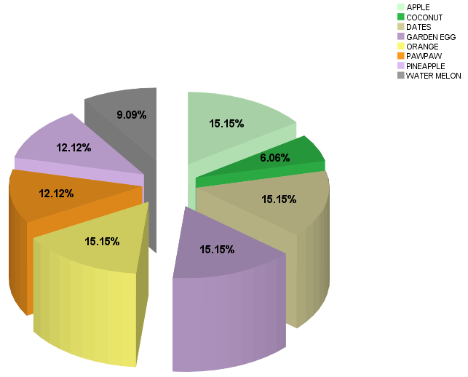

**Figure 1: PREVALENCE OF BACTERIA CONTAMINATION AMONG SAMPLES COLLECTED**

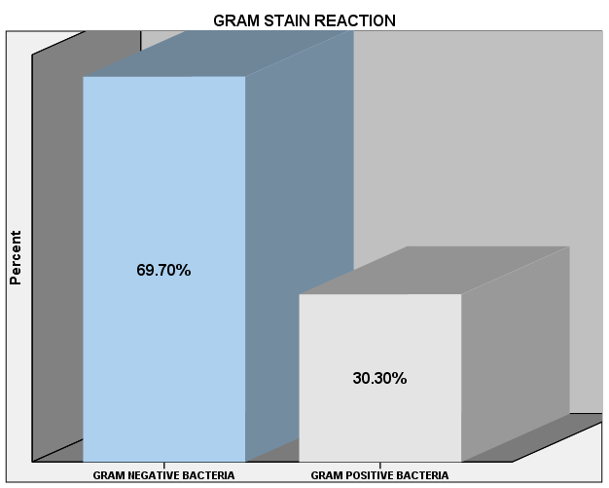

**Figure 2: Bar Chart of Gram Stain Reaction of Organisms Associated with Ready to Eat Fruits**

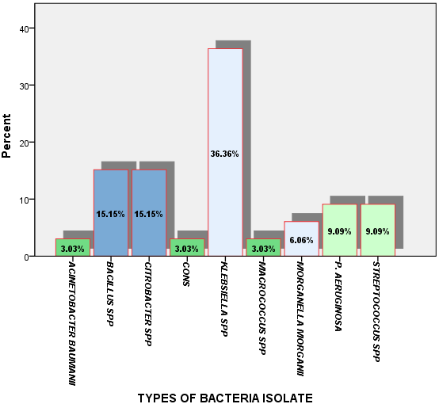

**Figure 3: Types of MDR bacteria present on ready-to-eat fruits**

**TABLE 2: LEVEL OF RESISTIVITY AND SUSCEPTIBILITY OF THE ISOLATED ORGANISMS TO THE ELEVEN SELECTED ANTIBIOTICS**

|  |  |  |  |  |  |  |  |  |  |  |  |
| --- | --- | --- | --- | --- | --- | --- | --- | --- | --- | --- | --- |
| ORGANISM | GEN | CTR | ERY | CXC | OFL | AUG | CAZ | CRX | CPR | NIT | CXM |
| *Acinetobacter baumanii* | R | R | R | R | S | R | S | R | S | R | R |
| *CONS* | S | R | R | R | S | R | R | R | S | I | R |
| *Macrococcus spp* | R | R | R | R | S | R | R | R | S | R | R |
| *Morganella morganii* | R | R | R | R | S | R | I | R | I | S | R |
| *Bacillus spp* | R | R | R | R | S | S | R | R | I | R | R |
| *Citrobacter spp* | R | R | S | R | R | R | R | R | I | R | S |
| *Klebseilla spp* | R | I | R | I | S | R | R | R | S | S | R |
| *Pseudomonas aerigunosa* | S | R | R | R | R | R | R | R | S | S | S |
| *Strepthococcus spp* | R | R | R | R | R | R | R | R | S | R | R |

KEY; R= RESISTANCE I= INTERMEDIATE S= SENSITIVE

GEN= GENTAMYCIN CTR= CEFTRIAZONE ERY= ERYTHROMYCIN

CXC= COXACILLIN OFL= OFLOXACIN AUG= AUGMENTIN

CAZ= CEFTAXIDIME CRX= CEFUROXIME CPR= CIPROFLOXACIN

NIT= NITROFRANTOIN CXM= CEFIXIME

**Table 3: Percentage of resistivity and susceptibility of the isolated organisms to the eleven selected antibiotics**

|  |  |  |  |
| --- | --- | --- | --- |
| **Isolated Organism** | Number of resistance drugs | Number of intermediate resistance drugs | Number of susceptible drugs |
| *Acinetobacter baumanii* | 8 | 0 | 3 |
| *CONS* | 7 | 1 | 3 |
| *Macrococcus spp* | 9 | 0 | 2 |
| *Morganella morganii* | 7 | 2 | 2 |
| *Bacillus spp* | 8 | 1 | 2 |
| *Citrobacter spp* | 8 | 1 | 2 |
| *Klebseilla spp* | 6 | 2 | 3 |
| *Pseudomonas aerigunosa* | 7 | 0 | 4 |
| *Strepthococcus spp* | 10 | 0 | 1 |
| Total | 70 (70.71%) | 7 (7.07%) | 22 (22.22%) |

**Table 4.: Results of Chi-square Test**

|  |  |  |  |
| --- | --- | --- | --- |
| **Chi-Square Tests** | | | |
|  | Value | Df | Asymp. Sig. (2-sided) |
| Pearson Chi-Square | 27.000a | 24 | .304 |
| Likelihood Ratio | 22.915 | 24 | .525 |
| N of Valid Cases | 9 |  |  |
| a. 36 cells (100.0%) have expected count less than 5.  The minimum expected count is .11. | | | |

**Table 5: sellers hand wash**

|  |  |  |  |  |  |
| --- | --- | --- | --- | --- | --- |
| **How do you typically wash your hands before handling fruits?** | | | | | |
|  | | Frequency | Percent | Valid Percent | Cumulative % |
| Valid | no washing | 2 | 6.7 | 6.7 | 6.7 |
| water only | 23 | 76.7 | 76.7 | 83.3 |
| soap and water | 4 | 13.3 | 13.3 | 96.7 |
| hand sanitizer | 1 | 3.3 | 3.3 | 100.0 |
| Total | 30 | 100.0 | 100.0 |  |

**Table 6: Ways of displaying RTE fruits for sale**

|  |  |  |  |  |  |
| --- | --- | --- | --- | --- | --- |
| **How are the fruits displayed for sale?** | | | | | |
|  | | Frequency | Percent | Valid Percent | Cumulative % |
| Valid | on open shelve | 10 | 33.3 | 33.3 | 33.3 |
| on a flat tray | 8 | 26.7 | 26.7 | 60.0 |
| inside sole glass | 8 | 26.7 | 26.7 | 86.7 |
| Anyhow | 4 | 13.3 | 13.3 | 100.0 |
| Total | 30 | 100.0 | 100.0 |  |

**Table 7: Knowledge on multi drug resistance bacteria and fruits handling.**

|  |  |  |  |  |  |
| --- | --- | --- | --- | --- | --- |
| **Have you received training on MDR bacteria and fruit handling?** | | | | | |
|  | | Frequency | Percent | Valid Percent | Cumulative % |
| Valid | Yes | 8 | 26.7 | 26.7 | 26.7 |
| No | 22 | 73.3 | 73.3 | 100.0 |
| Total | 30 | 100.0 | 100.0 |  |

**Table 8: Use of hand gloves when handling fruit**

|  |  |  |  |  |  |
| --- | --- | --- | --- | --- | --- |
| **Do you use gloves when handling fruit?** | | | | | |
|  | | Frequency | Percent | Valid Percent | Cumulative % |
| Valid | Yes | 8 | 26.7 | 26.7 | 26.7 |
| No | 22 | 73.3 | 73.3 | 100.0 |
| Total | 30 | 100.0 | 100.0 |  |