**Estimation of Shoreline Erosion and accretion extend in Orashi river, Rivers State, Nigeria using Geo-spatial and machine learning**

**Abstract:**

This study assesses shoreline erosion and accretion along the Orashi River in Ahoada West LGA, Rivers State, Nigeria, using geospatial tools. Landsat imagery spanning five decades (1974–2024) was obtained from the United States Geological Survey (USGS) and analyzed with ArcGIS 10.6 and machine learning techniques to identify changes in the river's shoreline. The results show significant erosion over a 30-year period, with a decrease from 9.09 km² in 1974 to 5.05 km² in 2004. A brief period of accretion occurred in 2014 (7.11 km²), before erosion resumed in 2024 (6.07 km²). Projections suggest further erosion, with an expected shoreline area of 5.23 km² by 2034. The study explores the geological processes driving erosion and accretion, highlighting their impact on coastal stability, ecosystems, and local communities. Erosion rates fluctuated, peaking at 82% from 1974 to 1984, followed by stabilization and subsequent increases. Accretion was most prominent from 2004 to 2014, with a 99% deposition rate. Geospatial tools provided valuable understanding into quantifying and visualizing shoreline trends, aiding predictive modeling for sustainable coastal management. The integration of remote sensing and GIS allows for a comprehensive understanding of shoreline dynamics, essential for informed decision-making. Predictive modeling emphasizes the importance of continuous monitoring, offering proactive strategies for climate change adaptation and coastal protection.

**Keywords**: Erosion, accretion, climate change, Machine learning, GIS, Orashi River

1. **INTRODUCTION**

The Orashi River, a critical waterway in Ahoada West Local Government Area (LGA), Rivers State, Nigeria, is increasingly threatened by shoreline erosion. This natural process, which involves the gradual removal of coastal land by water forces such as waves, tidal currents, and river flow, poses significant risks to lives, properties, and essential infrastructure (Environmental Protection Agency [EPA], 2023). While erosion is a dominant concern, accretion the deposition of sediment along the shoreline also occurs in certain areas, creating a dynamic interplay between land loss and gain. These opposing processes have profound environmental and socio-economic implications, altering ecosystems, displacing communities, and disrupting livelihoods. Understanding the mechanisms and impacts of shoreline change is therefore essential for effective coastal management and sustainable development. Shoreline change, defined as the loss or gain of land along the water's edge, serves as a critical indicator of environmental health and vulnerability in coastal regions (Almar et al., 2023). Erosion can lead to the destruction of natural habitats, cultural heritage sites, and critical infrastructure, while accretion may alter ecosystems and disrupt human activities. Early detection and analysis of these changes are vital for identifying ecological threats and implementing mitigation measures (Melet et al., 2014). Long-term monitoring of shoreline dynamics provides invaluable insights into the impacts of climate change, human activities, and natural processes on coastal environments. However, traditional methods of shoreline monitoring often lack the precision, scalability, and efficiency required to address these challenges comprehensively. Advancements in geospatial technologies and machine learning have significantly improved shoreline monitoring, enabling researchers and policymakers to analyze shoreline changes with unprecedented accuracy. Recent studies highlight the potential of integrating Geographic Information Systems (GIS) and machine learning algorithms for detecting, mapping, and predicting shoreline changes (Eteh et al., 2024a). These tools enhance data-driven decision-making, allowing for more effective mitigation and adaptation strategies to combat erosion and other coastal hazards (Khomsin et al., 2021). This research aims to leverage geospatial technologies and machine learning techniques to assess the extent of shoreline erosion and accretion along the Orashi River, particularly in Joinkrama, Nigeria. By employing historical satellite imagery and data-driven modeling approaches, this study seeks to quantify shoreline dynamics and provide actionable insights into the causes and implications of these changes. The findings will contribute to the body of knowledge necessary for developing sustainable strategies to protect vulnerable coastal communities and preserve the natural environment.The effectiveness of geospatial tools in shoreline change analysis has been demonstrated in multiple studies. For instance, Okpobiri et al. (2025) showcased the potential of GIS and machine learning in monitoring sandbars along the River Niger in the Niger Delta, emphasizing the importance of spatial analysis in understanding sedimentation patterns. Similarly, Obiene et al. (2022) utilized satellite imagery and GIS techniques to reconstruct historical shoreline positions and estimate erosion rates. In another study, Oborie et al. (2023) applied remote sensing techniques to assess shoreline changes and identify high-risk erosion zones, further validating the applicability of geospatial methodologies for shoreline change detection. Additionally, recent research by Eteh et al. (2024b) analyzed the impact of dam management and rainfall patterns on flooding in the Niger Delta using Sentinel-1 SAR data, underscoring the intricate relationship between hydrological changes and shoreline dynamics. Another study by Eteh et al. (2024a) explored the integration of machine learning with the Digital Shoreline Analysis System (DSAS) to examine historical shoreline trends and predict future changes along the River Niger. These studies collectively highlight the importance of employing advanced analytical methods to gain deeper insights into coastal processes and inform policy decisions. These studies collectively highlight the transformative potential of geo-spatial and machine learning technologies in addressing coastal environmental challenges. This research builds on these advancements by leveraging Landsat imagery and machine learning techniques to analyze shoreline erosion and accretion along the Orashi River in Ahoada West LGA. The study focuses on identifying patterns of erosion and accretion, quantifying the extent and magnitude of these changes, and exploring their potential causes and implications for the surrounding environment and communities. By integrating geo-spatial tools with machine learning, this research aims to provide a comprehensive understanding of shoreline dynamics in the study area, contributing to the development of robust strategies for coastal management and disaster risk reduction. The significance of this study lies in its potential to inform evidence-based decision-making and sustainable development in Ahoada West LGA. By quantifying the extent of shoreline erosion and accretion, the research will provide critical data for identifying high-risk areas, prioritizing intervention efforts, and designing mitigation measures. Furthermore, the use of advanced technologies such as machine learning and GIS will enhance the accuracy and efficiency of shoreline monitoring, enabling stakeholders to respond more effectively to environmental challenges. Ultimately, this research seeks to safeguard the future of the Ahoada West LGA communities and the surrounding ecosystem, ensuring their resilience in the face of ongoing environmental change. In summary, the Orashi River's shoreline dynamics represent a complex and pressing environmental issue that demands urgent attention. Through the application of geo-spatial tools and machine learning, this study aims to advance our understanding of erosion and accretion processes, providing a foundation for sustainable coastal management in Ahoada West LGA. By building on the findings of previous research and leveraging cutting-edge technologies, this research contributes to the growing body of knowledge on shoreline change and its implications for coastal communities in the Niger Delta and beyond.

**1.1 Study Area**

The study area is situated in Ahoada West Local Government Area, Rivers State, Nigeria, within latitudes 4°58'0"–5°9'11" N and longitudes 6°26'0"–6°32'28" E (Figure 1), encompassing communities such as Joinkrama, Akinima, Mbiama, Akiogbologbo, Okaika Better Land, Igovia, Okparaki, Oruama, Oshie, Ubeta, Ubie, Upatabo, Uyalama along the eastern bank of the Orashi River (Mbajiorgu et al., 2003; Mmom & Aifesehi, 2013). The Orashi River, originating as a waterfall at 183 m above sea level in Ezeama, Dikenafai, Imo State, flows through Imo, Anambra, Rivers, and Bayelsa states, serving as a critical water source for drinking, agriculture, and fishing (Anazoo & Ibe, 2008; Nema, 2004). The region lies within the Niger Delta Basin, a Tertiary-Recent sedimentary belt characterized by flat, low-lying terrain prone to seasonal flooding due to poor drainage and a network of rivers, including the Orashi and Taylor Creek (Eteh & Okechukwu, 2021; Nwankwo & Ekeocha, 2015). The climate is tropical, with annual rainfall of 1,500–4,000 mm supporting mangrove forests, freshwater swamps, and lowland rainforests (UNEP, 2021; Asuk et al., 2018). Soils vary from coarse sands to silts, with greyish hues reflecting alluvial deposition (Nwankwo & Ekeocha, 2015).

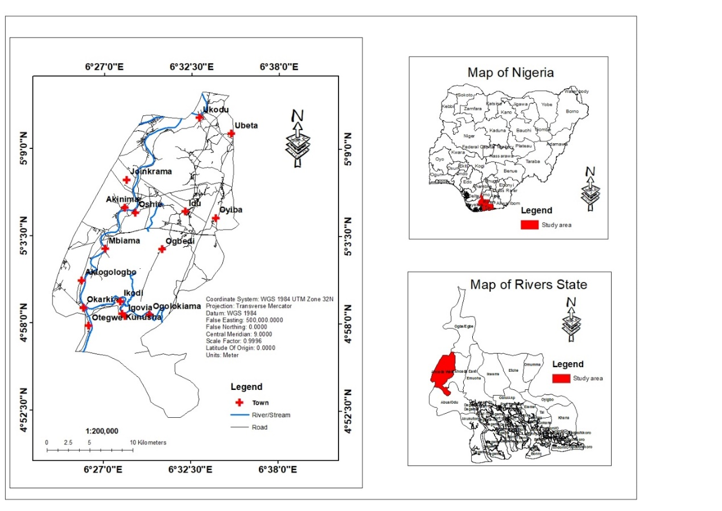

Figure 1: Study area map

* 1. **Geological Setting**

Geologically, the area forms part of the Niger Delta Basin, structured into three lithostratigraphic units: the Akata Formation (Paleocene–Holocene), composed of marine shales and turbidite sands that act as hydrocarbon source rocks; the Agbada Formation (Eocene–Recent), a paralic sequence of sandstones and shales hosting 99% of the delta’s hydrocarbon reservoirs; and the Benin Formation (Miocene–Recent), comprising coarse sands and gravels that form the primary aquifer for groundwater (Reyment, 1965; Short & Stauble, 1967; Reijers, 2011). The shallow Holocene aquifer (60–90 m depth) within the Benin Formation is recharged by seasonal rainfall, though dry-season shortages impact communities reliant on wells (Offodile, 1992; Abam & Nwankwoala, 2020). The region’s hydrocarbon resources, exploited by companies like Shell and Agip, drive economic activity but exacerbate environmental challenges, including pollution and ecosystem disruption, compounded by the delta’s low elevation and complex hydrology (Oborie & Eteh, 2023; Edet, 1993).

1. **MATERIALS AND METHODS**

**Data Collection**   
Data collection for this study involved a combination of field surveys and satellite imagery acquisition. Field surveys were conducted in March 2024 along a 50 km stretch of the Orashi River, utilizing a Garmin 64s GPS unit to record georeferenced shoreline waypoints with a positional accuracy of ≤3 m (Garmin, 2023). A Canon EOS 7D digital camera captured high-resolution (18 MP) photographs of riverbank features, including sediment types, vegetation cover, and anthropogenic activities, which were later geotagged and cross-referenced with satellite data for validation. Field notes provided supplementary observational records. Satellite imagery spanning five decades (1974–2024) was sourced from the United States Geological Survey (USGS) Earth Explorer platform, comprising multispectral Landsat scenes (Path/Row 189/56 and 189/55) with a spatial resolution of 30 m. These included Level-1 Terrain Precision (L1TP) products from Landsat 1, 4, 5, 7, and 8, selected for their cloud-free coverage (<10%) during the dry season (December–February) to minimize atmospheric distortions (USGS, 2023; Jensen, 2015). Key spectral bands—Visible (Blue, Green, Red) and Near-Infrared (NIR)—were prioritized due to their sensitivity to water-land boundaries (Doxani et al., 2020).

* 1. **Data Preprocessing**

The preprocessing phase focused on refining raw satellite data to enhance accuracy and usability. Atmospheric correction was applied using the FLAASH algorithm in ArcGIS 10.8 to mitigate scattering effects caused by aerosols and water vapor, ensuring consistent radiometric calibration across scenes (Chavez, 1996). Adjacent Landsat scenes were mosaicked using histogram matching to maintain tonal uniformity across the study area. Georeferencing aligned all imagery to the WGS 1984 UTM Zone 32N coordinate system, leveraging 20 ground control points (GCPs) collected during field surveys to achieve a geometric RMSE of <0.5 pixels (15 m) (Mishra & Coulibaly, 2022). Band composites were generated by combining Blue (Band 2), Green (Band 3), Red (Band 4), and NIR (Band 5) spectral channels to create false-color images that accentuated the contrast between water bodies and terrestrial features (Jensen, 2015). Field-collected GPS waypoints and photographs were spatially aligned with preprocessed satellite data using protocols outlined by Congalton & Green (2019), ensuring positional accuracy for subsequent analyses.

* 1. **Data Processing**

Data processing encompassed shoreline extraction, change detection, and predictive modeling. Unsupervised classification using the ISO Cluster algorithm (10 classes) in ArcGIS Pro segmented preprocessed images into distinct land cover categories, including water, vegetation, and bare soil (Richards & Jia, 2006). Classified water bodies were converted to vector polygons, smoothed with a 3x3 majority filter to reduce pixelation, and isolated using SQL queries based on NIR reflectance thresholds (NIR < 0.2 for water). Manual corrections addressed misclassifications caused by shadows or floating vegetation (Lu & Weng, 2020; Doxani et al., 2020).

Change detection analysis involved overlaying sequential shorelines (1974–2024) in ArcGIS. Erosion and accretion extents were quantified using the formulas:

Erosion = Previous year's area – Intersect Eq 1.

Accretion = Area of next year- Intersect Eq 2.

Paired t-tests assessed significant differences in annual erosion/accretion rates (p < 0.05).

* 1. **Machine Learning Forecasting**

A univariate linear regression model predicted future shoreline positions using historical data (1974–2024):

y = β₀ + β₁x + ε Eq 3.

where y = cumulative area change, x = time (years), β0​ = intercept, β1= slope, and ϵ = error term (OpenStax. 2023). Assumptions of linearity, normality, and homoscedasticity were verified using residual plots and Shapiro-Wilk tests. Data were split into training (1974–2014) and testing (2014–2024) sets, achieving an R² of 0.87. Confidence intervals (95%) were computed to quantify prediction uncertainty (Freedman et al., 2020).

* 1. **Uncertainty Mitigation**

Uncertainties were mitigated through rigorous geometric and classification accuracy assessments. Co-registration errors were minimized to RMSE < 0.5 pixels, and confusion matrices derived from 30% stratified random samples yielded an Overall Accuracy of 89% and Kappa coefficient of 0.82, exceeding the 85% threshold for reliable land cover mapping (Congalton & Green, 2019; Foody, 2020).

* 1. **Limitations and Future Work**
* **Spatial Resolution**: Landsat’s 30-m resolution limited detection of small-scale changes; future studies could integrate high-resolution imagery (e.g., Sentinel-2).
* **Temporal Gaps**: Missing data in 1989–1994 due to cloud cover were interpolated, potentially introducing bias.
* **Model Complexity**: Linear regression assumes monotonic trends; machine learning models (e.g., Random Forest) could capture nonlinear dynamics (Maxwell et al., 2018).

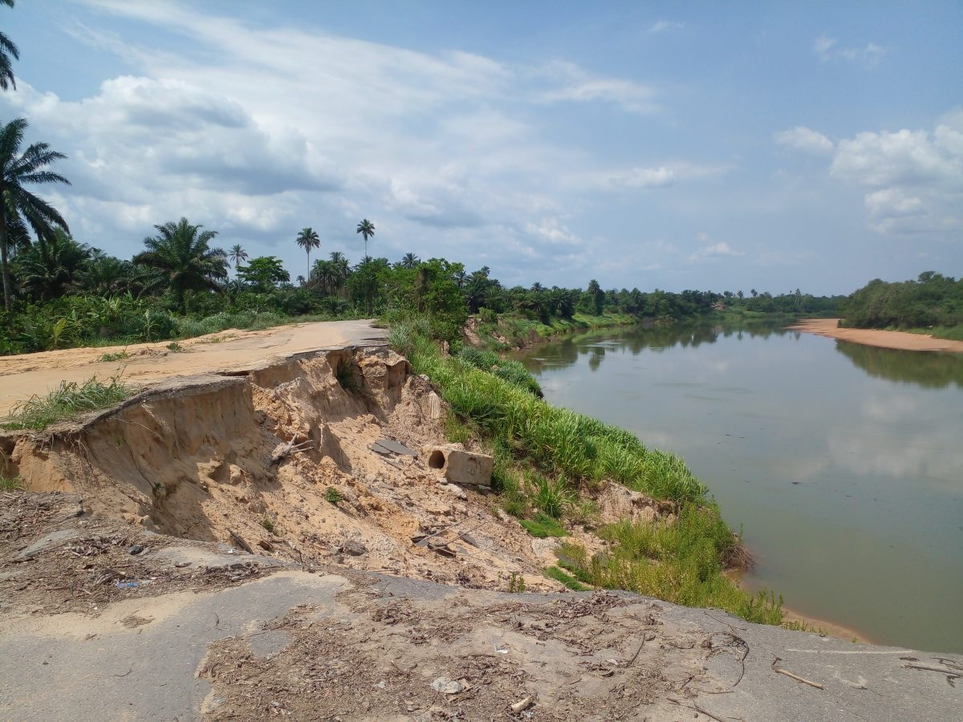

Plate 1: Erosion along Joinkrama 2 road in Ahoada West LGA, Rivers State, Nigeria

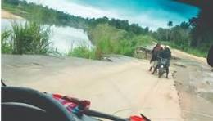

Plate 2: Erosion along Akinima road in Ahoada West LGA, Rivers State, Nigeria

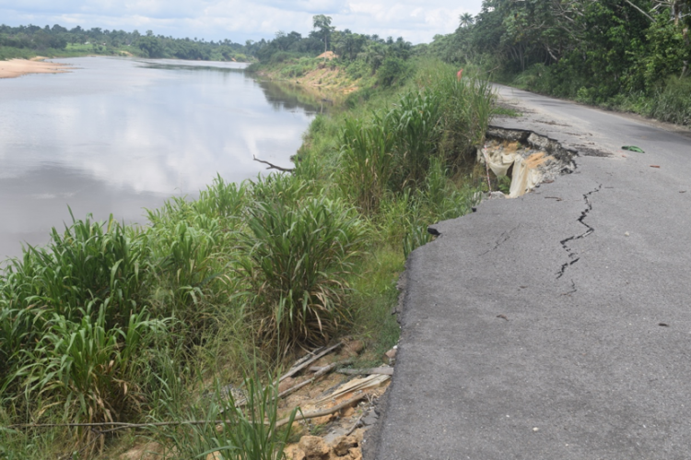

Plate 3: Erosion along Joinkrama 3 road in Ahoada West LGA, Rivers state, Nigeria

1. **RESULTS AND DISCUSSION**
   1. **Shoreline Dynamics Over Time**

Table 1 presents an in-depth summary of the river area in square kilometers throughout multiple decades, spanning 1974 to 2024. The data illustrates the progressive changes in the Orashi River’s extent. A significant decline in river area from 9.09 km² in 1974 to 5.05 km² in 2004 highlights a substantial erosional phase (Table 1 and Figure 2). This loss of approximately 4.04 km² over three decades underscores the vulnerability of the shoreline to erosional processes during this timeframe such as in plate 1 to 3.

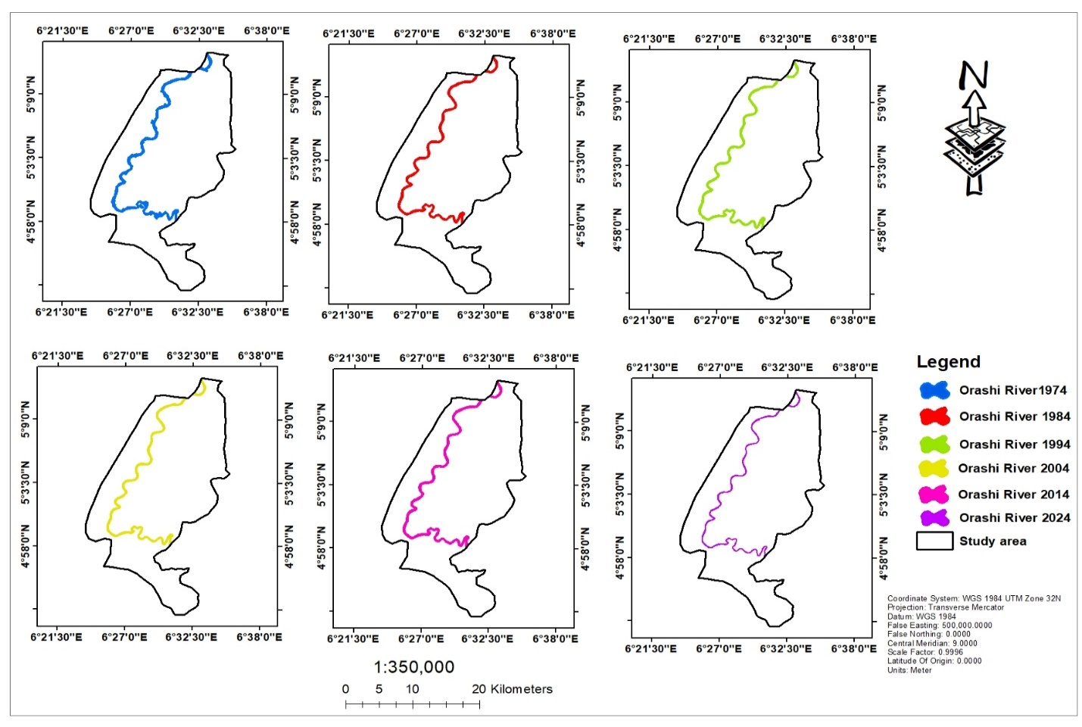Figure 2: Map showing shoreline changes in Orashi River from 1974 to 2024

The persistent decline in river area during these years suggests that external factors, such as changes in hydrodynamics, sediment transport dynamics, and increasing human activities, have contributed to the observed pattern. Natural processes like rainfall variability, climate change, and upstream modifications in river discharge could have intensified sediment loss, thereby exacerbating erosion rates. The combination of these natural and anthropogenic influences has reshaped the shoreline, necessitating a deeper investigation into causal factors and mitigation strategies.

In contrast, a notable accretion phase was observed in 2014 when the river area increased to 7.11 km², suggesting a temporary reversal of erosion. This increase is likely due to sediment deposition, shifts in hydrodynamics, or anthropogenic influences such as dam construction or dredging activities. However, this trend did not persist, as the river area declined again to 6.07 km² by 2024, reaffirming the dominance of erosional forces (Figures 2 and 3). These findings indicate that while accretional phases occur intermittently, the overall trend points to progressive shoreline retreat. The sporadic nature of accretion suggests that sediment availability fluctuates due to seasonal variations, extreme weather events, and hydrological modifications.

Table 1: Shorelines area in Orashi River from the Landsat imageries (1974-2024)

|  |  |
| --- | --- |
| **Year** | **The River area (km2)** |
| 1974 | 9.09 |
| 1984 | 6.31 |
| 1994 | 5.82 |
| 2004 | 5.05 |
| 2014 | 7.11 |
| 2024 | 6.07 |
| 2034 Predicted* | 5.23 |

Table 2:Estimating area for erosion and accretion in the study area (1974 to 2024)

|  |  |  |  |  |  |  |  |
| --- | --- | --- | --- | --- | --- | --- | --- |
| **Year** | **Previous Year (km²)** | **Next Year (km²)** | **Intersect (km²)** | **Erosion (km²)** | **Accretion (km²)** | **Erosion (%)** | **Accretion (%)** |
| 1974-1984 | 9.09 | 6.31 | 5.98 | 3.11 | 0.68 | 82 | 18 |
| 1984-1994 | 6.31 | 5.82 | 5.63 | 0.68 | 0.19 | 78 | 22 |
| 1994-2004 | 5.82 | 5.05 | 4.93 | 0.89 | 0.12 | 90 | 10 |
| 2004-2014 | 5.05 | 7.11 | 5.02 | 0.03 | 2.09 | 1 | 99 |
| 2014-2024 | 7.11 | 6.07 | 5.95 | 1.16 | 0.12 | 9 | 9 |
| 2024-2034 Predicted* | 6.07 | 5.23 | 5.19 | 0.88 | 0.04 | 96 | 4 |

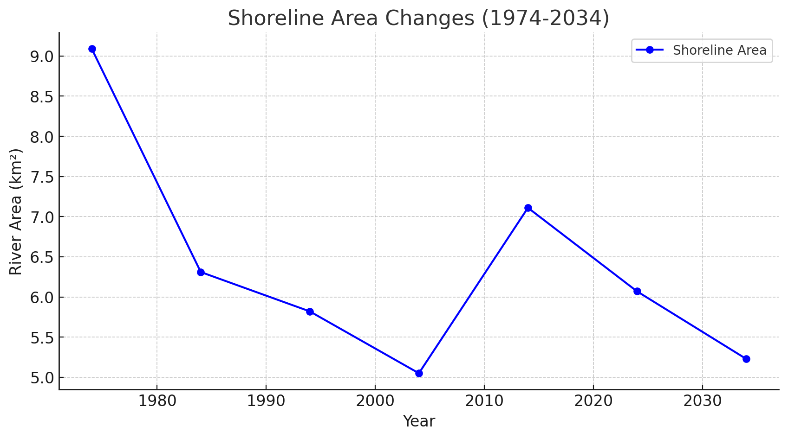

Figure 3: Area Against Year in Orashi River from 1974 to 2024 and Prediction of 2034

Geospatial modeling was employed to predict future shoreline alterations based on historical trends and environmental parameters. By 2034, it is anticipated that the river area will decrease further to 5.23 km² (Table 1, Figure 3). This projection aligns with the observed long-term erosion trends and factors such as climate change, human interventions, and sediment transport dynamics. These insights are crucial for coastal planning and intervention strategies. Predictive modeling techniques, including Convolutional Neural Networks (CNNs), provided insights into the rate of future shoreline change. The models accounted for variables such as precipitation patterns, upstream sediment load, deforestation impacts, and land-use changes. The anticipated reduction in river area highlights the necessity of proactive interventions to minimize further degradation. Such interventions may include improved watershed management practices, afforestation programs, and engineered structures such as revetments and groynes to mitigate erosion.

* 1. **Spatial and Temporal Patterns of Erosion and Accretion**

Figures 4 provide spatial and graphical representations of shoreline dynamics from 1974 to 2024, illustrating the temporal fluctuations between erosion and accretion phases. The visualization of shoreline movement over five distinct time intervals allow for a clear understanding of erosional hotspots and areas of sediment accumulation. Additionally, Figure 2 supplements these insights by illustrating the correlation between river area and time, further emphasizing the variability in shoreline stability. The spatial representation of erosion-prone zones highlights areas that require urgent intervention. Mapping tools provided by GIS enabled the classification of erosion risk levels, allowing stakeholders to prioritize regions vulnerable to severe land loss. Through comparative analysis, the most critical erosion-prone sections of the river were identified, highlighting the necessity of targeted interventions in high-risk locations. These spatial insights are essential for local authorities and policymakers in planning effective shoreline management strategies.

* 1. **Quantification of Erosion and Accretion**

Shoreline erosion and accretion processes in the Orashi River are influenced by sediment transport, wave action, tidal dynamics, and human interventions such as land use changes and infrastructure development. Analyzing the data in Table 2 and Figures 4 provides a comprehensive view of these dynamics.

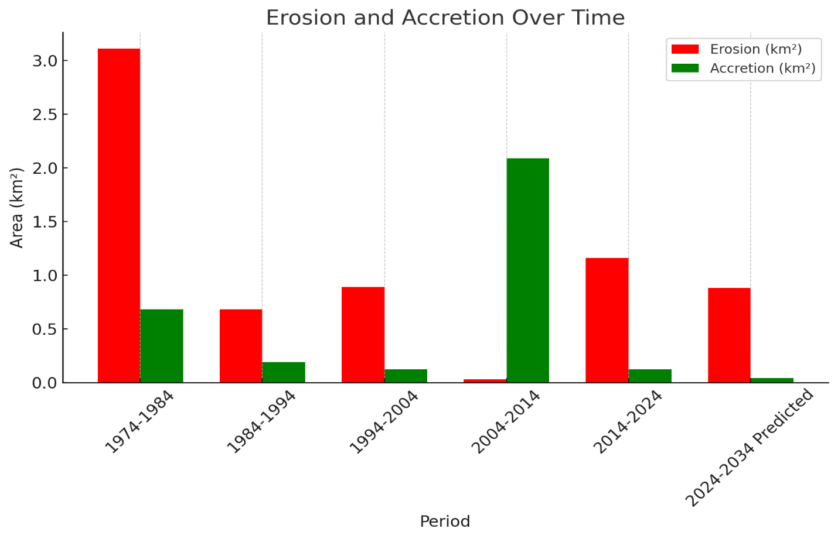

Figure 4: bar chart on erosion and accretion from (1974 to 2024)

* 1. **Erosion Trends**

Erosion rates varied significantly over the five decades. From 1974 to 1984 (Table 2), erosion accounted for 82% of shoreline changes, indicating a period of intense coastal retreat due to natural and anthropogenic factors. The increased riverbank failure and sediment loss during this period may have resulted from intensified river discharge, seasonal flooding, and deforestation along the riverbanks. The excessive removal of vegetation weakens soil stability, making it more susceptible to erosive forces (Figures 5-11). Between 1984 and 1994, erosion rates slightly declined to 78%, suggesting some stabilization, though significant shoreline loss continued. The interplay between sediment supply and hydrodynamic forces plays a vital role in this stabilization. Despite the minor reduction in erosion rate, coastal land loss remained a critical issue, emphasizing the ongoing vulnerability of the riverbanks to degradation.

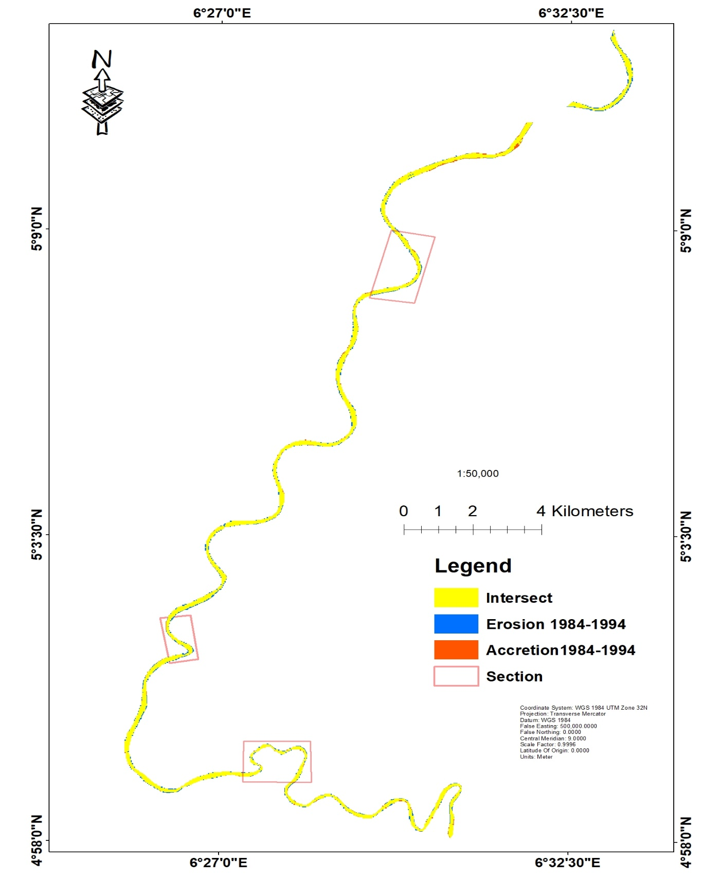

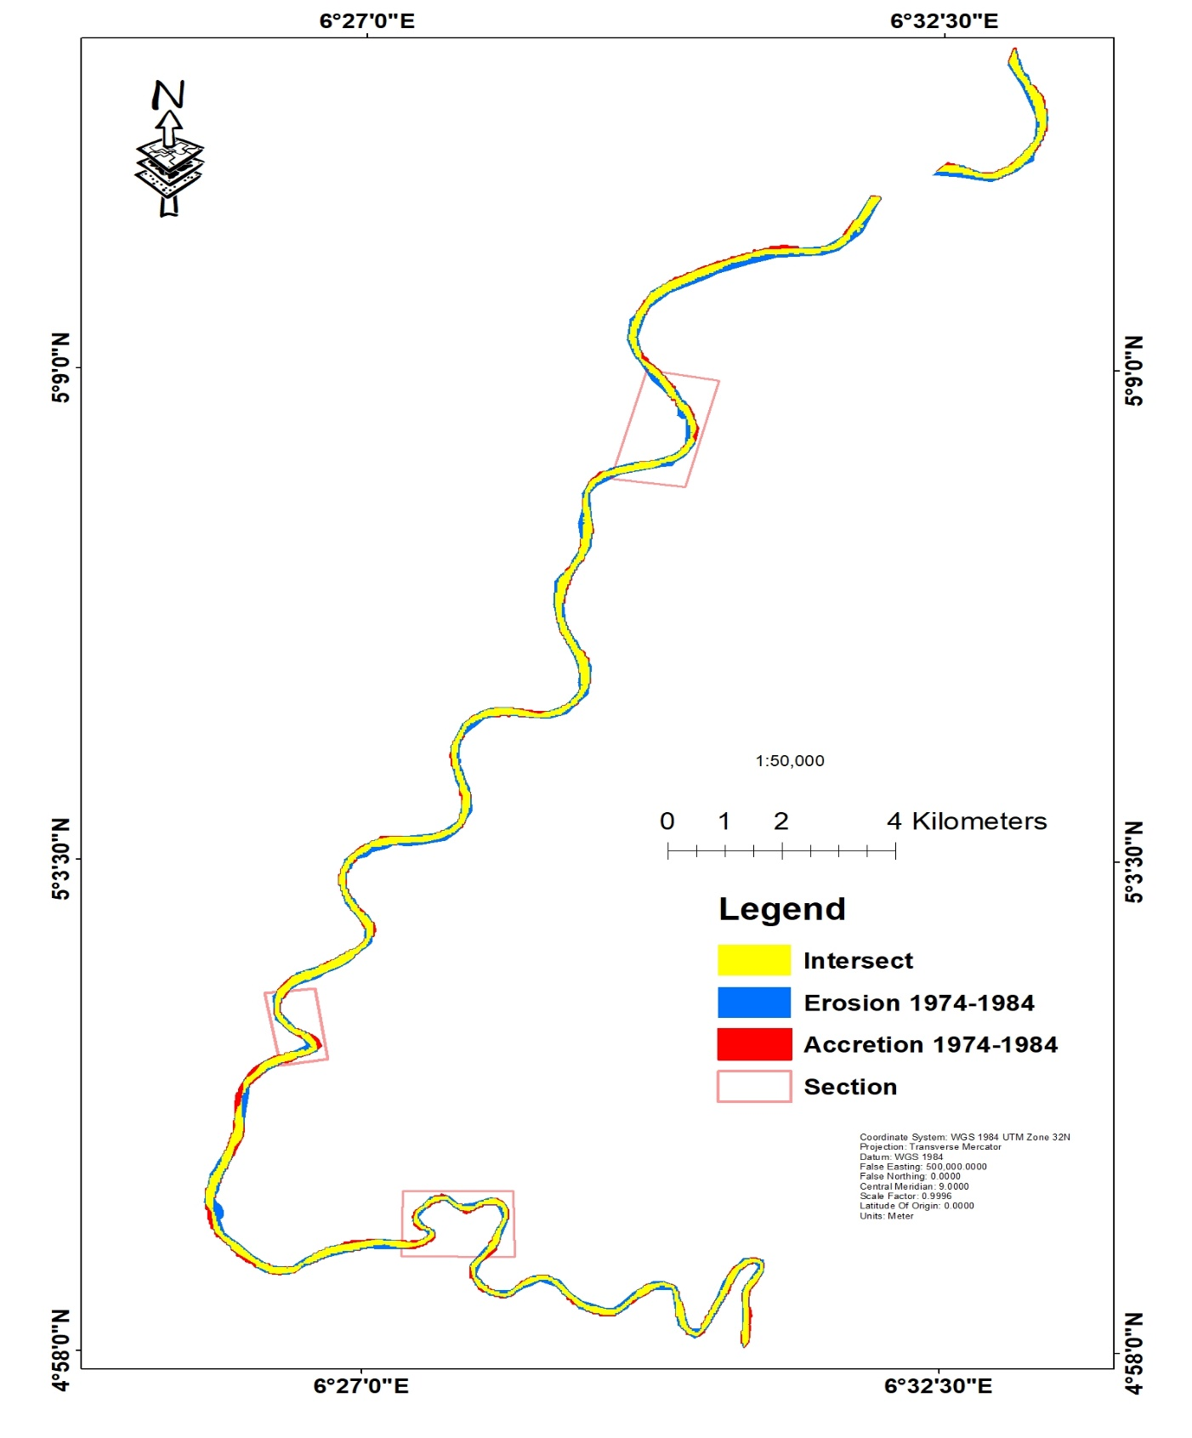

Figure 5: Map of erosion and accretion area in Orashi River from 1974-1984.

Figure 6: Map of erosion and accretion area in Orashi River from 1984-1994

From 1994 to 2004, erosion intensified again, contributing to 90% of shoreline changes, likely due to increased river discharge, sediment transport modifications, and human activities such as deforestation and construction (Table 2). The loss of sediment from the upstream areas and intensified urbanization near the river may have exacerbated this high erosion rate. Furthermore, the impact of climate change-induced flooding during this period cannot be ignored, as extreme weather events accelerate sediment displacement. A notable shift occurred between 2004 and 2014 when erosion rates dropped dramatically to 1%, while accretion dominated at 99%. This suggests a significant sediment deposition event, possibly due to hydrodynamic changes, altered river flow, or artificial interventions like embankment construction. However, erosion rates rose again from 2014 to 2024, accounting for 9% of shoreline changes, indicating a return to a more balanced erosion-accretion interplay.

* 1. **Accretion Trends**

Accretion patterns displayed significant temporal variations. Initially, between 1974 and 1984, accretion contributed to only 18% of shoreline changes, indicating a sediment deficit. By 1984 to 1994, accretion increased slightly to 22%, likely due to enhanced sediment deposition from upstream sources. However, the most pronounced accretion phase occurred between 2004 and 2014, where 99% of changes were attributed to sediment accumulation (Table 2). This period of rapid accretion could be linked to altered river discharge, anthropogenic modifications, or natural geomorphic shifts.

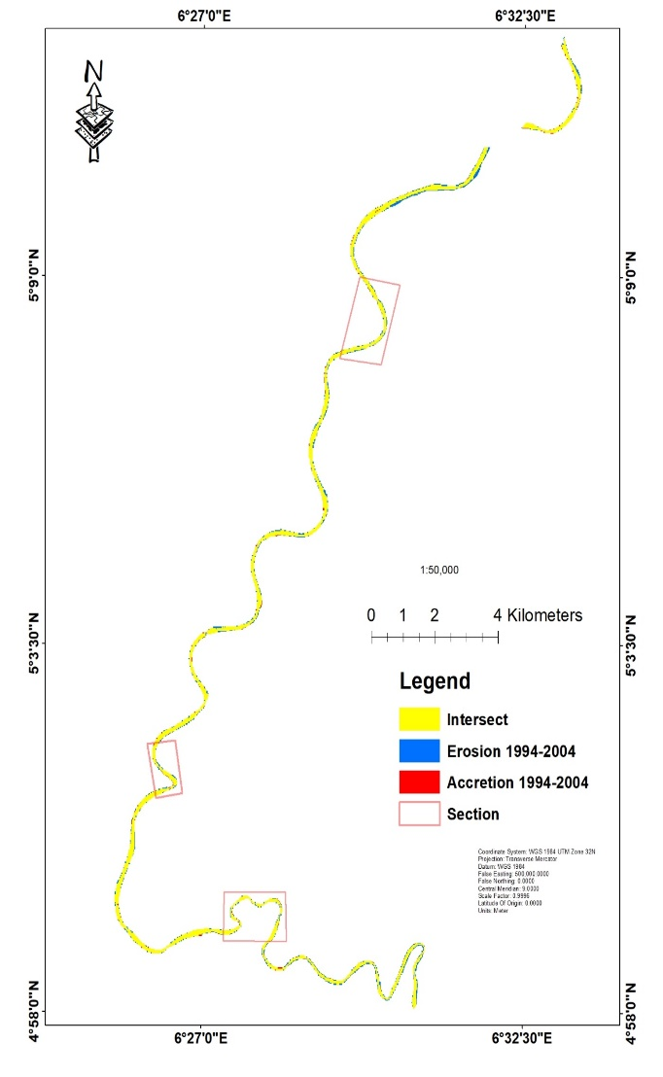

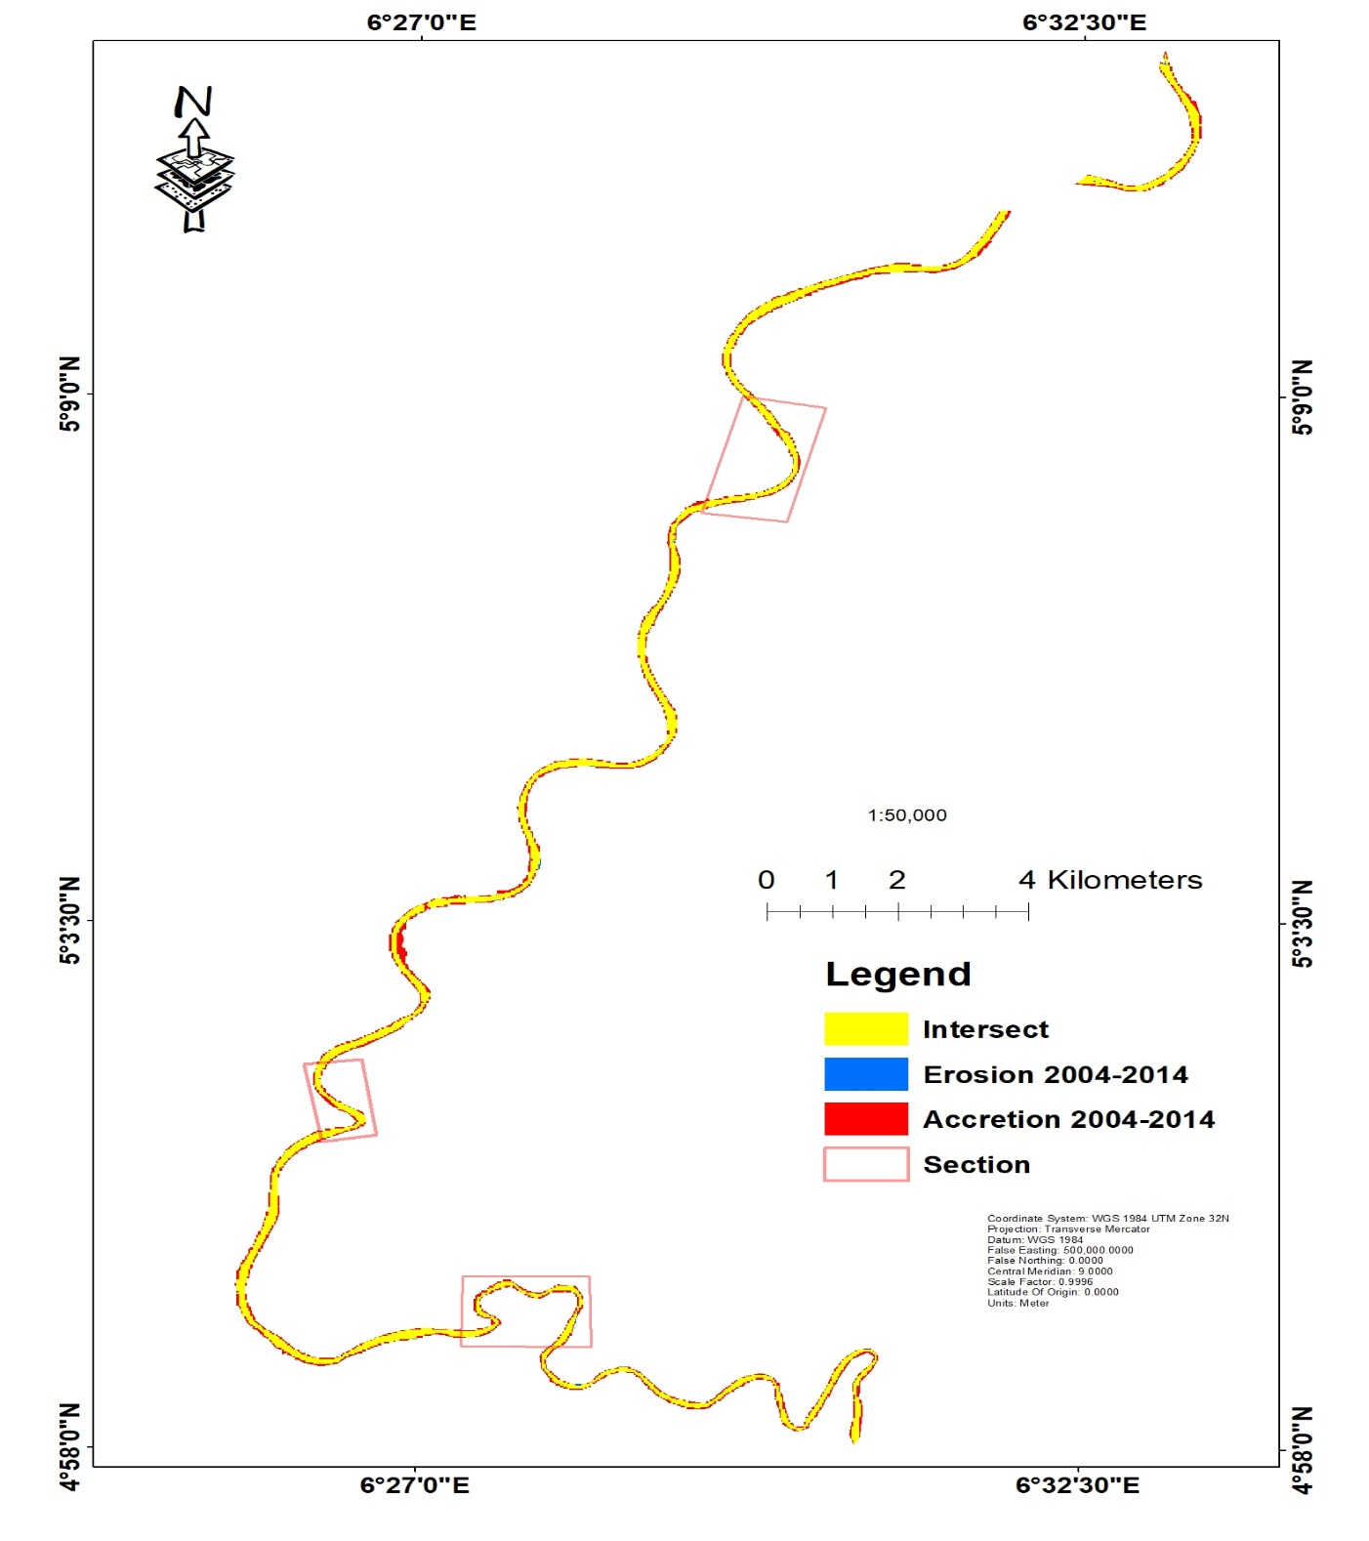

Figure 7: Map of erosion and accretion area in Orashi River from 1994-2004.

Figure 8: Map of erosion and accretion area in Orashi River from 2004-2014.

From 2014 to 2024, accretion rates declined slightly to 9%, suggesting reduced sediment deposition compared to the previous decade, but still playing a critical role in shaping the shoreline. The continuous but slower accumulation of sediment suggests that the forces influencing shoreline stability remain dynamic, necessitating ongoing monitoring.

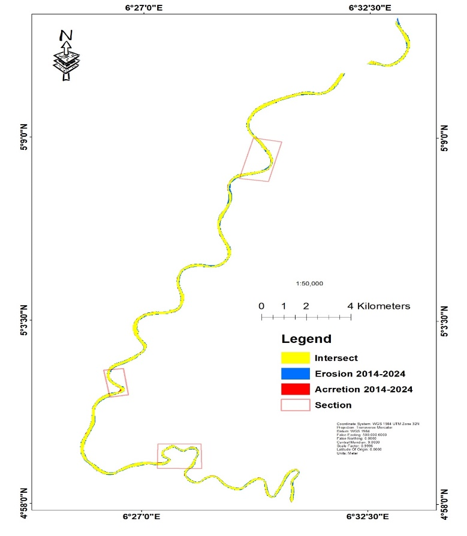

Figure 9: Map of erosion and accretion area in Orashi River from 2014-2024.

The integration of geospatial tools and machine learning models provided precise quantification and visualization of shoreline changes. Figures 10a to 10c illustrate the spatiotemporal distribution of erosion and accretion zones, assisting in the identification of high-risk areas. By utilizing remote sensing, GIS, and predictive modeling techniques, these analyses offer valuable insights for shoreline management and policy-making.

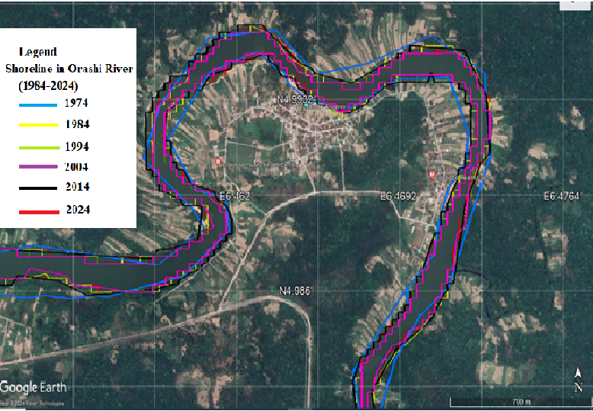

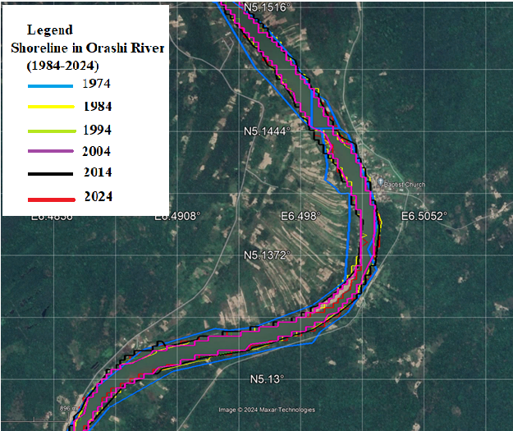

Figure 10a: Google Earth map section of shoreline changes in Orashi River from 1974-2024

Figure 10b: Google Earth map section of shoreline changes in Orashi River from 1974-2024

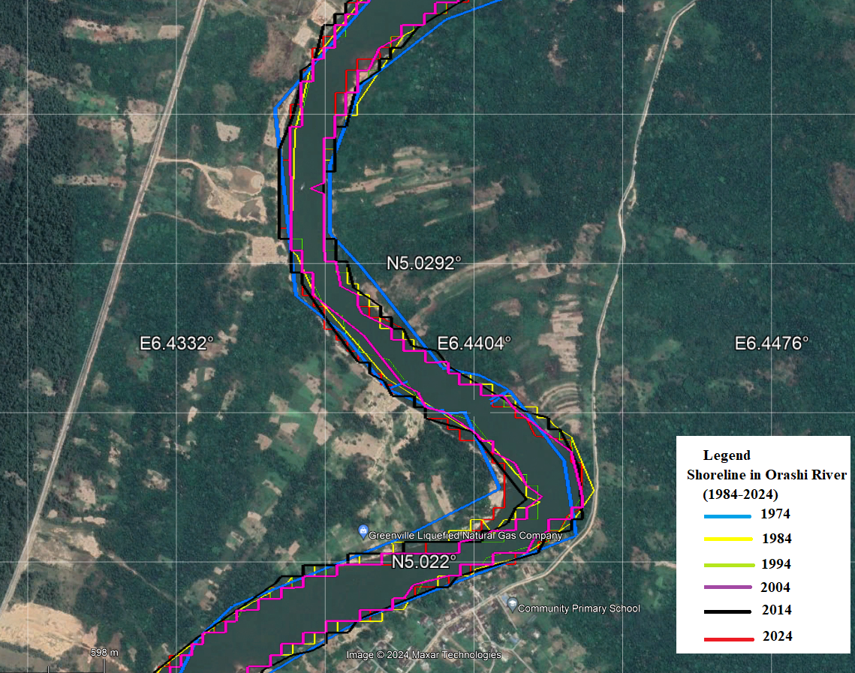

Figure 10c: Google Earth map section of shoreline changes in Orashi River from 1974-2024

These models effectively analyzed multi-temporal satellite imagery and extracted patterns to forecast future trends. The ability to automate classification through machine learning enhances efficiency in large-scale shoreline monitoring.

* 1. **T-test**

The paired t-test results for annual erosion and accretion rates along the shoreline of the Orashi River in Rivers State, Nigeria, reveal nuanced dynamics in sediment redistribution over the 50-year study period (1974–2024) in Table 3, analyzed through geospatial and machine learning techniques. Despite observable fluctuations in erosion and accretion magnitudes across decades, the statistical analysis demonstrates **no significant difference** between mean annual erosion (dˉ=0.534 km2) and accretion rates at the 95% confidence level (t=0.733, p>0.05, df=4, critical t=±2.776). This suggests that, while localized changes are evident (e.g., erosion dominated early periods like 1974–1984 at 3.11 km², while accretion spiked to 2.09 km² during 2004–2014), the net balance between sediment loss and gain does not exhibit a statistically consistent directional trend over time. The high variability in differences (standard deviation sd=1.63 km2sd​=1.63km2) underscores the dynamic and episodic nature of shoreline processes in this fluvial system, likely influenced by seasonal flooding, anthropogenic activities, or sediment supply fluctuations.

Table 3: Comparing paired erosion and accretion values for each time interval

|  |  |  |  |
| --- | --- | --- | --- |
| **Period** | **Erosion (km²)** | **Accretion (km²)** | **Difference (Erosion – Accretion)** |
| 1974–1984 | 3.11 | 0.68 | 2.43 |
| 1984–1994 | 0.68 | 0.19 | 0.49 |
| 1994–2004 | 0.89 | 0.12 | 0.77 |
| 2004–2014 | 0.03 | 2.09 | -2.06 |
| 2014–2024 | 1.16 | 0.12 | 1.04 |

The outlier in 2004–2014, where accretion surged to 99% (2.09 km²) against minimal erosion (0.03 km²), disproportionately influenced the dataset, reflecting possible human interventions (e.g., dredging) or natural sediment deposition events. However, the small sample size (n=5) limits the statistical power to detect subtle trends, a common challenge in long-term geospatial studies. Machine learning models, trained in satellite-derived shoreline data, would need to account for this variability to improve predictive accuracy. The results align with the percentages reported in Table 2, where erosion dominated three periods (82%, 78%, and 90%) but reversed sharply in 2004–2014. This inconsistency highlights the importance of integrating geospatial analysis with hydrodynamic and anthropogenic drivers to contextualize erosion-accretion patterns.

* 1. **Implications for Coastal Management**

The findings emphasize the need for proactive shoreline management strategies. The identification of persistent erosion zones necessitates intervention measures such as shoreline reinforcement, sediment replenishment, and controlled development policies. Additionally, predictive modeling aids in forecasting future trends, allowing policymakers to implement mitigation strategies to curb further shoreline degradation

### CONCLUSION

The study of shoreline dynamics in the Orashi River, Rivers State, Nigeria, from 1974 to 2024 revealed significant fluctuations between erosion and accretion phases. The period from 1974 to 2004 showed a dominant erosional trend, with the river area declining from 9.09 km² in 1974 to 5.05 km² in 2004, representing a loss of approximately 4.04 km² (44.4%) over three decades. Between 1974 and 1984, erosion contributed to 82% of shoreline changes, and between 1994 and 2004, erosion accounted for 90%. A temporary reversal occurred from 2004 to 2014, where the river area increased to 7.11 km², showing 99% of the changes were due to accretion (2.09 km²), likely driven by hydrodynamic changes or human interventions. However, the river area slightly declined again to 6.07 km² in 2024, reaffirming the continued dominance of erosional forces. Geospatial modeling forecasts further reduction of the river area to 5.23 km² by 2034, with erosion again expected to dominate, accounting for 96% of the shoreline changes between 2024 and 2034. The paired t-test results also revealed no significant difference between erosion and accretion rates at the 95% confidence level (t=0.733, p>0.05), indicating that while localized changes were observed (e.g., 99% accretion from 2004 to 2014), the overall trend of shoreline degradation remains unpredictable but still leaning towards erosion. The high variability (standard deviation = 1.63 km²) underscores the dynamic nature of shoreline processes influenced by seasonal flooding, anthropogenic activities, and sediment fluctuations.

### Recommendations

### Given the 44.4% loss of river area from 1974 to 2004 and projected reductions by 2034, immediate interventions such as revetments and groynes are essential to prevent further erosion.

### Programs aimed at stabilizing soil and reducing sediment loss should be implemented, especially along erosion-prone sections, to mitigate deforestation impacts and enhance riverbank stability.

### Integrating geospatial technologies and machine learning for real-time monitoring can help track dynamic shoreline changes and improve early warning systems for potential threats.

### Future shoreline management should consider climate projections to ensure resilience against changing hydrological conditions and extreme weather events.

1. **REFERENCES**

Asuk S.A, Offiong E.E, Ifebueme N.M, (2018). Species composition and diversity of mangrove swamp forest in southern Nigeria. Int J Avian & Wildlife Biol. 2018;3(2):159-164. DOI: 10.15406/ijawb.2018.03.00078

Edet, A. E. (1993). Groundwater Quality Assessment in parts of Eastern Niger Delta, Nigeria. Environmental Geology, Springer-Verlag, 22, 41-46.

Etu-Efeotor, J. O. (1981). Preliminary hydrogeochemical investigations of surface water in part of the Niger Delta. Bulletin of the Nigeria Mining GeoScience Association, 18, 103-110.

Etu–Efeotor, J. O. (1997). Fundamentals of petroleum geology. Paragraphic Publications, Port Harcourt, Nigeria.

Nwankwo, I., and Ekeocha, N. (2015). Evaluation of Deviation of Some Soil Contamination Indicators Due to Oil Spillage in Joinkrama, Rivers State. Scientific Research Journal scirj, Volume III, 19–24.

Abam, T. K. S. and Nwankwoala, H. O. (2020) Hydrogeology of Eastern Niger Delta: A Review. Journal of Water Resource and Protection, 12, 741-777.

Offodile, M. E. (1992). An Approach to Groundwater Study and Development in Nigeria. Mecon Services Ltd; Jos.

Reijers, T. J. A. (2011). Stratigraphy and Sedimentology of the Niger Delta. Geologic, The Netherlands, 17(3), 133–162.

Reyment, R. A. (1965). Aspects of the Geology of Nigeria—The Stratigraphy of the Cretaceous and Cenozoic Deposits. Ibadan University Press.

Short, K. C., and Stauble, A. J. (1967). Outline of the geology of the Niger Delta. Bull. AAPG, 51, 761-779.

Udom, G. J., Esu, E. O., and Ekwere, S. J. (1998). Quality status of groundwater in Calabar Municipality, Southeastern Nigeria. Global Journal of Pure and Applied Sciences, 4(2), 163-169.

Udom, G. J., Etu-Efeotor, J. O., and Esu, E. O. (1999). Hydrochemical evaluation of groundwater in parts of Port Harcourt and Tai-Eleme Local Government Areas, Rivers State. Global Journal of Pure and Applied Sciences, 5(5), 545-552.

United State Geological Survey. (2023). https://www.usgs.gov/.

United Nations Environment Programme (UNEP). (2011). Environmental Assessment of Ogoni land, Nigeria.

Nema Obih (2004). "My Father's Village – Excerpts from a Memoir in Progress (New York)"  (PDF).  [www.oralhistory-productions.org](http://www.oralhistory-productions.org).

Afolabi, Matthew, and Stephen Darby (2022) "Spatial and Temporal Variations in Shoreline Changes of the Niger Delta during 1986–2019" Coasts 2, no. 3: 203-220. <https://doi.org/10.3390/coasts2030010>

Obiene, E. A., Eteh, D. R., & Michael, I. I. (2022). Analysis of Shoreline Changes in Ikoli River in Niger Delta Region Yenagoa, Bayelsa State Using Digital Shoreline Analysis System (DSAS). Journal of Marine Science.

Eteh D. & Okpobiri, O. (2021). Floodplain Mapping and Risks Assessment of the Orashi River Using Remote Sensing and GIS in the Niger Delta Region, Nigeria. Journal of Geographical Research. 4. 10-16. 10.30564/jgr.v4i2.3014.

Eteh, D. R. , Lolade, A. A. ., Nicholas, D. O. ., Opukumo, A. W. ., & Omonefe, F. (2022). The Environmental Impact of Shoreline Changes and Land Use/Land Cover Change Detection in the Niger Delta Region using Geospatial Technology. Journal of Asian Scientific Research, 12(4), 237–248. <https://doi.org/10.55493/5003.v12i4.4650>

Ekong, F. (2017) GIS Based Analysis of Shoreline Change in Ibeno, Akwa Ibom State, Nigeria. Journal of Environmental Protection, 8, 637-649. doi: 10.4236/jep.2017.85041.

Oborie, E., Emmanuel, F. I., & Lawrence, O. E. (2023). Investigation of Coastline Changes in Sagbama, LGA Bayelsa State, Nigeria Using Remote Sensing. International Journal of Engineering Technology and Information. 4(4), 1-8. DOI: 10.51626/ijeti.2023.04.00067

Oborie E, Fatunmibi I, , Otutu A. O. (2023). Shoreline Change Assessment in the Orashi River, Rivers State, Nigeria, using the Digital Shoreline Analysis System (DSAS). Sumerianz Journal of Scientific Research, 6(4), 70-77.

Oborie E & Eteh D. R., 2023. "[**Flood influence using GIS and remote sensing based morphometric parameters: A case study in Niger delta region**](https://ideas.repec.org/a/asi/joasrj/v13y2023i1p1-15id4719.html)," [Journal of Asian Scientific Research](https://ideas.repec.org/s/asi/joasrj.html), Asian Economic and Social Society, vol. 13(1), pages 1-15.

Environmental Protection Agency (EPA). (2023, January 19). Shoreline erosion. Retrieved from <https://www.epa.gov/>

Ituen, Uwem & U., Johnson, & C., Njoku,. (2014). Shoreline Change Detection in the Niger Delta: A Case Study of Ibeno Shoreline in Akwa Ibom State, Nigeria.. 14. 25-34. Global Journal of Human Social Sciences: Geography, Geo-Sciences and Environmental. ,http://globaljournals.us.org

Maulud, K, Mohd, F & Md N, Noorashikin & Wan m. J, Wan s & wan mohtar, Hanna & Adnan, Nor & Syed Abdul Rahman, Syed Ahmad Fadhli. (2024). Vulnerability Assessment and Management for Coastal Erosion. 10.1007/978-3-031-50848-6_6.

Su, Qianxin & Li, Zhiqiang & Li, Gaocong & Zhu, Daoheng & Hu, Pengpeng. (2023). Coastal erosion risk assessment of Hainan Island, China. Acta Oceanologica Sinica. 42. 79-90. 10.1007/s13131-022-2122-1.

Amangabara, G & Onyewuchi, O. (2021). Morphological Changes along the shoreline of the arcuate Niger Delta from Parts of Delta State to Akwa Ibom State between 1986 and 2016. Ghana Journal of Geography. 13. 221-234. 10.4314/gjg.v13i1.11.

Parker, B.B. (2003) The Difficulties in Measuring a Consistently Defined Shoreline. Journal of Coastal Research, 38, 44-56

Khomsin, K, Pratomo, D., & Pramudya, F. (2021). Evaluation of shoreline change using multitemporal satellite images. IOP Conference Series: Earth and Environmental Science, 731, 012006. DOI: 10.1088/1755-1315/731/1/012006.

Almar, R., Stieglitz, T., Addo, K.A. et al. Coastal Zone Changes in West Africa: Challenges and Opportunities for Satellite Earth Observations. Surv Geophys 44, 249–275 (2023). <https://doi.org/10.1007/s10712-022-09721-4>

Melet, A., Teatini, P., Le Cozannet, G. et al. Earth Observations for Monitoring Marine Coastal Hazards and Their Drivers. Surv Geophys 41, 1489–1534 (2020). <https://doi.org/10.1007/s10712-020-09594-5>

OpenStax. (2023, December 13): Introductory Business Statistics 2e Section 13.6 Predicting with a Regression Equation. OpenStax.

Anazoo, I. J., & Ibe, S. N. (2008). Sanitary quality of Ulasi River, Okija, Anambra State, Nigeria. African Journal of Applied Zoology and Environmental Biology, 7(1). doi:10.4314/ajazeb.v7i1.41147

Mbajiorgu, C. C.; et al. (2003). "A water quality study of Urashi river at selected locations" (PDF). 29th WEDC International Conference Towards the Millennium Development Goals:

Mmom, P. C., & Aifesehi, P. E. (2013). Impact of the 2012 Flood on Water Quality and Rural Livelihood in the Orashi Province of the Niger Delta, Nigeria. Journal of Geography and Geology, 5(3). doi:10.5539/jgg.v5n3p216.

Garmin. (2023). *Garmin GPSMAP 64s Owner’s Manual*. Garmin Ltd.

Jensen, J. R. (2015). *Introductory digital image processing: A remote sensing perspective* (4th ed.). Pearson.

United States Geological Survey (USGS). (2023). *Earth Explorer: Remote sensing data acquisition and analysis platform*. https://earthexplorer.usgs.gov

Doxani, G., Papadopoulou, M., Lafazani, P., Tsakiridis, N., & Kotsakis, S. (2020). Shoreline mapping using Sentinel-2 imagery and object-based image analysis. *Remote Sensing, 12*(21), 3613. https://doi.org/10.3390/rs12213613

Chavez, P. S. (1996). Image-based atmospheric corrections—Revisited and improved. *Photogrammetric Engineering & Remote Sensing, 62*(9), 1025-1036.

Mishra, A. K., & Coulibaly, P. (2022). Geospatial data preprocessing techniques for flood risk assessment: A review. *Hydrology, 9*(1), 27. https://doi.org/10.3390/hydrology9010027

Congalton, R. G., & Green, K. (2019). *Assessing the accuracy of remotely sensed data: Principles and practices* (3rd ed.). CRC Press.

Richards, J. A., & Jia, X. (2006). *Remote sensing digital image analysis: An introduction* (4th ed.). Springer.

Lu, D., & Weng, Q. (2020). A survey of image classification methods and techniques for improving classification performance. *International Journal of Remote Sensing, 41*(12), 4505-4532. https://doi.org/10.1080/01431161.2019.1707846

Freedman, D., Pisani, R., & Purves, R. (2020). *Statistics* (5th ed.). W. W. Norton & Company.

Foody, G. M. (2020). Explaining the unsuitability of the kappa coefficient in the assessment and comparison of the accuracy of thematic maps obtained by image classification. *Remote Sensing of Environment, 239*, 111630. https://doi.org/10.1016/j.rse.2019.111630

Maxwell, A. E., Warner, T. A., & Fang, F. (2018). Implementation of machine-learning classification in remote sensing: An applied review. *International Journal of Remote Sensing, 39*(9), 2784-2817. <https://doi.org/10.1080/01431161.2018.1433343>

Okpobiri, Okechukwu, Charles Ugochukwu Akajiaku, Desmond Rowland Eteh, and Paaru Moses. 2025. “Using Machine Learning and GIS to Monitor Sandbars Along the River Niger in the Niger Delta, Nigeria”. *International Journal of Environment and Climate Change* 15 (2):182-203. https://doi.org/10.9734/ijecc/2025/v15i24721.

Eteh, D.R., Paaru, M., Egobueze, F.E. *et al.* Utilizing Machine Learning and DSAS to Analyze Historical Trends and Forecast Future Shoreline Changes Along the River Niger, Niger Delta. *Water Conserv Sci Eng* **9**, 91 (2024). <https://doi.org/10.1007/s41101-024-00324-1>

Eteh, D.R., Egobueze, F.E., Paaru, M. *et al.* The impact of dam management and rainfall patterns on flooding in the Niger Delta: using Sentinel-1 SAR data. *Discov Water* **4**, 123 (2024). <https://doi.org/10.1007/s43832-024-00185-8>