***Original Research Article***

**NDVI-Based Geospatial Analysis of Forest Cover Alterations in Daldali Reserve Forest, Assam, India**

**ABSTRACT**

|  |
| --- |
| The study conducts a comprehensive comparative and analytical analysis of Land Use and Land Cover (LULC) changes in Daldali Reserve Forest (RF) from 1994 to 2024 using the Normalized Difference Vegetation Index (NDVI) method. The investigation focuses on the transformation of vegetation cover over three decades, with NDVI maps from 1994, 2009, and 2024 serving as the primary data sources. The NDVI range was classified into five threshold values: below 0 for water bodies, 0 to 0.2 for bare soil, rock, sand, and cloud, 0.2 to 0.3 for shrubs and grassland, 0.3 to 0.5 for sparse vegetation, and above 0.5 for dense vegetation. The analysis reveals significant trends, including a marked decline in dense vegetation, an increase in sparse vegetation and shrub/grassland, and a troubling expansion of bare soil and degraded land. The study identifies both anthropogenic and natural factors as drivers of these LULC changes. Deforestation and land use change, forest fires, climate change, and soil erosion are highlighted as key contributors to the observed degradation. The ecological implications are profound, with potential consequences including biodiversity loss, disruption of ecosystem services, and reduced resilience to climate change. In response to these findings, the study recommends a multifaceted approach to conservation and restoration, including sustainable forest management, reforestation, fire prevention, soil conservation, and the restoration of hydrological balance. Strengthening legal and institutional frameworks, promoting alternative livelihoods for villagers, and enhancing biodiversity conservation efforts are also critical. The study underscores the urgency of collective action by government agencies, non-governmental organizations, research institutions, and local communities to restore the health and vitality of Daldali RF, ensuring its long-term sustainability and continued provision of ecological, economic, and cultural benefits.. |

Keywords: *Land Use and Land Cover, Daldali Reserve Forest, Normalized Difference Vegetation Index, Threshold Values*

**Introduction**

LULC changes are critical environmental transformation indicators, significantly influencing ecosystem services, biodiversity, and climate regulation. Understanding these changes is essential for sustainable land management, especially in regions experiencing rapid urbanization, agricultural expansion, deforestation, or other anthropogenic activities. The analysis of spatiotemporal variations in LULC, combined with the projection scenarios of the future and evaluation of intensity across intervals, categories, and transitions, bring forth a comprehensive insight into current as well as potential trends of future development [1]. LULC change detection using Remote Sensing (RS) and Geographic Information System (GIS) technologies have emerged as a vital tool in environmental monitoring, providing spatial and temporal insights into landscape dynamics [2-4].

The NDVI method is one of the most widely used indices in LULC change analysis. The NDVI, initially one of the earliest RS tools has been generated to make easy the complexities of multi-spectral imagery, and since then it has become the most widely used index for the analysis of vegetation [5]. It leverages the differential absorption of red and near-infrared light by vegetation to quantify the greenness of a landscape, thereby serving as a proxy for vegetation cover [6, 7]. NDVI has been instrumental in detecting vegetation changes across various spatial scales, from global assessments to localized studies, enabling the monitoring of deforestation, desertification, and urban sprawl [8, 9]. At present, the identification as well as tracking of both short-term and long-term changes using RS data and GIS are indispensable for providing live updates into LULC, land surface temperature (LST), and NDVI, by capturing both spatial as well as temporal shifts [10].

The application of NDVI in LULC change analysis is particularly significant in regions like Daldali RF, where the interplay between natural and anthropogenic factors has led to substantial modifications in land cover [11, 12]. Deforestation, agricultural encroachment, and infrastructural development are among the primary drivers of LULC changes in such forested landscapes, leading to habitat fragmentation, loss of biodiversity, and alterations in ecosystem services [13, 14].

The Normalized Difference Vegetation Index (NDVI) is widely employed for assessing vegetation cover and growth activity in both qualitative and quantitative terms [15]. NDVI-based LULC change detection provides an efficient means of quantifying these changes over time, offering insights that are crucial for formulating conservation strategies and land management policies [16, 17]. The ability to monitor LULC changes through NDVI not only aids in assessing the health of forest ecosystems but also in understanding broader environmental implications such as carbon sequestration, hydrological cycles, and climate change mitigation [18, 19]. Moreover, the integration of NDVI with other RS indices and ancillary data enhances the accuracy of LULC classifications, facilitating more robust environmental assessments [20, 21].

Despite its widespread use, the NDVI method has certain limitations, including sensitivity to atmospheric conditions, soil background, and the saturation effect in dense vegetation [22, 23]. Addressing these challenges requires the incorporation of advanced techniques such as multi-temporal analysis, machine learning algorithms, and the fusion of NDVI with other vegetation indices to improve the reliability of LULC change detection [24, 25]. Recent advancements in RS technology, including the availability of high-resolution satellite imagery and the development of cloud-based platforms like Google Earth Engine, have further expanded the potential of NDVI in LULC studies [26, 27].

This study focuses on analyzing LULC changes in the Daldali RF using the NDVI method, examining the period between 1994 -2024 to identify trends and drivers of land cover modifications. The research aims to provide a comprehensive assessment of the spatial and temporal dynamics of vegetation cover in the area, contributing to the broader understanding of environmental change in northeastern India [28, 29]. The findings are expected to inform conservation efforts and support sustainable land management practices in the region, aligning with national and global environmental objectives [30, 31].

**Study Area**

Daldali RF, located in the Karbi Anglong district of Assam, India, is a vital ecological region covering approximately 123.33 square kilometers, according to the Department of Forestry, Government of Assam. However, digitized measurements indicate a slightly smaller area of 123 square kilometers. The RF is characterized by predominantly flat terrain, with a few elevated regions adding some topographical variation, slopes ranging from moderate slopes to steep inclines, interspersed with small streams that contribute to the region's hydrology. The climate is tropical, with heavy monsoon rains supporting a dense canopy of tropical evergreen and semi-evergreen species like many medicinal plants, teak, bamboo, etc.

Daldali is rich in biodiversity, serving as a crucial corridor for elephants and a habitat for various wildlife, including tigers, leopards, and numerous bird species. The human-elephant conflict is a common challenge, and the Daldali Reserve Forest has similarly faced this issue. The forest faces challenges such as human-elephant conflict, especially during the harvest season. While largely untouched, some encroachment for agriculture and settlements has occurred at the forest's fringes. The Daldali RF is essential for biodiversity conservation, and the livelihoods of local communities. Its preservation is vital to maintaining the region's ecological balance.

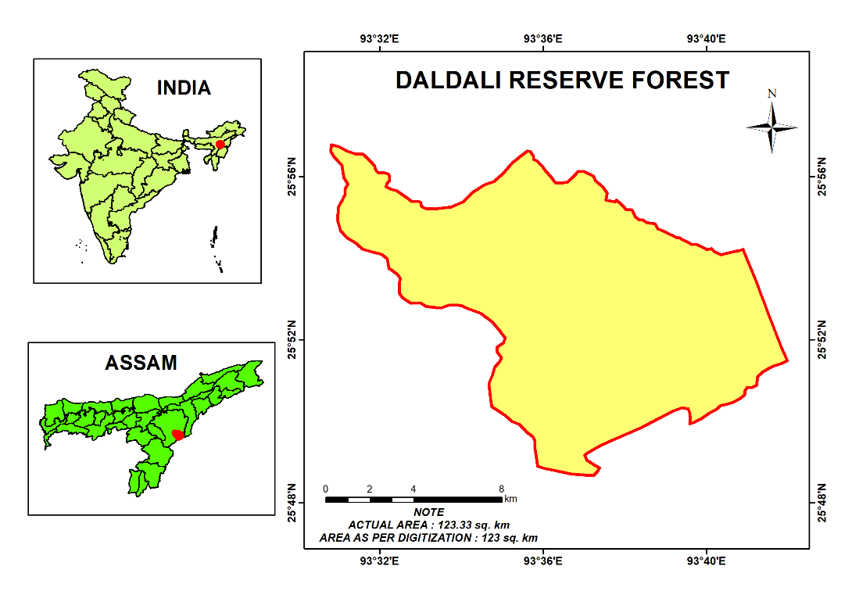

Figure 1: Location Map of the Study Area

**Methodology**  
Landsat 5 and 8 data (Path-Row 135-042) with 30 m spatial resolution of 1994, 2009, and 2024 were acquired from the United States Geological Survey (USGS) portal[1] (Table 1). These data were used to gather information about the forest cover of Daldali RF. The NDVI method, implemented through a raster calculator, was employed to detect forest cover in the protected areas. The raster calculator tool in GIS software allows the creation and execution of single-line algebraic expressions that output the result as a raster. The NDVI range was classified using five different threshold values [32, 33]: below 0 for water bodies, 0 to 0.2 for bare soil, rock, sand, and cloud, 0.2 to 0.3 for shrubs and grassland, 0.3 to 0.5 for sparse vegetation, and above 0.5 for dense vegetation (Table 2). The NDVI maps of the said years were reclassified for change analysis of the features. As the data used have 30 m spatial resolution, a pixel covers an area of 900 sq. m. The pixel value of each class is therefore multiplied by 900 to determine their total area coverage. Again, the total area in sq. m is divided by 10,00,000 to convert it into sq.km.

The formula used for NDVI is



Table 1: Details of Satellite Data Used

|  |  |  |  |  |  |  |
| --- | --- | --- | --- | --- | --- | --- |
| YEAR | SATELLITE | SENSOR | DATE of ACQUISITION | PATH and ROW | RESOLUTION | BAND USED |
| 1994 | LANDSAT 5 | ETM+ | 04-01-1994 | 135 042 | 30m | B3 & B4 |
| 2009 | LANDSAT 5 | ETM+ | 13-01-2009 | 135 042 | 30m | B3 & B4 |
| 2024 | LANDSAT 8 | ETM+ | 07-01-2024 | 135 042 | 30m | B4 & B5 |

**Table: 2 NDVI classes**

|  |  |
| --- | --- |
| **RANGE OF NDVI VALUE** | **FEATURES** |
| BELOW 0 | WATERBODY |
| 0-0.2 | BARE SOIL, ROCK, SAND and CLOUD |
| 0.2-0.3 | SHRUB/GRASSLAND |
| 0.3-0.5 | SPARSE VEGETATION |
| ABOVE 0.5 | DENSE and HEALTHY VEGETATION |

**Result**

A comparative and analytical analysis of the LULC changes in Daldali RF from 1994 to 2024 using NDVI is crucial to understanding the transformation of the forest ecosystem. The analysis will encompass the interpretation of NDVI maps provided for the years 1994, 2009, and 2024. The focus

will be on identifying trends in vegetation cover changes, understanding the underlying causes, and exploring the implications of these changes on the ecosystem.

**Introduction to NDVI and LULC Change Analysis**

The NDVI method is a widely used RS technique that quantifies vegetation by measuring the difference between the near-infrared (which vegetation strongly reflects) and red (which vegetation absorbs) electromagnetic spectrum bands. NDVI values range from -1 to +1, where values closer to +1 indicate healthy vegetation, and values below 0 suggest the absence of vegetation (e.g., water bodies, bare soil).

LULC change analysis using NDVI provides valuable insights into the dynamics of forest cover, land degradation, and ecosystem health. In the context of Daldali RF, the analysis of NDVI maps from 1994, 2009, and 2024 allows us to track the temporal and spatial shifts in vegetation cover, which are indicative of broader environmental and anthropogenic influences.

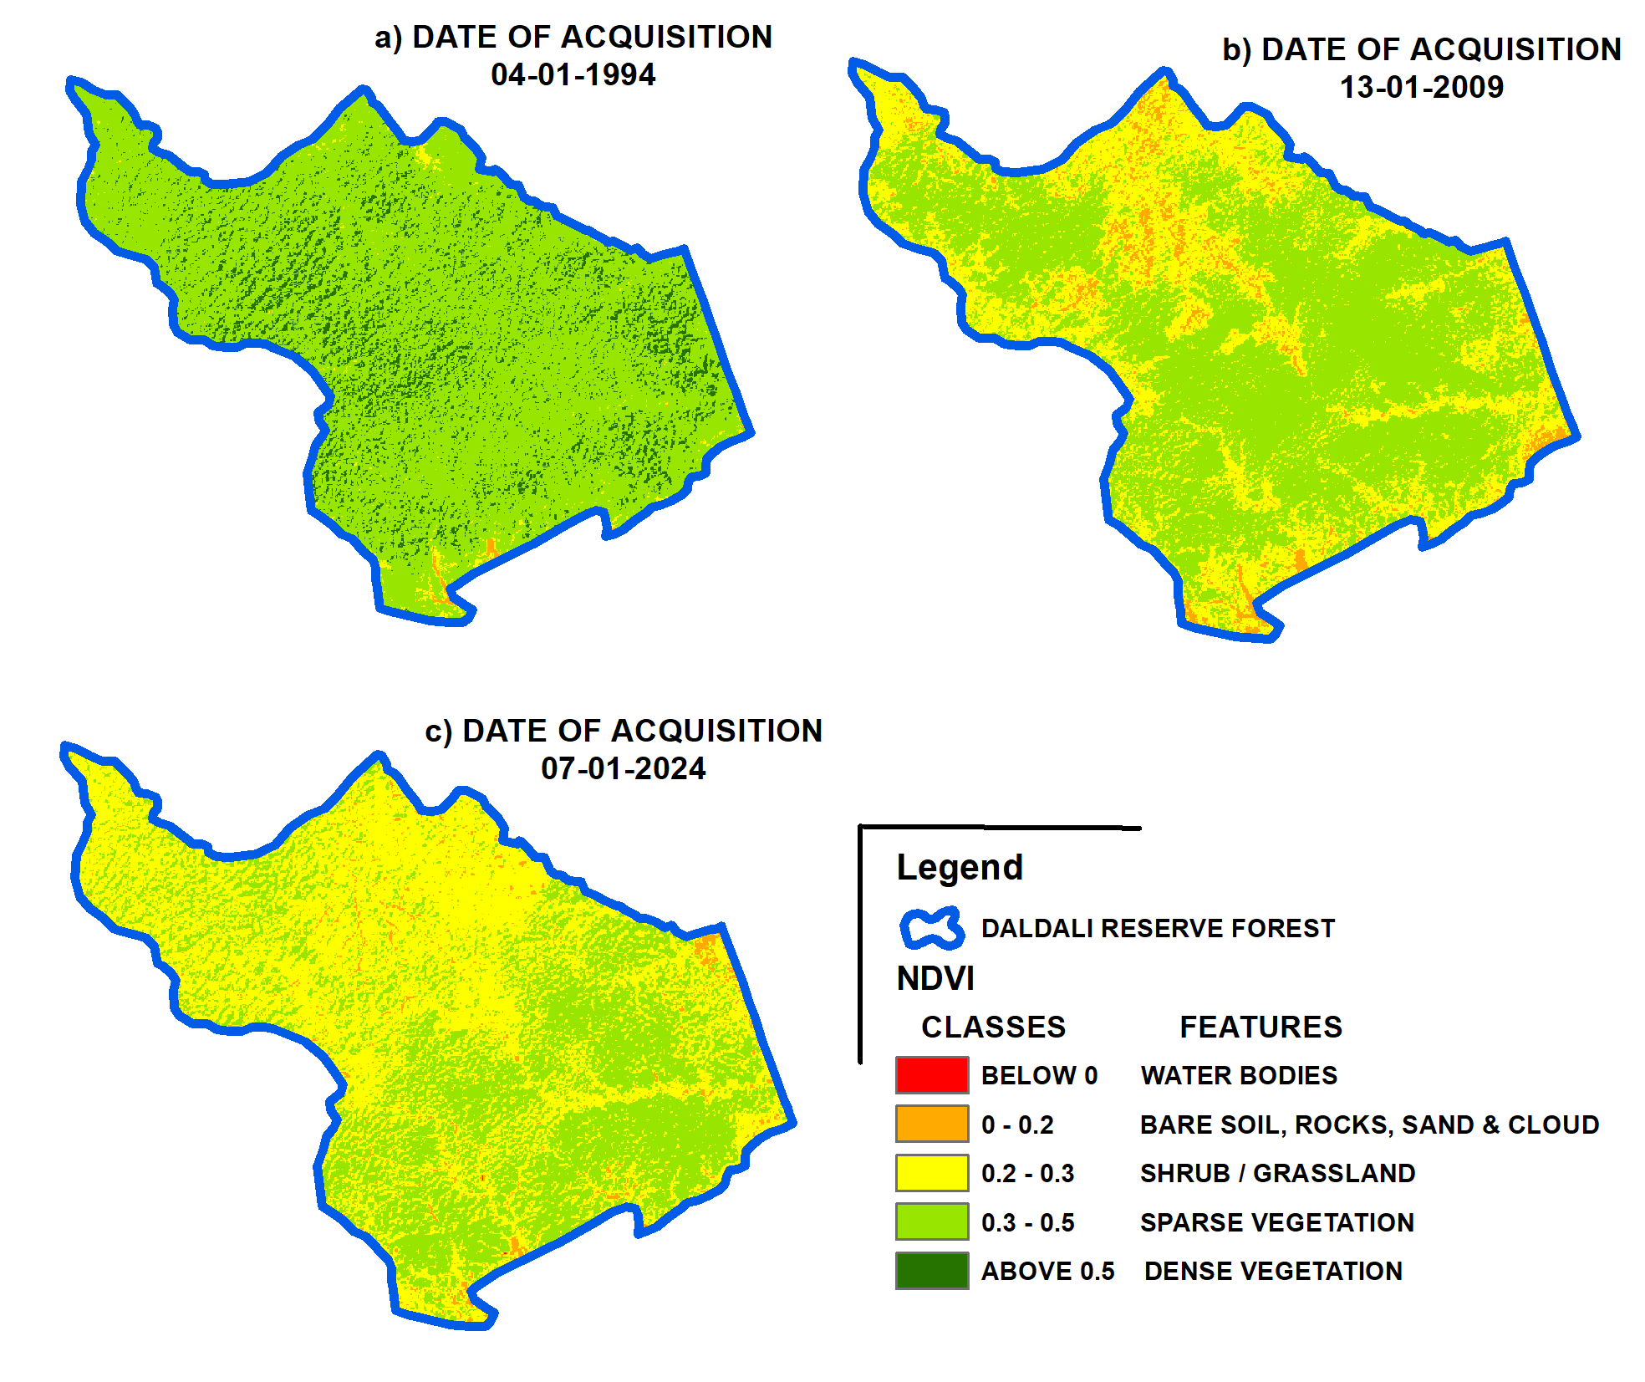

Figure 2: LULC Map of Daldali RF

**1994: A Baseline of Dense Vegetation**

The NDVI map (Figure 2) of 1994 reveals a landscape dominated by dense vegetation, with NDVI values predominantly above 0.5 (Table 3). This indicates that the Daldali RF was characterized by a healthy forest cover. Sparse vegetation (NDVI values between 0.3 and 0.5) was minimal, and areas classified as shrub/grassland (NDVI values between 0.2 and 0.3) were limited. Bare soil, rocks, sand, and clouds (NDVI values between 0 and 0.2) were scarcely present, suggesting that the forest was largely undisturbed by anthropogenic activities or natural calamities that could have led to significant soil exposure or degradation.

The dominance of dense vegetation in 1994 can be attributed to several factors, including the forest's protected status, effective conservation practices, and possibly lower levels of human encroachment. The healthy forest ecosystem likely supported a rich biodiversity, provided habitat for various wildlife species, and contributed to the region's ecological stability.

Table 3: LU/LC Change Analysis (1994, 2009, and 2024)

|  |  |  |  |  |  |
| --- | --- | --- | --- | --- | --- |
| **1994** | | | | | |
| FEATURES | NDVI RANGE | PIXEL COUNT | AREA  (in sq.m) | AREA  (in sq.Km) | PERCENTAGE (%) |
| WATERBODY | - 0.06 — 0 | 1 | 900 | 0 | 0 |
| BARE SOIL, ROCK, SAND and CLOUD | 0 — 0.2 | 523 | 470700 | 0.5 | 0.38 |
| SHRUB / GRASSLAND | 0.2 — 0.3 | 2110 | 1899000 | 1.9 | 1.54 |
| SPARSE VEGETATION | 0.3 — 0.5 | 116526 | 104873400 | 104.9 | 85.31 |
| DENSE VEGETATION | 0.5 — 0.62 | 17447 | 15702300 | 15.7 | 12.77 |
| **2009** | | | | | |
| FEATURES | NDVI RANGE | PIXEL COUNT | AREA  (in sq.m) | AREA  (in sq.Km) | PERCENTAGE (%) |
| WATERBODY | - 0.06 — 0 | 1 | 900 | 0 | 0 |
| BARE SOIL, ROCK, SAND and CLOUD | 0 — 0.2 | 6911 | 6219900 | 6.2 | 5.10 |
| SHRUB / GRASSLAND | 0.2 — 0.3 | 49857 | 44871300 | 44.9 | 36.50 |
| SPARSE VEGETATION | 0.3 — 0.47 | 79838 | 71854200 | 71.9 | 58.40 |
| DENSE VEGETATION | — | — | — | — | — |
| **2024** | | | | | |
| FEATURES | NDVI RANGE | PIXEL COUNT | AREA  (in sq.m) | AREA  (in sq.Km) | PERCENTAGE (%) |
| WATERBODY | - 0.06 — 0 | 3 | 2700 | 0 | 0 |
| BARE SOIL, ROCK, SAND and CLOUD | 0 — 0.2 | 3449 | 3104100 | 3.1 | 2.52 |
| SHRUB / GRASSLAND | 0.2 — 0.3 | 77089 | 69378300 | 69.4 | 56.43 |
| SPARSE VEGETATION | 0.3 — 0.44 | 56068 | 50461200 | 50.5 | 41.05 |
| DENSE VEGETATION | — | — | — | — | — |

**2009: Onset of Degradation and Shrub Encroachment**

By 2009, the NDVI map (Figure 2) shows a significant reduction in areas classified as dense vegetation. The NDVI values above 0.5, which were dominant in 1994, have markedly decreased, with a corresponding increase in areas with NDVI values between 0.3 and 0.5, indicative of sparse vegetation (Table 3). Moreover, the shrub/grassland category (NDVI values between 0.2 and 0.3) has expanded, particularly in regions where dense vegetation once prevailed.

This shift suggests the onset of forest degradation, which could be attributed to several factors. Deforestation, whether due to logging, agricultural expansion, or infrastructure development, is a likely contributor to the reduction in dense vegetation. Additionally, forest fires, disease outbreaks, or climate-related stressors such as rainfall scarcity may have exacerbated the decline in vegetation health. The increase in shrub and grassland areas points to the forest's transition toward a less mature ecosystem. Shrub encroachment often follows the disturbance of dense forest cover, particularly in regions where human activities or adverse environmental conditions hinder the natural regeneration of trees. The loss of dense forest cover has far-reaching ecological implications, including reduced carbon sequestration capacity, habitat fragmentation, and increased vulnerability to further degradation.

Figure 3: Graphical Representation of Temporal Variation of Area under LULC Classes

**2024: Alarming Decline in Vegetation Health**

The NDVI map for 2024 presents a stark picture of the Daldali RF's continuing decline (Figure 2). Dense vegetation areas (NDVI values above 0.5) have become increasingly scarce, with the majority of the forest now classified as sparse vegetation (NDVI values between 0.3 and 0.5) or shrub/grassland (NDVI values between 0.2 and 0.3). The encroachment of bare soil, rocks, and sand (NDVI values between 0 and 0.2) is also more pronounced, indicating further degradation of the forest floor (Table 3, Figure 3).

This trend is indicative of ongoing deforestation and land degradation processes that have persisted and perhaps accelerated over the past decade. The continued reduction in dense vegetation suggests that reforestation efforts, if any, have been insufficient to counteract the loss of forest cover. Moreover, the spread of bare soil and degraded land suggests that soil erosion, possibly driven by deforestation and unsustainable land use practices, has become a significant issue. The 2024 NDVI map highlights the critical need for immediate conservation interventions to halt and reverse the degradation of the Daldali RF. The loss of vegetation cover has likely led to a decline in biodiversity, with potential cascading effects on the forest's ecosystem services, including water regulation, climate moderation, and soil fertility.

**Comparative Analysis of LULC Changes (1994-2024)**

A comparative analysis of the NDVI maps from 1994, 2009, and 2024 reveals a clear and concerning trend of forest degradation over the 30 years. The following key changes can be identified:

1. **Decline in Dense Vegetation:** The most striking change is the progressive decline in areas with NDVI values above 0.5, which signifies dense vegetation. This decline suggests that the forest's overall health and biomass have decreased significantly, potentially leading to reduced carbon sequestration and habitat loss for forest-dependent species.
2. **Increase in Sparse Vegetation and Shrub/Grassland:** As dense vegetation areas have declined, regions classified as sparse vegetation (NDVI values between 0.3 and 0.5) and shrub/grassland (NDVI values between 0.2 and 0.3) have expanded. This shift indicates a transition toward a more open, less mature forest structure, which is often associated with lower biodiversity and greater susceptibility to further degradation.
3. **Expansion of Bare Soil and Degraded Land:** The presence of bare soil, rocks, and sand (NDVI values between 0 and 0.2) has increased over time, particularly between 2009 and 2024. This expansion suggests that soil erosion and land degradation have become more pronounced, likely exacerbating the forest's vulnerability to further degradation and reducing its ecological resilience.

**Underlying Causes of LULC Changes**

The observed LULC changes in Daldali RF can be attributed to a combination of anthropogenic and natural factors. Understanding these causes is essential for developing effective conservation strategies.

1. **Deforestation and Land Use Change:** One of the primary drivers of forest degradation is deforestation, often driven by agricultural expansion, logging, and infrastructure development. In many forested regions, including Daldali RF, the demand for land for farming, settlement, and other human activities has led to the clearing of dense forest cover. This process not only reduces the extent of forested land but also disrupts the forest's natural regeneration processes.
2. **Forest Fires:** Forest fires, whether caused by natural events or human activities, can have devastating effects on vegetation cover. Fires can lead to the loss of dense forest, resulting in the expansion of shrub and grassland areas. Repeated fires can further degrade the land, making it difficult for the forest to recover and leading to the spread of bare soil and degraded land.
3. **Climate Change:** Climate change is another significant factor that can influence LULC changes. Changes in temperature and precipitation patterns can stress forest ecosystems, making them more vulnerable to degradation. Prolonged droughts, for example, can reduce the health of dense vegetation, leading to its transition into sparse vegetation or shrubland.
4. **Soil Erosion:** The expansion of bare soil and degraded land areas suggests that soil erosion has become a significant issue in Daldali RF. Soil erosion can be exacerbated by deforestation, which removes the protective cover of vegetation, leaving the soil exposed to the elements. Over time, erosion can lead to the loss of fertile topsoil, further hindering the forest's ability to regenerate.

**Ecological Implications of LULC Changes**

The LULC changes observed in Daldali RF have significant ecological implications, particularly for biodiversity, ecosystem services, and climate regulation.

1. **Biodiversity Loss:** The decline in dense vegetation and the expansion of degraded land likely result in a loss of biodiversity. Dense forests provide critical habitat for a wide range of species, from large mammals to small invertebrates. As the forest becomes more open and fragmented, many species may lose their habitat, leading to population declines or even local extinctions.
2. **Disruption of Ecosystem Services:** Forests provide essential ecosystem services, including water regulation, carbon sequestration, and soil stabilization. The degradation of Daldali RF reduces its ability to perform these functions, potentially leading to negative consequences for the broader region. For example, reduced vegetation cover can lead to more variable water flows, increasing the risk of flooding or drought.
3. **Impact on Climate Regulation:** Forests play a critical role in climate regulation by sequestering carbon dioxide from the atmosphere. The loss of dense vegetation in Daldali RF likely reduces the forest's carbon sequestration capacity, contributing to higher levels of atmospheric carbon dioxide and exacerbating climate change. Additionally, the release of carbon stored in vegetation and soil due to deforestation and land degradation can further contribute to global warming.

**Recommendations for Conservation and Restoration**

The alarming trends observed in the LULC changes of Daldali RF underscore the urgency of implementing comprehensive conservation and restoration strategies. These recommendations aim to address the root causes of forest degradation, restore ecological balance, and ensure the long-term sustainability of the forest ecosystem.

**1. Implementation of Sustainable Forest Management Practices:**

Sustainable forest management is crucial for balancing the need for resource extraction with the preservation of forest ecosystems. It is essential to implement practices that limit deforestation and promote the sustainable use of forest resources. This can include controlled logging with reforestation requirements, selective harvesting that minimizes ecological disruption, and the establishment of buffer zones around sensitive areas to prevent encroachment. Moreover, community involvement in forest management, through participatory approaches, can enhance the effectiveness of these strategies by ensuring that local needs and knowledge are integrated into conservation efforts.

**2. Reforestation and Afforestation Initiatives:**

Reforestation of degraded areas and afforestation of suitable non-forest lands within and around Daldali RF are critical for restoring lost vegetation cover. These initiatives should prioritize the planting of native tree species that are well-adapted to the local environment and capable of supporting the region’s biodiversity. Additionally, mixed-species plantations can enhance ecosystem resilience and provide a more diverse range of habitats. Reforestation efforts should also focus on reconnecting fragmented forest patches to create continuous corridors for wildlife, thus reducing the negative impacts of habitat fragmentation.

**3. Fire Management and Prevention Programs:**

Given the potential role of forest fires in contributing to vegetation loss, it is imperative to develop and implement fire management and prevention programs. These programs should include measures such as controlled burns to reduce fuel loads, the creation of firebreaks to prevent the spread of wildfires, and the establishment of early warning systems to detect and respond to fires quickly. Public awareness campaigns and training programs for local communities on fire prevention and management can further reduce the risk of accidental as well as intentional (jhum cultivation) fires and enhance the overall resilience of the forest to fire-related disturbances.

**4. Soil Conservation and Erosion Control Measures:**

To combat the spread of bare soil and land degradation, soil conservation measures should be prioritized. Techniques such as contour plowing, terracing, and the establishment of vegetative cover on vulnerable slopes can significantly reduce soil erosion. Additionally, the use of organic mulches and cover crops can enhance soil fertility and structure, promoting the natural regeneration of vegetation. Erosion control measures should also focus on stabilizing riverbanks and other erosion-prone areas to prevent further land degradation and protect water quality.

**5. Restoration of Hydrological Balance:**

The health of forest ecosystems is closely linked to the hydrological balance of the region. Restoration efforts should include measures to protect and restore water sources within the forest, such as springs, streams, and wetlands. This can be achieved by reforesting riparian zones, reducing water extraction for agricultural or industrial purposes, and implementing watershed management practices that enhance water infiltration and reduce runoff. Maintaining a healthy hydrological balance will not only support vegetation growth but also ensure the availability of water for wildlife and local communities.

**6. Strengthening Legal and Institutional Frameworks:**

Effective conservation of Daldali RF requires legal and institutional frameworks that support the enforcement of environmental laws and regulations. Strengthening the capacity of local forest departments and other relevant institutions to monitor and manage the forest is crucial. This can include increasing funding for conservation initiatives, enhancing the training and resources available to forest rangers, and improving coordination between government agencies, non-governmental organizations, and local communities. Additionally, stricter enforcement of laws against illegal logging, land encroachment, and wildlife poaching is necessary to protect the forest and its biodiversity.

**7. Promoting Alternative Livelihoods for Local Communities:**

Many instances of deforestation and land degradation are driven by the need for land and resources to support local livelihoods. To reduce pressure on the forest, it is important to promote alternative, sustainable livelihoods for communities living in and around Daldali RF. This can include the development of eco-friendly agricultural practices, the promotion of agroforestry, and the establishment of community-based tourism initiatives that provide economic benefits while preserving the forest. Additionally, providing education and training on sustainable land management and conservation can empower communities to adopt practices that protect the forest while meeting their economic needs.

**8. Biodiversity Conservation and Wildlife Protection:**

Conservation efforts should prioritize the protection of the forest’s biodiversity, particularly species that are endangered or have critical ecological roles. Establishing and maintaining wildlife corridors, protected areas, and biodiversity hotspots within the forest can help preserve habitats and support species populations. Conservation programs should also include measures to mitigate human-wildlife conflicts, such as the use of early warning systems, the construction of wildlife-friendly barriers, and the promotion of coexistence strategies that benefit both people and wildlife.

**9. Monitoring and Research Programs:**

Continuous monitoring of LULC changes and other ecological parameters is essential for assessing the effectiveness of conservation and restoration efforts. Implementing RS technologies, such as satellite imagery and drones, can provide valuable data on forest cover, vegetation health, and land use patterns. Additionally, research programs should focus on understanding the drivers of forest degradation, the impacts of climate change on the ecosystem, and the effectiveness of different conservation strategies. Collaborations between research institutions, government agencies, and local communities can enhance the knowledge base and inform adaptive management practices.

**10. Community Engagement and Education:**

Engaging local communities in conservation efforts is key to ensuring the long-term success of restoration initiatives. Community-based conservation programs that involve local stakeholders in decision-making processes can foster a sense of ownership and responsibility for the forest. Environmental education programs can raise awareness about the importance of forest conservation and provide communities with the knowledge and skills needed to participate in sustainable land management. Empowering communities through education and capacity-building initiatives can also strengthen their ability to advocate for the protection of their natural resources.

**Conclusion**

The LULC change analysis of Daldali RF over the period from 1994 to 2024 reveals a concerning trend of forest degradation, characterized by a significant decline in dense vegetation and an increase in sparse vegetation, shrub/grassland, and bare soil. These changes are indicative of ongoing deforestation, land degradation, and ecological stress, driven by factors such as unsustainable land use practices, forest fires, climate change, and soil erosion. The ecological implications of these changes are profound, with potential consequences for biodiversity loss, disruption of ecosystem services, and reduced resilience to climate change. The forest's declining health also threatens the livelihoods of local communities and the broader environmental stability of the region.

In response to these challenges, a multifaceted approach to conservation and restoration is required. Sustainable forest management, reforestation, fire prevention, soil conservation, and the restoration of hydrological balance are essential strategies for halting and reversing the degradation of Daldali RF. Strengthening legal and institutional frameworks, promoting alternative livelihoods, protecting biodiversity, and engaging local communities are also critical components of a successful conservation strategy. Ultimately, the long-term sustainability of Daldali RF will depend on the collective efforts of government agencies, non-governmental organizations, research institutions, and local communities. By working together to implement effective conservation and restoration practices, it is possible to restore the health and vitality of this important forest ecosystem, ensuring that it continues to provide essential ecological, economic, and cultural benefits for generations to come.

**References**

1. Abbas, Z., Yang, G., Zhong, Y., & Zhao, Y. (2021). Spatiotemporal change analysis and future scenario of LULC using the CA-ANN approach: A case study of the greater bay area, china. *Land*, *10*(6), 584.
2. Coppin, P., Jonckheere, I., Nackaerts, K., Muys, B., & Lambin, E. (2004). Digital change detection methods in ecosystem monitoring: A review. International Journal of Remote Sensing, 25(9), 1565-1596.
3. Muttitanon, W., & Tripathi, N. K. (2005). Land use/land cover changes in the coastal zone of Ban Don Bay, Thailand using Landsat 5 TM data. International Journal of Remote Sensing, 26(11), 2311-2323.
4. Tiwari, N., & Kashyap, P. J. (2024). Urban Growth Dynamics of National Capital Region of India Using Geospatial Technology. Asian Journal of Geographical Research, 7(2), 35–52. https://doi.org/10.9734/ajgr/2024/v7i2230
5. Fung, T., & Siu, W. (2000). Environmental quality and its changes, an analysis using NDVI. *International Journal of Remote Sensing*, *21*(5), 1011–1024. <https://doi.org/10.1080/014311600210407>
6. Rouse, J. W., Haas, R. H., Schell, J. A., & Deering, D. W. (1973). Monitoring vegetation systems in the Great Plains with ERTS. In S. C. Freden, E. P. Mercanti, & M. Becker (Eds.), Third Earth Resources Technology Satellite (ERTS) Symposium (pp. 309-317). NASA SP-351.
7. Tucker, C. J. (1979). Red and photographic infrared linear combinations for monitoring vegetation. *Remote Sensing of Environment*, 8(2), 127-150.
8. Lillesand, T. M., Kiefer, R. W., & Chipman, J. W. (2015). Remote sensing and image interpretation (7th ed.). John Wiley & Sons.
9. Pettorelli, N., Vik, J. O., Mysterud, A., Gaillard, J. M., Tucker, C. J., & Stenseth, N. C. (2005). Using the satellite-derived NDVI to assess ecological responses to environmental change. Trends in Ecology & Evolution, 20(9), 503-510.
10. Fatemi, M., & Narangifard, M. (2019). Monitoring LULC changes and its impact on the LST and NDVI in District 1 of Shiraz City. *Arabian Journal of Geosciences*, *12*(4), 127.
11. Jensen, J. R. (2007). Remote sensing of the environment: An Earth resource perspective (2nd ed.). Pearson Prentice Hall.
12. Wang, J., Price, K. P., & Rich, P. M. (2001). Spatial patterns of NDVI in response to precipitation and temperature in the central Great Plains. International Journal of Remote Sensing, 22(18), 3827-3844.
13. Geist, H. J., & Lambin, E. F. (2002). Proximate causes and underlying driving forces of tropical deforestation. Bioscience, 52(2), 143-150.
14. Lambin, E. F., Turner, B. L., Geist, H. J., Agbola, S. B., Angelsen, A., Bruce, J. W., … Xu, J. (2001). The causes of land-use and land-cover change: Moving beyond the myths. Global Environmental Change, 11(4), 261-269.
15. Zhan, Z. Z., Liu, H. B., Li, H. M., Wu, W., & Zhong, B. (2012). The relationship between NDVI and terrain factors--a case study of Chongqing. *Procedia Environmental Sciences*, *12*, 765-771.
16. Fensholt, R., & Proud, S. R. (2012). Evaluation of Earth Observation-based global long-term vegetation trends—Comparing GIMMS and MODIS global NDVI time series. Remote Sensing of Environment, 119, 131-147.
17. Turner, B. L., Lambin, E. F., & Reenberg, A. (2007). The emergence of land change science for global environmental change and sustainability. Proceedings of the National Academy of Sciences, 104(52), 20666-20671.
18. Running, S. W., Nemani, R. R., Heinsch, F. A., Zhao, M., Reeves, M., & Hashimoto, H. (2004). A continuous satellite-derived measure of global terrestrial primary production. Bioscience, 54(6), 547-560.
19. Zhang, G., Xiao, X., Dong, J., Kou, W., Jin, C., Qin, Y., & Moore, B. (2013). Mapping paddy rice planting areas through time series analysis of MODIS land surface temperature and vegetation index data. ISPRS Journal of Photogrammetry and Remote Sensing, 85, 148-159.
20. Chen, J., Zhou, W., & Pickett, S. T. A. (2015). Remote sensing of urban areas: An ecological perspective. Frontiers in Ecology and the Environment, 13(7), 393-399.
21. Lu, D., Mausel, P., Brondízio, E., & Moran, E. (2004). Change detection techniques. International Journal of Remote Sensing, 25(12), 2365-2407.
22. Huete, A. R., Liu, H. Q., Batchily, K., & van Leeuwen, W. J. D. A. (1997). A comparison of vegetation indices over a global set of TM images for EOS-MODIS. Remote Sensing of Environment, 59(3), 440-451.
23. Kogan, F. N. (2001). Operational space technology for global vegetation assessment. Bulletin of the American Meteorological Society, 82(9), 1949-1964.
24. Foody, G. M. (2003). Remote sensing of tropical forest environments: Towards the monitoring of environmental resources for sustainable development. International Journal of Remote Sensing, 24(20), 4035-4046.
25. Zhu, Z., & Woodcock, C. E. (2014). Continuous change detection and classification of land cover using all available Landsat data. Remote Sensing of Environment, 144, 152-171.
26. Azzari, G., & Lobell, D. B. (2017). Landsat-based classification in the cloud: An opportunity for a paradigm shift in land cover monitoring. Remote Sensing of Environment, 202, 64-74.
27. Gorelick, N., Hancher, M., Dixon, M., Ilyushchenko, S., Thau, D., & Moore, R. (2017). Google Earth Engine: Planetary-scale geospatial analysis for everyone. Remote Sensing of Environment, 202, 18-27.
28. Jha, C. S., Goparaju, L., Tripathi, A., Gharai, B., & Sharma, N. (2000). Land use/land cover change in North-East India: A remote sensing approach. International Journal of Remote Sensing, 21(1), 1221-1236.
29. Roy, P. S., & Roy, A. (2010). Land use and land cover change in India: A remote sensing & GIS perspective. Journal of the Indian Society of Remote Sensing, 38(4), 685-707.
30. Indian Space Research Organization (ISRO). (2012). National Remote Sensing Centre annual report 2011-12. Hyderabad: NRSC.
31. United Nations Environment Programme (UNEP). (2014). Assessing global land use: Balancing consumption with sustainable supply. UNEP/International Resource Panel.
32. Bhandari, A. K., Kumar, A., & Singh, G. K. (2012). Feature extraction using Normalized Difference Vegetation Index (NDVI): A case study of Jabalpur city. *Procedia technology*, *6*, 612-621.
33. Bid, S. (2016). Change detection of vegetation cover by NDVI technique on catchment area of the Panchet Hill Dam, India. *International Journal of Research in Geography (IJRG)*, *2*(3), 11-20.

1. USGS portal: <https://earthexplorer.usgs.gov/>