Assessing the Trends of Annual Water Level Change in the Erhai Lake, Southwest China and Water Volume

.

ABSTRACT

|  |
| --- |
| Understanding the dynamic changes of lake water level and water volume is condu-cive to the protection and restoration of the environment of a lake, which is of great significance to the rational utilization of water resources and the promotion of sus-tainable economic development along the lake. Taking Erhai Lake in Southwest China as the study area, this research quantifies and analyzes the long-term variation trends of water level and water volume from 1987 to 2020 based on multi-source data and an integrated approach. The results shown: (1) using multi-source data and an integrated approach enables the rapid analysis of long-term trends in water level and water volume changes for lake with missing monitoring data; (2) annual water level and annual water volume of the Erhai Lake fluctuated greatly, showing a downward trend during the period from 1987 to 2020. The results from this study provide basic data for the rational use of water resources, the management and protection of the environ-ment of the Erhai Lake. |

*Keywords: water level; water volume; change trend; Erhai Lake*

1. INTRODUCTION

Lakes are an important part of terrestrial freshwater resources, and play a key role in the global water cycle and regulating regional climate (Chunqiao et al., 2020; Yang et al., 2020). Lakes provide many ecosystem services for human beings and all kinds of organisms (Rinke et al., 2019; Pham-Duc et al., 2020), many countries have included lake protection in their national sustainable development goals (Feng et al., 2022). The study of lake changes is of great value in revealing climate change, environmental change and the impact of human activities (Yang et al., 2020).

Water level (WL) and water volume (WV) are important physical parameters of lakes and also are important contents for the study of lake evolution (Kediao et al., 2019; Yaseen et al., 2020). Their changes are indicative of climate change and human activity impacts (Woolway et al., 2020; Ma et al., 2019). WL are key parameters and major climate variables for the Global Hydrological Data Center (GHDC) and Global Climate Observation System (GCOS) of the World Meteorological Organization (WMO) (Kostianoy et al., 2022). The changes of WL and WV directly or indirectly affect the lake ecosystem health (Woolway et al., 2020; Fang et al., 2019). With the global warming and the increasing human ac-tivities, the monitoring of WL and WV changes has become one of the important envi-ronmental issues of research and concern, and has attracted the attention of govern-ments and departments. Therefore, continuous and long-term monitoring of WL and WV changes is very important for assessing the impact of human activities on water environment, and is of importance in understanding the relationship between the wa-ter dynamics and climate change (Woolway et al., 2020; Ma et al., 2019).

Traditionally, the monitoring of WL and WV changes has been based on ground-based hydrological stations observations. This method is time-consuming and labor-intensive, and the monitoring area and timeliness are limited, thus it is nearly impossible to provide long-term monitoring information of WL and WV in a large and heterogeneous environment (Normandin et al., 2018). Since 1970, remote sensing is widely used in limnology and lake management for identifying, measuring, and characterizing the proper-ties of lakes (Chipman, 2019). Satellite radar altimetry (Topex/Poseidon, CryoSat-1/2, Jason-1/2/3) and laser altimetry (ICESat-1/2, MABEL) provide capable of measuring WL of lakes (Ma et al., 2019; Chipman, 2019; Duan and Bastiaanssen, 2013). However, the information of WL is limited by the time duration of the satellite altimetry data (Ma et al., 2019). Radar altimetry data for WLs are available as early as 1992 from the Topex/Poseidon [9], while laser altimetry data are available as early as 2003 from ICESat-1 (Ma et al., 2019). Therefore, the discontinuity of monitoring data and the mismatch of in-formation between datasets undermine the comparability of different WL measurements, making it difficult to analyze the trend of WL changes. WV is typically estimated using empirical equations established based on lake area and WL (Ma et al., 2019; Schwatke et al., 2020; Getirana et al., 2018). However, this method has an implicit assumption that the lake is fitted as a conical frustum (Ma et al., 2019; Cael et al., 2017). Other approach estimated WV using lake area and the lakeside topographic slopes (derived from a digital elevation model) (Schwatke et al., 2020; Cael et al., 2017; Zhan et al., 2022). Either way, the prediction accuracy of lake WV is highly unreliable (Cael et al., 2017). Mainly because the lake bottom morphology may be uplifted, depressed or undulated, which is not isotropic and uniform. Currently, accurate WV in a lake can be estimated based on WL and bathymetric map (Ma et al., 2019; Duan and Bastiaanssen, 2013; Cael et al., 2017).

The Erhai Lake is a typical plateau fault depression freshwater lake, ranking seventh in China's freshwater lakes. The Erhai Lake, which plays an important role in coordinating regional ecological balance and maintaining the ecological security of the upper and middle reaches of the Yangtze River, is one of the national key protected water bodies. Driven by global climate change and human activities, the environment of Erhai Lake and its watershed has experienced dramatic transformations in recent decades, including a decline in regional rainfall and the expansion of farmland and construction areas. Thus, long-term and continuous monitoring the change trend of WL and WV in the Erhai Lake is of great significance for lake water resources management and rational utilization (Zheng et al., 2021; Wu et al., 2020), and is of importance in assessing the impact of human activities on water environment.

As previously mentioned, long-term monitoring of WL and WV changes presents significant challenges and uncertainties, such as data compatibility among different satellite altimetry sensors, the continuity of monitoring data, and the modeling of lakebed topography. To address these issues, we utilized multi-source data and an integrated methodology to monitor the change trends in WL and WV of Erhai Lake over long periods of time. The primary goal of this research is to analyze the long-term change trend in Erhai Lake's WL and WV from 1987 to 2020. Specifically, the objectives are to: (1) develop a methodological framework for assessing long-term trends in change of WL and WV; (2) analyze the change trend in WL and WV of the Erhai Lake.

2. material and methods

**2.1 Study area**

The Erhai Lake, located in the central part of Dali Bai Autonomous Prefecture (Fig. 1), is the second largest freshwater lake in the Yunnan-Guizhou Plateau and the seventh largest freshwater lake in China. The Erhai Lake has a mid-subtropical plateau monsoon climate, with an average annual temperature of 15.6℃ and an average annual precipitation of 1032 mm (Wu et al., 2020). The Erhai Lake is 41.5 km long from north to south and 3-9 km wide from east to west. It is long and narrow, shaped like an ear. The Erhai Lake is a typical urban fringe lake, which is close to Dali city (a central city of western Yunnan Province). The Erhai Lake is also the main source of drinking water in Dali city. It has many functions, such as water supply, tourism, climate regulation, etc., and is of great significance in supporting a variety of regional ecosystem services. The Erhai Lake plays a pivotal role in regional social and economic development as well as in the construction of ecological civilization (Wu et al., 2020).

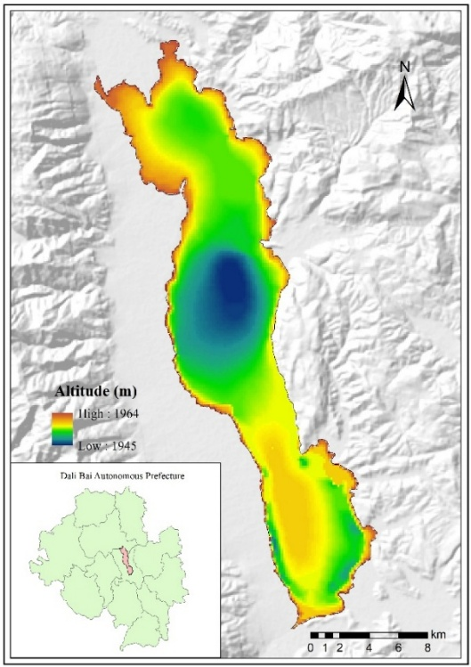

**Fig. 1. Location of the study area and elevation map of water depth based on bathymetry data. Note that the background image is the hillshade generated by GDEM V3 ( from USGS LPDAAC).**

**2.2 Data Sources**

Lake area is a key intermediary variable for analyzing long-term trends in WL and WV changes (Gownaris et al., 2018; Crétaux et al., 2016). Imagery from the longest-operating Landsat satellite series was utilized to extract the area of the Erhai Lake. However, Erhai Lake is located in the mid-subtropical plateau monsoon climate zone and is jointly controlled by the Indian Ocean and Pacific Ocean monsoon, there are few cloud-free images in a year (Schwatke et al., 2015). Together with the long revisit period of Landsat, it leads to the number of available images in the study area is restricted (Yang et al., 2020). For these reasons, we retrieved all Landsat satellite images (p131r42) from 1987 to 2020 within the study area, the maximum cloud cover was set to 80%. All the imagery data were obtained from the EROS Science Processing Architecture (ESPA) (https://espa.cr.usgs.gov). In total, 519 scenes Landsat images from 1987 to 2020 were used.

WL is based on “Database for Hydrological Time Series of Inland Waters” (DAHITI) and is calculated by modelling to obtain long time series of WL data. DAHITI provides global hydrological information on various lakes, reservoirs, rivers and wet-lands (Schwatke et al., 2015). Compared with Global Reservoirs and Lakes Monitor (GRLM) and HY-DROWEB (Duan and Bastiaanssen, 2013), DAHITI is more comprehensive. In the DAHITI, WL data of Erhai Lake has been provided since 17 April 2016, and there are 57 data between 2016 and 2020, with an error of 0-0.057 m (from DAHITI accurcy report).

In addition, the measured bathymetry data in 2004 was used as an important parameter for the accurate assessment of WV of the Erhai Lake. The bathymetry data was based on sonar sensors to describe the underwater topography of the Erhai Lake (Fig. 1).

**2.3 Methods**

Located in a cloud-prone and topographically complex plateau and mountainous region, monitoring the long-term trends of WL and WV in Erhai Lake poses considerable challenges. Therefore, a specific technical framework is required to monitor the change trend in WL and WV of the Erhai lake over the long term (Fig. 2). We propose a four-stage framework to monitor and analyze the change trend of WL and WV in the Erhai Lake from 1987 to 2020: (1) synthesize annual lake areas to minimize the impact of cloud cover and data scarcity on lake area extraction; (2) establish a water level-area relationship model using short-term WL data from DAHITI to derive long-term annual WL information; (3) calculate WV using the synthesized annual lake area, the calculated annual water levels, and bathymetry map; and (4) analyze the trends in WL and WV changes of Erhai Lake from 1987 to 2020.

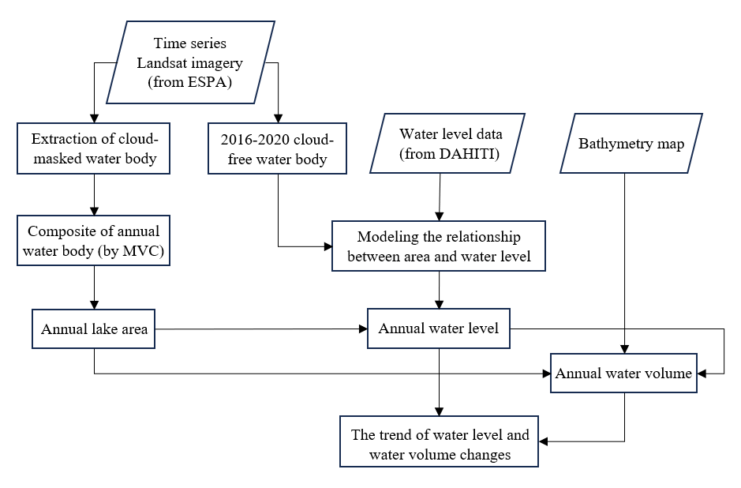

**Fig. 2. Flowchart for analyzing trends in water level and water volume over long periods of time in cloudy and monitoring data deficient areas.**

**2.3.1 Annual water body composite and area calculation**

The extraction of lake area is affected by cloud cover and long revisit period of Landsat satellites, often resulting in incomplete image coverage or data discontinuities. These issues lead to temporal and spatial data gaps, making it difficult to ensure data comparability across different periods (Yang et al., 2020). To tackle these challenges, a compromise approach was adopted. Water bodies are extracted from cloud-masked Landsat imagery, and then a maximum value composite (MVC) method was employed to inte-grate all the waters within a year. This process combines all cloud-masked water body data from a given year into annual water body image, which is then used to calculate the area of MVCed water body. The compositeness and area calculation of annual lake water bodies are performed using the following workflow.

Firstly, the cloud and cloud shadow mask are generated by MFmask algorithm (Qiu et al., 2017), and the cloud and cloud shadow of Landsat imagery is removed by the mask. Based on the data after removal of clouds and cloud shadows, a modified normalized difference water index (MNDWI) is calculated to enhance the water information (Equation 1) (Chen and Yu, 2016; Xu, 2007). In order to avoid the uncertainty and subjectivity of threshold selec-tion for water extraction by MNDWI, we use the response difference of water to different bands to construct the radiation relationship expression (Equation 2), and automatically extract water from Landsat images without relying on subjective judgment. At the same time, in order to maximize the accuracy of water extraction, we use the multi-band true-color combination images that remove clouds and cloud shadows to visually inspect and edit the water information one by one. The overall accuracy of extracted water body exceeded 90%. Then, using the extracted water bodies within a year, the annual lake water body is synthesized using the MVC method, and its area is cal-culated.

$MNDWI=\frac{R_{Green}-R_{SWIR}}{R_{Green}+R_{SWIR}}$ (1)

$W=\left(MNDWI\right)*\left[\left(R_{NIR}>R_{SWIR}\right)∩\left(R_{SWIR}>R_{Green}\right)\right]$ (2)

$W$ for the extracted water image, $R_{Green}$， $R_{NIR}$， $R_{SWIR}$ represent the green, near infrared and short wave infrared bands of Landsat series satellite images.

**2.3.2 Calculation of annual WL and annual WV**

Due to the WL data of the Erhai Lake in the DAHITI covers a short period of time, it cannot meet our demand for long-term continuous WL information. To deal with this issue, WL from DAHITI (2016-2020) and area extracted from cloud-free Landsat imagery are combined to estimate a relationship model (Ma et al., 2019). We firstly performed Pearson correlation analysis using WL data from the DAHITI for the period 2016-2020 and area data extracted from cloud-free Landsat images (13 scenes) for the same or adjacent period, and the Pearson correlation coefficient of " WL–area" was as high as 0.95. Then, a regression model was constructed, the relationship is illustrated in Figure 3. From this, area can be employed to convert WL for other time series (Lee et al., 2022). Based on annual lake area data, annual WL of the Erhai Lake from 1987 to 2020 is inversely calculated by using this model.

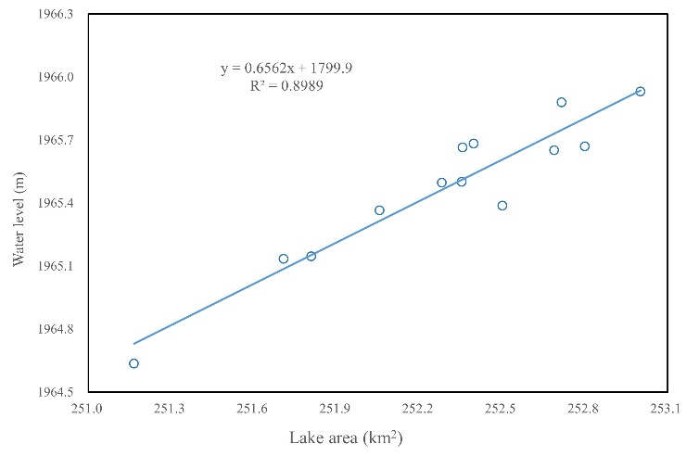

**Fig. 3. Linear regression model and goodness of fit between WL and lake area.**

Then, annual WL and boundaries of annual lake area were combined to create the elevation contours of the lake boundaries in different years. The bathymetry map measured in 2004 (Fig. 1) was intersected with the elevation contours of the lake boundaries to generate the three-dimensional topography of lake for different years (Ma et al., 2019). Finally, annual WV was calculated.

**2.3.3 Analyzing the trend of annual WL and WV changes**

We applied the least squares method to plot trend lines for the annual WL and WV over time, providing insights into the long-term variation trends of WL and WV for the Erhai Lake.

3. results

**3.1 Change in annual lake area**

Fig. 4 shows the change characteristics of the annual area of Erhai Lake. From 1987 to 2020, Annual area of the Erhai Lake fluctuated and showed a decreasing trend. Among them, the Erhai Lake had the largest annual area of 257.67 km2 in 1991 and the smallest annual area of 245.58 km2 in 2016. Annual area of the Erhai Lake fluctuated sharply from 1987 to 1999 and from 2013 to 2017, while annual area changed rela-tively smoothly from 1999 to 2013 and from 2017 to 2020.

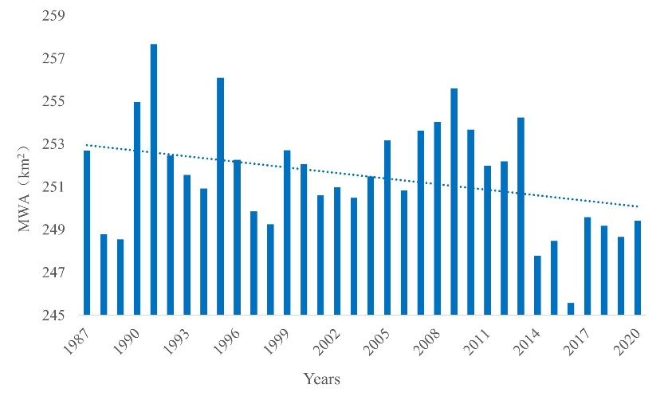

**Fig. 4. Changes in annual area of the Erhai Lake from 1987-2020.**

**3.1 Change trend of annual WL and WV**

From 1987 to 2020, Annual WL of the Erhai Lake showed a downward trend (Fig. 5). Comparing annual WL changes in the past 34 years, it can be seen that the overall change range of annual WL in the Erhai Lake is between 1961.05 m and 1968.98 m, the highest annual WL appeared in 1991, which was 1968.98 m, and the lowest annual WL was 1961.05 m occurred in 2016. The most dramatic change in the rising annual WL of the lake was from 1989 to 1991, with a total rising annual WL of 5.98 m. The most dramatic drawdown occurred in 2013-2014, with a drawdown of 4.23 m. Since 2009, annual WL of the Erhai Lake began to decline sharply. From 2009 to 2016, annual WL of the Erhai Lake declined in all the years except a few years (annual WL rose in 2013 and 2015), with a cumulative decline of 6.58 m. In 2017, annual WL rose, but it was still below the trend line. From 2017 to 2020, annual WL changed smoothly without dramatic changes.

It can be seen from Fig. 5 that annual WV of the Erhai Lake is similar with the change trend of annual WL, showing a downward trend in general. In 2020, the amount of water decreased by 0.41 billion m³ compared to 1987. During the study period, the maximum annual WV of the Erhai Lake was 4.39 billion m³ in 1991, and the minimum annual WV was 2.89 billion m³ in 2016. In the process of annual WV change, the largest increase was in 1989-1991, with an increase of 1.13 billion m³. During the period of 1991-1994, annual WV was decreasing, and after 1992, annual WV was be-low the trend line. During the period from 2014 to 2020, annual WV is below the trend line, except for the increase of annual WV in 2016-2017 and 2019-2020, annual WV in other years is decreasing, so that 2016 is the year with the minimum annual WV in the study period.

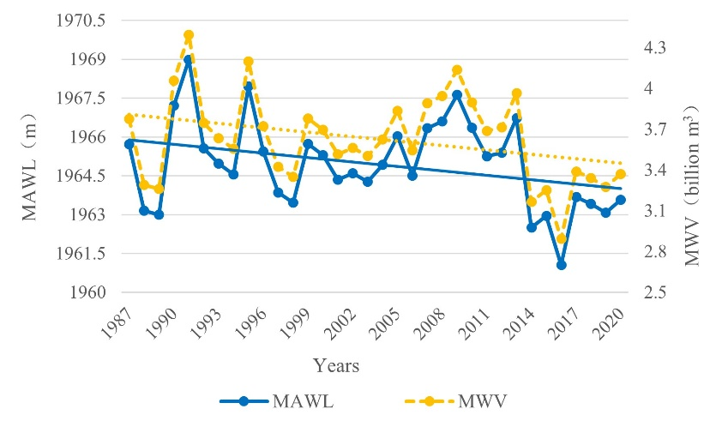

**Fig. 5. Annual WL, annual WV and their change trend of the Erhai Lake from 1987 to 2020.**

4. discussion

In this study, three main datasets (Landsat satellites images, DAHITI and bathymetry map) were used which enabled the estimation change of WL and WV. However, there are still many challenges in obtaining WL and WV data. On the one hand, the cloudy weather has resulted in few or no available Landsat data in the study area; on the other hand, there is no long-term spatial and temporal continuity Erhai data in the DAHIT dataset.

To overcome these problems, the integrated method was used. A linear regression model was developed using the existing time matched data pairs on lake area and WL (Zhang et al., 2021). Based on the annual lake area, annual WL was obtained using the established re-gression model. Thus, filling in WL gaps of the long time series. Subsequently, annual WV of the Erhai Lake from 1987 to 2020 was calculated by integrating the annual lake area, annual WL and bathymetry map. There was not achievable in previous studies.

The study did not obtain WL and WV at a defined point in time, but rather the annual WL and annual WV obtained through synthesis and conversion, which makes it difficult to verify the results. In spite of the difficulty of validation, the study has its rationale and scientific validity. Firstly, Landsat images may be distributed in different months for different years, which may introduce a seasonal bias in lake area. Instead, the annual lake maps from the study were generated by all available Landsat images that is less than 80% cloud coverage, which can minimize the effect of area fluctua-tions in different months. It solves the problem of only being able to acquire cloud-free images in most optical satellite applications. A WL–area regression model can be es-tablished by overlapping WL and area (from 2016 to 2020) in time, thereby obtaining annual WL information for long time series. Meanwhile, the image interpretation ac-curacies of the Erhai Lake area from 2016 to 2020, which participated in the model construction, were all above 90%. The errors introduced into the model due to the area error were effectively controlled. Compared to the DAHITI dataset, annual WL for 2016-2020 have a similar fluctuating downward trend as the DAHITI data (Figs. 5 to 6). In addition, the bathymetry map is the basic data of lake characteristics, which reflects the topography features of the lake bottom. The bathymetry map can effectively improve the accuracy of WV calculation and help to accurately monitor the long-term changes of lake WV (Li et al., 2022).

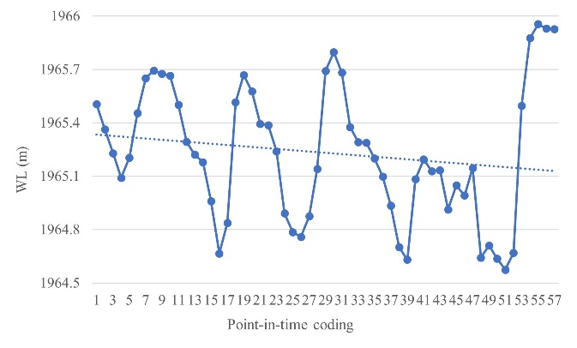

**Fig. 6. Changes in 57 WL data of the Erhai Lake from 2016 to 2020 in DAHITI database. (The numbers 1-57 represent the point in time when the data was recorded, and the recording time is available on the DAHITI website.)**

Fig. 4 show significant fluctuations in annual WL and annual WV between 1987 and 2020, with a general downward trend. Huang et al. found that WV of the Erhai Lake have a remarkable positive correlation with the annual precipitation, but significantly negative with temperature (Huang et al., 2013). Wu et al. also found that the annual pre-cipitation in the Erhai lake showed a decreasing trend (decreasing up to 87 mm/10a) during 1990-2019 (Wu et al., 2020). These has directly or indirectly led to a decrease in the amount of water entering the Erhai Lake year by year (Wu et al., 2020). In recent years, with the rapid de-velopment of tourism and agricultural economies and population growth, water de-mand in the basin is increasing every year. Another aspect, the influx of a large num-ber of people have led to the disorderly interception of streams into the lake for water intake (such as the cascade interception of eighteen streams in Cangshan Mountain). Under the joint action of human and natural factors, the amount of water flowing into the Erhai Lake is decreasing directly or indirectly, which leads to the decreasing trend of WL and WV in the study period. This also indirectly validates the rationality and ef-ficiency of our scenario in assessing WL and WV variation trends.

5. Conclusion

As the seventh largest freshwater lake in China, the Erhai Lake plays an important role in regional sustainable development and ecological environmental protection. Monitoring and analyzing changes of critical water resources information in the Erhai Lake is an urgent and necessary task. While, the measurement and evaluation of WL and WV of the Erhai Lake are faced with the problems such as cloudy coverage and data gaps. Based on multi-source data and using an integrated approach, we realized a long-term assessment of the changes in annual WL and annual WV of the Erhai Lake. The main conclusions are as follows:

(1) The combination of multi-source data is a feasible and effective method to detect changes in annual WL and annual WV. The method used in the study provide technical reference and support for the rapid assessment of annual WL and WV variation trends in other lakes lacking long-term observational data.

(2) We developed the linear regression model between WL and area, which can estimate WL for the Erhai Lake using a no-cost and simple method. And the model is a convenient and efficient water resource management tool when attempting to calculate WL in a timely and cost-effective manner.

(3) The study provides consistent long-term time-series information on annual WL and annual WV from 1987 to 2020. We found that annual WL and annual WV of the Erhai Lake fluctuated greatly, showing a downward trend during the period from 1987 to 2020.

References

Chunqiao, S., Pengfei, Z. and Ronghua, M.A. (2020). Progress in remote sensing study on lake hydrologic regime. Journal of Lake Sciences, 32, 1406-1420.

Yang, X., Wang, N., Chen, A.a., et al. (2020). Changes in area and water volume of the Aral Sea in the arid Central Asia over the period of 1960–2018 and their causes. Catena, 191.

Rinke, K., Keller, P.S., Kong, X., et al. (2019). Ecosystem Services from Inland Waters and Their Aquatic Ecosystems. In Atlas of Ecosystem Services. pp. 191-195.

Pham-Duc, B., Sylvestre, F., Papa, F., et al. (2020). The Lake Chad hydrology under current climate change. Scientific Reports, 10.

Feng, Y., Zhang, H., Tao, S., et al. (2022). Decadal Lake Volume Changes (2003–2020) and Driving Forces at a Global Scale. Remote Sensing, 14.

Kediao, H.E., Wei, G.A.O., Changqun, D., et al. (2019). Water level variation and its driving factors in Lake Dianchi, Fuxian and Yangzong during 1988-2015. Journal of Lake Sciences, 31, 1379-1390.

Yaseen, Z.M., Naghshara, S., Salih, S.Q., et al. (2020). Lake water level modeling using newly developed hybrid data intelligence model. Theoretical and Applied Climatology, 141, 1285-1300.

Woolway, R.I., Kraemer, B.M., Lenters, J.D., et al. (2020). Global lake responses to climate change. Nature Reviews Earth & Environment, 1, 388-403.

Ma, Y., Xu, N., Sun, J., et al. (2019). Estimating water levels and volumes of lakes dated back to the 1980s using Landsat imagery and photon-counting lidar datasets. Remote Sensing of Environment, 232.

Kostianoy, A.G., Lebedev, S.A., Kostianaia, E.A., et al. (2022). Interannual Variability of Water Level in Two Largest Lakes of Europe. Remote Sensing, 14.

Fang, Li, Rubinato, et al. (2019). Analysis of Long-Term Water Level Variations in Qinghai Lake in China. Water, 11.

Normandin, C., Frappart, F., Lubac, B., et al. (2018). Quantification of surface water volume changes in the Mackenzie Delta using satellite multi-mission data. Hydrology and Earth System Sciences, 22, 1543-1561.

Chipman, J. (2019). A Multisensor Approach to Satellite Monitoring of Trends in Lake Area, Water Level, and Volume. Remote Sensing, 11.

Duan, Z. and Bastiaanssen, W.G.M. (2013). Estimating water volume variations in lakes and reservoirs from four operational satellite altimetry databases and satellite imagery data. Remote Sensing of Environment, 134, 403-416.

Schwatke, C., Dettmering, D. and Seitz, F. (2020). Volume Variations of Small Inland Water Bodies from a Combination of Satellite Altimetry and Optical Imagery. Remote Sensing, 12.

Getirana, A., Jung, H.C. and Tseng, K.-H. (2018). Deriving three dimensional reservoir bathymetry from multi-satellite datasets. Remote Sensing of Environment, 217, 366-374.

Cael, B.B., Heathcote, A.J. and Seekell, D.A. (2017). The volume and mean depth of Earth's lakes. Geophysical Research Letters, 44, 209-218.

Zhan, P., Song, C., Luo, S., et al. (2022). Lake Level Reconstructed From DEM-Based Virtual Station: Comparison of Multisource DEMs With Laser Altimetry and UAV-LiDAR Measurements. IEEE Geoscience and Remote Sensing Letters, 19, 1-5.

Zheng, L., An, Z., Chen, X., et al. (2021). Changes in Water Environment in Erhai Lake and Its Influencing Factors. Water, 13.

Wu, H., Wang, S., Wu, T., et al. (2020). Assessing the Influence of Compounding Factors to the Water Level Variation of Erhai Lake. Water, 13.

Gownaris, N.J., Rountos, K.J., Kaufman, L., et al. (2018). Water level fluctuations and the ecosystem functioning of lakes. Journal of Great Lakes Research, 44, 1154-1163.

Crétaux, J.F., Abarca-del-Río, R., Bergé-Nguyen, M., et al. (2016). Lake Volume Monitoring from Space. Surveys in Geophysics, 37, 269-305.

Schwatke, C., Dettmering, D., Bosch, W., et al. (2015). DAHITI – an innovative approach for estimating water level time series over inland waters using multi-mission satellite altimetry. Hydrology and Earth System Sciences, 19, 4345-4364.

Qiu, S., He, B., Zhu, Z., et al. (2017). Improving Fmask cloud and cloud shadow detection in mountainous area for Landsats 4–8 images. Remote Sensing of Environment, 199, 107-119.

Chen, Y. and Yu, S. (2016). Assessment of urban growth in Guangzhou using multi-temporal, multi-sensor Landsat data to quantify and map impervious surfaces. International Journal of Remote Sensing, 37, 5936-5952.

Xu, H. (2007). Modification of normalised difference water index (NDWI) to enhance open water features in remotely sensed imagery. International Journal of Remote Sensing, 27, 3025-3033.

Lee, C.-M., Kuo, C.-Y., Yang, C.-H., et al. (2022). Assessment of hydrological changes in inland water body using satellite altimetry and Landsat imagery: A case study on Tsengwen Reservoir. Journal of Hydrology: Regional Studies, 44.

Zhang, C., Lv, A., Zhu, W., et al. (2021). Using Multisource Satellite Data to Investigate Lake Area, Water Level, and Water Storage Changes of Terminal Lakes in Ungauged Regions. Remote Sensing, 13.

Li, Y., Yang, W., Li, J., et al. (2022). A Novel Method for Mapping Lake Bottom Topography Using the GSW Dataset and Measured Water Level. Remote Sensing, 14.

Huang, H., Wang, Y. and Li, Q. (2013). Climatic Characteristics over Erhai Lake Basin in the Last 50 Years and the impact on Water Resources of Erhai Lake. Meteorological Monthly, 39, 436-442.