***Original Research Article***

**Efficacy of biofilm forming isolates for sewage treatment**

.

ABSTRACT

|  |
| --- |
| **Aim:** The present work on biofilm examined the various applications of biofilm isolates in the sewage treatment by utilizing their capabilities to form biofilm.  **Study design:** The biofilm samples were collected from various locations, brought to the laboratory for analysis followed by the isolation and identification of bacterial isolates. Among the isolates, *Pseudomonas aeruginosa* surface attached biofilm was utilized for sewage treatment and was subjected to pH, Total Suspended Solids (TSS), Dissolved Oxygen (DO), Biological Oxygen Demand (BOD) and Chemical Oxygen Demand (COD) analysis prior to and following the treatment.  **Place and Duration of Study:** The study was conducted in the Department of Microbiology, Sree Narayana Guru College of Arts and Science, Coimbatore for duration of 6 months.  **Methodology:** Biofilm-forming bacteria were isolated, identified and among them, Pseudomonas aeruginosa, which was identified by biochemical analysis and MALDI biotyping, was employed for their possible applications in the treatment of sewage. Prior to and following the treatment by means of surface-attached biofilm, the water samples have been observed to find out the pH, Total Suspended Solids, Dissolved Oxygen, Biological Oxygen Demand and Chemical Oxygen Demand levels in order to detect the level of pollution.  **Results:** It was noted that pH, TSS, BOD and COD were considerably declined and DO was elevated in the sewage sample after the treatment with *Pseudomonas* biofilm signifying its potential for remediation of waste water.  **Conclusion:** The results showed that the concentrations of pollutants were decreased following the treatment with biofilm. This report suggests that the procedure used to treat waste water effluents was satisfactory. During the water treatment procedure, organic compounds in the sewage sample were consumed and removed by organisms present in the surface-attached biofilm, representing this technology as a cost-effective and environmental friendly solution for managing the wastewater. |

*Keywords: BOD, COD, MALDI biotyping,* Pseudomonas aeruginosa

1. INTRODUCTION

Complex populations of bacteria are recognized as biofilms which are embedded in an extracellular polymeric matrix (EPS) and they form on various surfaces1. External factors such as pH, gravitational forces, hydrodynamic forces, temperature, Brownian motion, type of surfaces inhabited, secondary messengers, quorum sensing, and other signalling molecules have an impact on the entire biofilm development process2. The attachment or separation, growth & maturity are the three main stages of biofilm formation process3. The development of biofilms on biotic or abiotic surfaces is the end result of microbial cells from a single or multiple species. According to4, microbes are protected from the detrimental chemical reactions, antimicrobial agents and harsh environmental conditions by biofilm.

Majority of the time, biofilms are formed on solid substrates in aqueous solutions. According to1, they are usually established in a range of natural and man-made circumstances, such as industrial setting and medical devices which may cause both positive and negative impacts. A wide variety of surfaces, including medical equipments, industrial/potable water pipelines, biological tissues and natural aquatic environments, can develop Biofilms5. Numerous microorganisms have the potential to generate biofilms6. The microorganisms that are enclosed in the biofilm are not affected by antibiotic treatments. The EPS generated by bacterial isolates in the biofilm functions as a physical or chemical barrier in order to stop the antibodies and many different antibiotics from penetrating the cell 7.

Biofilms are not always hazardous. The biofilm approach has emerged as one of the most widely used wastewater treatment technologies in recent years due to its advantages of increased microbial biomass, greater variety of microbial species and enhanced treatment efficiency8. Better oxygen dispersion, faster rates of organic contaminant breakdown, larger surface areas, and shorter hydraulic retention times are among the benefits that biofilm-based waste water treatment technologies have demonstrated over suspended biological treatment methods9. The principal contaminants in waste water include suspended particles, soluble organic matter, and faecal pathogenic bacteria; however, waste is not limited to human faeces and water. Sewage may also detect a wide range of pollutants, including trace elements, pesticides, detergents, heavy metals, solvents etc. Water, Energy and food security have become an increasingly vital challenge for India and the rest of the world10. The present study intends to isolate, identify, and characterize the bacterial species identified in biofilms collected from different ecosystems and to treat sewage by surface-attached biofilm isolates.

2. material and methods

**Collection of Sample**

With the assistance of sterile cotton swabs, samples were collected from various locations such as sewage, floors, otitis media, wounds, contact lenses, dental plaque, poultry processing environments, rocks, waste water pipes, and urinary catheters. The samples were then stored in pre-sterilized test tubes containing sterile peptone broth and brought to the laboratory for analysis.

**Processing of Samples**

Samples were plated onto sterile, adequately labelled Nutrient agar plates. The plates were incubated at 370C for duration of 24 hours and the results were observed after the incubation time.

**Isolation of Bacteria**

A variety of selective media were created and sterilised, including FDA medium, blood agar, MacConkey agar, Bismuth sulphite agar, Eosine methylene blue agar, and mannitol salt agar and plated on to sterilized petriplates. These plates were streaked with the isolated colonies from Nutrient Agar plates. Following that, the plates were incubated for 24 hrs at 370C. Colony morphology was studied following the incubation period.

**Identification of Bacteria**

The isolated organisms were subsequently verified by gram staining, biochemical analysis, motility testing and further by Bruker Daltonik MALDI biotyping11.

**Sewage treatment using Surface attached Biofilm**

**Preparation of Surface attached Biofilm**

A sterile 250 ml beaker was filled with 20–30 ml of sterile nutritional broth and 200 ml of sterile distilled water. A sterile forceps was used to submerge 10-15 pieces of aluminium foil in the beaker. The beaker was left at room temperature for one hour. Subsequently, a beaker containing 1 ml of bacterial culture (identified as *Pseudomonas aeruginosa* by Bruker Daltonik MALDI Biotyping) was added to the beaker and covered. A setup for the formation of biofilm was seen following a 15-day incubation period.

**Sewage treatment**

Prior to treatment, the biological oxygen demand, or BOD, of the sewage water was measured. Using sterile forceps, the above-prepared biofilm of *Pseudomonas* sp was removed and added to the sewage water sample collected in the conical flasks. After that, the flasks were stored at room temperature for incubation.

**Methods to analyze the efficiency of Sewage Treatment**

1. **pH**

The pH of the sewage sample treated with the biofilm was evaluated using a digital pH meter.

1. **Methods of analysis of solids in waste water sample**

Before evaporation, the sample was filtered to extract total and dissolved solids. Filtration was used to recover suspended residues. The fixed residue represents the total solids produced after one hour of combustion.

$$Total solids mg/l =\frac{increase in weight in mg }{ml of sample taken}$$

1. **Suspended and dissolved solids (SS & DS)**

A known quantity of sample was placed in a dry dish and evaporated to achieve a consistent weight at 103°C in an oven to guarantee dryness. After allowing it to cool the dry dish was measured.

$$Total dissolved solids mg/l = \frac{mg of residue x 1000 }{ml of sample taken}$$

$$Suspended solids mg/l = total solids (TS) – total dissolved solids (TDS)$$

1. **Determination of dissolved oxygen in liquid sample**

Winkler's method was performed to determine the dissolved oxygen levels (Kumar *et al*., 2020).

1. **BOD & COD Analysis of treated water sample**

BOD examination was carried out in the treated water samples, which is based on the concept of aerobic decay of biodegradable organic materials present in the sample by microorganisms 12,13. The reducing components which are present in the sample were oxidized by using potassium dichromate solution in an acidic media and were measured calorimetrically to analyze the COD13.

3. results and discussion

**Isolation and Identification of Bacterial species from Biofilm samples**

A total of 18 samples were collected and were processed under sterile conditions to avoid contamination. The samples were plated on to nutrient agar (Figure 1, 2, 3, 4, 5 & 6) and the well isolated colonies from nutrient agar were cultured in various selective media. The colonies were subjected to morphological, cultural characteristics, biochemical and Maldi-Toff analysis. The results of the above analysis are given in the table 1,2,3,4, 5 & 6.

Fig 1-6: **Isolation and Identification of Bacterial species using petri plats method**

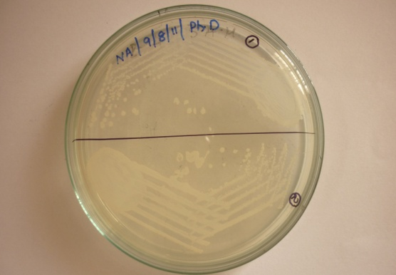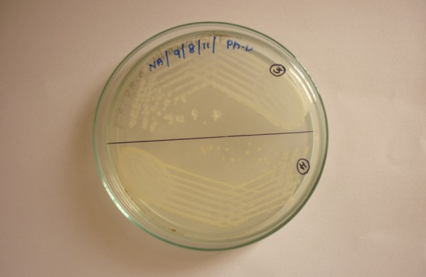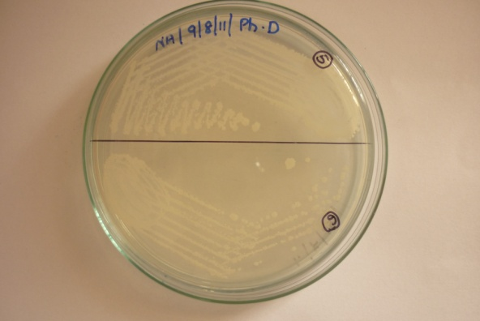

Fig. 3

Fig. 2

Fig. 1

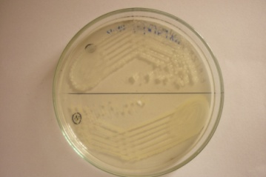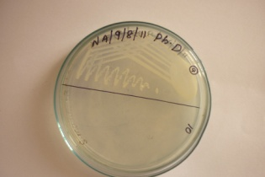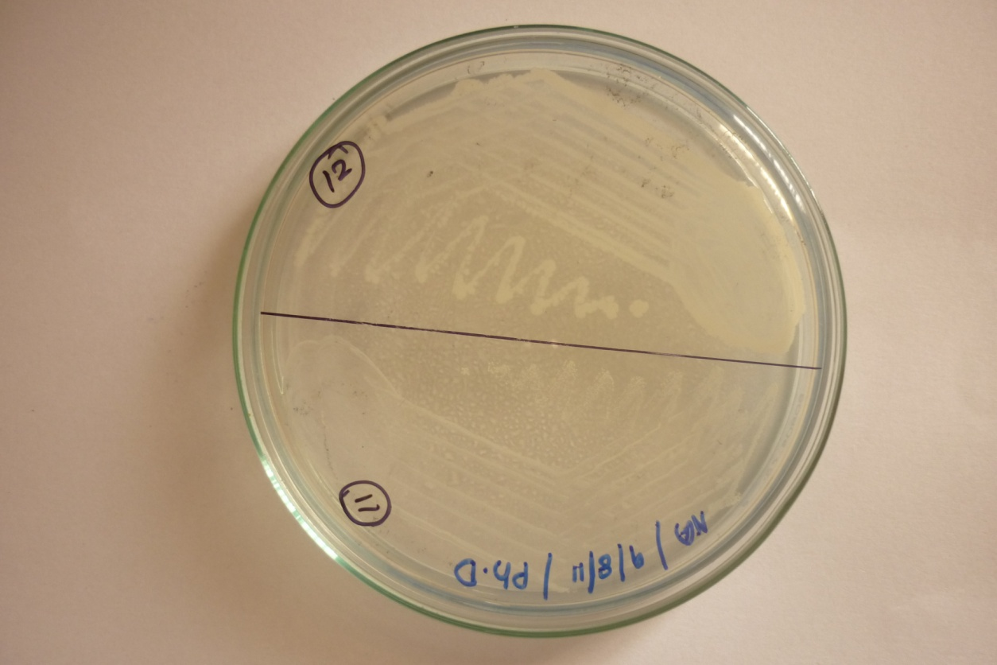

Fig. 6

Fig. 5

Fig. 4

**Table 1: Bacterial species isolated from different Biofilm samples**

|  |  |  |
| --- | --- | --- |
| **NO.** | **BIOFILM SAMPLES** | **BACTERIAL SPECIES ISOLATED** |
| **I.** | **Urinary catheter** |  |
|  | Sample 1  Sample 2  Sample 3 | Coagulase negative *Staphylococcus*  *Escherichia coli*  Coagulase negative *Staphylococcus*  *Pseudomonas aeruginosa*  *Klebsiella* sp |
| **II.** | **Wound** |  |
|  | Sample 1  Sample 2 | *Staphylococcus aureus*  *Staphylococcus aureus*  *Pseudomonas aeruginosa* |
| **III.** | **Dental plaque** |  |
|  | Sample 1  Sample 2 | *Streptococcus sp*  *Streptococcus sp* |
| **IV.** | **Contact lens** |  |
|  | Sample 1 | *Pseudomonas aeruginosa* |
| **V.** | **Otitis media** |  |
|  | Sample 1  Sample 2 | *Streptococcus* sp  *Pseudomonas aeruginosa*  *Streptococcus sp* |
| **VI.** | **Rocks** |  |
|  | Sample 1  Sample 2 | *Pseudomonas fluorescens*  *Micrococcus* sp  *Micrococcus* sp  *Escherichia coli* |
| **VII.** | **Waste water pipes** |  |
|  | Sample 1  Sample 2 | *Pseudomonas aeruginosa*  *Micrococcus sp*  *Escherichia coli* |
| **VIII.** | **Poultry processing environment** |  |
|  | Sample 1  Sample 2 | *Salmonella* sp  *Salmonella* sp  *Escherichia coli* |
| **IX.** | **Floors** |  |
|  | Sample 1  Sample 2 | *Pseudomonas fluorescens*  *Micrococcus* sp  *Pseudomonas fluorescens* |

**Table 2: Morphological characters of Isolated Microorganisms**

|  |  |  |  |  |
| --- | --- | --- | --- | --- |
| **No.** | **Bacterial species** | **Gram staining** | **Spore staining** | **Motility test** |
| 1. | *Staphylococcus aureus* | Gram positive cocci in clusters | Non spore forming | Non motile |
| 2. | Coagulase negative *Staphylococcus* | Gram positive cocci in clusters | Non spore forming | Non motile |
| 3. | *Streptococcus* sp | Gram positive cocci in chains | Non spore forming | Non motile |
| 4. | *Micrococcus* sp | Gram positive cocci in tetrads or clusters | Non spore forming | Non motile |
| 5. | *Escherichia coli* | Gram negative rods singly or in pairs | Non spore forming | Motile |
| 6. | *Klebsiella* sp | Gram negative rods | Non spore forming | Non motile |
| 7. | *Salmonella* sp | Gram negative rods | Non spore forming | Motile |
| 8. | *Pseudomonas fluorescens* | Gram negative rods | Non spore forming | Motile |
| 9. | *Pseudomonas aeruginosa* | Gram negative rods | Non spore forming | Motile |

**Table 3: Cultural characteristics of Isolated Bacterial species**

|  |  |  |
| --- | --- | --- |
| **I. *Staphylococcus* sp** | | |
| 1.  2.  3.  4. | Nutrient agar  Blood agar  Mac Conkey agar  Mannitol salt agar | Large, round, smooth, glistering, golden yellow colonies  Large, round, smooth, glistering colonies with β- hemolysis  Small, pin headed, pink coloured colonies  Bright yellow colonies |
| **II. *Micrococcus* sp** | | |
| 1.  2. | Nutrient agar  Micrococcus FDA medium | Small, round, convex, yellow coloured colonies  Small, round, convex, yellow coloured colonies |
| **III. *Streptococcus* sp** | | |
| 1.  2. | Nutrient agar  Blood agar | Circular, pin point, translucent colonies  Small, circular, semitransparent, low convex disc with an area of clear hemolysis (β) around the colonies |
| **IV. *Escherichia coli*** | | |
| 1.  2.  3. | Nutrient agar  Mac Conkey agar  EMB agar | Large, circular, low convex, smooth, grayish white translucent colonies  Pink coloured colonies (lactose fermenters)  Small, smooth colonies with green metallic sheen |
| **V*. Klebsiella* sp** | | |
| 1.  2. | Nutrient agar  Mac Conkey agar | Large, dome shaped colonies  Pink, mucoid colonies (lactose fermenters) |
| **VI. *Salmonella* sp** | | |
| 1.  2.  3.  4. | Nutrient agar  Mac Conkey agar  SS agar  Bismuth Sulphite agar | Large, circular, low convex, smooth, translucent colonies  Colourless colonies ( non lactose fermenters)  Black centered pink edged colonies  Jet black colonies |

|  |  |  |
| --- | --- | --- |
| ***VII. Pseudomonas fluorescens*** | | |
| 1.  2.  3.  4. | Nutrient agar  Mac Conkey agar  Blood agar  Cetrimide agar | Green coloured sheen which fluoresce in UV light  Pale coloured colonies  Small, pin headed, grey coloured colonies, but no hemolysis  Green coloured colonies |
| **VIII. *Pseudomonas aeruginosa*** | | |
| 1.  2.  3.  4. | Nutrient agar  Mac Conkey agar  Blood agar  Cetrimide agar | Large, opaque, irregular green coloured colonies with a distinctive, musty, mawkish or earthy smell  Pale coloured colonies  Large, flat, spreading colonies which are often hemolytic and usually pigment producing, giving a dark greenish- blue colour  Bluish green colonies |

**Table 4: Morphological and Biochemical analysis of *Pseudomonas aeruginosa***

|  |  |  |
| --- | --- | --- |
| **S.No.** | **Experiment** | ***Pseudomonas aeruginosa*** |
| 1. | Gram's staining | Negative |
| 2. | Capsule | Non-capsulated |
| 3. | Gas-production | Negative |
| 4. | Hemolysis | Beta Hemolytic |
| 5. | Indole | Negative |
| 6. | Methyl Red | Negative |
| 7. | Voges Proskauer | Negative |
| 8. | Citrate | Positive |
| 9. | Motility | Motile |
| 10. | Oxidase | Positive |
| 11. | Shape | Rod |
| 12. | Spore | Non-spore former |
| 13. | Triple sugar ion test | Alkali |
| 14. | Urease | Negative |
| 15. | Carbohydrate fermentation  Fructose  Glucose  Sucrose  Maltose | Positive  Positive  Negative  Negative |

**Table 5: Maldi-Toff Result Overview**

|  |  |  |  |  |  |
| --- | --- | --- | --- | --- | --- |
| **Analyte Name** | **Analyte ID** | **Organism (best match)** | **ScoreValue** | **Organism (second best match)** | **ScoreValue** |
| [F1](mhtml:file://J:\240513_Batch%20III%20Nehru%20college.mht!file:///C:\Documents%20and%20Settings\Administrator\Application%20Data\Bruker%20Daltonik\MALDIBiotyperAutomationControl\HtmpResults\240513_Batch%20III%20Nehru%20college.html#ID0EDDA)**( - ) ( C )** | MG2 | not reliable identification | [1.539](mhtml:file://J:\240513_Batch%20III%20Nehru%20college.mht!file:///C:\Documents%20and%20Settings\Administrator\Application%20Data\Bruker%20Daltonik\MALDIBiotyperAutomationControl\HtmpResults\240513_Batch%20III%20Nehru%20college.html#ID0EA) | not reliable identification | [1.406](mhtml:file://J:\240513_Batch%20III%20Nehru%20college.mht!file:///C:\Documents%20and%20Settings\Administrator\Application%20Data\Bruker%20Daltonik\MALDIBiotyperAutomationControl\HtmpResults\240513_Batch%20III%20Nehru%20college.html#ID0EA) |
| [F2](mhtml:file://J:\240513_Batch%20III%20Nehru%20college.mht!file:///C:\Documents%20and%20Settings\Administrator\Application%20Data\Bruker%20Daltonik\MALDIBiotyperAutomationControl\HtmpResults\240513_Batch%20III%20Nehru%20college.html#ID0ECDA)**( - ) ( C )** | FG2 | not reliable identification | [1.413](mhtml:file://J:\240513_Batch%20III%20Nehru%20college.mht!file:///C:\Documents%20and%20Settings\Administrator\Application%20Data\Bruker%20Daltonik\MALDIBiotyperAutomationControl\HtmpResults\240513_Batch%20III%20Nehru%20college.html#ID0EA) | not reliable identification | [1.263](mhtml:file://J:\240513_Batch%20III%20Nehru%20college.mht!file:///C:\Documents%20and%20Settings\Administrator\Application%20Data\Bruker%20Daltonik\MALDIBiotyperAutomationControl\HtmpResults\240513_Batch%20III%20Nehru%20college.html#ID0EA) |
| [F3](mhtml:file://J:\240513_Batch%20III%20Nehru%20college.mht!file:///C:\Documents%20and%20Settings\Administrator\Application%20Data\Bruker%20Daltonik\MALDIBiotyperAutomationControl\HtmpResults\240513_Batch%20III%20Nehru%20college.html#ID0EBDA)**( - ) ( C )** | MG1 | not reliable identification | [1.563](mhtml:file://J:\240513_Batch%20III%20Nehru%20college.mht!file:///C:\Documents%20and%20Settings\Administrator\Application%20Data\Bruker%20Daltonik\MALDIBiotyperAutomationControl\HtmpResults\240513_Batch%20III%20Nehru%20college.html#ID0EA) | not reliable identification | [1.296](mhtml:file://J:\240513_Batch%20III%20Nehru%20college.mht!file:///C:\Documents%20and%20Settings\Administrator\Application%20Data\Bruker%20Daltonik\MALDIBiotyperAutomationControl\HtmpResults\240513_Batch%20III%20Nehru%20college.html#ID0EA) |
| [F4](mhtml:file://J:\240513_Batch%20III%20Nehru%20college.mht!file:///C:\Documents%20and%20Settings\Administrator\Application%20Data\Bruker%20Daltonik\MALDIBiotyperAutomationControl\HtmpResults\240513_Batch%20III%20Nehru%20college.html#ID0EADA)**( +++ ) ( A )** | HG2 | *Pseudomonas aeruginosa* | [2.357](mhtml:file://J:\240513_Batch%20III%20Nehru%20college.mht!file:///C:\Documents%20and%20Settings\Administrator\Application%20Data\Bruker%20Daltonik\MALDIBiotyperAutomationControl\HtmpResults\240513_Batch%20III%20Nehru%20college.html#ID0EA) | *Pseudomonas aeruginosa* | [2.216](mhtml:file://J:\240513_Batch%20III%20Nehru%20college.mht!file:///C:\Documents%20and%20Settings\Administrator\Application%20Data\Bruker%20Daltonik\MALDIBiotyperAutomationControl\HtmpResults\240513_Batch%20III%20Nehru%20college.html#ID0EA) |

**Table 6: Maldi-Toff Matched Pattern**

|  |  |  |  |
| --- | --- | --- | --- |
| **Rank (Quality)** | **Matched Pattern** | **Score Value** | **NCBI Identifier** |
| 1 **( +++ )** | *Pseudomonas aeruginosa* ATCC 27853 THL | 2.357 | [287](http://www.ncbi.nlm.nih.gov/Taxonomy/Browser/wwwtax.cgi?mode=info&id=287) |
| 2 **( ++ )** | *Pseudomonas aeruginosa* 19955_1 CHB | 2.216 | [287](http://www.ncbi.nlm.nih.gov/Taxonomy/Browser/wwwtax.cgi?mode=info&id=287) |
| 3 **( ++ )** | *Pseudomonas aeruginosa* DSM 50071T HAM | 2.119 | [287](http://www.ncbi.nlm.nih.gov/Taxonomy/Browser/wwwtax.cgi?mode=info&id=287) |

A biofilm is a self-produced, organized community of bacteria that produces a matrix made of protein, [polysaccharides](https://www.sciencedirect.com/topics/agricultural-and-biological-sciences/polysaccharide), and extracellular DNA around itself 14. Formation of biofilm comprised of five main steps; (i) reversible adhesion of bacteria with the substrate (ii) irreversible adhesion of bacteria to the substrate (iii) EPS synthesis (iv) maturation of biofilm, and (v) dispersal/detachment of the biofilm15. Recently, a new, simpler biofilm model, going beyond the classical five-step model, was proposed 16. On Earth, over 99% of bacteria are thought to live in structured biofilm communities 17. According to the Centres for Disease Control and Prevention, bacteria developing in biofilms cause over 65% of infections. It is estimated that 60% of all food-borne epidemics are caused by biofilms15.

The present work deals with the isolation, identification and characterization of bacterial species from various biofilm samples and sewage treatment using surface attached biofilm. For the isolation and characterization of bacterial species present in various biofilm samples, samples were collected from different sources and were processed under sterile conditions for the isolation of bacteria. The bacterial species isolated from biofilm samples were *Staphylococcus aureus*, Coagulase negative *Staphylococcus*, *Micrococcus* sp, *Streptococcus* sp, *Escherichia coli*, *Salmonella* sp, *Klebsiella* sp, *Pseudomonas aeruginosa* and *Pseudomonas fluorescens.* Among the isolates, the isolate *Pseudomonas aeruginosa* which was identified by MALDI Biotyping was used for preparing surface attached biofilm for sewage treatment.

Biofilms can form on a wide range of surfaces, such as food, teeth, rocks submerged in water, and different types of biomedical implants5. According to18, there were various circumstances when the production of biofilms was harmful. Bacterial biofilms may have beneficial effects in addition to negative ones; these positive effects are now employed as biological control agents for wastewater treatment19 and bioremediation treatment of hazardous chemicals20. It is evident that, in some circumstances, biofilms protect bacteria from the environment and improve their adaptability to it21.

**Sewage treatment using surface attached Biofilm**

Following a 15-day incubation period, it was noticed that the *Pseudomonas aeruginosa* biofilm was found to be developed on the aluminum foil pieces. On each incubation day, a noticeable change in colour or decrease in colour was observed. Following the incubation time, a clear solution with transparency was developed.

**Characteristics of effluents and efficiency of Treatment**

The parameters such as pH, DO, TSS, BOD and COD before and after treatment analyzed in this study are given in the table. Reduction in pH, TSS, BOD, COD and increased level of DO were observed in the sewage sample after treatment with *Pseudomonas* biofilm. The results of the analysis are mentioned in the table 7.

**Table 7: Characteristics of effluents and efficiency of Treatment**

|  |  |  |
| --- | --- | --- |
| **Parameters** | **Before treatment** | **After treatment** |
| pH | 6.81 | 5.43 |
| DO | 3.52 | 7.8 |
| TSS | 148.53 | 36.25 |
| BOD | 179.33 | 5.73 |
| COD | 350.32 | 69.83 |

Reduction in pH, TSS, BOD, COD and increased level of DO were observed in the sewage sample after the treatment with surface attached biofilm formed by   
*Pseudomonas aeruginosa*. Similar findings were reported by10 in which waste water parameters such as pH, TSS, BOD, COD were dramatically reduced and dissolved oxygen was elevated after the treatment of the waste water treatment plant. The results showed that the concentrations of pollutants were decreased following the treatment with biofilm. This shows that the procedure used to treat waste water effluents was satisfactory. According to1, the most significant application of biofilms is probably in the bioremediation of wastewater. This is due to the fact that organic compounds in the water are consumed and removed by the organisms in the surface-attached biofilm during treatment. Because of their excellent capacity to eliminate contaminants, biofilm have been utilized for wastewater treatment for several years now22. According to23, biofilm-based waste water treatment technologies are utilised to remove organic and nitrogenous pollutants from wastewater.

Petroleum-based companies have generated hydrocarbons in marine environments that can be removed by a number of bacteria such as *Pseudomonas*, *Arthrobacter*, *Alcanivorax*, *Cyclocasticus*, *Bacillus*, and *Rhodococcus* species24. Microbial biofilms present a significant health risk in wastewater; nevertheless, these biofilms also seem to have the ability to remediate the wastewater25. Water that has been treated using an alternate method is likely to have more microbiological contamination than water that has gone through a biofilm-based filter. Bioremediation and wastewater treatment processes using Biofilm depend heavily on the breakdown of various organic and inorganic pollutants22.

Waste from industrial activity has been generated internationally and continues to be created and disposed, resulting in contaminated surroundings. To tackle the problem, numerous remediation solutions have been launched; however these approaches require qualified professionals and may potentially introduce toxic compounds into the environment.  Biofilm removes metal contamination from the environment via cell signalling and quorum sensing26.  Water that has been treated with chlorine is safe to drink, but it may still be an odd colour, smell terrible, and taste bad. So, drinking water utilities go to tremendous efforts to offer us with the type of drinking water we want. In comparison to suspended growth-based technologies, biofilm-based technology has emerged as a viable option for treating industrial wastewater27.

If wastewater with high quantities of BOD, COD, and TSS were dumped into the water bodies, the water becomes highly polluted. To address this issue, the results suggest that the sewage treatment using biofilm is an economically viable method for treating municipal waste water effluents before they are dumped into the oceans or rivers. Biofilms are gaining significance in the degradation of organic contaminants, primarily because they offer eco-friendly, cost-effective, and green technologies4. Biofilm-based water treatments plants are extremely effective and are energy-efficient28. Regular monitoring and optimization are required to ensure the long-term efficiency of treatment systems based on biofilms.

4. Conclusion

According to the current study, use of *Pseudomonas aeruginosa* biofilm for treatment is a useful strategy for improving the quality of sewage. Following the sewage treatment with biofilm, BOD and COD was dramatically reduced and Dissolved oxygen was elevated, representing an increased level of organic matter removal. Sewage treatment by means of biofilm is an effective and cost effective technology. This approach shows promise as a practical bioremediation and water treatment method, offering a cost-effective and environment friendly wastewater management alternative. Further research could improve the conditions essential for biofilm formation and evaluate its effectiveness with alternative bacterial strains and substrates. It is also necessary to investigate the possibility of scaling up the biofilm-based therapy for large-scale sewage treatment applications.

Consent (where ever applicable)

Not Applicable

Ethical approval (where ever applicable)

Not Applicable

References

1. [Asghar Ali](https://pubmed.ncbi.nlm.nih.gov/?term=Ali%20A%5BAuthor%5D),[Andaleeb Zahra](https://pubmed.ncbi.nlm.nih.gov/?term=Zahra%20A%5BAuthor%5D), [Mohan Kamthan](https://pubmed.ncbi.nlm.nih.gov/?term=Kamthan%20M%5BAuthor%5D),[Fohad Mabood Husain](https://pubmed.ncbi.nlm.nih.gov/?term=Husain%20FM%5BAuthor%5D), [Thamer Albalawi](https://pubmed.ncbi.nlm.nih.gov/?term=Albalawi%20T%5BAuthor%5D), [Mohammad Zubair](https://pubmed.ncbi.nlm.nih.gov/?term=Zubair%20M%5BAuthor%5D), [Roba Alatawy](https://pubmed.ncbi.nlm.nih.gov/?term=Alatawy%20R%5BAuthor%5D), [Mohammad Abid](https://pubmed.ncbi.nlm.nih.gov/?term=Abid%20M%5BAuthor%5D) and [Md Salik Noorani](https://pubmed.ncbi.nlm.nih.gov/?term=Noorani%20MS%5BAuthor%5D). (2023). Microbial Biofilms: Applications, Clinical Consequences, and Alternative Therapies. [Microorganisms](https://www.ncbi.nlm.nih.gov/pmc/?term=%22Microorganisms%22%5bjournal%5d), 11(8):1934. [10.3390/microorganisms11081934](https://doi.org/10.3390/microorganisms11081934).
2. Zhao, X., Zhao, F., Wang, J., & Zhong, N. (2017). Biofilm formation and control strategies of food borne pathogens: food safety perspectives. RSC Advances*,* 7, 36670–36683. 10.1039/c7ra02497e.

# Jun Wei, Xiao Huang, Hongjie Wang, Fupeng Wang, Xueyong Liu, Yu Yan, Yanhu Qu. (2023). Insight into biofilm formation of wastewater treatment processes: Nitrogen removal performance and biological mechanisms*.* [Science of the total Environment](https://www.sciencedirect.com/journal/science-of-the-total-environment), [903](https://www.sciencedirect.com/journal/science-of-the-total-environment/vol/903/suppl/C), 166550. <https://doi.org/10.1016/j.scitotenv.2023.166550>.

1. [Indranil Chattopadhyay](https://pubmed.ncbi.nlm.nih.gov/?term=Chattopadhyay%20I%5BAuthor%5D),[Rajesh Banu, J](https://pubmed.ncbi.nlm.nih.gov/?term=J%20RB%5BAuthor%5D), [Mohamed Usman](https://pubmed.ncbi.nlm.nih.gov/?term=Usman%20TM%5BAuthor%5D), T.M.,& [Sunita Varjani](https://pubmed.ncbi.nlm.nih.gov/?term=Varjani%20S%5BAuthor%5D). (2022). Exploring the role of microbial biofilm for industrial effluents treatment. Bioengineered, 13(3), 6420–6440. 10.1080/21655979.2022.2044250.
2. Rodney M Donlan. (2001). Biofilms and Device Associated Infections. Emerging Infectious Diseases, 7(2): 277–281. [10.3201/eid0702.010226](https://doi.org/10.3201/eid0702.010226).
3. George, O’ Toole., Kaplan, H.B., & Kolter, R. (2000). Biofilm formation as Microbial Development. [Annual Review of Microbiology, 54, 49-79.](https://www.annualreviews.org/content/journals/micro)[[10.1146/annurev.micro.54.1.49](https://www.annualreviews.org/content/journals/micro)](https://doi.org/10.1146/annurev.micro.54.1.49)[.](https://www.annualreviews.org/content/journals/micro)
4. Spoering, A., & Lewis, K. (2001). Biofilms and planktonic cells of *Pseudomonas aeruginosa* have similar resistance to killing by Antimicrobials. Journal of Bacteriology, 183(123), 6746-6751. 10.1128/JB.183.23.6746-6751.2001.
5. Yuan, J., Ma, J., Sun, Y., *et al*., (2020).  Microbial degradation and other environmental aspects of microplastics/plastics. Science of the Total Environment, 715:136968. <https://doi.org/10.1016/j.scitotenv.2020.136968>.
6. Abdelfattah, A., Hossain, MI. & Cheng, L. (2020). High-strength wastewater treatment using microbial cbiofilm reactor: a critical review. World Journal of Microbiology and Biotechnology, 36 (5), 1–10. [10.1007/s11274-020-02853-y](https://doi.org/10.1007/s11274-020-02853-y).
7. Kumar Chetan, Sharma Devender, Thakur Manisha , Sharma Chaman. (2020). Comparative Study of Wastewater Parameters before and After Treatment of WWTP –A Case Study*.* International Journal of Research in Engineering and Science (IJRES)*,* 8(10), 58-63.

# [Neelja Singhal](https://pubmed.ncbi.nlm.nih.gov/?term=%22Singhal%20N%22%5BAuthor%5D) , [Manish Kumar](https://pubmed.ncbi.nlm.nih.gov/?term=%22Kumar%20M%22%5BAuthor%5D) , [Pawan K Kanaujia](https://pubmed.ncbi.nlm.nih.gov/?term=%22Kanaujia%20PK%22%5BAuthor%5D) , &  [Jugsharan S Virdi](https://pubmed.ncbi.nlm.nih.gov/?term=%22Virdi%20JS%22%5BAuthor%5D). (2015). MALDI-TOF mass spectrometry: an emerging technology for microbial identification and diagnosis. Frontiers in Microbiology, 6:791. 10.3389/fmicb.2015.00791.

1. Morin-Crini, N., & Crini, G. (2017). “Eaux industrielles contaminées,” in Réglementation, paramètres chimiques et biologiques, procédés d’épuration innovants (in French). Editors N. Morin-Crini, and G. Crini (France: Besançon: Presses Universitaires de Franche-Comté). IBSN: 978-2-84867-589-3.
2. Lacalamita, D., Mongiovi, C., & Crini, G. (2023). Chemical substances present in discharge water generated by laundry: analytical monitoring. Water Science and Engineering, 16, 324-332, 10.1016/j.wse.2023.07.004.

# Pallee Shree, Chandra Kant Singh, Kushneet Kaur Sodhi, Jaya Niranjane Surya, & Dileep Kumar Singh. (2023). Biofilms: Understanding the structure and contribution towards bacterial resistance in antibiotics, [16](https://www.sciencedirect.com/journal/medicine-in-microecology/vol/16/suppl/C):100084, <https://doi.org/10.1016/j.medmic.2023.100084>.

1. Muhammad, M.H., Idris, A.L., Fan, X., Guo, Y., Yu, Y., Jin, X., Qiu, J., Guan, X., & Huang, T. (2020). Beyond risk: bacterial biofilms and their regulating approaches. Frontiers in Microbiology, 11:928, <https://doi.org/10.3389/fmicb.2020.00928>.

# [Karin Sauer](https://www.nature.com/articles/s41579-022-00767-0#auth-Karin-Sauer-Aff1-Aff2), [Paul Stoodley](https://www.nature.com/articles/s41579-022-00767-0#auth-Paul-Stoodley-Aff3-Aff4-Aff5-Aff6), [Darla M. Goeres](https://www.nature.com/articles/s41579-022-00767-0#auth-Darla_M_-Goeres-Aff7), [Luanne Hall-Stoodley](https://www.nature.com/articles/s41579-022-00767-0#auth-Luanne-Hall_Stoodley-Aff3), [Mette Burmølle](https://www.nature.com/articles/s41579-022-00767-0#auth-Mette-Burm_lle-Aff8), [Philip S. Stewart](https://www.nature.com/articles/s41579-022-00767-0#auth-Philip_S_-Stewart-Aff7) & [Thomas Bjarnsholt](https://www.nature.com/articles/s41579-022-00767-0#auth-Thomas-Bjarnsholt-Aff9-Aff10). (2022). The biofilm life cycle: expanding the conceptual model of biofilm formation. Nature Reviews Microbiology, 20, 608–620.

1. Tasneem, U., Yasin, N., Nisa, I., Faisal Shah, Ubaid Rasheed et al., (2018). Biofilm producing bacteria: A serious threat to public health in developing countries. Journal of Food Science and Nutrition, 1(2), 25-31. [10.35841/food-science.1.2.25-31](https://doi.org/10.35841/food-science.1.2.25-31).
2. Coughlan, L.M., Cotter, P.D., Hill, C., & Alvarez-Ordonez. (2016). A. New weapons to fight old enemies: novel strategies for the (Bio) control of bacterial biofilms in the food industry. Frontiers in Microbiology, 7:1641. <https://doi.org/10.3389/fmicb.2016.01641>.
3. Ali, J., Sohail, A., Wang, L., Rizwan Haider, M., Mulk, S., & Pan, G. (2018). Electro-microbiology as a promising approach towards renewable energy and environmental sustainability. Energies, 11:1822.  <https://doi.org/10.3390/en11071822>.
4. Irankhah, S., Abdi Ali, A., Mallavarapu, M., Soudi, M.R., Subashchandrabose, S., Gharavi, S., *et al*., (2019). Ecological role of Acinetobacter calcoaceticus GSN3 in natural biofilm formation and its advantages in bioremediation. Biofouling, 35, 377–391. DOI: 10.1080/08927014.2019.1597061.
5. Musa Hassan Muhammad, Aisha Lawan Idris, Xiao Fan, Yachong Guo, Yiyan Yu, Xu Jin, Junzhi Qiu, & Xiong Guan Tianpei Huang. (2020). Beyond Risk: Bacterial Biofilms and their Regulating Approaches. Frontiers in Microbiology, 11: 928. [10.3389/fmicb.2020.00928](https://doi.org/10.3389/fmicb.2020.00928).
6. [Sonia Saini](https://pubs.rsc.org/en/results?searchtext=Author%3ASonia%20Saini),  [Sanjana Tewari](https://pubs.rsc.org/en/results?searchtext=Author%3ASanjana%20Tewari),  [Jaya Dwivedi](https://pubs.rsc.org/en/results?searchtext=Author%3AJaya%20Dwivedi)  and  [Vivek Sharma](https://pubs.rsc.org/en/results?searchtext=Author%3AVivek%20Sharma). (2023). Biofilm-mediated wastewater treatment: a comprehensive review. Materials Advances, 6, 1415-1443. 10.1039/d2ma00945e.
7. Angelidaki, I., Karakashev, D., Batstone, D.J., *et al*., (2011). Biomethanation and its potential. Methods in Enzymology, 494, 327–351. 10.1016/B978-0-12-385112-3.00016-0.
8. Sonawane, J.M., Rai, A.K., Sharma, M., Tripathi, M., & Prasad R. (2022). Microbial Biofilms: Recent Advances and Progress in Environmental Bioremediation. Science of the Total Environment*,* 824:153843. 10.1016/j.scitotenv.2022.153843.
9. Li, L., He, Z., Liang, T., Sheng, T., Zhang, F., Wu, D., Ma, F. (2022). Colonization of Biofilm in Wastewater Treatment: A Review. Environmntal Pollution journal, 293:118514. 10.1016/j.envpol.2021.118514.
10. Sufiara Yousuf, Rahul Singh. (2024). Biofilm- Mediated Heavy Metals Bioremediation. Microbial Applications for Environmental Sustainability, 201-215. 10.1007/978-981-97-0676-112.
11. Annapurna Maurya, Rajesh Kumar & Abhay Rai. (2023). Biofilm-based technology for industrial water treatment. Current technology, applications and future perspectives, 39:112. [10.1007/s11274-023-03567-7](https://doi.org/10.1007/s11274-023-03567-7).
12. Akao, P.K., Singh, B., Kaur, P., Sor, A., Avni, A., Dhir, A., *et al*., (2021). Coupled Microalgal–Bacterial Biofilm for Enhanced Wastewater Treatment without Energy Investment. Journal of Water Process Engineering*,* 41:102029.