**Assessment Land Use/Land Cover Changes in Kuje Traditional Urban Sector of the Federal Capital Territory of Nigeria.**

**Abstract**

*This study assessed land use/land cover changes in Kuje Traditional Urban Sector of the Federal Capital Territory of Nigeria. Multi-Criteria Remote Sensing and GIS techniques was adopted in this study. Moderate satellite images of the study area were obtained from Google Earth Pro for period of 1992 and 2012, and the high-resolution satellite image was acquired from SAS Planet for the period of 2022. Location data for verification of Land use/Land cover characteristics were sourced using hand held GPS 60cx. The bands combinations were 4, 3, 2 for all the imageries. This study adopted the supervised classification method that uses the spectral signatures obtained from training samples to classify an image. ERDAS Imagine and ArcGIS 10.1 software’s were used for the analysis. In the traditional Kuje urban sector, agricultural land use between the year 1992 to 2002 decrease from 237.27 to 220.28 hectares, bare surface increase with 7.064 hectares, built-up area had an increase of 43.85 hectares, vegetal land cover decreases with 292.182 hectares of vegetal area coverage. Between the years 2002 to 2012, there was an increase in agricultural land use with 17.74 hectares, bare surface increased with 147.89 hectares, built-up area increased with 115.67 hectares while vegetation had the largest change in area with a decrease of area coverage with -282.196 hectares. Between 2012 and 2022 there was a loss in agricultural land use area coverage with -107.84 hectares, bare surface declined with -154.81 hectares, vegetation land cover also declined with -8.28 hectares while there was a massive increase in built-up area with 271.82 hectares. Generally, findings show a reduction in agricultural land use area, bare surface and vegetal cover but with consistent increase in the built-up area.*

**Keywords:** Land use, Land cover, Traditional, Sector,Kuje, hectares.

1. **Introduction**

Traditional urban settlements have rich history dating back thousands of years and have evolved in various forms across different cultures and regions. One of the earliest urban civilizations emerged in Mesopotamia, with urban areas like Ur and Babylon. Egyptian traditional urban areas like Memphis and Thebes were centers of civilization, with well-planned streets and structures like temples and palaces (Sheriff, 2021). Traditional African towns developed around natural resources and trade routes, with unique architectural styles and community structures (Adewale *et al.,* 2014). The history of traditional urban settlements in Nigeria is rich and diverse, reflecting the country's cultural, economic, and social dynamics over the centuries (Ahmed, 2009). Traditional urban centers in Nigeria have evolved from pre-colonial times through periods of colonial rule to modern times (Adewale *et al.,* 2014).

Over the years, several traditional urban settlements in Nigeria have evolved characterized with variety of architectural styles, cultural practices, and community organization that reflect the diversity of Nigeria's ethnic groups. These settlements such as those found in Kano, Benin, Ibadan, Sokoto, Zaria, Onitsha etc typically have evolved over centuries, often around natural resources or trade routes, and are still inhabited today, although they may have experienced modernization and urbanization to varying degrees (Olayiwola and Aguda, 2009; Aguilera *et al.,* 2013).These traditional urban settlements in Nigeria are not only significant for their architectural heritage but also for the cultural practices and social structures that have been preserved within them.

Traditional urban settlements typically have populations that vary widely depending on factors such as geographical location, historical significance, cultural heritage, and economic opportunities. Ancient traditional urban areas had populations numbering in the hundreds of thousands or even millions during their peak periods (Aguilera *et al.,* 2013). Meanwhile, smaller traditional towns might have populations ranging from a few hundred to a few thousand inhabitants. These populations can fluctuate over time due to various factors such as migration, economic changes, political events, and natural disasters as observed in Kuje Traditional urban area. Despite the economic growth and urban development, traditional urban settlements in Nigeria face numerous challenges in the modern era. Issues such as inadequate infrastructure, poor urban planning, informal settlements, traffic congestion, and environmental degradation are prevalent in many cities (Ahmed, 2009).

Over the years in Nigeria, traditional urban settlements often experience growth and land use changes driven by a variety of factors, including demographic shifts, economic development, technological advancements, and social dynamics (Jibrin *et al.,* 2021). This trend is a reflection of the growth of urban population that increased from 220 million in 1900 to 732 million in 1950 and is expected that there will be 4.9 billion urban dwellers by 2030 (annual urban growth rate of 1.8%). Almost all of this growth will be in lower income regions of Africa and Asia where urban population is likely to triple and in Asia will more than double (Adewale, 2019).

Of all the regions of the world, Asia and Africa are urbanizing faster and are projected to become 56% and 64% urban, respectively by 2050 (Williams, 2017). At current Nigeria urban population growth rate is of about 2.8%–3% a year, meaning the country's urban population (the traditional urban sectors inclusive) will double in the next two decades (UN-Habitat, 2013). As populations increase, traditional urban settlements expand to accommodate the growing numbers of residents. This growth often leads to densification, with increase in buildings, construction and revitalization of transportation networks, such as roads, highways, and public transit becoming more intensive. Economies in traditional urban area usually shift from agrarian to industrial or service-based economies, resulting in changes in the types of land use, such as the conversion of agricultural land to industrial or commercial use (Ishaya *et al.,* 2010; Williams, 2017. Also, environmental factors such as deforestation, soil degradation, and flooding can stimulate land use/land cover changes in traditional urban settlements. Deforestation for agriculture or urban expansion can lead to habitat loss and ecological imbalances. Land tenure systems in traditional urban settlements usually leads to land use dynamics also informal land tenure arrangements or unclear property rights usually result in land speculation, informal development, and land use conflicts within traditional urban sectors (Adewale, 2019).

Understanding these drivers of land use and land cover changes is crucial for sustainable planning and management in traditional urban settlements in Nigeria. Efforts to ascertain land use/land cover changes in Kuje traditional urban sector of Kuje urban area is paramount towards comprehensive land use planning, infrastructure development, and environmental conservation strategies.

**2. The Study Area**

Kuje Traditional Urban Sector is located within Kuje town which is the headquarters of Kuje Area Council that lies between latitude 8027'43'' to 80 56'32''’ North of the equator and longitude 60 58'13'' to 7033'11'' East (Figure 1. The traditional sector of the town cover 609.066 hectares(Figure 2).The Kuje Traditional Urban sector is void of vegetation with distinct wet and dry season climatic condition. The wet season falls between the months of April to October while dry season is between November and March with average rainfall of 1555mm and mean temperature during the dry season ranges between 30.4 and 35.10C while the temperature ranges between 25.8 and 30.20C in the raining season (Ishaya and Mashi, 2008).

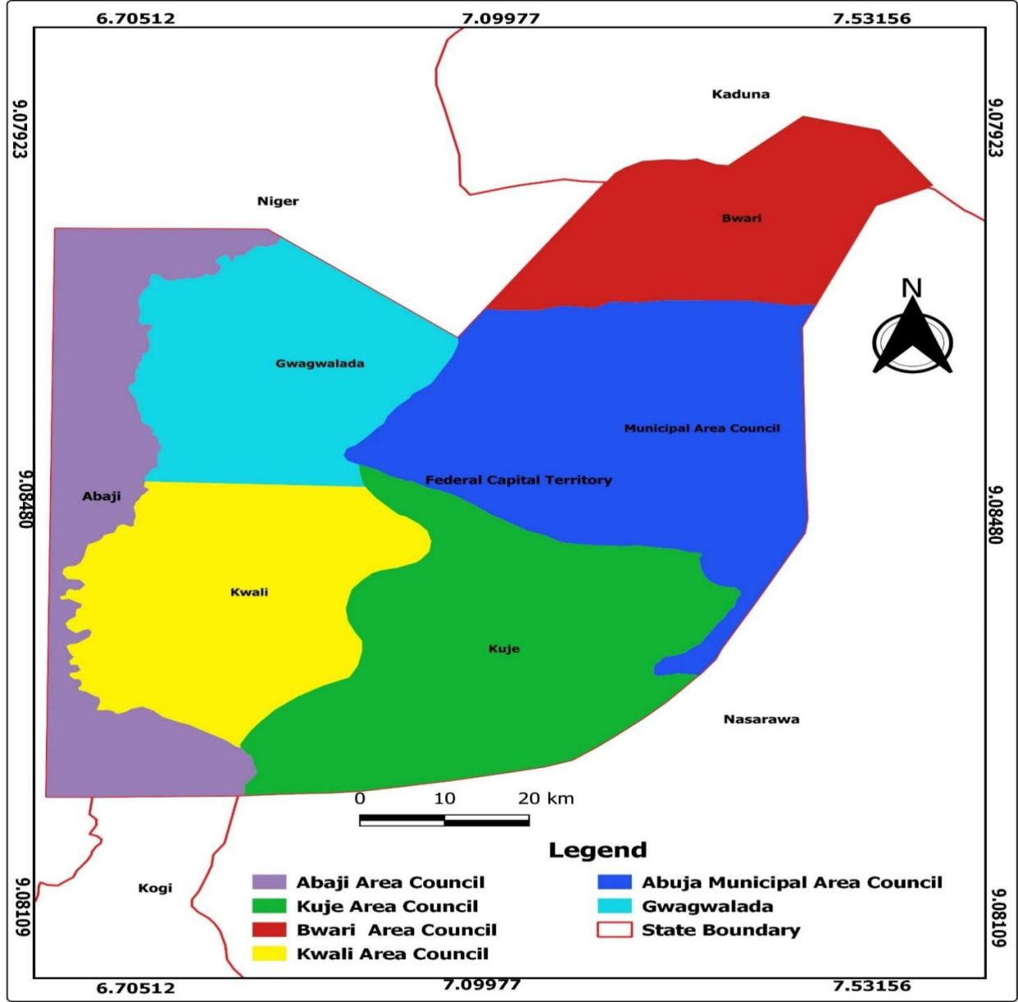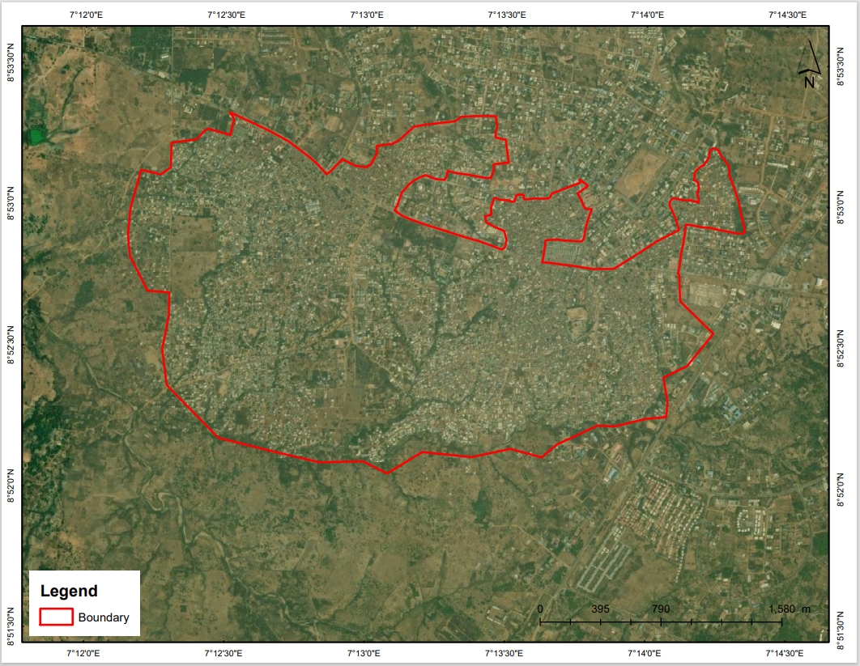

**Figure 1: Area Councils in the FCT Figure 2: Image of Kuje Town Showing Slum Area**

At the fringes of the town, the suitability of the soil for agriculture influenced the major economic activity in the study area which is farming. The major ethnic groups are the Gbagyi and Gwandara who are mostly farmers engaged in farming of yams, cassava, cocoyam, sweet potatoes, groundnuts, rice, maize, guinea corn, rice, melon. Cat fish farming, cattle are reared by the nomadic Fulani’s, sheep, goats and poultry are kept mostly on free range system mostly by other tribes other than the Gbagyi and Gwandaras who have come to settle there. Due to its proximity to the city, Kuje town has been experiencing rapid expansion buildings and spontaneous increase in human activities over the years as the population continued to increase in the area, the urban renewal exercise witnessed between 2003 and 2005 has forced many people to settle in the satellite towns of Kuje, Gwagwalada, Kubwa, Zuba and Bwari which is one of the major causes of slums growth in the satellites towns in the FCT (Ishaya and Areo, 2018).

**3. Research Methodology**

Multi-Criteria Remote Sensing and GIS techniques was adopted in this study. The manipulation of remotely sensed data using GIS makes this study a multi-criteria approach. The output of the multi-criteria remote sensing, GIS techniques is the land use/land cover and change detection results of the Traditional Kuje Urban sector.

**3.2: Types of Data Needed and Method of Data Acquisition**

In carrying out this study, data were collected from both secondary and primary sources which were analyzed to achieve the aim and objectives of the study. Moderate satellite images of the study area were obtained from Google Earth Pro for period of 1992 and 2012, and the high-resolution satellite image was acquired from SAS Planet for the period of 2022. The satellite images utilized in this study are shown in Table 1. Location data for verification of Land use/Land cover characteristics were sourced using hand held GPS 60cx.

**Table 1: Satellite Images Utilized**

|  |  |  |  |  |  |  |  |
| --- | --- | --- | --- | --- | --- | --- | --- |
| S/N | Data | Type | Year | Format | Resolution | Source | Relevance |
| i | Delineated slum boundary | Secondary |  | Shape file |  | Field observation and Google Earth | To define the spatial boundary |
| ii | Moderate resolution aerial imagery | Secondary | 2002 & 2012 | TIFF | 30m | Google Earth Pro | For object-based image analysis |
| iii | High resolution aerial imagery | Secondary | 2022 | TIFF | 0.5m | SAS Planet | For image classification analysis |

**Source: Researcher Compilation, 2023.**

**3.3: Method of Data Analysis**

Generally in most researches that involves geo-informatics techniques stages flow from data acquisition, data pre-processing, data manipulation and analysis and finally result presentation.

***3.3.1 Pre-Processing of Satellite Image***

***a. Object based image analysis***

This is the process of collecting or obtaining a remotely sensed data via satellite feeds, the process involves launching of the Google Earth Pro software, navigated to the area of interest, the north arrow toggle was aligned to fitting the satellite imagery to be captured. The time slider tool was used to back date the time for historical imageries, afterward the four point were indicated on the four-cardinal point of the imageries using point tool and their ground coordinate points were obtained to enable geo-referencing. However, the satellite imageries were saved and map option was adjusted and maximum resolution was selected, and save image to download to the satellite imagery.

***b. Delineation of the urban slum and Pre-processing of the satellite images***

Ten geographic coordinates were obtained in the informal settlement area in the study area for ground truthing so as to aid precise mapping of the urban slum. However, the obtained data were imported on Google Earth Pro and the “Add Polygon function” were used to delineate the Traditional Kuje Urban Sector of Kuje Urban Area. In classification of satellite images, a pre-processing of the satellite images is very necessary. Image pre-processing involved image geometric correction and image enhancement. Image pre-processing was to normalize the imageries as expected for classification from sensors. Issues of interest for ratification during pre-processing includes the resolution, the spectral bands of the imagery, year of acquisition, the features shown, data evaluation and geo-referencing and the projection of the imagery itself for the imageries were used in this study.

**Table 2: Coordinates Points for Geo-referencing**

|  |  |  |  |
| --- | --- | --- | --- |
| S/N | Point ID | Easting | Northing |
| 1 | P1 | 304337.166 | 982670.115 |
| 2 | P2 | 306266.366 | 982483.616 |
| 3 | P3 | 305648.751 | 981172.886 |
| 4 | P4 | 304955.773 | 981327.334 |

Source: Researcher Compilation, 2023.

***3.3.2: Land use/Land cover Analysis***

After the pre-processing of the satellite imageries (1992, 2002 and 2012 Google Earth Pro and SAS Planet 2022), the study area was carefully cropped out and was used to pan-sharpen the imageries from the imageries. This was done using spatial modeller tools within the ERDAS Imagine software environment. Image pan-sharpen is important because helped improve the quality of image classification and the imageries were classified using version 15 of Erdas imagine software. The bands combinations of 4, 3, 2 (Red, Green and Blue bands) for all the imageries. This study adopted the supervised classification method that uses the spectral signatures obtained from training samples to classify an image. A signature file was created by training samples cells, which was used for the multivariate classification tools to classify the image. After the classification, the result was moved to ArcGIS 10.1 environment where the land use/land cover statistics were extracted. Assessment of changes over the four satellite epochs were carried out from one class to the other.

**Table 3: Land Use/Land Cover Classes considered**

|  |  |
| --- | --- |
| **Classes** | **Description** |
| Bare Surface | Fallow fields/Lands |
| Built-up areas | Paved surfaces, settlements, developed infrastructures and tarred roads |
| Agricultural Land Use | This include cultivated fields |
| Vegetation cover | Vegetation, in form of trees, shrubs of different height and density |

**Source: Researcher Generated Classification Schemes, 2023**

The land use/land cover classes in Table 3 were considered based on reconnaissance survey and pre-study verification of the study area images using Google Earth. The results of the land use/land cover types were produced in hectares to enable evaluation of land use/land cover changes. The statistical results were generated using version 15 of ERDAS Imagine software.

The verification of the imageries were further done with reference to Google earth image and the land use/land cover assessment was carried out using version 15 of ERDAS imagine software. Using the land use/land cover maps, the change magnitude, change trend and annual rate change were generated using the formulas thus;

Magnitude = Magnitude of the new year - Magnitude of the previous year……… *Equation 1*

The percentage change for each land use/land cover classes were calculated by dividing magnitude change by sum of the observed changes between the years concerned and multiplied by 100 as presented in the equation thus:

$Trend =\frac{Magnitude of Change x 100}{Sum of Change }…Equation$ 2

In ascertaining the annual rate of land use/land cover classes, the trend multiply by number of study years divided by 100o periods, for example 1988 – 1998, 1998-2008 as shown in equation:

$Annual Rate of Change =\frac{Trend × number of study years in between }{100 }……Equation$ 3

Also, graphs representing spectral signatures for each of the land use/land cover characteristics were generated and plotted using the statistical results of classified imageries of the three studied years.

**3.4 Software's used**

In this study, the software used in the research are;

1. ArcGIS 10.1
2. Version 15 of ERDAS
3. Google Earth Pro
4. SAS Planet

**4.0: Results and Discussion**

**4.1: Kuje Urban Land Use/Land Cover Categorization from 1992-2022**

In line with the aim of the study which is to assess changes in land use/land cover of traditional urban sector of Kuje Urban area of the Federal Capital Territory of Nigeria from Remotely Sensed Imageries over the past four decades (1992, 2002, 2012 and 2022). The area under consideration covers about 609.066 hectares.

***4.1.1: Land Use/Land Cover Categorization in Kuje Traditional Urban Sector in 1992***

Figure 3a, and Table 4 revealed the characterization of land use/land cover of Kuje traditional urban sector (Kayarda Kuje and Central Pasali Kuje) of Federal Capital Territory in the year 1992. The traditional urban sector land use/land cover were categorized into agricultural land, bare surface, vegetation, and built-up area. In the year 1992, vegetation area coverage was the highest with 326.13 hectares (53.55%), agricultural land covered 237.25 hectares (38.95%), built-up area covered 34.36 hectares (5.64%) and the least was bare surface with an area coverage of 11.326 hectares (1.86%). The overall accuracy level of the land use/land cover analysis result is 81% and 1.13 Kappa accuracy value.

***4.1.2: Land Use/Land Cover Categorization in Kuje Traditional Urban Sector in 2002***

Figure 3b and Table 4 revealed the characterization of land use/land cover of Kuje traditional urban sector (Kayarda Kuje and Central Pasali Kuje) of Federal Capital Territory in the year 2002. The traditional urban sector land cover/land uses were categorized into agricultural land, bare surface, vegetation, and built-up area. In the year 2002, vegetation area coverage was the highest with 292.186 hectares (47.97%), agricultural land covered 220.28 hectares (36.17%), built-up area covered 78.21 hectares (12.84%) and the least was bare surface with an area coverage of 18.39 hectares (3.01%). The overall accuracy level of the land use/land cover analysis result is 79% and Kappa accuracy value of 1.12.

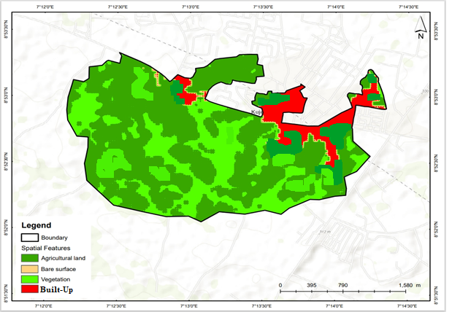 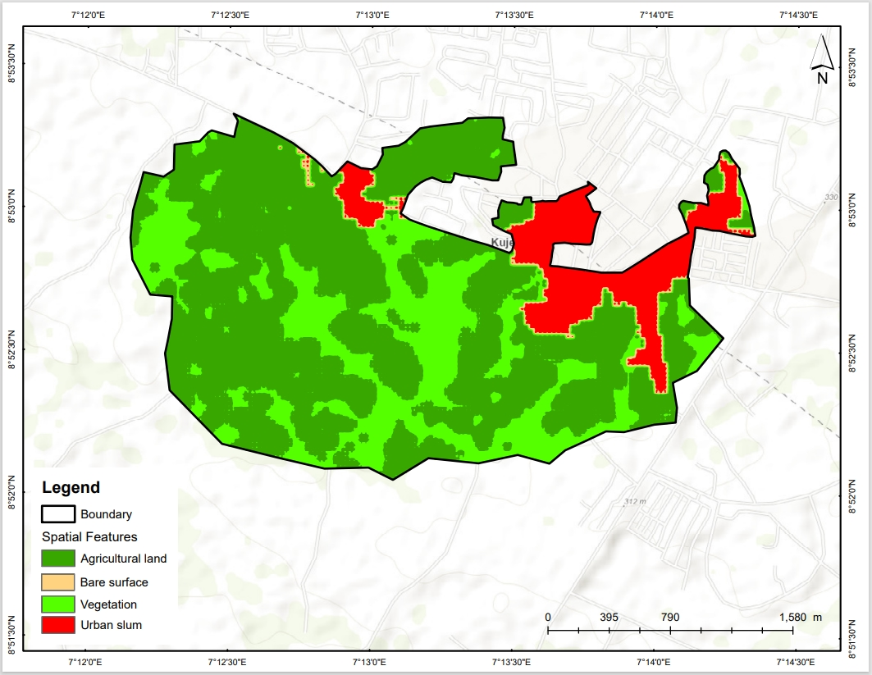

**Figure 3a: LULC of Kuje Traditional Urban Sector in 1992 Figure 3b: LULC of Kuje Traditional Urban Sector in 2002**

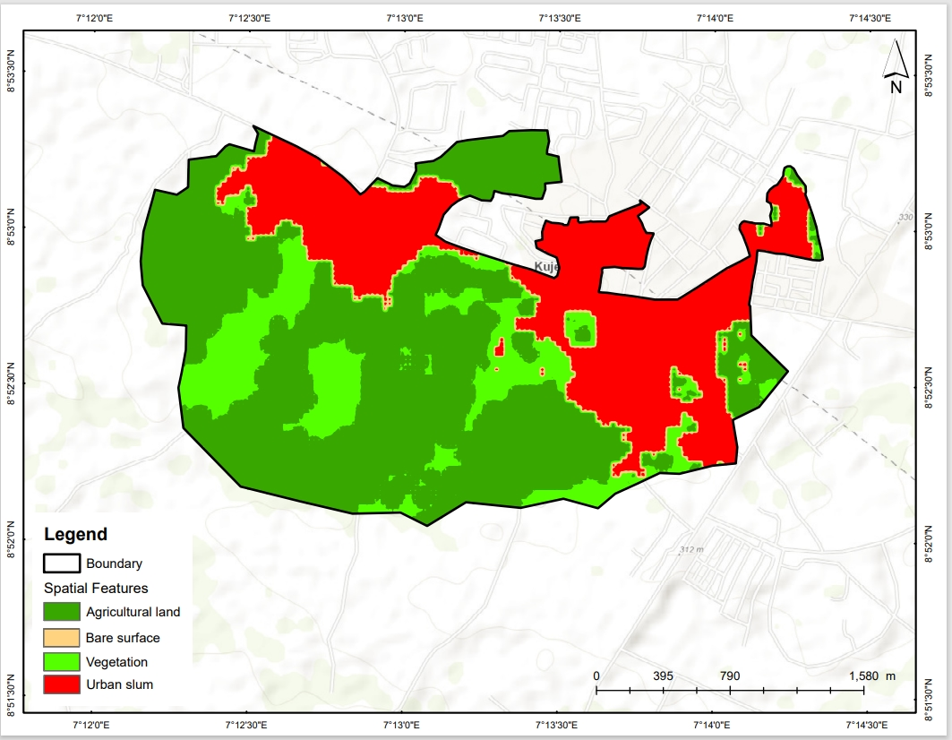 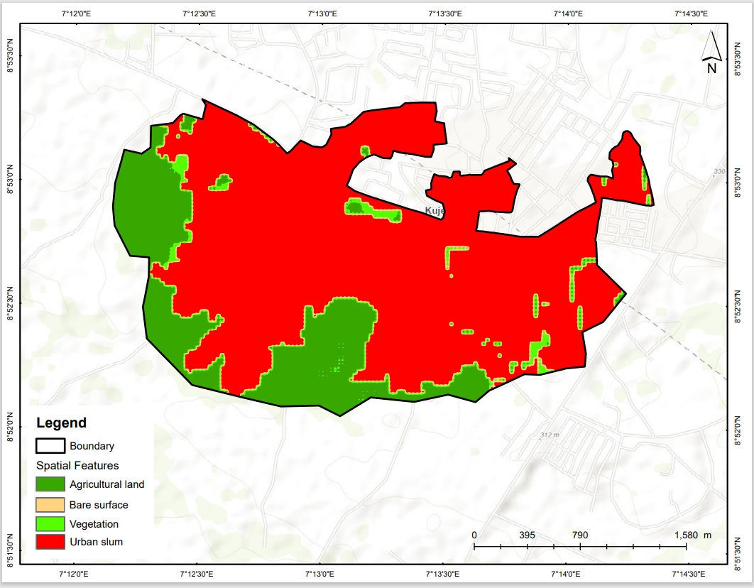

**Figure 3c: LULC of Kuje Traditional Urban Sector in 2012 Figure 3d: LULC of Kuje Traditional Urban Sector in 20222**

***4.1.3: Land Use/Land Cover Categorization in Kuje Traditional Urban Sector in 2012***

In 2012, the categorized land use/land cover Kuje Traditional urban sector of Kuje urban area (Kayarda Kuje and Central Pasali Kuje) shows that the highest area coverage was agricultural land with 238.02 hectares (39.08%), built-up area had an area coverage of 193.88 hectares (31.83%), bare surface with area coverage of 166.28 hectares (27.3%) while vegetation had as low as 9.99 hectares (1.64%) land coverage in the years 2012 (Figure 3c and Table 4). The overall accuracy level of the land use/land cover analysis result is 71% and Kappa accuracy value of 1.07.

**Table 4: Land use/ Land Cover of Kuje Traditional Urban Sector in 1992**

|  |  |  |  |  |
| --- | --- | --- | --- | --- |
| **Class** | **1992 Area in Hectares (%)** | **2002Area in Hectares (%)** | **2012 Area in Hectares (%)** | **2022 Area in Hectares (%)** |
| **Agricultural land** | 237.25(38.95) | 220.28(36.17) | 238.02 (39.08) | 130.18 (21.37) |
| **Bare surface** | 11.326(1.86) | 18.39(3.01) | 166.28(27.3) | 11.47 (1.88) |
| **Built-up** | 34.36(5.64) | 78.21(12.84) | 193.88(31.83) | 465.7 (76.46) |
| **Vegetation** | 326.13(53.55) | 292.19(47.97) | 9.99 (1.64) | 1.71 (0.28) |
| **Total** | 609.066(100) | 609.066(100) | 609.066(100) | 609.066(100) |
| **Overall accuracy** | 81% | 79% | 71% | 82% |
| **Kappa accuracy** | 1.13 | 1.12 | 1.07 | 1.2 |

**Source: Researcher Analysis, 2023**

***4.1.4: Land Use/Land Cover Categorization in Kuje Traditional Urban Sector in 2022***

In Kuje Traditional urban sector, the classified image (Figure 3d and Table 4) revealed that in 2022 vegetation covered 1.71 hectares (0.28%), bare surface covered an area of 11.47 hectares (1.88%), agricultural land depicts 130.18 hectares (21.37%), while built-up area covered 465.7 hectares (76.46%) being the highest in 2022. The overall accuracy level of the land use/land cover analysis result is 82% and Kappa accuracy value of and 1.2.

**4.2: Changes in Traditional Kuje Urban Sector** **LULC from 1992 to 2022**

In the traditional Kuje Urban Sector, agricultural land use between the year 1992 to 2002 decrease from 237.27 to 220.28 hectares (-16.97 hectares), from 2002 to 2012 there was an increase of agricultural land use from 220.28 to 238.02 hectares (17.74 hectares). There was large decrease of -107.84 hectares of agricultural land from 2012 with agricultural land use area of 238.02 hectares and 130.18 hectares in 2022 (Table 5). Agricultural land use decrease from 1992 to 2002 but increase from 2002 to 2012 but decrease from 2012 to 2022. There was an increase in bare surfaces from 1992 to 2002 and from 2002 to 2012 while significant decrease in bare surface area was record from 2012 to 2022 (See Table 5). This is in agreement with the findings of [Muhammad](https://ges.rgo.ru/index.php/jour/search?authors=Muhammad%20AND%20Nasar-u-Minallah)*et al.* (2021) in his spatio-temporal analysis of urban expansion and future growth Patterns of Lahore, Pakistahe observed that built-up area of Lahore has seen remarkable increase during the past five decades. Just as in this study he utilized supervised image classification of maximum likelihood algorithm on Landsat MSS (1973 and 1980), TM (1990), ETM+ (2000), TM (2010), and OLI/TIRs (2020) images. The observation of Aminu *et. al.,* (2019) on land use/cover into urban expansion in Dutse Metropolis, Jigawa State, Nigeria is also in agreement to the findings of this study. So also Bankole and Bakere (2017), ascertain the dynamics of urban land use changes with remote sensing in Ibadan, Nigeria and observed significant agricultural land loss to buildings. Michael *et. al.,* (2017) and Adeyemi *et. al.,* (2022) Danbaba and Ishaya (2022) observations agreed with the findings in Kuje Traditional Urban Sector.

The trend of bare surface in the traditional Kuje urban sector shows that between 1992 to 2002 bare surface increase with 7.064 hectares (11.326 to 18.39 hectares), from 2002 to 2012 there was an increase of 147.89 hectares from 18.39 to 166.28 hectares but with significant decrease in bare surface area of -154.81 hectares from 2012 to 2022 (Table 5). Akpu *et. al.,* (2017), carried out a geospatial analysis of urban expansion and its impact on vegetation cover in Kaduna Metropolis, Nigeria. She observed that at this rate of vegetation loss and urban expansion, the city land was stripped bare of almost all her vegetation cover within the study period. Aminu *et. al.,* (2019) observation on the transition from Land Use/Cover into Urban Expansion in Dutse Metropolis, Jigawa State, Nigeria is also in agreement to the findings of this study. Similarly to the findings of Akpovwovwo (2020) in a study carried on urban growth analysis of Warri and environs, Delta State, Nigeria using remote sensing Approach between 1987 and 2014 observed that bare land was seen to fluctuate marginally through the period under study. Qurratulain and Umair (2019); Ishaya and Omika (2020) and Sheriff (2021) were of similar opinions.

It was observed that from 1992 to 2002 built-up area in the Kuje traditional urban area had an increase of 43.85 hectares (from 34.36 to 78.21 hectares respectively). Results also shows an increase of 115.67 hectares in built up area from 78.21 hectares in 2002 to 193.88 hectares in 2012. Similarly there was an built up area within the traditional urban sector between 2012 to 2022 had an increase of 271.82 hectares with built area of 193.88 hectares in 2012 and 465.7 hectares in 2022 (See Table 5). Increase in built-up area leads to the depreciation in vegetal cover in Traditional Kuje urban area. The findings of this study are in agreement with that of Asa *et. al.,* (2020) in their spatial assessment of urbanization using GIS in selected neighbourhoods of Port Harcourt Metropolis using GIS to determine the spatial and temporal changes from 1999, 2009 and 2019. Findings from this study based on the classified Landsat imageries revealed spatial changes of an increase in built-up area value of 591 hectares in 1999 to 4066 hectares in 2009 and to 666 hectares in 2019, hence, caused a reduction in vegetation cover with the value of 5038 hectares in 1999 to 3733 hectares in 2009 and to 1515 hectares in 2019. The results indicate that this accretive built-up area expansion is attributed to socio-economic, demography, conversion of farmland, rural-urban migration, proximity to transportation routes, and commercial factors ([Muhammad,](https://ges.rgo.ru/index.php/jour/search?authors=Muhammad%20AND%20Nasar-u-Minallah)2021; Asa *et. al.,* 2020; Opeyemi *et al.,* 2015).

Vegetal land cover of the Traditional Kuje Urban Sector decrease with -33.944 from 1992 having 326.13 hectares of vegetal cover to 2002 with 292.182 hectares of vegetal area coverage. From 2002 to 2012 there was also a significant decrease of vegetal land cover area with -282.196 hectares. Similarly, years 2012 - 2022 experienced a decrease (-8.28 hectares) in vegetal land cover area from 9.99 hectares to 1.71 hectares (Table 5). This observation went in line with what Victor, Uchenna and Chukwubueze (2019) unveiled in their study on the spatio-temporal monitoring and prediction of physical urban development of part of Nike, Enugu, Nigeria Using Remote Sensing and GIS from 1997 to 2018. The percentage land cover for built up area in 1997, 2004, 2011 and 2018 were 5.45%, 11.71%, 15.00%, and 39.32% with more impact on vegetal cover. These results a show fast and exponential changes, which serves as an early warning for overflowing slum development (Ishaya and Tokulla 2013; Victor, Uchenna and Chukwubueze (2019) which differ not in the situation observed in the traditional urban sector of Kuje urban area of the FCT of Nigeria.

**Table 5: Traditional Kuje Urban Sector** **Land Use/Land Cover Changes from 1992-2022**

|  |  |  |  |  |  |  |  |  |  |
| --- | --- | --- | --- | --- | --- | --- | --- | --- | --- |
| **LU/LC** | **1992**  **Area (Ha)** | **2002**  **Area (Ha)** | **change Area (Ha)** | **2002**  **Area (Ha)** | **2012**  **Area (Ha)** | **change Area (Ha)** | **2012**  **Area (Ha)** | **2022**  **Area (Ha)** | **change Area (Ha)** |
| Agricultural land | 237.25 | 220.28 | -16.97 | 220.28 | 238.02 | 17.74 | 238.02 | 130.18 | -107.84 |
| Bare surface | 11.326 | 18.39 | 7.064 | 18.39 | 166.28 | 147.89 | 166.28 | 11.47 | -154.81 |
| Built-Up | 34.36 | 78.21 | 43.85 | 78.21 | 193.88 | 115.67 | 193.88 | 465.7 | 271.82 |
| Vegetation | 326.13 | 292.186 | -33.944 | 292.186 | 9.99 | -282.196 | 9.99 | 1.71 | -8.28 |
| **Total** | **609.066** | **609.066** |  | **609.066** | **609.066** |  | **609.066** | **609.066** |  |

Source: Researcher analysis, 2023.

The loss of vegetal cover and agricultural land to built-up areas in the Kuje Traditional Urban sector of Kuje urban area in the Federal Capital Territory (FCT) of Nigeria presents challenges on food security as the loss of fertile land can reduce local food production capacity, leading to increased dependence on food from external communities. In areas like Kuje with a strong traditional agricultural heritage, the conversion of agricultural land to built-up areas can disrupt traditional livelihoods and cultural practices.

Given this radical conversion of vegetal cover and agricultural land to built-up areas over the years, loss of biodiversity, including native plant species have cascading effects on ecosystem health and resilience. This conversion contributes to urban sprawl which over the years strain infrastructure and urban services leading to water scarcity, sanitation problems, traffic congestion, pollution, and pressure on existing amenities (Garboa, Oruonye and Ahmed, 2016),

Other implications associated with the serious increase of built-up area is impact on water resources through increased runoff and reduced infiltration, leading to challenges such as flooding, erosion, and diminished water quality in rivers and streams. Vegetal cover provides numerous ecosystem services, including carbon sequestration, air purification, soil stabilization, and water regulation these services may be compromised. Kwasi *et. al.,* (2022) asserted that built-up areas typically absorb and retain more heat than vegetated areas, leading to the urban heat island effect resulting to higher temperatures, increased energy consumption for cooling, and adverse health effects for residents in the traditional urban sector of Traditional Kuje Urban sector.

**5. Conclusion**

This study assessed land use/Land cover changes in Kuje Traditional Urban sector of the Federal Capital Territory of Nigeria. The study concluded that there is serious decrease in agricultural land use area, bare surface and vegetal cover but with consistent increase in the urban built up area. The vegetal land cover, agricultural land use, bare surface gave way to built-up area from 1992 to 2022. The loss of vegetal cover and agricultural land to built-up areas in the Kuje Traditional Urban sector of Kuje urban area in the Federal Capital Territory (FCT) of Nigeria presents challenges which includes; threat to food security as a result of loss in fertile land; depreciating traditional agricultural heritage, disruption traditional livelihoods and cultural practices; loss of biodiversity including native plant species; depreciation of ecosystem health and resilience; strain infrastructure and urban services leading to water scarcity, sanitation problems, traffic congestion, pollution, and pressure on existing amenities. The increase built-up area will impact on water resources through increased runoff and reduced infiltration, leading to challenges such as flooding, erosion, and diminished water quality in rivers and streams; degraded ecosystem services, including carbon sequestration, air purification, soil stabilization, and stimulates heat island effect resulting to higher temperatures, increased energy consumption for cooling, and adverse health effects for residents in the traditional urban sector of Traditional Kuje Urban sector.

**6. Recommendations**

After careful analysis of the outcome of results from the field, this study proffers the following recommendations with a view to solve and stem the problem of rapidly expanding slums.

1. The Kuje traditional urban sector must be incorporated into Kuje Urban planning through gentrification of buildings after careful planning since demolition is not an option due to large concentration of indigenous people within the traditional urban sector.
2. There is need to fence the existing Kuje traditional urban sector in Kuje urban area to prevent continual growth of the Kuje traditional urban sector beyond its current land area of 609.066 hectares.
3. There must be a system that creates spaces for low income earner who work in the Federal Capital Territory as most houses in planned areas of the FCT are not affordable. If this is done, the influx of people into Kuje traditional urban sector will reduce.

**References**

Adewale Y. (2019). Challenges of Slum Upgrading in Port Harcourt, River State, Nigeria. [*The Indonesian Journal of Planning and Development*](https://www.researchgate.net/journal/The-Indonesian-Journal-of-Planning-and-Development-2442-983X?_tp=eyJjb250ZXh0Ijp7ImZpcnN0UGFnZSI6InB1YmxpY2F0aW9uIiwicGFnZSI6InB1YmxpY2F0aW9uIiwicG9zaXRpb24iOiJwYWdlSGVhZGVyIn19). 5(1), 11-20.

Adeyemi A. A., Asimiyu M. J., and Lekan M. S. (2022). Mapping of Indices of Slum and Informal Housing Development in Akure, Ondo State, Nigeria. *Journal of Geography, Environment and Earth Science International.* 26(1), 40-49.

Aguilera, F., Valenzuela, L.M. and Botequilha-Leitão, A. (2011) Landscape Metrics in the Analysis of Urban Land Use Patterns: A Case Study in a Spanish Metropolitan Area. *Landscape and Urban Planning*. 99, 226-238. <http://dx.doi.org/10.1016/j.landurbplan.>

Ahmed, Y.A. (2009) Settlements Pattern and Functional Distribution in an Emerging Communities: A Case of a Local Government Area of Kwara State, Nigeria. *The Social Sciences*. **4**, 256-263.

Akpovwovwo U. E (2020). An Urban Growth Analysis of Warri and Environs, Delta State, Nigeria: A Remote Sensing Approach. FUW Trends in Science & Technology Journal, 5(2). 533 – 537.www.ftstjournal.com.

[Akpu](https://www.researchgate.net/profile/Benedine-Akpu?_sg%5B0%5D=YQULjkJ6j-sx5r5hVtNB4IeKEh1jajfSlnqgVf6ExAt-KlpBPxhZYAPHcF6gAqo7eMy-ag0.kjGWUukkYNuQgkcwYZgRUryvBcSmpNRVN4VrKi7yg6x0q7EMfrdcMoV8tJEUeXHprDKpgnKkUbTqLzgbbxNzhQ&_sg%5B1%5D=DETN4YrtarI67qRDofDm3sUkhMOnhBE0p7tunXG-v6ZdLCLpTBH6LNOR7UErkD0oWgVIgKk.9RVo0GHWOsECZ2DbYRt8mpe2ONmnLs5e-g-YHPUrzauuYzG_KZXwBgCmIp-QQ_gutgeg3XJS7tGEZS7e0lfGTA&_tp=eyJjb250ZXh0Ijp7ImZpcnN0UGFnZSI6InB1YmxpY2F0aW9uIiwicGFnZSI6InB1YmxpY2F0aW9uIiwicG9zaXRpb24iOiJwYWdlSGVhZGVyIn19) B., [Tanko](https://www.researchgate.net/profile/A-Tanko-2?_sg%5B0%5D=YQULjkJ6j-sx5r5hVtNB4IeKEh1jajfSlnqgVf6ExAt-KlpBPxhZYAPHcF6gAqo7eMy-ag0.kjGWUukkYNuQgkcwYZgRUryvBcSmpNRVN4VrKi7yg6x0q7EMfrdcMoV8tJEUeXHprDKpgnKkUbTqLzgbbxNzhQ&_sg%5B1%5D=DETN4YrtarI67qRDofDm3sUkhMOnhBE0p7tunXG-v6ZdLCLpTBH6LNOR7UErkD0oWgVIgKk.9RVo0GHWOsECZ2DbYRt8mpe2ONmnLs5e-g-YHPUrzauuYzG_KZXwBgCmIp-QQ_gutgeg3XJS7tGEZS7e0lfGTA&_tp=eyJjb250ZXh0Ijp7ImZpcnN0UGFnZSI6InB1YmxpY2F0aW9uIiwicGFnZSI6InB1YmxpY2F0aW9uIiwicG9zaXRpb24iOiJwYWdlSGVhZGVyIn19) A.I., [David Jeb](https://www.researchgate.net/scientific-contributions/David-Jeb-2204678515?_sg%5B0%5D=YQULjkJ6j-sx5r5hVtNB4IeKEh1jajfSlnqgVf6ExAt-KlpBPxhZYAPHcF6gAqo7eMy-ag0.kjGWUukkYNuQgkcwYZgRUryvBcSmpNRVN4VrKi7yg6x0q7EMfrdcMoV8tJEUeXHprDKpgnKkUbTqLzgbbxNzhQ&_sg%5B1%5D=DETN4YrtarI67qRDofDm3sUkhMOnhBE0p7tunXG-v6ZdLCLpTBH6LNOR7UErkD0oWgVIgKk.9RVo0GHWOsECZ2DbYRt8mpe2ONmnLs5e-g-YHPUrzauuYzG_KZXwBgCmIp-QQ_gutgeg3XJS7tGEZS7e0lfGTA&_tp=eyJjb250ZXh0Ijp7ImZpcnN0UGFnZSI6InB1YmxpY2F0aW9uIiwicGFnZSI6InB1YmxpY2F0aW9uIiwicG9zaXRpb24iOiJwYWdlSGVhZGVyIn19), [Bala Dogo](https://www.researchgate.net/profile/Bala-Dogo?_sg%5B0%5D=YQULjkJ6j-sx5r5hVtNB4IeKEh1jajfSlnqgVf6ExAt-KlpBPxhZYAPHcF6gAqo7eMy-ag0.kjGWUukkYNuQgkcwYZgRUryvBcSmpNRVN4VrKi7yg6x0q7EMfrdcMoV8tJEUeXHprDKpgnKkUbTqLzgbbxNzhQ&_sg%5B1%5D=DETN4YrtarI67qRDofDm3sUkhMOnhBE0p7tunXG-v6ZdLCLpTBH6LNOR7UErkD0oWgVIgKk.9RVo0GHWOsECZ2DbYRt8mpe2ONmnLs5e-g-YHPUrzauuYzG_KZXwBgCmIp-QQ_gutgeg3XJS7tGEZS7e0lfGTA&_tp=eyJjb250ZXh0Ijp7ImZpcnN0UGFnZSI6InB1YmxpY2F0aW9uIiwicGFnZSI6InB1YmxpY2F0aW9uIiwicG9zaXRpb24iOiJwYWdlSGVhZGVyIn19) (2017). Geospatial Analysis of Urban Expansion and Its Impact on Vegetation Cover in Kaduna Metropolis, Nigeria. [*Asian Journal of Environment & Ecology*](https://www.researchgate.net/journal/Asian-Journal-of-Environment-Ecology-2456-690X). 3(2):1-11

Aminu S Z., Sabitu D., Ahmed A., (2019). Transition from Land Use/Cover into Urban Expansion in Dutse Metropolis, Jigawa State, Nigeria. *Themes in Applied Sciences Research.* 2(1), 1-8.

Asa E. B., Precious N. E. and Ebiwari W, (2020). Spatial Assessment of Urbanization Using GIS in Selected Neighbourhoods of Port Harcourt Metropolis. *Journal of Geography, Environment and Earth Science International.* 24(7), 13-24, 2020.

Bankole M. O. and Bakare H. O. (2011). Dynamics of urban land use changes with remote sensing: Case of Ibadan, Nigeria. Journal of Geography and Regional Planning. 4(11), 632-643.

Danbaba Goma and Ishaya Sunday (2022). Assessing the pattern of Land use and Land Cover Changes and its Implication on surface water in Kaduna State, Nigeria. Benin Journal of Geography, Planning and Environmental 2(1), 102 -123.

Garboa, K. Oruonye, E.D., Ahmed Y. M. (2016). Urban sprawl analysis in Jalingo Metropolis, Taraba State Nigeria. *Review of Environment and Earth Sciences.* 3(2), 30-37.

Ishaya S. and Areo, Isaac Olajide (2018). Assessment of of Landuse/Landcover change in Kwali Area Council UsingGeo-Informatic Techniques. *The Environmental Studies (A Multidisciplinary Journal).* 1(1)2, 38-47.

Ishaya S., and Mashi S.A. (2008).Using GIS to Map Fadama Areas in the Central Abuja, Nigeria. *Journal of Sustainable Development in Agriculture and Environment.* 3(2), 110-118.

Ishaya S.,Ifatimehin, O.O. and Okafor C. (2008). Remote sensing and GIS applications in urban expansion and loss of vegetation cover in Kaduna town, northern Nigeria. *Journal of Geography and Planning Sciences.*2(1), 33-40**.**

Ishaya S., Olowonefa G. and A.B.C Ojie. (2010). Assessment of Agricultural Land Changes Due to Urbanization Using Remote Sensing and GIS Techniques in Federal Capital Territory of Nigeria. *International Journal of Agricultural and Rural Development.* 1(3): 90-97. University of Abuja.

Ishaya S. and Omika U.Y (2020). Geo-Informatic Application in Anomalies Assessment In The Master Plan Of Idah Town, Kogi State, Nigeria. *FUDMA Journal of Sciences (FJS).* 4(2): 567-576 DOI: <https://doi.org/10.33003/fjs-2020-0402-186>

Jibrin G., Yusuf A. Y., Helmi Z. Mohd S., Usman S. L., and Abubakar A. (2021). A Three Decades Urban Growth Monitoring in Hadejia, Nigeria Using Remote Sensing and Geospatial Techniques. IOP Conf. Series: Earth and Environmental Science 620 (2021) 012012.

Kwasi F., Darko E. Atiemo, E. J., Van Etten (2022). Urban sprawl and microclimate in the Ga East municipality of Ghana. *Heliyon 8 (2022) 09791.* <https://doi.org/10.1016/j.heliyon.2022.e09791.>

Michael A. O., Isaac O. O. and Olusola O. P (2017). Urban renewal strategies in developing nations: A focus on Makoko, Lagos State, Nigeria. *Journal of Geography and Regional Planning.* 10(8), 229-241. DOI: 10.5897/JGRP2017.0631

Muhammad N. M., Sahar Z., Atta-ur R., Omer R., (2021). Spatio-temporal analysis of urban expansion and future growth patterns of Lahore, Pakistan. *Geography, Environment, Sustainability*. 14(3), 41-53.

Olayiwola, A.M. and Aguda, A.S. (2009) Hierarchy of Service Centres in Ijesaland, Nigeria. *Journal of Geography* *and Regional Planning*. **2**, 131-143.

Opeyemi A. Z., Lazarus M. O., & Richard A. M.,(2015). Urbanization: A Catalyst for the Emergence of Squatter Settlements and Squalor in the Vicinities of the Federal Capital City of Nigeria. *Journal of Sustainable Development.* 8(2), 134-148.

Qurratulain S. and Umair B (2022). Assessment of Urbanization and Urban Sprawl Analysis through Remote Sensing and GIS: A Case Study of Faisalabad, Punjab Pakistan. *International Journal of Academic Research in Business and Social Sciences*. 9(4), 16 – 36.

Sheriff O. J. (2021). Mapping and Monitoring Slums Using Geoinformation Technologies. Thesis Submitted to Paris Lodron University Salzburg, Faculty of Natural Sciences, Department of Geoinformatics.

Tokula A.E. and Ishaya S. (2013). An Analysis of Urban Expansion and Loss of Farmland in Anyigba Kogi State Using Remote Sensing and GIS Techniques. *Nigeria Journal of Tropical Geography.* 4(2): 569-580. Nasarawa State University, Keffi, Nigeria.

UN-HABITAT (2013). The Challenge of Slums: Global Report on Human Settlements. Earthscan, London: UN-Habitat. 2013.

Victor N., Uchenna O., and Chukwubueze O. (2019). Spatio-Temporal Monitoring and Prediction of Physical Urban Development of Part of Nike, Enugu, Nigeria Using Remote Sensing and GIS. Journal of the Indian Society of Remote Sensing. 4(2), 8-16.

Williams P., (2017). Urbanization In Sub-Saharan Africa And The Challenge Of Access To Basic Services. Cambridge University Press.