**ECOLOGICAL STUDIES ON WATER CATCHMENTS IN LIMBE MUNICIPALITY, CAMEROON**

# 

# **ABSTRACT**

Ecological surveys were carried out to assess the impact of landuse land cover changes on water quality of some water catchments in Limbe municipality. Satellite images were acquired and processed from 2000 and 2020. A pixel-based comparison was used to produce change information on pixel basis and thus, interpret the changes more efficiently. Classified image pairs of data for two different decades were compared using cross-tabulation in order to determine qualitative and quantitative aspects of the changes for the periods from 2000 to 2020. Quantitative data of the overall land use changes as well as gains and losses in each category were then compiled. Water samples were collected and analyzed for physicochemical parameters, bacteriological and heavy metal using standard procedures. High concentrations of phosphates were detected in all 3 streams. High concentrations of total nitrogen were detected only in Ngonde stream, with ammonium exceeding safe limits. Nickel (Ni (<1µg/L)) and cadmium (Cd (<0.01mg/L)) were above the WHO standards. Bacteriological parameters were found to be high in all water bodies. Urban agriculture and settlement were the main human activities that affect water quality in the Limbe Municipality. Given the vital ecosystem services offered by these catchments, continuous monitoring is recommended and likewise the strict implementation of laws governing the use and management of aquatic resources in Cameroon.

**Keywords: Landuse and Land Cover, Water Quality, anthropogenic activites**

**Introduction**

Water is a key natural resource, which is vital for the survival of all ecosystems on the planet. However, less than 1% of the earth’s water resources are accessible to humans as fresh water, in the form of either surface or ground water (Wohlfahrt *et al.,* 2010). Water quality is a general descriptor of water properties in terms of physical, chemical and/or biological characteristics. Problems associated with water quality are commonly attributed to nutrient, chemical and pathogen loadings into aquatic systems as a result of both natural and anthropogenic factors (Kuhl *et al.*, 2010).

Land use and land cover dynamics are widespread, accelerating and significant processes driven by human actions but also producing changes that impact humans (Agarwal *et al*., 2012). Research on land use and land cover (LULC) changes and their impact on stream water quality has gained significant attention over the past decade as a result of increasing concerns about environmental sustainability, water resource management, and ecosystem health. These dynamics alter the availability of different biophysical resources including soil, vegetation, water, animal feed and others. Consequently, land use and cover changes could lead to a decreased availability of different products and services for human, livestock, agricultural production and damage to the environment as well. One of the most important benefits that wetlands provide is the capacity to maintain and improve water quality. When wetlands have rich natural diversity of plants and animals they can act as filtering systems, removing sediments, nutrients and pollutants from water (Tanner and Sukias,2011).

Safe drinking water, good sanitation and hygiene are important for good health, human survival and development. However, human activities have affected water quality in many river catchments worldwide (Hellar *et al.,*2013). The presence of contaminants is as a result of human activities. Industrial water pollution has also been reported in many countries in Africa and changes in water quality are usually associated with changes in land use (Pullanikkatil and Urama, 2011). Characterizing changes in land use, coupled with increased population growth, has revealed the vulnerability of water quality in various catchments. The clearing of natural vegetation and the transformation of natural land use into urban developments are known to increase runoff and sediment loads, which also facilitates the transfer of pollutants from land to waterbodies (Zheng *et al*., 2012).

Combined pressures of human population growth, inadequate treatment of human wastes and ineffectively managed and treated industrial and agricultural wastes make it imperative that continuous monitoring of water quality is implemented for the provision of clean and safe water for human consumption and optimal environmental integrity. Africa’s water resources are under-utilized and pollution of both surface and groundwater resources has been increasing, leading to serious health risks to both humans and the ecosystem (Tundu *et al*., 2018).

The intensities of the disturbances caused by urbanizations vary along different spatial and temporal scales (Lindegarth and Hiskin 2001), creating complex interactions between them. For example, as a result of urbanization there are changes in sediment loads and water quality. Aquatic systems and associated organisms within affected areas may be exposed to elevated concentrations in trace metals, pesticides, hydrocarbons and nutrients (Faulkner, 2004).

Cameroon is endowed with many freshwater resources, most of whose quality is unknown. Most of the streams in Limbe provide vital ecosystem services like provision of water for drinking, laundry and irrigation together with the other supporting and cultural services (Malika *et al.,* 2019).

Very little information has been documented on the effects of land use activities on freshwater resources in Limbe. The water quality of most of the streams (both the physicochemical and bacteriological parameters) are unknown. Previous studies on ground water quality and management were carried out a decade ago (Awemo, 2012). With the current trends in the influx of humans from different parts of the country as a result of the sociopolitical unrest, the construction of houses in ecologically sensitive areas in Limbe coupled with indiscriminate/poorly constructed waste disposal structures make freshwater streams in this municipality very vulnerable to pollution. Even though there is a high anthropogenic pressure on both the streams and the surrounding vegetation through agricultural activities, settlement, there are no documented studies to determine, soil physicochemical properties and how these are related to the observed land uses. The various land uses may have severe ecotoxicological implications on the water quality, biodiversity and conservational status of aquatic biodiversity. Although different studies have been carried out on aquatic resources in Limbe; Awemo, 2012; Malika *et al.*, 2019, little has been done on monitoring the water quality in relation to GIS techniques. There is paucity of knowledge on the effects of land use changes on water and riparian soil quality within these catchment areas. This research aims at bridging this gap.

The overall objective of this study is to determine the ecological status of some freshwater resources in Limbe Municipality with respect to land use land cover changes, water and soil quality. The specific objectives included

1. To characterize Land Use Changes around some water sources in Limbe Municipality
2. To assess the water and soil quality of some water sources in Limbe municipality

# MATERIAL AND METHODS

**3.1. Description of the Study Area**

Limbe is located in the Eastern slopes of Mount Cameroon, between latitudes 3°20 1 and 4°15 1North and between longitude 8°15 1 and 9°35 1 East in Fako Division of the South West Region of Cameroon. It is a cosmopolitan city with beautiful coastal beaches, historic monuments, a botanic garden, and a wildlife center. It is not only an international touristic destination but the major petroleum and agricultural hub of Cameroon. Limbe has a mountainous terrain with fertile volcanic soils suitable for agriculture. The lone oil refinery is located in Limbe and the Cameroon Development Corporation (CDC) banana, palm, and rubber plantations. (Lambi *et al.,* 2010).

The forest line appears to be controlled by periodic volcanic activity, ash falls and lava flows, which can destroy existing forest through soil burial and fire effects and inhibit regrowth on bare lava flows and deep deposits of volcanic ash (Suh *et al*., 2015).

The climate of Limbe is sub-equatorial with two distinct seasons: a dry season of four months from November to March and a rainy season of 8 months from April to October with a mean annual rainfall of 3,100 mm (Suh *et al*., 2015)**.** The monthly rainfall frequently exceeds 500 mm and sometimes is over 1,000 mm in June, July and August. The mean annual temperature is about 26 °C while the relative humidity is generally above 85% (Fombe and Molombe, 2015). The population of Limbe is about 112,641 persons, the male population is about 56547 persons (50.2%) and the female population is about 56094 persons (49.8%) Agbor and Tefeh, (2013).

Limbe is characterized by a number of springs, some of which developed into stream at lower elevation (Malika *et al.,* 2019). The population of this municipality suffers from access to pipe-borne water, which is also erratic particularly in the dry season, increasing pressure on surface freshwater resources like streams and rivers. There is therefore potable water scarcity due to poor management of the available sources, placing the inhabitants at risk of water related hazards (Agbor and Tefeh, 2013).

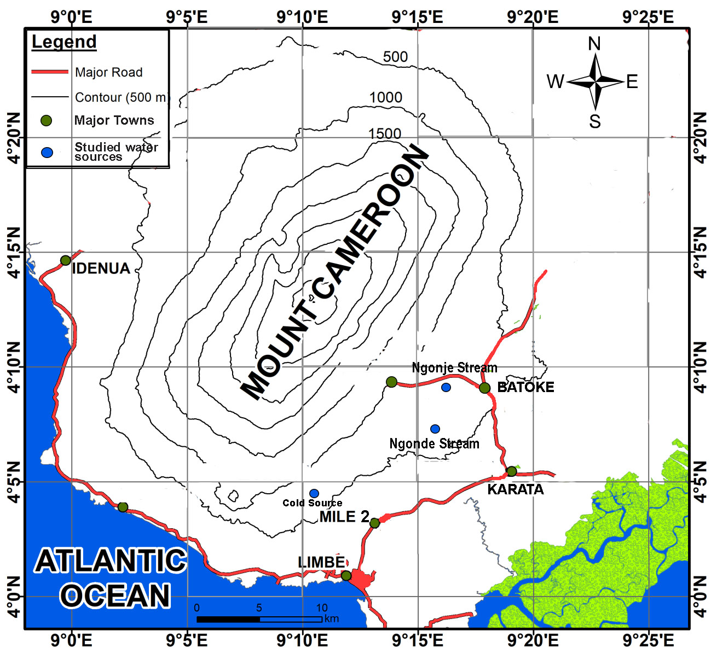

Figure 1. Location of the studied water sources within Limbe municipality**, Cameroon**

**3.2. Description of the selected sampling sites**

Purposive sampling technique was used in selecting the sampling sites (Table 1) which was based mainly on the different influences of land use changes on the water sources in the study area. Three water sources were chosen. These were cold source, Ngonde stream and Ngonje streams (Figure 1).

### Table 1: Observed Characteristics of study

|  |  |  |  |  |
| --- | --- | --- | --- | --- |
| **Site** | **Site Name** | **Latitude** | **Longitude** | **Description** |
| Site 1 | Ngonje | N 4°2'23.946" | E 9°5'38.754" | A stream from where the inhabitants drink, surrounded with agricultural and other human activities |
| Site 2 | Ngonde | N 4°2'2.406" | E 9°5'51.42" | A stream from where the inhabitants drink, surrounded with agricultural and other human activities, with a small holder palm plantation |
| Site 3 | Cold Source | N 4°02'14.91" | E 9° 12' 33.996" | A spring, the inhabitants drink from the spring, it is surrounded with many houses, fish pond, agriculture and other anthropogenic activities. |

**3.4 Trends in the different land use and land cover**

For the determination of trends in plant community structure as a result of land use changes, a post-classification detection method was employed. The ground truth data were in the form of reference data points collected using Geographical Positioning System (GPS) from the three study sites, using satellite images from 2000 and 2020. A pixel-based comparison was used to produce change information on pixel basis and thus, interpret the changes more efficiently. Classified image pairs of data for two different decades were compared using cross-tabulation in order to determine qualitative and quantitative aspects of the changes for the periods from 2000 to 2020. Quantitative data of the overall land use changes as well as gains and losses in each category were then compiled.

**3.6.2. Water sampling in the selected water sources**

For each water source, three sets of samples were collected in triplicates for nutrient, heavy metal and bacteriological analyses, at the top 10 cm of the water surface. Water temperature was taken *in situ* using the water the portable Hanna probe including other physicochemical parameters like dissolved oxygen, conductivity, pH, total dissolved solids (TDS). Samples were transported to this laboratory in ice boxes few hours after collection.

**3.7 Laboratory Analyses**

**3.7.1 Physicochemical parameters**

The following physicochemical parameters were analysed; Total alkalinity using titration method which utilizes phenolphthalein indicator and sulphuric acid while the level of Total Dissolved Solids (TDS), Electrical Conductivity (EC), Dissolved Oxygen (DO), pH was determined using standard procedures (APHA, 2005)

**3.7.2 Nutrient and heavy metal analyses**

Nitrates were determined by distillation and colorimetry. The filtered samples were buffered at a pH of 9.5 with a borate for the hydrolysis of cyanates and organic nitrogen compounds and was then distilled into a solution of boric acid. The ammonium in the distillate was determined by colorimetric techniques. A second distillation carried with the addition of Devanda alloy powder gave the nitrate content in the solution as described by APHA (2005). Phosphates were determined using molybdenum blue- ascorbic acid method by adding phenolphthalein indicator followed by drop-wise addition of 5 M sulphuric acid, ammonium molybdate and ascorbic acid was then added and mixed thoroughly as described in APHA, (2005). After 10-20 minutes the absorption of each sample was measured at 880 nm wavelength using a blank reagent as reference solution using a spectrophotometer. The concentrations of K+ and Na+ were determined using flame spectrophotometry. The concentrations of arsenic, chromium, cadmium, nickel and lead were determined. Two millimetres of each water sample was digested with concentrated nitric acid and hydrochloric acid in the ratio 3:1. The absorbances of the different heavy metals in the digests were read using Rayleigh 130B series spectrophotometer following APHA (2005).

**3.9. Data Analyses**

Data was analysed using excel and R statistical programming language (R Core Team, 2020).

**3.9.1 Analyses of water and soil sample data**

One-way ANOVA was used to separate the means of water and soil physicochemical parameters, bacterial load and heavy metal concentration across the three sites. Pearson’s correlation analysis was used to investigate the relationship between soil and water physicochemical parameters, bacterial load and heavy metal concentration. Principal component analysis was also used to close in on the key variables involved in driving the total variability in the datasets.

**3.9.2 Image Analysis**

Bands were used to display images in standard colour composites for land-use and vegetation mapping. The maps were compared on pixel by pixel basis. Change detection of the various land cover categories was done by comparing land cover statistics. Annual rates of change of land cover types were determined by dividing the total change in cover type (in ha) within each period by the number of years between the periods. The accuracy of the classifications was assessed by comparing the classifications with reference data that is believed to accurately reflect the true land cover.

**RESULTS**

Generally, post classification of images revealeda major decline with respect to area coverage of dense forest and grass land classes and a corresponding increase in the area of settlements and agriculture classes from 2002 to 2020.

**4.8.1 Land use changes observed in Cold Source Limbe municipality during 2000 and 2020**

Classified maps of 2000 and 2020 of the cold source study sites produced from extracted Landsat images are shown in Figure 2 and 3. The different land use changes observed at the cold source in the year 2000 (Figure 2) were open forest, agricultural mosaic, settlement and grass land. The open forests around the spring (green) has been completely converted over time (2020) to agricultural land (orange) and some to bare soil (yellow), in 2000 there was grass land that has been converted to settlement in 2020 (Figure 3).

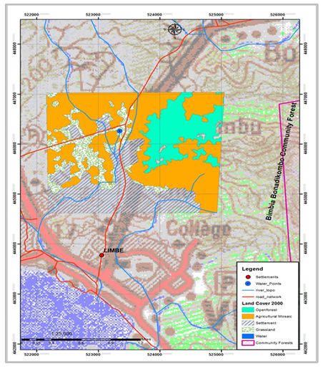

### Figure 2: Land use changes in cold source Limbe Fako Division in the year 2000

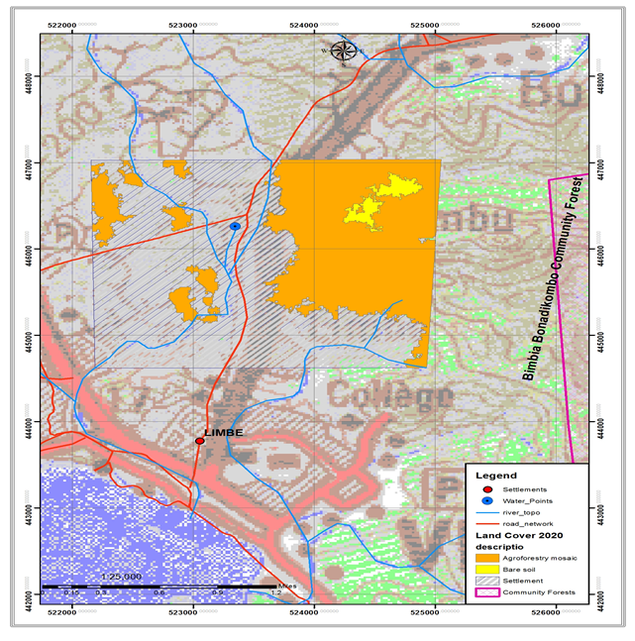

### Figure 3: Land use changes in cold source Limbe in the year 2020

4.8.2 Land use changes observed in cold source Limbe municipality during 2000 and 2020

The results in Table 2 show a major decline with respect to area coverage in the cold source municipality was observed in dense forest and grass land classes whereas, the area of settlements and agriculture classes were increased. Dense forest land shrank from 42992ha in 2000 to 21000ha in 2020 of the total area, recording 51.15% area loss. Grassland reduced from 87133ha in 2000 to 00ha in 2020, recording 100% area loss. The share of settlements was 171117ha in 2000 of the total area which increased up to 777814ha in 2020, recording 58.13% area augmentation. The Agriculture class increased from a share of 312788ha in 2000 to 777814ha in 2020, recording 59.78% area augmentation.

## Table. 2. Land use practices observed in Cold Source Limbe municipality during 2000 and 2020

|  |  |  |  |  |  |
| --- | --- | --- | --- | --- | --- |
| **Land cover/use classes** | **Area (ha)**  **2000** | **Area (ha)**  **2020** | **Area augmentation** | **%Area gain** | **%Area loss** |
| **Dense forest** | 42,992 | 21,000 | 21,992 | 00% | 51.15% |
| **Settlement** | 171,117 | 408,733 | -237,616 | 58.13% | 00% |
| **Agriculture** | 312,788 | 777,814 | -465,026 | 59.78% | 00% |
| **Grass land** | 871,333 | 000 | 871,333 | 00% | 100% |

4.9.2 Land use changes observed in Ngonje and Ngonde water sources in Limbe Municipality Fako Division from 2000 and 2020.

Classified maps of 2000 and 2020 of Ngonje and Ngonde water sources produced from extracted Landsat images are shown in Figure 4 and 5. The different land use changes observed in Ngonje and Ngonde in the year 2000 (Figure 4) were open forest, agricultural mosaic, settlement and plantation agriculture. The open forests around the streams (green) has been completely converted over time in 2020 (Figure 5) to agricultural land (orange), all the land for plantation agriculture in 2000 has been converted to agricultural mosaic in 2020.

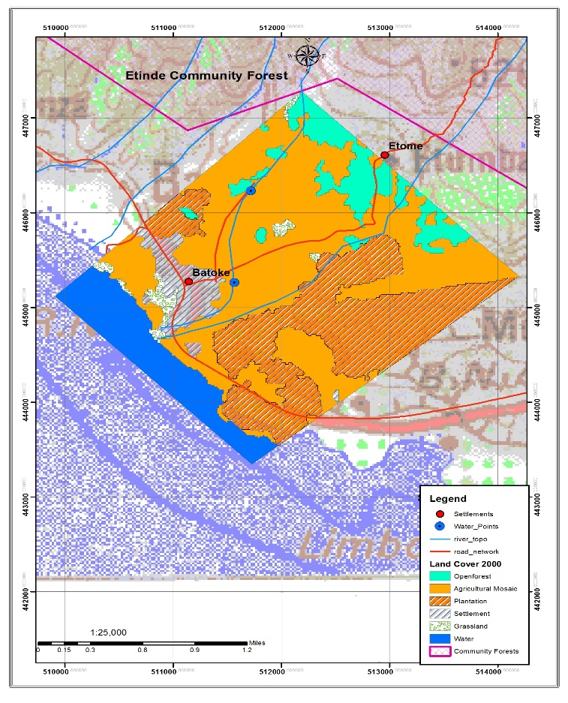

### Figure 4: Land use changes in Ngonje and Ngonde Limbe Municipality, Fako Division in the year 2000

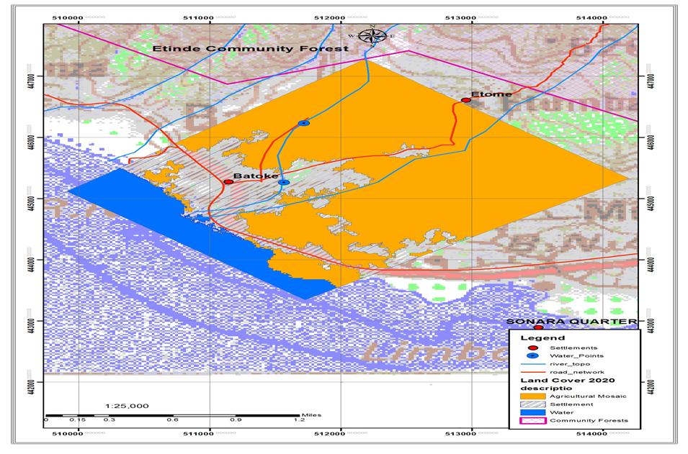

### Figure 5: Land use changes in Ngonje and Ngonde Limbe Municipality, Fako Division in the year 2020

The results in Table 3 show that major decline with respect to area coverage in Limbe municipality was observed in open forest and plantation agriculture classes. Whereas, the area of Settlements and Agriculture classes was increased. Vegetation land shrank from233,402ha in the year 2000, to 00ha in the year 2020 of the total area recording 100% total area loss. While Settlement land increased from 414,984ha in 2000 to 819,324ha in 2020 recording 49.35% area augmentation. The share of plantation agriculture that was 233,402ha in 2000 of the total area reduced to 00ha in 2020 recording 100% area loss. The Agriculture class was increased from a share of 389,346 in the year 2000 to 861,113ha in the year 2020, recording 58.74% area augmentation.

## Table 3. Land use changes observed in Ngonje and Ngonde Limbe municipality during 2000 and 2020

|  |  |  |  |  |  |
| --- | --- | --- | --- | --- | --- |
| Land cover/use classes | Area (ha) in  2000 | Area (ha) in 2020 | % Area augmentation | %Area gain | %Area loss |
| Open forest | 233,402 | 000 | 233,402 | 00% | 100% |
| Settlement | 414,984 | 819,327 | -404,343 | 49.35% | 00% |
| Plantation agriculture | 233,402 | 000 | 233,402 | 00% | 100% |
| Agricultural mosaic | 389,346 | 861,113 | -471,767 | 54.78% | 00% |

## 4.9. Physicochemical parameters of water samples from three selected water sources in the Limbe municipality

Generally, all three streams are freshwater streams, very transparent and minimally polluted with a neutral to slightly basic pH ranging between 7.15-7.34. The concentration of all physicochemical parameters (Table 4), except pH, temperature, and potassium significantly varied across study sites at the (p<0.01). Turbidity values ranged from 1-1.45 NTU in Ngonde and Ngonje respectively.

Phosphates differed significantly with the highest values recorded in Ngonde and Mile 2 and this was above WHO 2017 permissible levels for drinking water, although suitable for irrigation.

Ammonium was detected to measureable levels in Ngonde and Mile 2 but very high concentrations were detected in Ngonde. A similar trend was also recorded in total nitrogen.

## Table 4: Physicochemical parameters of water samples from three water sources in the Limbe Municipality Fako, Cameroon

|  |  |  |  |  |  |
| --- | --- | --- | --- | --- | --- |
| **Parameter** | **Water source** | | | **P - value** | **WHO standard (2017)** |
| **Ngonje** | **Ngonde** | **Mile 2** |
| pH | 7.15a | 7.35a | 7.25a | 0.142ns | 6.5-9.5 |
| Temperature (oC) | 22.9 a | 23.5 a | 21.75 a | 0.198ns | ≤25 |
| Turbidity | 1.45 a | 1.00 b | ND | 0.000*** | <5NTU |
| Electrical conductivity(mS/cm) | 0.085b | 0.055 b | 0.21 a | 0.001*** |  |
| Total nitrogen (mg/L) | ND | 4.24 a | ND |  |  |
| Potassium (mg/L) | 5.18 a | 1.88 a | 3.56 a | 0.544ns |  |
| Alkalinity | 122 b | 105 b | 392 a | 0.000*** |  |
| Salinity | 42.5 b | 27.5 c | 109a | 0.000*** |  |
| Sodium | 0.16 b | 0.16 b | 0.91 a | 0.000*** | <20mg/L |
| Ammonium (mg/L) | ND | 3.70 | ND | 0.000*** | <0.3 mg/L |
| PO4-3 | 6.75 b | 12.5 a | 10.5 a | 0.005*** | <5 mg/L |

Means that do not share a letter within the same row are significantly different. ND: below detectable levels

## Heavy metal concentration of water samples from three water sources in the Limbe municipality

Our findings indicated that As, Cr and Pb were all absent in all the three study sites. Generally, study site significantly (p<0.01) affected the concentrations of Cd and Ni at the 1% level of significance. Specifically, Cd recorded its highest value (50.9 mg/kg) at the Mile 2 study site while its lowest value (14.05 mg/kg) was recorded at the Ngonde study site. On the other hand, Ni recorded its highest value (135.75 mg/kg) at Ngonje and least value (0.00 mg/kg) at the Cold Source study site.

## Table 5: Heavy metal concentration of sediment samples from three water sources in the Limbe municipality

|  |  |  |  |  |  |
| --- | --- | --- | --- | --- | --- |
| **Heavy metal (mg/L)** | **Water source** | | | **P - value** | **WHO standard**  **(2017)** |
| **Ngonje** | **Ngonde** | **Cold Source** |
| As | 0 | 0 | 0 | / | <0.01 |
| Cr | 0 | 0 | 0 | / | <2µg/L |
| Cd | 19.67b | 14.05c | 50.90a | 0.000*** | <1µg/L |
| Ni | 135.75a | 96.86b | 0.00c | 0.000*** | <0.01mg/L |
| Pb | 0 | 0 | 0 | / | <0.01mg/L |

## Bacterial load of water samples from three water sources in the Limbe municipality

Bacteria were detected in all samples collected from study areas with significant differences in their counts across study sites. For all bacterial categories, concentrations were highest at Ngonde, followed by Ngonje and least in the Cold Source study site (Table 6)

## Table 6: Bacterial load of water samples from three water sources in the Limbe municipality, Cameroon

|  |  |  |  |  |
| --- | --- | --- | --- | --- |
| **Bacteria** | **Water source** | | | **P – value** |
| **Ngonje** | **Ngonde** | **Cold source** |
| Total bacteria | 550.0b | 1117.0 a | 19.50 c | 0.000*** |
| Total coliform bacteria | 155.0 b | 875.0 a | 8.50 c | 0.000*** |
| *E. coli* | 95.0 b | 490.0 a | 3.50 c | 0.000*** |
| *Salmonella* sp | 67.5 b | 400.0a | 0.00 c | 0.000*** |
| *Shigella* sp | 5.00 b | 75a | 0.00c | 0.000*** |

## 4.12 Relationship between water physicochemical parameters, heavy metal concentration and bacterial load

## 4.12.1 Correlation analysis between water physicochemical parameters and heavy metal concentration

Figure 6 is a visual presentation of the correlation matrix of physicochemical parameters and heavy metal load in water from three water sources in the Limbe municipality. Positive correlations are displayed in blue and negative correlations in red color. Color intensity and the size of the circle are proportional to the correlation coefficients. Results indicated that Cd showed a very strong positive (r ≥ 0.99) correlation with Na, salinity (Sali.), alkalinity (Alk.) and electrical conductivity (EC) and a strong negative (r ≤ -0.6) correlation with NH4, total nitrogen (TN), turbidity (Turb.) and Temperature (Temp.). Nickel on the other hand showed a strong positive (r ≥ 0.6) relationship with turbidity and temperature and a strong negative (r ≤ -0.6) relationship with Na, salinity, alkalinity and electrical conductivity. It is worth noting that all physicochemical parameters that showed a positive relationship with Cd, showed a negative relationship with Ni.

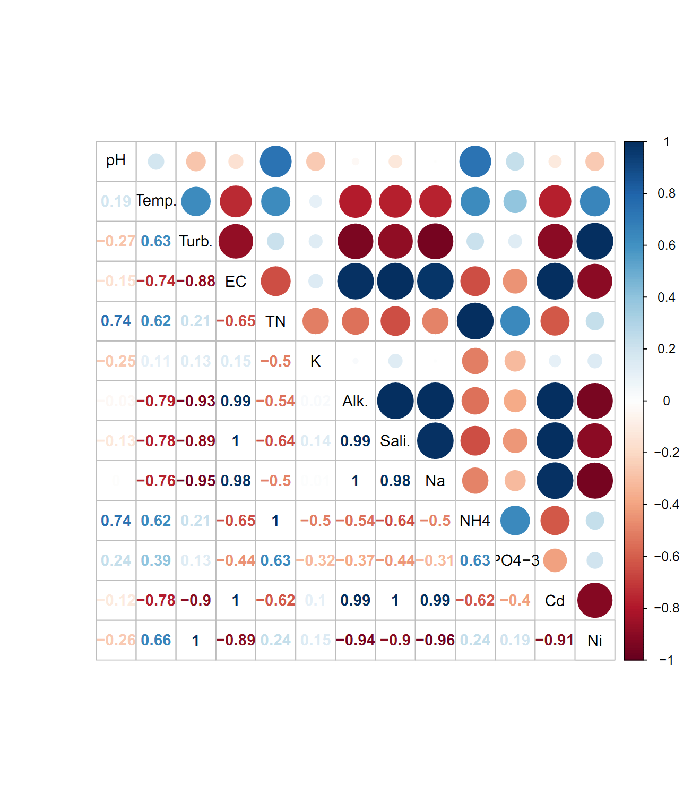

### Figure 6: Correlogram of physicochemical parameters and heavy metal load in water samples from three water sources in the Limbe municipality

## 4.12.2 Correlation analysis between water physicochemical parameters and bacterial load of water samples.

There was a strong positive (r ≥ 0.6) relationship between phosphate and with all bacterial categories except with total bacteria (TB) which were moderately positive (r = 0.58). Ammonium (NH+4), total nitrogen (TN) and temperature (Temp.) all recorded a strong positive (r ≥ 0.6) relationship with all bacterial types. pH was strongly, positively (r = 0.65) and moderately, positively (r = 0.54) to *Shigella sp*. (Shi.). Sodium, salinity, alkalinity and electrical conductivity all recorded strong negative (r ≤ – 0.6) correlations with all the bacterial types except *Shigella*, which recorded a moderate negative relationship with sodium and alkalinity (r = – 0.51 and – 0.56 respectively).

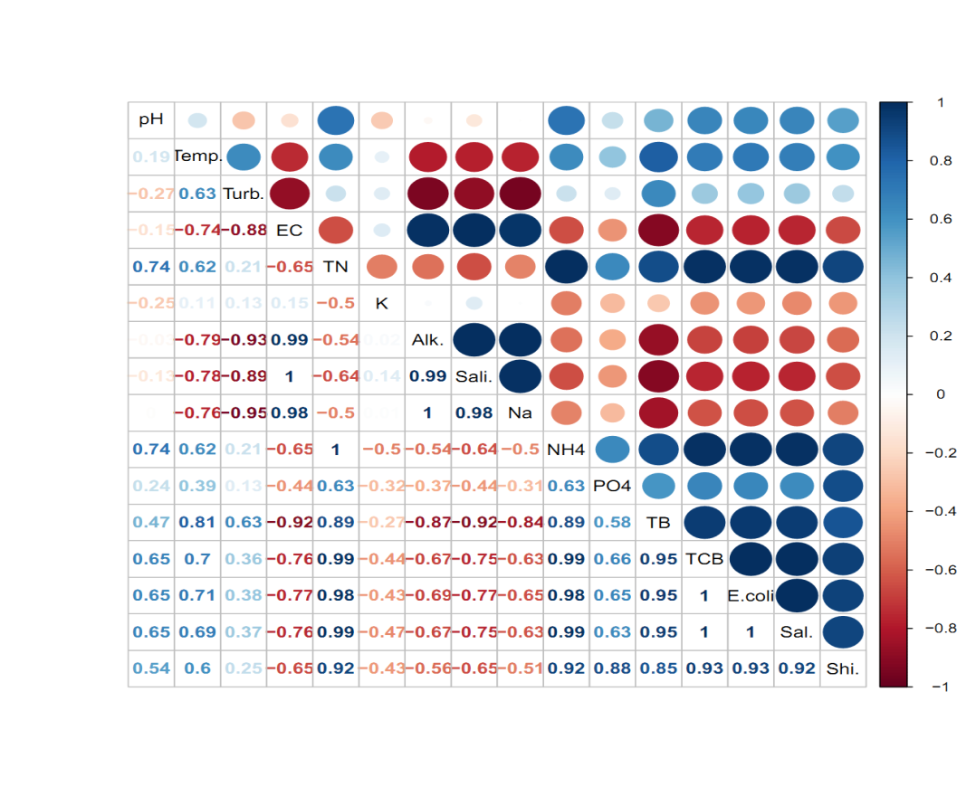

### Figure 7: Correlogram of physicochemical parameters and bacterial load in water samples from three water sources in the Limbe municipality

## 4.12.3 Principal component analysis between water physicochemical parameters, heavy metal load and bacterial concentration

## 4.12.3 Proportion of variation explained by each principal component

The eigenvalues and proportion of variation explained by each principal component as presented on (Table 7) shows that the total variation in the dataset was explained by 5 principal components. Cumulatively, the first 2, 3 and 4 principal components captured over 89%, 94% and 98% of total variability in the dataset respectively.

### Table 7: Proportion of variation explained by each principal component

|  |  |  |  |
| --- | --- | --- | --- |
|  | **Eigenvalue** | **Percentage of variance** | **Cumulative percentage of variance** |
| comp 1 | 12.17016 | 67.61199 | 67.61199 |
| comp 2 | 3.873558 | 21.51977 | 89.13176 |
| comp 3 | 0.918322 | 5.101789 | 94.23355 |
| comp 4 | 0.750518 | 4.169544 | 98.40309 |
| comp 5 | 0.287444 | 1.596909 | 100 |

## 4.12.4 Contributions of variables to each principal component

Results oncontributions of variables to each principal component (Table 8) the highest contribution to dimension 1 came from total bacteria while the least came from pH. Contrary to dimension 1, the highest contrition to dimension 2 was accounted for by pH while the least contrition was made by total bacteria. The most important variable on the third dimension was still pH while the least important variable was alkalinity. On dimension 4, PO4-3 contributed the highest while Ni contributed the least. Finally, on dimension 5, the highest contribution came from temperature and the least came from total bacteria.

## Table 8: Contributions of variables to each principal component of water in the three selected water sources

|  |  |  |  |  |  |
| --- | --- | --- | --- | --- | --- |
| **Variable** | **Dim.1** | **Dim.2** | **Dim.3** | **Dim.4** | **Dim.5** |
| pH | 1.292391 | 13.78554 | 24.01104 | 5.035775 | 17.54429 |
| Temp. | 5.345707 | 0.970953 | 10.01795 | 6.245351 | 60.16451 |
| Turb. | 3.737859 | 13.7365 | 0.510052 | 0.880458 | 0.596131 |
| EC | 7.234748 | 2.584509 | 0.295454 | 0.798542 | 3.722779 |
| TN | 6.085381 | 6.477987 | 0.420029 | 0.411503 | 0.530645 |
| K | 0.655001 | 7.56441 | 46.69382 | 23.76017 | 7.009888 |
| Alk. | 6.557158 | 5.177872 | 0.004527 | 0.086784 | 0.251446 |
| Sali. | 7.249677 | 2.844363 | 0.254932 | 0.508149 | 0.476588 |
| Na | 6.161244 | 6.290739 | 0.003366 | 0.660926 | 0.52188 |
| NH+4 | 6.085381 | 6.477987 | 0.420029 | 0.411503 | 0.530645 |
| PO4- | 3.002312 | 3.167359 | 13.84095 | 49.24192 | 5.30551 |
| Cd | 7.068638 | 3.398399 | 0.055782 | 0.67718 | 0.870451 |
| Ni | 4.001698 | 13.05282 | 0.428084 | 0.023112 | 1.138872 |
| TB | 8.152404 | 0.060684 | 0.569077 | 0.030111 | 0.012859 |
| TCB | 7.130466 | 3.339187 | 0.188284 | 0.096879 | 0.142481 |
| *E. coli* | 7.226685 | 3.003599 | 0.286282 | 0.152105 | 0.1337 |
| *Sal.* | 7.085952 | 3.352473 | 0.122385 | 0.740133 | 0.379123 |
| *Shi.* | 5.9273 | 4.714616 | 1.877947 | 10.2394 | 0.668205 |

## 4.12.4 PCA biplot for water physicochemical parameters, heavy metal concentration and bacterial load

Results fromPCA biplot for water physicochemical parameters, heavy metal concentration and bacterial load Figure 8 high concentrations of Na, alkalinity, Cd, electrical conductivity and salinity were more associated with the Mile 2 spring. High concentrations of turbidity, Ni and K were more associated with the Ngonje water source while high concentrations of *E. coli*, *Shigella sp*., total coliform bacteria (TCB), *Salmonella sp*., NH4, total bacteria (TB), total nitrogen (TN), PO34- and pH were more associated with the Ngonde water source.

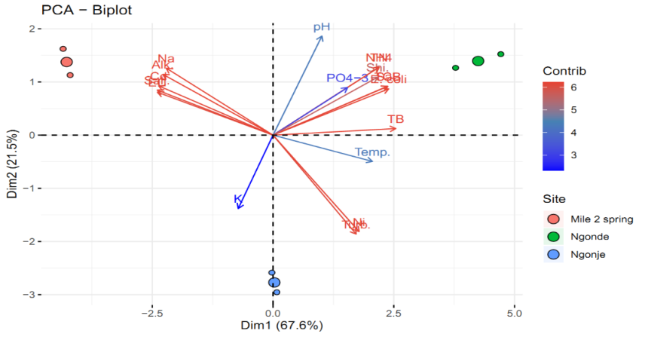

### Figure 8: PCA biplot for water physicochemical parameters, heavy metal concentration and bacterial load

## 4.12.5. Variables having significant correlations with Dim 1

Results ofvariables having significant correlations with Dim 1 (Table 9), out of the 18 variables included in the PCA, 12 were significantly (p<0.05) correlated with the first principal component while none was significantly correlated with the other 4 principal components (α = 0.05). By showing significant correlations with principal component 1, which explains 67.6% of total variability in the dataset, these 12 variables are by implication the key players in the determination of the dynamics of the dataset. Details of variables that are strongly and significantly (p<0.05) correlated with principal component 1.

### Table 9: Variables having significant correlations with Dim 1

|  |  |  |
| --- | --- | --- |
| **Variable** | **Correlation coefficient (r)** | **p-value** |
| Total bacteria | 0.996073 | 2.31E-05 |
| *E. coli* | 0.937816 | 0.00568 |
| TCB | 0.931552 | 0.006867 |
| *Salmonella sp.* | 0.92864 | 0.007457 |
| NH4 | 0.860581 | 0.027801 |
| Total nitrogen | 0.860581 | 0.027801 |
| *Shigella sp*. | 0.84933 | 0.032342 |
| Na | -0.86593 | 0.025758 |
| Alkalinity | -0.89332 | 0.016465 |
| Cd | -0.9275 | 0.007693 |
| Electrical conductivity | -0.93834 | 0.005586 |
| Salinity | -0.93931 | 0.005414 |

## 5.1. 5 Trends in Land use change mapping and analysis using Remote Sensing

The comparison of each class of pixel images of 2000 and 2020 showed that there has been a marked land use and land cover change during the study period of 20 years. During the 2000–2020 period the percentage area covered by Agriculture in Limbe municipality increased while there was a decrease in the area covered by vegetation and grass land. There has been a rapid urban growth especially in major cities such as especially Limbe which is a touristic site, attracting many tourists and the administrative headquarter of the southwest region, Cameroon.

**Implications of changes in LULC on water quality**

Predicting long-term water quality trends in response to landuse changes is very vital, although very challenging as the impacts of LULCC are complex. The conversion of land to urban, agricultural farmlands and settlement often leads to an increase in impervious surfaces via the creation of roads, buildings, thus reducing water infiltration with a resultant increase in runoffs. Runoffs usually carry pollutants, sediments, nutrients, bacteria and heavy metals from the surroundings into water bodies, resulting in water quality degradation. Furthermore, changes in landcover associated with deforestation or urbanization can disrupt the natural infiltration and buffering capacities of ecosystems, reducing their ability to regulate water quality. increased sedimentation in water bodies has been linked to the removal of vegetation along water courses by man which increases the likelihood of sediments being washed into water bodies. This is aggravated by the fact that storm water is poorly managed in the country, thus contributing to pollute streams and rivers. Another factor could be the effects of climate which has exacerbated the impacts of land use changes on water quality. Increase in temperature may favour the proliferation of bacteria in water ways, thus impairing its quality and suitability for drinking and even recreation. Based on the WHO, 2017 standards no bacteria should be found in water used for drinking. Findings from this study have therefore revealed varied concentrations of different bacteriological parameters within the study sites.

High concentrations of phosphate was detected in all three streams, with highest values in Ngonde and Mile 2 Cold source. Phosphates were higher than 5mg/l permissible levels set by WHO 2017 for drinking water. Agricultural landuse has been implicated in nutrient enrichment of streams and rivers, contributing to algal blooms, oxygen depletion and associated biodiversity loss. The results revealed conversion of forest to agricultural mosaics within 2 decades (from 2002 to 2020). The conversion of forests to agricultural land exposes water bodies to pollution from agrochemicals, particularly nitrates and phosphates. Most of the sites had small scale agricultural farms where crops such as plantains, cocoyams et c were planted.

## 5.1.6 Physico-chemical parameters of some water catchments in the Limbe municipality.

Temperature is one of the most important essential parameters of aquatic habitats because almost, all the physical, chemical and biological properties are governed by temperature (Araoye, 2008). In this study, the mean temperature across all the water catchments was highest in Ngonde and Ngonje outlet which could be attributed to the fact that the Ngonde and Ngonje water sources are not under shade as opposed to the water catchments under shade as reported by (Campanella *et al*., 2016) this has brought about a difference in water temperature across the water sources in the Limbe municipality.

The turbidity of the water sources was highest in Ngonje outlet which could be due to the presence of suspended particles from trees, runoffs and anthropogenic influences which reduces the light intensity (Shah, 2017). High turbidity restricts the light penetration which indirectly affects macrophytes community structure since plants requires light for their metabolic activities (Campanella *et al*., 2016).

The electrical conductivity was highest in the Cold Source at Mile 2 and the difference across water sources were statistically significant. The increase in water conductivity in the Cold Source at Mile 2 could result from higher total ionic concentration since the conductivity of natural water is directly proportional to the concentration of ions (Shah, 2017). Furthermore, the level of conductivity in water gives a good indication of the amount of dissolved substances in it, such as phosphate, nitrate and nitrites (Nygren *et al*, 2012). On the other hand, (Adobi *et al*., 2015) reported that biodiversity diminished with increasing electrical conductivity of water. Therefore, the Cold Source at Mile 2 water source which has more concentration of dissolve ions was poor in biodiversity (Adobi *et al*., 2015).

The concentration of ammonium was highest at the Ngonde water source exceeding the WHO safe limits. This is due to the fact that the concentration of waste water discharged and fertilizer applications around the Ngonde water catchment as a result of anthropogenic influences was greater (Fonge et al., 2012). The high concentration may give rise to potential health risks particularly in pregnant women and bottle-fed infants (Kempster et al., 1997). The toxicity of nitrates in human is due to the body's reduction of nitrate to nitrites.

The concentration of phosphates exceeded the WHO safe limits in all the three study sites. This may be due to the fact that the concentration of waste water discharged and fertilizer applications around the water sources as a result of anthropogenic influences is greater (Fonge et al., 2012).

## 5.1.7 Bacterial community structure of some water catchments in the Limbe Municipality

The composition of bacterial communities in a given environment depends on the interaction between various factors such as the geographic environment, temperature, pH, light intensity and nutrient concentrations. (Nygren *et al*, 2012)

In this study, across the studied water catchments in the Limbe municipality, coliform had the highest load while salmonella was the lowest. This is in accordance with the findings of (Niyogi; 2005), who stated that these water catchments in urban towns are more influenced by faecal contamination from septic tanks which has the influence of causing diseases in humans. the highest abundance of total bacteria count was recorded in the Ngonde water sources. These ties with the opinion of (Chang and Fang, 2007) who stated that water source are more influenced by anthropogenic contamination.

*Shigella spp*. are Gram-negative, non-spore forming rod-shaped bacteria and are members of the family Enterobacteriaceae. which grow in the presence or absence of oxygen. *Shigella spp* are transmitted by the faecal-oral route by either person-to-person contact, or consumption of contaminated food or water (Nygren *et al.* 2012). For this study, the highest abundance of *Shigella* was recorded in the Ngonde and Ngonje water sources. This is due to factors such as decreasing temperature, high pH. *Shigella species* has been shown to increase with: decreasing temperature, and increasing pH, (Lemunier *et al*., 2005).

Total coliforms are a group of bacteria commonly found in the environment, for example in soil or vegetation, as well as the intestines of mammals, including humans wherein the presence of fecal coli forms or *Escherichia coli* is used as an indicator for the presence of any of water borne pathogens (Lemunier *et al*., 2005).

For this study, the highest abundance of coliform count was recorded in the Ngonde and Ngonje water sources. This is could be due to the fact that Ngonde and Ngonje are more exposed to fecal contamination from settlement very close to the water sources as opposed to the other water source which are less exposed in the study area (Nygren *et al.* 2012).

In this study, Salmonella was highest in the Ngonde water source which may be due to the fact that this is more exposed to fecal contamination as oppose to the other water sources in the study area (Beuchat *et al*., 1998).

## 5.1.10 Heavy metal concentration of water samples from three water sources in the Limbe municipality

Although it is acknowledged that heavy metals have many adverse health effects and last for a long period of time in the environment, heavy metal exposure continues and is increasing in many parts of the world. Heavy metals are significant environmental pollutants and their toxicity is a problem of increasing significance for ecological, evolutionary, nutritional and environmental reasons (Brochin *et al*., 2014).

In this study, Cd recorded its highest value at the Mile 2 study site while its lowest value was recorded at the Ngonde study site This could be as a result of the fact that Cd is a byproduct of mineral fertilizers, (Alina *et al*., 2012). Cadmium is highly toxic to the kidney and it accumulates in the proximal tubular cells in higher concentrations. Cadmium can cause bone mineralization either through bone damage or by renal dysfunction, (Alina et al., 2012). Studies on humans and animals have revealed that osteoporosis (skeletal damage) is a critical effect of cadmium exposure along with disturbances in calcium metabolism, formation of renal stones and hypercalciuria. Ni recorded its highest value at Ngonje study site, this could be as a result of increased anthropogenic activities. Anthropogenic sources of nickel include fertilisers, steel works, metal plating and coinage, fuel combustion and detergents (Sorriel *et al*., 2010). Nickel is necessary in many organism's diets but can become carcinogenic and toxic in high doses, (Booth, 2010). Women are more commonly allergic to nickel exposure than men. Exposure to skin can cause dermatitis upon contact, (Berg *et al.,* 2013). Inhalation of nickel is the greatest risk of developing health problems, as it becomes highly carcinogenic Berg *et al*., (2013).

## 5.2 Conclusion

The relationship between land use and land cover change and water quality in highlights the need for integrated approaches to the management of the environment. Sustainable development approaches that incorporate agricultural, industrial and urban development with ecosystem preservation are crucial for ensuring and safeguarding the long term health of water resources. For this to be possible, continuous monitoring, sensitization of the community and community involvement can help mitigate these negative effects of LULCC on aquatic resources. There has been a gradual reduction of forest cover and an increase in settlement and agricultural mosaics in Limbe between 2002 and 2020. Based on the results obtained by employment of GIS applications, it is concluded that the land use practices in the study area have altered significantly in 20 years. The LU shift in the Limbe municipality was evident by the decline in the area of vegetation and water class and augmentation of area covered by classes of settlements and barren land.

The proliferation of settlement around water bodies has led to fecal contamination and phosphate pollution of these streams above WHO permissible levels. This could have health implications on some community dwellers using these water sources for domestic uses. The water quality of the Ngonje and Ngonde water sources in the Limbe municipality are not satisfactory for uses such as drinking, bathing or irrigation due to the high levels of some bacteria (*shigella, salmonella,* and *coliform*) and some heavy metals (Nickel, and Cadmium).

According the Forestry Law in Cameroon, the management of all aquatic resources is carried out by the councils. Very good and explicit laws governing the use and management of aquatic resources be implemented so as to safeguard the very important ecosystems.

## 5.3 Recommendation

It is recommended that water from the water sources in the Limbe municipality should be treated before use for drinking, laundry and irrigation of vegetables cultivated around water sources.

The presence of some pollution indicators like S*higella* shows that some water sources are heavily polluted. It is therefore recommended that all human activities around waters should be avoided. Furthermore, sewage tanks should also be constructed faraway about (300m) from these water sources in order to prevent contamination. Local farmers should be discouraged from farming practices that involve encroaching on the wetland area in collaboration with upstream land owners in an effort to reduce deforestation and associated soil erosion. Effective irrigation systems that minimize water wastage should be considered. Application practices of agricultural chemicals should be changed to minimize inputs to these water sources. Monitoring of domestic sewage discharges from properties around the water sources should be periodically carried out.

Control of the proliferation of aquatic invasive species should be taken into consideration.

**REFERENCES**

Abobi, S.M., Ampofo, Y., Kpodonu, T., Alhassan, E. H., Abarike, E.D., Atindaana, S. A., Akongyuure, D. N., Konadu, V. and Twumasi, F. (2015) Socio-Ecological Importance of Aquatic Macrophytes to Some Fishing Communities in the Northern Region of Ghana. *Elixir Bio Diver. 79 (2015) 30432-30437*

Agbor T, Tefeh R (2013). Buea Water crises Worsening. Cameroon Postline No. 01448

Alina, M., Azrina, A., Mohd, Y. A. S., Mohd, Z. S., Mohd, I. E. H. and Muhammad, R. R. (2012). Heavy metals (mercury, arsenic, cadmium, plumbum) in selected marine fish and shellfish along the Straits of Malacca. *Int Food Res J,* 19(1): 135–140.

Balanson S, Walton BM, Wolin GA and Mal TK. (2005). Aquatic Macrophyte Diversity and Habitat Characterisation of the Cuyahoga River Watershed in North-eastern Ohio. The Ohio Journal of Science, 105, 88-96.

Campanella, B., Onor, M., D’Ulivo, A., Giannecchini, R., D’Orazio, M. and Petrini, R. (2016). Human exposure to thallium through tap water. A study from Valdicastello Carducci and Pietrasanta (northern Tuscany, Italy). *Science of the Total Environment*, 548:33-42

Chang, J.M. and Fang, T. J. (2007). Survival of Escherichia coli O157:H7 and Salmonella enteric serovars Typhimurium in iceberg lettuce and the antimicrobial effect of rice vinegar against E. coli O157:H7*. Food Microbiology,* 24: 745-751.

Dar NA, Pandit AK and Ganai BA. (2014). Factors affecting the distribution patterns of aquatic macrophytes. Limnological Reviews, 14, 75 -81.

Deshmukh UB, Shende MB and Rather OS. (2016). Aquatic macrophytes biodiversity assessment from Asolamendha reservoir of Chandrapur district, Maharashtra State (India). International Journal of Applied Research, 2, 293-298

Fonge BA, Egbe EA, Fongod AN, Tening AS, Achu RM, Yinda GS and Mvondo- Ze A. (2012). Effects of Land Use on Macrophyte Communities and Water Quality in the Ndop Wetland Plain, Cameroon. Journal of Agriculture and Social Sciences, 12, 41 – 49.

Kamel KA. (2013). Phytoremediation Potentiality of Aquatic Macrophytes in Heavy Metal Contaminated Water of EL-Temsah Lake, Ismailia, Egypt. Middle-East Journal of Scientific Research, 14, 1555-1568.

Kempster P. L., Van Vliet H. R. and Kuhn A. (1997). The Need for Guideline to Bridge the Gap between Ideal Drinking Water Quality and Quality which is Practicably Available and Acceptable. Water SA 23(2): 163–167.

Lambi CM, Kometa SS (2009). An Evaluation of Water Resources on the Eastern Slopes of Mount Cameroon. *J. Hum. Ecol*. 28(1):47-55.

Lemunier, M., Francou, C., Rousseaux, S., Houot, S., Dantigny, P., Piveteau, P. and Guzzo, J. (2005). Long-term survival of pathogenic and sanitation indicator bacteria in experimental biowaste composts. *Applied Environmental Microbiology,* 71:5779–5786.

Malika, E., Rene, N., Ndefon, P., Kamgno, J. and Njunda, A. L (2019). Seasonal Comparison of Contaminants in Drinking Water from Catchment to Household in Fako, *International Journal of Trend in Scientific Research and Development*, *4(1):* *2456 – 6470*

Niyogi, S. K. (2005). Shigellosis*. The Journal of Microbiology.* 43(2):133-143.

Nygren, B.L., Schilling, K.A., Blanton, E.M., Silk, B.J. and Cole, D.J. Mintz ED (2012) Foodborne outbreaks of shigellosis in the USA*. Epidemiology and Infection, 141(2):233–241.*

*Shamim Al Mamun . Shatabdi Saha . Jannatara Ferdush . Tanmoy Roy Tusher . Md. Abu-Sharif . Md. Ferdous Alam . Megan R. Balks . Zakia Parveen*. (2021). Cadmium contamination in agricultural soils of Bangladesh and management by application of organic amendments: evaluation of field assessment and pot experiments. *Environ Geochem Health*. DOI: 10.1007/s10653-021-00829-x

Sudhira, H. S.; Kumar, V. S. Monitoring of lake water quality in Mysore city, proceedings of Lake 2000. International symposium on restoration of lakes and wetlands, 27 – 29 Nov. 2000, CSIC Auditorium, Indian Institute of Science, Bangalore, (2000), 1–10.

Tita MA, Kuitcha D, Magha A, Ndjama J and Kamgang KBV. (2012). Occurrence of macrophytes in the Mezam river system in Bamenda (Cameroon) and their role in nutrient retention. Syllabus Review, Science Series 3, 1-10.