**IMPACT OF ARTISANAL MINING ON ENVIRONMENTAL SUSTAINABILITY AND RESOURCE MANAGEMENT IN KADUNA STATE, NIGERIA**

**ABSTRACT**

Mining is a global phenomenon with severe effects on natural resources including loss of vegetation, agricultural lands and domestic water sources. Artisanal mining which is one of the human activities carried out in the rural communities of Kaduna State has severe effects on the environment and people source of livelihood. This study assesses the impact of artisanal mining on environmentalsustainabilityandnatural resource management in Kaduna State, Nigeria. A mixed-methods approach was used, which includes both quantitative and qualitative data collection techniques. Data for the study was analysed using descriptive statistics like percentage and mean. Result of the study showed grand mean scores of 4.42 for the mining communities and 4.74 for non-mining communities, which were above 3.00 the benchmark for acceptance based on the standard for rating Likert scale. Findings of the study indicated that artisanal mining had adverse effects on vegetation distribution, agricultural lands, domestic water sources and biodiversity, grazing land, wildlife and medicinal herbs. Households face difficulties accessing these resources due to degradation by miners and other human activities. It is therefore, recommended that security personnel (vigilante groups, civil defence, police and forest guards) should put more efforts to prevent incursion of miners into the forests for mining of minerals by constant monitoring of such areas, and the need for farmers to report miners that forcefully mined minerals in their farms to security agents to be arrested and punished. There is need for adoption of environmentally friendly mining technologies or community-based resource management approaches.

**Keywords:** Artisanal mining, Environmental Sustainability and Natural Resource Management

**1. INTRODUCTION**

Minerals play significant roles in boosting the manufacturing sector and creating jobs for a sizeable proportion of the world population (Mancini & Sala, 2018). Mining activities have negative effect on the environmental, which may constrain the achievement of other sustainable development goals such as good health and clean water (Alhaji & Kanayochukwu, 2020). This sector has detrimental effects on the environment and health of the people (Fagariba *et al,* 2024; Donkor *et al,* 2024). Mining of minerals like Gold, Tantalite, Tin and Columbite affect the sustainable utilisation of natural resources which in turn affects household livelihood (Sarma, *et al*, 2010; Arthur *et al,* 2016; Sheriff *et al,* 2018). For example, mining of minerals affect the environment and socioeconomic lives of people and communities involved directly or indirectly in it (Amankwah and Anim-Sackey, 2004; Hilson, 2002). Environmental problems associated with mining of minerals are soil erosion, loss of vegetation, soil fertility and decline in biodiversity and pollution (Xuejiao *etal*, 2019). This affects agriculture and other sources of livelihood.

Artisanal mining has adverse effects on livelihood/household income as it induces vulnerability through destruction of farmlands thereby forcing many households into extreme poverty (World Bank, 2014; Sheriff *et al,* 2018). Destruction of farmlands/arable lands by artisanal mining has significant effect on food security and low agricultural produce and food crops in many parts of the world (Onwuka *et al*, 2013; Intergovernmental Forum on Mining, Minerals and Sustainable Development-IGF, 2018). Water pollution and contamination also induce vulnerability in many mining communities worldwide. For example, most artisanal mining activities are undertaken involving the use of water, which affects sources of water for domestic and agricultural activities such as drinking, cooking, irrigation farming and livestock (IGF, 2018; Alhaji & Kanayochukwu, 2020). This reduces access to safe drinking water, hence, causing water shortages in many communities, especially in developing world.

Mining affects rural economy because it reduces grazing lands (World Bank, 2009). Herding is the dominant livelihood strategy for herders in the world. However, as minerals are mined, grazing land diminishes which affect the traditional livelihood of herders. For example, Zankan et al. (2022), reported that mining affects herder’s livelihood in different ways, such as the relocation to new areas, increase in revenue for herders as the demand for animal products increases and new markets open, threat of chronic impoverishment for herders unable to adapt to new grazing areas or access to new income‐generating opportunities and competition for natural resources (water, grazing land) which may lead to conflict, livestock becomes vulnerable to death and injuries due to mining pits left after the mining operation.

Land is vulnerable in different parts of the world due to mining (Wang *et al,,* 2019). Water pollution, low soil fertility and vegetation induced by mining makes it challenging to ensure environmental sustainability and sustainable use of the natural resource base (Sheriff *et al,* 2018) which reduces forest cover (Sarma, *et al*, 2010; Arthur *et al,* 2016). This activity affects the local environment and associated biota through the removal of vegetation and topsoil, the displacement of fauna, the release of pollutants, and the generation of noise particularly where the diversion of forest land for mining takes place (Singh, Singh and Singh, 2010; Goswami, 2015; United Nations Development Project-UNDP, 2017). Declined in vegetation causes invasive species to occupy the area, and as a result, posing severe threats to biodiversity and household sources of livelihood.

In Nigeria, mining contributes very little income to the national economy despite the abundant deposits of minerals such as tin and columbite, iron ore, coal, lead and gold. For example, the sector accounted for only 0.18% of GDP in 2018, and today, the activity is mainly poverty-driven and supports the livelihoods of at least 500,000 people (Ango *et al,* 2019). Artisanal mining is a source livelihood that provides employment opportunity and generates lot of income for households in Nigeria (Bansah *et* *al*., 2018). However, its operation is associated with many negative externalities, such as environmental degradation, crime and health hazards. One tragic example identified by Ango et al (2019) is the 2010 lead poisoning outbreak in Nigeria’s Northwestern Zamfara State, which killed approximately 400 children and has affected thousands more.

Kaduna State is also blessed with different minerals in commercial quantities, such as tin, tantalite, sapphire, zircon, gold and nickel. However, presence of these minerals has attracted artisanal mining in different parts of the State such as Birnin Gwari, Antang, Godo-Godo and Kajuru (Kareem & Owao, 2000; Adekoya, 2003; Yunana and Banta, 2014, Gadzama, 2015). Artisanal mining causes environmental degradation through erosion and deforestation (Yunana & Banta, 2014). Natural resources such as vegetation, agricultural lands, biodiversity and grazing land are primary sources of livelihoods that artisanal mining has degraded and need to be investigated in the study area. As such, there is need to carry out a study that would look at the impact of artisanal mining on environmental sustainability and natural resource management. However, this study assesses the impact of artisanal mining on environmental sustainability and resource management in Kaduna State, Nigeria with a view to provide information for sustainable living and management of natural resources.

**2. Materials and Methods**

**2.1 Study Area**

Kaduna State is located in north Central Nigeria, a country in West Africa. It is one of the 36 states of the Federal Republic of Nigeria. The State lies from latitudes 9 º 03′ to 11 º 32′ N and longitudes 6 º 05′ to 8 º 38′E East of the Greenwich Meridian. Kaduna State covers an area of 46, 053 km² and constitutes 5% total land area of Nigeria. It shares boundary with Kano, Katsina and Zamfara States in the North, Bauchi and Plateau States to the East, Niger State to the West and FCT and Nasarawa State South. Politically, Kaduna State consists of 23 local government areas, as shown in Figure 1. Presence of minerals like gold, Sapphire, Tin and Tantalite across the local government areas have made the State a favourable ground mining to take place.

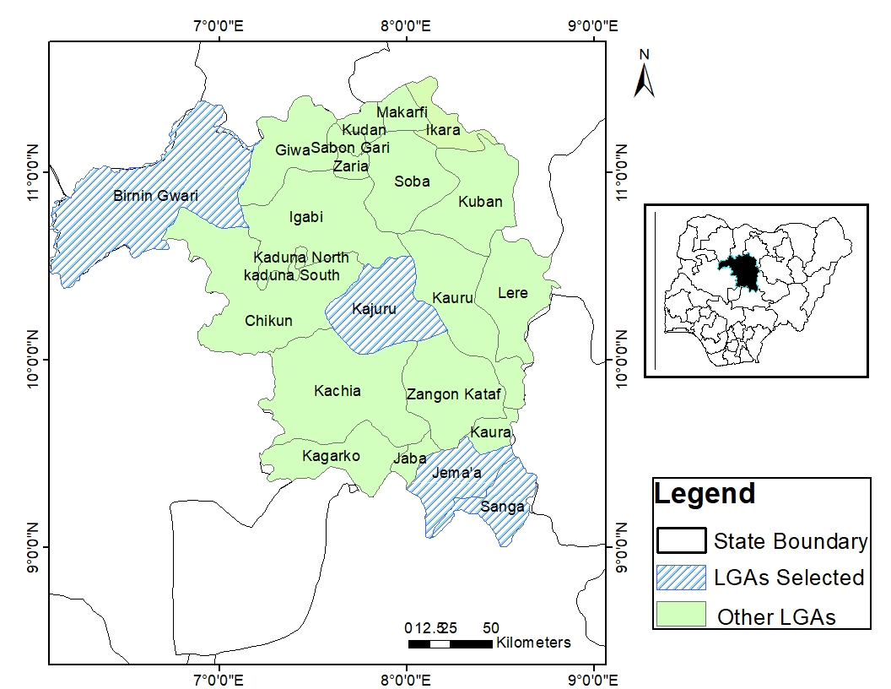

**Figure 1: Map of Kaduna State showing the local government Areas selected for the study**

**Source: GIS Lab, Department of Geography BUK**

Climatically, Kaduna State has an AW climate as classified by Koppen with two distinct seasons (dry and moist). The moist (rainy) season is much longer in the southern part of the State around Kafanchan and Kagoro, where it begins in April and ends in October, while, in the northern part (Zaria and Makarfi), the rainfall regime is similar to that of the Kano region which lasts from mid-May to September (Abaje *et* *al*, 2018). The State experiences a single peak of rainfall either in August or September. The seasons are influenced by the tropical maritime air mass and tropical continental air mass. The mean annual rainfall decreases from 1659.44 mm in the southern part of the State (Kafanchan) to 1245.97mm in the central (Kaduna) and 1016.66 mm in the northern part (Zaria) (Abaje *et* *al*, 2018). Average annual rainfall and humidity for the study area are 1307.36mm and 56.64%. The rainy season makes water available for mining to take. However, it does not favour mining of minerals in the study area because rain water fills mining pits that causes collapse of underground roofs. The average minimum and maximum temperature are 15.1ºC and 35.18ºC. The orographic effects of the Jos Plateau and the Kagoro hills have positive effects on the climate in the southern part, influencing rainfall, temperature, and relative humidity (Ishaya and Abaje, 2008).

The study area lies within the Guinea savanna region of Nigeria where rainfall is heavier (Buba, 2015). The geology of the study area consists of underlain Pre-Cambrian rocks of the basement complex mainly granite, gneiss, migmatite and quartzite (Nigeria Mining & Metal Sector (NMMS, 2017). Presence of the geology promotes mining of minerals because it hosts different minerals like gold, sapphire, zircon, tin and tantalite in commercial quantities. The dominants economic activities are farming, mining and commerce, rearing of animals and hunting. The population is culturally diverse, with differences in religion, ethnicity, traditions and social norms between the predominantly Hausa/Muslim population in the northern part of the State and Christians of a variety of ethnic groups in the south.

**2.2 Data Collection**

The study involved a reconnaissance visit to mining areas with the help of subsistence miners present to have firsthand information about the study area. These visits identified four local government areas in Kaduna State where artisanal mining occurs (Sanga, Jema’a, Kajuru and Birnin-Gwari local governments). Data for this study was collected through the questionnaire, Focus Group Discussion (FGD), in-depth interviews and direct field observation. Rural household heads from both mining and non-mining communities were purposively selected for the study. This is because the household heads from mining communities were directly affected by artisanal mining and were in a better position to share their knowledge and concerns about the mining activities. Household heads from the mining communities were selected based on proximity to mining sites and the intensiveness of artisanal mining activities in such areas. While, household heads from-non mining communities served as “control”. Household heads at the age of 18 or above were contacted because of their adequate knowledge and information they have on artisanal mining activities in the study area. The minimum age threshold was used because, at that age, every person could decide for themselves and participate in decision making at both local and national level.

Three hundred and eighty four (384) respondents were administered with a questionnaire across the study area (Krejcie and Morgan, 1970). Self questionnaire administration was adopted to avoid incompleteness of questionnaire and increase response rate of the respondents. The study had two focus groups involving miners and farmers in each local government selected for the study. Collectively, eight focus groups were done in the study area. A group of 6-10 people of a particular category was selected in a place, followed by another category to discuss issues and questions itemized for the research. Twelve (12) key informant officers that involved officials of the miners, farmers and community heads were selected for the in-depth interviews from the local government areas selected. They were contacted personally and discussed issues itemized for the study. The FGD and In-depth interview were carried out to complement the result obtained from the questionnaire survey.

**2.3 Data Analysis**

Data for the study was analysed using percentage, mean and Nvivo, version 11.0 software. Nvivo is a software program used for qualitative and mixed-methods research. Specifically, it analyses unstructured text, audio, video, and image data. It can condense extensive qualitative data from interviews, FGD, in-depth interviews and participatory rural appraisal in textual format.

**3. RESULT AND DISCUSSION**

**3.1 Demographic Characteristics of the Respondents**

**Table 1: Demographic Characteristics of the Respondents**

|  |  |  |  |  |
| --- | --- | --- | --- | --- |
| Variable | Categories | Mining Community n (%) | Non-Mining Community n (%) | Total n (%) |
| Sex | Male | 105 (54.7%) | 138(71.9%) |  |
|  | Female | 87(45.3%) | 54(28.1%) |  |
| Total |  | **192(100%)** | **192 (100%)** | **384 (100%)** |
| Age | Less than 20 | 24(12.5%) | 14(7.3%) |  |
|  | 20-29 years | 32(16.7%) | 30(15.6%) |  |
|  | 30-39 years | 77(40.1%) | 80(41.7%) |  |
|  | 40-49 years | 41(21.4%) | 19(9.9%) |  |
|  | 50-59 years | 12(6.3%) | 45(23.4%) |  |
|  | 60 and above | 6(3.0%) | 4(2.1%) |  |
| Total |  | **192(100%)** | **192(100%)** | **384(100%)** |
| Marital Status | Single | 20(10.4%) | 8(4.2%) |  |
|  | Married | 110(57.3%) | 144(75%) |  |
|  | Widow | 62(32.3%) | 40(20.8%) |  |
| Total |  | **192(100%)** | **192(100%)** | **384(100%)** |
| Education | Non formal Education | 38(19.8%) | 21(10.9%) |  |
|  | Basic | 77(40.1%) | 66(34.4%) |  |
|  | Secondary | 46(23.9%) | 57(29.7%) |  |
|  | Tertiary | 27(14.1%) | 46(23.9%) |  |
|  | Others | 4(2.1%) | 2(1.1%) |  |
| Total |  | **192(100%)** | **192(100%)** | **384(100%)** |
| Occupation | Farmer | 78(40.6%) | 115(59.9%) |  |
|  | Artisan/farmer | 11(5.7%) | 22(11.5%) |  |
|  | Trader/farmer | 17(8.9%) | 25(13.0%) |  |
|  | Civil Servant | 19(9.9%) | 28(14.6%) |  |
|  | Miner | 67(34.9%) | 2(1.0%) |  |
| Total |  | **192(100%)** | **192(100%)** | **384(100%)** |

**Source: Field survey, 2021**

Table 1 depicts the demographic characteristics of the respondents in both mining and non-mining communities. However, 54.7% (105) and 71.9% (138) of the respondents were males in the mining and non-mining communities respectively, while, 87(45.3%) and 54(28.1%) were females. 40.1% and 41.7% fall within the age range of 30–39 years respectively in both communities. About 57.3% and 75% were married respectively in both communities, 19.8% did not attend school in mining communities and 10.9% in non-mining communities. Regarding farming, 40.6% and 59.9% respectively were farmers in both mining and non-mining communities. However, even those that claimed not to be farmers practice little agriculture like planting of crops and domestication of animals in their gardens.

**3.2 Impact of Artisanal Mining on Environmental Sustainability and Resource Management in Kaduna State**

Table 2 presents and discusses the impact of artisanal mining on environmental sustainability and resource management in Kaduna State. Outcome of the study shows that artisanal mining has several impacts on environmental sustainability and natural resource management in the study area, such as reduction in vegetation, destruction of agricultural lands, pollution and contamination of domestic water sources, loss of biodiversity, reduction in available land for grazing, lost of wildlife and unavailability of medicinal herbs.

**Table 2: Impact of Artisanal Mining on Environmental Sustainability and Resource Management in Mining and Non-Mining Communities of Kaduna State**

|  |  |  |  |  |
| --- | --- | --- | --- | --- |
| **S/N** | **Item** | **Mean** | | **Remark** |
| **Mining Com.** | **Non-Min Com.** |
| 1 | Artisanal mining and utilisation of vegetation resources | 4.40 | 4.59 | Agreed |
| 2 | Artisanal mining and utilisation of agricultural lands | 4.38 | 4.83 | Agreed |
| 3 | Artisanal mining and utilisation of water sources | 4.53 | 4.73 | Agreed |
| 4 | Artisanal mining and utilisation of biodiversity | 4.31 | 4.78 | Agreed |
| 5 | Artisanal mining and availability of grazing land | 4.55 | 4.79 | Agreed |
| 6 | Artisanal mining and availability of wildlife | 4.47 | 4.68 | Agreed |
| 7 | Artisanal mining and availability of medicinal herbs | 4.28 | 4.74 | Agreed |
|  | Grand Mean | 4.42 | 4.73 | Agreed |

**Source: Field survey, July, 2021**

Table 2 shows the mean scores on the impact of artisanal mining on environmental sustainability and resource management between the mining and non-mining communities in Kaduna State, Nigeria. From the table, it is indicated that the mean score for items 1-7 is 4.40, 4.38, 4.53, 4.31, 4.55, 4.47 and 4.28 for the mining communities and 4.59, 4.83, 4.73, 4.78, 4.79, 4.78 and 4.74 respectively for the non-mining communities, which were above 3.00 the benchmark for acceptance based on the standard for rating Likert scale (Brown, 2010). It shows that artisanal mining poses severe impact on natural resource sustainability in the rural communities of Kaduna State Nigeria. The grand mean of all items in table 2 is 4.42 and 4.74 which mean agreed based on Likert scale. Therefore, the sustainability of natural resources depends on artisanal mining in the rural communities of Kaduna State of Nigeria.

*Artisanal Mining and Utilisation of Vegetation Resources*

Result of the study indicates that artisanal mining does not ensure sustainable utilisation of vegetation resources in Kaduna state (Table 2). Miners engage in mineral extraction to achieve their livelihood objective without considering the fact that the activity has undesirable effects on the environmental resources around them and other sources of livelihood. However, they remove vegetation resources that provide shed to the soil, food for man and other organisms, oxygen for life to function on earth and control soil erosion, flooding, drought and desertification.

Most of the mining communities have low tree species density and diversity because of mining of minerals (emerald, sapphire and tantalite) and other factors like climate, farming, overgrazing, deforestation and hunting. For example, tree species like Daniellia oliveri, Khaya senegalensis, Prosopis africana and Pterocarpus erinaceus that are known to be found in the study area are disappearing at an alarming rate due to human activities like mining, bush burning, lumbering, farming and hunting. Findings of this study is similar to that of Arthur et al. (2016), Papworth et al. (2017), Zankan et al. (2020), that identified the environmental effect of mining and commercial woodfuel harvesting to the disappearing of tree species. It also supported that of Schueler et al. (2011), Girard *et al.,* (2022) and Landrigan et al. (2022) who noted that deforestation caused by mining claimed vast area of forest every year across the world. However, some of the miners maintained that mining activity does not affect the vegetation resources because they instruct miners not to uproot trees during mining. This view was well illustrated by the chairman of mining association of Godogodo Chiefdom:

“We have warned our members not to uproot trees rampantly to maintain their availability in our land since they are good for our survival. We use them as food, medicine, woodfuel and timber for sale to earn income and roof our houses”.

Increased clearing of land for mining of minerals affects vegetation resources where vast areas of plants (trees, shrubs and herbs) are destroyed every year due to such activity. Large tracts of land have lost their vegetation cover due to artisanal mining (Mensah and Tuokuu, 2023). This problem has also had a corresponding impact on the hydrological cycle in the mining areas of Kaduna State, because many rivers don’t longer store water due to high level of deposition of sand and rock debris. Vegetation which provides cover (shed) for the land is uprooted leaving the land to high insolation that makes the soil loose and easily washed away by water to the nearby rivers. This has caused shallowness of many rivers across the study area. Findings of this work agrees with that of Mensah et al. (2015) which viewed that increased vegetation clearing for mining of minerals has adversely altered the hydrological regimes and, or patterns in the western region of Ghana.

*Artisanal Mining and Utilisation of Farmlands in Kaduna State*

Table 2 indicates that artisanal mining does not ensure the sustainable utilisation of agricultural lands in the study area. Miners degrade agricultural lands through mining activities, which makes such lands not suitable for crop production. However, this activity has led to loss farmlands, affecting agricultural production and household income generating opportunities in the rural communities of Kaduna State. Findings of this study are similar to those of Arthur et al. (2016), who reported that small-scale mining has adverse effects on livelihood/household income as it induces vulnerability through the destruction of farmlands, which causes small-scale farm holders, to lose their livelihood and household income and render others to extreme poverty.

In some mining communities of Kaduna State, mining is carry out involving the refilling of mining pits (land reclamation), which allows farmers to return to their farmlands after regaining nutrients. However, mining activities degrade soil fertility by destroying organisms that help in soil development, uprooting vegetation cover. Important soil organisms are destroyed and stable soil aggregates disrupted, eventually depriving the soil of organic matter and low macronutrients necessary for plant growth (Mensah *et al.* 2015). For example, in Godogodo, agricultural lands would not be available in some years to come due intensive mining if drastic actions are not taking. Mining is done illegally in the farm without the knowledge of the owners. However, this problem has forced many farmers to allow mining in their farms and collect little compensation. Surface mining is also mainly responsible low soil fertility where it is practiced; result in reduction of agricultural practices. Degradation of arable lands, contamination and pollution of water bodies can shift labour from food crop farming to mining. Surface mining is responsible mainly for the low food production, food price spikes and the high cost of living, especially in illegal mining regions (Gilbert and Albert, 2016; Assan & Muhammed, 2018). However, surface mining is considered to be a short term land use that may be followed by productive farmland, if reclamation is done correctly.

Household heads in non-mining communities also acknowledged that artisanal mining affects the sustainable utilisation of agricultural lands in mining communities. Miners create irregular surfaces on farmlands; remove the vegetal cover which led to low level of agricultural production in the study area. As such, the sustainability of farmland would not be assured with artisanal mining. Results of this work agrees with the outcome of previous studies (Mensah *et al.* 2015; Gilbert and Albert, 2016), which revealed that land in areas surrounding mines is rendered bare and susceptible to increased erosion and loss of viability for agricultural purposes, among other uses and that major illegalregions of Ghana recorded progressively lower food productivity and correspondingly higher consumer price indices than the national averages over the last few years from 2012 to 2016. Earnings from mining are used to support declining crop production caused by such activity that forces households to desert their farmlands and this contributes more to agricultural production (World Bank, 2016; Hentschel, *et al.* 2002).

*Artisanal Mining and Utilisation of Water Sources*

Table 2 shows that artisanal mining does not ensure sustainable utilisation of water sources in Kaduna State. Most mining activities occur on water bodies such as streams and rivers and sands are moved to those areas to be washed which affects water quality, turbidity, pollution and contamination of the water sources. Most of the water sources that provide water for domestic and agricultural activities such as cooking, consumption, washing of clothes, plates and irrigation have been damaged due to artisanal mining in the mining communities of Kaduna State. result of thisstudysupports the outcome of previous studies (World Bank, 2014; Arthur *et al.* 2016; IGF, 2018; Kumi-Boateng & Stemn, 2020), which revealed that most water bodies that served as sources of water for domestic and agricultural activities had been destroyed in many mining communities across the world.

Lots of sediments are deposited along the river and stream channels, which have led to shallowing of those sources, forcing them to dry out and have affected irrigation farming and available water for domestic uses, leading to food insecurity and household means of income generation. Findings of this study are in line with that of Hentschel et al. (2002), who stressed that the environmental effects of artisanal mining are mercury and cyanide pollution, direct dumping of tailings and effluents into rivers, threats from improperly constructed tailings dams, river damage in alluvial areas, river siltation, erosion damage and deforestation, and landscape destruction.

Most of the water bodies used for mining of minerals in the rural areas of Kaduna State have been polluted and contaminated by miners. They defecate within the surrounding where mining occurs which are washed by rainfall to the water bodies that pollute the water sources. Deposition of sediments on waterways causes shallowing of the river channels leading to flooding and erosion of farmlands on the banks of the rivers. Such problem has contributed to food insecurity as many farmlands have been damaged by flooding and erosion. For example, in Birnin Gwari where gold mining occurs, mercury is released into water sources which contaminate them. Result of this work conforms to Ncube-Phiri et al. (2015), Mensah et al. (2015), Idris-Nda et al, (2018), Keita, (2018) and Bansah et al. (2018), which noted that artisanal gold mining has negative effect on water quality (turbidity), pollution and crop and livestock production. Household heads in non-mining communities also admitted that artisanal mining does not ensure the sustainable utilisation of domestic water sources. Most communities that found on downstream where mining of mineral occurs had problem of water pollution and contamination. They noted that mining is not the only cause of degradation of domestic water sources; however domestic water sources are also degraded in the non-mining communities by fishermen that use chemicals (insecticides) for fishing especially during the dry season.

*Artisanal Mining and Utilisation of Biodiversity*

The distribution of biodiversity on earth depends on different factors, such as climate and anthropogenic disturbances. Table 2 shows that artisanal mining does not ensure sustainable distribution of biodiversity in Kaduna State. Most mining activities take place on forest lands, farmlands and water bodies and this has led to loss of different species of plants and animals and other living organisms that are beneficial to the environment (plate 1). Even though mining pits may provide shelter for some animal species especially the burrow type, there are several other species, such as antelope, which cannot survive where mining occurs. Artisanal mining affected the vegetation distribution in Kaduna State because it led to reduction in the density and diversity of woody species, affecting the ecological system.

Most water sources in the mining communities host lots of biological diversity, and had been polluted and contaminated by miners which destroyed aquatic living organisms like fish, prawn and amphibians. Biodiversity distribution suffers worldwide due to anthropogenic factors such as hunting, farming and mining. Result of this study agrees with that of Arthur et al. (2016), who stressed that increasing artisanal activities has led to rapid destruction to biodiversity, and forest resources in Ghana.

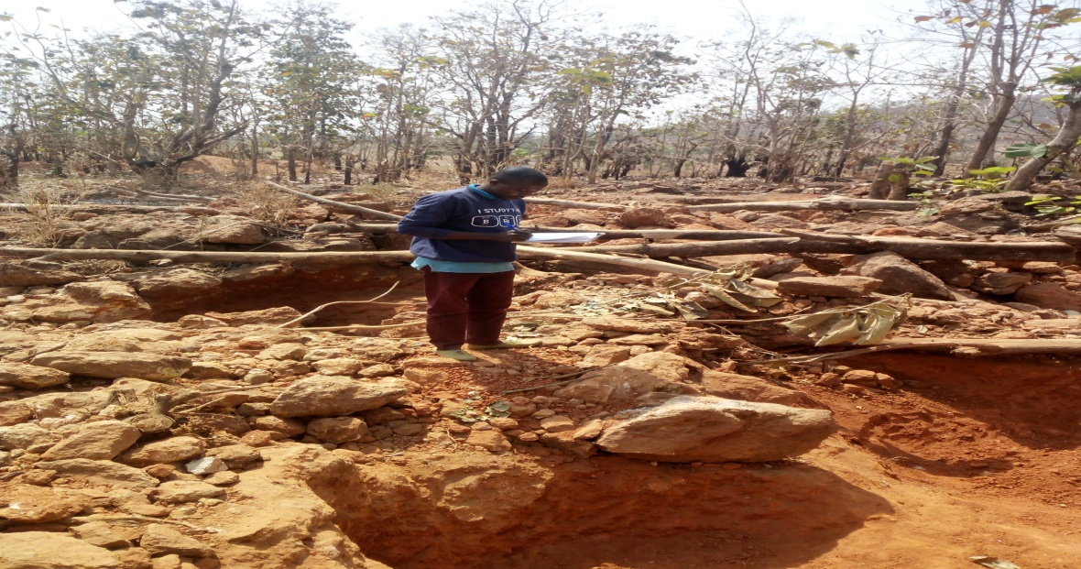

**Plate 1: Removal of Trees due to Artisanal Mining at Fasakwari, Jema’a LGA**

**SOURCE: Field Survey, January, 2022**

Households in non-mining communities stressed that artisanal mining affects sustainable utilisation of biodiversity due to the removal of vegetation and degradation of domestic water sources. Artisanal mining is not the only human activity that reduces biological diversity in the study area. However, there are several factors like climate, farming, overgrazing and fishing that have reduced biodiversity distribution in the study area. The participants noted that local fishermen also apply different chemicals in the streams and rivers during fishing which destroys aquatic living things.

*Artisanal Mining and Availability of Grazing Land*

Rearing of livestock is another means of livelihood in rural areas worldwide. Result of the study (Table 2) shows that artisanal mining does not ensure availability grazing land in the mining communities of Kaduna State. Mining areas are associated with mining pits, ponds and ditches (plate 2A & 2B), which reduces available land for grazing of livestock. Many livestock such as cattle, pig and goat have been lost due to mining pits in the mining communities of Kaduna state. Result of this work agrees with the findings of World Bank (2009) and Zankan et al. (2022), which reported that mining whether artisanal, small scale or large scale affects rural economy because it reduces available land for grazing of livestock as those areas are increasingly taken up for exploration and exploitation activities.

Miners set fire to the bush to clear more areas for mining, which reduces livestock access to vegetation resource and this has forced many livestock owners (herders) to relocate to new and safer areas.Findingsofthis work is in line with that of Ncube-Phiri et al. (2015) and Keita (2018), who stressed that artisanal gold mininghas adverse effects on livestock production as grazing areas are burnt, cattle have nothing to feed on, thus local livelihoods are compromised in the process.However, the increased level of insecurity in the country recently where farmlands, lives and properties worth millions of Naira are destroyed every day in Nigeria, made some farmers to appreciate artisanal mining as the mining pits serve as barriers that block livestock (cattle) access to their farmlands to destroy their crops, even though, they also loss their livestock such as pigs, goats, ducks and children when they fall in the mining pits. This was well illustrated by one of the discussants:

“Mining reduces available land for grazing but we like it sometimes especially when it is carried out near our farms which prevent livestock from destroying our crops, even though, our livestock used to fall in the mining pits”.

Insecurity has further increased the level of vulnerability among rural households in Kaduna State, because many of them allowed mining to take place in their farms to create barriers for protection against livestock, which result in reduction of agricultural lands. However, in non-mining communities, households admitted that they have available lands for grazing due to absence of mining.

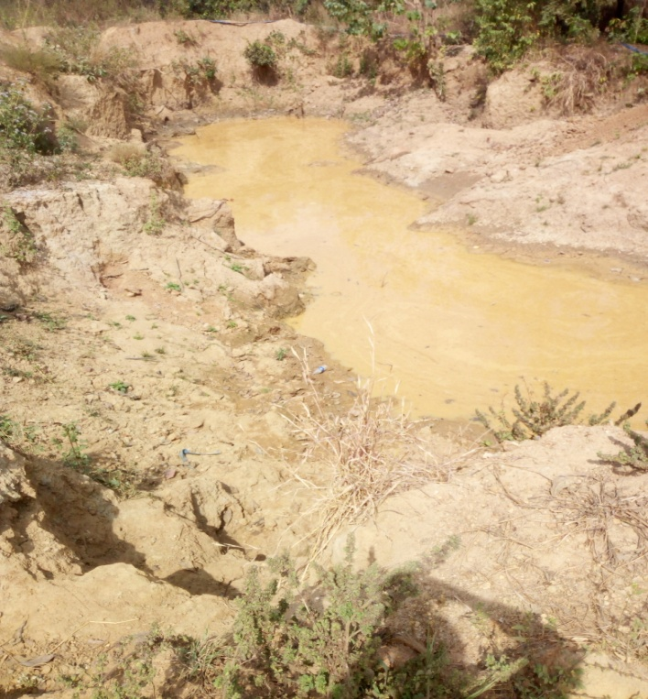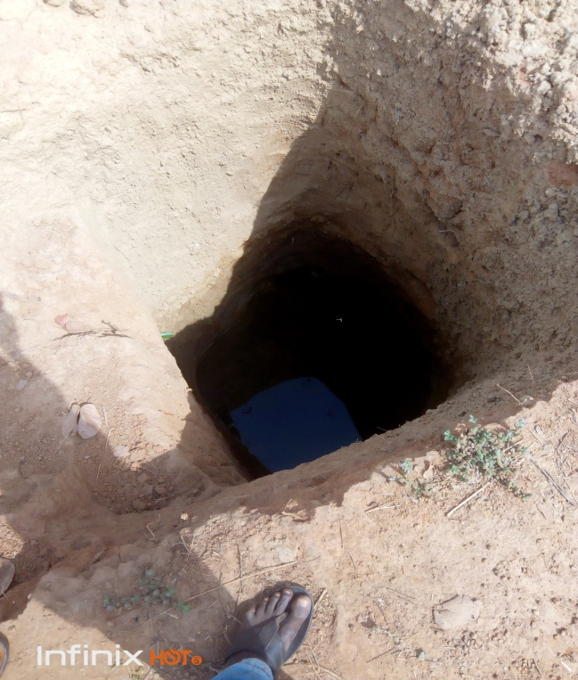

2A 2B

**Plates 2A: Mining Pond at Godogodo, Jema’a LGA and 2B: Mining Pit at Tari, Sanga LGA**

**Source: field Survey, January, 2022**

*Artisanal Mining and Availability of Wildlife*

Wildlife is not evenly distributed worldwide due to different factors such as climate, natural disasters and anthropogenic disturbances. Result of the study shows that artisanal mining does not ensure the availability of wildlife in the rural areas of Kaduna State. Mining of minerals leads to removal of vegetation that provides shelter, food and oxygen for animals including man. Removal of plants due to mining and other human activities forced many animals to flee from such area due to loss of shelter.

Mining and other human activities such as farming, hunting and overgrazing have forced many wildlife to disappear in the rural areas of Kaduna State, especially the mining communities. The distribution of mining pits and ponds serve as death traps for wildlife and has reduced their distribution across the mining communities of Kaduna State when they fall into the mining pits and ponds. Findings of this work supports Ncube-Phiri et al. (2015), who noted that wildlife was greatly affected as animals fell in open pits that are left unattended by gold panners in Zimbabwe. Ndinwa and Ohwona (2014), revealed that the majority of rural poor in Nigeria earn their livelihood directly from the rich natural resources such as land and forests through farming, hunting and related activities, which have led to the clearance of large areas of land in square kilometres, thus, destroying the forest that many animal species and people depend on for food and habitation which disrupts the balance in the ecosystem and many species known to inhabit this environment may have migrated away or are exterminated.

Miners mine their minerals without considering the fact that their activity has undesirable effects on the environment. The study has shown that wildlife reduced every day in the study area at an alarming rate. Reduction in wildlife in the study area slows down hunting activities. Findings of this study is in line with that of Abdul (2010) and Zankan et al. (2020), which noted that human activities such as farming, lumbering, commercial woodfuel harvesting and hunting have led to the disappearance of wildlife in Jema’a local government to areas with thick vegetation cover. There are several wildlife including buffalo, chimpanzee, lion and gorilla that were available in the study area in the last 30-40 years ago but have disappeared due to human activities.Findings of this study agrees with that of Ontoyin and Agyemang (2014) who stressed that hunting was almost abandoned in Talensi-Nabdam area of Ghana due to mining activities.

In non-mining communities, however rural household heads also admitted that artisanal mining does not ensure the availability of wildlife in the rural communities of Kaduna State. They noted that mining pits serve as dead trap for wild species such as antelope and rabbit. Vegetation which provides shelter for wildlife are removed during mining without replacement which has adverse effects on the density and diversity of tree species and wildlife, as many of them fled to areas with thick vegetation cover for safety. Disappearing of wildlife does not only happen in the mining areas, still occurs across the country because of human activities such as farming, hunting and overgrazing which threaten the existence of wildlife as people clear large extents of land every day for different activities. OECD (2017) noted that mining is an activity that has threatened the existence of mammals and birds in OECD countries.

*Artisanal Mining and Availability of Medicinal Herbs*

The primary source of medicinal herbs worldwide is the vegetation resource. This resource is diminishing at an alarming rate, especially in developing countries, as a result of human activities. Result of the study shows that artisanal mining does not ensure the availability of medicinal herbs in the study area. Provision of medicinal herbs depends on the availability of vegetation resources in such area. In most of the mining communities, such as Tsohon Gwari, Godogodo, Kufana and Tari, mining, farming, lumbering and overgrazing led to loss of vegetation that serves as a source of medicinal herbs. Unregulated activities result in risk accumulation processes as it promotes land degradation, vegetation destruction, and pollution of water sources (Mwango, 2014).

On the contrary, insecurity has favoured the distribution of vegetation in Birnin Gwari local government area in the recent years, as bandits prevent people from farming, hunting, grazing and mining which allowed that area to have more plants (trees, shrubs and herbs) that makes medicinal herbs available. However, in regions like Godogodo where mining is done intensively, many plants have been removed making the native Doctors work far distances before getting the herbs which affect their occupation and their means of livelihood. Mismanagement of our environmental resources made people more vulnerable to diseases and poverty. In non-mining communities however, households admitted that artisanal mining had severe effects on medicinal herbs production due to the removal of trees, shrubs and herbs available on the land. Mining is not the only reason responsible for the degradation of medicinal herbs in Kaduna State. Still, there are other human activities like farming where large hectares of land is cleared for crop production, overgrazing and lumbering also affect medicinal herbs production. Sustainability of livelihood assets mainly natural, physical, human, social, and financial capital is a security of rural households against poverty, hunger, unemployment, and sustainable development, especially in mining areas.

**CONCLUSION**

Sustainability encompasses environmental stewardship, social equity, economic prosperity and corporate responsibility. Artisanal mining is carried out in an unsustainable manner which has had severe effect on households’ sources of livelihood. Such activity is carried out on land which degrades agricultural land, trees, shrubs and domestic water sources. Vegetation is a source of medicinal herbs, timber and food to people, has been degraded through artisanal mining which has led to loss of jobs and food. Degradation of vegetation resources by artisanal mining and other human activities lead to reduction in density and diversity of tree species, causing drought and desertification. Artisanal mining damages critical watersheds and causing dryness of rivers. It creates open wells and ponds that serve as death traps for humans, domestic animals and wildlife result in reduction in biodiversity distribution which causes imbalance in the environment as household sources of livelihood and other organisms are endangered. Open wells carved out by artisanal mining have served as breeding ground for mosquitoes which has had severe health effects on households. Agriculture which is the bedrock of the economy has been reduced by artisanal mining, leading to food insecurity. It is therefore, recommended that security personnel (vigilante groups, civil defence, police and forest guards) should put more efforts to prevent incursion of miners into the forests for mining of minerals by constant monitoring of such areas, and the need for farmers to report miners that forcefully mined minerals in their farms to security agents to be arrested and punished. There is need for adoption of environmentally friendly mining technologies or community-based resource management approaches.

**References**

Abaje, I. B, Achiebo, P. J and Matazu, M. B. (2018). Spatio‐Temporal Analysis of Rainfall Distribution in Kaduna State,Nigeria. *Ghana Journal of Geography Vol. 10(1): 1–21*

Abdul, J. (2010). Impact of Man Activities on the Vegetation of Nindem/Tsonje Forest Reserves, Kaduna State: Unpublished Undergraduate Project, Submitted to the Department of Geography, BUK

Adekoya, J. A. (2003). Environmental Effect of Solid Minerals Mining. *Journal of Physical Science Kenya. pp. 625 - 640.*

Alhaji, M. I and Kanayochukwu, E. C. (2020). Spatial Location of Artisanal Mining activities in Niger State and its Implication to the Environment. *International Journal of Engineering Applied Sciences and Technology, 2020 vol. 5, issue 1, ISSN no. 2455-2143, pages 711-719*

Arthur, F. Agyemang-Duah, W. Gyasi, R. M, Yeboah, Y. J and Otieku, E. (2016). Nexus between Artisanal and Small-Scale Gold Mining and Livelihood in Prestea Mining Region, Ghana. *Geography Journal, Vol. (2016) 1- 18*

Amankwah, R.K. and Anim-Sackey, C., (2004). Strategies for sustainable development of the small-scale gold and diamond mining industry of Ghana. *Resources Policy 29 (1): 131–138*

Ango, M, Blessing, M, Choquette, B, Erdenebat, B, Jagdish, S, Kamara, A. M, Tang, K. Y, Wideroth, A Worthington, J. (2019). Creation of a Sustainable Mining Program through Formalization of Artisanal and Small Scale Miners. Government of Nigeria Capestone Report, Columbia University in the City of New York

Assan, J. K. and Muhammed. A. (2018). The impact of mining on farming as a livelihood strategy and its implications for poverty reduction and household well-being in Ghana. *International Journal of Development and Sustainability. Volume 7 Number 1 (2018): Pages 1-20*

Bansah, K. J. Dumakor-Dupey, N.K. Kansake, B. A. Assan, E. and Bekui, P. (2018). Socioeconomic and environmental assessment of informal artisanal and small-scale mining in Ghana. *Journal of Cleaner Production 202 (2018) 465-475*

Buba, T. (2015). Impact of Different Species of Different Sizes on Spatial Distribution of Hebaceous Plants in the Nigeria Guinea Savanna Ecological Zone. *Journal of Sceintifica Research Vol 2015*

Donkor, A.K.; Ghoveisi, H. Bonzongo, J.-C.J. (2024). Use of Metallic Mercury in Artisanal Gold Mining by Amalgamation: A Review of Temporal and Spatial Trends and Environmental Pollution*. Minerals 2024, 14, 555. https://doi.org/ 10.3390/min14060555*

Fagariba, C. J, Sumani, J. B.B and Mohammed, A. S. (2024). Artisanal and Small-Scale Gold Mining Impact on Soil and Agriculture: Evidence from Upper Denkyira East Municipality, Ghana. *European Journal of Environment and Earth Sciences Vol. 5 | Issue 3 | May 2024*

Gadzama, I. U. (2015). Effect of Participation in Artisanal and Small-Scale Mining on the Output, Income and Standard of Living of Farmers in Kaduna State, Nigeria: An Unpublished Ph. D Thesis Submitted to the School of Postgraduate Studies Ahmadu Bello University, Zaria, Kaduna State, Nigeria

Gilbert, G and Albert, O. (2016). Illegal Small-Scale Gold Mining in Ghana: A Threat to Food Security. *Journal of Food Security, 2016, Vol. 4, No. 5, 112-119*

Girard, V. Molina-Millan, T and Vic, G. (2022). Artisanal Mining in Africa. NOVAFRICA Working Paper Series

Goswami, S. (2015). Impact of Coal Mining on Environment. Academic Publishing House Researcher, Vol. 92, 3 (2015), 85-96

Hentschel T, Hruschka F and Priester M. (2002). Global Report on Artisanal and Small Scale Mining. London: IIED and WBCSD, Mining, Minerals and Sustainable Development Project (MMSD)

Hilson, G. (2002). Small-scale Mining and its Socio-economic Impact in Developing Countries. [*Natural Resources Forum*](https://www.researchgate.net/journal/1477-8947_Natural_Resources_Forum)*, Vol., 26, 1(2002):3 - 13*

Idris-Nda, A.. Waziri, N.M. Bida, A.D and Abdullahi, S. (2018). Socio-Economic Impacts of Artisanal and Small-Scale Mining in Parts of Niger State, Central Nigeria. *International Journal of Mining Science (IJMS) Volume 4, Issue 3, 2018, PP 21-30. DOI: http://dx.doi.org/10.20431/2454-9460.0403003*

Intergovernmental Forum on Mining, Minerals, Metals and Sustainable Development (IGF, 2018). Global Trends in Artisanal and Small-Scale Mining (ASM): A review of key numbers and issues. *Report prepared by the International Institute for Environment and Development (IIED) for the Intergovernmental Forum on Mining, Minerals and Sustainable Development (IGF)*, Winnipeg

Ishaya, S. and Abaje, I. B. (2008). Indigenous People's Perception on Climate Change and Adaptation Strategies in Jema'a LGA, Kaduna State, Nigeria: *Journal of Geography and Regional Planning, Vol. 1(8) 138-144*

Kareem, I. A. and Owao, S. (2000). The Effects of Mining Activities on the Environment of Sanga Forest Reserved, Kaduna State. Faculty of Environmental Sciences, University of Jos Nigeria, Vol. 4, No1 (2000)

Keita, M. M. (2018). Environmental and Socio-Economic Impacts of Artisanal Gold Mining on Agricultural Production in Sikasso Region, Mali. An Unpublished Ph. D Thesis Submitted to the Department of Environmental Science of Egerton University

Krejcie, R. V and Morgan, D. W. (1970). Determining Sample Size for Research Activities. Educational and Psychological Measurement 1970, 30, 607-610.

Kumi-Boateng, B. and Stemn, E. (2020), “Spatial Analysis of Artisanal and Small-Scale Mining in the Tarkwa-Nsuaem Municipality of Ghana”, *Ghana Mining Journal,* Vol. 20, No. 1, pp. 66 - 74.

[Landrigan](https://ehjournal.biomedcentral.com/articles/10.1186/s12940-022-00877-5#auth-Philip-Landrigan-Aff1-Aff2), P,  [Bose-O’Reilly](https://ehjournal.biomedcentral.com/articles/10.1186/s12940-022-00877-5#auth-Stephan-Bose_O_Reilly-Aff3), S,  [Elbel](https://ehjournal.biomedcentral.com/articles/10.1186/s12940-022-00877-5#auth-Johanna-Elbel-Aff3), J, [Nordberg](https://ehjournal.biomedcentral.com/articles/10.1186/s12940-022-00877-5#auth-Gunnar-Nordberg-Aff4), G, [Lucchini](https://ehjournal.biomedcentral.com/articles/10.1186/s12940-022-00877-5#auth-Roberto-Lucchini-Aff5), R, [Bartrem](https://ehjournal.biomedcentral.com/articles/10.1186/s12940-022-00877-5" \l "auth-Casey-Bartrem-Aff6), C, [Grandjean](https://ehjournal.biomedcentral.com/articles/10.1186/s12940-022-00877-5#auth-Philippe-Grandjean-Aff7), P, [Mergler](https://ehjournal.biomedcentral.com/articles/10.1186/s12940-022-00877-5#auth-Donna-Mergler-Aff8), D, [Moyo](https://ehjournal.biomedcentral.com/articles/10.1186/s12940-022-00877-5#auth-Dingani-Moyo-Aff9-Aff10-Aff11), D, [Nemery](https://ehjournal.biomedcentral.com/articles/10.1186/s12940-022-00877-5" \l "auth-Benoit-Nemery-Aff12), B, [von Braun](https://ehjournal.biomedcentral.com/articles/10.1186/s12940-022-00877-5#auth-Margrit-Braun-Aff6-Aff13), M and [Nowak](https://ehjournal.biomedcentral.com/articles/10.1186/s12940-022-00877-5#auth-Dennis-Nowak-Aff3), D. (2022). Reducing Disease and death from Artisanal and Small-Scale Mining (ASM) - the urgent need for responsible mining in the context of growing global demand for minerals and metals for climate change mitigation. [*Environmental Health*](https://ehjournal.biomedcentral.com/)*volume 21, 78(2022)*

Mancini, L and Sala, S. (2018). Social Impact Assessment in the Mining Sector: Review and Comparison of Indicators Frameworks. *Resources Policy 57 (2018) 98–111*

Mensah, A. K. Mahiri, I. O, Owusu, O, Mireku, O. D, Wireko, I and Kissi, E. A. (2015). Environmental Impacts of Mining: A Study of Mining Communities in Ghana. *Applied Ecology and Environmental Sciences, Vol. 3, 3(2015) 81-94*

Mensah, A. K and Tuokuu F. X. D. (2023), Polluting our rivers in search of gold: how sustainable are reforms to stop informal miners from returning to mining sites in Ghana? *Front. Environ. Sci. 11:1154091. doi: 10.3389/fenvs.2023.1154091*

Mwango, O, K. (2014). Impact of open pit artisanal gold mining in Rongo Constituency. Being an undergraduate Research Project Submitted in Partial Fulfillment of the Requirements for the Degree of Bachelor of Environmental Planning and Management of Kenyatta University

Ncube-Phiri, S, Ncube, A, Mucherera, B. and Ncube, M. (2015). ‘Artisanal small-scale mining: Potential ecological disaster in Mzingwane District, Zimbabwe’, Jàmbá. *Journal of Disaster Risk Studies, Vol 7, 1(2015) 1-11*

Ndinwa, G. C. C and Ohwona, C. O. (2014). Environmental and Health Impact of Solid Mineral Exploration and Exploitation in South-Northern Nigeria: A Case Study of Igarra in Edo State. *Review of Environment and Earth Sciences, Vol 1, No1 (2014) 24-36*

Nigeria Mining and Metal Sector. (NMMS, 2017). Investment Promotion Brochure October 2017. Ministry of Steel and Development

Ontoyi,J and Agyemang, I. (2014). Environmental and Rural Livelihoods Implication of Small-scale Gold Minng in Talensi-Nabdam District of Northern Ghana. *Journal of Geography and Regional Planning, Vol. 7, 8(2014) 150-159*

Onwuka, S.U, Duluora, J.O and okoye C.O. (2013). Socio-Economic Impacts of Tin Mining in Jos, Plateau State, Nigeria. *International Journal of Engineering Science Invention, Vol. 2, No 7(2013) 30-34*

Papworth, S, Rao, M, Myint, M. O, Latt, T. T, Tizard, R, Pienkowski, T and Carrasco, L. R. (2017). The Impact of Gold Mining and Agricultural Concessions on the Tree cover and local Communities in Northern Myanmar. Scientific Reports

Sarma, K, Kushwaha, S.P.S and Singh, K. J. (2010). Impact of coal mining on plant diversity and tree population structure in Jaintia Hills district of Meghalaya, North East India. *New York Science Journal Vol. 3 9(2010) 79-85*

Schueler, V., Kuemmerle, T., and Schro¨der, H., (2011). Impacts of Surface Gold Mining on Land Use Systems in Western Ghana. *AMBIO (2011) 40:528–539*

Sheriff, I., Gogra, A.B. and Koroma, B.M. (2018). Investigation into the Impacts of Artisanal Gold Mining on the Livelihood Foundation of Baomahun Community in Southern Sierra Leone. *Natural Resources, 9, (2018) 42-54.* https://doi.org/10.4236/nr.2018.92004

Singh, P. K, Singh, R and Singh, G., (2010). Impact of Coal Mining and Industrial Activities on Land Use Pattern in Angul-talcher Region of Orissa, India. *International Journal of Engineering Science and Technology, Vol. 2(12), 2010, 7771-7784*

United Nation Development Project (UNDP, 2017). Strategic Environmental Assessment (SEA) for the Mining Sector in Kenya. Draft SEA Report for the Mining Sector in Kenya

Wang, L. Jia, Y. Yao, Y and Xu, D. (2019). Identification and evaluation of land use vulnerability in a coal mining area under the coupled human-environment. *Open Geosci. 2019; 11:64–76*

World Bank. (2009). Potential Social Impacts of Mining Development in Southern Mongolia, World Bank, Washington, DC.siteresources.worldbank.org

World Bank (2014). Sustainable and Responsible Mining in Africa: A getting Started Guide. International Finance Corporation. World Bank Group

World Bank. (2016). Women and Artisanal and Small-Scale Mining (ASM). Accessed on 18/01/ 2020froms[wbextractives@worldbank.org](mailto:wbextractives@worldbank.org)[www.worldbank.org/en/topic/extractiveindustries/brief/gender-in extractive-industries](http://www.worldbank.org/en/topic/extractiveindustries/brief/gender-in%20extractive-industries)

Xuejiao, Xiao, Zhao, Zhang, Li and Sun. (2019). Drivers of Spatio-temporal ecological Vulnerability in an Arid Coal Mining Region in Western China. Ecological Indicators. Vol. 106, 105475

Yunana, M. A. and Banta, A. L. (2014). Socio-economic Effects of Illegal Mining Activities in Antang District of Jema‟a Local Government Area, Kaduna State. *Journal of Environmental Sciences and Resources Management. 6(2): 12 - 21.*

Zankan, J.A.A, Isah, M.N, Abubukar, M.Y. (2020). Environmental Implications of Commercial Woodfuel Harvesting in Jema’a Local Government, Kaduna State, Nigeria. *Ethiopian Journal of Environmental Studies & Management 13(3): 364 – 375, 2020.*

Zankan J.A.A., Abdul I., Mande A.J., Abdul H.A. (2022), Livelihood Implication of Artisanal Mining on Herders in Jema’a and Sanga Local Government Areas of Kaduna State, Nigeria. *African Journal of Social Sciences and Humanities Research 5(5), 27-47.* *DOI: 10.52589/AJSSHR-F4SHZ0HD*