**MAPPING THE IMPACT OF SKILL DEVELOPMENT ON SUSTAINABLE LIVELIHOODS OF TRIBAL YOUTH: A BIBLIOMETRIC ANALYSIS**

**ABSTRACT**

*In order to increase employability, productivity, and economic resilience and support sustainable livelihoods particularly for tribal youth skill development is essential. By analysing academic literature from top databases, this study does a bibliometric analysis to map the effect of skill development on sustainable livelihoods. The study uses sophisticated bibliometric approaches to pinpoint important research trends, well-known authors, prestigious journals, and theme clusters in this field. As key facilitators of long-term economic stability, the results show an increasing number of research focusing on digital skills, entrepreneurial development, and vocational training. The report also emphasizes how government regulations, business partnerships, and technology developments influence skill-development programs. Additionally, the study identifies gaps in the literature and proposes possible directions for further investigation, especially with regard to quantifying the long-term socioeconomic advantages of skill development. Policymakers, educators, and academics who want to improve the efficacy of skill development programs for sustainable livelihoods would find this bibliometric study to be quite insightful.*

**Keywords:** *Sustainable Livelihood,*

*Skill Development,*

*Bibliometric Analysis,*

*Vocational Training,*

*Digital Skill,*

*Tribal Youth*

1. **INTRODUCTION**

Poverty and economic insecurity are the major challenges in many parts of India where the poor, particularly the tribal youth suffer from deprivation in multiple ways such as low income, insecure livelihoods, inadequate social infrastructure and poor access to the resources. The economy of India is largely based on agriculture however its growth is hampered by small landholding, low productivity, drought and chronic flooding. There is emerging need for livelihoods diversification and provide alternative livelihoods opportunities for poor to reduce dependency on agriculture and sustain in the changing economy. Underprivileged groups live predominantly in rural areas and they often have smaller landholdings or less productive plots of land that is inadequate for their livelihoods. There is lack of livelihoods opportunities for low-income people especially in rural areas. Therefore, migration is a foregone conclusion in search of employment and better wage for all sections of society. Important to note is that most of the migrants’ workers are un-skilled and working in informal sector.

In a developing country like India, a large number of people are unemployed or pushed to a low-income job, often engaged with temporary or seasonal employment. Largely they are under-employed and do not have adequate opportunities for a gainful employment (Gupta.S.P, 2006,). Indeed, this leads to the root cause of poverty and unemployment among the low-income population. There is emerging need to develop alternative livelihoods for low-income groups by providing skill development and vocational training to tackle unemployment and underemployment. Majumdar.S (2008) argues that knowledge and skills are the driving forces of economic and social development of any state. Low-income people and youth need skills to find a job and enhance their income in India. Ahmed (2007) argues that, development of skilled workers is likely to enhance the efficiency and flexibility of the labour market and reduce skills bottlenecks in India. Skilled workers have opportunities that they easily absorbed in to the economy and their job mobility is improved. Skill development is gaining tremendous importance in India in recent past that contributes meaningfully to enhance livelihoods of low-income people in general and tribal youth from odisha in particular .

India is now facing a high economic growth and technological advancements that has created new job market and enhanced employment opportunities in recent past. In this scenario, a large share of the workforce would shift from the primary sector to the secondary and tertiary sectors. Further, it requires skilled and educated workforce to enhance efficiency and improve the quality. In India, skill development programmes are playing role to provide gainful employment and enhancing employability and creating livelihoods opportunities for low-income people in India. The Government of India in recent years has laid a lot of emphasis on strengthening skill training to cater the emerging need of the market by focusing on employability skills.

The Industrial Training Institutes (ITIs) plays major role to impart skills in India however, they offering traditional courses without assessing the labour market requirements that results imbalance of supply-demand ratio of labour force (Gupta. S.P 2006). There is lack of participation of employers in the ITIs/ Training Centres. In addition, there is gap between skills demanded by job market and supplied by the training providers. In India, there is lack of space for vocational training in the formal education system with a view to enhance employability among youth.

* **Problem Statement**

Sustainable livelihood is a crucial aspect of socio-economic development, particularly in addressing poverty and unemployment. Skill development plays a vital role in empowering individuals and communities, yet there is a lack of comprehensive bibliometric analysis on this subject. Understanding the research landscape, key contributions, and trends in this domain can help policymakers, researchers, and educators design effective strategies for skill-based livelihood enhancement.

* **Aim of the Paper**

This study aims to conduct a bibliometric analysis of research on sustainable livelihood through skill development, using VOS viewer to map scholarly contributions, co-authorship networks, citation patterns, and thematic clusters. The goal is to identify research gaps and provide insights into the evolving discourse on this topic.

1. **RESEARCH METHODOLOGY**

A bibliometric study is used to examine the data collected on the chosen topic. This literature evaluation is an important contribution to sustainable livelihood research because it provides a systematic method of study selection (Briones-Bitar et al. 2020; Herrera-Franco et al. 2021; Montalván-Burbano et al. 2021). As a result, the advice presented can help to reduce potential biases and inaccuracies when selecting research studies for a literature review. Furthermore, the results of the current literature can be utilised to emphasise the limitations of knowledge in the chosen study field and identify the research gap more effectively.

The bibliometric analysis used the similarity visualisation technique. This type of visualisation is known as bibliometric mapping, and it allows you to see connections in the scientific field structure in terms of authors, countries, documents, keywords, and other scientific production factors (Briones-Bitar et al. 2020; et al. 2021). The bibliometric analysis was divided into three stages: data collection; software and data cleaning; and analysis, interpretation, and visualisation.

* **Data Compilation**

This study conducts a review in the Scopus database from 2001 to 2025 to identify scholarly studies articulating skill development with sustainable livelihoods. The search equation for this study was TITLE-ABS-KEY (("sustainable livelihood" OR "livelihood sustainability”) AND ("skill development" OR vocational training" OR "capacity building”) AND ("tribal youth" OR "indigenous youth" OR "rural youth")), which provided 192 document results, revealing that the research subject remains underexplored and that there is potential to generate scholarly contributions, as well as extend sustainable livelihood research through skill development.

* **Software and Data Cleaning**

In the second stage, the collected articles were examined with the VOS viewer. The information gathered during the first stage was saved to an Excel spreadsheet for analysis and organisation. The constructed database included a variety of parameters such as author names, cited publications, journal titles, and keywords. Furthermore, the papers were clustered, and clustering solutions were shown. Clustering is a method of analysis that groups things based on their similarity or difference (Chen et al. 2016; Nobanee 2021). Thus, keywords retrieved from publications that had a high association with one another were placed in an appropriate cluster.

Publications were clustered based on their relatedness. The decision was made between the two most common bibliometric analysis methodologies, namely citation or word relations. Cluster identification for this work was carried out using the word relations approach, which uses related words in full texts of publications, abstracts, and titles (Van Eck and Waltman 2017; Nobanee 2020). Furthermore, the bibliometric approach based on word relations was used due to the numerous benefits that this type of analysis gives for the research aim. Co-word analysis identified linkages between concepts used to examine the sustainable livelihood topic in order to understand the existing status of research concepts and predict where future research should be performed. However, the co-word method to bibliometric analysis has certain challenges. Certain words may have varied meanings depending on the context, resulting in an inaccurate representation of publications from distinct domains. Furthermore, certain phrases are broad and can be applied to research in a variety of fields, providing no useful information about the relatedness of articles (Van Eck and Waltman 2017). Hence, while evaluating the study results, it should be considered that clusters may comprise keywords that do not have a strong semantic relationship.

The VOS viewer programme was used to examine clustering solutions at an aggregate level using a term-map. A word map visualises the subjects covered by each cluster (Van Eck and Waltman 2017). This visualisation allows you to emphasise the key terms that appear in publications inside a cluster, as well as the co-occurrence of relationships between these terms. A key assumption of clustering is that items in the same cluster represent comparable subjects. In addition to the co-word analysis, which was deemed the core focus of the literature review, cluster analysis was used to examine other aspects of publications, such as authors and cited papers. Cluster analysis of word relations revealed four groups of subjects addressed in the chosen publications. Items in distinct clusters are shown in different colours, and each point on the term map is assigned a colour based on the density of keywords at that location. As a result, more prominent points signified a greater weight for neighbouring words, and vice versa.

* **Analysis, Interpretation, and Visualization**

The final stage was a careful inspection of the highlighted clusters. All qualitative data from each article was exported into an excel file and then integrated into ad hoc pivot tables. The total connection strength for each publication's attributes was determined, demonstrating multiple publications where two elements appear together (Guo et al. 2019). The literature review was conducted using the resulting tables and visualisation maps.

1. **ANALYSIS AND INTERPRETATION**

* **Publication Trends: Year-wise growth in research articles**

Figure 1 depicts the time distribution of articles across the observed period, which ranged from 1999 to 2025. There has been limited development in the number of publications devoted to sustainable livelihood and skill development, and for several years, there was just very few articles on the subject until it acquired popularity in 2018. Since then, the annual number of publications on sustainable livelihood has increased significantly. This statistic illustrates that the biggest number of papers, so far, on sustainable livelihood was in 2024, which was 24 articles. The number is expected to rise by 2025 as the topic undergoes a widespread upheaval.

**FIGURE 1** **time distribution of articles across the observed period**

***Source: Compiled from collected data.***

* **Document source and type**

We examine the documents collected from the Scopus database using the document type, source type, and source title. A document can be a published paper, a conference paper, a review, a book, a book chapter, an editorial, or something else. Figure 2 summarises the document type analysis. Over more than 75% works are published in articles on sustainable livelihood, with conference papers 16% and books and book chapters 8%, respectively.

**FIGURE 2** **document type analysis**

***Source: Compiled from collected data.***

* **Most Cited paper**

This part relies on citations obtained by authors from 1991 to 2025, arriving at the most productive and influential authors over time. Tables 3 provide useful information on the most productive and influential authors on rural sustainability livelihood over the 25-year period. The most cited papers were identified based on citation count and connectivity within the network. These papers often introduce ground-breaking theories, novel methodologies, and influential frameworks that shape future research.

**TABLE 1 List of most cited paper**

|  |  |  |  |  |
| --- | --- | --- | --- | --- |
| **RANK** | **AUTHOR** | **YEAR** | **TITLE** | **CITATION** |
| 1 | Beck T.; Nesmith C. | 2001 | Building on poor people’s capacities: The case of common property resources in India and West Africa | 122 |
| 2 | Khatiwada S.P.; Deng W.; Paudel B.; Khatiwada J.R.; Zhang J.; Su Y. | 2017 | Household livelihood strategies and implication for poverty reduction in rural areas of central Nepal | 121 |
| 3 | Chena H.; Zhu T.; Krotta M.; Calvo J.F.; Ganesh S.P.; Makot I. | 2013 | Measurement and evaluation of livelihood assets in sustainable forest commons governance | 97 |
| 4 | Abisuga-Oyekunle O.A.; Fillis I.R. | 2017 | The role of handicraft micro-enterprises as a catalyst for youth employment | 63 |
| 5 | Stacey N.; Gibson E.; Loneragan N.R.; Warren C.; Wiryawan B.; Adhuri D.; Fitriana R. | 2019 | Enhancing coastal livelihoods in Indonesia: an evaluation of recent initiatives on gender, women and sustainable livelihoods in small-scale fisheries | 62 |
| 6 | Lapeyre R. | 2011 | The Groot-Berg lodge partnership in Namibia: Towards poverty alleviation and empowerment for long-term sustainability | 61 |
| 7 | Ding W.; Jimoh S.O.; Hou Y.; Hou X.; Zhang W. | 2018 | Influence of livelihood capitals on livelihood strategies of herdsmen in inner Mongolia, China | 59 |
| 8 | Manwa H.; Manwa F. | 2014 | Poverty alleviation through pro-poor tourism: The role of Botswana Forest Reserves | 58 |
| 9 | Wu M.-Y.; Pearce P.L. | 2014 | Host tourism aspirations as a point of departure for the sustainable livelihoods approach | 50 |
| 10 | Meher R. | 2009 | Globalization, displacement and the livelihood issues of tribal and agriculture dependent poor people: The case of mineral-based industries in India | 49 |

***Source: Compiled from collected data.***

* **Keyword Analysis**

Keyword cluster analysis was used to represent and compare the content of the most popular articles, which included the author's keywords. Furthermore, the frequency with which terms appeared was used to identify the current streams and topics employed in the chosen research field. Table 2 shows the top 10 keywords with the highest frequency of occurrence. Thus, the following terms appeared most frequently in the article titles: livelihood (37 occurrences), Sustainability (24 occurrences), capacity building (27 occurrences), and sustainable development (29 occurrences). The VOS viewer programme also generated a theme map in which words with density appeared. The high keyword density in the cluster analysis indicates a strong link with other keywords stated in the articles' titles.

**TABLE 2** **Keyword Analysis**

|  |  |  |  |  |
| --- | --- | --- | --- | --- |
| **Rank** | **Keyword** | **Occurrence** | **Link** | **Total Link Strength** |
| 1 | Livelihood | 37 | 38 | 133 |
| 2 | Sustainability | 24 | 32 | 93 |
| 3 | Capacity Building | 27 | 31 | 89 |
| 4 | Sustainable development | 29 | 35 | 76 |
| 5 | Youth | 19 | 25 | 54 |
| 6 | Sustainable livelihoods | 23 | 23 | 43 |
| 7 | Agriculture | 13 | 24 | 41 |
| 8 | Rural area | 9 | 20 | 33 |
| 9 | Adaptive Management | 6 | 20 | 32 |
| 10 | Empowerment | 9 | 18 | 29 |

***Source: Compiled from collected data.***

Figure 3 depicts the similarity results, demonstrating how the clusters are all interconnected. As a result, the search string was effective since the boundaries of interconnections are blurred and bordering articles represent themes from multiple clusters. Figure 3 shows that four groups of keywords were highlighted.

The first cluster is highlighted in red contains 13 elements, and the most commonly used keywords in the cluster are indigenous knowledge, livelihood, rural development and sustainability. The second cluster is highlighted in green contains 12 elements, and the most commonly used keywords in the cluster are adaptive management, capacity building, and sustainable development. The third cluster is highlighted in blue contains 9 elements, and the most commonly used keywords in the cluster are employment, innovation and youth. Finally, the fourth cluster is highlighted in yellow and contains six elements which includes phrases like education and empowerment.

**FIGURE 3 Similarity results, demonstrating how the clusters are all interconnected**

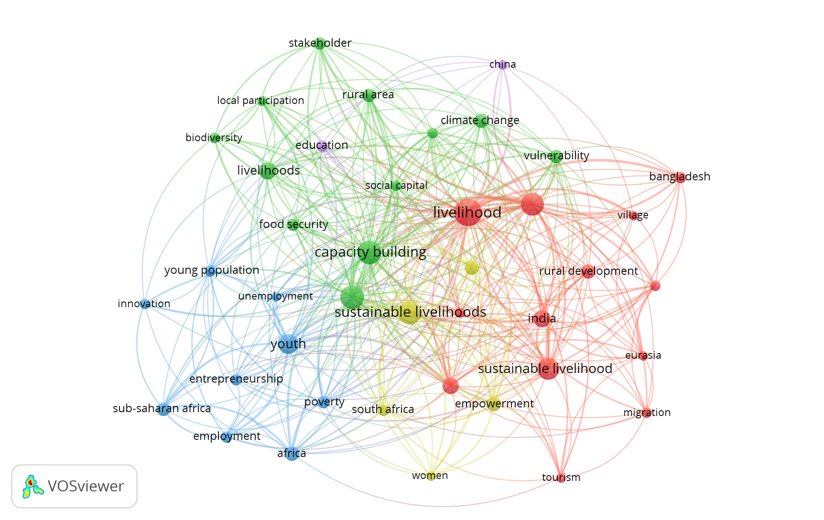

***Source: Compiled from collected data.***

* **Co-Authors Network**

Figure 4 depicts the cluster distribution of authors based on their number of publications and their citation. The literature review comprised a total of 535 writers. This figure shows the authors who have at least two articles in the dataset. Thus, the most publications were contributed by Islam, Md. Monirul (3 papers), followed by Goswami, Gour Gobinda (2 papers). The remaining writers in the list were the authors of two papers.

**FIGURE 4** **Cluster distribution of authors based on their number of publications and their citation**

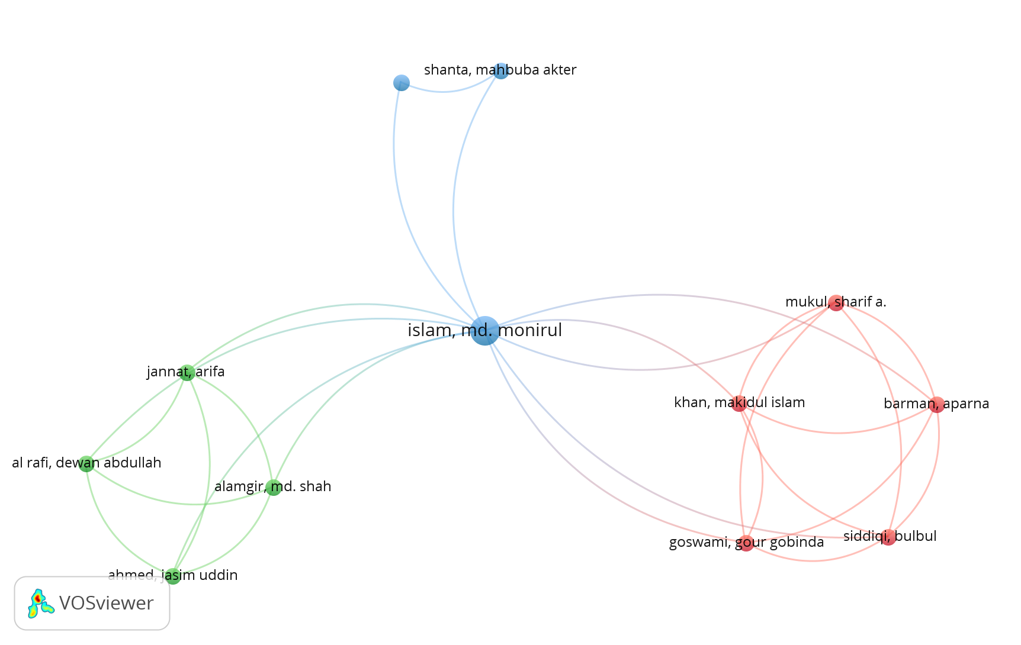

***Source: Compiled from collected data.***

* **Co-Authorship among organisations**

Figure 4 depicts the results co-authorship among organisations, demonstrating how the organisations are all interconnected. The visualization reveals a dense collaboration network, with several major institutions forming the central nodes. These key organizations exhibit co-authorship frequency, indicating their role as research hubs.

**FIGURE 5** **Co-authorship among organisations, demonstrating how the organisations are all interconnected**

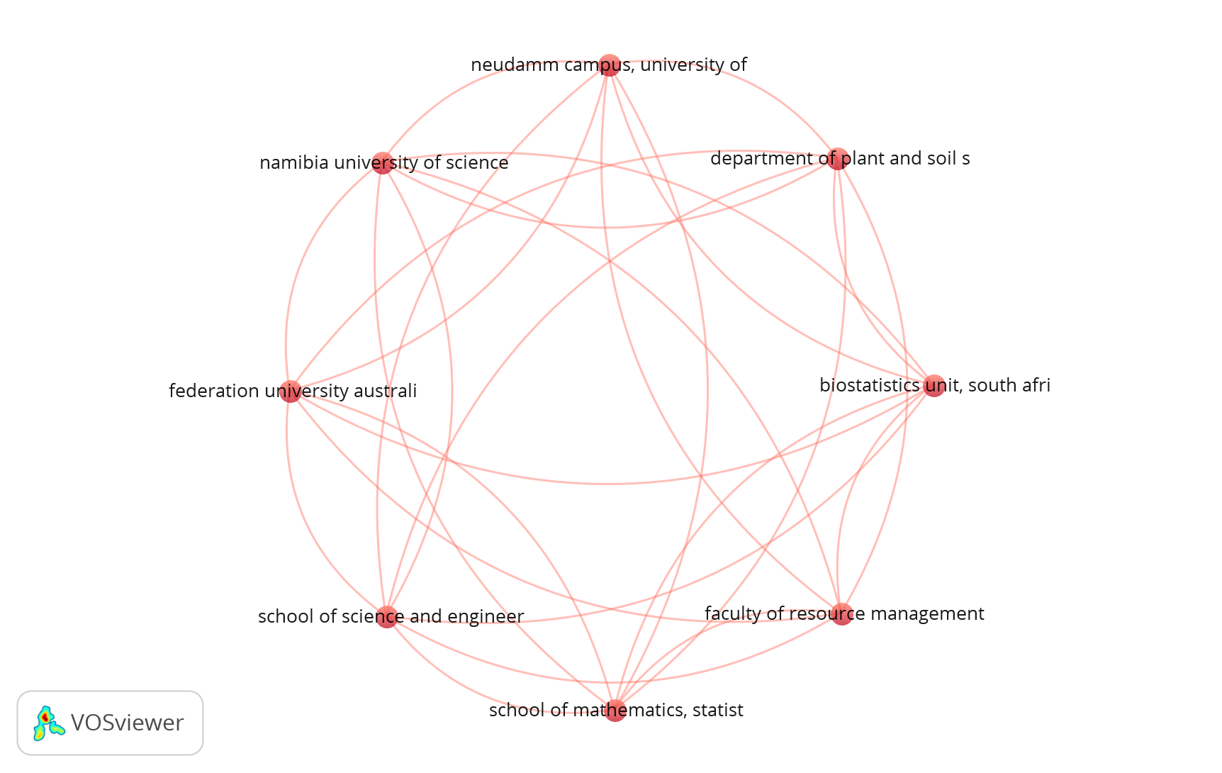

***Source: Compiled from collected data.***

* **Co-operation network among countries**

The visualization in figure 6 reveals a highly interconnected network, with several major countries forming central nodes. These key nations exhibit co-authorship frequency, indicating their role as research leaders on this topic in global academia. The most influential countries were identified based on the number of co-authored publications and link strength. India South Africa, United Kingdom, exhibit strong research ties, while other countries have relatively fewer connections.

**FIGURE 6** Hi**ghly interconnected network, with several major countries forming central nodes.**

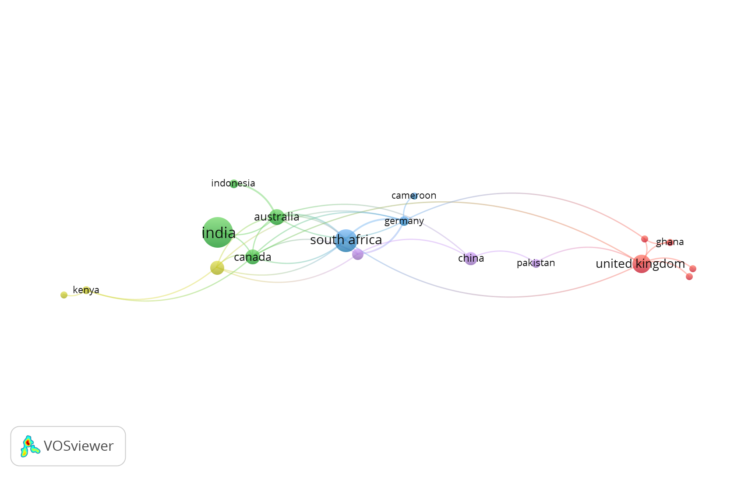

***Source: Compiled from collected data.***

1. **FINDINGS AND DISCUSSION**

The bibliometric analysis of sustainable livelihood through skill development highlights diverse strategies across different geographical regions, focusing on the role of skill enhancement in fostering economic stability, poverty alleviation, and environmental sustainability. A common theme emerging from the study is the interplay between formal and informal skill development initiatives in empowering marginalized communities, including women, youth, and indigenous populations. Many studies emphasize the significance of vocational training, digital literacy, and entrepreneurial skills in enabling sustainable livelihoods.

Several papers examine the impact of industry-specific skill development, such as aquaculture, agroforestry, and non-timber forest product harvesting, in creating employment opportunities for vulnerable communities. Particularly in South Asia and Africa, community-based livelihood interventions have proven to be effective when integrated with local knowledge systems and conservation strategies. Case studies from Bangladesh, India, and Africa demonstrate how livelihood diversification, especially in rural and coastal regions, contributes to economic resilience against climate change and environmental degradation. The importance of ecosystem-based approaches, such as sustainable tourism and agro-ecology, also emerges as a key factor in ensuring long-term livelihood sustainability.

Technology and digital skills play a growing role in sustainable livelihood strategies, with studies highlighting how Industry 4.0 and ICT tools enhance employability and market access. For instance, MSMEs and rural entrepreneurs in developing economies benefit significantly from targeted training programs in financial literacy, digital marketing, and mechanized farming. Additionally, the research underscores the role of corporate social responsibility (CSR) initiatives in bridging skill gaps and promoting sustainable business models.

Gender and social inclusion remain critical aspects of skill development programs, with several studies revealing persistent challenges in integrating women and marginalized groups into the mainstream economy. Traditional vocational education and training (TVET) programs are increasingly being reformed to address gender disparities and equip women with entrepreneurial skills, particularly in agriculture and small-scale industries. Findings from sub-Saharan Africa suggest that TVET can serve as a transformative tool not only for economic empowerment but also for social change by challenging patriarchal structures.

Climate change and environmental sustainability are recurring themes across multiple studies, with an emphasis on adaptive skill-building for climate-resilient livelihoods. Several research papers highlight the role of non-formal education and indigenous knowledge systems in preparing rural communities for environmental shocks. Sustainable agriculture, agroforestry, and renewable energy projects are identified as crucial livelihood strategies, particularly in regions prone to extreme weather conditions.

Despite the positive impact of skill development programs, challenges such as policy fragmentation, limited financial resources, and inadequate infrastructure continue to hinder large-scale implementation. Many studies call for stronger public-private partnerships, increased government support, and better integration of community-led initiatives into national development frameworks.

Overall, the bibliometric analysis reveals that skill development is a fundamental driver of sustainable livelihoods, but its success depends on a multi-faceted approach that considers economic, social, and environmental dimensions. Strategic interventions that align with local needs, technological advancements, and inclusive development models have the potential to create lasting positive impacts on livelihoods worldwide.

1. **CONCLUSION**

This bibliometric analysis highlights the critical role of skill development in fostering sustainable livelihoods, particularly among marginalized communities, by enhancing economic resilience, promoting gender empowerment, and enabling climate adaptation. Various studies emphasize the impact of vocational training, digital literacy, and entrepreneurship in diversifying income sources and strengthening long-term sustainability. However, challenges such as limited access to education, financial constraints, and inadequate policy frameworks persist, underscoring the need for stronger collaboration between governments, private sectors, and local communities. Bridging these gaps through innovative, inclusive, and scalable solutions will be essential in ensuring equitable and resilient livelihoods. Future research should focus on addressing systemic barriers and leveraging emerging technologies to create sustainable livelihood opportunities for diverse populations.

**REFERENCES**

1. *Gupta, S.P (2006). Globalisation, Economic reforms and Employment strategy in India. New Delhi: Academic Foundation. 45-97.*
2. *Ahmed,S (2007). Job Creation and poverty reduction in India, towards rapid and Sustained Growth. New Delhi: SAGE Publications. 283-315.*
3. *Majumdar, S. (2008). Modelling growth strategy in small entrepreneurial business organisations. The Journal of Entrepreneurship, 17(2), 157-168.*
4. *Chen, Xiuwen, Jianming Chen, Dengsheng Wu, Yongjia Xie, and Jing Li. 2016. Mapping the research trends by co-word analysis based on keywords from funded project. Procedia Computer Science 91: 547–55.*
5. *Van Eck, Nees Jan, and Ludo Waltman. 2017. Citation-based clustering of publications using CitNetExplorer and VOSviewer. Scientometrics 1112: 1–19*
6. *Briones-Bitar, J., Carrión-Mero, P., Montalván-Burbano, N., & Morante-Carballo, F. (2020). Rockfall research: A bibliometric analysis and future trends. Geosciences, 10(10), 403.*
7. *Briones-Bitar, J., Carrión-Mero, P., Montalván-Burbano, N., & Morante-Carballo, F. (2020). Rockfall research: A bibliometric analysis and future trends. Geosciences, 10(10), 403.*
8. *Nobanee, Haitham. 2020. Big Data in Business: A Bibliometric Analysis of Relevant Literature. Big Data 8: 459–63.*
9. *Nobanee, Haitham. 2021. A Bibliometric Review of Big Data in Finance. Big Data 9: 1–6.*
10. *Herrera-Franco, G., Montalván-Burbano, N., Mora-Frank, C., & Bravo-Montero, L. (2021). Scientific research in Ecuador: A bibliometric analysis. Publications, 9(4), 55.*
11. *Montalván-Burbano, N., Velastegui-Montoya, A., Gurumendi-Noriega, M., Morante-Carballo, F., & Adami, M. (2021). Worldwide research on land use and land cover in the amazon region. Sustainability, 13(11), 6039.*
12. *Nobanee, Haitham, Maryam Alhajjar, Ghada Abushairah, and Safaa Al Harbi. 2021. Reputational Risk and Sustainability: A Bibliometric Analysis of Relevant Literature. Risks 9: 134.*