Original Research Article

Profitability and Resource Use Efficiency of Large Cardamom Production in Lamjung District, Nepal

ABSTRACT

Aims: This study investigates the profitability and resource use efficiency of large cardamom production in Lamjung district, Nepal, providing valuable insights into its economic viability and sustainability.
Place and Duration of Study: A comprehensive analysis of the economic aspects of large cardamom production was conducted using data collected in 2023 from Besishahar municipality and Marshyangdi rural municipality in Lamjung District, Nepal with 91 samples.
Methodology: The study was conducted among of 91 large cardamom growers in the Lamjung district using a simple random sampling method. Cost-return analysis, Cobb-Douglas production function, and the marginal value product-marginal factor cost (MVP-MFC) approach were used to estimate the profitability and resource use efficiency of large cardamom in the study area.
Results: Results revealed the profitable business of large cardamom with a benefit-cost ratio of 1.32. The return to scale value was estimated at 1.103, indicating increasing returns to scale. Labor and saplings were found to have significant effects on the gross income of large cardamom production. Resource use efficiency analysis showed labor, manure, and plant protection chemicals were underutilized, while saplings and fixed resources were overutilized. A 1% increase in labor cost raises income by 1.187%, while a 1% increase in sapling cost reduces income by 0.146%, both significant at the 1% level.
Conclusion: This study provides valuable insights for policymakers, researchers, and farmers by highlighting the socio-economic and economic dimensions of large cardamom farming in the study area. Aligning the current resource utilization practices with optimal levels of resource utilization, the development of basic infrastructures like irrigation, market information systems, and policy efforts on enhancing the scheme of crop insurance is recommended for profitable large cardamom production. The findings serve as a crucial foundation for designing targeted policies and interventions that support the large cardamom farming community while promoting sustainable agricultural practices.

Keywords: Large cardamom, resource use efficiency, cobb-douglas production function, profitability analysis

- INTRODUCTION
Large cardamom (Amomum subulatum) is a perennial herbaceous spice crop that thrives in shaded areas, belonging to the Zingiberaceae family, commonly referred to as "Black Gold" or "Brown Gold," it is more popularly known as "Kholsa ko Sun" in Nepal [1]. Large Cardamom, which holds the 5th position among Nepal's top export commodities, is a key agricultural product of the country and has also been recognized as a highly prioritized export item in the Trade Policy 2015 and the Nepal Trade Integration Strategy (NTIS) 2023 [2]. In the fiscal year 2022/23, Nepal exported large cardamom valued at NPR 8.28 billion, comprising 5.27 percent of the total exports [2]. In the fiscal year 2021/22 the total area under large cardamom production, productive area, total production, and yield were 19144 hectares, 15795 hectares, 8714 Metric tons, and 0.55mt/ha respectively [3]. Among all the large cardamom-producing districts of Nepal, Lamjung ranks in the eighth place in terms of production and sixth in terms of total area under cardamom cultivation [3]. The productive area and yield of Lamjung district in the fiscal year 2021/22 were 465 hectares and 0.39 mt/hectare respectively [3].
Lamjung's extensive large cardamom production faces a number of difficult obstacles in spite of its economic potential. As an indigenous spice crop cultivated for generations, large cardamom farming in Nepal relies heavily on traditional methods. For instance, a common practice among Nepalese large cardamom growers is the complete absence of fertilizer application, relying instead on decomposing shaded leaves and weeds, to nourish the plants [4]. Enhancing productivity can be achieved either by advancing technology or by optimizing the efficiency of the resources utilized [5]. Farmers might utilize resources efficiently but fail to reach an economically optimal level due to insufficient knowledge about maximizing resource effectiveness [6]. The efficient utilization of resources promotes effective farming practices, fostering commercialization and intensification by enhancing profitability and competitiveness [7]. Enhancing economic gains in agriculture largely depends on boosting crop productivity through the optimal use of existing resources. In this regard, evaluating the current efficiency of resource utilization in large cardamom cultivation becomes critically important. To address this, the present study was undertaken with the primary aim of analyzing the efficiency of resource allocation and productivity in large cardamom production systems.
- METHODOLOGY

  - Study Area
The study was carried out in the Lamjung district of Gandaki province. Two local levels namely Besishahar Municipality and Marsyangdi Rural Municipality was purposively taken for the study. These research locations were within the command area of Prime Minister Agriculture Modernization Project (PM-AMP), Project Implementation Unit (PIU), cardamom zone as shown in Fig 1.

\

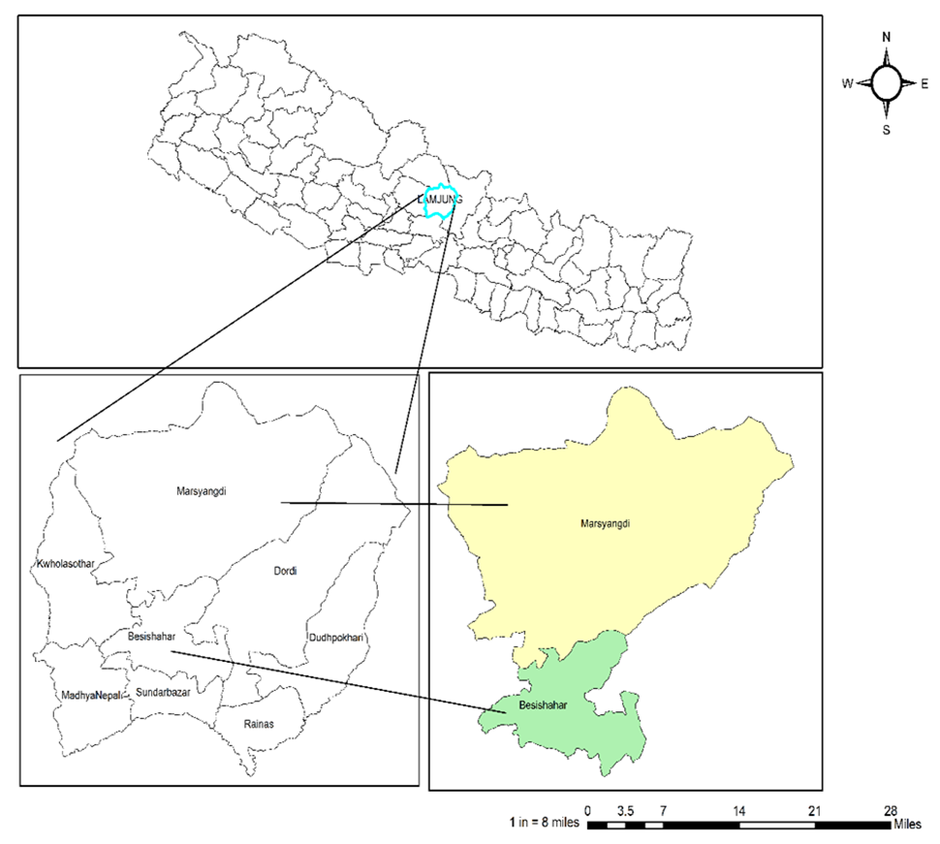Figure 1. Study area

  - Sampling and Data Collection Process
The study area consists of nine hundred and sixty large cardamom producers. A total of ninety-one large cardamom farmers were selected from the study area by using simple random sampling. Sample size was calculated by using Taro Yamane’s formula [8].
$n= \frac{N}{1+Ne^{2}}$ $= \frac{960}{1+960*{0.1}^{2}}$ = 91
Where, n = sample size, N = population size (sampling frame) & e = level of precision considered as 10%.
Primary data were collected through household surveys focus group discussions and key informant interviews. Meanwhile, secondary data were obtained from Agriculture Knowledge Center (AKC) annual reports, published literature, newspapers, magazines, bulletins, and official records from both government and non-government organizations.

  - Techniques of Data Analysis
The data collected from the household survey were coded and entered into MS Excel 2016, then analyzed using STATA 14.2 software. Descriptive statistics (sum, mean, relative frequency, minimum, maximum, and standard deviation) were used to analyze production, cost, and price. The efficiency of large cardamom farmers was estimated using the Cobb-Douglas production function model.

  - Estimation of Resource Use Efficiency
When the marginal value product (MVP) equals the marginal factor cost (MFC), the usage of resources is deemed efficient, i.e. when the allocative efficiency (MVP/MFC) equals one. The Cobb-Douglas production function (CDPF) was employed to understand how different inputs like labor, fertilizer, plant protection chemicals and other farming resources contribute to the overall large cardamom profitability. MFC was indicated in terms of additional rupees spent on supplying individual resources. MVP for each resource is the projected additional gross revenue generated by adding one unit of that resource while holding other resources constant, as computed using CDPF coefficients. CDPF model is widely utilized to describe the relationship between output and inputs, offering a close approximation to real-world production outcomes. The Cobb-Douglas production function used for analysis is given as,
Y =aX₁^{b1} X₂^{b2} X₃^{b3} X₄^{b4} X₅^{b5} e^{u} (1)
Upon log transformation of equation 1
logY = loga + b₁logX₁ + b₂logX₂ + b₃logX₃ + b₄logX₄ + b₅logX₅ + u
where,
Y = Gross income from large cardamom production (Rs.)
X₁= Manure cost (Rs.)
X₂= Plant protection chemical cost (Rs.)
X₃ = Total Fixed cost (Land tax, repair and maintenances, depreciation) (Rs.)
X₄= Sapling cost (Rs)
X₅= Labor cost (Rs)
u = Error term
a= Intercept
log= Natural logarithm
b₁, b₂, b₃, b₄ and b₅ are coefficients of respective variables.

The efficiency ratio (r) was computed using the formula
$r= \frac{MVP}{MFC}$
where,
MFC= Marginal factor cost
MVP= Marginal value product,
the marginal value product was computed by using the formula:
$$MVPi=bi \frac{Y}{Xi}$$

Where,
bi = Estimated regression coefficients
Y and Xi are the values from the geometric mean.
Efficiency estimation
r = 1 indicates the efficient use of resource
r < 1 indicates overuse of the resource
r > 1 indicates underuse of resource
The relative percentage change in MVP of each resource was estimated by using the following formula.
D= (1- MFC/MVP) ×100
Or, D= (1-1/r) ×100
Where, D= The absolute value of percentage change in MVP of each resource.

  - Return to Scale
Coefficient of regression of each input was used for RTS calculation as follow:
RTS =∑bi
Where,
bi = coefficient of i^{th} explanatory variables obtained from Cobb-Douglas production function.
The criteria for Return to Scale were determined based on value: less than 1 indicating decreasing returns to scale, equal to 1 representing constant returns to scale, and greater than 1 signifying increasing returns to scale.

- RESULTS AND DISCUSSIONS
  - Socioeconomic and Demographic Characteristics
Socio-economic and demographic characteristics of large cardamom producers in the study regions are given in Table 1. The mean age of the farmers was 50.06 years with a standard deviation of 11.674, indicating that most of the farmers were middle-aged. This corroborates other agriculture studies, whereby most farmers are middle-aged; this is because this age bracket can handle most labor-demanding crops with acquired experience and bodily strong [9]. The average household size was 5.87, comprising 3.79 economically active people and 2.08 dependents, with an average dependency ratio of 0.55. This shows that the majority of the households have a high percentage of their members employed, which is extremely important for a labor-intensive crop such as cardamom [10]. The average land coverage under cardamom was 0.58 hectares with an average yearly income of NRs. 110,569.78 which demonstrated cardamom farming as a significant source of income for the households. However, the high standard deviation in annual income is around NRs. 118,045.85 depicted a high fluctuation in the income status of the farmers, which may be due to differences in farm size, management, and marketing.

Table 1. Socio-demography of the study area
Variables | Mean
Age of Respondent (year) | 50.06(11.674)
Family size | 5.87(2.67)
Economically active | 3.79(1.31)
Dependent | 2.08(1.74)
Dependency ratio | 0.55(0.39)
Land area under large cardamom(hectare) | 0.58(0.43)
Annual revenue from large cardamom (NRs.) | 110569.78(118045.85)
Experience (year) | 11.61(5.79)
Note: Figures in parentheses indicate standard deviation.
Source: Field Survey ,2023

  - Cobb-Douglas Production Function Analysis
Using the Cobb-Douglas production function (CDPF), gross income of production is regressed with independent cost items. The results of the Cobb-Douglas production function presented in Table 2, demonstrated that the regression model used to assess the influence of various independent variables on income from large cardamom cultivation was highly significant. This significance was evidenced by a probability value of 0 for the F test, indicating strong statistical significance. Furthermore, the adjusted R-squared (R²) value was calculated to be 0.947. This high adjusted R² value signifies that approximately 94.7% of the variation in total income derived from cardamom production could be explained by the independent variables included in the regression equation.
Among the independent variables taken in the regression equation in Table 2 shows that the cost of labor for large cardamom has a significant positive effect on the annual income from cardamom production. The result shows that a percentage increase in the cost of labor will increase the income from cardamom by 1.187 and the result was significant at a 1% level of significance.
Similarly, a percentage increase in the cost of sapling will decrease the income from cardamom by 0.146% and the result was significant at a 1% level of significance. This could be due to the perennial nature of cardamom, which requires a long gestation period before yielding returns, making initial investments in saplings a financial burden for farmers. It may be the fact due to the perennial nature of the crop and once the crop is transplanted, it requires 3 to 4 years to take the harvest and the harvest reaches its peak by 6 years onward. Further, a percentage increase in the cost of plant protection chemicals, fix costs and manure increases the income from cardamom by 0.028%, 0.022%, and 0.012% respectively but the effect was non-significant

Table 2. Production function analysis of large cardamom production
Variables | Coefficients. |  | Standard Error |  | t-value | p-value |  | Sig
log_manure_cost | 0.012 |  | .014 |  | 0.91 | 0.365
log_plant protection chemical cost | 0.028 |  | .023 |  | 1.21 | 0.230
log_total fixed cost | 0.022 |  | .029 |  | 0.74 | 0.464
log_sappling cost | -0.146 |  | .028 |  | -5.27 | 0.000 |  | ***
log_labor cost | 1.187 |  | .034 |  | 34.63 | 0.000 |  | ***
Constant | 0.012 |  | .134 |  | -0.89 | 0.376
Mean dependent var |  | 4.853 |  | Number of observations |  |  | 91
R-squared |  | 0.950 |  | Adjusted R² |  |  | 0.947
F-test |  | 324.551 |  | Probability > F |  |  | 0.000
Return to scale |  | 1.103 |  | Bayesian crit. (BIC) |  |  | -153.251
*** p<.01, ** p<.05, * p<.1
Source: Field Survey ,2023
  - Return to Scale
The return to scale in cardamom production was calculated as 1.103 (Table 2). This indicates a slightly increasing return to scale in cardamom production. In practical terms, this means that if there is an increase in the cost of variable inputs, the resulting increase in income from cardamom production would be slightly higher. In other words, the additional proportion of output generated is slightly more than the additional input employed. Similar to this finding, [4] found return to scale was increasing in large cardamom production in Bhojpur. In contrast, [11] found elasticity of large cardamom production was decreasing return to scale in Nepal East corridor.

  - Estimation of resource use efficiency
The ratio of the MVP to MFC of the manure cost, plant protection chemicals and labor were positive and greater than one, indicating under-utilization. Further ratio of MVP to MFC of sapling and total fixed cost were less than one, indicating overuse of the resources. Additionally, resource use efficiency of the total fixed cost was positive but that of sapling is negative. The resource use efficiency ratio was highest for plant protection chemical cost (9.408) followed by manure cost (3.833) and labor cost (2.346). This indicated that spending more on plant protection chemicals, manure costs, and labor costs would yield more returns. For instance, every additional rupee spent on plant protection chemicals, manure cost, and labor would result in the returns of NRs. 9.408, NRs. 3.833 and NRs. 2.346 respectively. These were the cases of underutilization of resources among which labor cost was the only one which is statistically significant. Sapling cost and total fixed cost were found to be over-utilized resources. The negative ratio of sapling cost (-0.676) suggested that every additional rupee spent on sapling would reduce the gross revenue by NRs. 0.676 and also statistically significant. The efficiency ratio of total fixed cost was 0.299 which indicated that an additional one rupee spent on total fixed cost would yield only NRs. 0.299. This suggests that further investment in these areas would not yield proportional returns, a finding supported by studies on diminishing returns in agricultural inputs.
Table 3. Resource use efficiency of large cardamom production
Variable | Coefficient | Ratio GM | MVP | MFC | r | Percentage adjustment | Efficiency
log_manure_cost | 0.012 | 307.915 | 3.833 | 1 | 3.833 | 73.913% | Underutilized
log_plant protection chemical cost | 0.028 | 331.557 | 9.408 | 1 | 9.408 | 89.371% | Underutilized
log_total fixed cost | 0.022 | 13.818 | 0.299 | 1 | 0.299 | -234.054% | Over utilized
log_sappling cost | -0.146 | 4.627 | -0.676 | 1 | -0.676 | 247.725% | Over utilized
log_labor cost | 1.187 | 1.976 | 2.346 | 1 | 2.346 | 57.376% | Underutilized
Source: Field survey, 2023

  - Benefit-cost analysis
The study found human labor cost accounting major part NRs 90,178 per hectare of total cost of large cardamom production. Due to poor access and intervention of agro-machineries for saplings transplantation and harvesting, human labor was solely engaged in planting and harvesting. Furthermore, other intercultural operations like weeding, application of plant protection measures, and earthing up were carried out manually. The total cost and gross revenue for large cardamom production in the study area was found to be NRs. 149,646.53 per hectare and NRs. 198,458.57 per hectare respectively. The benefit-cost ratio was calculated as 1.32 (Table 4) confirming profitability of large cardamom production. Similar to this finding, [4] and [12] found b/c ratio of 1.467 and 2 in Bhojpur and Tehrathum districts of Nepal respectively.
Table 4. Cost and return from large cardamom production
Variables | NRs/ha
Labor cost | 90,177.51
Sapling cost | 40,211.04
Manure cost | 3,388.56
Plant protection cost | 686.39
Total fixed cost | 15,183.03
Total cost | 149,646.53
Gross income | 198,458.57
B/C ratio | 1.32
Source: Field survey, 2023
- CONCLUSION AND RECOMMENDATIONS
Labor is seen to have a positive impact on profitability, and investment in saplings has a detrimental effect. Efficient use of labor and re-evaluation of investments in saplings will maximize profitability. Underutilization of labor, manures, and plant protection chemicals, and overutilization of saplings and fixed items point towards re-alignment of investments in these inputs intending to boost yields, and savings in terms of cost savings with no loss in production level, respectively. The return to scale value of 1.103 indicates slightly increasing returns, suggesting that additional investment in inputs results in proportionally higher output. The benefit-cost ratio of 1.32 confirms the profitability of large cardamom farming, suggesting that every rupee invested generates a return of NRs. 1.32. However, the analysis was based on cross-sectional data, preventing the assessment of long-term trends and changes in productivity. Further studies should consider incorporating panel data for better trend analysis. To harness the full potential of large cardamom as a driver of rural livelihoods and export growth, policymakers should prioritize farmer training on input optimization, subsidize underutilized resources, and promote sustainable agronomic practices. Addressing these inefficiencies can elevate Nepal’s competitiveness in global spice markets, aligning with national strategies like NTIS 2023. Future research should explore climate-resilient techniques, value addition through processing and export, gender and role in use of resources and market linkages to further strengthen this "Black Gold" sector.

COMPETING INTERESTS
Authors have declared that no competing interests exist.

REFERENCES
- Acharya, M. (2019). A review on status and profitability of large cardamom production in Nepal. International Journal of Financial, Accounting, and Management, 1(1), 17–22. https://doi.org/10.35912/ijfam.v1i1.53
- NFTS. (2023). Nepal Foreign Trade Statistics. Nepal Foreign Trade Statistics 2022/2023, 20.
- MOALD. (2023). Statistical information on Nepalese agriculture 2078/79 (2021/22). Kathmandu: Ministry of Agricultural and Livestock Development, Government of Nepal.
- Kalauni, D., & Joshi, A. (2019). Production economics, marketing and critical success factors of Large Cardamom in Bhojpur, Nepal. Cogent Food and Agriculture, 5(1). https://doi.org/10.1080/23311932.2019.1701358
- Dhungana, S. M., Regmi, P. P., Dhakal, S. C., & Devkota, N. R. (2023). Efficiency of Resource Allocation of Large Cardamom Production: A Case for Nepal East Corridor. Asian Journal of Economics, Business and Accounting, 23(19), 109–116. https://doi.org/10.9734/ajeba/2023/v23i191076
- Dhakal, S. C., Regmi, P. P., Thapa, R. B., Sah, S. K., & Khatri-Chhetri, D. B. (2015). Resource Use Efficiency of Mustard Production in Chitwan District of Nepal. International Journal of Applied Sciences and Biotechnology, 3(4), 604–608. https://doi.org/10.3126/ijasbt.v3i4.13525
- Mutoko, M. C., Hein, L., & Shisanya, C. A. (2014). Farm diversity, resource use efficiency and sustainable land management in the western highlands of Kenya. Journal of Rural Studies, 36, 108–120. https://doi.org/10.1016/j.jrurstud.2014.07.006
- Yamane, Taro. 1967. Statistics, An Introductory Analysis, 2nd Ed., New York: Harper and Row.
- Shrestha, J., Prasai, H. K., Timsina, K. P., Shrestha, K. P., Pokhrel, D., Poudel, K., Yadav, M. P., & ………………………………………………………………………………………………. (2018). Large cardamom in Nepal: Production practice and economics, Processing and Marketing (Issue February 2020).
- Feder, G., Just, R., & Silberman, D. (1985). Adoption of agricultural innovations in developing countries: A survey World Bank staff working paper no. 444. The University of Chicago Press, 2(33), 255–295. https://www.journals.uchicago.edu/doi/pdfplus/10.1086/451461
- Kandel, S. (2019). Economics of Production and Marketing of Organic Large Cardamom in Panchthar District of Nepal. Acta Scientific Agriculture, 3(8), 133–144. https://doi.org/10.31080/asag.2019.03.0574
- Bhandari, N., & Bhandari, T. (2018). Marketing and Socioeconomics Aspects of Large Cardamom Production in Tehrathum, Nepal. Journal of Nepal Agricultural Research Council, 4(April), 79–85. https://doi.org/10.3126/jnarc.v4i1.19693

