The Role of Artificial Intelligence in Strategic Decision-Making.

.

ABSTRACT

|  |
| --- |
| **Aims:** The aim of the paper was to examine the issues associated with AI in business decision-making, focusing on matters such as bias, competence, the absence of a comprehensible strategy as well as inadequate attention to strategic, legal and explainability factors  **Study design:** Qualitative research design.  **Place and Duration of Study:** MFIs in Zimbabwe, between November 2024 to January 2025.  **Methodology:** We interviewed 4 participants each with a diverse role in the field of artificial intelligence (partnership manager, concept manager for analytics and AI, legal consultant and a software engineer)  **Results:** The results underscore key legal and strategic issues related to AI in business decision-making, specifically focusing on privacy, explainability, bias fairness and competence and education. Respondents proposed several solutions to address these concerns, including the promotion of diverse and inclusive decision-making processes, the classification of data and the implementation of AI models that can elucidate the decisions made by AI systems.  **Conclusion:** The findings offer valuable guidance for companies looking to adopt AI technologies into their decision-making frameworks, assisting them in overcoming existing obstacles in this area. However further research may be required on a larger scale to validate the findings. |

*Keywords: : artificial intelligence, automation, business intelligence, cognitive computing, data analytics, decision support systems, machine learning, strategic decision-making.*

1. INTRODUCTION

**1.1 Background to the Study**

Artificial intelligence (AI) is a groundbreaking technological advancement that is revolutionizing businesses by facilitating accurate decision-making, minimizing time and costs, and enhancing data gathering. It combines cloud technology, network devices, robotics, computers and digital content generation. AI plays a fundamental role in determining future marketing schemes as companies increasingly leverage AI software to optimize operations, lower expenses, speed up turnaround times and increase productivity. Organizations that have embraced AI-driven marketing solutions are likely to secure a competitive advantage.

Machine learning leverages AI-driven experiences and empirical data to construct and retain knowledge, enhancing problem-solving efficiency by identifying patterns for algorithms (Brynjolfsson & McAfee ,2017). In contrast, deep learning develops neural networks as it learns, requiring human involvement to provide examples that guide the AI in addressing problems as indicated by Davenport, Guha, Grewal and Bressgott (2020). This approach is frequently employed in multi-layered learning systems designed to tackle complex issues.

Integrating AI into decision-making procedures has the potential to revolutionise businesses by increasing productivity, precision and creativity. However, it also presents challenges that need to be addressed, including data privacy, security concerns, ethical implications, and the impact on the workforce (Chui, Kamalnath & cCarthy, 2018). The automation of tasks through AI can alter job roles, making reskilling or upskilling essential for employees (Duan, Edwards & Dwivedi, 2019). Furthermore, ethical considerations regarding the responsible and transparent deployment of AI technologies are vital. As businesses increasingly adopt AI solutions, the decision-making landscape will experience significant changes that will influence the future of various industries.

**1.2 Problem Statement**

The rapid advancement of AI technologies presents a critical challenge for businesses seeking to incorporate these tools into their strategic policymaking processes. Despite the potential advantages of AI in improving analytical capabilities and generating actionable insights from extensive datasets, numerous organizations face challenges in successfully implementing AI-driven solutions that are compatible with their current business models. This research aims to examine the complexities and implications of AI adoption in decision-making, focusing on how it transforms traditional practices, influences marketing strategies, and addresses significant operational challenges, ultimately reshaping the landscape of business growth and innovation.

**1.3 Conceptual Framework**

Data is a vital resource for AI; without data, AI systems could not operate efficiently or provide insightful suggestions. This link emphasises how crucial it is to include sound data practices into company plans in order to improve decision-making capabilities, as seen in Figure 1.

**Figure 1**

*Conceptual Framework*

Business Strategy IT Strategy

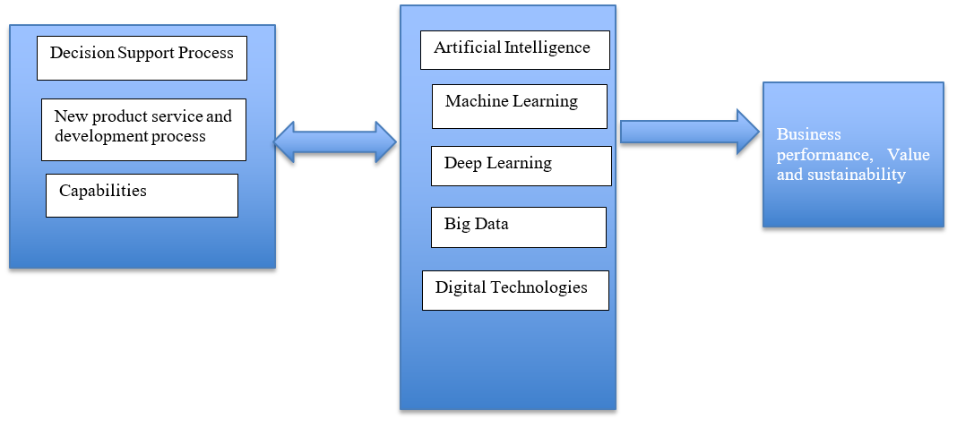

*Source:*Author’s configuration

**1.4 Brief Literature Review**

The rise of artificial intelligence has sparked a considerable amount of academic research examining its effects on various aspects of administrative management, especially in the area of strategic decision-making. Scholars such as Brynjolfsson and McAfee (2017) and Davenport et al. (2020) have extensively explored how AI technologies can enhance policymaking processes within organizations. AI has the potential to offer significant insights through its capabilities in analyzing data, predictive modeling and mechanization, which can empower companies to make well-versed strategic decisions.

The incorporation of AI into tactical management has been examined in various studies that evaluate its possible benefits and drawbacks. Research conducted by Chui, Kamalnath and McCarthy (2018) highlights the transformative impact of AI on organizational performance and competitiveness. Leveraging AI tools enables companies to enhance operational efficiency, optimize the allocation of resources, and improve customer engagement, which collectively contributes to a stronger competitive position in the marketplace.

In the contemporary landscape, data mining, big data, and the handling of vast datasets have emerged as pivotal elements in the decision-making process for organizations (Niu et al.,2021). While humans typically draw on their historical experiences to inform their choices, AI systems utilize vast datasets to extract insights and make predictions (Ma & Sun, 2020). The discrepancy highlights how humans and AI each contribute uniquely to strategic decision-making, emphasizing their complementary roles in the process.

AI modeling effectively aligns client requirements with service delivery by improving particular decision-making processes and significantly reducing both time and costs.AI systems excel in data collection, forecasting, and trend analysis, enabling businesses to predict customer lifetime value accurately (Dwivedi et al.,2021). This ability ultimately results in a decrease in the bounce rates of the system. Through a process known as data mining or opinion mining, AI analyzes vast amounts of data, including web searches for public opinions and sentiments (Kaplan & Haenlein, 2020).

The study conducted by Duan, Edwards and Dwivedi in 2019 aims to illustrate the impact of AI on policymaking processes. It emphasizes how AI can perform wide-ranging evaluations that may either augment or supplant human participation, mostly in the context of integrating as well as engaging AI structures. The research delves into the consequences of revitalized AI-driven vigorous frameworks and offers various suggestions for experts who work with information systems. The paper opens with a synopsis of the historical development of AI, citing articles from reputable international journals. It explores broad facets of AI and the significant trials it presents, together with the essential cooperation and synchronisation needed to either enhance or completely replace human delegates. Additionally, the study examines how AI can be applied in dynamic environments during the big data era, providing twelve recommendations for specialists, but also contemplating upcoming trends about the development of AI and how it relates to human jobs.

**1.5 Scope**

The study looks at how developments in artificial intelligence (AI) are affecting the operations and service delivery of Microfinance Institutions (MFIs) in Zimbabwe between November 2024 and January 2025. In order to obtain information about the integration of AI technologies within MFIs, implementation challenges, regulatory considerations and the overall efficacy of these technologies in enhancing financial inclusion and operational efficiency, the research will interview four participants in a variety of roles: partnership manager, concept manager for analytics and AI, legal consultant, and software engineer. The goal of this qualitative method is to give a thorough grasp of how MFIs are now navigating the changing digital landscape in Zimbabwe.

**1.6 Justification of the Study**

The study holds significant importance in the quickly changing corporate environment of today, where companies progressively rely on data-driven insights to navigate complex environments. As companies face unprecedented challenges and opportunities, understanding how AI can enhance strategic decision-making processes becomes crucial. Integrating AI into decision-making frameworks allows organizations to improve their responsiveness to changes in the market and enhance their competitive advantage.

Furthermore, by addressing the disparity between theoretical frameworks of decision-making as well as real-world uses of AI technology, our study advances the scholarly conversation. It explores not only the benefits but also the potential risks and ethical considerations associated with AI implementation in strategic contexts. The research highlights best practices and offers a roadmap for organizations seeking to leverage AI effectively through the examination of case studies across various industries. This study is significant as it provides valuable guidance for leaders aiming to harness AI’s capabilities while fostering an organizational culture that embraces innovation and ethical responsibility.

2. methodology

To achieve the goal of this paper, which is to examine the ways in which AI is incorporated into strategic decision-making. of organizations, a qualitative approach was employed in this study. The study employed a combination of primary and secondary data sources.

**2.1 Primary Data**

The study has been enhanced by the use of qualitative interviews, which has helped to clarify how AI affects corporate decision-making. To better understand people's experiences and find underlying trends, this study design uses a qualitative technique. When respondents provide answers in their own words, qualitative analysis is conducted . In contrast to online questionnaires that enable for widespread involvement from a diverse audience, interviews are favored due to their ability to be carried out either face to face or through zoom meeting, which facilitates a closer exchange. This technique also provides the interviewer with enhanced authority over the choice of participants, enabling them to make certain that responders are pertinent to the research topic.

A roadmap for interviews was developed, as outlined in Appendix 1, featuring questions directed at individuals with proficiency in artificial intelligence, specifically concerning its use in making strategic commercial and legal decisions. Participants were selected grounded on their previous or present involvement with AI in professional settings. The questions' design considered the necessity of striking a balance between structure and standardisation to guarantee that the answers would be as useful and instructive as feasible. The four individuals interviewed for this research represent a range of roles within the AI and technology sectors (refer to Table 1).

**Table 1**

*Target population*

*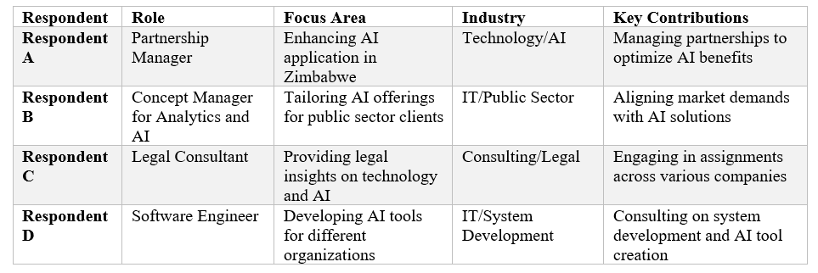Source*: Marimira, (2024).

In this research, the intended audience included four individuals who represented various positions in the technology and AI industries. Each respondent offers a distinct viewpoint shaped by their specialized experiences, which is essential for comprehending the complex AI's function in making strategic decisions.

**2.2 Secondary Data**

A thorough literature assessment that includes books, scholarly papers, previous surveys, data and reports about the application of AI in corporate decision-making served as the foundation for this paper's theoretical chapter and research design. To identify the most correct and pertinent publications and data for this study, a thorough examination of all theoretical developments was carried out. These were then chosen based on their suitability and relevance.

**2.3 Data Analysis**

To gain a deeper understanding of the subject, a qualitative analysis method was employed, which involves conducting ongoing analyses throughout the interview process rather than solely after data collection (Sutton & Austin, 2015 ). According to Sutton and Austin, 2015) ,the final text produced from this method comprises a blend of quotes and descriptive text accompanied by interpretations and comments. Limited written notes were transcribed throughout the sessions, and the interviews were taped. Consequently, the tapes were later transcribed. In order to increase clarity and comprehension, the written material was divided into parts in accordance with the interview guide because the replies lacked clear themes.

3. results and discussion

3.1 Results

We share the findings from qualitative interviews among four participants who are highly knowledgeable about AI and making informed choices in this section. The data collected demonstrates a sophisticated comprehension of the ways in which AI technologies are now being integrated into organisational strategy, highlighting the benefits and difficulties faced by decision-makers.

**3.1.1 The use of AI**

Respondent A indicates that AI can be utilized to enhance making business decisions across a variety of sectors. However, many leaders in these industries often do not fully grasp the capabilities of AI and how it can improve their decision-making processes. Respondent B, on the other hand, has a deeper understanding of the investigative aspects of AI. Respondent C brings significant know-how from the public sector, possessing engaged in numerous AI projects that mainly focus on applications of machine learning. Furthermore, Respondent D has been involved in initiatives where AI was employed to evaluate necessities as well as resources for prioritizing tasks and managing projects.

**Table 2**

*Findings from interviews on the use of AI.*

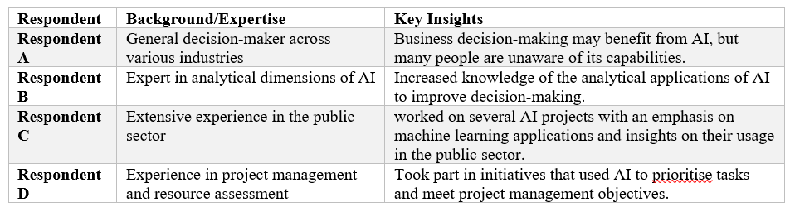

*Source*: Marimira, (2024).

**3.1.2 AI in Strategic Decision-making**

Table 3 presents a summary of different applications of AI in strategic decision-making, derived from insights obtained through interviews with four participants. Each participant offered distinct viewpoints on the impact of AI on business decisions, highlighting factors such as improved efficiency, predictive analytics, reduction of errors, achievement of objective results and mechanization.

**Table 3**

*Various Uses of AI in Strategic Decision Making*

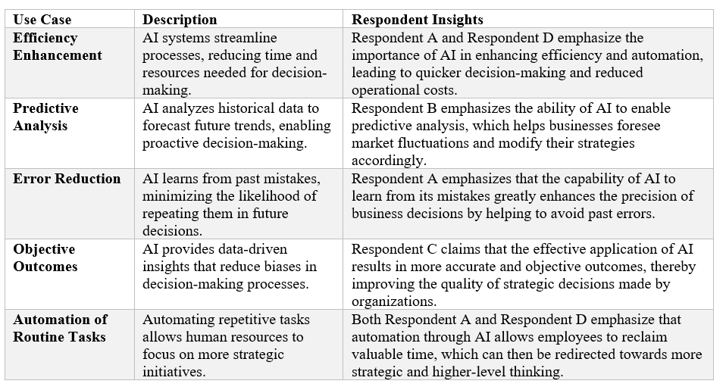

*Source*: Marimira, (2024).

**3.2 Discussion**

Respondent A’s organization does not engage in direct investments in artificial intelligence but rather works with associates who invest on their behalf. The AI technologies employed by Respondent A along with its associates are not designed for any particular sector; rather, they include technologies that are widely applicable, such information-driven systems. The main goal of every project in Respondent A's business is on putting into practice, which leads to difficulties that are mainly associated with rather than technical execution, information transfer, ethical issues and legal compliance. Respondent A articulates a sense of contentment with the organisation’s strategy regarding the use of AI, emphasizing a robust pride in cultivating a neutral setting where partners' knowledge exchange and AI development are prioritised over sales goals.

Both Respondents A and D emphasize that a major impact of AI is its capacity to improve organizational efficiency by swiftly and accurately processing large volumes of information, enabling businesses to make quicker decisions while lowering operational costs. Respondent B highlights AI’s analytical capabilities, which facilitate predictive analyses based on historical data trends, allowing businesses to anticipate shifts in their surroundings or the state of the market and modify their plans appropriately. Additionally, the learning ability of AI, as noted by Respondent A, is vital for reducing errors in decision-making processes. AI systems can make suggestions to assist avoid similar problems in the future by looking at prior errors.

According to Respondent C, the appropriate use of AI leads to outcomes that are more factual and objective than those produced by traditional methods, which are often subject to human biases and subjective interpretations. Additionally, both Respondents A and D emphasize the advantage of automation, as it enables organizations to assign routine tasks to AI systems, allowing human employees to focus on strategic planning and complex problem-solving. According to respondent A, the most significant impact of AI lies in its ability to enhance efficiency and speed, a sentiment echoed by Haenlein and Kaplan (2019, p. 9). Conversely, respondents’ B and C argue that AI’s greatest contribution is in predictive analysis, which assists humans in making informed decisions; this perspective aligns with Dwivedi et al. (2021, p. 7), who highlight that predictive capabilities can foster both efficiency and responsible decision-making through AI. As of right now, every responder agrees that AI systems and technologies are more effective as assisting tools for those who make decisions than as completely independent solutions.

Even though most people think that some activities could ultimately be completely automated, human oversight is still necessary for decision-making processes in the current scenario. Because humans are ultimately in charge of making final decisions, AI is best used to provide recommendations to them. This view is supported by Duan et al. (2019, p. 68), who agree that due to the nascent nature of big data within AI frameworks, decision-making technologies should primarily function as support mechanisms for human operators.

Both participant A and B voice their worries about the lack of understanding regarding AI usage and its potential to enhance policymaking, a perspective that is supported by the findings of Aung, Wong and Ting (2021). Additionally, respondents’ C and D raise issues about the lack of quality information available, reinforcing the observations made by Aung et al. (2021, p. 375) in their earlier research.

It is becoming more and more important for businesses to have a strategy plan for integrating AI as the technology develops and finds uses in a variety of industries. AI's capacity to evaluate vast amounts of data raises a number of legal and strategic issues, especially with regard to the openness of data use in decision-making. A revolutionary shift in organisational operations and competition in the contemporary corporate environment is represented by the integration of AI into strategic decision-making. The various ways that AI might enhance decision-making creativity, accuracy, and efficiency have all been covered in detail in this study. AI technologies, such as machine learning algorithms, predictive analytics, and natural language processing, offer organisations substantial opportunity to use data-driven insights that enable better informed and timely decisions, according to a thorough study of the literature and case studies.

4. Conclusion

It is becoming more and more crucial for businesses to create a strategy plan for integrating ai as the technology develops and finds uses in a variety of industries. AI's capacity to handle enormous volumes of data presents a number of legal and strategic issues, especially with regard to the openness of data use in decision-making. A revolutionary change in how businesses function and compete in the contemporary business environment is represented by the incorporation of ai into strategic decision-making processes.

The results show that AI empowers decision-makers by giving them advanced tools to examine complicated information, in addition to streamlining operational procedures. This capacity lowers the cognitive biases frequently connected to human judgment and improves forecast accuracy. Additionally, AI promotes innovation by allowing companies to investigate novel business plans and tactics that were previously unfeasible because of constraints in data analysis skills.

However, this study has also brought to light important obstacles and moral dilemmas related to using AI in strategic decision-making. A cautious approach to AI adoption is required due to concerns like algorithmic bias, data privacy, and the possibility of employment displacement. To guarantee the appropriate use of AI technology while optimizing their advantages, organizations must give ethical frameworks and governance structures top priority.

References

1.Brynjolfsson, E., & McAfee, A. (2017). Machine, platform, crowd: Harnessing our digital future. *WW New York: Norton & Company*, *564*.

2.Davenport, T., Guha, A., Grewal, D., & Bressgott, T. (2020). How artificial intelligence will change the future of marketing. *Journal of the Academy of Marketing Science*, *48*, 24-42.

3. Chui, M., Kamalnath, V., & McCarthy, B. (2018). McKinsey Analytics, An executive's guide to AI.

4. Duan, Y., Edwards, J. S., & Dwivedi, Y. K. (2019). Artificial intelligence for decision making in the era of Big Data–evolution, challenges and research agenda. *International journal of information management*, *48*, 63-71.

5. Niu, Y., Ying, L., Yang, J., Bao, M., & Sivaparthipan, C. B. (2021). Organizational business intelligence and decision making using big data analytics. *Information Processing & Management*, *58*(6), 102725.

6. Ma, L., & Sun, B. (2020). Machine learning and AI in marketing–Connecting computing power to human insights. *International Journal of Research in Marketing*, *37*(3), 481-504.

7. Dwivedi, Y. K., Hughes, L., Ismagilova, E., Aarts, G., Coombs, C., Crick, T., ... & Williams, M. D. (2021). Artificial Intelligence (AI): Multidisciplinary perspectives on emerging challenges, opportunities, and agenda for research, practice and policy. *International journal of information management*, *57*, 101994.

8. Kaplan, A., & Haenlein, M. (2020). Rulers of the world, unite! The challenges and opportunities of artificial intelligence. *Business Horizons*, *63*(1), 37-50.

9. Sutton, J., & Austin, Z. (2015). Qualitative research: Data collection, analysis, and management. *The Canadian journal of hospital pharmacy*, *68*(3), 226.

10. Haenlein, M., & Kaplan, A. (2019). A brief history of artificial intelligence: On the past, present, and future of artificial intelligence. *California management review*, *61*(4), 5-14.

11. Aung, Y. Y., Wong, D. C., & Ting, D. S. (2021). The promise of artificial intelligence: a review of the opportunities and challenges of artificial intelligence in healthcare. *British medical bulletin*, *139*(1), 4-15.

Abbreviations

*AI: Artificial Intelligence*

*DL: Deep Learning*

*DSS: Decision Support Systems*

*RPA: Robotic Process Automation*

APPENDIX 1

**Interview Guide**

The questions used to collect primary data:

1. Has your current workplace made any investments in AI technologies? If so, how long has this investment been ongoing? If not, please proceed to the next section.
2. In which department or area of the company are AI technologies being utilized?
3. What challenges did the company encounter during the implementation of AI?
4. Are you content with the current application of AI within the organization? If yes, what aspects of AI usage contribute to your satisfaction? If no, what improvements do you believe could be made?
5. How do you perceive the impact of AI on business decision-making processes?
6. Is your current workplace employing AI for making business decisions? If yes, what challenges arise from using AI in decision-making?
7. In your opinion, is AI better suited as an aid for human decision-makers or as a replacement for them? Please elaborate on your reasoning.