*Minireview Article*

INFLUENCE OF PLASTIC ENDODONTIC INSTRUMENTS ON THE AGITATION PROTOCOL OF IRRIGANTIC SOLUTIONS IN CHEMICAL-MECHANICAL PREPARATION: INTEGRATIVE REVIEW

.

ABSTRACT

|  |
| --- |
| **Introduction:** The mechanical action in endodontic treatment is performed by endodontic files, and the chemical action by auxiliary solutions. However, both individually are insufficient in cleaning and removing the smear layer. Thus, there was a need to develop techniques for agitating the solutions using ultrasound tips or plastic instruments thatwould assist in this process, for better disinfection of the canals.  **Aims:** Evaluate the effectiveness of plastic endodontic instruments (Eddy, Easy Clean and EndoActivator) in cleaning the root canals and their efficiency in endodontic treatment.  **Methodology:** A search for articles was conducted in the PubMed, Bireme and SciELO databases. The descriptors “Endodontic Irrigation”, “Sonic Irrigation” and “Activation Systems” were used in a cross-search. Articles in both Portuguese and English, from January 2015 to April 2020, were included. Literature review articles that were not relevant to the study were excluded. Of the total of 17 articles found, 5 were duplicates across the platforms, 5 met the exclusion criteria, and 7 were selected for the integrative review.  **Results:** The instruments showed greater efficiency in removing smear layer, biofilm and bacteria present inside the root canal, through agitation of auxiliary chemical solutions, such as sodium hypochlorite and EDTA.  **Conclusion:** It can be concluded that the plastic instruments Eddy, Easy Clean and EndoActivator proved to be a good option in the cleaning protocol of root canal systems. |

*Keywords: Endodontics, Endodontic Irrigation, Sonic Irrigation, Activation Systems, Easy Clean, EndoActivator, Eddy.*

1. INTRODUCTION

Endodontic treatment consists of the disinfection and sealing of the root canals, with the goal of eliminating the microbial infection present. This procedure becomes necessary when clinical and radiographic evidence indicate the need for intervention, being performed according to the diagnosis of biopulpectomy or necropulpectomy (Plotino et al., 2016). Thus, the main purpose of endodontic treatment is the eradication of a possible infection in the dental element, promoting pain relief and eliminating the patient's discomfort. It is expected that through this procedure, the tooth will be functionally preserved in the oral cavity (Bragante et al., 2018; Neelakantan et al., 2020).

However, for endodontic treatment to be successful, it is essential to follow specific protocols. Considering that the treatment typically involves four stages (surgical access, root canal shaping, cleaning and disinfection, and obturation), it is imperative that the dentist has appropriate technical and procedural expertise to carry out each phase of the procedure (Marcos-Arenal et al., 2009). Given the challenges presented in each clinical case, the need for technological advances in endodontic treatment arose, aiming to optimize the effectiveness of protocols during the procedure. In this context, endodontic motors were developed, offering the dentist greater modeling capacity and speed control during root canal instrumentation. However, the mere increase in speed and improvement of modeling does not, by itself, ensure effective canal cleaning.

Several studies indicate that more than 60% of the total area of the root canal is not adequately prepared after the use of rotary instruments, regardless of the technique used (Wagner et al., 2017; Oliveira et al., 2014). This fact is attributed to the lack of compatibility between the geometry of the files and the anatomy of the canal, as the instruments were designed to fit the conical shape of the canal without considering the existing anatomical variations. Curvatures and complex internal anatomy represent considerable challenges during the procedure (Siqueira Júnior et al., 2018). Thus, remaining microorganisms are left in areas where the instruments cannot perform their cutting function, and the irrigants do not reach the required concentration or contact time.

During the shaping process, cutting the dental structure results in the formation of a layer known as the "smear layer," which consists of a mixture of organic and inorganic materials from the dentin tissues, microorganisms, and pulp debris (Araújo et al., 1998). Several methods are employed during endodontic procedures to eliminate this layer, such as the use of chemical substances, forming the process known as Chemical-Medical Preparation (PQM) (Siqueira, 2007; Dioguardi et al., 2018).

Sodium hypochlorite (NaOCl) is the most commonly used irrigant for canal disinfection. In addition, 17% EDTA (ethylene diamine tetraacetic acid), which is a chelating agent, is also commonly used and has been recommended to improve the effectiveness in removing the smear layer (Bueno et al., 2019; McComb & Smith, 1975; Scelza et al., 2003; Hülsmann et al., 2003). This agent acts as an adjunct, compensating for the limitation of NaOCl in removing the mineral dentin matrix during the biomechanical preparation of the root canals (Hülsmann et al., 2003; Scelza et al., 2004).

In the context of the cleaning protocol, it is essential to ensure the complete removal of the smear layer, promoting the opening of dentinal tubules to prevent the persistence of an infectious process that may compromise the success of the treatment (Chugal et al., 2003). Therefore, it is crucial to have rigorous control over the disinfection process, with particular emphasis on the fact that the persistence of infections is associated with microorganisms' resistance to antimicrobial agents. In this context, irrigation plays an essential role in endodontic treatment (Qing et al., 2006).

Conventional manual irrigation is typically carried out through plastic syringes and needles, which deliver the irrigating solution into the root canal. However, literature reviews indicate that the conventional approach results in less effective irrigation, especially in certain anatomical regions and in the apical third of the root canal. As a result, various techniques have been developed to optimize the action of the solutions after canal instrumentation, including sonic irrigation and ultrasonic irrigation (Gulabivala et al., 2010). This allows for more effective cleaning through the use of chemical-mechanical methods, utilizing auxiliary means, where the mechanical action is carried out by the endodontic files and the chemical action is performed by the auxiliary solutions. However, when used in isolation, both approaches prove insufficient for the cleaning and complete removal of the smear layer.

Thus, the agitation of the irrigating solution has proven to be a fundamental step for the success of endodontic treatment, being recommended to promote antisepsis in isthmus regions and areas of difficult access, where conventional instruments cannot reach. Studies demonstrate that this technique is effective in cleaning the root canal system (SCR), allowing the removal of inorganic residues that would not be eliminated by conventional irrigation (Ahmad et al., 1987; Sabins et al., 2003; Van der Sluis et al., 2007).

Passive ultrasonic irrigation (PUI) refers to the activation of the chemical irrigating solution within the SCR, aiming to improve the effectiveness of disinfection. Studies have shown that this technique makes root canal cleaning more efficient (Van Der Sluis et al., 2007; Gu et al., 2009), as well as optimizing the removal of the smear layer and dentin debris, especially in the apical region (Ahmad et al., 1987).

Sonic irrigation is performed using devices attached to handpieces or electric motors, where forced vibration occurs at the connected end, and at the other end, the vibration occurs freely. These systems operate with high amplitude vibration but at a low frequency (Jiang et al., 2010; Blank-Gonçalves et al., 2011). Several systems are available on the market, including those that are important for this study: Eddy®, Easy Clean®, and EndoActivator®.

The Eddy® (VDW, Munich, Germany) tips are flexible, sterile, disposable, made of non-cutting polyamide material, with a size 25 and a taper of 0.04. Their operating principle is sonic activation, functioning at frequencies of 5000 to 6000 Hz, and are activated by an air-driven handpiece (Fig. 1).

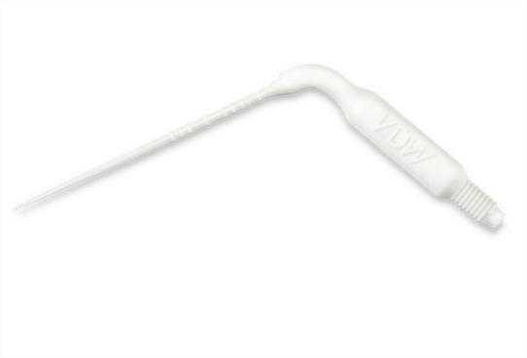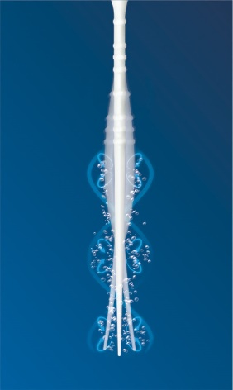 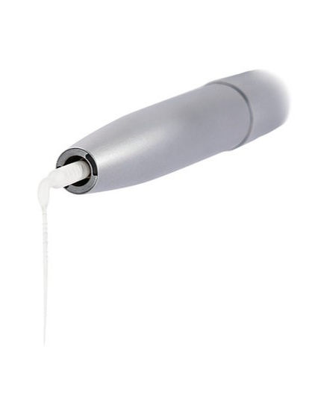

**(a) (b) (c)**

**Fig. 1 - Eddy® (a) tip (b) movement (c) handpiece**

Source: <https://www.vdw-dental.com/en/>

The Easy Clean® from Easy Dental Equipment (Belo Horizonte, MG, Brazil) is a sterilized plastic device that resembles a rotary endodontic instrument with a 25 gauge and 0.04 taper. The active part of the device has the shape of an "airplane wing" (Fig. 2).

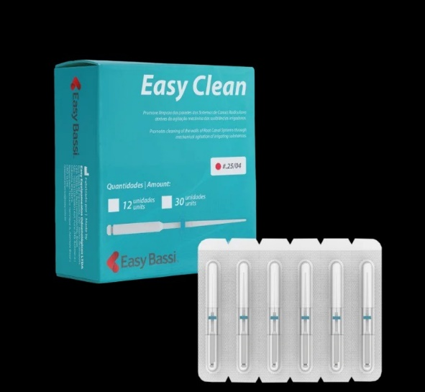 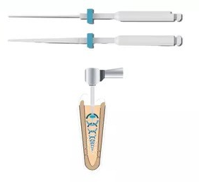

**(a) (b)**

**Fig. 2 - Easy Clean® (a) product (b) active part and movement**

**Source:** <https://easybassi.com.br/>

The EndoActivator® (Dentsply Tulsa Dental, Tulsa) is a sonic activation device that operates through a cordless, battery-powered handpiece to activate flexible tips made of polymeric material (Urban et al., 2017) (Fig. 3).

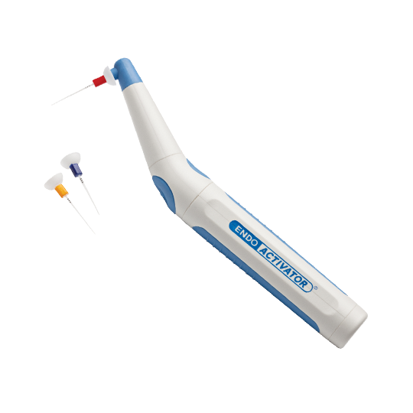

**Fig. 3 - EndoActivator®**

**Source:** <https://www.dentsplysirona.com/en-si/discover/discover-by-brand/endoactivator.html>

2. methodology

A literature review was conducted with the aim of identifying articles that investigate the use of plastic endodontic instruments in the disinfection and removal of the smear layer during the root canal cleaning protocol. For this purpose, the databases PubMed, Bireme, and SciELO were consulted. The search resulted in the identification of studies that discuss the influence of plastic instruments on the cleaning efficacy during endodontic treatment.

For the search, the descriptors "Endodontic Irrigation," "Sonic Irrigation," and "Activation Systems" were used and combined. Articles in Portuguese and English, published between January 2015 and April 2020, were considered. The search resulted in nine articles on the PubMed platform, seven on Bireme, and one on SciELO. Among the 17 articles identified, five presented duplicates across the platforms. Additionally, one article was excluded because it did not use plastic instruments in its methodology, and another was disregarded as it was a literature review rather than a clinical or laboratory study. As a result, seven articles were selected to compose the final sample of the research.

3. results and discussion

The research on the influence of plastic endodontic instruments, using the previously mentioned descriptors, resulted in seven articles. The abstracts were read and evaluated by a single examiner, who excluded one article for being clinical and laboratory tests unrelated to root canal cleaning, but rather to apical blockage. Therefore, six articles remained, which are explained in table 1.

**Table 1 – Summary of the Studied Articles**

|  |  |  |
| --- | --- | --- |
| **Author (year) country** | Sample and methodology | Results |
| **Kaloustian *et al*. (2019) France.** | The distal canals of 40 lower molars, previously shaped with the Protaper System and filled with X2 gutta-percha, were subjected to an initial root filling and later a retreatment, with the aim of evaluating the volume of remaining material. The teeth were divided into four groups to test the additional effect of two sonic irrigations using devices in the removal of the filling material: Eddy (VDW) and MM1500 (Micro-Mega). In the first two groups, the 2shape system was followed by MM1500 and Eddy; in the third and fourth groups, the Reciproc System was followed by MM1500 and Eddy. | Sonic activation resulted in a significant reduction in the residual filling material volume, with a decrease of 3.21% (*P* = 0.013) in the first group, 1.38% (*P*= 0.012) in the second group, 1.83% (*P* = 0.008) in the third group, and 1.83% (*P* = 0.012) in the fourth group. However, at the end of the study, the percentage of residual material did not show a significant difference between the groups throughout the entire length of the canal (*P* = 0.163). |
| **Zeng *et al*., (2018) China.** | Thirty-eight single-rooted premolars, previously instrumented and autoclaved, were inoculated with enterococcus faecalis (ATCC-29212) for a period of 21 days. Two teeth were kept as negative controls, without bacterial exposure. For the inoculated teeth, six were used as positive controls, without irrigation. The remaining teeth (30 units) were randomly assigned to two groups (N = 15), using 3% naocl as the irrigant: (A) size 30 - syringe needle irrigation (sni), and (B) EDDY (VDW, Munich, Germany). Twelve teeth from each group and four teeth from the positive control group were evaluated for bacterial reduction using the MTT test. | The MTT test indicated that both SNI and EDDY significantly reduced the intracanal bacterial load compared to the positive control, with no significant difference between the two techniques. Confocal laser scanning microscopy (clsm) revealed that eddy was more effective in eliminating intratubular bacteria in the coronal and middle portions of the root canal, compared to sni, but not in the apical portion. In all regions of the canal (coronal, apical, and middle of the root), both systems failed to completely eradicate bacteria that proliferated deep within the dentinal tubules. |
| **Mancini *et al*. (2018) Italy.** | Eighty single-rooted mandibular premolars were decoronated to a standardized length of 15 mm. The specimens were shaped to ProTaper F4 (Dentsply Maillefer) and irrigated with 5.25% NaOCl at 37°C. The teeth were divided into six groups (two control groups [n = 10] and four test groups [n = 15]) according to the final irrigation/activation technique (sonic irrigation [EndoActivator], passive ultrasonic irrigation [PUI], negative apical pressure [EndoVac], and laser-activated irrigation [LAI]). The root canals were then sectioned longitudinally and observed under field emission scanning electron microscopy to assess the presence of smear layer at 1, 3, 5, and 8 mm from the apex. The scores were analyzed by Kruskal-Wallis and Mann-Whitney U tests. | The EndoActivator was more efficient than the PUI, LAI, and control groups in removing the smear layer at 3, 5, and 8 mm from the apex. The EndoVac was superior to all groups in smear layer removal at 1 mm from the apex. At 5 mm from the apex, both the EndoActivator and EndoVac removed more smear layer than the LAI and control groups. None of the activation/application systems completely removed the smear layer, but the EndoVac and EndoActivator showed the best results at different points along the canal. |
| **Duque *et al.* (2016) Brazil.** | Fifty mesial roots from lower molars were embedded in epoxy resin using a metal mold. The blocks containing the roots were then sectioned at 2, 4, and 6 mm from the apex. After instrumentation, the roots were divided into five groups (n = 10) to apply the final irrigation protocol, using the following methods: Easy Clean in continuous rotation, Easy Clean in alternating motion, PUI, EndoActivator, and conventional irrigation. Scanning electron microscope (SEM) images were obtained after instrumentation and after the first, second, and third activations of the irrigating solution to assess the area of remaining debris. | The three activation protocol of the irrigating solution for 20 seconds resulted in better cleaning of the canal and isthmus. At the end of all procedures, the analysis of the canals revealed a statistical difference only at 2 mm, where Easy Clean in continuous rotation was more efficient than conventional irrigation. Regarding the isthmus, the greatest difference was observed, with Easy Clean in continuous rotation showing greater efficacy than conventional irrigation at all three levels analyzed, and EndoActivator being more effective at 4 mm. PUI provided greater cleaning than conventional irrigation at 6 mm. No statistical differences were observed between Easy Clean in continuous rotation, Easy Clean in alternating motion, and PUI. |
| **Cesário *et al*. (2018) Brazil.** | Fifty acrylic prototype maxillary incisors were instrumented and included in a mold. The specimens were longitudinally sectioned, and a longitudinal groove was made on the inner surface of the root canal in one of the hemisected portions, where dentin remnants were inserted. The specimens were divided into five groups (n = 10): G1: conventional irrigation with an open-ended needle; G2: conventional irrigation with a dual needle with lateral ventilation; G3: Easy Clean in alternating motion; G4: Easy Clean in continuous rotation (ECCR); and G5: passive ultrasonic irrigation (PUI). All samples were scanned using tomography for analysis. | No significant difference (P > 0.05) was observed between passive ultrasonic irrigation (PUI) and Easy Clean in continuous rotation (ECCR). However, ECCR was significantly more effective (P = 0.05) than the groups using conventional irrigation techniques. |
| **Kato *et al*. (2016) Brazil.** | Mesiobuccal root canals of 10 mandibular molars were prepared with a 30/.05 final instrument. The specimens were embedded in flasks containing heavy body silicone, cleaved longitudinally, and 6 round indentations were made into the apical region of the buccal half at 1-mm intervals. The same specimens were used to prepare a blank control group (no debris), a negative control group (completely covered by debris), and 2 experimental groups: PUI and irrigation with reciprocating activation: Easy Clean (EC). Standardized images of the indentations were obtained under environmental scanning electron microscopy and assessed by 2 examiners. The amount of debris was then classified using a 4-category scoring system. | The EC group showed statistically similar results to the blank control group at all 6 root levels examined. The PUI group obtained statistically similar results to the negative control group at the three most apical levels, and similar results to the blank control group at the three most cervical levels. |
| **Haupt *et al*. (2019) Germany.** | This study evaluates the effectiveness of different activated irrigation techniques in removing debris and smear layer from curved root canals. Ninety lower molars, with a root canal curvature between 20 and 40 degrees, were divided into 4 groups (n = 20): syringe irrigation (SI), passive ultrasonic activation (PUI), sonic activation with EDDY (ED) or EndoActivator (EA), and a control group. The mesiobuccal root canals were prepared to size 40, 0.04 and irrigated with NaOCl (3%), according to the corresponding irrigation technique. | One sample was excluded due to root fracture during the separation procedure. None of the irrigation techniques were able to completely remove the debris and smear layer. |

**Source:** Direct research (2020)

Kaloustian et al. (2019) evaluated that there was no significant difference between the 2Shape and Reciproc systems in removing gutta-percha/sealer. However, sonic activation with MM1500 and Eddy significantly improved the removal of the filling material.

Zeng et al. (2018) found that both the sonic irrigation activation system and syringe needle irrigation reduced the intracanal bacterial load but were not able to completely eliminate all bacteria located in the depths of the dentinal tubules of root canals infected with Enterococcus faecalis.

Mancini et al. (2018) concluded that EndoActivator and EndoVac were more effective in removing the smear layer from the walls of the root canal compared to PUI (passive ultrasonic irrigation) and LAI (laser-activated irrigation) methods. Using field emission scanning electron microscopy (FESEM), the researchers observed that the first two methods provided more efficient cleaning, suggesting that EndoActivator and EndoVac are the best options to optimize irrigation and improve results in endodontic treatment.

Duque (2016) evaluated and concluded that the Easy Clean method, when used in continuous rotation at low speed, is more efficient, providing better cleaning of the canal and isthmus compared to other systems.

Cesário et al. (2018) evaluated five groups and observed that the difference between the PUI and ECCR systems was insignificant (P > 0.05), with Easy Clean proving to be more efficient compared to conventional techniques.

Kato et al. (2016) evaluated four groups using the following systems: Easy Clean with reciprocating motion, passive ultrasonic irrigation (PUI), negative control, and blank control. The study focused on the apical evaluation of the mesiovestibular root canals and found that the Easy Clean system with reciprocating motion showed similar results to the blank control, while the PUI system had results similar to the negative control.

Haupt et al. (2019) evaluated four groups: syringe irrigation, EndoActivator, PUI (passive ultrasonic irrigation), and EDDY. EndoActivator demonstrated the highest efficiency, with 87% of the dentin surface cleaned, followed by the EDDY system with 80%, PUI with 72.5%, and syringe irrigation with 55%.

4. Conclusion

Based on the results presented, it can be concluded that irrigation activation systems such as EndoActivator and Easy Clean demonstrated greater effectiveness in removing residual material and the smear layer from the root canal walls, compared to conventional techniques or other systems like PUI (passive ultrasonic irrigation) and LAI (laser-activated irrigation). Among the methods evaluated, EndoActivator stood out as highly efficient in smear layer removal, while Easy Clean, especially in continuous motion, was more effective in cleaning the canal and isthmus. In comparison with other methods, the EDDY system was more effective than PUI (72.5%) and syringe irrigation (55%). This indicates that the EDDY system achieved good results in terms of cleaning the dentin surface, although it did not surpass the EndoActivator.

However, none of the systems managed to completely remove the smear layer or the bacteria located in the deep dentinal tubules. These results suggest that, although there is no completely ideal solution, the use of advanced irrigation activation technologies can significantly optimize root canal cleaning and improve outcomes in endodontic treatment.

References

1. Plotino, G., Cortese, T., Grande, N. M., Leonardi, D. P., Di Giorgio, G., Testarelli, L., & Gambarini, G. (2016). New technologies to improve root canal disinfection. Brazilian Journal of Dentistry, 27(1), 3-8.

2. Bragante, F. O., Botelho Filho, C. R., da Silva, A. C., da Silva, B. M., Fariniuk, L. F., Leonardi, D. P., & Tomazinho, F. S. F. (2018). Success rate of endodontic treatment of patients treated at the Center for Dental Specialties. South-Brazilian Journal of Dentistry, 15(1), 27-33.

3. Neelakantan, P., Liu, P., Dummer, P. M., & McGrath, C. (2020). Oral health–related quality of life (OHRQoL) before and after endodontic treatment: a systematic review. Clinical oral investigations, 24, 25-36.

4. Marcos-Arenal, J. L., Rivera, E. M., Caplan, D. J., & Trope, M. (2009). Evaluating the paper point technique for locating the apical foramen after canal preparation. Oral Surgery, Oral Medicine, Oral Pathology, Oral Radiology, and Endodontology, 108(5), e101-e105.

5. Wagner, M. H., Da Rosa, R. A., de Figueiredo, J. A. P., Duarte, M. A. H., Pereira, J. R., & Só, M. V. R. (2017). Final irrigation protocols may affect intraradicular dentin ultrastructure. Clinical oral investigations, 21, 2173-2182.

6. Oliveira, M. A. V. C. D., Venâncio, J. F., Pereira, A. G., Raposo, L. H. A., & Biffi, J. C. G. (2014). Critical instrumentation area: influence of root canal anatomy on the endodontic preparation. Brazilian Dental Journal, 25, 232-236.

7. Siqueira Junior, J. F., Rôças, I. D. N., Marceliano-Alves, M. F., Pérez, A. R., & Ricucci, D. (2018). Unprepared root canal surface areas: causes, clinical implications, and therapeutic strategies. Brazilian oral research, 32, e65.

8. Araújo, M. A. J. D., Rode, S. D. M., Villela, L. C., & Gonçalves, R. D. (1998). Qualitative evaluation of the effect of cleaning agents on the dentin sludge layer: ultrastructural study using scanning electron microscopy. Journal of Dentistry of the University of São Paulo, 12, 99-104.

9. Siqueira Jr, J. F., Paiva, S. S., & Rôças, I. N. (2007). Reduction in the cultivable bacterial populations in infected root canals by a chlorhexidine-based antimicrobial protocol. Journal of Endodontics, 33(5), 541-547.

10. Dioguardi, M., Di Gioia, G., Illuzzi, G., Laneve, E., Cocco, A., & Troiano, G. (2018). Endodontic irrigants: Different methods to improve efficacy and related problems. European journal of dentistry, 12(03), 459-466.

11. Bueno, C. R. E., Cury, M. T. S., Vasques, A. M. V., Sarmiento, J. L., Trizzi, J. Q., Jacinto, R. C., et al. (2019). Cleaning effectiveness of a nickel-titanium ultrasonic tip in ultrasonically activated irrigation: a SEM study. Brazilian oral research, 33, e017.

12. McComb, D., & Smith, D. C. (1975). A preliminary scanning electron microscopic study of root canals after endodontic procedures. Journal of endodontics, 1(7), 238-242.

13. Scelza, M. F. Z., Teixeira, A. M., & Scelza, P. (2003). Decalcifying effect of EDTA-T, 10% citric acid, and 17% EDTA on root canal dentin. Oral Surgery, Oral Medicine, Oral Pathology, Oral Radiology, and Endodontology, 95(2), 234-236.

14. Hülsmann, M., Heckendorff, M., & Lennon, A. (2003). Chelating agents in root canal treatment: mode of action and indications for their use. International endodontic journal, 36(12), 810-830.

15. Scelza, M. F. Z., Pierro, V., Scelza, P., & Pereira, M. (2004). Effect of three different time periods of irrigation with EDTA-T, EDTA, and citric acid on smear layer removal. Oral Surgery, Oral Medicine, Oral Pathology, Oral Radiology, and Endodontology, 98(4), 499-503.

16. Chugal, N. M., Clive, J. M., & Spångberg, L. S. (2003). Endodontic infection: some biologic and treatment factors associated with outcome. Oral Surgery, Oral Medicine, Oral Pathology, Oral Radiology, and Endodontology, 96(1), 81-90.

17. Qing, Y., Akita, Y., Kawano, S., Kawazu, S., Yoshida, T., & Sekine, I. (2006). Cleaning efficacy and dentin micro-hardness after root canal irrigation with a strong acid electrolytic water. Journal of endodontics, 32(11), 1102-1106.

18. Gulabivala, K., Ng, Y. L., Gilbertson, M., & Eames, I. (2010). The fluid mechanics of root canal irrigation. Physiological measurement, 31(12), R49.

19. Ahmad, M., Ford, T. R. P., & Crum, L. A. (1987). Ultrasonic debridement of root canals: acoustic streaming and its possible role. Journal of endodontics, 13(10), 490-499.

20. Sabins, R. A., Johnson, J. D., & Hellstein, J. W. (2003). A comparison of the cleaning efficacy of short-term sonic and ultrasonic passive irrigation after hand instrumentation in molar root canals. Journal of endodontics, 29(10), 674-678.

21. Van der Sluis, L. W. M., Versluis, M., Wu, M. K., & Wesselink, P. R. (2007). Passive ultrasonic irrigation of the root canal: a review of the literature. International endodontic journal, 40(6), 415-426.

22. Gu, L. S., Kim, J. R., Ling, J., Choi, K. K., Pashley, D. H., & Tay, F. R. (2009). Review of contemporary irrigant agitation techniques and devices. Journal of endodontics, 35(6), 791-804.

23. Jiang, L. M., Verhaagen, B., Versluis, M., & van der Sluis, L. W. (2010). Evaluation of a sonic device designed to activate irrigant in the root canal. Journal of endodontics, 36(1), 143-146.

24. Blank-Gonçalves, L. M., Nabeshima, C. K., Martins, G. H. R., & de Lima Machado, M. E. (2011). Qualitative analysis of the removal of the smear layer in the apical third of curved roots: conventional irrigation versus activation systems. Journal of endodontics, 37(9), 1268-1271.

25. Urban, K., Donnermeyer, D., Schäfer, E., & Bürklein, S. (2017). Canal cleanliness using different irrigation activation systems: a SEM evaluation. Clinical oral investigations, 21, 2681-2687.

26. Kaloustian, M. K., Nehme, W., El Hachem, C., Zogheib, C., Ghosn, N., Mallet, J. P., et al. (2019). Evaluation of two shaping systems and two sonic irrigation devices in removing root canal filling material from distal roots of mandibular molars assessed by micro CT. International Endodontic Journal, 52(11), 1635-1644.

27. Zeng, C., Willison, J., Meghil, M. M., Bergeron, B. E., Cutler, C. W., Tay, F. R.,et al. (2018). Antibacterial efficacy of an endodontic sonic-powered irrigation system: an in vitro study. Journal of Dentistry, 75, 105-112.

28. Mancini, M., Cerroni, L., Iorio, L., Dall’Asta, L., & Cianconi, L. (2018). FESEM evaluation of smear layer removal using different irrigant activation methods (EndoActivator, EndoVac, PUI and LAI). An in vitro study. Clinical Oral Investigations, 22, 993-999.

29. Duque, J. A., Duarte, M. A. H., Canali, L. C. F., Zancan, R. F., Vivan, R. R., Bernardes, R. A., & Bramante, C. M. (2017). Comparative effectiveness of new mechanical irrigant agitating devices for debris removal from the canal and isthmus of mesial roots of mandibular molars. Journal of endodontics, 43(2), 326-331.

30. Cesario, F., Duarte, M. A. H., Duque, J. A., Alcalde, M. P., de Andrade, F. B., So, M. V. R.,

31. et al. (2018). Comparisons by microcomputed tomography of the efficiency of different irrigation techniques for removing dentinal debris from artificial grooves. Journal of Conservative Dentistry and Endodontics, 21(4), 383-387.

32. Kato, A. S., Cunha, R. S., da Silveira Bueno, C. E., Pelegrine, R. A., Fontana, C. E., & de Martin, A. S. (2016). Investigation of the efficacy of passive ultrasonic irrigation versus irrigation with reciprocating activation: an environmental scanning electron microscopic study. Journal of endodontics, 42(4), 659-663.

33. Haupt, F., Meinel, M., Gunawardana, A., & Hülsmann, M. (2020). Effectiveness of different activated irrigation techniques on debris and smear layer removal from curved root canals: a SEM evaluation. Australian endodontic journal, 46(1), 40-46.