***Case report***

**Pediatric animal facial bite: consequences and management- Case Report**

**Abstract**

Facial animal bites pose a significant challenge due to the risk of infection, functional impairment, and aesthetic concerns. Injuries can range from superficial wounds to life-threatening head and neck injuries, and fatalities have been reported. The danger of stray animal bites lies in the infection they may transmit, as without rapid and accurate medical intervention, they may lead to the death of the patient or permanent deformities. The psychological insult can result in fear and nightmares and can have an adverse effect on quality of life for both the victim and their family. This article describes the surgical management of a patient with a lacerated wound involving both superficial and deep parts of the anterior and lateral regions in the face; the upper lip and the right cheek. Furthermore, the right Stenson’s duct was disrupted because of a wolf bite. Before reconstructing the lacerated wounds, stenting and repair of the Stenson’s duct was achieved restoring the cosmetic, anatomical and functional aspects of the patient, in addition to prevention of the salivary complications.

**Keywords:** Facial bite, Stenson’s duct, Pediatric.

**Introduction**

About 85–90% of animal facial bites are brought on by dogs, teenagers are typically the victims rather than adults [1]. About 10% of adult animal bite injuries occur in the head and neck, compared to 78% of child bite injuries [2]. Lips, nose, and cheek make up the main target area [3]. The three primary forms of soft tissue wounds caused by animal bites are punctures, lacerations, and avulsions, with or without a real tissue defect [4]. Animal bite wounds to the face can be problematic due to aesthetic concerns, infection, and occasionally serious damage to the airway, cervical spine, vascular system, cerebral and ocular structures, facial nerve, and parotid duct simultaneously [5]. Establishing a unified protocol for mangment of animal facial bites is quite difficult as each bite is different, resulting in a wide range of injury starting from superficial abrasions to significant tissue loss, including bone injury, thus requiring individual treatment plan [6]. Treatment options include local flaps and skin or composite grafts, primary and delayed primary closure and secondary intention [7]. The corner stones of management are prevention of infection together with restoring the functional and cosmetic aspects [8].

**Case presentation**

An 8 -year-old boy was admitted to our emergency clinic with a lacerated wound involving his central and lateral regions of his face. The parents stated that he was bitten by a wolf while he was in the farm, about 1 hour ago. General status; the patient was alert, conscious, uncomfortable and in pain. The Glasgow Coma Scale was 15/15. No wounds involving his body expect for the facial wound. The abdomen was lax, normal respiratory movements with no symptoms of respiratory distress. Vital signs; the patient was normotensive, normothermic with tachycardia and rapid pulse. No fractures in the extremities have been reported. Local status; A lacerated wound involving the full thickness of the upper lip (according to modified MCFONTZL classification of facial lacerations [8] (Figure 1) [2] extending to the right external nares (Figure 2).

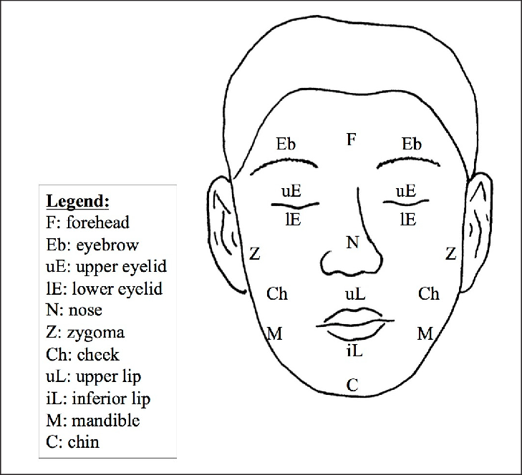

**Figure 1**. Modified MCFONTZL classification of facial lacerations [9]

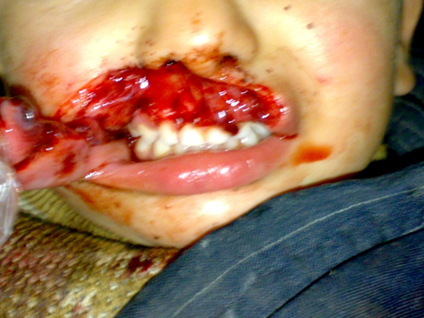

**Figure 2**. The upper lip full-thickness wound extending to the right external nares.

Furthermore, the wound extended few centimeters in the right cheek causing full thickness tissue disruption involving the continuity of the right Stenson’s duct (Figure 3). No signs of airway obstruction with no foreign bodies detected in the airways. No facial fractures. No active bleeding. No signs of facial nerve affection. No active bleeding.

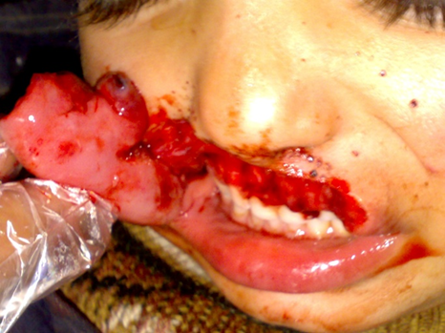

**Figure 3.** The wound extends to the right cheek disturbing the continuity of the right Stenson’s duct.

The clinical findings following the injury are summarized in Table 1.

**Table 1: Summary of Clinical Findings.**

|  |  |
| --- | --- |
| Parameter | Findings |
| Laceration Location | Right upper lip, Right cheek |
| Depth | Full-thickness |
| Bleeding | Controlled |
| Stenson’s Duct Status | Disrupted; salivary leakage observed |
| Neurological Exam | Facial nerve intact |
| Vascular Supply | Adequate tissue perfusion |

The preoperative mangment included using 500 mL of normal saline with diluted povidone-iodine for wound irrigation, in addition to infiltration of 600 IU of Rabies Immune Vaccine (RIG) (20 IU/Kg), around the wound margins and intramuscularly, in addition to administration of 450mg perfalgan IV solution (15 mg/kg) for pain control, IV antibiotics; 900mg Amoxicillin-Clavulanate (30 mg/kg) and metronidazole.

**Operative mangment.**

Undergeneral anesthesia with endotracheal intubation, local infiltration of (2%) lidocaine solution with epinephrine (1:100,000) was done across the wound edges seeking hemostasis before trimming of the wound.

http://www.ejomr.org/JOMR/archives/2014/4/e5/v5n4e5ht.htm J Oral Maxillofac Res 2014 (Oct-Dec) | vol. 5 | No 4 | e5 | p.5

(page number not for citation purposes)

JOURNAL OF ORAL & MAXILLOFACIAL RESEARCH Roccia et al.

in HF falls (Figure 5).

In total, 114 patients (20.5%) presented with

associated injuries, which were mainly orthopaedic

(especially involving the limbs), followed by

neurosurgical and thoracic (particularly the costal

bones) (Table 2). Overall, 80% of the patients with HF

Figure 4. Modied MCFONTZL classication of facial lacerations

http://www.ejomr.org/JOMR/archives/2014/4/e5/v5n4e5ht.htm J Oral Maxillofac Res 2014 (Oct-Dec) | vol. 5 | No 4 | e5 | p.5

(page number not for citation purposes)

JOURNAL OF ORAL & MAXILLOFACIAL RESEARCH Roccia et al.

in HF falls (Figure 5).

In total, 114 patients (20.5%) presented with

associated injuries, which were mainly orthopaedic

(especially involving the limbs), followed by

neurosurgical and thoracic (particularly the costal

bones) (Table 2). Overall, 80% of the patients with HF

Figure 4. Modied MCFONTZL classication of facial lacerations

http://www.ejomr.org/JOMR/archives/2014/4/e5/v5n4e5ht.htm J Oral Maxillofac Res 2014 (Oct-Dec) | vol. 5 | No 4 | e5 | p.5

(page number not for citation purposes)

JOURNAL OF ORAL & MAXILLOFACIAL RESEARCH Roccia et al.

in HF falls (Figure 5).

In total, 114 patients (20.5%) presented with

associated injuries, which were mainly orthopaedic

(especially involving the limbs), followed by

neurosurgical and thoracic (particularly the costal

bones) (Table 2). Overall, 80% of the patients with HF

Figure 4. Modied MCFONTZL classication of facial lacerations

Stenson’s Duct Repair with Stenting: The proximal and distal ends of Stenson’s duct were exposed and its continuity was restored using a silastic stent connecting both distal and proximal portions of the transected duct and sutured throughout using 5-0 nylon sutures allowing free salivary drainage (Figure 4).

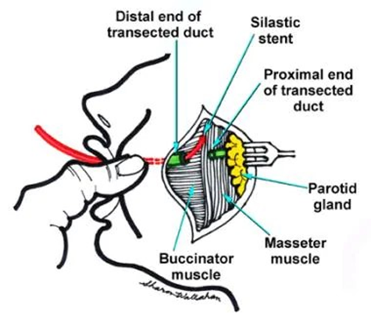

**Figure 4**. Stenson’s Duct Repair with Stenting [10].

The edges of the wound were carefully approximated geometrically, trimmed and sutured in layers using absorbable sutures Vicryl® 3-0, which led to the establishment of an appropriate vermilion border (Figure 5).

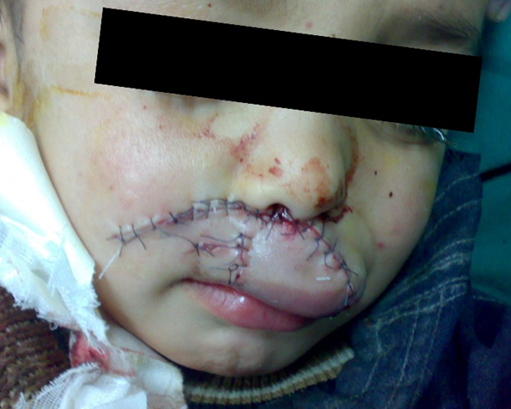

**Figure 5**. Post-operative repair.

Operative-time: 45 minutes.

**Results**

The patient started oral feeding few hours postoperatively, with no complications regarding cosmetic, functional aspects and no salivary complications. The patient was discharged on the 6th post-operative day.

During the follow-up:

The patient continued his RIG vaccinations poster doses.

Cosmetic, anatomical and functional aspects have been successfully restored, in addition to prevention of salivary complications; oral dryness and infection, and salivary fistula. No complications were reported during both postoperative hospitalization and follow-up periods.

The patient showed no complications regarding speech, masticatory functions or salivary complications.

**Discussion**

Facial injuries from animal bites are a frequent reason for patients to go to emergency rooms. The majority of patients are children under the age of ten.  
The perioral area is the primary site, with the nose and ears coming in second and third. Both local flap reconstruction and wound infection are most likely to occur in cheek wounds.

Increased rates of infection are not implied by oral cavity perforation wounds. For wounds of Lackmann class II or above, we advise prophylactic antibiotic use with amoxicillin, clavulanic acid, and wound drains. In terms of infection rates and aesthetic results, primary closure of the wounds appears to be the preferred course of therapy, if at all possible.

**Conclusion**

The corner stones of succussing our operation, were immediate primary repair of facial soft tissues injuries along with prevention of infection together with restoring the continuity of the disrupted Stenson’s duct.

**Consent**

Patient’s informed written consent was taken to publish her case for academic purpose.

**Ethical approval**

As per international standards or university standards written ethical approval has been collected and preserved by the authors.

**Disclaimer (Artificial intelligence)**

Authors hereby declare that NO generative AI technologies such as Large Language Models (ChatGPT, COPILOT, etc.) and text-to-image generators have been used during the writing or editing of this manuscript.

**References**

1. Benjamin B, Lukasz K, Larry K, Kyle K, Hans P. A Unique of Rhizobium radiobacter Peritoneal Dialysis Catheter-related Peritonitis from a Cat Bite. *American Journal of Medical Case Reports*. 2018;6(6):103-105. doi: 10.12691/ajmcr-6-6-1.
2. Ali S, Ali S. Dog bite injuries to the face: A narrative review of the literature. *World J Otorhinolaryngol Head Neck Surg*. 2022;4;8(3):239-244. doi: 10.1016/j.wjorl.2020.11.001
3. Salem S, Mekhaeel M, Protasov A, Taha N, Arafa M, Salma N. OUTCOMES OF A PEDIATRIC FACIAL FRACTURE RECONSTRICTION. CASE REPORT. [*Archiv Euromedica*](https://www.researchgate.net/journal/Archiv-Euromedica-2199-885X?_tp=eyJjb250ZXh0Ijp7ImZpcnN0UGFnZSI6ImhvbWUiLCJwYWdlIjoicHVibGljYXRpb24iLCJwb3NpdGlvbiI6InBhZ2VIZWFkZXIifX0). 2024;14(6):1-8. doi: [10.35630/2024/14/6.604](http://dx.doi.org/10.35630/2024/14/6.604)
4. Tam B, Matsushima K, Chiba H, Park T, Slocum C, Lam L, Inaba K, Demetriades D. Nationwide Analysis of Dog Bite Injuries: Different Age Groups, Different Injury Patterns. *Am Surg.* 2021;87(10):1612-1615. doi:10.1177/00031348211024657
5. Khan K, Horswell B, Samanta D. Dog-Bite Injuries to the Craniofacial Region: An Epidemiologic and Pattern-of-Injury Review at a Level 1 Trauma Center. *J Oral Maxillofac Surg.* 2020;78(3):401-413. doi: 10.1016/j.joms.2019.11.002.
6. Chen T, Karim M, Grace ZT, Magdich AR, Carniol EC, Benson BE, Svider PF. Surgical management of facial dog bite trauma: A contemporary perspective and review. *World J Otorhinolaryngol Head Neck Surg*. 2022;26; 9:2:123-130. doi: 10.1002/wjo2.75
7. Nehru S, Thangaraju P, Cibee N, Velmurugan H. Dog Bite Injury: Rusk Became a Risk - A Case Report. *Infect Disord Drug Targets.* 2024;24:6:e250124226174. doi: 10.2174/0118715265277314231211045515
8. Sameh S, Mekhaeel Sh, Protasov V, Taha N, Elshliby A. Management of Pediatric Fracture Mandible by Closed Reduction Technique: A Case Report. *Asian Journal of Case Reports in Surgery*. 2025;8(1):119-26. doi.org/10.9734/ajcrs/2025/v8i1609
9. Schultz B, Sosin M, Nam A, Mohan R, Zhang P, Khalifian S, Vranis N, Manson PN, Bojovic B, Rodriguez ED. Classification of mandible defects and algorithm for microvascular reconstruction. *Plast Reconstr Surg.* 2015;135(4):743e-754e. doi: 10.1097/PRS.0000000000001106
10. <https://www.researchgate.net/publication/271591965/figure/fig4/AS:392314875858958@1470546563750/Modified-MCFONTZL-classification-of-facial-lacerations-24.png>
11. <https://emedicine.medscape.com/article/868651-treatment?form=fpf>