***Case report***

**Unexpected Foreign Body Mimicking Anastomotic Stricture After Neonatal Jejunal Atresia Repair: A Case Report**

**ABSTRACT**

**Aims:** Proximal small bowel atresia is a rare congenital condition that requires early surgical correction. Postoperative complications such as anastomotic strictures and adhesive obstructions are well-documented; however, foreign body-induced obstruction at an anastomotic site is rare. This case highlights an unusual etiology of bowel obstruction in a young child with a history of jejunal atresia repair, emphasizing the need to consider uncommon causes when evaluating persistent gastrointestinal symptoms.

**Case Presentation:** We report a case of a 3-year-old girl presenting with abdominal distension and sub-occlusive symptoms, characterized by stool cessation but continued gas passage. Her medical history included neonatal surgery for complete jejunal atresia. Imaging studies suggested a possible anastomotic stricture, but definitive diagnosis remained unclear. Exploratory laparotomy revealed extensive adhesions and a localized obstruction at the previous anastomotic site, caused by a calcified date pit. The foreign body was successfully removed via enterotomy, and the anastomotic site was confirmed to be patent. The patient recovered uneventfully, with resolution of obstructive symptoms.

**Discussion:** While anastomotic strictures are a well-recognized complication following small bowel atresia repair, foreign body obstruction at an anastomotic site is uncommon, especially in young children. This case underscores the importance of considering alternative diagnoses when clinical and radiological findings are inconclusive.

**Conclusion:** This report highlights the need for thorough evaluation in cases of unexplained bowel obstruction post-surgery. When standard diagnostic modalities fail to provide clarity, exploratory surgery remains a crucial tool for identifying rare causes of obstruction and guiding appropriate management.

Keywords: Anastomotic stricture; foreign body; Jejunal atresia; Postoperative complications; Child; Case report

**INTRODUCTION**

Proximal small bowel atresia is a rare congenital anomaly that necessitates prompt surgical correction in the neonatal period (Kulkarni, 2010). Postoperative complications, including adhesive intestinal obstruction, anastomotic leakage, and stricture, are well-documented (Kumaran et al., 2002). However, this case is notable for an unusual etiology of intestinal obstruction, specifically due to an impacted foreign body at the anastomotic site. This finding highlights the need for clinicians to consider atypical causes of obstruction in patients with a history of bowel surgery, as the clinical presentation of an anastomotic stricture can occasionally be mimicked by other, more atypical, pathologies.

**PRESENTATION OF CASE**

A 3-year-old girl presented to the emergency department of our tertiary hospital with progressive abdominal distension and sub-occlusive syndrome over three days. Her symptoms included cessation of stool passage, while gas passage persisted. Her past medical history was significant for neonatal surgery on the second day of life to correct complete jejunal atresia. Despite early surgical intervention, she experienced recurrent gastrointestinal symptoms indicative of chronic bowel obstruction, necessitating multiple evaluations and hospital admissions.

She was admitted following a recent episode of marked abdominal distension (Fig. 1) and sub-occlusive syndrome for further diagnostic assessment and management. Although she remained hemodynamically and neurologically stable, her persistent abdominal distension and pallor warranted further investigation. The initial differential diagnosis included anastomotic stricture, adhesion-related obstruction, and less common etiologies such as foreign body ingestion. An abdominal plain radiograph revealed air-fluid levels in the stomach, duodenum, and proximal jejunum, with reduced air in the remainder of the abdomen (Fig. 2). Ultrasound demonstrated a significant disparity in bowel caliber, with marked dilation of the stomach and proximal bowel loops, but no obvious site of obstruction. A gastrointestinal contrast study showed delayed passage of contrast through the proximal intestine, raising suspicion for an anastomotic stricture (Fig. 3). Given the diagnostic uncertainty, an exploratory laparotomy was indicated.

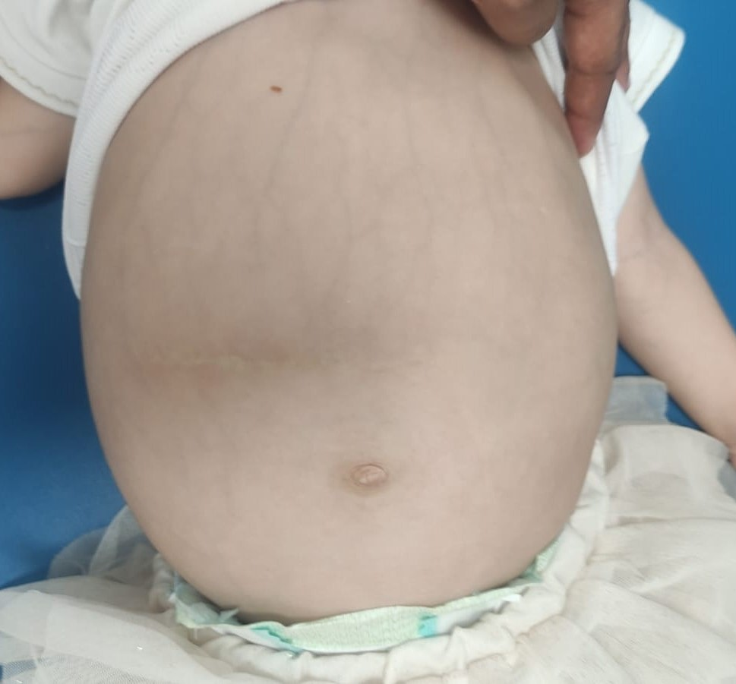

**Fig. 1. Clinical image showing abdominal distension.**

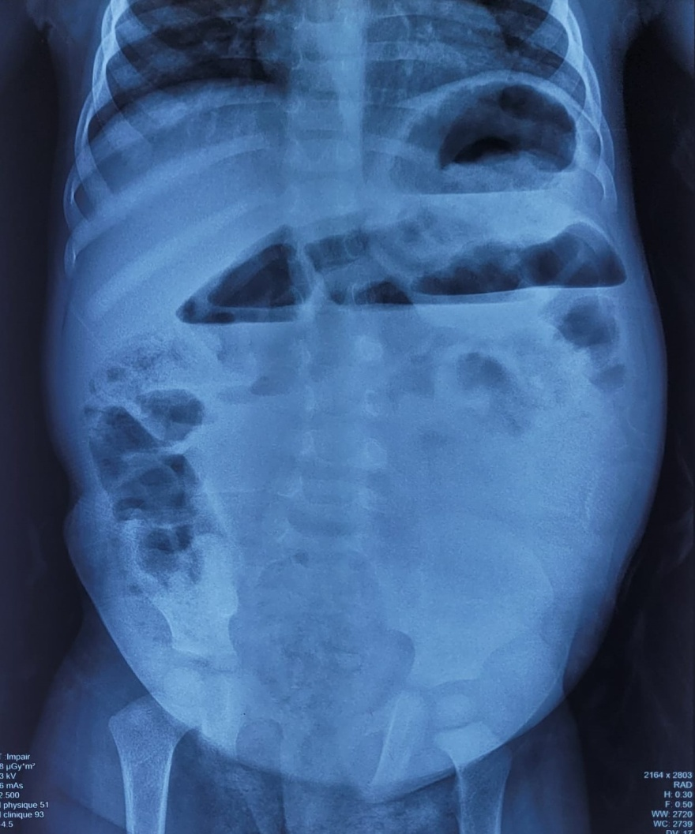

**Fig. 2. Plain abdominal radiograph showing air-fluid levels in the stomach, duodenum, and proximal jejunum, with decreased air in the rest of the abdomen.**

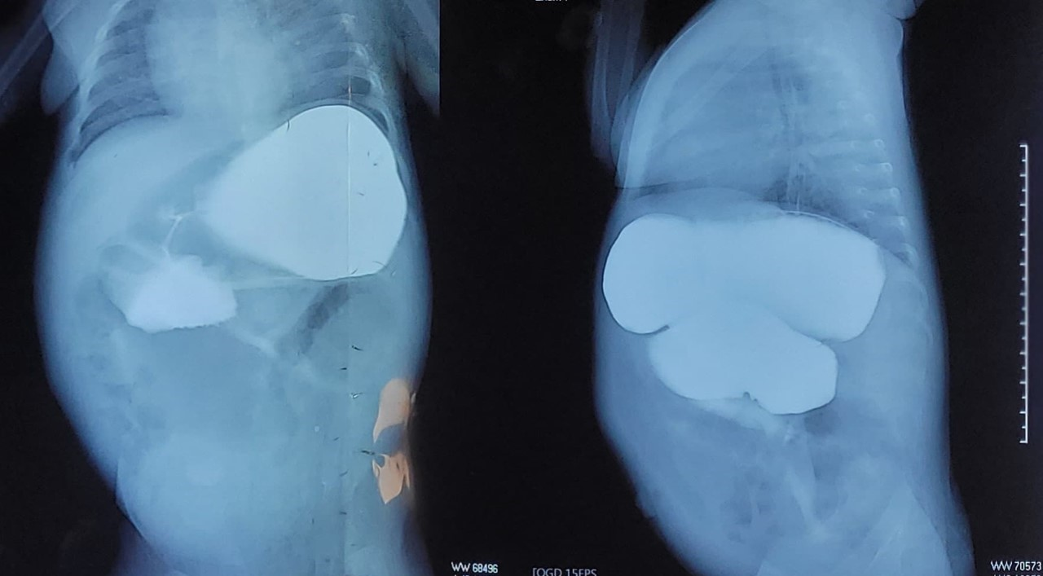

**Fig. 3. Gastrointestinal contrast study demonstrating delayed passage of contrast through the proximal intestine.**

The patient was admitted to the operating room. Under general anesthesia, a right-sided transverse laparotomy was performed through the previous incision site. Upon entry into the peritoneal cavity, extensive adhesions between the parietal wall and intestinal loops were observed, along with multiple fibrous bands tethering the bowel. Careful adhesiolysis and debridement were carried out to release the small intestine. A markedly dilated proximal intestinal loop was identified (Fig. 4A), suggesting obstruction at the previous anastomotic site. Further exploration revealed an unexpected cause: an oval, hard foreign body was lodged at the anastomosis. The distal bowel loops appeared non-dilated, indicating a localized obstruction. An enterotomy was performed to extract the foreign body, which was later identified as a calcified date pit (Fig. 4B, C). An 18 Fr suction catheter was passed through the anastomosis without resistance, confirming its patency. The enterotomy site was then closed with interrupted sutures. Postoperatively, the patient recovered uneventfully, with complete resolution of obstructive symptoms. Oral feeding was reintroduced gradually, and she remained asymptomatic at follow-up.

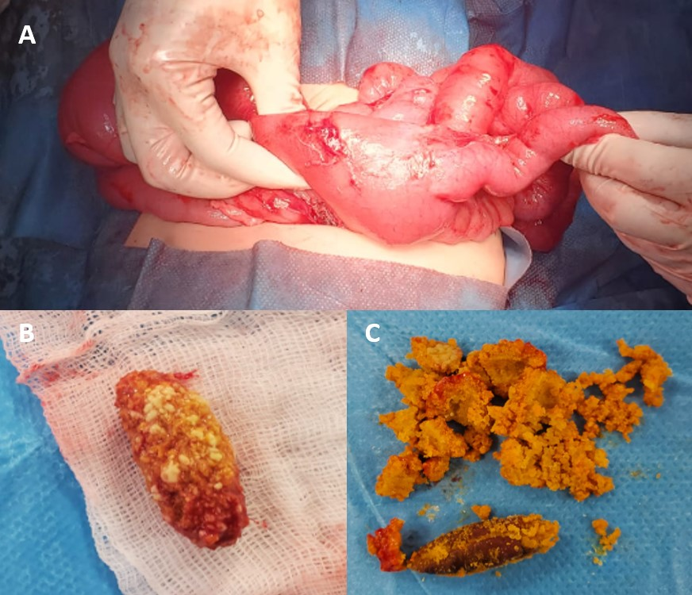

**Fig. 4. Surgical findings showing: (A) Dilation of the first intestinal loop. (B) Foreign body extraction: a calcified date pit. (C) The date pit after decalcification.**

**DISCUSSION**

This case highlights a rare but clinically significant scenario in which an obstructing foreign body, rather than an anastomotic stricture, was the underlying cause of bowel obstruction in a patient with a history of proximal small bowel atresia. While anastomotic strictures are a well-recognized complication following bowel surgery, this case underscores the importance of considering alternative etiologies when standard diagnostic and therapeutic approaches fail to resolve symptoms.

Proximal small bowel atresia, a challenging congenital condition, is typically managed surgically in the neonatal period (Oh, 2023). Postoperative complications, including anastomotic strictures, are common and frequently present with features of bowel obstruction, as well documented in the literature (Yeung et al., 2016). However, the contribution of foreign bodies to obstruction at anastomotic sites, such as in our case, is an uncommon occurrence. While such obstructions have been reported in older children and adults, they remain infrequent in neonates and young children (Griffiths and Glancy, 2020).

Initially, the differential diagnosis included anastomotic stricture, adhesion-related obstruction, and less common causes such as foreign body impaction. Initial imaging suggested a delayed contrast passage at the anastomotic site, raising suspicion for a stricture. However, the presence of extensive adhesions and a non-dilated distal bowel loop suggested a localized obstruction, necessitating further evaluation. This case highlights the limitations of non-invasive diagnostic methods and emphasizes the role of surgical exploration in cases where imaging findings are inconclusive.

Exploratory laparotomy proved to be a crucial step in identifying and managing the obstruction. The discovery of a date lodged at the anastomotic site confirmed that the foreign body, rather than a stricture, was responsible for the obstruction. The patient’s subsequent uneventful recovery illustrates the efficacy of prompt surgical intervention in resolving an unusual cause of obstruction and reinforces the principle that even less common etiologies must be considered in cases of unexplained bowel obstruction, particularly in patients with a history of congenital intestinal anomalies.

Despite the clinical value of this report, its limitations include the single-case design, lack of long-term follow-up, and the rarity of the specific foreign body encountered. These factors restrict the generalizability of the findings. Nonetheless, this report emphasizes the need for heightened clinical suspicion and comprehensive evaluation in similar cases. Further research and additional case series are warranted to better characterize the frequency of foreign body-induced obstruction in pediatric patients with a history of proximal small bowel atresia.

**CONCLUSION**

This case report highlights a rare but clinically significant cause of bowel obstruction in a patient with a history of proximal small bowel atresia. While anastomotic strictures are a well-documented postoperative complication, this case underscores the importance of considering alternative etiologies, including foreign body obstruction, particularly when standard diagnostic and therapeutic approaches fail to resolve symptoms.

**COMPETING INTERESTS**

Authors have declared that no competing interests exist.

**CONSENT**

All authors declare that ‘written informed consent was obtained from the patient’s parents (legal guardian) for publication of this case report and accompanying images. A copy of the written consent is available for review by the Editorial office/Chief Editor/Editorial Board members of this journal.

**ETHICAL APPROVAL**

It is not applicable for case reports.

**REFERENCES**

Griffiths, S., Glancy, D.G., 2020. Intestinal obstruction. Surgery (Oxford) 38, 43–50. https://doi.org/10.1016/j.mpsur.2019.10.014

Kulkarni, M., 2010. Duodenal and small intestinal atresia. Surgery (Oxford) 28, 33–37. https://doi.org/10.1016/j.mpsur.2009.10.004

Kumaran, N., Shankar, K.R., Lloyd, D.A., Losty, P.D., 2002. Trends in the Management and Outcome of Jejuno-Ileal Atresia. Eur J Pediatr Surg 12, 163–167. https://doi.org/10.1055/s-2002-32726

Oh, C., 2023. Jejunoileal Atresia: A Contemporary Review. Adv Pediatr Surg 29, 89. https://doi.org/10.13029/aps.2023.29.2.89

Yeung, F., Tam, Y.H., Wong, Y.S., Tsui, S.Y., Wong, H.Y., Pang, K.K.Y., Houben, C.H., Mou, J.W.C., Chan, K.W., Lee, K.H., 2016. Early Reoperations after Primary Repair of Jejunoileal Atresia in Newborns. J Neonat Surg 5, 42. https://doi.org/10.21699/jns.v5i4.444