**Case report**

**CORPORA AMYLACEA IN WARTHIN’S TUMOR: A RARE HISTOPATHOLOGICAL FINDING**

**ABSTRACT-** This case report presents a rare instance of Warthin’s tumor with presence of corpora amylacea. While Warthin’s tumor is a common benign neoplasm of the parotid gland, the occurance of corpora amylacea is exceedingly rare. This report aims to shed light on the histopathological characteristics, potential etiologies, and clinical significance of corpora amylacea in Warthin’s tumor.

**KEYWORDS**- Warthin’s tumor, Papillary cystadenoma lymphomatosum, Corpora amylacea

## INTRODUCTION

Warthin’s tumor, also known as papillary cystadenoma lymphomatosum, was first reported by Hildebrand in 1895 as a variant of lateral cervical cyst. It typically presents as a slow-growing, painless mass in the parotid region [1]. Histopathologically, it is characterized by double-layered oncocytic epithelium with a papillary and cystic pattern. The presence of round, acellular, lamellated eosinophilic structures within cystic spaces, known as corpora amylacea, is an exceptionally rare finding [2]. These structures exhibit amyloid-like characteristics histochemically and have been reported only in a handful of cases in literature [3].

**CASE PRESENTATION**

A 52-year-old male patient reported to OPD with the chief complaint of swelling over right parotid region for the past 7 months (Chart. 1). The swelling was insidious in onset and progressively increased in size. There was no history of pain, pus discharge, paraesthesia or halitosis during the course of enlargement. The patient was a chronic smoker since 32 years with a frequency of 6-8 bidis per day.

On extraoral examination, a single swelling of dimension 4.9×3.3 cm was palpated in right preauricular area involving the submandibular lymph nodes. The swelling was painless, non- pulsatile and non- reducible. The right ear lobe was raised, lymph nodes were palpable and facial asymmetry was evident. Intraoral examination revealed no abnormalities and mouth opening was adequate.

Hematological and biochemical findings were within normal limits. MRI neck revealed large lobulated cystic lesion appearing hypotense on T1, hypertense on T2 in superficial lobe of right parotid gland. USG neck revealed a mass of size 4×3×5.3 cm over right parotid region.

**MACROSCOPIC FINDINGS**

The gross examination of the excised mass revealed a creamish brown colored, ovoid shaped lesion measuring about 7×4×3.5 cm. The cut section showed a large circumscribed, encapsulated colloid mass, yellowish tan in color with a soft consistency measuring about 4×3.5×3 cm (Fig. 2A).

Another small encapsulated lesion was present 3 cm away from the first lesion measuring about 2×1.5×1.5 cm.

**MICROSCOPIC FINDINGS**

Multiple sections from the specimen showed a well encapsulated tumor with varying proportion of papillary cystic architecture lined by bilayered oncocytic epithelium (Fig. 2C). The epithelial cells comprised of inner columnar and outer cuboidal cells with granular eosinophilic cytoplasm and round to oval nucleus (Fig. 3D). The intervening stroma within the papillary structures showed dense lymphocytic infiltrate with germinal centre formation (Fig. 3E). The cystic spaces contained homogeneous eosinophilic material with few concentric lamellar condensed deposits resembling corpora amylacea (Fig. 3F). The surrounding glandular tissue appeared normal in morphology.

**DISCUSSION**

Corpora amylacea are round, eosinophilic, laminated structures typically composed of glycoproteins and polysaccharides. They are commonly observed in aging tissues or degenerative diseases but are rare in Warthin's tumor [1]. Theories regarding their formation include degenerative processes, ductal obstruction, and secretory stasis [4]. Their presence in Warthin’s tumor could be attributed to the cystic and oncocytic nature of the lesion, promoting secretory stasis. The clinical significance of corpora amylacea remains uncertain, but their identification is crucial to avoid misdiagnosis with amyloid or other calcified bodies.

Several studies have discussed corpora amylacea in various organs, but its occurrence in salivary gland neoplasms, particularly Warthin’s tumor, remains rare [1-3]. This rarity contributes to diagnostic challenges. Additionally, its histochemical similarity to amyloid poses potential diagnostic pitfalls, necessitating awareness among pathologists. The review of literature also suggests a possible link between chronic inflammation and corpora amylacea formation, which could be relevant given the patient’s history of chronic smoking [4].

In summary, previous studies have reported the presence of round, laminated eosinophilic structures, known as corpora amylacea, in the cytology and biopsy specimens of Warthin’s tumor—structures more commonly associated with the prostate (5). In the present case, these eosinophilic structures appear as concentric lamellar deposits, further emphasizing the tumor’s diagnostic specificity.

**Data Availability** No datasets were generated or analysed during the current study.

**Compliance with Ethical Standards**

**Conflicts of Interest:** No conflict of interest

**Research involving human participants and/or animals**: Does not contain any study with human participants or animals performed by any of the authors.

**Informed Consent**: Written informed consent was obtained from the patient.

**REFERENCES**

1. David R, Buchner A. Corpora amylacea in adenolymphoma (Warthin's tumor). Am J Clin Pathol. 1978;69(2):173-175.

2. Singh AP, Tandon A, Chowdhary A, Mujoo S. Adenolymphoma: A probing entity: Case report and review. J Nat Sci Biol Med. 2013;4(2):492-496.

3. Eveson JW, Cawson RA. Warthin's tumor (cystadenolymphoma) of salivary glands: A review of 278 cases. Oral Surg Oral Med Oral Pathol. 1986;61(3):256-262.

4. Kolary-Siekierska K, Jalocha-Kaczka A, Niewiadomski P, Milonski J. Warthin tumors – risk factors, diagnostics, treatment. Nowotwory J Oncol. 2024;74:99-104.

5. Flezar M, Pogacnik A. Warthin’s tumor: unusual vs. common morphological findings in fine needle aspiration biopsies. Cytopathology; 2002, 13, 232- 241.

Figure 1- Clinical image demonstrating swelling of right parotid region

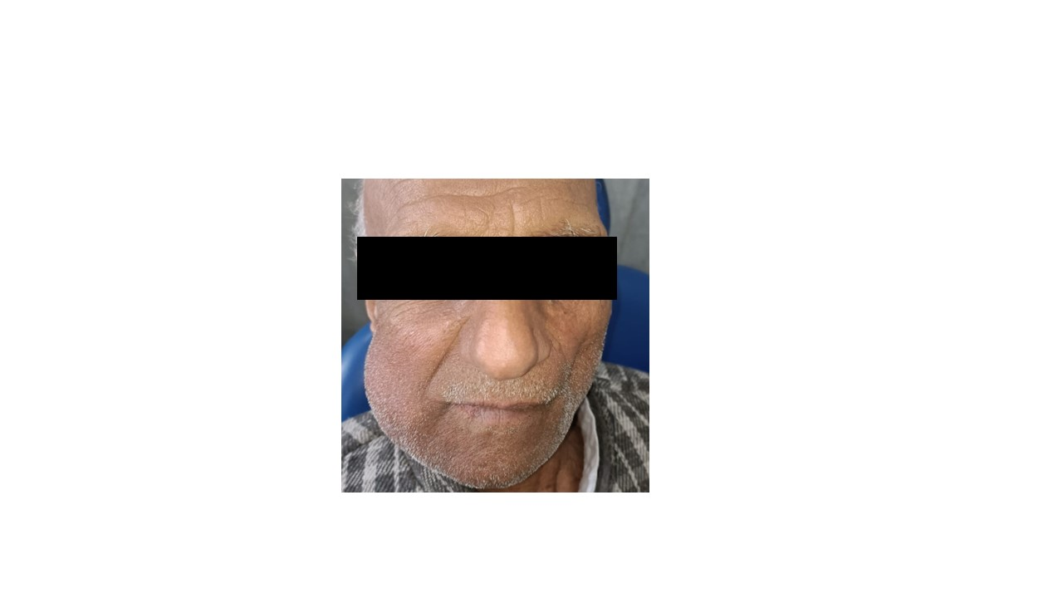

Figure 2: A) Inked cut section of the gross specimen shows a large circumscribed encapsulated colloid mass, yellowish tan in colour and glistening with soft consistency measuring approximately 4×3.5×3 cm, B) Hand draw illustration of Warthin’s tumor, C) Photo micrograph a panoramic view showing well encapsulated tumor with papillary architecture of tumor lined by bilayered oncocytic epithelial cells. The cystic spaces contain homogeneous eosinophilic material with stroma showing lymphocytic infiltrate. (H&E 40X)

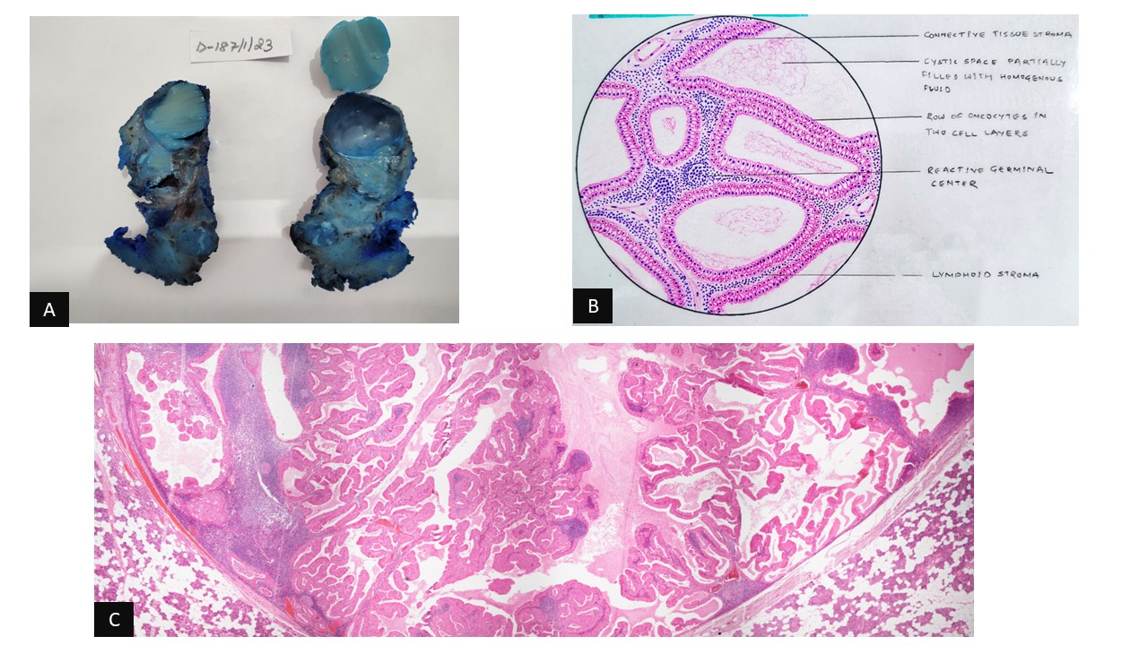

Figure 3: D) Photo micrograph showing bilayered oncocytic epithelial cells lining the papillary structures. Stroma show lymphocytic infiltrates. (H&E 200X), E) Photo micrograph showing well encapsulated tumor with papillary architecture of tumor lined by bilayered oncocytic epithelial cells. The cystic spaces contain homogeneous eosinophilic material with stroma showing lymphocytic infiltrate. (H&E 40X), F) Photo micrograph showing homogeneous eosinophilic material with presence of concentric lamellar structures suggestive of corpora amylacea. (H&E 400X), G) Photo micrograph showing bilayered oncocytic epithelial cells lining the papillary structures. (PTAH 200X)

