***Case report***

**A Rare Intruder of the Biliary Tract - Gallbladder Ascariasis**

**Abstract**

Gallbladder ascariasis is a rare yet significant condition caused by the migration of *Ascaris lumbricoides* into the biliary system. This case report describes a 54-year-old male presenting with persistent upper abdominal pain and perianal itching. Imaging studies, including ultrasonography and MRCP, confirmed the presence of gallbladder ascariasis. Despite initial medical management with Albendazole, symptoms persisted, necessitating laparoscopic cholecystectomy. Postoperative findings revealed fragments of *Ascaris lumbricoides* within the gallbladder. The patient experienced complete resolution of symptoms following surgery and continued anthelmintic therapy. This report underscores the importance of considering gallbladder ascariasis in endemic regions when evaluating unexplained abdominal pain. Early diagnosis through imaging and appropriate management, including surgical intervention, when necessary, can prevent severe complications.

**Keywords**

Gallbladder ascariasis, *Ascaris lumbricoides*, ultrasonography, laparoscopic cholecystectomy, anthelmintic therapy.

**Introduction**

Ascariasis is a common helminthic infection caused by *Ascaris lumbricoides* [1]. It is a significant global health issue, particularly in tropical and subtropical regions. While the parasite usually resides asymptomatically in the jejunum, its migration into the biliary tract can lead to several complications. Gallbladder ascariasis constitutes only around 2% of biliary ascariasis cases [2]. Understanding the management of gallbladder ascariasis is crucial due to its potential to cause severe complications if not treated promptly, including biliary colic, cholecystitis, and obstructive jaundice [3].

Despite its clinical significance, there is limited research on the optimal management strategies for gallbladder ascariasis. Our report aims to address this gap by providing insights into the surgical and non-surgical management of gallbladder ascariasis, especially in male patients. We found that early surgical intervention combined with appropriate medical therapy results in better outcomes for male patients with gallbladder ascariasis.

**Case Report**

A 54-year-old male presented to the outpatient department of surgery with complaints of persistent dull upper abdominal pain for one month and perianal itching for ten days. There were no associated symptoms such as fever, jaundice, or passage of worms in vomitus or stools. Abdominal examination revealed mild tenderness in the right hypochondrium with no pallor or icterus.

Laboratory investigations showed eosinophilia and alkaline phosphatase levels of 288 IU/L. Ultrasonography of the abdomen was suggestive of a distended gallbladder with an elongated mobile echogenic structure within the gallbladder lumen, with internal echoes suggestive of a parasitic infestation most likely ascariasis. The thickness of the gallbladder wall was normal (Figure 1). Magnetic Resonance Cholangiopancreatography was performed which revealed a curvilinear, tubular, hypointense structure within the gallbladder with a maximum thickness of 4 mm, suggestive of gallbladder ascariasis (Figure 2).

The patient was started empirically on Albendazole 400 mg twice a day for one week; however, the pain persisted, and the patient was taken up for laparoscopic cholecystectomy (Figure 3). Examination of the extracted gallbladder showed fragments of *Ascaris lumbricoides* worms and bile (Figure 4). Albendazole was continued for two more weeks, and complete resolution of symptoms was noted on follow-up.

**Discussion**

Ascariasis is one of the major diseases prevalent in tropical and subtropical countries [4]. It is transmitted through the ingestion of faecal material containing eggs. The parasite primarily resides in the jejunum but can migrate to various organs, including the liver, heart, lungs, and biliary system. Gallbladder ascariasis remains a rare diagnosis due to the anatomical barriers posed by the narrow and tortuous structure of the cystic duct [5]. Chronic abdominal pain without other typical symptoms underscores the importance of considering gallbladder ascariasis in endemic regions. The clinical symptoms of gallbladder ascariasis are nonspecific, often presenting as vague abdominal pain, fever, or vomiting.

Ultrasonography is the most sensitive diagnostic investigation due to its accessibility and ability to visualize live worms in real time. It plays a critical role in diagnosis, showing characteristic findings such as curvilinear tubular structures with a "triple sign" or the "belly dance" movement of worms on ultrasound [6].

The established treatments for biliary ascariasis include anthelmintic drug therapy, endoscopic extraction, and surgical removal [7]. Anthelmintic drug therapy is typically administered before or just after surgical intervention.

Although conservative management is an option, it is ineffective in cases where the worm is deceased, or there are concomitant stones or strictures that impede the worm's return to the duodenum. In such cases, surgical intervention via laparoscopic cholecystectomy is recommended, particularly in cases of recurrent symptoms, inflammation, or the presence of a dead worm, to prevent complications such as abscess formation and biliary strictures [8]. Endoscopic procedures are especially effective in managing ascariasis in the bile duct. However, they are ineffective in managing gallbladder ascariasis.

**Conclusion**

Gallbladder ascariasis, though rare, should be included in the differential diagnosis for patients presenting with unexplained upper abdominal pain, particularly in endemic areas. Ultrasonography is invaluable for diagnosis. While conservative therapy may be attempted, cholecystectomy remains the definitive treatment for symptomatic cases, followed by deworming therapy.

**References**

1. Maguire JH. Intestinal nematodes (roundworms). Principles and practice of infectious diseases. 2005.
2. Khuroo MS, Zargar SA, Mahajan R. Hepatobiliary and pancreatic ascariasis in India. The Lancet. 1990 Jun 23;335(8704):1503-6.
3. Sultan Khuroo M, Ali Zargar S, Nabi Yattoo G, Yousuf Dar M, Javid G, Ahmad Khan B, Iqbal Boda M, Mahajan R. Sonographic findings in gallbladder ascariasis. Journal of clinical ultrasound. 1992 Nov;20(9):587-91.
4. Angcual ED, Aquino JP, Basila AV, Klyne H, Buenavista R, Comilang AJ, Cortez RJ, Flordelis ML, Hermida EJ, Lubiano RA, Villanueva AJ. ASCARIS LUMBRICOIDES: A LITERATURE REVIEW.
5. Bouree P, Barthod F, Chagnon S. Ascaris in gallbladder: report of a case and review. Journal of the Egyptian Society of Parasitology. 2005 Aug 1;35(2):491-6.
6. Imtiaz WA. Gallbladder ascariasis. Turk J Gastroenterol. 2011;22(2):178-82.
7. Yoshihara S, Toyoki Y, Takahashi O, Sasaki M. Laparoscopic treatment for biliary ascariasis. Surgical Laparoscopy Endoscopy & Percutaneous techniques. 2000 Apr 1;10(2):103-5.
8. Shah OJ, Dar MA, Wani NA, Robbani I, Zargar SA. Biliary ascariasis as a cause of post-cholecystectomy syndrome in an endemic area. Digestive surgery. 2004 Jun 18;21(2):108-13.

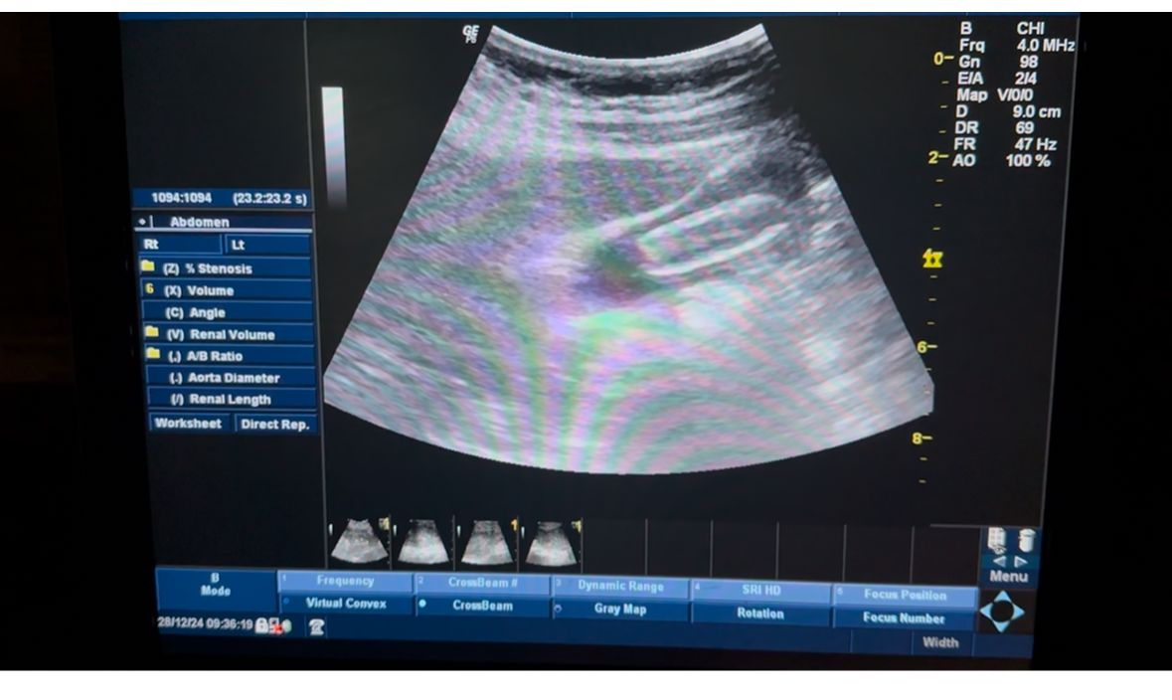

Figure 1 Thickness of the gallbladder wall

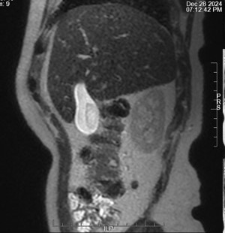

Figure 2 Gallbladder ascariasis

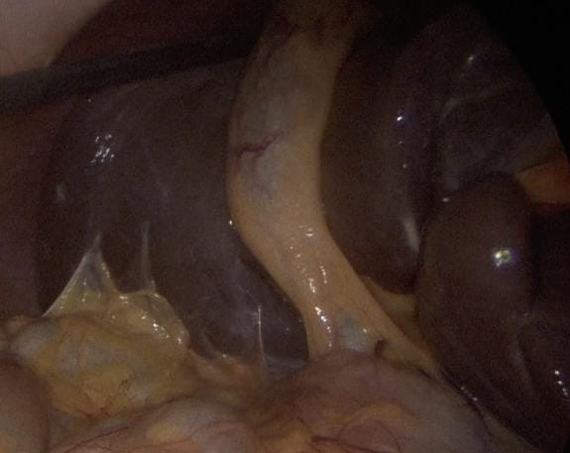

Figure 3 Laparoscopic cholecystectomy

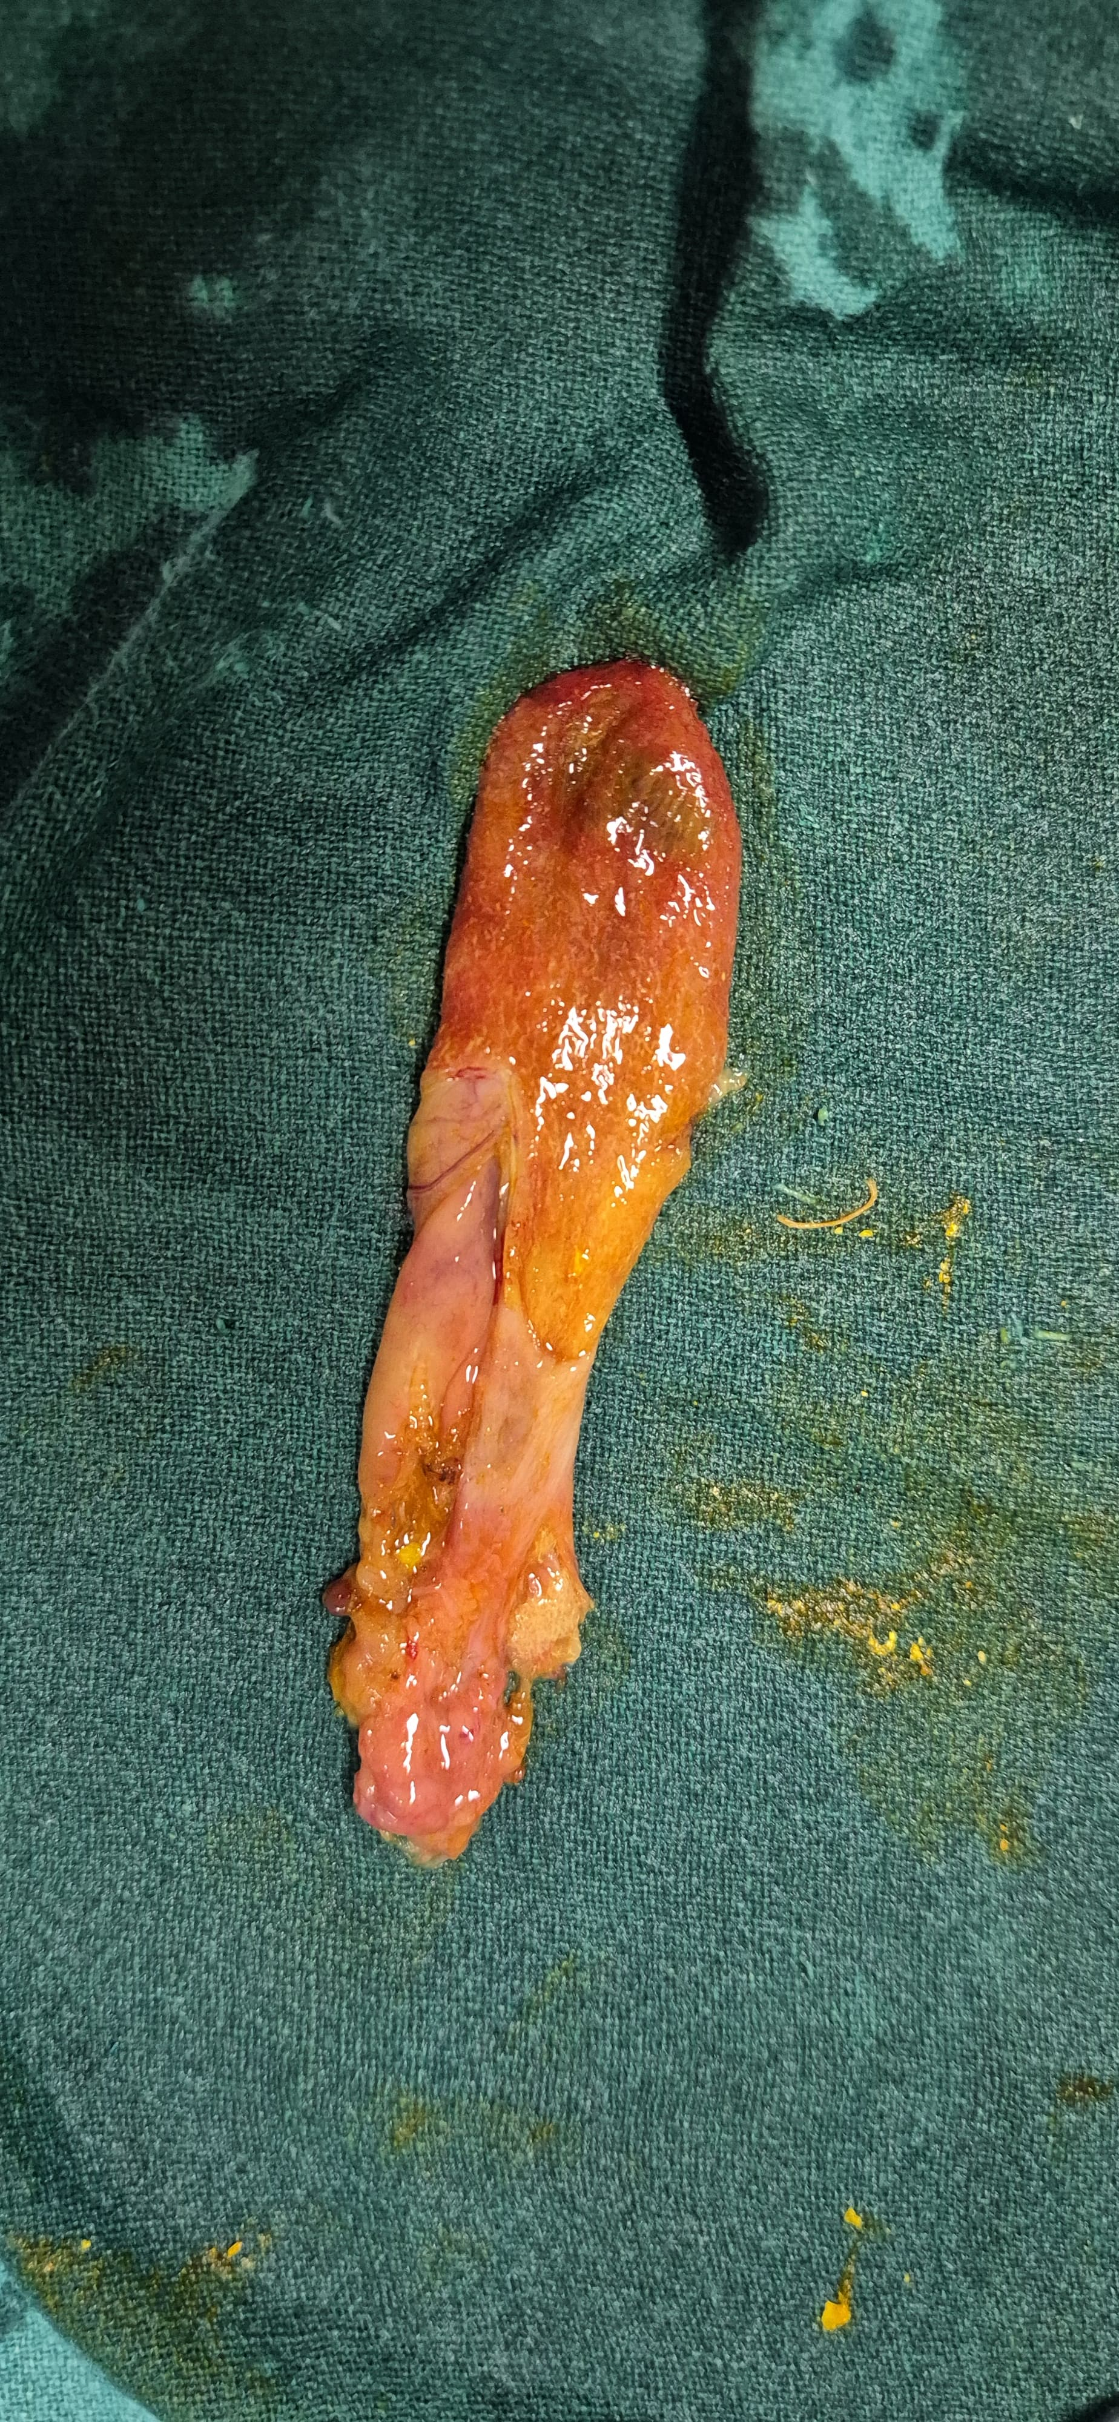

Figure 4 *Ascaris lumbricoides* worms and bile