***Case report***

NAVIGATING THERAPEUTIC CHALLENGES: MANAGEMENT OF CARCINOMA STOMACH WITH INTRALUMINAL METASTASES

ABSTRACT

Gastric cancer is the fifth most common neoplasm and the third most common cause of cancer death. Gastric cancer is metastatic at the time of diagnosis in 33% of cases. But metastases to small bowel and large bowel is rare.51-year-old gentleman with past history of total gastrectomy 10 months back and completed 6 cycles of chemotherapy and 28 fractions of radiotherapy, presented with generalized tiredness, loss of weight and loss of appetite. On evaluation with CECT abdomen, he was found to have multiple polypoidal lesions in small bowel as well as colon. Colonoscopy and biopsy were done from rectosigmoid polypoidal lesion, which proved to be metastatic lesions from gastric carcinoma. Since the lesions were multifocal and did not cause any complete obstruction of the small bowel or colon, no resection was attempted and the patient was sent for palliative chemotherapy. The most common sites of metastasis in gastric carcinoma are liver, peritoneum, lung, and bone. Gastric carcinoma metastazing to intraluminal sites like small bowel and large bowel are rare. The development of intraluminal metastases within a relatively short time frame (one year) suggests an aggressive nature of the disease. Confirmation of recurrence often comes with a grim prognosis, highlighting the challenging nature of managing the disease at this stage. There is no consensus statement regarding the management of cases in which pathological report show isolated tumour cells at margin of specimen rather than truly positive margins as in this case.

BACKGROUND

Although the small intestine accounts for approximately 75% of the length of the gastrointestinal tract and 90% of its mucosal surface area, it remains a rare site for malignancy, representing <2% of all gastrointestinal malignancies(3).The lower incidence of small bowel malignancy may be due to faster transit time compared to colon, causing less exposure to carcinogens. The fluid nature of the small bowel contents may be causing less irritation to the mucosa. Another hypothesis is that pH of the small bowel contents may inhibit carcinogens.(4)

CASE DETAILS

51-year-old male with no known comorbidities, who underwent total gastrectomy about 10 months back, presented with generalized tiredness, loss of weight of about 5 kilograms in past 3 months and loss of appetite. His physical examination revealed a frail, cachectic male with epigastric fullness. A firm mass was palpable in the epigastric region. No other mass was palpable. No left supraclavicular lymph nodes (Virchow’s node) or pelvic peritoneal deposits palpable. Other systemic examinations were within normal limits.

INVESTIGATIONS

Basic blood investigations were done which revealed a haemoglobin value of 10.2 g/dl. His total leukocyte count, renal function tests and liver function tests were within acceptable limits. CECT Abdomen was taken, which showed multiple enhancing wall thickening in sigmoid colon, transverse colon, ascending colon, proximal and distal jejunum. Additionally, there was evidence of distal jejuno-jejunal intussusception without any signs of obstruction. The presence of moderate to gross high-density ascites with scalloping of liver margins was also noted.

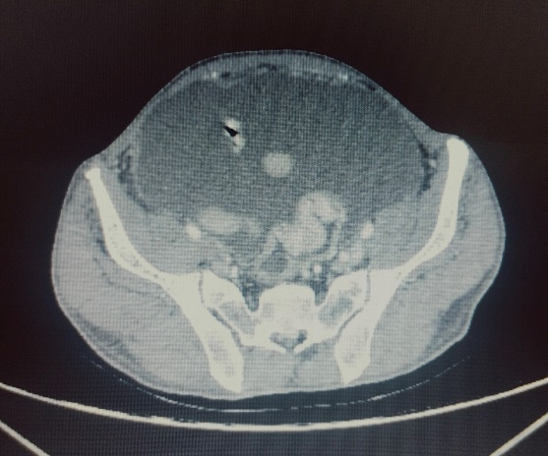 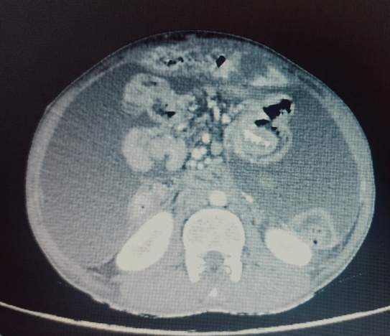

B

A

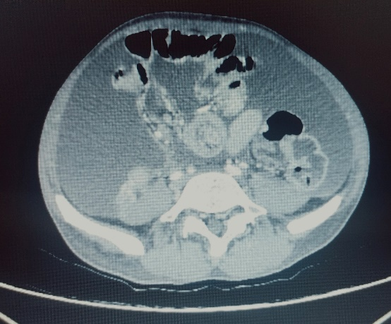 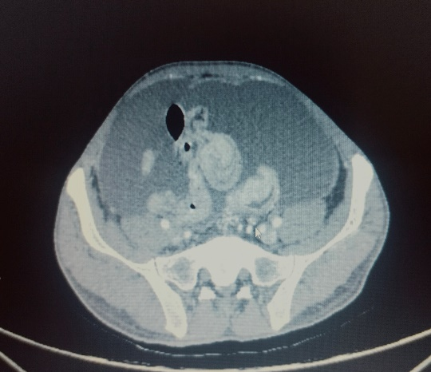

D

C

Fig 1: (A): Enhancing wall thickening rectosigmoid region. (B): Polypoidal lesion in small bowel. (C), (D): Distal jejuno-jejunal intussusception

The radiology and medical gastroenterology services were consulted for recommendations. For confirmation, flexible sigmoidoscopy was done which revealed polypoidal lesions in sigmoid colon- suspicious for metastatic deposits-multiple biopsies were taken.

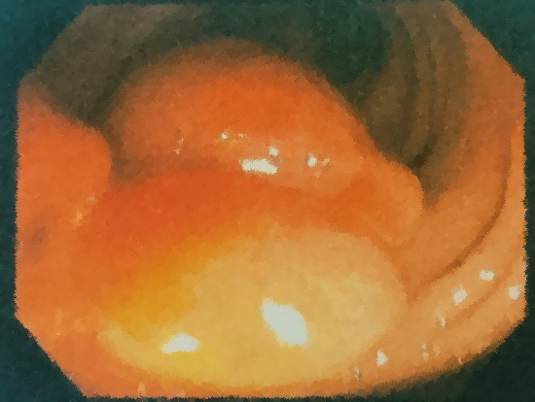 

Fig 2: Colonoscopy: Polypoidal lesions in the sigmoid colon.

The biopsy report came out as consistent with metastases from carcinoma of stomach.

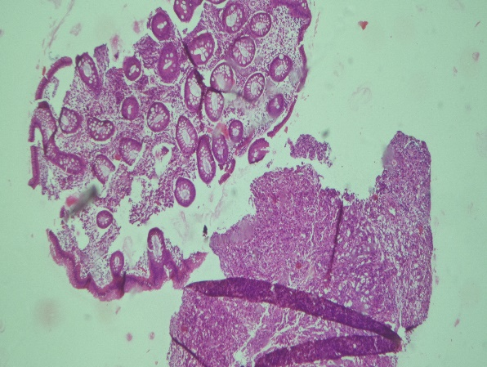

Fig 3: Colonic biopsy showing sheets of neoplastic cells which are poorly cohesive without forming glands (lower right).Normal mucin rich glands on the upper left part of the figure.

***Past history***

10 months back, 50-year-old gentleman presented with complaints of postprandial abdominal discomfort for 3 months. He had history of significant loss of weight and loss of appetite. The patient underwent esophagogastroduodenoscopy which showed linitis plastica of the stomach and grade 2 hiatus hernia.

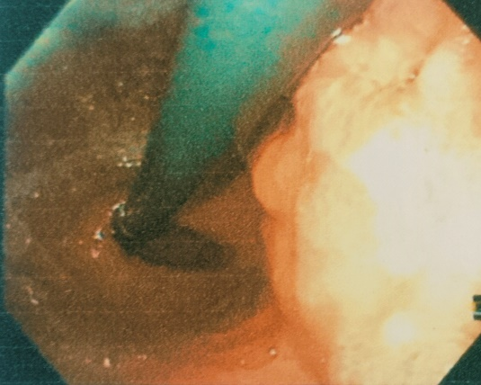 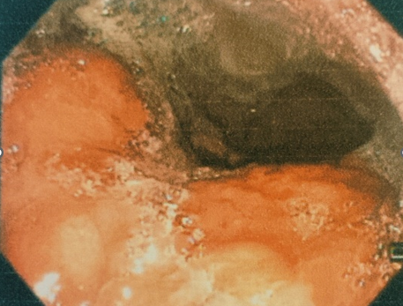

B

A

Fig 4: Upper GI Endoscopy: (A) friable oedematous mucosa starting from cardia. (B): Extending along the lesser curvature.

Multiple areas of the stomach were biopsied given the appearance of linitis plastica. CECT abdomen and pelvis along with HRCT chest was done for staging, which revealed no locoregional lymphadenopathy or metastatic disease.

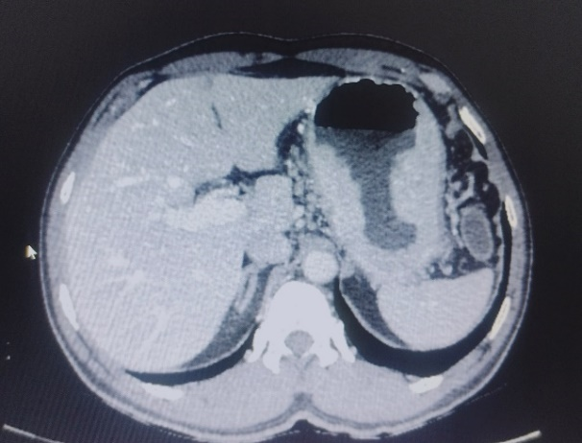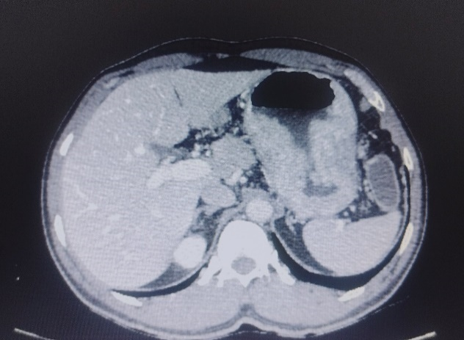

A

B

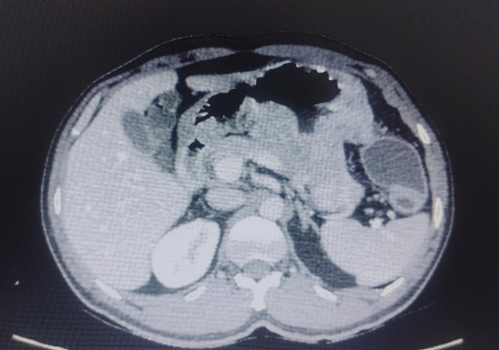

C

Fig 5: CECT Abdomen showing (A) and (B): Tumor involving greater and lesser curvature of stomach.

(C): Doubtful infiltration of tumour to pancreatic body and tail.

After multidisciplinary evaluation, he underwent Staging laparoscopy followed by open total D2 gastrectomy, oesophagojejunostomy and feeding jejunostomy. The histopathology report was consistent with poorly cohesive carcinoma – signet ring cell type involving body, greater curvature, lesser curvature and antrum. Histologic grade was G3. Occasional individual tumour cells were seen extending to subserosal connective tissue margins. Proximal margin was free of neoplasm. Perineural invasion was present. 6 metastatic lymph nodes were present. He was started on adjuvant chemotherapy. He was on regular follow-up postoperatively.

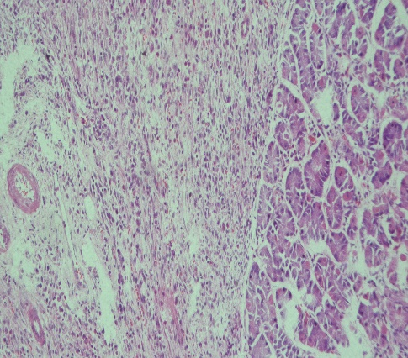 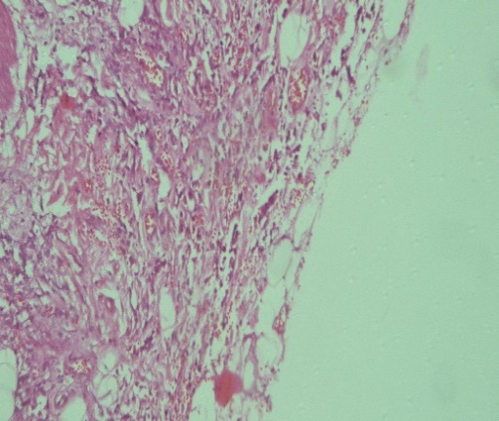

B

A

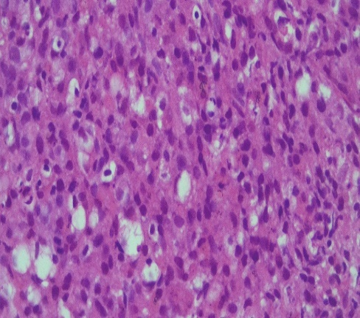

C

Fig 6: (A): Gastric biopsy showing sheets of tumour cells – normal parietal cells on the right. Tumor on the left of the figure - poorly differentiated, arranged as sheets without gland formation.

(B): Occasional tumour cells reaching the resected margin

(C): High power showing tumour cells having moderate eosinophilic cytoplasm, and pleomorphic round hyperchromatic nuclei. Few signet ring cells noted

OUTCOME AND FOLLOWUP

The biopsy report came out as consistent with metastases from carcinoma of stomach. Multidisciplinary tumour board evaluation was conducted. In view of the wide spread metastatic nature of the disease and absence of complications like luminal obstruction, perforation and bleeding, he was sent to Medical Oncology department for palliative chemotherapy.

In a case of definitely involved margins, there are multitude of options to embark on – reresection or adjuvant treatments may be considered. Here, there are occasional tumour cells at the distal margin, which is indicative of the intraluminal spread of the disease at diagnosis itself, which portends a poor prognosis. There is no literature with regards to ideal treatment options for cases in which distal margin shows occasional tumor cells.

DISCUSSION

Gastric cancer is the second most common cancer worldwide, with a frequency that varies greatly across different geographic locations.(5)Gastric cancer continues to be one of the leading causes of cancer-related death. Gastric cancer is the second most common cancer worldwide, with a frequency that varies greatly across different geographic locations.(6)

Various risk factors contribute to the onset of gastric cancer, with H. pylori identified as the primary initiating factor. This bacterium is implicated in the induction of chronic inflammation, following a stepwise progression of disease. Over an extended period, this process evolves through stages of chronic gastritis, atrophic gastritis, intestinal metaplasia, dysplasia, and metaplasia, ultimately culminating in the development of gastric cancer. Environmental risk factors encompass obesity, cigarette smoking, alcohol consumption, and dietary patterns characterized by elevated salt intake, red meat consumption, and the intake of processed meats. (1)

Lauren classification of gastric cancer is the most commonly used classification for gastric adenocarcinoma among all of the classification systems. Lauren divided the histology of gastric cancer into two groups - the intestinal type and the diffuse type. The indeterminate type was included later to describe an uncommon histology. Signet ring cell carcinoma is included in the diffuse type.(7) Diffuse adenocarcinoma is more poorly differentiated, not clearly associated with gastric metaplasia, and show some genetic similarities to neuroendocrine cancer .(8) The genetics of diffuse adenocarcinoma are not fully understood, but molecular profiling have suggested a different gene expression pattern from intestinal adenocarcinoma.(9)

Esophagogastroduodenoscopy (EGD) with mucosal biopsy is the procedure of choice for diagnosis of gastric cancer. Endoscopy is regarded as the most sensitive and specific diagnostic method in patients suspected of harbouring gastric cancer. Endoscopy allows direct visualization of tumour location, the extent of mucosal involvement, and biopsy (or cytologic brushings) for tissue diagnosis. The mass or any suspicious abnormal mucosa, indicative of potential malignancy, is specifically targeted for biopsy. Multiple specimens are collected at the tissue site to ensure thorough sampling, allowing for deeper penetration into gastric tissue for a comprehensive assessment. CT scan is the imaging of choice as it is invaluable in staging gastric cancer and assessing the extent of local invasion.Top of Form

The signet ring cell carcinoma accounts for approximately 10% of gastric cancers and is defined by the presence of signet ring cells in over 50% of the tumour. SRC is known to have a female predominance, is more common in the younger population, and is usually located in the middle and distal stomach .(10) The 2010 WHO classification recognizes four major histologic patterns of gastric cancers: tubular, papillary, mucinous and poorly cohesive plus uncommon histologic variants (11).According to the WHO classification, the poorly cohesive carcinoma type includes the signet ring cell carcinoma(7). Gastric signet-ring cell gastric carcinoma are composed of tumour cells with prominent cytoplasmic mucin, resulting in a crescent-shaped nucleus at the cell periphery .(12)

Gastric signet-ring cell carcinoma (GSRC) is an unfavourable subtype of gastric cancer that presents with greater invasiveness and poorer prognosis in advanced stage than other types of gastric cancer. Gastric signet-ring cell gastric carcinoma is more common in women and young patients than non-signet ring cell gastric carcinoma. Most patients with early GSRC complain of chronic gastritis-like symptoms, such as abdominal pain and abdominal distension, which may be misdiagnosed as gastritis and peptic ulcer. Signet ring cell carcinoma spreads horizontally in the lamina propria without invading the gastric epithelium. So, it is difficult to accurately evaluate the size and margin of Signet ring cell carcinoma since endoscopy may not detect the part of Signet ring cell carcinoma hiding beneath the normal gastric epithelium (7).

The German S3 Guidelines also refer to Lauren’s classification when recommending a resection margin of 8 cm for the diffuse type and a 5 cm margin for the intestinal type(13). The rationale for this recommendation is the discontinuous proliferation of diffuse gastric cancers(14). Signet ring cell carcinoma have worse prognosis compared to other subtypes of gastric cancer.

The most common sites of metastasis from gastric carcinoma are liver, peritoneum, lung, and bone in that order. Metastases to the lung, nervous system, and bone were more frequent in cardia cancer and men, whereas non-cardia cancer more frequently metastasized within the peritoneum. Signet ring adenocarcinomas more frequently metastasized within the peritoneum , bone and ovaries, and less frequently to the lungs and liver compared with generic adenocarcinoma.(2)Signet ring adenocarcinoma exhibited a twofold higher occurrence of peritoneal metastases compared to generic-type adenocarcinoma, while metastases presumably originating from hematologic spread were observed less frequently. The mucus secreted by adenocarcinomas might infiltrate the nearby stroma, expediting the tumor's invasion into the stroma and, consequently, promoting dissemination to the serosa and throughout the peritoneal fluid.(15)

SRC occurs primarily in the stomach with common sites of metastasis being the lymph nodes, peritoneum, and intestines. Metastases to intestines is rare. There are very few case reports of gastric carcinoma metastasizing to intestines. Also, multiple metastases to small and large bowel are rarer, which is our case.

Recurrence remains a significant concern even when curative resection is feasible, with approximately 60% of patients experiencing a return of the disease.(16)In Western countries, individuals undergoing primary tumor resection followed by postoperative chemoradiation therapy typically exhibit a 5-year survival rate of approximately 40%.(17) Once there is evidence of recurrence, the patient is rarely curable.

References

1. Then EO, Grantham T, Deda X, Ramachandran R, Gaduputi V. Metastatic Gastric Cancer to the Colon. World J Oncol. 2021 Aug;12(4):127–31.

2. Riihimäki M, Hemminki A, Sundquist K, Sundquist J, Hemminki K. Metastatic spread in patients with gastric cancer. Oncotarget. 2016 Jul 20;7(32):52307–16.

3. Choudhry MN, Ali M, Hasan N. Small bowel obstruction secondary to gastric adenocarcinoma. BMJ Case Rep. 2009 Jul 23;2009:bcr11.2008.1225.

4. Adenocarcinoma of the small bowel - Hutchins - 2001 - ANZ Journal of Surgery - Wiley Online Library [Internet]. [cited 2023 Oct 12]. Available from: https://onlinelibrary.wiley.com/doi/abs/10.1046/j.1440-1622.2001.02149.x?sid=nlm%3Apubmed

5. Bozzetti F, Marubini E, Bonfanti G, Miceli R, Piano C, Gennari L. Subtotal Versus Total Gastrectomy for Gastric Cancer. Ann Surg. 1999 Aug;230(2):170.

6. Schwartz GK. Invasion and metastases in gastric cancer: in vitro and in vivo models with clinical correlations. Semin Oncol. 1996 Jun 1;23(3):316–24.

7. Berlth F, Bollschweiler E, Drebber U, Hoelscher AH, Moenig S. Pathohistological classification systems in gastric cancer: Diagnostic relevance and prognostic value. World J Gastroenterol WJG. 2014 May 21;20(19):5679–84.

8. Bakkelund K, Fossmark R, Nordrum I, Waldum H. Signet ring cells in gastric carcinomas are derived from neuroendocrine cells. J Histochem Cytochem Off J Histochem Soc. 2006 Jun;54(6):615–21.

9. Yue G, Sun X, Gimenez-Capitan A, Shen J, Yu L, Teixido C, et al. TAZ Is Highly Expressed in Gastric Signet Ring Cell Carcinoma. BioMed Res Int. 2014;2014:393064.

10. Changes in the location and type of gastric adenocarcinoma - Antonioli - 1982 - Cancer - Wiley Online Library [Internet]. [cited 2023 Oct 16]. Available from: https://acsjournals.onlinelibrary.wiley.com/doi/10.1002/1097-0142(19820815)50:4%3C775::AID-CNCR2820500425%3E3.0.CO;2-W

11. Hu B, El Hajj N, Sittler S, Lammert N, Barnes R, Meloni-Ehrig A. Gastric cancer: Classification, histology and application of molecular pathology. J Gastrointest Oncol. 2012 Sep;3(3):251–61.

12. Benesch MGK, Mathieson A. Epidemiology of Signet Ring Cell Adenocarcinomas. Cancers. 2020 Jun 11;12(6):1544.

13. Meyer HJ, Hölscher AH, Lordick F, Messmann H, Mönig S, Schumacher C, et al. [Current S3 guidelines on surgical treatment of gastric carcinoma]. Chir Z Alle Geb Oper Medizen. 2012 Jan 1;83(1):31–7.

14. Gall FP, Hermanek P. New aspects in the surgical treatment of gastric carcinoma--a comparative study of 1636 patients operated on between 1969 and 1982. Eur J Surg Oncol. 1985 Sep 1;11(3):219–25.

15. Choi JS, Kim MA, Lee HE, Lee HS, Kim WH. Mucinous gastric carcinomas: clinicopathologic and molecular analyses. Cancer. 2009 Aug 1;115(15):3581–90.

16. Deng JY, Liang H. Clinical significance of lymph node metastasis in gastric cancer. World J Gastroenterol WJG. 2014 Apr 14;20(14):3967–75.

17. Rohatgi PR, Yao JC, Hess K, Schnirer I, Rashid A, Mansfield PF, et al. Outcome of gastric cancer patients after successful gastrectomy: influence of the type of recurrence and histology on survival. Cancer. 2006 Dec 1;107(11):2576–80.