*Case report*

**Late-Onset Radiation-Induced Carotid Artery Stenosis Following Head and Neck Cancer Treatment**

.

ABSTRACT

This case report presents a 68-year-old female with a complex medical history including metastatic squamous cell carcinoma of unknown primary site, treated with excisional biopsy and definitive chemoradiotherapy (CRT), and surgically treated stage 0 cervix cancer. The patient displayed the presentation of severe proximal right internal carotid artery (ICA) stenosis, picked up during a carotid duplex examination. The clinical course includes comprehensive treatment for squamous cell carcinoma involving the lymph nodes of the head and neck region, including Chemoradiotherapy and concurrent Cisplatin chemotherapy. Diagnostic findings reveal new severe proximal right ICA stenosis compared to prior assessments. This case highlights the importance of continued monitoring of long-term vascular complications post management of patients who have undergone chemoradiation.

*Keywords: Metastatic squamous cell carcinoma, Chemoradiotherapy, Internal carotid artery stenosis, Cervix cancer, Vascular complications*

1. INTRODUCTION

Carotid artery stenosis (CAS) is a well-known sequela of atherosclerotic vascular disease and an important risk factor for both stroke and transient ischemic attacks, accounting for nearly 10-15% of cases. It usually affects the proximal internal carotid and the distal common carotid arteries.[1] Unlike carotid artery atherosclerosis associated with traditional cardiovascular risk factors, carotid artery stenosis developing as a sequela of radiotherapy may be considered a separate entity. Pathological examination of these lesions has found them to be more fibrotic and less inflammatory in cases associated with radiation exposure.[2] Also, the radiation-induced lesions tend to be long segmented lesions, at atypical sites with aggressive plaque resulting in rapid progression.[3] Early recognition and treatment are paramount in reducing cardiovascular mortality and morbidity, which are already elevated in patients who have undergone radiation therapy.[2] Here, we present the case of a 68-year-old female who developed clinically significant carotid artery stenosis 9 years post-radiotherapy, detected during a routine outpatient evaluation.

2. Case Presentation

We present the case of a 68-year-old female who was diagnosed with severe proximal right ICA stenosis in January 2023. Patient has history of squamous cell carcinoma with unknown primary and metastasis to left cervical lymph nodes for which treatment was given from January to March 2014. This treatment was delivered by helical IMRT followed by cisplatin chemotherapy concurrently. The patient received 7 cycles of cisplatin at dosage of 35 mg/m2. The radiotherapy treatment plan was complex, comprising three planning target volumes (PTVs) receiving different dose levels: PTV1 was treated to 66 Gy divided in 33 fractions and PTV2 was treated to 54. It was 6 Gy in 28 fractions, and PTV3 was 50. In total, the cumulative dose that was delivered was 4 Gy in 28 fractions. Axial IMRT as shown in Figure 1 depicts dose prescriptions to PTVs as part of head and neck radiation treatment plan with high dose to the gross disease and low dose to areas at risk while minimizing dose to the surrounding organs.

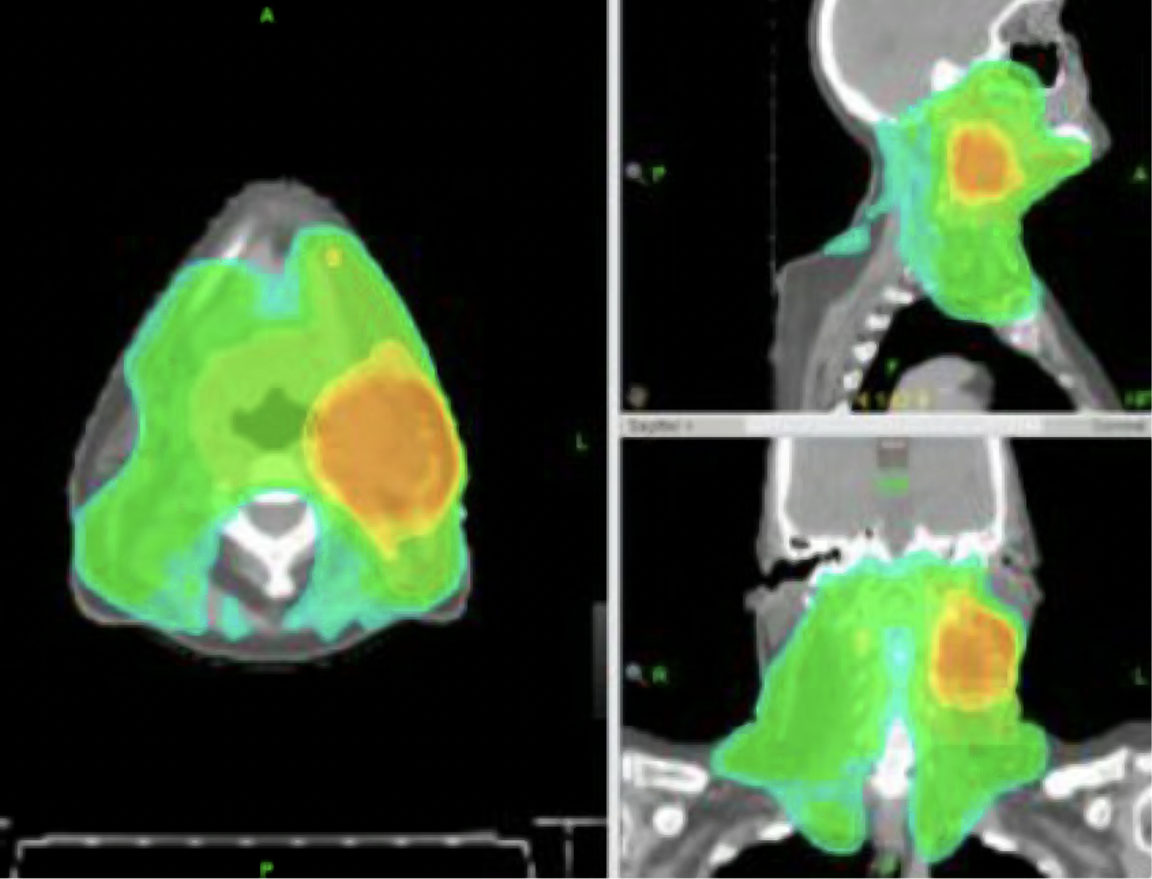

Figure 1. Axial l intensity-modulated radiotherapy (IMRT) Views Showing Dose Distributions to PTVs as part of head and neck radiation treatment plan. The differentially colored regions show various PTVs that receive different prescribed radiation doses. For the highest dose (orange/yellow), the targeted region of the gross disease in PTV1, and lower doses (green) for areas at risk in PTV2 and PTV3, while shielding the surrounding organs at risk.

The patient was treated for cancer and then she was treated with right upper lobectomy in 2015 for metastasis, but it was Organizing pneumonia which is a common side effect of radiotherapy. She also has had a total abdominal hysterectomy and bilateral salpingo-oophorectomy in 2011 due to stage 0 cervical cancer. Largely, the patient did not have any conventional risk factors of vascular diseases; however, she developed carotid artery stenosis later.

Based on the patient\RL’s history and the clinical findings, the possibilities of radiation-induced carotid artery stenosis, late-onset atherosclerotic carotid artery stenosis and chemotherapeutic agents-induced vascular complications were considered. The investigation process was very important in identifying the degree of stenosis and the area of narrowing. A normal result was obtained from a routine duplex ultrasound in 2020; however, finding stenosis was quite surprising. As per the CTA done in 2023, the right ICA occlusion was severe, and the left common carotid artery stenosis was mild to moderate. Such a massive shift over such a short duration brought out the competitive tone of the stenosis.

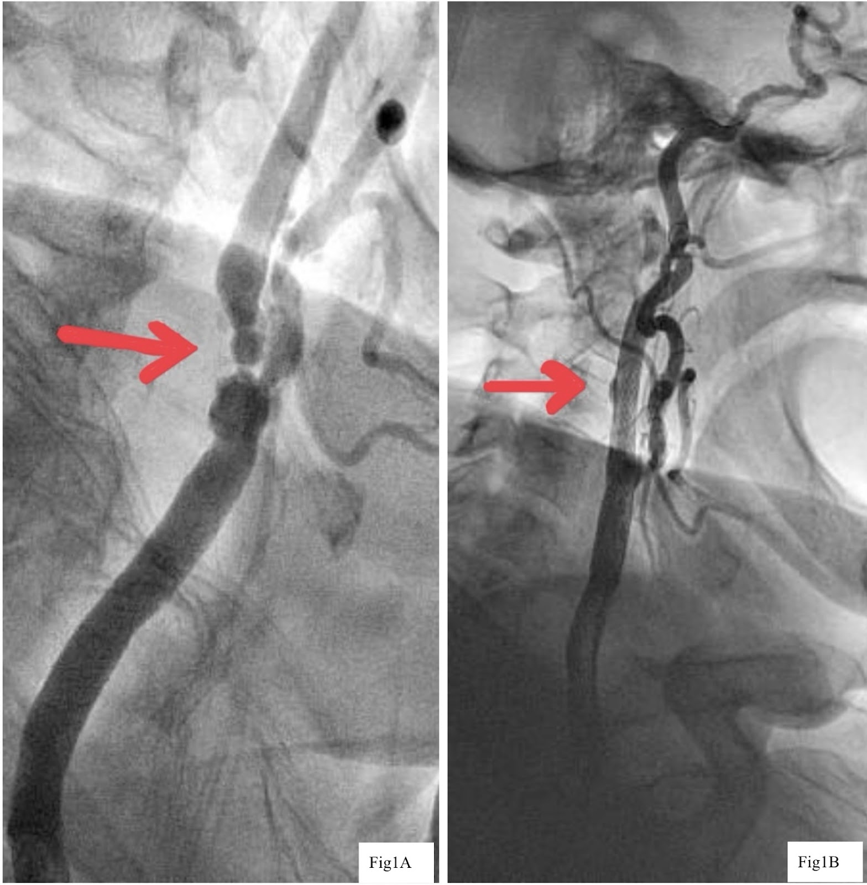

**Figure 2.** (**A**) Red arrow—CTA showing severe right ICA occlusion with moderate degenerative changes in bilateral common carotid arteries. (**B**) Red arrow—post-stenting angiogram showing successful re-channelization of the right ICA.

According to these results, further management was planned as carotid artery stenting of the right ICA. The procedure was done with the view of establishing good re-channelling and to minimize the chances of cerebrovascular accidents.

Conclusion and Outcomes:

The case presents a noteworthy instance of a patient developing clinically significant carotid artery stenosis 9 years post-radiotherapy, despite having normal duplex ultrasound findings just 3 years prior to diagnosis. The rapid progression of the stenosis underscores the potential long-term vascular risks associated with head and neck radiotherapy, even in patients without traditional cardiovascular risk factors.

The carotid artery stenting procedure on the right ICA was successful, achieving satisfactory re-canalization. Following the intervention, the patient had an uneventful postoperative course and was discharged on dual antiplatelet therapy. This case highlights the critical importance of long-term surveillance for vascular complications in patients with a history of head and neck radiotherapy. It suggests that regular vascular screening may be beneficial in this patient population, even years after their initial cancer treatment, to enable early detection and timely intervention for radiation-induced vascular complications.

3.discussion

Management of loco-regionally advanced Head and Neck Squamous cell carcinoma (HNSCC) involves either radiotherapy with concurrent chemotherapy or surgery followed by adjuvant radiotherapy.[4] Large vessel complications such as carotid artery stenosis has a much greater clinical significance than already well-described radiation-induced microvascular dysfunction. CAS can lead to stroke and transient ischemic attacks.[5] A review article by Carpenter et al showed that radiotherapy (RT) is an independent risk factor for stroke and asymptomatic CAS. RT correlated with high rates of stroke in two case-control studies with head and neck cancer (HNC) patients. Compared to surgery alone, RT use was associated with an increased 10-year risk of stroke and a 15-year risk of fatal stroke. RT also correlated with high rates of asymptomatic stenosis in multiple cross-sectional studies of HNC patients, with CAS prevalence ranging from 11.7% at a mean of 72 months post-RT to 19.8% at a mean of 24 months post-RT. [6]

Pathophysiology involves radiation causing apoptosis and senescence of the endothelial cells which which lead to the release of inflammatory mediators, leading to chronic inflammation, lipid per-oxidation and cellular dysfunction. Monocytes and smooth muscle cells (SMC) migrate into the media to clear oxidised LDL, resulting in atherosclerotic plaque. Carotid atherosclerosis is the most important factor influencing the formation of CAS after head and neck RT. Thus, radiation-induced CAS occurs through a combination of direct vessel damage, accelerated atherosclerosis, intimal proliferation, necrosis of the media, and peri-adventitial fibrosis. Macrophages secrete multiple inflammatory mediators, including tumour necrosis factor-beta and transforming growth factor-beta (TGF-β), to maintain chronic inflammation.[7] Additionally, Cisplatin-containing chemotherapy may contribute to the acute endothelial toxicity.[8]

Colour Doppler Ultrasound (CDUS) is the first choice for CAS screening. The B mode provides information on plaque features and allows measurement of the thickness of the artery wall. CT angiography has the advantages of high spatial resolution, fast imaging, and ease of calcified plaque identification. MR angiography is a safe and convenient tool for detecting vessel stenosis. Several studies revealed that MR angiography has similar accuracy to CT angiography for evaluating CAS.[2]

The gold standard for the treatment of carotid stenosis is endarterectomy. However, patients who have undergone RT of the neck are considered ’high risk’ for the procedure. Previous RT results in periadventitial fibrosis, impairing vessel dissection. The endarterectomy plane is frequently obliterated, with concomitant weakening of the arterial wall, rendering the procedure difficult. Also, cervical RT often produces carotid lesions that are more extensive requiring more complicated vascular reconstruction or vessel replacement, as well as adding to the perioperative morbidity. Local wound complications are reported to be more frequent as well. Thus carotid artery stenting is a viable alternative for these patients.[9] A meta-analysis by Fokkema et al comparing endarterectomy versus stenting for carotid artery stenosis in patients that had undergone head and neck radiation concluded that patients undergoing CEA had more temporary (Cranial Nerve Injury) CNI, whereas patients treated with CAS were shown to have a greater risk on late cerebro-vascular events and restenosis ≥50%. However, the results do not indicate the preferred treatment.[10]

The cost-effectiveness of CAS screening depends on CAS prevalence. The American Society of Neuroimaging determined that CAS screening is cost-effective for reducing stroke where CAS prevalence is ≥20%. In this context, the current data by Carpenter et al suggest that it would be reasonable to start screening HNC patients for asymptomatic CAS between 2- and 5-years following RT completion.[6]

4. Conclusion

In conclusion, this case highlights the potential risk of post-radiotherapy carotid stenosis in patients with head and neck cancer, particularly those receiving intensive treatment regimens involving high-dose radiotherapy and concurrent chemotherapy. Long-term surveillance for vascular complications is essential in the management of these patients to facilitate early detection and intervention, thereby minimizing the risk of cerebrovascular events and optimizing long-term outcomes.

Consent (where ever applicable)

Written informed consent for publication of their clinical details and/or clinical images was obtained from the patient.

Ethical approval (where ever applicable)

As per international standards or university standards written ethical approval has been collected and preserved by the author(s).

References

1. Bonati LH, Kakkos S, Berkefeld J, et al. European Stroke Organisation guideline on endarterectomy and stenting for carotid artery stenosis. European Stroke Journal. 2021;6(2):I-XLVII. doi:10.1177/23969873211012121

2. Fernández-Alvarez, V., López, F., Suárez, C., Strojan, P., Eisbruch, A., Silver, C. E., … & Ferlito, A. (2018). Radiation-induced carotid artery lesions. Strahlentherapie und onkologie, 194(8), 699-710.

3. Shichita, T., Ogata, T., Yasaka, M., Yasumori, K., Inoue, T., Ibayashi, S., … & Okada, Y. (2009). Angiographic characteristics of radiation-induced carotid arterial stenosis. Angiology, 60(3), 276-282.

4. Anderson, G., Ebadi, M., Vo, K., Novak, J., Govindarajan, A., & Amini, A. (2021). An Updated Review on Head and Neck Cancer Treatment with Radiation Therapy. Cancers, 13(19), 4912. https://doi.org/10.3390/cancers13194912

5. Xu, J., & Cao, Y. (2014). Radiation-induced carotid artery stenosis: a comprehensive review of the literature. Interventional neurology, 2(4), 183-192.

6. Carpenter, D. J., Mowery, Y. M., Broadwater, G., Rodrigues, A., Wisdom, A. J., Dorth, J. A., … & Brizel, D. M. (2018). The risk of carotid stenosis in head and neck cancer patients after radiation therapy. Oral oncology, 80, 9-15

7. Zheng, Z., Zhao, Q., Wei, J., Wang, B., Wang, H., Meng, L., … & Jiang, X. (2020). Medical prevention and treatment of radiation-induced carotid injury. Biomedicine & Pharmacotherapy, 131, 110664

8. Cameron, Alan C.1; Hall, M.1; Rios, F.1; Waterston, A.2; White, J.2; Touyz, R.M.1; Lang, N.N.1. VASCULAR EFFECTS OF ANTI-CANCER CISPLATIN THERAPY. Journal of Hypertension 36():p e99, June 2018. | DOI: 10.1097/01.hjh.0000539254.11971.d4

9. Cheng, S. W., Ting, A. C., Lam, L. K., & Wei, W. I. (2000). Carotid stenosis after radiotherapy for nasopharyngeal carcinoma. Archives of Otolaryngology–Head & Neck Surgery, 126(4), 517-521

10. Fokkema, M., den Hartog, A. G., Bots, M. L., van der Tweel, I., Moll, F. L., & de Borst, G. J. (2012). Stenting versus surgery in patients with carotid stenosis after previous cervical radiation therapy: systematic review and meta-analysis. Stroke, 43(3), 793–801. https://doi.org/10.1161/STROKEAHA.111.633743