***Case report***

**Solitary rectal ulcer syndrome: An unusual complication of Celiac disease**

**Abstract:**

Solitary rectal ulcer is reported to be a rare disease among children therefore it is usually difficult to diagnose.Several studies have been done regarding clinical presentation and diagnosis of solitary rectal ulcer syndrome (SRUS).Celiac disease has been rarely associated with SRUS and currently no data is available regarding the incidence of SRUS in celiac disease. Here we present to you a case of a 15 years old boy, with previously diagnosed with celiac disease, now presented with bleeding per rectum and was diagnosed to have SRUS.

**Keywords:** Celiac disease; Bleeding per rectum; solitary rectal ulcer

**Introduction:**

Solitary rectal ulcer is reported to be a rare disease among children therefore it is usually difficult to diagnose.1 Several studies have been done regarding clinical presentation and diagnosis of solitary rectal ulcer syndrome (SRUS). A study done by Dehghani SM and his colleagues stated that the most common presenting complain of SRUS is bleeding per rectum, followed by excessive straining during defecation. Other symptoms associated are tenesmus, mucus in stool, constipation, abdominal pain and diarrhea. It can also present as rectal prolapse and something coming out of anus.Diagnosis of solitary rectal ulcer depends on the clinical history and histopathological findings of rectal biopsy. The histology of solitary rectal ulcer has a unique appearance including thickening of mucosa with disruption of crypt architecture and fibromuscular obliteration.2Here we present to you a case of a 15 years old boy, with previously diagnosed with celiac disease,now presented with bleeding per rectum and was diagnosed to have SRUS.

**Case presentation:**

15 years old male patient was diagnosed with celiac disease 9 years back on the basis of positive HLA DQ2 test. His tissue transglutaminase IgA and IgG antibodies were negative and endoscopic biopsy showed features of Marsh class 1 (increased intraepithelial lymphocytes with no crypt hyperplasia). His mother and elder brother also had celiac disease. He was managed with gluten free diet, on which he responded and his diarrhea resolved. Since last 5 years he had presented to us multiple times with the complain of bleeding per rectum. Bleeding per rectum was on and off, painless, bright red in color and occurred at the end of defecation, quantity of around half a cup, associated with constipation and something coming out of anus. There was no history of fever or weight loss.

On examination, thin lean male with no obvious signs of anemia, jaundice and clubbing. His chest was clear and abdomen was soft, non-tender on palpation. No visceromegaly was appreciated. Digital rectal examination showed finger tinged with bright red blood, no hemorrhoids were found. His baseline labs were sent. ESR was sent to rule out tuberculosis which came within normal limits. His colonoscopy was done several times. In 2018, his colonoscopy showed a small ulcer with whitish exudates and surrounding erythema in sigmoid colon. Biopsy was taken which revealed features of moderate chronic non-specific colitis. He was managed conservatively with laxatives and high fiber diet.

After around 2 years he presented to us again with bleeding per rectum which did not resolve on conservative measures. This time we did proctoscopy via clear plastic TriView anoscope which showed bulging of mucosa. A provisional diagnosis of mucosal rectal prolapse was made and injection sclerotherapy was done using 5% phenol in almond oil which was injected in three quadrants of rectal mucosa (3mL in each quadrant). This session of sclerotherapy was repeated after two months. His bleeding stopped for only few months and he followed again in out-patient department with similar complain.

In February 2022, flexible sigmoidoscopy was done which revealed multiple sessile polyps of Paris class I, which were removed via polypectomy snare and were sent for histopathology. Biopsy showed features of inflamed , hyperplastic polyp. He was discharged on oral antibiotics and was advised lactulose. During this course of time patient was strictly on gluten free diet.

On 11th May 2022, another colonoscopy was performed on which we found a healed ulcer with a polypoidal appearance in rectum. Biopsy was taken from rectal ulcer, which showed focal splaying of muscle fibres in lamina propria and architectural distortion. Based on the clinical and histopathlogical findings, unexplained, prolonged history of bleeding per rectum, a final diagnosis of SRUS was made (**Figure-1**).

He was advised high fiber diet after the consultation with nutritionist and was also prescribed laxatives and stool softners to prevent constipation with marked improvement in his symptoms noted on recent follow up.

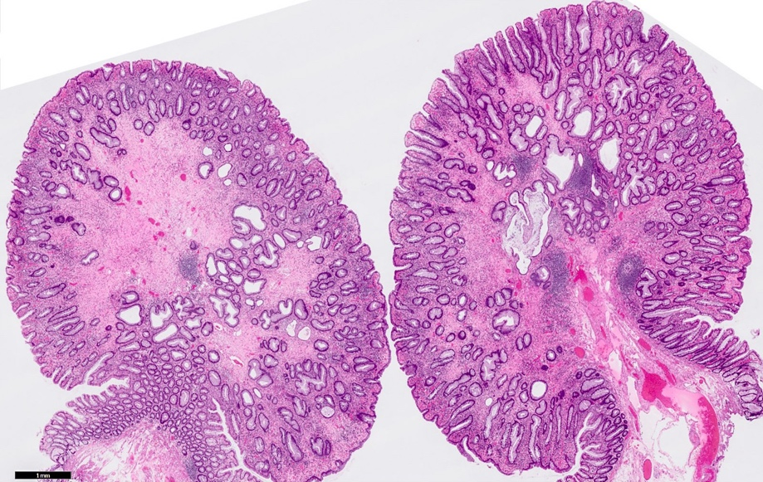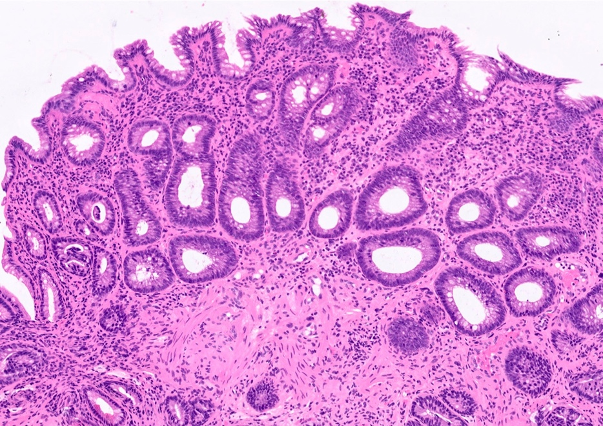

**Figure-1:** Solitary Rectal Ulcer Syndrome (SRUS).1**A:** Low power scanner view showing polypoidal appearance of SRUS. **1B:** Thickened muscularis mucosae and fibromuscular hyperplasia of lamina propria

**Discussion:**

Celiac disease has variable presentation and is associated with multiple disorders. In a retrospective study done in Pakistan, most common presenting symptoms of celiac were diarrhea, weight loss and abdominal pain.3 Celiac disease is associated with many complications including malabsorption, nutrient and mineral deficiencies, Intestinal lymphomas, Osteoporosis/osteomalacia, collagenous sprue, dental defects, Idiopathic pulmonary hemosiderosis, Glomerular IgA nephropathy, Infertility and cardiomyopathy.4 In our case, we report a rare complication of celiac disease which is solitary rectal ulcer syndrome. Literature review showed no case report regarding association of celiac and solitary rectal ulcer syndrome. This case is first to be reported in which celiac disease patient developed solitary rectal ulcer syndrome. Other rare associations reported with solitary rectal ulcer are Ehlers Danlos syndrome and tailgut cyst.5,6 It is essential to distinguish solitary rectal ulcer from other devastating conditions such as inflammatory bowel disease, amebiasis, lymphogranuloma venereum, chronic ischemic colitis, endometriosis, colitis cystica profunda, and malignancy. Concomitant haematochezia may be misdiagnosed as anal fissure caused by constipation, or other causes of rectal bleeding such as a juvenile polyp.7

Rectal prolapse is associated with 16%-59% of solitary rectal ulcer in adults. But our patient also had rectal prolapse, as previously reported in children with solitary rectal ulcer syndrome.8 Rectal prolapse may be occult, and defecography can be used to obtain a final diagnosis.

The purpose of writing this case report is to highlight the possibility of solitary rectal ulcer syndrome in celiac disease patients if they present with bleeding per rectum or rectal prolapse.

**References:**

1. Blackburn C, McDermott M, Bourke B. Clinical presentation of and outcome for solitary rectal ulcer syndrome in children. JPediatr Gastroenterol Nutr 2012; 54: 263-265 [PMID: 22266488 DOI: 10.1097/MPG.0b013e31823014c0]
2. Dehghani SM, Bahmanyar M, Geramizadeh B, Alizadeh A, Haghighat M. Solitary rectal ulcer syndrome: Is it really a rare condition in children? World J Clin Pediatr. 2016 Aug 8;5(3):343-8. doi: 10.5409/wjcp.v5.i3.343. PMID: 27610352; PMCID: PMC4978629.
3. Abbas Z, Raza S, Yakoob J, Abid S, Hamid S, Shah H, Jafri W. Varied presentation of celiac disease in Pakistani adults. J Coll Physicians Surg Pak. 2013 Jul;23(7):522-4. PMID: 23823965.
4. Jabeen, R. . Complications of Celiac Disease. In: Rodrigo, L. , Hernández-Lahoz, C. , editors. Celiac Disease - From the Bench to the Clinic [Internet]. London: IntechOpen; 2019 [cited 2022 Nov 23]. Available from: https://www.intechopen.com/chapters/63167 doi: 10.5772/intechopen.80465
5. Baba CS, Sharma PK. Association of Ehlers-Danlos syndrome and solitary rectal ulcer syndrome. Indian Journal of Gastroenterology 2007 Vol 26 May – June
6. Ząber A, Kucharski JM, Zapała B, Konys J, Banasiuk M, Banaszkiewicz A. An unusual aetiology of solitary rectal ulcer syndrome. Pediatria Polska - Polish Journal of Paediatrics. 2022;97(2):156-158. doi:10.5114/polp.2022.116815.
7. Tjandra JJ, Fazio VW, Petras RE, Lavery IC, Oakley JR, Milsom JW, Church JM. Clinical and pathologic factors associated with delayed diagnosis in solitary rectal ulcer syndrome. Dis Colon Rectum. 1993;36:146–153.
8. Ertem D, Acar Y, Karaa EK, Pehlivanoglu E. A rare and often unrecognized cause of hematochezia and tenesmus in child-hood: solitary rectal ulcer syndrome. Pediatrics 2002; 110: e79