***Case report***

**Neuroendocrine tumor of esophagus as a rare case of dysphagia in an elderly male-A case report from Pakistan**

**Abstract:**

Neuroendocrine tumors (NETs) are the neoplasms that develop from the enterochromaffin cells and can involve different parts of the body. Esophageal NETs are rare with most of them presenting as neuroendocrine cancers (NEC) and are associated with poor prognosis.Here, we present to you a case of an elderly male,who was evaluated for dysphagia and underwent endoscopy and radiological investigations and was diagnosed as esophageal NET on the basis of the histopathology.

**Keywords:** Esophagus; Dysphagia; Neuroendocrine tumor

## Introduction:

Neuroendocrine tumors (NETs) are the neoplasms that develop from the enterochromaffin cells and can involve different parts of the body such as the intestine, pancreas, lung, and almost all other organs.1 However, the esophageal NETs are still rare and comprise only 1.4% of all gastro-entero-pancreatic NETs. This is because the neuroendocrine system is not well developed in the esophagus.2 NETs comprise 0.15- 2.80% of esophageal carcinomas.3 Most of the esophageal NETs (70%) present as neuroendocrine carcinomas (NECs) and have a poor prognosis and low survival rate. 4

The WHO definition for NECs include positive endocrine marker such as chromogranin A, synaptophysin and CD56. A Ki67 or mitotic index of 20% or more is also necessary for diagnosing NEC. The tumors with less than 20% Ki 67 positivity are diagnose as neuroendocrine tumors(NETs). 5 NEC can be categorized into two groups: limited disease (LD) and the extended disease (ED). For ED, chemotherapy is the predominant treatment strategy, and radiotherapy is also applied for some cases. For LD, the therapeutic strategy is more complicated. In some studies, long-term survivors are treated with surgical resection (esophagectomy and extended lymph node dissection) with or without adjuvant chemotherapy.6 However, even for LD, multi-modality treatments such as surgery followed by adjuvant chemo-(radio)-therapy or neo-adjuvant chemotherapy followed by surgery are commonly recommended.7

Here we present to you a case of an elderly male, who was evaluated for symptoms of dysphagia and was diagnosed as NET of esophagus. This is the first case reported from Pakistan, describing Esophageal NET as a rare cause of dysphagia in an elderly male.

## 2 Case Report

75-year old, elderly male, smoker with (40 pack years) presented in the gastroenterology clinic with complaints of difficulty in swallowing for both solids and liquids for 1 month. It was gradual in onset, progressive in nature and was associated with mid epigastric pain mostly after food intake, that was burning in nature and was non radiating and was associated with decreased appetite and unintentional weight loss of 12 kg in 3 months. On examination, he was cachexic looking and lean built male. He underwent esophagogastroduodenoscopy showing large erythematous ,friable, fungating growth 26cm from incisors extending up to 34cm causing luminal narrowing through which gastroscope negotiated with slight difficulty.Multiple biopsies were taken from the growth (**Figure-1**). Esophageal biopsy revealed multiple fragments of esophageal mucosa lined by stratified squamous epithelium and underlying stroma showed infiltrating neoplastic lesion composed of sheets ,cords and nesting arrangement of atypical round blue cells exhibiting pale to mildly eosinophilic cytoplasm with hyperchromatic nuclei. Synoptophysin was diffusely positive while Ki-67 shows strongly nuclear positivity in 70% of atypical cells. The histopathological features were suggestive of neuroendocrine carcinoma((Small cell type) (WHO grade III).

Cross sectional imaging was performed showing soft tissue density with irregular margins involving mid-Esophagus measuring approximately 8.2cm in cranio-caudal diameter with marked luminal narrowing along with few enlarged lymph nodes were also seen in para-esophageal (measuring 2.6x1.6x1.0cm) and inguinal region(enlarged metastatic abdominal and pelvic lymphadenopathy)(**Figure-2**).

He was then referred by the multidisciplinary team (MDT) to the medical oncologist for further management and Palliative chemotherapy. Meanwhile, he also underwent feeding jejunostomy for feeding purposes.

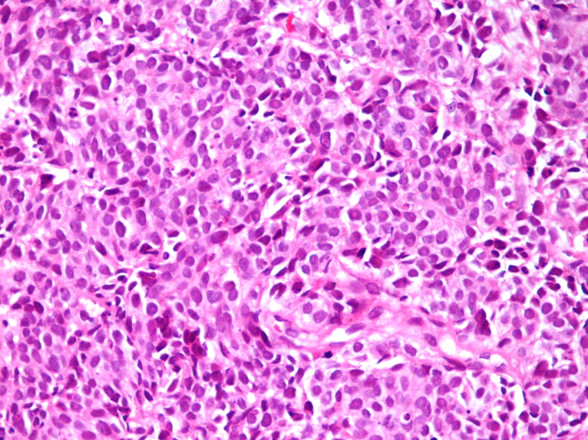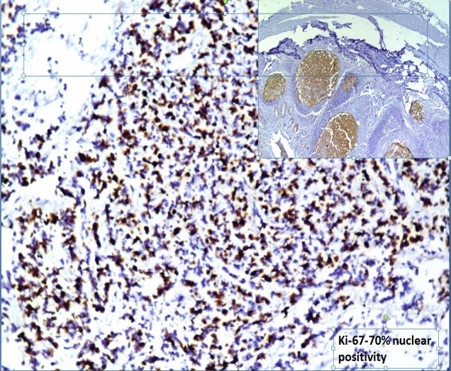

**B**

**A**

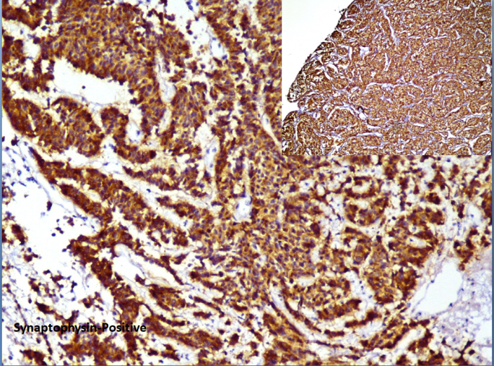

**C**

**Figure 1:** The histopathological features were suggestive of neuroendocrine carcinoma(WHO grade III) **1A:** Esophageal biopsy showing esophageal mucosa lined by stratified squamous epithelium and underlying stroma showed infiltrating neoplastic lesion composed of sheets ,cords and nesting arrangement of atypical round blue cells exhibiting pale to mildly eosinophilic cytoplasm with hyperchromatic nuclei. **1B.**Synoptophysin was diffusely positive.**1C** Ki-67 shows strongly nuclear positivity in 70% of atypical cells.

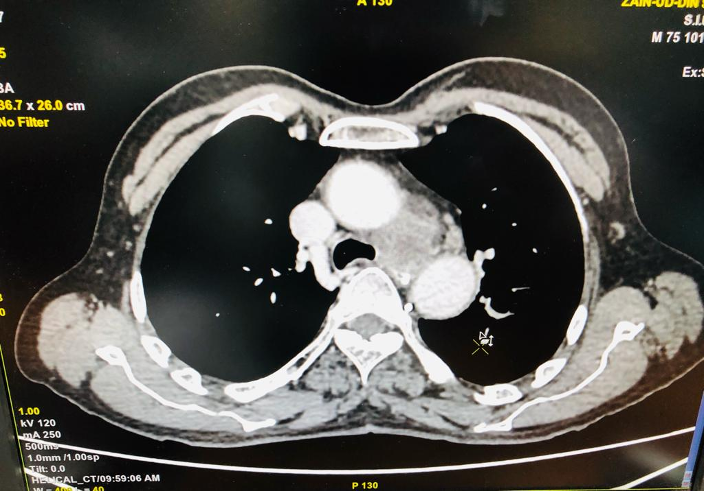 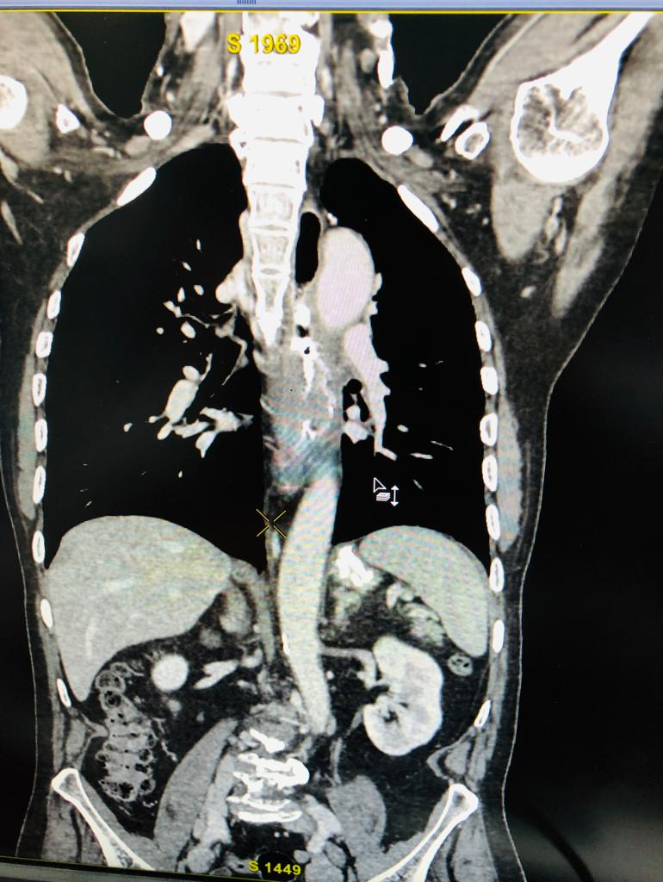

**A**

**B**

**Figure-2:** **A**-CT chest was performed showing soft tissue density with irregular margins involving mid-Esophagus measuring approximately 8.2cm in cranio-caudal diameter with marked luminal narrowing(**blue arrow**). **B** -Few enlarged lymph nodes were also seen in para-esophageal (measuring 2.6x1.6x1.0cm) and inguinal region (**orange arrow**) (enlarged metastatic abdominal and pelvic lymphadenopathy

## Discussion

Esophageal NETs are high grade tumors that behave aggressively. Usually, it is associated with late diagnosis in most of the patients and the patients usually have widespread disease with poor prognosis at the time of presentation. Currently, clinical treatment strategies of neuroendocrine carcinomas are very limited. High grade neoplasms are often regarded as a systemic disease and chemotherapy is the mainstay of therapy.7

Although low incidence of esophageal neuroendocrine tumors, our results give a better picture of the behavior of this rare condition. The present study shows this disease affects mainly men in Forties or fifties. Middle and lower esophageal thirds are most frequently affected. Nevertheless, future multicenter efforts are needed for randomized clinical trials evaluating therapeutic guidelines.

**References:**

1. Lee CG, Lim YJ, Park SJ, et al. The clinical features and treatment modality of esophageal neuroendocrine tumors: a multicenter study in Korea. BMC Cancer 2014;14:569.
2. Lee CG, Lim YJ, Park SJ, et al. The clinical features and treatment modality of esophageal neuroendocrine tumors: a multicenter study in Korea. BMC Cancer 2014;14:157–67
3. Weinberg JS, Suki D, Hanbali F, et al. Metastasis of esophageal carcinoma to the brain. Cancer 2003;98:1925–33
4. Glickman JN and Odze RD. Epithelial neoplasms of the esophagus. In: Odze RD, Goldblum JR, editors. Odze and Goldblum surgical pathology of the GI tract, liver, biliary tract, and pancreas. 3. Philadelphia: Elesevier Saunders; 2015. pp. 674-706.
5. Tanaka T, Matono S, Nagano T, Nishimura K, Murata K, Yamana H, et al. Surgical management for small cell carcinoma of the esophagus. Dis Esophagus. 2010;23(6):502–5. 10.1111/j.1442-2050.2009.01045.
6. Situ D, Lin Y, Long H, Zhang L, Lin P, Zheng Y, et al. Surgical treatment for limited-stage primary small cell cancer of the esophagus. Ann Thorac Surg. 2013;95(3):1057–62. 10.1016/j.athoracsur.2012.11.014.
7. Chen SB, Yang JS, Yang WP, Weng HR, Li H, Liu DT, Chen YP. Treatment and prognosis of limited disease primary small cell carcinoma of esophagus. Dis Esophagus. 2011;24:114-9.