**EFFECTS OF THE MIXTURE OF TIGER NUTS (*Cyperus esculentus)* and Date palm (*Pheonix dactilfera*) FLOUR ON THE REPRODUCTIVE FUNCTIONS OF MALE WISTAR ALBINO RATS.**

**Abstract**

The use of synthetic drugs in the treatment of infertility has been shown to produce some adverse effects and it is quite expensive. The present study investigated the impact of the *Cyperus esculentus* (Tiger nuts) and *Pheonix dactilfera* (Date palm) flours on the reproductive profile of male Wistar rats. Thirty (30) male Wistar rats weighing 70-120g were obtained from the Animal House of the Biochemistry Department, University of Port Harcourt, Choba, Rivers State Nigeria. Acclimatization was done for one week before experimentation. Water and rat feeds were provided ad libitum and the animals were kept under room temperature. The animals were grouped into six of five rats per group, Group one (1) the control was administered rat feed only, Group two (2) was given rat feed and Tiger nut flour only, Group Three (3) was given rat feed and Date palm flour only, Group four (4) was given rat feed, Tiger nut and Date flour mixture in ratio 1:1, Group five (5) was given rat feed and mixture of Tiger nut and Date flour in ratio 1:2 and Group Six (6) was given rat feed with mixture of tiger nut and Date flour in ratio 2:1 for twenty-eight days. The animals were sacrificed under anesthesia (chloroform suffocation) and blood samples were collected through cardiac puncture into EDTA bottles. The testis was collected through ab-domino-thoracic dissection into plain bottles containing Bouin’s fixatives for histological study. Part of the testes were collected in plain bottles for sperm analysis. The result revealed a significant boost in sperm count, viability, and motility in all groups compared to the control. Group VI administered rat feed with a mixture of tiger nut and Date flour in a ratio of 2:1 showed a marked increase in testosterone (2.30nmol/L) level, also with a significant (p≤0.05) increase in FSH (2.31mIU/ML). Normal spermatocytes, seminiferous tubules, and spermatogonia of the group given the formulated diet were histologically shown to have no pathology in the Testes compared to the control. Tiger nuts flour when in combination with Dates flour increased the sperm count and quality more than when the two samples were used separately and has also proven to be safe for the Testes without posing any harm.

**Keywords:** Histhopathology, Testosterone, Follicle Stimulating Hormone (FSH).

**INTRODUCTION**

Research by World Health Organization, observed that male fertility is dropping to nearly 50% among married couples. This might be as a result of a stressful lifestyle which has enhanced subjects that suffers from sexual dysfunction (WHO, 2000). There are Synthetic drugs for these problems, but the disadvantage of these drugs is adverse side effect. Natural treatment on the other hand is advised because it is believed to be devoid of side effect, this might not be true due to the fact that there are scarcity of information on the adverse effect of these medicinal plants used against fertility problem (Carpentier *et al.,* 2004).

*Cyperus esculentus* (Tiger nuts) is a perennial plant species that belongs to the Cyperaceae family and grows abundantly in the Mediterranean region. The cultivation of this plant started far back as 5000 BC in Egypt (Defelis,2002). These tubers are commonly known by several names such as chufa, earth almond, and tiger nuts (Pascual *et al.,* 2000). The rich carbohydrate, protein and fat content of this plant makes it serves as food to man and animal (Tunde and Oke, 2012). In the Middle East this plant is called “the seeds of men” when translated literarily. This is because they believe that it aids male sexually.

The Date palm (*Phoenix dactyllifera L.*) has been cultivated since the 6000 years. Date palm is a genus of palm, the most important species of which is the common Date palm, a native of the North half of Africa, the South West of Asia and some parts of India. Dates contain a high percentage of carbohydrates, fats comprising 14 different types of fatty acids, 15 salts and minerals, proteins with 23 different amino acids, 6 vitamins and dietary fibre. These nutritional benefits of dates are for those that take it as food rather than those that just have it as snack (Sahari *et al.,* 2007).

**STATEMENT OF THE PROBLEM**

Infertility is s condition where there is a regular and unprotected sex without conception for a period of one year. There are associated male factors that could lead to this problem. About 50% of infertility is caused by male related factor. Using synthetic drugs to remedy this situation has not helped due to side effects, which has made many to resort to natural plant products. Even with the success recorded in the use of plant to improve fertility there is still need for more discoveries of the use of plants to cure infertility problems.

**AIMS AND OBJECTIVES**

The aim of this study is to know the effects of the mixture of tiger nuts(*Cyperus esculentus)* and Date palm (*Pheonix dactilfera*) flour on the reproductive functions of male Wistar rats.

The objectives were to:

1. Investigate the effect of the feed on sperm quality and quantity (volume, viability, viscosity, morphology, and sperm count).

2. Investigate the impact of the feed on the male hormones (testosterone and follicle stimulating hormones) of Wistar rats.

1. Determine its effect on the histology of the testes.

**MATERIALS AND METHOD**

**Plant collection and identification**

Tiger nuts *(Cyperus esculentus)* and Date fruits *(Phoenix dactylifera)* were purchased from slaughter market in Trans Amadi, Port Harcourt, Nigeria. The tubers were taken to the department of Plant Science and Biotechnology, University of Port Harcourt, Choba, for proper identification.

**Sample preparation:** The dried Tiger nuts tubers were thoroughly cleaned to remove stones and then sliced with a kitchen knife and subjected to further drying at 500C in an Oven. After drying it was ground to obtain a flour and then packaged in a transparent container until used for the study.

Dried Date fruits were cleaned and deseeded. This was subjected to oven drying at 500C, and then ground to flour and also stored in a transparent container until used for the study.

**Specimen (animal) used for the experiment:**

Thirty male albino male wistar rats weighing about 70 g- 120 g, were obtained from the Animal house of the University of Port Harcourt, Choba, Rivers State Nigeria. Acclimatization was done for one week prior to experimentation. Water and rat feeds were provided *ad libitum* and the animals kept under room temperature.

**Animal grouping and treatment:** After one week of acclimatization, the animals were randomly assigned to 6 groups, containing 5 Wistar rats each. Different ratios of Tiger nuts and Date flour were administered to the animals for 28days as follows:

1. Control group were administered rat feed only.
2. Group two were administered rat feed, and Tiger nuts flour only.
3. Group three were administered rat feed and Date fruit flour only.
4. Group four were administered rat feed and a mixture of Tiger nut flour and Date fruit flour (ratio of 1:1). The total amount of each feed mixture was 700g with 350g of Tiger nuts flour and 350g of Date fruit flour.
5. Group five were administered rats chow and a mixture of Tiger nuts flour and Date fruit flour in the ratio of 1:2 (i.e. 235g of Tiger nuts flour mixed with 470g of Date flour).
6. Group six were administered rats chow and a mixture of Tiger nuts flour and Date

Fruits flour in the ratio of 2:1(i.e. 470g of Tiger nuts mixed with 235g of Dates flour).

After 28 days, the animals were sacrificed under anaesthesia (chloroform suffocation) and blood sample collected through cardiac puncture into EDTA bottles. The Testes were collected through abdomino-thoracic dissection into plain bottles containing Bouin’s fixatives containing 75ml Picric acid, 25ml raw formaldehyde and 5ml acetic acid for histological study. Part of the testes were collected in plain bottles for sperm analysis.

## Determination of sperm parameters: (Haemocytometer method)

In a beaker containing 10ml diluting solution, the cauda part was excised and placed in the beaker after separation from each separated epididymis (sodium bicarbonate 5 g and formalin neutral 1 mL in 100 mL of distilled water). Spermatozoa were liberated for a few minutes into the solution after each section was quickly macerated with the aid of a sharp scissors. Neubauer Haemocytometre was used to carry out the sperm count under a microscope and the sperm count was calculated per epididymis. 2 drops of warm 2.9 percent sodium citrate were added after semen drop had been placed on the slide. A cover slip was used to cover the slide while examination was carried out under the microscope using x 40 objectives for these parameters: sperm motility, morphology, abnormality, sluggishness and dead cells.

**Hormonal assay**

**Determination of testosterone (Accu-Bind Kits)**

**Principle**

The principle uses a competitive immunofluorescence assay. A fluorescence conjugated anti-testosterone in a buffer (detection) binds to testosterone in a specimen and unbound anti-body binds to covalently coupled testosterone-BSA which has been made immovable on a test strip, as specimen migrates via the nitrocellular matrix. This way, the more testosterone in blood, smaller quantities of unbound fluorescence labelled antibodies accumulates on the test strip. The anti-testosterone antibody fluorescence intensity reflects the quantity of antigen captured and the ichroma reader processes it to establish the level of testosterone in the sample.

**Procedure**

Seventy-five microlitres of sample was added with the aid of transfer pipette into a sample mixing tube containing thirty microlitres of displacing reagent, the sample was thoroughly mixed and left to stand for ten minutes after closing the lid of sample mixing tube. The sample mixture was used instantly and incubated for three minutes. Seventy-five microlitres of sample was added with aid of transfer pipette into a tube containing the detection buffer, the sample was thoroughly mixed and left to stand for ten minutes after closing the lid of the detection buffer. The sample mixture was used immediately. Seventy-five microlitres of sample mixture was transferred using a pipette and dispensed into the sample well on the test cartridge. The Cartridge was left for twelve minutes before the Cartridge was inserted into the holder. The sample-loaded test cartridge was inserted into the Test Cartridge holder in the ichroma Reader for scanning.

## Determination of Follicle Stimulating Hormone (Accu-Bind Kits)

**Principle**

This analysis relies on immunoassay system via antigen-antibody interaction and fluorescence technology. The complete mixing of sample and a detection buffer, loaded into a sample well cartridge, forms complex of antibody (anti-FSH)-antigen (FSH)-antibody (anti-FSH) –fluorescence on the cartridge. Consequently, the more FSH is in plasma/plasma, the more complexes are accumulated on the membrane. The strength of the fluorescence on the membrane is scrutinized by the ichroma Reader which displays the FSH concentration on the LCD screen of the reader.

**Procedure**

Seventy-five microliters of sample was added with the aid of transfer pipette into a tube containing the detection buffer, the sample was thoroughly mixed and left to stand for ten minutes after closing the lid of the detection buffer. 75 µl of the sample was dispensed into the sample well on the test cartridge and left for fifteen minutes. The ichroma Reader was switched on and the ID chip was slotted into the ID chip port of the reader and proper orientation of the test cartridge was done. The select button on the ichroma Reader was pushed and the scanning process commenced, and the results were displaced on the screen.

**Histological examination**

Fixative principle: Bouin solution was used for fixing. It is a mixture of picric acid, acetic acid and formaldehyde which works together to produce a fixed tissue. Acetic acid helps to lyses the blood. Formalin makes the cytoplasm basophilic and helps harden the tissue although this is regulated by picric acid which also regulates the tissue swelling effect of acetic acid.

**Procedure**

Microscopic examination of the testis was undertaken. Pieces of tissues in the fixative were selected and histological procedures were then carried out. Tissues were fixed in Bouin’s solution for 12 hours. Section of the tissue were then selected from the fixative, cut, well labelled and then processed for histological studies. The tissues were first dehydrated by passing through graded percentage of alcohol solution in automated tissue processor as follows, 50 percent, 70 percent, 95 percent overnight, then absolute alcohol for two hours after which cleaning was done using xylene and then impregnation using molten paraffin wax, melting point 540C- 640C for one and half hours.

The tissue was subsequently embedded using fresh molten paraffin wax in L-shape iron moulds (embedding moulds 2cm x 3cm) and allowed to solidify. The paraffin blocks were then removed from the mould and trimmed. Attached to this is a wooden blocks (3cm- 4cm) and these were labelled accordingly. These blocks were placed in the microtome for sectioning or microtome. The micrometre was adjusted and set appropriately for sectioning serial thin uniform sections of about 8 micrometre thickness were produced. The best of the cut section were picked with stainless steel forceps and placed on glass slides. Twenty percent alcohol was applied to the paraffin ribbon to spread the serial sections on the slides. The sections were then floated in an electro-thermal water bath at 500C for the paraffin ribbon containing the section to spread out well.

The sections were then deparaffinised using pure xylene. The slides were then placed in absolute alcohol for 30 seconds to get rid xylene and this was done using nose forceps. The slides were then placed to a second dish of absolute alcohol to ensure all xylene had been removed. They were then immersed in 95 percent alcohol followed by 70 percent alcohol then 50 percent alcohol for 30 seconds each. The slides were then washed in distilled water and placed on stant’s hot plate at 600C for an hour to dewax. After dewaxing, the slides were stained for morphological changes and viewed using light microscope and histopathological changes were observed and recorded at X400 magnification.

**Data Analysis:**

All data were subjected to statistical analysis. The values reported as mean ±standard error mean (SEM) while one-way anova was used to test for differences between test groups and control groups using statistical package for social sciences (SPSS) version 21. The results were considered significant at p-values of less than 0.05 that is at 95% confidence level (p < 0.05).

**RESULTS**

**4.1a Sperm quality and quantity of albino wistar rats fed normal feed with tiger nut and Date for 28 days.**

Table 1a showed the results of sperm analysis of Wistar rats fed with different compositions of Tiger nuts and Dates fruit. There was marked increase in volume in Group II (0.24±0.11%), Group III (0.84±0.03%) and Group VI (0.16±0.04%) when compared with the control (0.02±0.01%). Sperm viability increased slightly in all the groups with the highest increase in Group IV (68.00±5.83%) when compared to the control ((58.00±2.54%). However normal morphology increased insignificantly in Group III (68.00±4.63%) and in Group IV (67.00±4.06%) when compared with the control (58.00±3.39%), while the abnormal morphology of the sperm increased in Group VI (57.00±4.89%) though not significant when compared with the control. There was notable increase in actively motile sperm cells in all the groups though not significant where the highest increase was found in Group IV (64.00±7.14%) when compared with the control value (52.00±3.39%). A marked decrease in sluggishly motile sperm cells was observed only in Group VI (10.00±0.01%) when compared with the control (12.00±1.22%). The death of sperm cells was increased in all the Groups with a significant (p≤0.05) increase in Group V (34.00±6.00%) when compared with the control (12:00±1.22%). There was also increase in sperm count though not significant in all the groups with Group IV (494.00±177.44x106) having the highest increase.

**4.1b Hormonal concentration of albino Wistar rats fed normal feed, tiger nut and Date for 28 days.**

Table 1b showed the result of the hormones analysed (testosterone and Follicle Stimulating Hormone). Result from the study showed that there was an insignificant marked increase in testosterone level in Group IV (1.40±0.15nmol/L) and group VI (2.30±0.63nmol/L) when compared with the control (1.30±0.19nmol/L). However, there was also an insignificant increase in follicle Stimulating hormone (FSH) in Group II (0.33±0.08mlU/ml), Group III (0.29±0.06mlU/ml), Group V (0.45±0.04mlU/ml) and a significant increase (P≤0.05) in Group VI (2.31±0.58mlU/ml) when compared with the control (0.25±0.04mlU/ml).

**Table 1a Sperm quality and quantity of albino wistar rats given normal feed, tiger nut and Date flour for 28 days.**

|  |  |  |  |  |  |  |  |  |
| --- | --- | --- | --- | --- | --- | --- | --- | --- |
| TEST GROUPS | Volume(%) | Viability (%) | NORM MORP(%) | ABN  MORP(%) | ACTIVELY  MOTILE(%) | SLUG(%) | DEATH(%) | SPERM COUNT (x106) |
| CONTROL | 0.02 ±0.01a | 58.00 ±2.54a | 58.00 ±3.39a | 42.00 ±3.39a | 52.00 ±3.39a | 12.00 ±1.22a | 12.00 ±1.22a | 62.00 ±18.27a |
| Group II | 0.24 ±0.11a | 61.00 ±3.31a | 58.00 ±3.74a | 41.00 ±3.31a | 55.00 ±5.24a | 12.00 ±1.22a | 33.00± 4.89a | 216.00 ±111.22a |
| Group III | 0.84 ±0.03a | 65.00 ±4.74a | 68.00 ±4.63a | 32.00 ±4.63a | 59.00 ±5.09a | 12.00 ±1.22a | 12.00 ±1.22a | 156 ±44.56a |
| Group IV | 0.08 ±0.03a | 68.00 ±5.83a | 67.00 ±4.06a | 33.00 ±4.06a | 64.00 ±7.14a | 12.00 ±1.22a | 24.00 ±7.31a | 494.00 ±177.44a |
| Group V | 0.09±0.03a | 61.00±6.00a | 61.00 ±4.84a | 38.00 ±5.38a | 54.00 ±5.78a | 12.00 ±1.22a | 34.00 ±6.00b | 334.00 ±160.33a |
| Group VI | 0.16 ±0.04a | 60.00 ±5.47a | 62.00 ±2.54a | 57.00 ±4.89a | 57.00 ±4.89a | 10.00 ±0.01a | 33.00 ±4.89a | 270.00 ±97.92a |

Data are mean values ± standard error of mean of three determinations, n=6 rats. Values that are in chats bearing the same superscript letters are not significant (p<0.05) compared to the control whereas values in chats bearing different superscript letters are significant (p<0.05) compared to the control. NORM MORP-=Normal morphology, ABNMORP = Abnormal Morphology, SLUG=sluggishly motile.

**Table 1b Hormonal concentration of albino wistar rats fed normal feed, tiger nut and Date for 28 days**.

|  |  |  |
| --- | --- | --- |
| TEST GROUPS | TESTOSTERONE  ( nmol/L) | FSH  ( mlU/ml) |
| CONTROL | 1.30 ±0.19a | 0.25 ±0.04a |
| Group II | 1.25±0.12a | 0.33 ±0.08a |
| Group III | 1.21 ±0.02a | 0.29 ±0.06a |
| Group IV | 0.92 ±0.0a | 0.25 ±0.04a |
| Group V | 1.40 ±0.15a | 0.45 ±0.04a |
| Group VI | 2.30 ±0.63a | 2.31±0.58b |

Data are mean values ± standard error of mean of three determinations. Values that are in the same column and bearing similar superscript letters are not significant (p>0.05) compared to the control whereas values that are in the same column with different superscript letters are significant (p<0.05) compared to the control.

**HISTOLOGY OF THE TESTES**

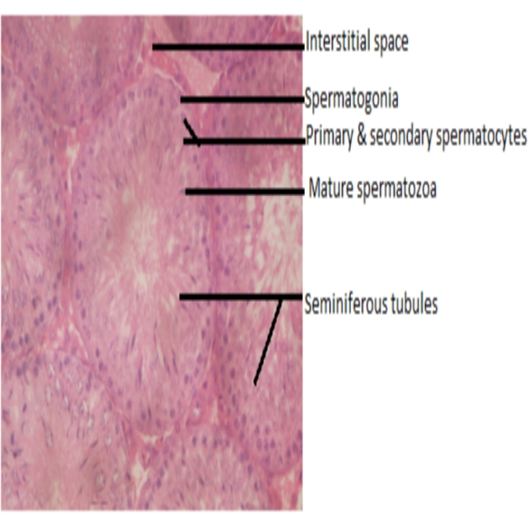

Plate 1 Showing photomicrograph of the testes of control rat. (H and E staining, 400x) stain. (H and E staining, 400x) stain. Normal seminiferous tubule, spermatocytes, and intact intact spermatogia

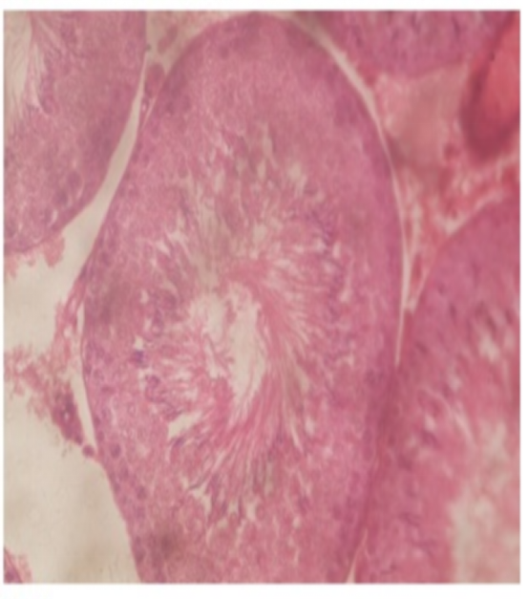

Plate 2. Showing photomicrograph of group 2 rat. (H and E staining, 400x). Normal seminiferous tubule, spermatocytes, interstitial cells and space and intact spermatogia.

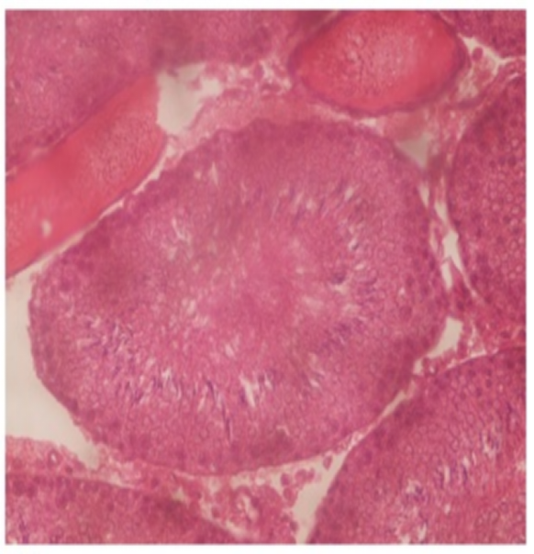

Plate 3. Showing the photomicrograph of group 3 rat. (H and E staining, 400x). Normal seminiferous tubule, spermatocytes, and distended spermatogia.

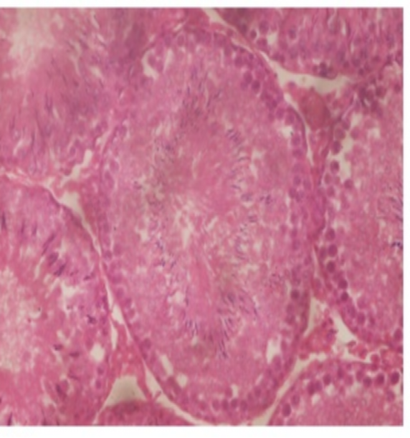

Plate 4. Showing photomicrograph of group 4 rat (H and E staining, 400x). Showing normal seminiferous tubule, formation of new secondary spermatocytes, and proliferated spermatocytes.

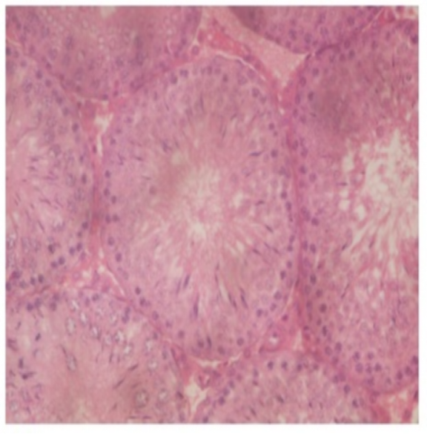

Plate 5. Showing photomicrograph of group 5 rat (H and E staining, 400x) stain. Improved seminiferous tubule, primary and secondary spermatocytes and intact interstitial cells.

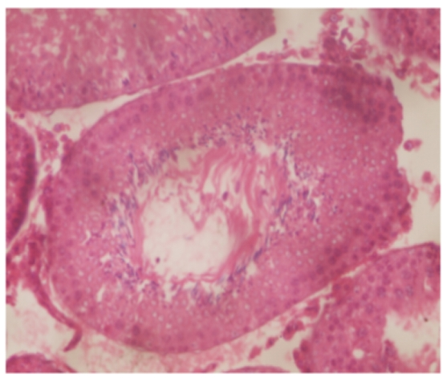

Plate 6. Showing photomicrograph of group 6 rat (H and E staining, 400x). Mild inflammation seminiferous tubule, spermatogia, interstitial cells, primary and secondary spermatocytes and intact interstitial cells.

**DISCUSSION**

In this study, it could be clearly demonstrated that the mixture of tiger nuts and Date flour enhanced the sperm quality and quantity. This is obvious in Group IV which was fed with tiger nuts and Dates flour in equal ratio (1:1). This might be due to the presence of flavonoids which was present in both samples which is a good antioxidant. Antioxidants have been shown to improve key steps in spermatogenesis, steroidogenesis (Sheweita *et al.*, 2005). Similar report was obtained by Biglari (2009), who confirmed that Dates are made up of phenolic compounds and flavonoids which provide antioxidant activities, also a report by Bennet *et al.,*(1966) and Mahran *et al.,*(1976) indicated that Date palm contains estradiol and flavonoid components which has helpful effects on sperm quality. Ekaluo *et al.,*(2015) used an aqueous extract of tiger nuts and confirmed that tiger nut extracts have the capability of enhancing sperm count and sperm quality and hence can improve fertility and ease toxicity on sperm. When combined with Dates flour, tiger nuts flour increased the sperm count and quality more than when the two samples were used separately.

Testosterone is the major male hormone it works with FSH to initiate and maintain spermatogenesis. In this study, the significant increase in testosterone and Follicle Stimulating hormone (FSH) observed in Group VI and the notable increase though not significant seen in Group V might be linked to the ability of the mixture therapy of Dates and tiger nut flour having androspermatogenic potentials. This agrees with the report of Ajiboye *et al.,* 2014 on the Aphrodisiac effect of aqueous root extract on lecaniodiscus cupaniodes in sexually impaired rats.

Normal spermatocytes, seminiferous tubules, and spermatogia of the group given the formulated diet were histologically shown to have no pathology compared to the control plates in Plate 13-18. This proves that the feed mixture is histopathologically safe for the testes.

**CONCLUSION**

The use of Tiger nuts and Dates to improve sperm quality and quantity in male Wistar rats resulted in the efficient regeneration of their sperm cells as can be evidenced in their volume, viability, morphology, motility, and sperm counts.

The combined use of Dates fruit and tiger nuts in wistar rats is a better option in enhancing male reproductive system as their use does not create or pose great risk to the testes.

In improving fertility, Tiger nuts alone and in combination with Dates enhanced the sex hormones (Testosterone and Follicle Stimulating Hormone) responsible for male fertility.

**RECOMMENDATION**

* Further studies should be carried out on male rats involving the female rats too to ascertain their mounting frequency, intromission frequency and Ejaculatory frequency. Also studies to ascertain their mounting latency, intromission latency and ejaculatory latency should be carried out.
* The combination therapy of tiger nuts and Dates should be tried on patients with erectile dysfunction to ascertain its effects.

**CONTRIBUTION TO KNOWLEDGE**

The administration of the mixture of Tiger nuts and Dates fruit helped in improving the sperm quality and quantity, and also the levels of the reproductive hormones (FSH and Testosterone) of male Wistar albino rats

**REFERENCES**

Ajiboye T.O, Nurudeen, O.O, Yakubu, M.T (2014). Aphrodisiac effect of aqueous root extract of *Lecaniodiscus cupaniodes* in sexually impaired rats. *Journal of basic and clinical physiology and pharmacology.* **25**(2): 241-248.

Biglari, F. (2009). Assessment of Antioxidant potential of Date (Phoenix Dactylifera) fruits from Iran, Effect of cold storage and addition to minced chicken Meat; *Universiti Sains Malaysia.* P 17.

Carpentier, M. Sahpaz, S. and Bailleul, F. (2004). “Plants and Erectile dysfunction”, Phototherapy, Volume **3**, page 66-71.

Defelis M.S. (2002). Yellow nutsedge *Cyperus esculentus L*. Snack food of the gods. *Weed / Technology,* **16**:901-907.

Ekaluo, U.B, Ikpeme, E.V, Etta, S.E, and Ekpo P.B. (2015). Effect of Aqueous extract of Tiger nut (*Cyperus esculentus*) on sperm parameters and Testosterone level of male albino rats. *Asian Journal of Biotechnology* **7**(1): 39-45.

Pascual B. Marto JV, Lopez-Galarza S, Sanbautista A, Alagarda J. (2000) Chufa *(Cyperus esculentus L. Varsativus Boeck)*: an unconventional corporation. Studies related to applications and cultivation. *Economic Botany*, **54**:439-448.

Sahari, M.A., Barzegar M. and Radfar R, (2007). Effect of Varieties on the composition of Dates *(Phoenix dactylifera L.)*. *Food Science and Technology International,* **13**:269-275

Sheweita, A.S, Tilmisany M.A, Al-Sawaf, H (2005). Mechanisms of male infertility: role of antioxidants. *Current Drug Metabolism* **6**:1-7.

Tuned-Akintunde Ty, Oke M.O (2012). Thin-layer drying characteristics of tiger nut *(Cyperus esculentus)* seeds. *Journal of food processing and preservation,* **36**: 457-464.

WHO (2000). Manual for standardized Investigation, Diagnosis and management of the Infertile Male, Cambridge. University Press, Cambridge, UK.