**Original Research Article**

**Nitrous Oxide (N₂O) Emissions in the Seagrass Beds of Inner Ambon Bay**

Abstract

The research on N₂O emissions is necessary to provide additional scientific information regarding greenhouse gas emissions in seagrass bed areas. N₂O is produced through the denitrification process by anaerobic bacteria in sediments or soil, while anthropogenically, N₂O can come from agricultural fertilizers, waste, and fuel combustion. This study was conducted from June to September 2023 in the seagrass bed areas of Tanjung Tiram and Halong, Inner Ambon Bay. Data collection for the water characteristics of the ecosystem included temperature, salinity, and pH, which were measured in situ using a thermometer, hand refractometer, and pH meter. Meanwhile, nitrate levels in the water were measured ex situ, where water samples were collected and brought to the laboratory for analysis. The analysis of greenhouse gas concentration, specifically CH₄, was conducted using the gas chromatography-mass spectrometry (GC-MS) method. The N₂O gas concentration for each seagrass species across locations showed relatively similar values. At the Tanjung Tiram site, the highest N₂O concentration was found in T. hemprichii at 0.372 ppm, while the lowest was in E. acoroides at 0.355 ppm. The highest N₂O emissions at the Tanjung Tiram site were recorded in H. pinifolia at 0.01289 mg/m²/hour, while the lowest emissions were in T. hemprichii at 0.00484 mg/m²/hour. In contrast, at the Halong Beach site, the highest N₂O emissions were observed in T. hemprichii at 0.00923 mg/m²/hour, while the lowest emissions were recorded in H. pinifolia at 0.00183 mg/m²/hour.

Keywords: N₂O emissions, fuel combustion, agricultural fertilizers, greenhouse gases

INTRODUCTION

The increase in greenhouse gases in the atmosphere has led to global warming and climate change. The primary greenhouse gases contributing to global warming are N₂O, CH₄, and CO₂. Human activities such as the use of fossil fuels like petroleum and coal, population growth leading to increased waste production, and environmental degradation through deforestation along coastal areas and inland for the development of settlements, plantations, mining, and aquaculture have contributed to the rise of greenhouse gases in the atmosphere (Rahmadania, 2022).

N₂O is the third-largest contributor to global warming, accounting for 7.9% after CO₂ at 76.7% and CH₄ at 14.3% (IPCC, 2007). Although the concentration of N₂O in the atmosphere is lower than that of CO₂, which is the primary contributor to global warming, N₂O has a relatively long lifetime of 150 years (Lilitnuhu, 2024). This means that N₂O persists in the atmosphere longer than CO₂ and CH₄. Furthermore, N₂O has a Global Warming Potential (GWP) of 310, indicating that its capacity to trap heat from infrared radiation is 310 times more effective than CO₂ (Wahyudi, 2016).

N₂O can originate from both natural and anthropogenic activities. According to Samiaji (2012), naturally, N₂O is produced through the denitrification process by anaerobic bacteria in sediments or soil, while anthropogenically, N₂O can come from agricultural fertilizers, waste, and fuel combustion. Coastal ecosystems, such as seagrass ecosystems, not only have the ability to absorb greenhouse gases but can also release N₂O due to organic matter originating from land and seagrass litter itself.

Two locations in Inner Ambon Bay with seagrass beds are Tanjung Tiram and Halong Beach. These two sites have the potential to absorb and release greenhouse gases. Research on the concentration and emission of greenhouse gases in seagrass beds remains very limited. In Maluku, two studies have been conducted on CO₂ emissions in seagrass beds (Siahaya et al., 2023; Krisye et al., 2023a). Therefore, research on N₂O emissions is necessary to provide additional scientific information regarding greenhouse gas emissions in seagrass bed areas.

**Method**

**Time and Location of the Study**

This study was conducted from June to September 2023 in the seagrass bed areas of Tanjung Tiram and Halong, Inner Ambon Bay (Figure 1). These two locations have relatively extensive seagrass beds with more than one species present. According to Rugebregt et al. (2020), four species were found in Tanjung Tiram, while five species were identified at Halong Beach. The species selected for this study were those that dominantly inhabit both locations.

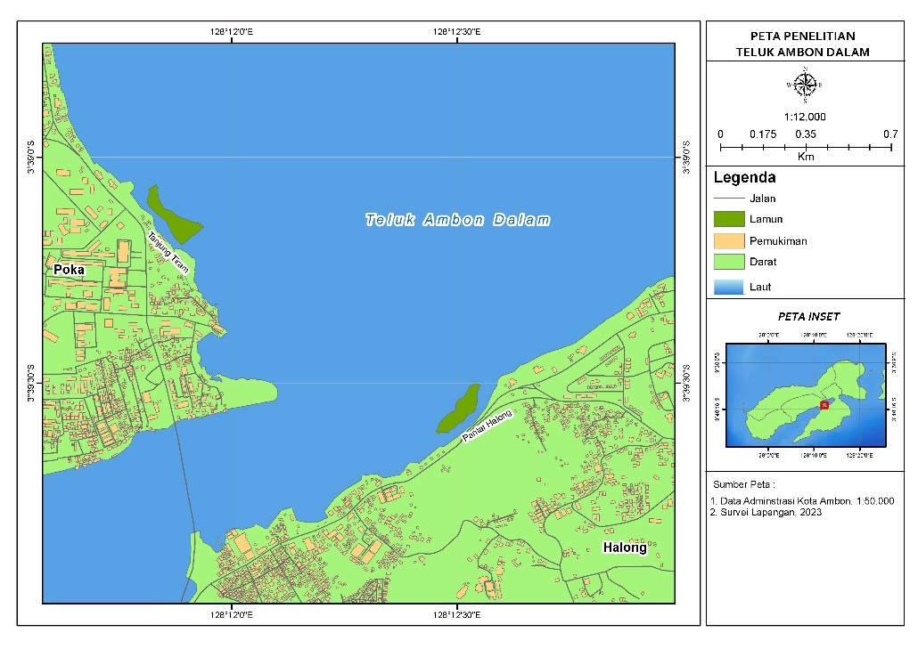

Inner Ambon Bay

Figure 1. Research Location

**Data Collection**

**Water Characteristics Data**

Data collection for the water characteristics of the ecosystem included temperature, salinity, and pH, which were measured in situ using a thermometer, hand refractometer, and pH meter. Meanwhile, nitrate levels in the water were measured ex situ, where water samples were collected and brought to the laboratory for analysis.

**Gas Sampling Method**

Gas sampling was conducted by placing a chamber over the sediment in the seagrass beds, targeting the dominant species present. Each location consisted of five chamber placement points, with a distance of 20 meters between points. The time interval for gas collection between points was 10 minutes. The chamber was placed at each point for 120 seconds, with gas samples collected five times at 30-second intervals, specifically at t = 0s, 30s, 60s, 90s, and 120s (Lin et al., 2020; Nazareth & Gonsalves, 2022). The collected gas was then transferred into 10 mL vial bottles (Rahman et al., 2018; Rahman et al., 2020) for greenhouse gas concentration analysis at the Greenhouse Gas Laboratory of the Agricultural Instrument Standardization Agency (BSIP) in Pati Regency, Central Java.

**Data Analysis**

**Greenhouse Gas Concentration Analysis**

The analysis of greenhouse gas concentration, specifically CH₄, was conducted using the gas chromatography-mass spectrometry (GC-MS) method. The analysis involved extracting 2–3 mL of gas from the vial bottle and passing it through a thermal conductivity detector using a syringe.

**Greenhouse Gas Emission Analysis**

After obtaining the greenhouse gas concentration values, carbon emission analysis was conducted using the equation from Rahman et al. (2020):

F = $⎸\frac{S* V* t* mW}{(RT* A)}$ ⎸

Note:

**F**: Carbon gas flux (µg/m²/hour)

**S**: Regression slope of carbon gas concentration measured every 30 seconds (ppm/s)

**V**: Chamber volume (L)

**A**: Surface area covered by the chamber (m²)

**R**: Ideal gas constant (0.082 L·atm/K·mol)

**T**: Temperature inside the chamber or air temperature (K)

**t**: Time transformation constant = (1 hour / gas sampling interval = 3600 seconds / 30 seconds = 120)

**mW**: Relative atomic mass of C (CH₄: 16 g/mol)

**RESULTS AND DISCUSSION**

**Seagrass Species**

The dominant seagrass species found at the study sites consisted of four species. In Tanjung Tiram, three species were identified: *Halodule pinifolia*, *Enhalus acoroides*, and *Thalassia hemprichii*, while in Halong Beach, four species were found: *Cymodocea rotundata*, *Halodule pinifolia*, *Enhalus acoroides*, and *Thalassia hemprichii*. Both Tanjung Tiram and Halong Beach host 28.57% of the total 14 seagrass species found in Indonesian waters (Krisye et al., 2023b). In Maluku waters, ten seagrass species have been recorded (Irawan, 2017). Differences in seabed substrate types influence the variation in seagrass species present, as each seagrass species has its own substrate preference for growth and survival (Yunita, 2014).

**Water Parameters**

The average temperature in the seagrass beds of Tanjung Tiram was 25°C, while at Halong Beach, it was 31°C. The temperature difference between the two study sites was influenced by weather conditions during observations — Tanjung Tiram experienced rainfall, whereas Halong Beach had clear weather. Water temperatures in Indonesian waters range between 24.6°C and 32.3°C (Patty, 2018), making these temperatures still favorable for seagrass growth.

The average salinity in the seagrass beds of Tanjung Tiram was 28.3‰, while at Halong Beach, it was 28.8‰. These salinity levels are still within the normal range for seagrass growth. According to Dahuri (2001), seagrass has a salinity tolerance ranging from 10‰ to 40‰. Based on water quality standards outlined in Government Regulation of the Republic of Indonesia Number 22 of 2021, salinity values should range between 33‰ and 34‰, with changes not exceeding ±5‰.

The average pH in the seagrass beds of Tanjung Tiram was 7.5, whereas at Halong Beach, it was 7.6. These pH values fall within the normal range for seagrass growth. According to Government Regulation of the Republic of Indonesia Number 22 of 2021, the standard water quality for pH ranges between 7 and 8.5. Based on the measured environmental parameters, the seagrass bed conditions at Tanjung Tiram and Halong Beach are considered good.

The average nitrate concentration in the seagrass beds at both Tanjung Tiram and Halong Beach was 0.01 mg/L. According to Government Regulation of the Republic of Indonesia Number 22 of 2021, the standard water quality limit for nitrate is 10 mg/L, indicating that the nitrate levels in the seagrass beds at Tanjung Tiram and Halong Beach are still within normal or good limits.

**N₂O Concentration**

The N₂O gas concentration for each seagrass species across locations showed relatively similar values. At the Tanjung Tiram site, the highest N₂O concentration was found in *T. hemprichii* at 0.372 ppm, while the lowest was in *E. acoroides* at 0.355 ppm. At the Halong Beach site, the highest N₂O concentration was observed in *H. pinifolia* at 0.376 ppm, while the lowest was in *C. rotundata* at 0.346 ppm (Figure 2).

Figure 2. N2O Concentration

Based on the concentration values obtained at Tanjung Tiram and Halong Beach, the differences between each seagrass species were not significant. This is further supported by the fact that nitrate concentrations at both locations were identical, at 0.01 mg/L. According to Riniatsih (2015), seagrass beds play a role in stabilizing aquatic environments, resulting in relatively uniform N₂O concentration distribution at both Tanjung Tiram and Halong Beach.

**N₂O Emissions**

At the Tanjung Tiram site, the highest N₂O emissions were observed in *H. pinifolia* at 0.01289 mg/m²/hour, while the lowest emissions were recorded in *T. hemprichii* at 0.00484 mg/m²/hour. In contrast, at the Halong Beach site, the highest N₂O emissions were found in *T. hemprichii* at 0.00923 mg/m²/hour, whereas the lowest emissions were observed in *H. pinifolia* at 0.00183 mg/m²/hour (Figure 3).

These differences may be attributed to substrate type and seagrass leaf morphology (Krisye et al., 2023a). At Tanjung Tiram, *H. pinifolia* grows on sandy substrates with higher porosity compared to muddy substrates, combined with small leaf morphology that does not fully cover the substrate area, facilitating gas release. Conversely, at Halong Beach, *H. pinifolia* is found on sandy substrates containing fine gravel, resulting in larger substrate pores. This increases the likelihood of oxygen (O₂) penetrating more easily, influencing the anaerobic denitrification process (Samiaji, 2012).

Figure 3. N2O Gas Emissions

**Conclusion**

The highest N₂O concentration at the Tanjung Tiram site was found in *T. hemprichii* at 0.372 ppm, while the lowest was in *E. acoroides* at 0.355 ppm. At the Halong Beach site, the highest N₂O concentration was observed in *H. pinifolia* at 0.376 ppm, with the lowest in *C. rotundata* at 0.346 ppm.

The highest N₂O emissions at the Tanjung Tiram site were recorded in *H. pinifolia* at 0.01289 mg/m²/hour, while the lowest emissions were in *T. hemprichii* at 0.00484 mg/m²/hour. In contrast, at the Halong Beach site, the highest N₂O emissions were observed in *T. hemprichii* at 0.00923 mg/m²/hour, while the lowest emissions were recorded in *H. pinifolia* at 0.00183 mg/m²/hour.

**Reference**

Dahuri, R. (2001). Coastal and marine space management along with the implementation of regional autonomy. Mimbar. Volume XVII No.2 April-June.

Intergovernmental Panel on Climate Change 2007. Climate Change 2007: Mitigation. Contribution of Working Group III to the Fourth Assessment Report of the Intergovernmental Panel on Climate Change [B. Metz, O.R. Davidson, P.R. Bosch, R. Dave, L.A. Meyer (eds)]. New York: Cambridge University Press.

Irawan, A. 2017. Lipi Ambon Seagrass Collection 2008-2015 Lipi Ambon Seagrass Collection Of 2008-2015. Lonawarta, XXIII(2), 1-21

Krisye, K., Fendjalang, S. N., & Rahman, R. (2023a). Concentration and CO2 Emissions in Seagrass Ecosystem Inner Ambon Bay. Agrikan Journal of Agribusiness Fisheries, 16(2), 57-62.

Krisye, K., Rahman, R., Fendjalang, S. N., & Sirajuddin, N. T. (2023b). Types and Coverage of Seagrass in the Waters of Maginti Island, West Muna Regency, Southeast Sulawesi. Grouper: Scientific Journal of Fisheries, 14(1), 24-28.

Lilitnuhu, M. K., Kesaulya, I., & Rahman, R. (2024). Global warming potential of nitrous oxide (N2O) gas emissions in the mangrove area of ​​Poka Village, Ambon City. Jurnal Laut Pulau: Hasil Penelitian Kelautan, 3(1), 10-18.

Lin C.W, Kao YC, Chou M.C, Wu H.H, Ho C.W, Lin H.J. 2020. Methane emissions from subtropical and tropical mangrove ecosystems in Taiwan. Forests. 11 (470): doi:10.3390/f11040470.

Nazareth, D.R., Gonzalves, M.J. 2022. Influence of seasonal and environmental variables on the emission of methane from the mangrove sediments of Goa. Environ Monit Assess. 194:249. Doi:https://doi.org/10.1007/s10661-02109734-3.

Patty, S. I., & Akbar, N. (2018). temperature, salinity, pH and dissolved oxygen conditions in coral reef waters of Ternate, Tidore and surrounding areas. Journal of Archipelago Marine Science, 1(2), 1-10.

Government of the Republic of Indonesia. 2021. Government Regulation of the Republic of Indonesia Number 22 of 2021 Concerning the Implementation of Environmental Protection and Management. Government Regulation. Jakarta.

Rahmadania, N. (2022). Global Warming Causes of the Greenhouse Effect and Its Mitigation. Journal of Engineering Sciences, 2(3).

Rahman, R., Effendi, H., & Rusmana, I. (2017). Estimation of carbon stock and absorption in mangroves in the Tallo River, Makassar. Journal of Forestry Sciences, 11(1), 19-28.

Rahman, Yulianda F, Rusmana I, Wardiatno Y. 2020. Seasonal fluxes of CO2, CH4 and N2O greenhouse gases in various mangrove species on the coast of West Muna Regency, Southeast Sulawesi, Indonesia. Plant Archives. 20(2): 4301 – 4311.

Riniatsih, I. (2016). Distribution of seagrass species is associated with the distribution of aquatic nutrients in the seagrass beds of Awur Jepara Bay. Journal of Tropical Marine, 19(2), 101-107.

Rugebregt, M. J., & Matuanakotta, C. (2020). Syafrizal. 2020. Species Diversity, Seagrass Cover, and Water Quality in Ambon Bay. Journal of Environmental Science, 18(3), 589-594.

Samiaji, T. (2012). Characteristics of N2O (Nitrogen Oxide) gas in the Indonesian atmosphere. Berita Dirgantara, 13(4).

Siahaya, M., Tupan, C. I., & Rahman, R. (2023). The Relationship between Seagrass Type Density and CO2 Emissions in Negeri Waai Waters, Salahutu District, Central Maluku Regency. Journal of Tropical Fisheries Management, 7(2), 69-75.

Wahyudi, J. (2019). Greenhouse Gas (GHG) Emissions from Open Burning of Household Waste Using the IPCC Model. Jurnal Litbang: Media Informasi Penelitian, Pengembangan Dan IPTEK, 15(1), 65-76.

Yunitha, A., Wardiatno, Y., & Yulianda, F. (2014). Substrate diameter and seagrass species on the Bahoi coast of North Minahasa: a correlation analysis. Jurnal Ilmu Pertanian Indonesia, 19(3), 130-135.