Technical and economic evaluation of mechanised canoe puller for small-scale fishery in Ghana

**ABSTRACT**

The small-scale fishing industry in Ghana pulls canoes manually upon arrival from fishing. Such activity has been identified as tedious and labour demanding among fishing activities. The study aimed to compare a canoe's manual and mechanised pulling. To compare the methods, the heart rate (HR) of two (2) fishermen trained to operate the developed canoe puller machine also involved in manual pulling during manual and mechanised pulling methods through the same distance while the time used was recorded. A polar heart rate (MP430) watch was used to measure the HR of the fishermen. A cost analysis was done for each operation. Descriptive statistics and analysis of variance (ANOVA) were done using GenStat software (VSN International, 2011). Means were obtained using the least significant difference (LSD). Statistical significance was carried out at p<0.05. The mean heart rates during manual and mechanised pulling were 123.15 and 103.10 bpm, respectively. The energy expenditure required for manual was 786.27 W and mechanised was 558.50 W. The mean time used during manual pulling through a distance of 130 m was 21.5 min while 8.4 min was recorded for mechanising. Mechanised pullingreduces labour costs by 64% and time reduction by 43.8%.

Keywords: Canoe pulling, heart rate, manual, mechanised, rest period.

**1 Introduction**

Fisheries play a critical role in the global economy and food security, providing livelihoods for millions and serving as a primary source of protein for over a billion people worldwide (Pradeepkiran, 2019). According to the Food and Agriculture Organization (FAO), global fish production, including aquaculture, reached 178 million metric tons in 2020, with 156 million tons used for human consumption. This represents a significant increase compared to previous decades, driven largely by the growth of aquaculture, which accounted for 46% of the global fish supply in 2020 (FAO, 2022). However, expanding fisheries, particularly capture fisheries, has led to several challenges, including overfishing, habitat destruction, and unsustainable practices (Jesintha, and Madhavi, 2020).

The FAO reports that about 34.2% of the world’s marine fish stocks are overfished, meaning that they are being harvested at a rate that exceeds their ability to replenish (FAO, 2022). Overexploitation threatens biodiversity, marine ecosystems, and the livelihoods of those who depend on fisheries. Key regions affected by overfishing include the Mediterranean and Black Seas, the Southeast Pacific, and the Southwest Atlantic (FAO, 2022). Industrial-scale fishing is the primary driver of overfishing, as larger vessels with advanced technology can harvest vast amounts of fish quickly, depleting stocks.

According to Ye and Gutierrez (2017), the efforts to combat overfishing have led to development of international agreements and sustainable fishery management practices. The 1995 FAO Code of Conduct for Responsible Fisheries and the United Nations Sustainable Development Goals (SDGs), particularly Goal 14 ("Life Below Water"), aim to conserve marine resources and ensure their sustainable use (FAO, 2022). Additionally, initiatives such as marine protected areas (MPAs) and fisheries management plans (FMPs) have been implemented in various countries to regulate fishing activities, protect vulnerable species, and promote sustainable practices (Muawanah et al., 2018). In 2018, the FAO estimated that about 7.6% of marine areas were under some form of protection (FAO, 2022). Aquaculture, or fish farming, has become an increasingly important aspect of the global fishery industry. China is the largest producer of farmed fish, contributing approximately 58% of the global aquaculture output in 2020. The success of aquaculture in Asia has contributed to stabilizing fish supply and reducing the pressure on wild fish stocks (FAO, 2022). However, aquaculture also faces challenges, such as pollution, disease outbreaks, and the overuse of antibiotics. Sustainable aquaculture practices are being promoted to address these issues, including improved feed management, water quality control, and responsible farming techniques (FAO, 2022).

In recent years, climate change has emerged as a significant threat to global fisheries (Ficke et al., 2007). Rising sea temperatures, ocean acidification, and changes in marine ecosystems have impacted fish stocks and migratory patterns. Species such as cod, salmon, and tuna are particularly vulnerable, as their breeding and feeding grounds are affected by warming waters. Coastal communities that rely on fisheries are increasingly exposed to the risks of extreme weather events and rising sea levels (Sumaila et al., 2019). To mitigate these impacts, global fisheries must adopt adaptive management practices that account for the effects of climate change on marine ecosystems.

Ghana, located along the Gulf of Guinea, has a long-standing fishing tradition, with fisheries playing an important role in the country’s economy and food security. The fisheries sector in Ghana consists of marine, inland, and aquaculture components. The marine subsector, which includes artisanal, semi-industrial, and industrial fisheries, is the most significant contributor to total fish production, accounting for approximately 70% of Ghana’s fish supply (Nunoo et al., 2015). Inland fisheries, particularly on Lake Volta, are also important, while aquaculture is a rapidly growing sector.

Artisanal fisheries dominate the marine sector in Ghana, employing over 80% of the fishing workforce and contributing significantly to the livelihoods of coastal communities (Finegold et al., 2010). These small-scale fishers typically use canoes, nets, and traditional fishing methods to harvest a variety of species, including small pelagic fish such as anchovies and sardinella. However, Ghana’s marine fish stocks have been in decline due to overfishing, illegal fishing practices, and the use of destructive fishing methods such as light fishing and monofilament nets (Nunoo et al., 2015).

The Ghanaian government, with support from international organizations such as the World Bank, has developed a Fisheries Management Plan (FMP) to address the challenges facing the sector. The FMP, introduced in 2015, aims to reverse the declining trend in fish stocks and establish a sustainable management regime for the country's fisheries (Fisheries Commission, 2015). Key strategies outlined in the FMP include reducing fishing efforts, enforcing fishing regulations, promoting alternative livelihoods for fishers, and developing aquaculture as a sustainable alternative to capture fisheries (Ali et al. 2022).

One of the most pressing challenges facing Ghana's fisheries is the issue of illegal, unreported, and unregulated (IUU) fishing, particularly by industrial trawlers. These trawlers, often foreign-owned, engage in practices such as "saiko" fishing, where catch is illegally sold to artisanal fishers. This practice depletes fish stocks and undermines the livelihoods of local fishers (Nunoo et al., 2015). In response, the government has strengthened enforcement measures, including the deployment of marine patrols and the use of vessel monitoring systems to track fishing activities (Fisheries Commission, 2015).

Aquaculture in Ghana has seen rapid growth in recent years, particularly in the production of tilapia. The sector has been promoted as a means of reducing pressure on wild fish stocks and meeting the growing demand for fish. By 2020, Ghana’s aquaculture production had increased to 76,000 metric tons, making it one of the largest aquaculture producers in West Africa (Finegold et al. 2010). However, challenges such as high feed costs, disease management, and limited access to credit continue to constrain the sector's growth.

Manual fishing, often referred to as artisanal or small-scale fishing, is a traditional method widely practiced in Ghana, particularly by communities along the coast and around inland water bodies like Lake Volta (Afoakwah et al. 2018). This form of fishing is labor-intensive, relying on simple, non-motorized equipment such as canoes, nets, and hooks, passed down through generations. Artisanal fishing plays a crucial role in Ghana’s fisheries sector, contributing significantly to both national fish production and local livelihoods (Nunoo et al. 2015). It is estimated that artisanal fishers account for more than 80% of the total marine fish catch in Ghana (Finegold et al. 2010).

Typically, fishers use dugout canoes, some of which are equipped with outboard motors for increased mobility, though a significant number still rely solely on manpower. The process begins with fishers paddling their canoes out to sea or into rivers and lakes, deploying various types of nets depending on the target species. Gill nets and seine nets are commonly used, and they are manually cast into the water and later hauled back to shore by teams of fishers using sheer physical strength (Akyeampong, 2007). The effort required to pull the nets to shore is physically demanding and often involves multiple individuals working together to manage the weight of the catch and the resistance of the ocean currents.

One of the traditional techniques employed by artisanal fishers is the "ali" or beach seine fishing method, where large nets are cast from the shore or a boat, and then pulled in by hand. This technique, though effective for catching small pelagic fishlike anchovies and sardinella, is notorious for its laborious nature, requiring hours of physical exertion. Fishers often work in groups, coordinating their movements to synchronize pulling the nets ashore, where the catch is collected (Asiedu et al. 2013).

Manual fishing in Ghana is not without its challenges. Laborious nature of manual fishing, particularly the task of pulling canoes and nets ashore after a day at sea, poses health risks to fishers, including musculoskeletal injuries and fatigue (Nunoo et al. 2015). Moreover, the lack of modern fishing technologies limits the efficiency and safety of small-scale fishers, as they often venture into dangerous waters with little protection against harsh weather or mechanical failures (Béné et al., 2015).

Despite these challenges, artisanal fishing continues to be a vital part of Ghana's socio-economic fabric, supporting coastal and inland communities. The government and international organizations have recognized the importance of this sector, initiating programs aimed at promoting sustainable fishing practices and improving the livelihoods of fishers through better access to modern fishing gear, training, and alternative income-generating activities (Fisheries Commission, 2015), it is not certain in the level of difficulty and adverse effect on labourers.

Fishermen depend on their mussels to pull canoes on shore in Ghana. This process is likely to affect their health on the job. The mechanical methods have been established by developing canoe-pulling machines.

The behaviour of fishermen in Ghana shows that they are ignorant about the long-term effect on over dependent on their strength to pull canoes but are always concerned availability of premix fuel to power their adbord motor for fishing but do not pay much attention to the long-term effect that will affect them in future. Serious evidence during the study suggests that pulling of canoe offshore after returning from fishing is extremely dangerous. The practice of pulling a canoe raises the question of whether fishermen or the Government know the implications of their actions. Therefore, the study aimed to analyse the level of difficulty and possible effects that may affect the pulling process.

The study makes two contributions: First, the study addresses important knowledge gaps on the drudgery, and secondary time spent in pulling canoes offshore, adding to the literature on small scare fishery within Ghana. This study seeks to compare manual and mechanised canoe pulling. To compare the two methods, the study aims at determining the drudgery and feasibility of manual canoe pulling and mechanical device developed.

*1.2 Drudgery*

Difficulty in doing the physical job is termed drudgery (Keim *et al*., 2004; Majumder and Shah, 2017). Drudgery in pulling canoe could be determined by the monitoring of heart rate (HR) signifies workload. HR is a sureness active technique of determining exercise oxygen treaty and energy spending for work done due to its solid connection with oxygen intake (Ericsson *et al*., 2006; Crouter *et al.,* 2004). Ericsson *et al*. (2006) settled that heart rate is an effective and dependable predictor of exercise intensity and energy outlay for activities for about 120 minutes. Arkoh et al. (2021) also compared manual and mechanised planting using the HR method. Arkoh et al. (2021); Amponsah *et al*. (2014) and Ericsson *et al*. (2006) gave several accounts on comparing manual (physical work) and mechanise activities.

**2 Materials and Methods**

*2.1 Description of fabricated canoe puller*

The detailed description of developed canoe puller is shown in **Figure** 1. The canoe puller consists of the gear box, engine and drum mounted on the frame.

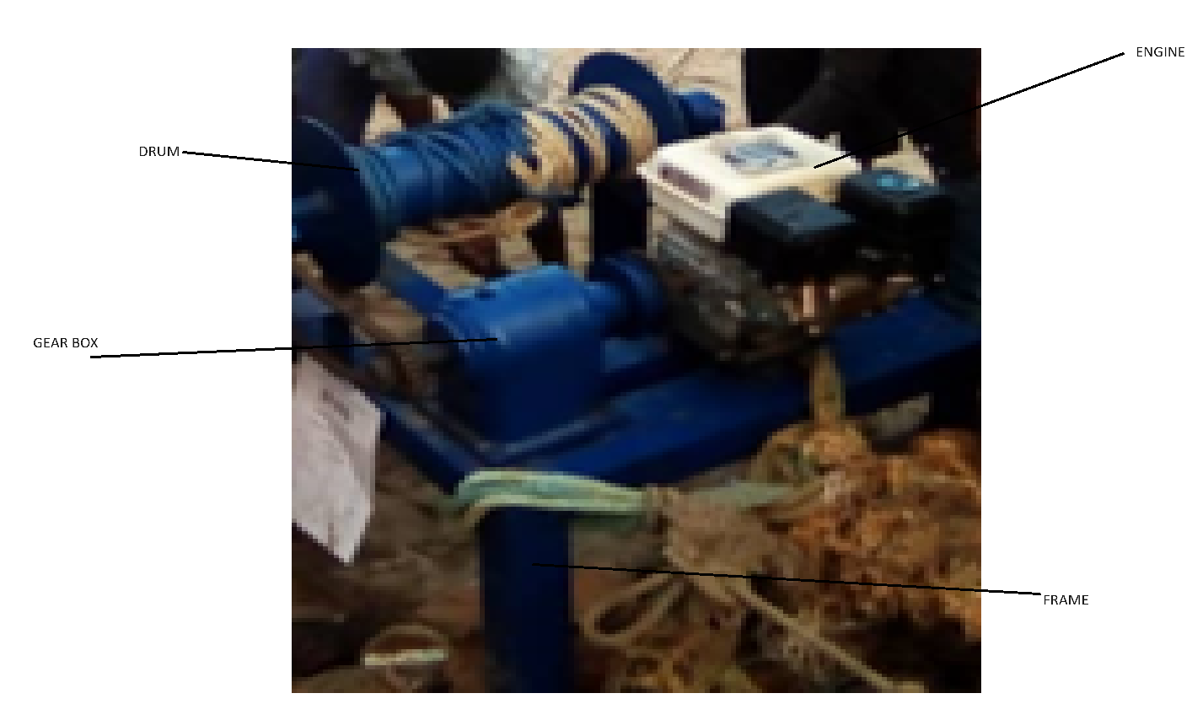

**Fig 1**: developed canoe puller during trial

*2.2 Study Area*

The evaluation of the mechanical canoe puller device was done at (OLA) beach located at Cape Coast in the Central Region of Ghana. The agro-ecological characteristics of the study area are as described in **Table 1**.

**Table 1** Agro-ecological characteristics of the test site

|  |  |  |
| --- | --- | --- |
| Characteristics |  | Location Cape Coat (OLA) Beach |
|  | 50481N,10, 14.91W |
| Agro-ecological |  | Coastal savanna transition |
| Average temperature (0C) |  | 27.6 |
| Wet season | Major | May-July |
|  | Minor | September-November |
| Average annual rainfall(mm) |  | 1009 |
| Relative humidity (%) |  | 68.8 |

*2.3 Heart rate measurement*

The heart rates of the workers were measured to determine energy expenditure whiles time was recorded to establish the duration of each operation to determine drudgery. A polar heart rate (M430) watch was used to obtain the mean heart rate for the respective operations. The watch was worn around the wrist of two (2) men on the right hand of the workers for 20 min before pulling operations started, the reason is that mounting the watch may induce stress. To know how much energy is used for physical work, the rest period (min/h) required by a person after work was determined using **Equation 1** adopted from Jones (1988). **Figure 2** presents polar watch for HR measurement. Heart rate energy conversion chart and rest period calculation was used for conversion(Foreman et al. 2022)**.**

$Tr=60 (1-\frac{250}{P})$ (1)

Where,

*Tr* = Total rest period (min/h), *P* = Gross energy consumption (Watts)

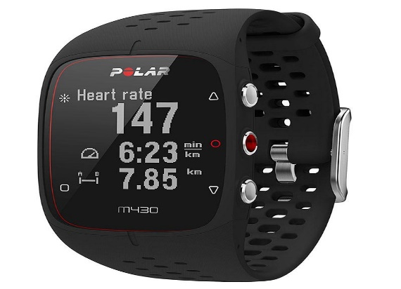

**Figure 2:** Polar (M430) watch.

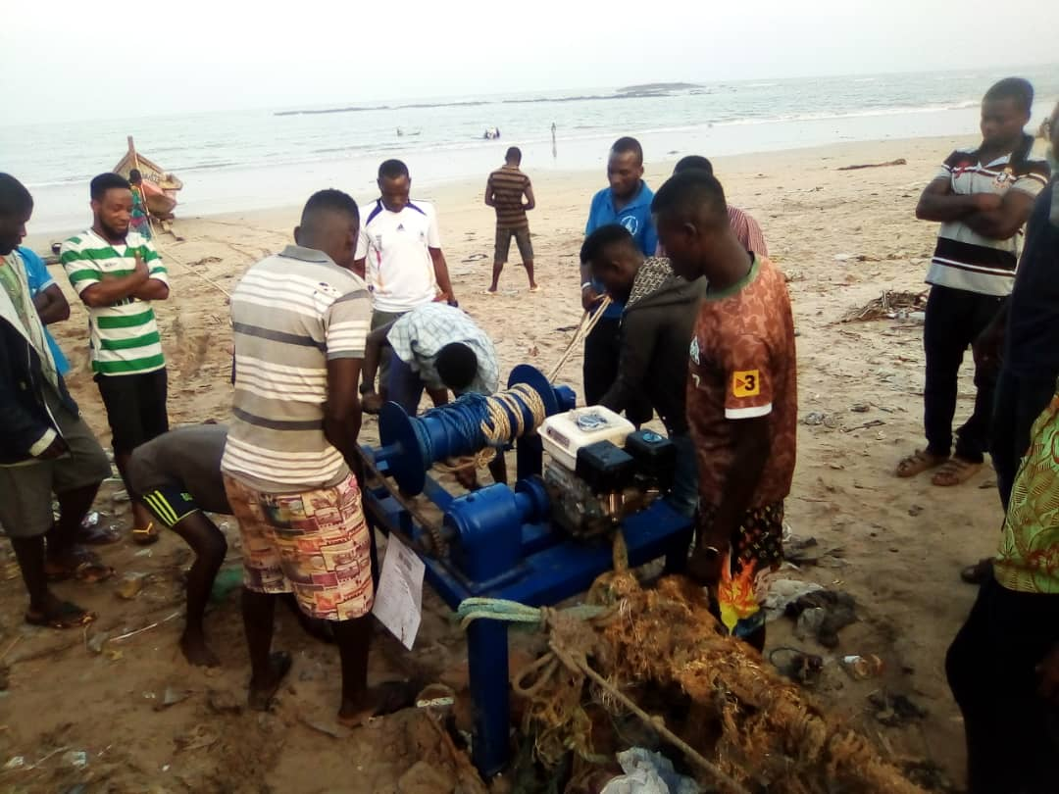

(A)

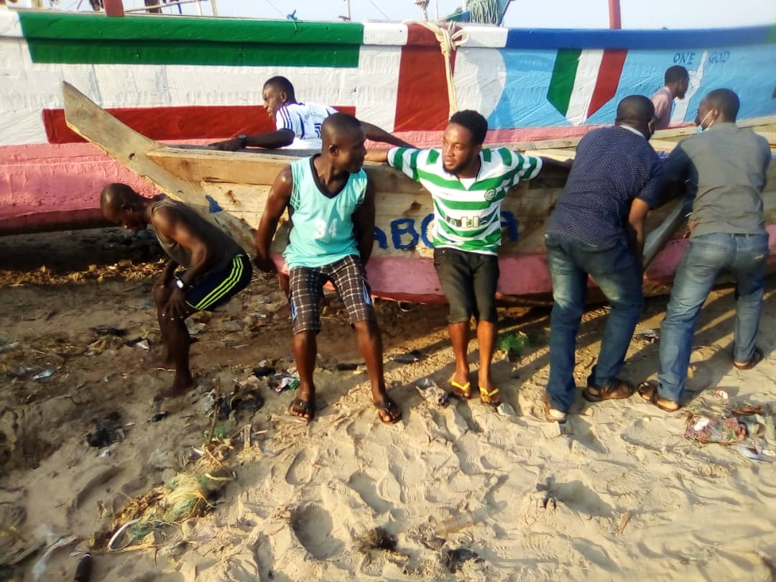

(B)

**Figure 3**: (A) Mechanised canoe pulling and (B) Manual canoe pulling (Source: Field survey)

*2.4 Fuel consumption measurement*

Arkoh et al. (2021) directly measured the fuel consumption of the tractor during the planting operation. The fuel used was determined by filling the fuel tank to the brim before and after each trial. Quantity of fuel in liters required to refill the tank was recorded as the fuel consumed for the pulling.

*2.5 Experimental design and data analysis*

The experiment design was a completely randomized design (CRD) with three (3) replications. The experimental factor was the method of pulling a canoe. The factor levels were manual and mechanized. Twenty fishermen (20) with an average weight of 78.46 kg were contracted to pull and control the canoe for manual operation while two men were used to guide the canoe during mechanised pulling. The pulling was done through the same distance of 130 m to determine time and drudgery for two different pulling methods. The same two men who wore the polar watch were involved in the respective operations.

Data obtained from the trials were statistically analysed. Descriptive statistics and analysis of variance (ANOVA) were done using GenStat software (VSN International, 2011). Means were obtained using the least significant difference (LSD). Statistical significance was carried out at p≤0.05. Turkey and Fisher's approach was used to determine any differences in treatment measured. **Table 2** presents the dimensions of a canoe used for the experiment.

**Table 2** Measurement of the canoe used.

|  |  |
| --- | --- |
| Dimensions | |
| Length (m) | 10 |
| Width (m) | 2 |
| Depth (m) | 0.8 |
| Weight (kg) | 1400 |

(Source: Field survey).

**3 Results and Discussion**

*3.1 Heart Rate Measurement*

**Table 3** presents the mean heart rate with corresponding gross energy consumption and rest period during manual and mechanized canoe pulling activities. The mean heart rates during manual and mechanized pulling were 123.15 and 103.10 bpm, respectively. Similarly, the energy expenditure needed for the manual was 786.27 W and for the mechanised was 558.50 W. There was a significant difference (p<0.05) in mean heart rate for manual and mechanize canoe pulling. It was observed from the mean heart rate, gross energy consumption, and rest periods that, a longer period of rest was needed to compensate for used energy. The association between energy consumption and the rest period was in line with findings by Arkoh et al. (2021); Amponsah *et al*. (2014); Bobobee and Gebresenbet, (2007) that, physical work requires more rest periods.

**Table 3** Mean heart rate (bpm), gross energy consumption (W), and total rest period (min/h) for manual and mechanize canoe pulling.

|  |  |  |  |
| --- | --- | --- | --- |
|  | Evaluation parameter |  |  |
| Activities | Mean Heart Rate (bpm) | Estimated Energy (W) | Rest Period (min/h) |
| Manual Pulling | 123.15a | 786.27 | 40.98 |
| Mechanized pulling | 103.10b | 558.50 | 33.18 |
| LSD | 11.36 |  |  |

*Within each column, means followed by the same subscript letter are significantly different (LSD) at p≤0.05.

The mean time used during manual pulling through a distance of 130 m was 21.5 minutes while 8.4 minutes was for mechanise through the same distance. This implies that 46 fishermen are required to pull a canoe of the same size in 8.4 minutes. The mean fuel consumed during the trial to pull through 130 m was 0.24 litres.

It was observed from the **Table 3** that mechanise pulling allows a reduction of 64% labour cost and reduced timeliness in pulling by 43.8%. Apart from several benefits of mechanising canoe pulling, the fact that the pulling is done in the shortest possible time and an appreciable reduction in labour cost as compared to manual pulling make it easier for the fishmongers to make their sales at the right time.

4 **Conclusions**

The study concluded that the mean heart rates during manual and mechanised pulling were 123.15 and 103.10 bpm, respectively. Similarly, the energy expenditure needed for the manual was 786.27 W and mechanised was 558.50 W. Mechanising pulling had demonstrated a much better reduction in total offloading cost fish upon arrival by about 64%, and 43.8% timeliness reduction over the manual pulling option.

**References**

Afoakwah, R., Osei, M. B. D., & Effah, E. (2018). A guide on illegal fishing activities in Ghana. *USAID/Ghana Sustainable Fisheries Management Project. Narragansett, RI: Coastal Resources Center, Graduate School of Oceanography, University of Rhode Island. Prepared by the University of Cape Coast, Ghana. GH2014_SCI048_UCC*, *64*.

Akyeampong, E. (2007). Maritime history and the fishing industry in colonial Ghana. Oxford University Press.

Ali, M., Atminarso, D., Anggraeni, D. P., & Kaban, S. (2022). Issues and challenges in sustainable development of fisheries and aquaculture of the Southeast Asian Region: Fishery management: Management of fishing capacity and combating IUU fishing. *The Southeast Asian State of Fisheries and Aquaculture 2022*, 122-127.

# Amponsah, S. K., Bobobee, E. Y., Agyare, W. A., Okyere, J. B., Aveyire, J., King, S. R. & Sarkodie-Addo, J. 2014. Mechanical cassava harvesting as influenced by seedbed preparation and cassava variety. Applied engineering in agriculture, 30**,** 391-403.

# Arkoh, A. K,Amponsah, S. K and Opoku-Asante J (2021). Comparative Analysis of Manual and Mechanized Yam Minisett Planting. *International Journal of Engineering and Advanced Technology (IJEAT) 11(1)*

Asiedu, B., Nunoo, F. K. E., & Pauly, D. (2013). The use of beach seine nets in Ghanaian fisheries: Impacts on fisheries and environment. Fisheries Centre Research Reports, 2013(2), 14-22.

Béné, C., Devereux, S., & Roelen, K. (2015). Social protection and sustainable natural resource management: initial findings and good practices from small-scale fisheries. *FAO Fisheries and Aquaculture Circular*, (C1106), I.

# Crouter, S., Albright, C. & Bassett, D. 2004. Accuracy Of The Polar S410 Heart Rate Monitor For Estimating The Energy Cost of Exercise. Medicine & Science in Sports & Exercise, 36**,** S249.

# Ericsson, F., Dalarna, U. & Björklund, G. 2006. The relationship between heart rate and power output during cycling competitions. FAO. 2013. FAO Statistical Yearbook: World Food and Agriculture, FAO. FAOSTAT, F. 2015. FAO Statistics Division; 2014.

FAO. (2022). The state of world fisheries and aquaculture 2022: Towards blue transformation. Food and Agriculture Organization of the United Nations.

Ficke, A. D., Myrick, C. A., & Hansen, L. J. (2007). Potential impacts of global climate change on freshwater fisheries. *Reviews in fish biology and fisheries*, *17*, 581-613.

Finegold, C., Gordon, A., Mills, D., Curtis, L., & Pulis, A. (2010). Western and Central African fisheries: Overview of fisheries resources and governance frameworks. WorldFish Center.

Fisheries Commission. (2015). Fisheries management plan of Ghana: A plan for sustainable fisheries management in Ghana 2015-2019. Ministry of Fisheries and Aquaculture Development.

Foreman, N. A., Lee, E. J., & Lundstrom, C. J. (2022). Assessment of a Treadmill Speed Incline Conversion Chart: A Validation Study. *International journal of sports physiology and performance*, *17*(7), 1030-1036.

Jesintha, N., & Madhavi, K. (2020). Marine capture fisheries: Sustainability issues. *International Journal of Fisheries and Aquatic Studies*, *8*(5), 34-37.

Jones, N. 1988. The interpretation of stage 1 exercise test results. Clinical exercise testing, 158.

# Keim, N. L., Blanton, C. A. & Kretsch, M. J. 2004. America’s obesity epidemic: measuring physical activity to promote an active lifestyle. Journal of the American Dietetic Association, 104**,** 1398-1409.

Majumder, J., & Shah, P. (2017). Mapping the role of women in Indian Agriculture. *Annals of Anthropological Practice*, *41*(2), 46-54.

Muawanah, U., Yusuf, G., Adrianto, L., Kalther, J., Pomeroy, R., Abdullah, H., & Ruchimat, T. (2018). Review of national laws and regulation in Indonesia in relation to an ecosystem approach to fisheries management. *Marine Policy*, *91*, 150-160.

Nunoo, F. K. E., Asiedu, B., Amador, K., Belhabib, D., & Pauly, D. (2015). Reconstruction of marine fisheries catches for Ghana, 1950–2010. Fisheries Centre Working Paper, 2015(70), 1-13.

Pradeepkiran, J. A. (2019). Aquaculture role in global food security with nutritional value: a review. *Translational Animal Science*, *3*(2), 903-910.

Sumaila, U. R., Lam, V. W., Miller, D. D., Teh, L., Watson, R. A., Zeller, D., & Pauly, D. (2019). Winners and losers in a world where the high seas is closed to fishing. Scientific Reports, 9(1), 1-10.

Ye, Y., & Gutierrez, N. L. (2017). Ending fishery overexploitation by expanding from local successes to globalized solutions. *Nature Ecology & Evolution*, *1*(7), 0179.