Design and fabrication of canoe pulling machine for small-scale fishery in Ghana

ABSTRACT

The canoe puller was designed and constructed to aid fishermen pull their canoe. The mechanise pulling was achieved by designing and fabricating the machine required to pull the canoe offshore. This study sought to ease the minds and strength of the fishermen who think the only means of pulling the canoe is by using their hands and strength. The concept design for the canoe-pulling machine was based on general evaluation criteria such as components, materials, cost, safety, maintenance, and accessibility, which enabled the researcher to arrive at the final project design. The construction was done to aid in the pulling of the canoe to ensure that persons (fishermen) who are done with their daily activities will not go through the hell of struggling to pull the canoe with their hands and strength. The maximum von misses’ stress recorded was 24.16 MPa while deformation was 28.5 mm. The mass, area, and volume of the designed canoe puller were 111.39 kg, 2.53 m2, and 14.99 m3 respectively. The design and construction of the canoe puller eliminate dependents of manpower for canoe pulling.

**Keywords:** Canoe puller, Fisher men, Manual pulling, Mechanised pulling.

**1 Introduction**

Fishing is a source of livelihood and nutrition for millions worldwide. However, the fishing industry is confronted with various challenges, particularly in manual activities involved in fishing activities. Globally, many fishing communities still depend heavily on manual labour for their processes, which leads to various challenges (Salas et al., 2007). A report by Acquah and Maclean (2024), on traditional fishing operations often requires physical effort, which includes hauling in nets and pulling canoes ashore. This labour-demanding nature can lead to physical strain and injuries among fishermen. Laraqui et al. (2024) reported that lifting heavy nets and guiding boats, frequently result in musculoskeletal disorders.

Although, the demand for fish has increased suddenly due to population growth and increased consumption, further straining manual fishing activities. Deepitha and Ajina, (2023) reports that global fish consumption is at an all-time high, demanding more resourceful methods of capture and processing. Conventionally manual methods struggle to preserve pace, leading to concerns over sustainability and the lessening of fish stocks (Pauly, 2022).

Studies indicate that the time spent on manual operations reduces actual fishing time, impacting production. A study by Lozano et al. (2023) reported that manual pulling and hauling can consume significant hours, restraining the number of trips fishermen makes and eventually affect their income.

Fishing in Ghana is not only an economic activity but also a cultural foundation. Ghana Statistical Service (2021) estimated that more than 2.7 million people are involved in fishing, which contributes significantly to the national economy. Despite its importance, the manual operations related with fishing pose substantial challenges. According to Evans (2022), pulling canoes ashore requires substantial effort and direction among community members, often causing delays and increased fatigue. This state of affairs is mostly problematic during peak fishing seasons when the demand for quick reversal times is high.

The manual nature of fishing in Ghana also worsens health and safety risks. Fishermen are prone to injuries from lifting heavy loads and tedious motions. Researcher, Laraqui et al. (2024) reported that a significant number of fishermen encounter work-related injuries, which not only affect their immediate health but also their long-term ability to work. Okyere et al. (2023) reported that health risks discourage younger individuals from involvement in the fishing industry, posing a threat to the sector's future sustainability.

The deficiencies associated with manual fishing operations in Ghana contribute to larger economic challenges. Reliance on community labour for tasks such as pulling canoes leads to functioning delays and increased rivalry for available manpower (Chowdhury and Gow, 2024). The reliance on community labour result in conflict within communities, particularly when labour is scarce. Furthermore, the lack of mechanisation in many Ghanaian fishing operation limits the potential for increased production. According to Gutierrez and Lemma (2024), mechanising canoe pulling is the solution to enhance efficiency of canoe retrieval and processing, allowing fishermen to focus more on actual fishing. The authors again reported that investing in technology could lead to higher productivity and better economic outcomes for fishing communities.

There are lots of coastal areas in Ghana where fishing is the major source of income. Fishermen in these areas find it difficult to pull their canoe whenever they return from fishing. They have a rope tied to the head of a canoe and on the sea and a person has to swim to the shore and organize about 20 people to help pull the canoe.  Even though these communities rely on only fishing activities, the process of pulling the canoe off shoes is tedious and time-consuming. Hence, the study aims to mechanising the pulling of canoe by designing and fabricating a canoe puller.

The study adopted the concept of a winch device for hauling. The hauling is made up of a rope, cable wound around a horizontal rotating drum and turned by a crank or motor and typically mounted at the rear of a towing vehicle.

A winch is a mechanical device that is used to pull in (wind up) or let out (wind out) to adjust the [tension](https://en.wikipedia.org/wiki/Tension_(physics)) of a [rope](https://en.wikipedia.org/wiki/Rope) or [wire rope](https://en.wikipedia.org/wiki/Wire_rope). In its simplest form, it consists of a [spool](https://en.wikipedia.org/wiki/Bobbin) attached to a hand [crank](https://en.wikipedia.org/wiki/Crank_(mechanism)). Winches are the basis of such machines as [tow trucks](https://en.wikipedia.org/wiki/Tow_truck), [steam shovels](https://en.wikipedia.org/wiki/Steam_shovel) and [elevators](https://en.wikipedia.org/wiki/Elevator) (Vigneshkumar and Rasagopal, 2008). More complex designs have [gear](https://en.wikipedia.org/wiki/Gear) assemblies and can be powered by electric, [hydraulic](https://en.wikipedia.org/wiki/Hydraulic), [pneumatic](https://en.wikipedia.org/wiki/Pneumatic) or [internal combustion](https://en.wikipedia.org/wiki/Internal_combustion) drives. It might include a [solenoid brake](https://en.wikipedia.org/wiki/Solenoid_brake) and/or a [mechanical brake](https://en.wikipedia.org/wiki/Mechanical_brake_stretch_wrapper) or [ratchet and pawl](https://en.wikipedia.org/wiki/Ratchet_(device)) which prevents it unwinding unless the [pawl](https://en.wikipedia.org/wiki/Pawl) is retracted. The study is expected to help the fishermen to pull their canoe to the shore easily after in a shortest possible time.

To design a canoe puller adopted the concept from a winch device for hauling or lifting. A winch consists of drum, motor, gear train, and chain drive. A drum is circular in shape and allows the wire to be neatly wrapped around it. A spool within the winch allows the drum to rotate in a circular motion, winding the cable in or out (Khoshbin et al., 2024). The motor powers the drum to turn so that it can pull in and wrap the wire around itself. Not all winches include a motor, most vehicle winches are electric and include a [winch motor](https://www.lbdcmotor.com/product/dc-motor-12v/winch-motor-hy61098.html) to speed things up considerably. The gear train component takes the power from the motor and converts it into pulling power, giving the winch the ability to pull in any kind of heavy material. These pieces come together to make the complete winch work. The cable wire is pulled out and attached to the object that is planned on towing. Once attached, the motor is turned on to turn the spool and pulls the cable back towards the vehicle and neatly around the drum. The item being towed comes along for the ride.

According to Wen and Zhang (2024) avoidance of slipping, steel chains are made up of rigid links hinged together to provide the necessary flexibility for warping around the driving and driven wheels. The wheels have projecting teeth and fit into the corresponding recesses, in the link of chain. The wheels and chain are thus constrained to move together without slipping and ensure a perfect velocity ratio (Adel, 2024)

**2 Materials and Methods**

*2.1 Materials selection*

The principle of mechanise canoe pulling adopted the concept of a winch device for hauling or lifting. Mild steel was used for the frame due to its resistance to breakage under stress and its weldability. The pieces were fabricated by tacking all joints to enable it for straightness and alignments temporary and also for corrections to be done before final welding. The motor mount and the drum mount were also constructed on the frame. The welded joints were grinded to prevent sharp edges. Agauge 12 electrode was used for welding the joints. The sprocket selected hadlow friction**,** self-lubrication,andabrasion resistance. **Figure 1** shows a sectional view of the designed “drum”. **Equation** **1** was used to determine the length of the rope.

**Table 1** Mild steel detail properties

|  |  |  |
| --- | --- | --- |
| Description/properties | Properties mild steel | Values |
|  | MASS DENSITY (g/cm3) | 7.85 |
| General | Yield strength (MPa) | 250 |
|  | Ultimate tensile strength (MPa) | 420 |
|  | Young’s Modulus (GPa) | 220 |
| Stress | Poisson’s Ratio (ul) | 0.275 |
|  | Shear Modulus (GPa) | 86.274 |
| Part name (s) | L60 x 60x5 Angle Bar |  |
|  | Bearing 116000 GOST 8995-75116108 |  |

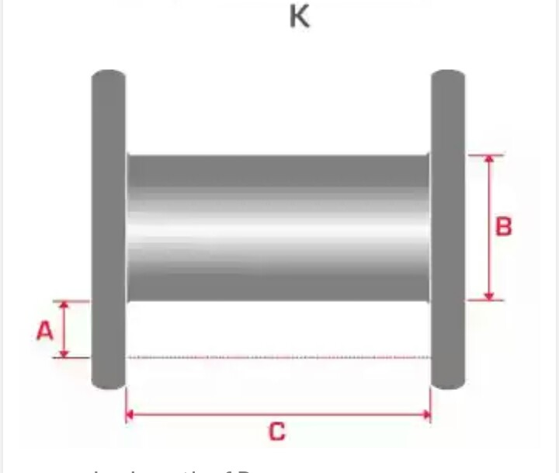

Figure 1 Sectional view of the “drum.”

*2.2 Drum Calculation*

Maximum load =10 KN

Diameter of rope =152 mm

Length of drum =610 mm

Desire length of winding = 76 mm

Thickness of drum = 10 mm

Length of the rope = $\frac{(A+B)×A×C}{K}$ (1)

Where; A =Desire length of winding, B = Diameter of barrel, C = Width between the flanges, K = A constant developed according to the diameter of the rope (20): Factor of safety = 6

*2.2 Bearing and Shear Stress on Axle*

**Figure 2 and 3** shows schematic drawing of a bearing and **Figure 3** shows the fabrication process of the designed canoe puller. The shear stress on axle, the analysis will be studied in two cases. One was the moment present at outer flange and shear force equally distributed. Other was reaction forces with no moment. Moment present at outer flange and shear force equally distributed. The reaction force act between the two flange and spread evenly them.

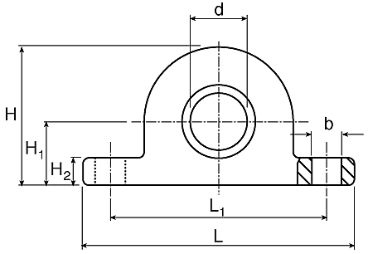

Figure 2: Schematic drawing of a bearing

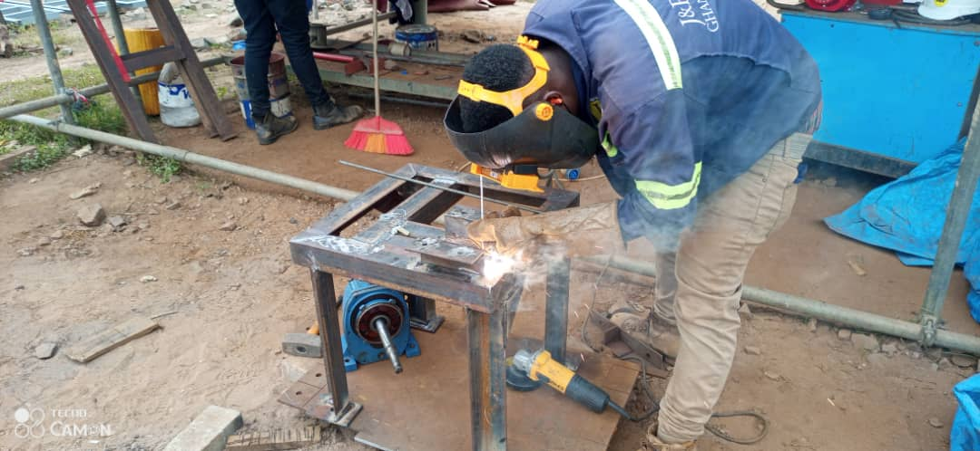

**Figure 3**: Fabrication process of the designed canoe puller.

**3 Results and Discussion**

*3.1 Frame Pieces in Isometric View for Fabrication*

**Figure 4 and 5** present pictorial and pictorial view of fabricated canoe puller, respectively.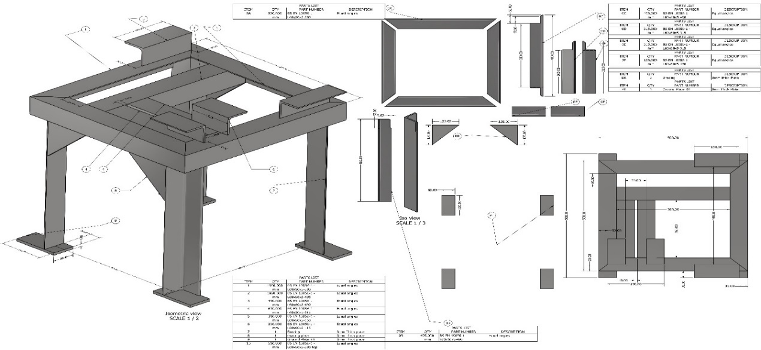**Figure 4:** Design drawing and dimensions of the frame for fabrication.

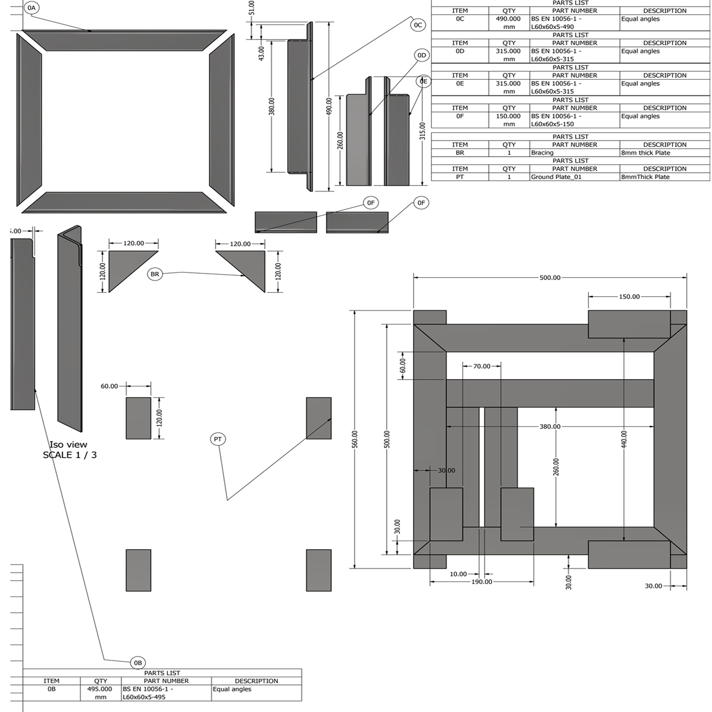

Figure 5 Pieces of angle iron for fabrication

*3.2 Exploded views of developed canoe puller*

Final design of the developed canoe puller is shown in Figure 6.

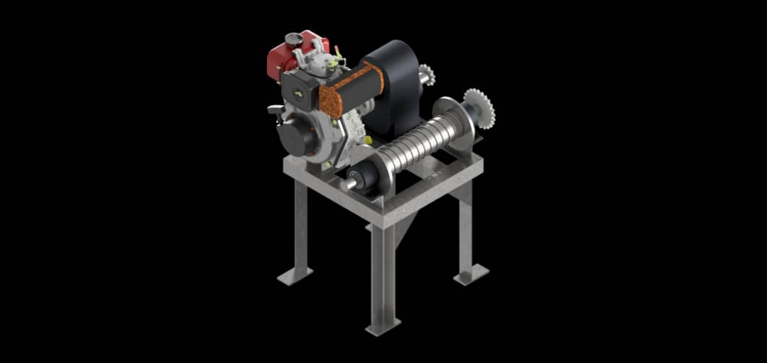

Figure 6: The Final Design

*3.3 Simulation results of the canoe puller*

**Table 2** presents a summary of simulation results of von misses’ stress, deformation among others. The maximum von misses’ stress recorded was 24.16 MPa while deformation was 28.5 mm. All these values were below the equivalent (von-misses’) stress and deformation standard values of 400-550 MPa for von misses’ stress and that of deformation of up to 50 mm. The mass, area and volume of the designed canoe puller were 111.39 kg, 2534250 mm2 and 14999100 mm3 respectively.

**Table 2** Specification of canoe puller

|  |  |  |
| --- | --- | --- |
| Description | Minimum | Maximum |
| Volume (mm3) | 28391400.00 | - |
| Mass (kg) | 216.352 | - |
| Von mises stress (mpa) | 0.0000187 | 24.16 |
| Deformation (mm) | 0.0 | 28.5 |
| Compressive stress (mpa) |  | -26.9 |

The maximum compressive stress is -26.9 MPa which occurs on the outside surface.

Note that the deformation shown is usually exaggerated by at least 10 times (or more). This allows the user to visualize the distortion for very stiff materials like steel, where distortion is often too small to notice visually. Maximum displacement in this case is 28.5 mm. **Safety factor** is based on the material's properties. A high safety factor means a safe product. It can be checked using the maximum stress values.

*3.4 Installation of mechanical drive systems, gearbox and drum the on frame*

The motor (prime mover) was installed on the frame, bolts and nuts (fasterners) were used to hold the motor on the motor mount on the frame. All alignments were properly checked and all corrections were done. **Figure 7** shows a developed canoe puller showing main components (engine, gearbox, drum and the frame).

The gearbox was coupled to the motor also on the frame. The gearbox is bolted firmly on the frame to avoid vibrations. All alignments were checked; shims were used to enable good alignments to use the right washers before bolting to the frame. All mechanical drive system (chain drive and sprockets) was installed after the gearbox installation. The drum was installed on the frame for the pulling mechanism. The drum was grooverd to enable the rope or wire coil around the drum during its operation. A bearing was fixed on both sides of the shaft on the drum which was then mounted on the bearing seat on the frame.

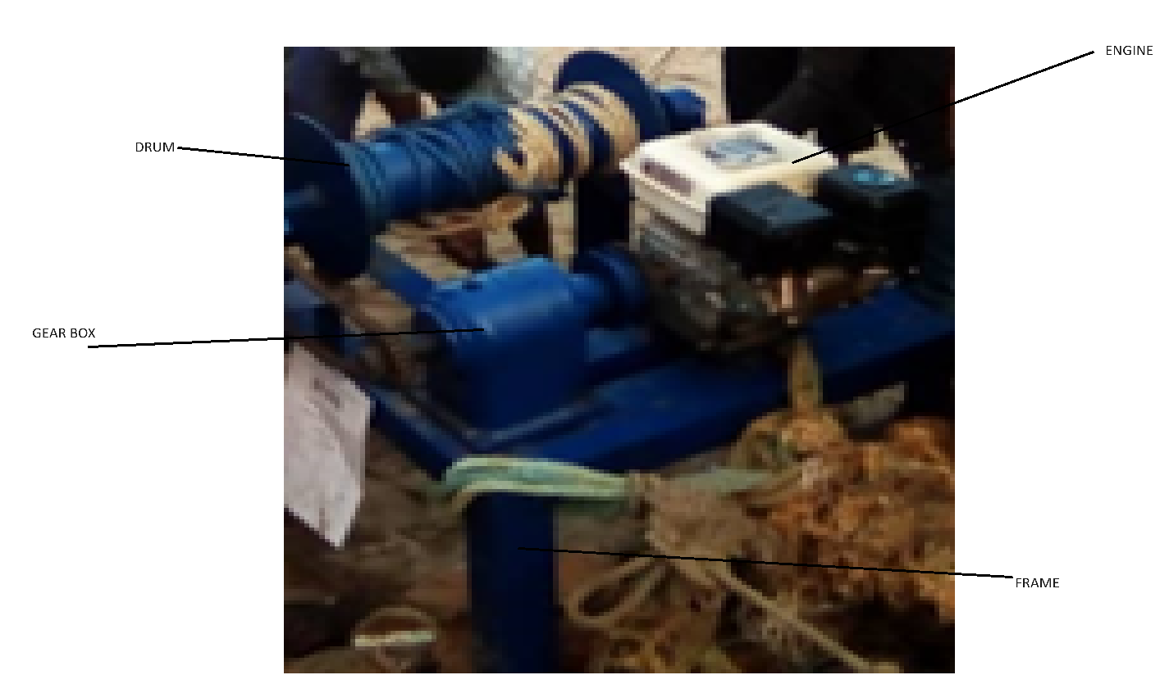

Figure 7: Developed canoe puller showing the main parts.

**4 Conclusion and Recommendations**

*4.1 Conclusion*

The canoe pulling machine was designed and constructed. All vibration analysis and corrective checks for the motor mount was factored during the assembling of the mechanical drive system. The maximum von misses’ stress recorded was 24.16 MPa while deformation was 28.5 mm. All these values were below the equivalent (von-misses’) stress and deformation standard values. The mass, area and volume of the designed canoe puller were 111.39 kg, 2534250 mm2 and 14999100 mm3 respectively.

*4.2 Recommendation*

The study recommended that the developed mechanized canoe puller should be evaluate to compare its efficiency against the pulling of canoe by reliance of fisher folks.

**References**

Acquah., E., O., & Maclean G., A. (2024). Songs of the Sea: the Socio-Cultural Fabric of Fisherfolk Work Songs in Winneba. *African Journal of Culture, History, Religion and Traditions*, *7*(2), 13–25. https://doi.org/10.52589/ajchrt-293yqahu

Adel, B. (2024). *Conception of multi-function machine for sweeping , cleaning roads and mowing lawns*. 2023–2024.

Chowdhury, A., & Gow, G. A. (2024). Digital Communication for Agricultural and Rural Development. In *Digital Communication for Agricultural and Rural Development*. https://doi.org/10.4324/9781003282075

Deepitha, R. P., & Ajina, S. M. (2023). *Journal of Indian Fisheries Association Inter-island Fishery Resources of Indian Ocean : A budding prospect for the Indian Seafood sector*. *50*(December).

Evans, C. (2022). All but Forgotten: Early Measures for Maritime Safety on Canada’s West Coast. *The Northern Mariner / Le Marin Du Nord*, *31*(4), 387–408. https://doi.org/10.25071/2561-5467.914

Gutierrez, M., & Lemma, A. (2024). *Estimating the impact of irregular and unsustainable fishing of distant-water fishing fleets in Ghana*. *May*. http://www.jstor.org/stable/resrep59273

Khoshbin, E., Otis, M. J. D., & Meziane, R. (2024). Reconfigurable cable-driven parallel mechanism design: physical constraints and control. *Robotica*, 1–47. https://doi.org/10.1017/S0263574724001486

Laraqui, O., Roland-Lévy, C., Ghailan, T., Bouri, H. El, Manar, N., Deschamps, F., & Laraqui, C. E. H. (2024). Musculoskeletal disorders of fishermen in the artisanal and coastal sector. *International Maritime Health*, *75*(1), 1–9. https://doi.org/10.5603/imh.98470

Lozano, A. G., Finkbeiner, E. M., & Finkbeiner, E. (2023). *Decent Work in the Artisanal Jumbo Flying Squid Fishery (Dosidicus gigas) in Peru*. *April*. https://doi.org/10.13140/RG.2.2.20444.67207

Okyere, S., Frimpong Boamah, E., Asante, F. A., & Yeboah, T. (2023). Children’s Work in Ghana: Policies and Politics. In *Children’s Work in African Agriculture*. https://doi.org/10.56687/9781529226072-013

Pauly, D. (2022). Why do fish reach first maturity when they do? *Journal of Fish Biology*, *101*(2), 333–341. https://doi.org/10.1111/jfb.14902

Salas, S., Chuenpagdee, R., Seijo, J. C., & Charles, A. (2007). Challenges in the assessment and management of small-scale fisheries in Latin America and the Caribbean. *Fisheries Research*, *87*(1), 5–16. https://doi.org/10.1016/j.fishres.2007.06.015

Vigneshkumar, N., & Rasagopal, P. (2008). The Study of Material Handling Equipment in Industries for Safety Operation. *International Journal of Advances in Engineering and Management (IJAEM*, *2*(5), 295. https://doi.org/10.35629/5252-0205295304