Original Research Article

Exploring the Potential of Traditional Eggplant Varieties in Malaysia for Sustainable Agriculture

.

ABSTRACT

|  |
| --- |
| This study evaluated traditional Malaysian eggplant cultivars (*terung rapuh* and *terung telunjuk*) compared to commercial varieties (*terung panjang* and *terung bulat*) for pest and disease resistance, and nutritional and phytochemical properties. The study was conducted at the Malaysian Agriculture Research and Development Institute (MARDI) in Serdang, Selangor. The eggplants were planted in single row planting with 90 cm between plants in the row and 200 cm between rows using Randomised Complete Block Design with three replicates. The proximate compositions and major elements analysis were conducted at accredited laboratory Unipeq, Universiti Kebangsaan Malaysia. The traditional cultivars demonstrated lower pest and disease incidence, particularly *terung telunjuk*, suggesting inherent resistance mechanisms. Nutritional analysis revealed that *terung rapuh* had the highest carbohydrate, energy value, and essential micronutrients (calcium, magnesium, iron, sodium, zinc). Furthermore, *terung rapuh* exhibited the strongest antioxidant activity and highest total phenolic content. These findings highlight the potential of traditional eggplant cultivars as valuable genetic resources for developing sustainable agriculture and promoting dietary diversity in Malaysia. Specifically, *terung rapuh* and *terung telunjuk* offer promising traits for breeding programs focused on enhanced pest and disease resistance, improved nutritional value, and increased antioxidant capacity. |

*Keywords: Indigenous eggplant; brinjal; underutilized crop; food security*

1. INTRODUCTION

Eggplant, also known as brinjal or aubergine, is a popular vegetable in Southeast Asia, including Malaysia. The name in Malaysia is called *terung*. It is botanically classified as a fruit, and the world production of eggplant is around 55.2 million tons (Jarerat et al., 2022). Eggplant is widely used in various cuisines, particularly in Asia, North Africa, and Southern Europe, and it is considered one of the greatest vegetables in terms of oxygen radical absorbance capacity due to its high phenolic content.

Vegetables industry in Malaysia has long been an integral component of the nation's agricultural landscape, contributing significantly to the country's economic prosperity and ensuring food security for its growing population. The production of eggplant in the country has experienced notable growth over the past decades, with the total harvested area of eggplant reaching approximately 2,705 hectares and a production volume of 45,776 metric tons as of the most recent reports in 2023 (Ministry of Agriculture and Food Security, 2024). However, the majority of the commercially cultivated eggplant varieties in Malaysia are derived from improved or hybrid lines, and the cultivation of traditional or local eggplant varieties has been gradually declining, potentially leading to the loss of valuable genetic resources and traditional agricultural knowledge. Recognizing the importance of preserving these traditional eggplant varieties, researchers have turned to the process of bioprospecting, which involves the systematic exploration and investigation of biodiversity for commercially valuable genetic, biochemical, and other resources.

Malaysia is blessed with a diverse array of traditional eggplant varieties that have been cultivated for a long time by local communities for generations. Each variety has its unique characteristics and potential benefits. One of the most popular variety in Malaysia is the *terung telunjuk*, a green pericarp with an elongated shape, which is perfect for making salad and served as a side dish. Other traditional eggplant varieties in Malaysia include *terung rapuh*, a light-colored pericarp, *terung asam*, a yellow-colored pericarp and *terung susu*, a white-colored pericarp. However, the traditional eggplant varieties in Malaysia have not been extensively studied, and there is a lack of information on their potential for sustainable agriculture.

Therefore, this study seeks to investigate the bioprospecting potential of selected traditional eggplant cultivar in Malaysia, with the aim of identifying unique characteristics and benefits that could contribute to the promotion of sustainable agriculture as well as their conservation and utilization in the region.

2. material and methods

**2.1 Field Evaluation**

The study was conducted at the Malaysian Agriculture Research and Development Institute (MARDI) in Serdang, Selangor. Four cultivars of eggplant were used in the experiment which were *terung telunjuk, terung rapuh, terung bulat* and *terung panjang*. This study employed a combination of field evaluation include agronomic practices, inventory of pest and diseases, and analyses of nutritional and energy value to achieve the research objectives.

All eggplants seeds were sown in the glasshouse and transferred to the field 3 weeks after germination. They were planted on raised bed measuring 30 cm height and 100 cm wide. The trial was established as single row planting with 90 cm between plants in the row and 200 cm between rows using Randomised Complete Block Design with three replicates.

Throughout the cultivation process, the eggplants received regular watering, scheduled fertilizer applications, and integrated pest management practices to ensure their optimal growth and development. Data for days to flowers, plant height, fruit number per plant, fruit weight and fruit yield were recorded. To further explore the nutritional and energy attributes of the traditional eggplant varieties, fruit samples from each cultivar were meticulously collected and subjected to a comprehensive analytical assessment to determine their diverse nutritional and energy-related properties. Analysis of variance was used to distinguish the plant means (SAS software).

**2.2 Inventory of Pest and Diseases**

An inventory of pests and diseases affecting the eggplant varieties was also conducted to assess their resilience and adaptability to local environmental conditions. Data on pest and disease incidence are recorded and compared among the selected cultivars. A total of three insect sampling techniques were carried out i.e. scoring, yellow sticky traps (YST) and sweeping (using sweep net). The collected insect samples were then identified and classified using taxonomic keys to determine the dominant pests affecting the eggplant cultivars.

Inventory of plants that infected by bacteria, fungi and viruses was done routinely based on the symptom’s development. Samples of infected plants will be collected and washed with 10% Clorox followed by 70% alcohol and three times rinse with distilled water. The clean samples then used for bacteria and fungus isolation. To isolate the bacteria, sample was crushed using mortar and pestle. Subsequently, the sap was spread on Nutrient Agar (NA) plate prior to incubation at 25° C for 1-2 days. Meanwhile for isolation of fungus, a cut of clean sample was placed on the Potato Dextrose Agar (PDA) media which then incubated at room temperature for 3-7 days. Isolation of virus was done by inoculating host plants with the sap of infected plants. Formation of lesion was observed and the infected leaves were then used in virus identification. For species identification, DNA samples of bacteria, fungi and viruses were extracted using DNA and/or extraction kit following manufacturer's instruction manual. Polymerase chain reaction (PCR) was performed using universal primers; 16S rRNA and 18S rRNA respectively for bacteria and fungi whilst specific primer was used for identification of virus.

**2.3 Analysis of Nutritional and Energy Value**

To determine the nutritional and energy-related properties of the traditional eggplant cultivars, fruit samples from each variety were meticulously collected and subjected to comprehensive analytical assessments. The samples of crude extract were sent to accredited laboratory Unipeq, Universiti Kebangsaan Malaysia for proximate compositions and major elements analysis. The proximate analysis of the eggplant samples was carried out to determine their moisture, ash, crude protein, crude fat, and carbohydrate content through the application of standard, well-established analytical procedure. The energy value in terms of kilojoules per 100 grams of fresh weight was also determined. For the mineral analysis, the eggplant samples were first digested for the accurate quantification of major minerals, including calcium, magnesium, sodium, zinc and copper.

**2.4 Determination of Antioxidant Activity (2,2-diphenyl-1-picrylhydrazyl (DPPH))**

Scavenging activity of the eggplant extracts on 2,2-diphenyl-1-picrylhydrazyl (DPPH) radicals was assayed according to Molyneux (2004) with slightly modifications with minimum exposure of light. Various concentrations of the eggplant crude extracts in methanol were prepared to give a final volume of 7 µl and were mixed with 280 µl of methanolic solution containing DPPH (Sigma, USA) radicals resulting in a final concentration of 0.06 mM. The mixture was vigorously shaken and left to stand for 30 min. in the dark. The absorbance was measured at 517nm. Meanwhile, ascorbic acid (Sigma, USA) was used as the positive control. The results were expressed as IC50 value (mg/ml), which is the inhibitory concentration at which DPPH radicals were scavenged by 50%.

**2.5 Determination of Total Phenolic Content (TPC)**

The total phenolic content of the eggplant extracts was estimated by a colorimetric assay as described by Singleton and Rossi (1965) with slightly modifications and minimum exposure of light. Crude extracts (50 µL) were mixed with 100 µl of Folin Ciocalteau’s phenol reagent (Merck, Germany). After 3 minutes, 100 µl of 10% sodium carbonate (Na2CO3) (Sigma Aldrich, USA) was added to the reaction mixture and allowed to stand in the dark for 60 minutes. The absorbance was measured at 725 nm and the total phenolic content was obtained from a calibration curve using gallic acid (0-10 µg/ml) as a standard reference. The test was run in triplicate. The results were mean values ± standard deviations and expressed as mg gallic acid per 100 g samples.

3. results and discussion

Two traditional eggplant varieties were used in the experiment which were *terung telunjuk* and *terung rapuh* (Figure 1)*.* Meanwhile *terung bulat and terung panjang* (Figure 2) were the commercial varieties used in the experiment. The field evaluation and inventory of the eggplant varieties in Malaysia revealed a range of promising characteristics, including their resilience to local environmental conditions, unique nutritional profiles, and potential medicinal properties especially for the traditional eggplant varieties. The analysis of various agronomic parameters, such as days to flowering, plant height, fruit number per plant, fruit weight, and fruit yield, highlighted the diverse growth and production potential of the tested cultivars.

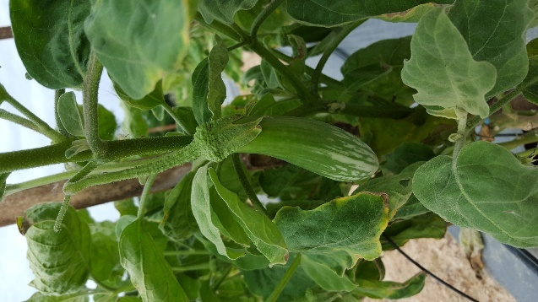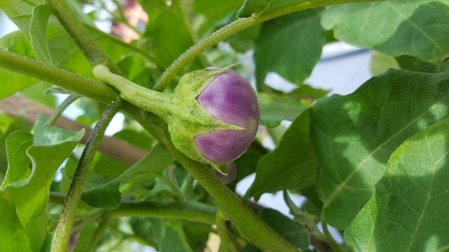

Figure 1. Tradistional eggplant varieties: t*erung telunjuk* (left) and *terung rapuh* (right).

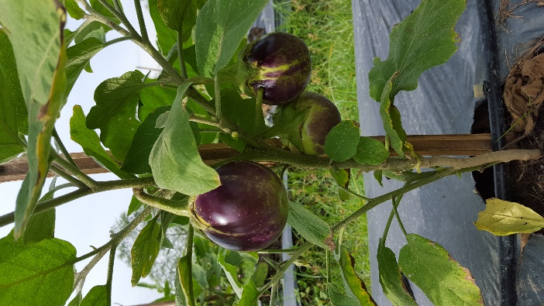 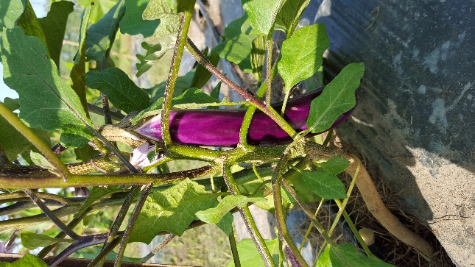

Figure 2. Commercial eggplant varieties: *terung bulat* (left) and *terung panjang* (right).

**3.1 Yield Traits**

Analysis of variance showed that *terung rapuh* has significantly different for days to flower among other cultivars but not in plant height across eggplant cultivar evaluated. Despite the observed variations in days to flowering, the study also found statistically significant differences in number of fruits per plant, average fruit weight, and total yield per plant between the traditional eggplant and commercial eggplant cultivars evaluated (Table 1).

*Terung rapuh* flowers the quickest at 49.83 days. *Terung telunjuk* takes the longest time, with 60.37 days. Other varieties (*terung bulat* and *terung panjang*) take intermediate times (56.30 and 55.13 days, respectively).  Plant height measurements revealed that *terung panjang* had the tallest plants with a height of 36.87 cm, followed by *terung bulat*, *terung telunjuk*, and *terung rapuh*. The results further demonstrated the diverse fruit production potential of the traditional eggplant cultivars, with *terung telunjuk* exhibiting the highest number of fruits per plant at 34.50, while *terung panjang* recorded the lowest fruit count among the varieties evaluated. However, in term of yield per plant, the commercial varieties *terung panjang* has the highest total yield, with 1912.70 grams per plant followed closely by *terung bulat* with a yield of 1880.70 grams per plant. Meanwhile *terung rapuh* and *terung telunjuk* have lower yields of 684.50 grams and 596.60 grams, respectively.

Table 1. Mean of days to flowers, plant height, fruit number, fruit weight and yield of *terung telunjuk*, *terung rapuh*, *terung bulat* and *terung panjang*.

|  |  |  |  |  |  |
| --- | --- | --- | --- | --- | --- |
| **Varieties** | **Days to flower** | **Plant height (cm)** | **Fruit no./plant** | **Fruit weight (g)** | **Yield/ plant (g)** |
| ***Terung telunjuk*** | 60.37ab | 30.10cd | 34.50a | 17.37g | 596.60f |
| ***Terung rapuh*** | 49.83e | 28.03d | 32.60a | 21.53g | 684.50f |
| ***Terung bulat*** | 56.30bcd | 31.47bcd | 19.80bcde | 123.97a | 1880.70ab |
| ***Terung panjang*** | 55.13cd | 36.87abc | 15.17e | 96.20c | 1912.70ab |

*Mean values with the same letter are not significantly different at p<0.05*

The traditional eggplant cultivars, *terung telunjuk* and *terung rapuh*, have the most fruits per plant but relatively low yield due to small fruit size as compared to the commercial varieties, *terung bulat* and *terung panjang* produces fewer fruits but achieves higher yield, due to the relatively large fruit size. Despite the lower total yields of *terung telunjuk* and *terung rapuh*, they command higher market prices than the larger-sized commercial eggplant cultivars. This is likely due to the strong consumer preference and demand for these traditional eggplant varieties, which are prized for their unique sensory attributes, such as distinctive flavor profiles and traditional culinary uses, as well as their status as locally-sourced and culturally-significant agricultural products.

**3.2 Insect Pest and Disease Incidence**

Field monitoring and laboratory analyses identified the dominant insect pests and diseases affecting the selected eggplant cultivars. The field evaluation identified the presence of several key insect pests, including green leafhoppers (*Amrasca sp*), fruit borer, thrips (*Thrips sp*), red spider mites, fruitfly (*Bactrocera dorsalis*), whitefly (*Bemisia tabaci*) and aphid, which were observed infesting the eggplant plants (Figure 3). The traditional eggplant cultivars, *terung rapuh* and *terung telunjuk*, demonstrated lower incidences of pest infestations compared to the commercial varieties, *terung panjang* and *terung bulat*. Moreover, *terung telunjuk* also shows of lowest percentage attacked by the fruit borer. This could be attributed to their inherent resistance or tolerance to common eggplant pests, potentially due to natural defense mechanisms or other cultivar-specific characteristics.

Figure 3. Percentage of pest infestation on *terung rapuh*, *terung telunjuk*, *terung panjang* and *terung bulat*.

To mitigate the impact of these pests and maintain the productivity of the traditional eggplant varieties, a multifaceted approach integrating the strategic use of eco-friendly biopesticides, physical barriers, and cultural practices such as crop rotation and companion planting would be crucial to achieve sustainable *pest* management (Ha, 2015).

Disease incidence was also monitored, with the *terung telunjuk* exhibiting lower susceptibility to common fungal and bacterial diseases, such as blight caused by the *Phomopsis vexans*, anthracnose caused by the Colletotrichum, and mosaic/mottling caused by viruses, compared to the commercial cultivars (Figure 4). These findings suggest that the traditional eggplant varieties may possess inherent resistance or tolerance to various biotic stresses, potentially stemming from their diverse genetic backgrounds and adaptation to local environmental conditions. The lower disease incidence observed in the traditional cultivars, such as *terung telunjuk*, could be attributed to their natural defense mechanisms and resilience, which have been developed through generations of cultivation in the local environment. This indicates the potential value of these traditional varieties as genetic resources for breeding disease-resistant eggplant cultivars and developing sustainable agricultural practices.

Figure 4: Percentage of disease incidence on *terung rapuh*, *terung telunjuk*, *terung panjang* and *terung bulat*.

**3.3 Nutritional, Energy and Phytochemical Properties**

The findings from the comprehensive analytical assessments revealed notable variations in the nutritional and energy-related properties among the traditional eggplant cultivars evaluated. Analysis of proximate composition from fresh samples of the different eggplant cultivars showed that *terung panjang* had the highest moisture content (91.8%), while *terung rapuh* had the highest protein content (2.46%). Additionally, the traditional eggplant cultivar terung rapuh displayed the highest carbohydrate levels across the tested varieties. The assessment also revealed that the traditional eggplant variety, *terung rapuh*, exhibited the highest energy value (223.1 kJ/100g), while the commercial cultivar, *terung panjang*, displayed the lowest energy value (127.1 kJ/100g) among the evaluated eggplant varieties (Table 2).

Table 2: Proximate analysis of terung telunjuk, terung rapuh, terung bulat and terung panjang

|  |  |  |  |  |  |  |
| --- | --- | --- | --- | --- | --- | --- |
|  | **% Moisture** | **% Protein** | **%**  **Ash** | **%**  **Fat** | **Total cho %** | **Energy kj/100g** |
| ***Terung telunjuk*** | 88.73 | 1.75 | 0.80 | 0.17 | 8.55 | 178.74 |
| ***Terung rapuh*** | 86.15 | 1.02 | 0.40 | 2.46 | 9.97 | 223.09 |
| ***Terung bulat*** | 88.45 | 0.99 | 0.42 | 1.45 | 8.69 | 183.93 |
| ***Terung panjang*** | 91.8 | 0.75 | 0.11 | 1.02 | 6.32 | 127.08 |

Further analysis of the mineral content indicated that the traditional eggplant cultivar *terung rapuh* had substantially higher levels of essential micronutrients, such as calcium (2374.2 mg/kg), magnesium (368 mg/kg), ferum (51.1 mg/kg), natrium (142.4 mg/kg), zinc (25.3 mg/kg) and copper (15.0 mg/kg), when compared to the other cultivars (Table 3). This finding suggests that the traditional eggplant cultivars, particularly *terung rapuh*, could potentially serve as a valuable dietary source of these essential minerals, which could contribute to addressing micronutrient deficiencies in the local population.

Table 3: The concentration (mg/kg) of mineral content in *terung telunjuk*, *terung rapuh*, *terung bulat* and *terung panjang*.

|  |  |  |  |  |  |  |
| --- | --- | --- | --- | --- | --- | --- |
|  | **Calcium**  (mg/kg) | **Ferum**  (mg/kg) | **Magnesium (x10)** (mg/kg) | **Sodium**  (mg/kg) | **Zinc**  (mg/kg) | **Copper**  (mg/kg) |
| ***Terung telunjuk*** | 261.8 | 52.2 | 251.1 | 276.2 | 22.3 | 10.9 |
| ***Terung rapuh*** | 2374.2 | 51.1 | 368.0 | 142.4 | 25.3 | 15.0 |
| ***Terung bulat*** | 292.8 | 33.1 | 372.9 | 123.6 | 13.8 | 9.1 |
| ***Terung panjang*** | 257.3 | 29.3 | 260.7 | 121.0 | 12.6 | 6.8 |

Meanwhile, radical scavenging test showed that, *terung rapuh* has the lowest IC50 value (2.38 mg/ml), suggesting it has the strongest inhibitory activity among the others eggplant cultivars (Table 4). IC50 is the concentration of a substance (in mg/ml) that is required to inhibit a biological or biochemical function by 50%. A lower IC50 indicates a stronger inhibitory effect and indicates stronger antioxidant activity (Kadhim et al., 2019). Additionally, total phenolic content (TPC) obtained from *terung rapuh* was 44.02 mg/g, highest compared to others eggplant cultivars. Total phenolic content (in mg/g), which is an indicator of the amount of phenolic compounds in the sample. Higher TPC usually suggests a higher antioxidant capacity. Hence it is suggested that the traditional eggplant cultivar *terung rapuh* exhibits higher levels of phenolic compounds and antioxidant activity compared to the others eggplant cultivars evaluated. *Terung rapuh* stands out with both the lowest IC50 (indicating stronger inhibition) and the highest TPC, making it potentially the most bioactive among the varieties tested. According to the study by Cao et al. (1996), eggplant is distinguished by its high levels of phenolic compounds, which confer antioxidant properties, and it ranks among the top ten vegetables with elevated antioxidant activity.

Thus, the traditional eggplant cultivars, particularly *terung rapuh*, could serve as valuable sources of natural antioxidants and bioactive phytochemicals, which have been shown to provide a range of health benefits, including the potential to mitigate oxidative stress and reduce the risk of chronic diseases (Gürbüz et al., 2018).

Table 4: The antioxidant activity IC50 values and total phenolic content (TPC) of eggplant cultivars.

|  |  |  |
| --- | --- | --- |
|  | **IC50 (mg/ml)** | **TPC (mg/g)** |
| ***Terung telunjuk*** | 6.11 | 35.61 |
| ***Terung rapuh*** | 2.38 | 44.02 |
| ***Terung bulat*** | 5.45 | 36.10 |
| ***Terung panjang*** | 6.65 | 27.39 |

4. Conclusion

The assessment of the traditional eggplant varieties in this investigation underscores their potential as valuable genetic resources for developing sustainable and resilient agricultural systems in Malaysia. The traditional eggplant cultivars, such as *terung rapuh* and *terung telunjuk*, exhibited lower susceptibility to common insect pests and diseases compared to the commercial eggplant varieties, suggesting their inherent resistance or tolerance traits. Furthermore, the traditional eggplant cultivars, particularly *terung rapuh*, displayed superior nutritional profiles, with higher levels of essential minerals, energy-related compounds, and antioxidant properties. They could serve as valuable genetic resources for developing new eggplant cultivars with improved antioxidant capacity and enhanced pest tolerance through selective breeding approaches. These findings emphasize the importance of conserving and promoting the cultivation of traditional eggplant varieties to ensure the sustainability and resilience of eggplant production in Malaysia, while also contributing to the diversification of the local food system and addressing nutritional challenges.

**DISCLAIMER (ARTIFICIAL INTELLIGENCE)**

Authors hereby declare that NO generative AI technologies such as Large Language Models (ChatGPT, COPILOT, etc.) and text-to-image generators have been used during the writing or editing of this manuscript.

References

Jarerat, A., Techavuthiporn, C., Chanchomsuek, C., & Nimitkeatkai, H. (2022). Enhancement of antioxidant activity and bioactive compounds in eggplants using postharvest LEDs irradiation. Horticulturae, 8(2), 134. https://doi.org/10.3390/horticulturae8020134

Molyneux, P. (2004). The use of the stable free radical diphenylpicrylhydrazyl (DPPH) for estimating antioxidant. Songklanakarin Journal of Science Technology, 26(2), 211-219.

Ministry of Agriculture and Food Security (2024). Malaysia agrofood in figures 2023. Policy and Strategic Planning Division Ministry of Agriculture and Food Security, Putrajaya.

Singleton, V. L., & Rossi, J. A. (1965). Colorimetry of total phenolics with phosphomolybdic-phosphotungstic acid reagents. American Journal of Enology and Viticulture,16,144-158

Ha, T. M. (2015). Developing an Integrated Pest Management Program for Tomatoes in The Red River Delta of Vietnam: A mini review. Aceh International Journal of Science and Technology, 4(2), 41-53. https://doi.org/10.13170/aijst.4.2.2488

Kadhim, N. J., Al-Rekaby, L. S., Redha, A. A., & Chappell, J. (2019). Chemical composition and antioxidant capacity of eggplant parts during vegetative and flowering stage. Journal of Physics Conference Series, 1294(9), 092013. https://doi.org/10.1088/1742-6596/1294/9/092013

Cao, G., Sofic, E., & Prior, R.L. (1996). Antioxidant capacity of tea and common vegetables. Journal of Agricultural and Food Chemistry, 44, 3426–3431.

Gürbüz, N., Uluişik, S., Frary, A., Frary, A., & Doğanlar, S. (2018). Health benefits and bioactive compounds of eggplant. Food Chemistry, 268, 602–610. https://doi.org/10.1016/j.foodchem.2018.06.09