Original Research Article

ADAPTABILITY OF GRAPE (Vitis vinifera var. ‘Red Cardinal’) CUTTINGS IN SURIGAO DEL NORTE SOIL CONDITIONS

abstrAct
Aims: This study explores the adaptability of grape (Vitis vinifera var. 'Red Cardinal') cuttings in diverse soil conditions across Surigao del Norte, Caraga, Philippines.

Study design: Data were analyzed using the Analysis of Variance (ANOVA) in Complete Randomized Design (CRD). Significant among treatment means were compared using the Tukey Honest Significant Difference (THSD).

Place and Duration of Study: The study was conducted at the nursery inside Surigao del Norte State University (SNSU) Mainit Campus, Magpayang, Mainit, Surigao del Norte. The duration of the study was from the first week of August 2023 up to the first week of December 2023.

Methodology: Physical components of each type of soil in selected municipalities in the province were characterized and analyzed using a hydrometer test while chemical characteristics were analyzed by a third-party soil testing laboratory in Agusan del Norte province. Soil types representing each municipality in Surigao del Norte were tested for the adaptability of this variety of grapes under nursery conditions. Survival and mortality rates and their agronomic characteristics, such as plant height, number of leaves, length and width of leaves, root length, and the number of roots,

Results: Results revealed that Surigao del Norte has varying soil types, from moderately coarse to moderately fine and heavy fine soils. Results of soil analysis showed that Alegria, Mainit, and Placer have sandy loam, sandy clay loam, and clay loam soils, respectively, with sufficient macro- and micronutrients and a low pH. Moreover, the municipality of Gigaquit has loamy-type soils with a moderately low pH and essential elements. Claver has clay soil that is low and deficient with these macro- and micronutrients and high in pH.

Conclusion: Generally, grape var. 'Red Cardinal' cuttings performed best in sandy loam soil with a higher survival rate and promising agronomic characteristics. While, loam and clay loam soils comparably exhibited good results for the growth performance of grape cuttings, these results offer valuable insights to local farmers in the province for grape cultivation, which could bring economic growth and improve their socio-economic landscape.

Keywords: Adaptability, grape cuttings, grapes var. ‘red cardinal’, soil conditions, Surigao
del Norte province
1. INTRODUCTION

Local farmers in Surigao del Norte, where farming had been a part of life for centuries, had long relied on traditional crops to make ends meet. By bringing something new and making them thrive in the soil conditions in the province, while figuring out how to get those new crops to really like our soil, dealing with issues like how they would adapt to the soil conditions, and on the other hand. In that study, Surigao del Norte could have created economic opportunities for local farmers, contributed to poverty reduction, enhanced local entrepreneurship, and improved the socio-economic well-being of the community. It could also have attracted tourists and Agri-tourists to the province, creating tourism opportunities and revenue.
Introducing crops that had been extremely beneficial to farmers in the Philippines, particularly in Surigao del Norte, had been critical; they needed guidance through the process, someone with knowledge and capacity to help improve their future with sustainable, nutritious, and marketable yield crops. Adapting to new crops had been crucial for farmers facing challenges like climate change, soil degradation, and shifting market demands. New crops resistant to these challenges had helped farmers sustain livelihoods and had ensured food security for the growing population. Grapes, nutrition powerhouses packed with vitamin C, had played vital roles in immune system health, connective tissue development, and wound healing. They had also been a source of vitamin K for blood clotting and maintaining healthy bones, and potassium for kidney and heart function, muscle contraction, and nerve signal transmission (Salomon, 2022). ‘Red Cardinal’ grapes, well-suited to the Philippine climate, had belonged to the Vitis labrusca species, commonly cultivated in the Ilocos Region by grape-growers (O’Callaghan, 2021). Cultivation of grapes had been steadily increasing in the country during the past several years. Grape vines had needed an adequate supply of essential nutrients like NPK to thrive well, which the APFF could have supplied. NPK represents nitrogen (N), phosphorus (P), and potassium (K) which are used by the plants (Yap, 2020).
Climate changes in the province have disrupted traditional planting times for farmers, impacting grape cultivation. Notably, tropical countries like India and Brazil excel in grape production. An adaptability trial in Surigao del Norte, conducted under nursery conditions, seeks to pinpoint grape varieties suitable for the specific soil conditions (Fernandez, 2021; Bhupendra, 2022).
The soils in the province had been basically clay and sandy loam types. The soils in the mainland area had generally been classified as loam soil characterized as permeable, moderately drained, and highly suitable for agricultural development (Shin, 2013). Thus, this study aims to evaluate the adaptability of ‘Red Cardinal’ grape cuttings (Vitis vinifera) under different soil conditions in Surigao del Norte. Specifically, it seeks to characterize soils in selected municipalities within the province and assess the performance of grapevine cuttings based on various adaptability parameters, including mortality rate, survival rate, number of leaves, width of leaves, height of leaves, overall plant height, root length, and the number of roots. Additionally, the study aims to identify the most suitable soil conditions for grape cultivation in Surigao del Norte, providing valuable insights for local agricultural development.

2. material and methods

LOCATION AND DURATION OF THE STUDY
The study was conducted at the nursery inside Surigao del Norte State University (SNSU) Mainit Campus, Magpayang, Mainit, Surigao del Norte. The duration of the study was from the first week of August 2023 up to the first week of December 2023.

EXPERIMENTAL DESIGN AND TREATMENTS
The experiment was set up using a Completely Randomized Design (CRD) and involved five distinct sampling locations. Five samples of the ‘Red Cardinal’ variety of Grape cuttings were assessed across varying soil conditions in Surigao del Norte. The primary focus of this study was to evaluate the adaptability of grape cuttings specifically to the soil conditions prevalent in Surigao del Norte. Soil samples were specifically sourced from the municipalities of Alegria, Mainit, Placer, Gigaquit, and Claver for this investigation.

COMPONENT 1: PHYSICO-CHEMICAL CHARACTERISTICS OF SOILS SURIGAO DEL NORTE PROVINCE

SOIL SAMPLE COLLECTION
The soil sample collection process was accurately carried out in various municipalities of Surigao del Norte namely, Alegria, Mainit, Placer, Gigaquit, and Claver. These municipalities had been carefully selected to capture a diverse range of soil characteristics representative of the province. Within each municipality, a total of 10 strategically chosen sample sites were established, considering factors such as topography, land use patterns, soil types, and vegetation cover.
To initiate the process of collecting soil samples, several materials were required. Initially, tools such as a garden hand trowel were employed to excavate the soil. Subsamples were collected by traveling in a zig-zag pattern, digging the soil surface to a depth of approximately 1 foot at each location, ensuring an accurate representation of the specific soil being studied. Following this, personal protective equipment (PPE) in the form of gloves was utilized to safeguard the hands during soil collection.
Additionally, plastic cellophane bags were used to hold the gathered soil, securing them by tying and attaching a strip of masking tape. This tape was used to label the cellophane bags with the corresponding collection location, providing identification for the origin of the soil.
Once the soil sample collection process was completed, the collected soil underwent a sun-drying procedure to remove moisture. Subsequently, the dried soil was placed in a mortar and pestle. The mortar served as a container in which the soil was ground or crushed, while the pestle was a tool used for crushing or mashing the collected soil within the mortar. Next, the soil underwent a screening process using a sand wired mesh screen, effectively removing any large particles and leaving behind only fine powdered soil. This step was crucial for preparing the soil for a precise analysis of its texture using a graduated cylinder.

CHARACTERIZATION OF SOILS IN SURIGAO DEL NORTE
To identify the soil types at the chosen sample sites, several materials were required. Firstly, a graduated cylinder was obtained. Additionally, representative soil samples were collected from the areas of interest to ensure their accuracy in reflecting the soil composition.
The soil collected and processed under the soil sample collection, resulting in fine soil, was transferred into a graduated cylinder and mixed with water to create a slurry. To create the slurry, approximately 500 mL of soil sample and 300 mL of water were added to a one-liter graduated cylinder. The mixture was thoroughly stirred to ensure an even distribution of soil particles in the water. The slurry was then allowed to settle for approximately 12 hours, enabling the larger and smaller particles to settle precisely. After the settling period, the soil mixture in the graduated cylinder was carefully analyzed.
Once the soil texture was determined, it could be classified using a soil triangle. A soil triangle is used to classify the texture class of soil based on the percentages of sand, silt, and clay. The boundaries of the soil texture classes were highlighted in blue, and the intersection of the percentages on the triangle determined the texture class.
Additionally, the identification of soil types in Surigao del Norte in terms of their soil composition involved several key steps. Soil samples were collected from different locations within the province, representing the diverse soil conditions present. These samples were then subjected to a thorough soil analysis by experts, including an assessment of their physical and chemical properties. The analysis involved determining soil texture, pH level, and nutrient composition, specifically the NPK. This classification system helped understand the characteristics and behavior of different soil types, crucial for determining the adaptability of grape cuttings in Surigao del Norte.

MAPPING
Surigao del Norte exhibited a variety of soil conditions supporting a wide range of crops, including sandy loam, clay loam, and loamy soil. The selection process for this study carefully considered factors such as topography, land use patterns, soil types, and vegetation cover.
Thorough attention to detail was given during the soil collection process across multiple municipalities in Surigao del Norte, namely Alegria, Mainit, Placer, Gigaquit, and Claver. These municipalities were chosen based on extensive research to ensure they represented the diverse agricultural landscape of the province. Within each municipality, ten strategically selected sample sites were established to comprehend a broad spectrum of soil variations and their implications for agriculture.
The mapping procedure was carried out using QGIS, an application dedicated to creating maps. After collecting the soil samples and identifying the soil types in various municipalities, maps were generated using a legend to indicate the symbols and classification of soil types in the province.
These maps were of utmost importance for the study, serving as guides for identifying the diverse range of soil types in the province. They represented the different soil types found in the chosen municipalities and provided valuable information for future researchers interested in understanding the soil types of the municipality in the province.

COMPONENT 2: ADAPTABILITY OF ‘RED CARDINAL’ GRAPES IN SOILS OF SURIGAO DEL NORTE PROVINCE

SOIL PASTEURIZATION
Soil pasteurization killed pathogenic organisms and weed seeds using aerated steam (Goldammer T., 2019). Its primary objective was to establish a clean and disease-free environment, facilitating optimal plant growth. This technique was particularly prevalent in greenhouse settings, nurseries, and in the preparation of potting mixes or soil amendments, making it highly relevant to the study. The process of soil pasteurization involved several steps and the utilization of specific materials.
To start, after the soil sample was identified for its soil type, the majority gathered from the ten sample sites represented the overall soil type in that municipality. Soil collection for planting the grape cuttings occurred using materials such as sacks for storing the collected soil and a shovel for excavation. After this procedure, the soil underwent a pasteurization process.
Then appropriate heating equipment was selected for the pasteurization process. Options included a steam pasteurizer, a soil steamer, or an oven, depending on availability and the scale of operation. It was important to have a reliable thermometer to monitor and regulate the temperature throughout the process, ensuring optimal pasteurization conditions. Suitable containers were prepared to hold the soil during pasteurization to ensure that it could withstand the applied heat. If utilizing a steam-based method, an adequate supply of water was required for steam generation.
Soil pasteurization killed pathogenic organisms and weed seeds using aerated steam. It was customary to apply steam for 30 minutes beyond the time when the coldest spot in the batch of root substrate being pasteurized reached 140 degrees F (60°C), although many growers pasteurized at a temperature of 160 degrees F (71°C). Most plant pathogens were killed by exposure to aerated steam at 140 degrees F (60°C) for a minimum of 30 minutes while higher temperatures were required to kill weed seeds. Some growers, however, over-steamed the soil by increasing the temperature to 212 degrees F (100°C) and holding it at this level for several hours. Over-steaming could cause a build-up of harmful substances in the soil—manganese toxicity and ammonium toxicity. Steam was provided by a portable steam generator or main steam line in the greenhouse (Goldammer T., 2019)

SOURCE OF GRAPE VINE CUTTINGS
The grape cuttings were ordered from Ms. Soto Len, a grape farmers and grape cuttings seller from Bauang, La Union. The variety of grapes was ‘Red Cardinal’, consisting of 75 cuttings at 10 pesos per cutting.

GRAPEVINE CUTTINGS PREPARATION
Upon receiving the package, the grape cuttings were carefully inspected for any signs of damage or disease. Any damaged or diseased cuttings were removed from the packaging and discarded. The remaining cuttings were then placed in a container of room temperature water. Subsequently, the cuttings were allowed to soak for 2-3 hours to rehydrate before being placed in the nursery.

PLANTING OF GRAPE CUTTINGS TO BAGGED SOIL
Once the nursery was ready and the soil had been gathered and pasteurized, the grape cuttings were transplanted into plastic bags. Following the study by Noyes, A. (2022), a large, sturdy container that could support vigorously growing vines was chosen.
The weight of soil in a 5x5x12 plastic bag, assuming it was filled to its maximum capacity, was approximately 1 kilogram (kg). However, a quantity of 3 kilograms sufficed for populating the bag with grape cuttings for planting. A 5x5x12 polyethylene bag was used in the study.
The process of transplanting the grapevines into a 5x5x12 plastic bag involved a series of steps. Initially, specific materials were required, including a stick that was six inches long and one inch wide. This stick was utilized to create a hole in the soil, allowing the placement of soil in the plastic bag without causing any harm to the cuttings and providing sufficient space for planting. Subsequently, the cuttings were carefully inserted into the bag, and the soil was adequately compacted by gently pressing it down. Water was poured after transplanting.
Once the grapevine cuttings were relocated to a plastic bag, it was important to shield the newly planted cuttings from dehydration by using ice water cellophane. This action was essential to prevent evapotranspiration, the loss of moisture from plants.

CARE AND MAINTENANCE
According to James (2023), caring for grapes in a greenhouse wasn’t particularly complicated. However, it was important to ensure that the growing conditions in the greenhouse met the requirements of the grapevines for a happy and healthy crop.

Sunlight
Grapevines required a minimum of 6-8 hours of direct sunlight during the growing season for optimal growth. Some shade during the day or the use of shade cloths was acceptable as long as there was ample indirect light. If the greenhouse didn't meet these light requirements, supplemental grow lights could be employed (James, 2023).

Soil Conditions
For optimal grape growth, rich and loamy soil enriched with organic matter was preferred. Soil was added with materials such as manure, leaf mold, or composted yard waste. Soil types varied in texture and moisture retention. Some soils dried rapidly, while others were prone to waterlogging. If a potting mix was chosen, it should have contained sufficient organic material like peat moss, enhancing both moisture retention and drainage simultaneously (James, 2023).

Temperature
Ideal greenhouse grapevine growth necessitated maintaining temperatures above 70°F throughout the day, with only minimal drops at night. Fruit development was favored within the range of 77-90°F. Adequate air circulation within the greenhouse was crucial. While warmer temperatures were essential for grapevine development, excessive heat could harm the vines. Improved greenhouse ventilation through vents and fans could mitigate this issue (James, 2023).

Watering
Regular and plentiful watering during the growing season was essential for grapevines to sustain rapid growth and fruit development. The soil should have remained adequately moist but not saturated. Employing a drip irrigation system ensured uniform and consistent root watering. Watering was necessary when the topsoil began to dry out. Signs of stress in the vines, such as withered roots and leaves, indicated immediate and deep watering was needed. Vines planted in soil were deeply watered about once a week. Container-grown grapevines might have required more frequent watering depending on soil drying rates (James, 2023).

Fertilization
Fertilization contributed to robust growth and disease prevention. Nitrogen was essential for vigorous vegetative growth, phosphorus supported flowering, and potassium enhanced fruiting. An optimal approach was to use a balanced fertilizer containing all three elements (NPK). The instructions on the fertilizer packaging guided proper application rates and frequency. Initial fertilization after planting encouraged growth, followed by monthly fertilization during the growing season (James, 2023).

Monitoring of Pest and Diseases
Cultivating grapevines within a greenhouse offered a degree of protection against pests and diseases. Nonetheless, greenhouses were not completely impervious, warranting proactive measures to safeguard grapevines. Addressing visible insects by manual removal, water spraying, or gentle shaking of plants was recommended. When dealing with grapevines, particular attention had to be paid to pests like aphids, mealybugs, and spider mites. Additionally, several diseases posed potential threats to grape crops. Powdery mildew, a fungal disease, could cause substantial harm if left unchecked. Characterized by small gray-white patches on leaves and stems, vigilance against powdery mildew was crucial (James, 2023).

DATA GATHERED
The researcher conducted a comprehensive assessment of several parameters. Data gathering was conducted weekly starting from planting. The collection of data was intended for only 3 months, starting from planting in the second week of September until the first week of December, to investigate the performance of grape cuttings in the soil conditions of Surigao del Norte.

1. Mortality Rate
Researchers thoroughly monitored the mortality rate of the cuttings to determine the survival rate in the nursery environment. The number of cuttings that did not survive was recorded and observed as well as compared to the total number planted, providing valuable insights into the adaptability and capability of the grape.
Formula:
MR= Total Number of Death
X 100
Total Number (N)

2. Survival Rate
The researchers then observed the survival rate of grape cuttings in the nursery environment. The number of cuttings that successfully survived was recorded and compared against the total number planted.
Formula:
SR= Total Number Survive
X 100
Total Number (N)

3. Plant Height (cm)
The researcher measured the plant height using a tape measure with centimeters (cm) as the unit used to assess the growth and development of the grape cuttings. By tracking the vertical growth of the plants, insights were gained into their overall development and ability to thrive in the given soil conditions.

4. Number of Leaves
The researcher accurately recorded the number of leaves on each grape cutting throughout the. This parameter served as a crucial indicator of the growth and productivity of the cuttings. The researchers observed the development and density of the leaves over time to evaluate the health and vigor of the grape cuttings. A higher leaf count indicated robust growth and the potential for a productive crop.

5. Width of Leaves (cm)
To obtain the width of grape leaves as a parameter in the adaptability trial of grape cuttings conducted in Surigao del Norte's soil conditions, researchers carefully measured the width of selected, healthy leaves using a measuring tape, recording the width of each leaf in centimeters on a data sheet for subsequent analysis.

6. Height of Leaves (cm)
Researchers measured leaf height in addition to width. This provided insights into growth patterns and morphology. Healthy leaves were selected, measured from base to tip using a measuring tape, recorded in centimeters, and ensured consistency. This complemented leaf width data, aiding adaptability assessment in this unique soil condition.

7. Root Length (cm)
To comprehensively assess the adaptability of grape cuttings to the soil conditions in Surigao del Norte, an essential parameter to consider was root length. The root system of plants played a crucial role in nutrient uptake, water absorption, and overall plant health. Researchers evaluated the root length by measuring the length of the basal to the tip of the roots as a measure of the cuttings' ability to establish a robust and well-developed root structure in the given soil environment. The collection of root length data was conducted as part of the final stage of the data collection process.

8. Number of Roots
The number of roots for each grape cutting were evaluated by counting the number of roots of each cutting. This data was collected as part of the final stage of the data collection processed.

STATISTICAL ANALYSIS
Data were analyzed using the Analysis of Variance (ANOVA) in Complete Randomized Design (CRD). Significant among treatment means were compared using the Tukey Honest Significant Difference (THSD).

3. results and discussion

PHYSICO-CHEMICAL CHARACTERISTICS OF SOILS IN SURIGAO DEL NORTE PROVINCE

- Physical Characteristics
The soil types of barangays in selected municipalities of Surigao del Norte are shown in Table 1. Based on hydrometer test analysis, the Municipality of Alegria was observed to have moderately course soil with textural classes identified as sandy loam, silt loam, and loam. While Mainit has a moderately fine soil with soil textural classes such as sandy clay loam, clay loam, silt loam, and loamy sand, A similar textural group was obtained in Placer, where soils are identified as clay loam, clay, and sandy loam. On the other hand, in the Municipality of Gigaquit, soil textural groups prevail with medium, of which soil textural classes are loam, clay loam, and sandy loam. However, the soil textural group of Claver was found to be heavy fine where soils are clay and clay loam.
The above soil types per municipality of Surigao del Norte are the average soil types of ten (10) selected barangays, as shown in Fig. 1.
This result was similar to the findings of Shin, (2013) that the soils in the province were basically clay and sandy loam types. The soils in the mainland area are generally classified as loam soil characterized as permeable, moderately drained and highly suitable for agricultural development.

Table 1. Soil types in selected municipalities in Surigao del Norte using hydrometer
test analysis.
LOCATION | SOIL TEXTURAL GROUP¹ | SOIL TEXTURAL CLASS²
Alegria | Moderately Course | Sandy loam, silt loam, and loam
Mainit | Moderately Fine | Sandy clay loam, clay loam, silt loam, and loamy sand
Placer | Moderately Fine | Clay loam, clay, and sandy loam
Gigaquit | Medium | Loam, clay loam, and sandy loam
Claver | Heavy Fine | Clay and clay loam
¹ These are categories that classify soil based on the percentages of sand, silt, and clay present.
² These are specific classifications within the soil textural groups that further define soil texture based on the percentage of sand, silt, and clay. Data are the average of soil textural class in selected ten (10) barangays per municipality.
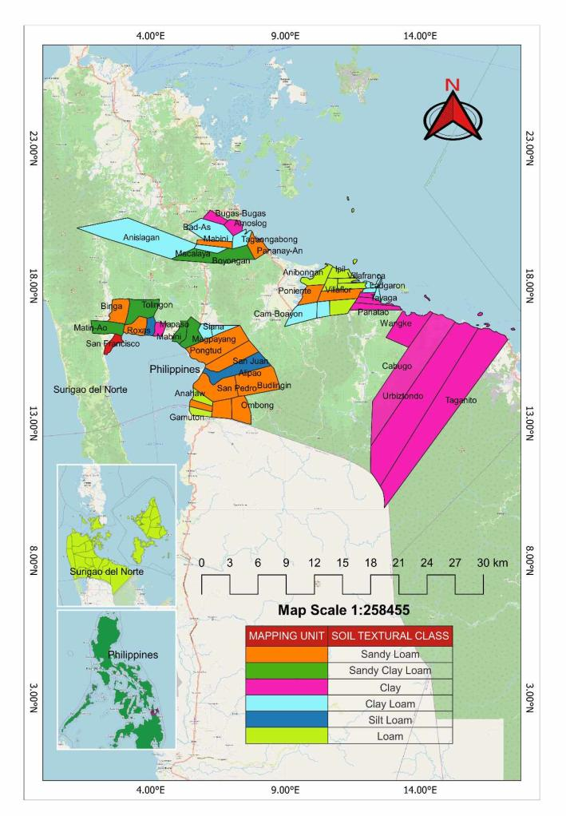
Figure 1. Soil type distribution in selected barangays in the municipalities of Surigao del Norte.
- Chemical Characteristics
The soil analysis data for the chosen municipalities of Surigao del Norte is listed in Table 2. Based on the results, the municipality of Alegria earned a soil pH of 6.17 with a low organic matter of 1.8% and 0.121% of total nutrients, where phosphorus is moderately low at 10 ppm and 57 ppm of potassium, which is moderately sufficient, where calcium and magnesium are sufficient, and where zinc is moderately deficient and sulfur is deficient. While Mainit obtained 5.78 soil pH, moderate organic matter with 2.4%, and 0.161% of total nutrients, where 11 ppm is moderately high in phosphorus but sufficient in potassium with 79 ppm, calcium and magnesium are similarly sufficient, with moderately deficient in zinc and deficient in sulfur.
The Municipality of Placer, on the other hand, acquired 5.81 soil pH, moderately low organic matter with 2.9%, 0.205% total nutrient, moderately low phosphorus with 8 ppm, sufficient potassium with 99 ppm, calcium and magnesium are the same, and deficient both with zinc and sulfur. Gigaquit had a 5.72 soil pH with moderately low organic matter (2.1%), 0.125% of total nutrients (phosphorus is moderately low at 10 ppm), and 102 ppm of potassium, which is sufficient, moderately deficient of calcium and magnesium, and moderately deficient of zinc and sufficient of sulfur. However, the municipality of Claver obtained a soil pH of 7.35, with a low percentage of organic matter with 0.9% and 0.08% of total nutrients and a low percentage of phosphorus with 1 ppm and 35 ppm, which is moderately deficient in potassium and calcium and both moderately deficient in terms of magnesium and zinc and deficient in sulfur.

Table 2. Chemical characteristics of different soil types in selected municipalities in Surigao
del Norte.
LOCATION | CHEMICAL CHARACTERISTICS
LOCATION | pH | % O.M. | Total N, % | P | K | Ca | Mg | Zn | S
Alegria | 6.17 | 1.8 | 0.121 | 10 | 57 | S | S | MD | D
Alegria | 6.17 | (L) | 0.121 | (ML) | (MS)
Mainit | 5.78 | 2.4 | 0.161 | 11 | 79 | S | S | MD | D
Mainit | 5.78 | (ML) | 0.161 | (MH) | (S)
Placer | 5.81 | 2.9 | 0.205 | 8 | 99 | S | S | D | D
Placer | 5.81 | (ML) | 0.205 | (ML) | (S)
Gigaquit | 5.72 | 2.1 | 0.125 | 10 | 102 | MD | S | MD | S
Gigaquit | 5.72 | (ML) | 0.125 | (ML) | (S)
Claver | 7.35 | 0.9 | 0.08 | 1 | 35 | D | MD | MD | D
Claver | 7.35 | (L) | 0.08 | (L) | (MD)
L=Low; ML=Moderately Low; MH= Moderately High; H=High; VH=Very High; D=Deficient; MD=moderately Deficient; MS=Moderately Sufficient; S=Sufficient

ADAPTABILITY OF GRAPE VAR. ‘RED CARDINAL’ CUTTINGS IN SURIGAO DEL NORTE SOIL CONDITIONS UNDER NURSERY CONDITION

- Survival and Mortality Rate
Mean survival and mortality rate of grape var. ‘Red Cardinal’ cuttings planted in different soil types in Surigao del Norte was presented in table 3. ANOVA revealed highly significant differences among soil types in both parameters.
Results showed that among these soil types, sandy loam demonstrated significantly highest survival rate 80% of grape cuttings with corresponding mortality rate at 20.00%. On the other hand, loam soil showcased second highest mean of survival rates at 66.67% with 33.33% mortality rates. Additionally, sandy clay loam and clay loam exhibited comparable survival rates of 60% with similar mortality rates of 40%. While clay typed of soil displayed least mean among soil type with 33.33% and 66.67% survival and mortality rate respectively. These results highlight the adaptability of the grape variety to diverse soil conditions, emphasizing the promising performance in multiple soil types within the province, except in Claver with clay type of soil based on its physical characteristics.
These findings partially correspond with those of Farooq et al. (2018). The highest mortality percentage in the soil might be due to its compactness and the poor nutritional status of the soil type. The survival, proper growth, and development of planted cuttings depend upon the physical and chemical composition of the soil type. A low chemical or physical profile of the soils can lead to abnormal or stunted growth of roots, which reduces the absorption of nutrients and water by roots and thus leads to moisture stress, dehydration, and lower nutrition levels inside the sprouting cutting.
Additionally, the results were similar to the findings of Cherlinka (2023) showed that sandy soil has an advantage for early planting due to its quick warming. Its resistance to erosion because of larger particles and loose structure makes it easy to cultivate. In contrast, clay soil, typically alkaline, hampers optimal nutrient uptake for plant growth, warming slowly and posing challenges for early planting. This soil type tends to become sticky and waterlogged, making it challenging to manage during wet periods and forming solid blocks during dry spells.

Table 3. Survival and mortality (%) of grape var. ‘Red Cardinal’ cuttings planted in
different soil types in Surigao del Norte.
SOIL TYPES | SURVIVAL (%) ** | MORTALITY (%) **
Sandy Loam | 80.00ª | 20.00ª
Sandy Clay Loam | 60.00^{b} | 40.00^{b}
Clay Loam | 60.00^{b} | 40.00^{b}
Loam | 66.67^{ab} | 33.33^{ab}
Clay | 33.33^{c} | 66.67^{c}
CV (%) = | 9.62 | 14.43
**=Significant at 1% level, THSD.

- Agronomic Characteristics
Agronomic characteristics of Grape var. ‘Red Cardinal’ cuttings planted in different soil conditions in Surigao del Norte is presented in table 4. Results of the ANOVA revealed significant effects of soil types on the plant height, root length and number of roots of grape cuttings. While, no significant differences were recorded on the number of leaves, width and height of leaves of the cuttings.
Plant Height (cm). Results showed that grape var. ‘Red Cardinal’ cuttings were significantly taller when planted to sandy loam, sandy clay loam, clay loam, and clay with height that ranged from 159.20 cm to 162.27 cm. Shorter plants were observed in pots with loam of soils with 155.88 cm plant height (Fig. 2).
Number of Leaves. Soil types do not have a significant influenced on the production of leaves of grape cuttings showing almost uniform number of leaves that ranged from 10-15 leaves.
Height (cm) and Width of Leaves. Height of leaves of grape cuttings planted in different soil types ranges from 5.09 to 6.12 cm, while, width of grape leaves ranged from 5.81 to 7.28 cm.
Root Length (cm). Root length of grape cuttings was significantly influenced by the soil types with sandy loam as the longest root length of 43.57 cm (Fig. 3). Comparably, grape cuttings planted in loam showed to have longer roots with 37.07 cm length, followed by the clay loam with 29.40 cm. Shorter root lengths on the other hand, it was observed in grape cuttings planted in clay soil with 15.80 cm length. Shortest roots were recorded in sandy clay loam with 11.00 cm.
Number of Roots. Significantly higher number of roots were recorded in grape cuttings planted in sandy loam, clay loam and loam with 25-31 primary roots. These were followed by cuttings planted in sandy clay loam and clay with 8-18 roots.
Generally, across agronomic parameters, sandy loam showed the most promising results, while clay-type soil obtained the least favorable results. These results relate to the findings of Böhlenius et al. (2016) that a gradual increase in height was observed throughout the experiment for cuttings growing in all sandy soil types. Furthermore, this outcome is related to Michaels' (2022) study, which found that sandy soils had excellent drainage and aeration, allowing roots to be exposed to air and easily penetrate the soil. In contrast, clay holds water so tightly that it is difficult for the plant to obtain its own. Wet clay is sticky and bunches together so tightly that it forms hard clods when it dries.
It is hard for roots to penetrate dry clay soil. This is also supported by Böhlenius et al. (2016), who found that soil texture influences root development with more and longer roots and finer roots present in soils with sandy texture.
However, in this study, grape cuttings produced least number of leaves and shorter leaves as it was affected by leaf scorching causes too much heat during the study period. Similar problem was experienced by Larano (2021) where leaf scorching and tip burn stands as one of his frustrating challenges, given the permanent harm inflicted on the affected plant areas. It's widely understood that excessive light, particularly direct sunlight, can significantly damage plants. Ensuring the right amount of light becomes crucial in safeguarding plant health.

Table 4. Agronomic characteristics of grape var. ‘Red Cardinal’ cuttings in different soil
conditions in Surigao del Norte.
SOIL TYPES | PLANT HEIGHT (cm)** | NUMBER OF LEAVES^{ns} | HEIGHT OF LEAVES (cm)^{ns} | WIDTH OF LEAVES (cm)^{ns} | ROOT LENGTH (cm)** | NUMBER OF ROOTS**
Sandy Loam | 160.42 ^{ab} | 13 | 5.50 | 6.02 | 43.57ª | 31ª
Sandy Clay Loam | 161.52 ^{ab} | 11 | 6.12 | 7.21 | 11.10^{c} | 16^{b}
Clay Loam | 162.27 ª | 15 | 5.16 | 7.28 | 29.40^{b} | 26ª
Loam | 155.8 ^{c} | 13 | 5.31 | 6.09 | 37.07^{ab} | 25ª
Clay | 159.20 ^{b} | 10 | 5.09 | 5.81 | 15.80^{c} | 8^{b}
CV (%) = | 16.8 | 15.6 | 18.6 | 17.5 | 12.9 | 13.5
**= Significant; ns= Not significant

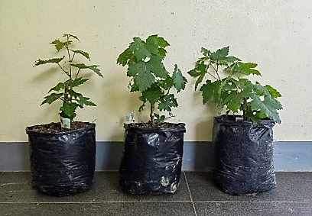
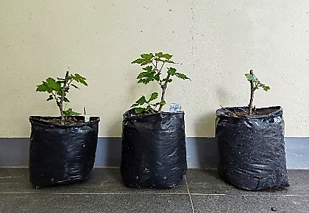
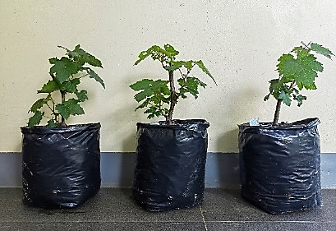
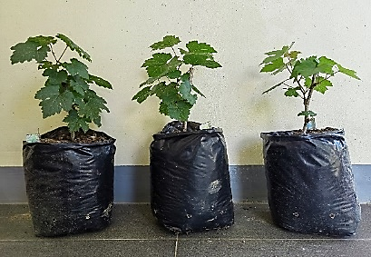
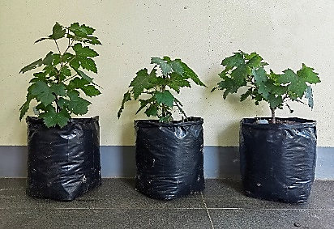
b

a
c
e
d

Figure 2. Grape var. ‘Red Cardinal’ cuttings growth in different soils in Surigao del Norte: (a) Sandy Loam; (b) Sandy Clay Loam; (c) Clay Loam; (d) Loam; and (e) Clay.

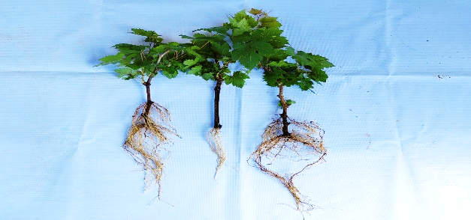
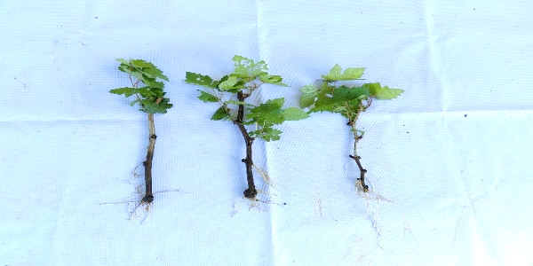
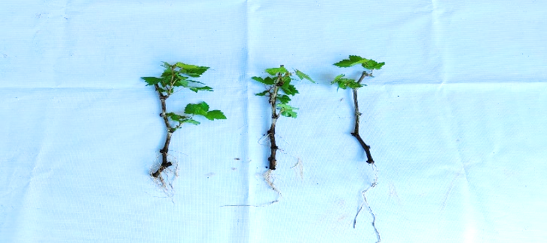
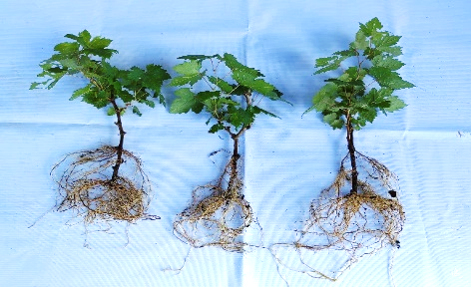
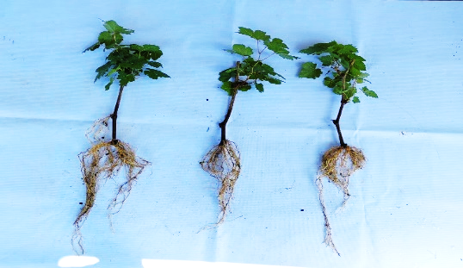
a
b
e
d
c

Figure 3. Root length of grape var. ‘Red Cardinal’ cuttings in different soils in Surigao
del Norte: (a) Sandy Loam; (b) Sandy Clay Loam; (c) Clay Loam; (d) Loam; and (e) Clay.

4. Conclusion
In conclusion, the adaptability of grape var. ‘Red Cardinal’ cuttings in Surigao del Norte varies across municipalities. Alegria, Mainit, Placer, and Gigaquit show promise for viticulture, while Claver presents challenges due to heavy-textured soil and nutrient deficiencies. Overall, grape var. 'Red Cardinal' cuttings thrive best in sandy loam, loam soil, and clay loam, with sandy clay loam and clay soils exhibiting the least performance. Therefore, municipalities like Alegria, Placer, and Gigaquit, with sandy loam, loam, and clay loam soils, respectively, hold potential for grape production. Additionally, selected areas in Mainit could also be suitable for cultivation. Hence, sandy loam, clay loam, and loam soils for grape cultivation, further investigating sandy clay loam soil's adaptability, researching other grape varieties, and ensuring proper transplanting practices such as shading cuttings before planting. It is also crucial to validate these findings in field conditions.

References

Adamant, A. (2022). How to Grow Grapes from Cuttings. Practical Self Reliance.
frocuttings/#:~:text=Place%20the%20potted%20cuttings%20in,replant%20the%20grape%20cuttings%20outdoors.

Bhupendra L. (2022). Growing Grapes in Containers | How to Grow Grapes in Pots & Care Balcony Garden Web.
Dixie Sandborn, Michigan State University Extension. (2023). Let’s grow grapes in containers. 4-H Plants, Soils & Gardening. https://www.canr.msu.edu/news/let-s-grow-grapes-in-containers

Böhlenius, H., Övergaard, R., and Jämtgård, S. (2016). Influence of Soil Types on Establishment and Early Growth of
&lt;i&gt;Populus trichocarpa&lt;/i&gt; Open Journal of Forestry, 06(05), 361–372. https://doi.org/10.4236/ojf.2016.65029

Madigan C. (2023). Growing Grapes: The Basics. Hachette Book Group. Hachette Book Group. https://www.hachettebookgroup.com/storey/growing-grapes-basics/#:~:text=Soil%20Needs&text=Well%2Ddrained%2C%20deep%2C%20fertile,providing%20heat%20for%20the%20vines.

Cherlinka, V. (2023). Types Of Soil in Agriculture to Grow Crops Efficiently. EOS Data Analytics.
https://knowledge.bsigroup.com/categories/sustainability-in-food-and agriculture? Creative=673133165414&keyword=sustainable%20farming%20practices&matchtype=b&network=g&device=c&gad_

Doctor, L. (2022). Grape Picking at Jarden De Uvas, Leon Iloilo. Lakwatserong Doctor.
https://lakwatserongdoctor.com/f/grape-picking-at-jarden-de-uvas-leon-iloilo

Dora Agri-Tech. (2020). Best soil condition requirements for grape planting Dora Agri Tech. Dora Agri-Tech.
https://doraagri.com/grape-planting https://doraagri.com/grape

Farooq, M., kakar, K., golly, M.K., ilyas, N., zib, B., khan, S., khan, I., Saboor, A. and bakhtiar, M., (2018)
Comparative Effect of Potting on Sprouting and Seedling Growth of Grape Cuttings. International Journal of Environmental and Agriculture Research.

Fernandez, T. (2021). Effects of climate change on Philippine agriculture Medium.
https://medium.com/bye-bye-plastic-bags/effects-of-climate-change-on-philippine-agriculture-b8211e36f1ec

Goldammer, T. (2019). Greenhouse Soil Pasteurization. https://www.greenhouse-
management.com/sample%20chapters/Greenhouse%20Management%20-%20Sample%20Chapters.pdf

Harry, H. (2021,). Cardinal - Table Grape Variety. Bio.IskamGo.com. https://bio.iskamgo.com/en/cardinal-table-
grape-variety/

James, J. (2023). How To Grow Grapevines in A Greenhouse | Greenhouse Emporium. Greenhouse Emporium.
https://greenhouseemporium.com/growing-grapevines-in-greenhouse/

Larano, L. (2021). 4 Main Causes of Leaf Scorching and Tip Burn & How to Treat Them.
Omysa. https://omysa.com/blogs/planting-101/4-main-causes-of-leaf-scorching-and-tip-burn-how-to-treat-them

Michaels, T. (2022). 12.1 Soils, fertility, and plant growth. Pressbooks.
https://open.lib.umn.edu/horticulture/chapter/12-1-soils-fertility-and-plant-growth/?fbclid=IwAR0y7sZzH-uIoUHYSSXoOsOj9hKU1UGI7RLegKYiGuPNEzf3Tl31XZDqhho

Noyes, A. (2022). Growing Grapes in Containers: How to Grow Grape Vines In Pots.Gardening
Chores. https://www.gardeningchores.com/growing-grapes-in-containers/

O’callaghan, L. (2021). Philippines Sets Grape Standards. Fruitnet. https://www.fruitnet.com/asiafruit/philippines-
setsgrapestandards/185348.article#:~:text=The%20Philippines%20has%20set%20new,Philippine%20National%20Standard%20(PNS).

Salomon, A. S. H. (2022). What Are Grapes? Nutrition, Health Benefits, Risks, and Types. EverydayHealth.com.
https://www.everydayhealth.com/diet-nutrition/diet/grapes-benefits-risks-types-how-grow-more/

Shin, V. J. (2013). Introducing Surigao del Norte - Physical Characteristics.
https://surigaonorte.tripod.com/introphysical.htm#:~:text=Introducing%20Surigao%20del%20Norte%20%2D%20Physical%20Characteristics&text

Yap, J., JR. (2020). Grapes Grow Well in Nueva Ecija. Agriculture Monthly.
https://agriculture.com.ph/2019/06/18/grapes-grow-well-in-nueva-ecija/

