**Effect of NPK fertilizer and spent mushroom substrate together on lettuce growth, yield and antioxidant enzyme activity**

**ABSTRACT**

The study investigates the effects of NPK fertilizer and spent mushroom substrate (SMS) on lettuce *(Lactuca sativa*) growth, yield, and antioxidant enzyme activity. SMS, a by-product of mushroom cultivation, is a sustainable organic fertilizer rich in organic matter and beneficial microbes, while NPK provides essential macronutrients for plant growth. A greenhouse experiment was conducted using four treatments: control (no amendment), SMS, NPK, and a combination of SMS and NPK. Key growth parameters, including plant height, number of leaves, and fresh and dry weights of leaves and roots, were measured, alongside oxidative stress markers and antioxidant enzyme activities. The results revealed that SMS and NPK independently improved lettuce growth and physiological responses, but their combined application had the most significant effects. The SMS+NPK treatment increased plant height, leaf and root biomass, and antioxidant enzyme activities while reducing oxidative stress markers like MDA and H₂O₂. This synergistic effect underlines the potential of integrating organic and inorganic fertilizers to enhance crop productivity sustainably. The findings highlight the benefits of SMS as an environmentally friendly amendment and its potential to complement NPK for sustainable agricultural practices.

**Keywords:** Spent mushroom substrate, NPK fertilizer, Antioxidant enzyme activity, Lettuce growth, Sustainable agriculture

# 1. INTRODUCTION

Agriculture's usage of both organic and inorganic fertilizers has drawn a lot of attention because of its effects on crop sustainability and production (Rahman and Zhang, 2018). Spent mushroom substrate (SMS), is a by-product of mushroom farming and a possible organic alternative (Mwangi et al., 2024). Plant development and soil health can be enhanced by SMS's abundance of organic matter, nutrients, and helpful bacteria. The popular inorganic alternative, NPK fertilizer, on the other hand, supplies nitrogen, phosphorous, and potassium in precise ratios designed to promote quick plant development (Wang et al., 2024; Qaswar et al., 2020).

Spent mushroom substrate is the biomass left over after commercial mushroom businesses harvest their mushrooms (Mohd Hanafi et al., 2018). There is a lot of concern about how to dispose of SMS produced during mushroom farming. Worldwide, it is anticipated that between 10 and 50 million metric tons of discarded mushroom compost will be produced each year (Jayaraman et al., 2024; Rahi et al., 2023). SMS is bulky, which makes disposal more difficult. In addition to annoying the surrounding area, uncontrolled SMS disposal pollutes the land, water, and air (Othman et al., 2020). The fungic yield of *Agaricus bisporus* spent substrate has been examined for textile dyes by Toptas et al. (2014) and for acid mine drainage using the system developed by Grembi et al. (2016). Many *Pleurotus* species’ residual substrate has been used to adsorb pesticides from fruit packing industry wastes (Papazlatani et al., 2019), antibiotics from swine wastewater (Chang et al., 2014), and water and copper with nickel content respectively (Kamarudzaman et al., 2022).Certain mushroom species have been researched for their ability to remove sulfa antibiotics (Mayans et al., 2021), methylene blue from waste industrial fluids (Dey et al., 2017), and fluoride from drinking water (Sadhu et al., 2021).

The annual plant lettuce (*Lactuca sativa* L. var. eden) is a member of the Asteraceae family of sunflowers (Amedor, 2014). Lettuce, a popular leafy vegetable that is ideal for studying the effects of different fertilizers due to its short growing season and nutritional content (Martínez-Ispizua et al., 2022). Despite the increasing demand for sustainable agriculture practices, achieving high crop yields while maintaining soil health remains a challenge for many farmers. Lettuce, as a high-demand vegetable crop, requires adequate and balanced nutrient inputs to achieve optimal growth and yield. Conventional farming methods often rely heavily on synthetic fertilizers such as NPK to meet crop nutritional needs. However, excessive reliance on inorganic fertilizers can degrade soil quality over time, disrupt microbial ecosystems, and contribute to environmental pollution. As such, there is a growing need to explore alternative and sustainable fertilization methods that support high crop productivity without compromising environmental health. Spent mushroom substrate (SMS) presents a potential solution to this challenge, offering a sustainable, organic alternative to synthetic fertilizers. Rich in organic matter and beneficial microbes, SMS has shown promise in improving soil structure, enhancing nutrient retention, and fostering plant growth (Huang et al., 2022; Rajavat et al., 2022). However, SMS alone may not meet all the nutritional needs of lettuce, as it can vary in nutrient composition depending on the type of mushroom grown. NPK fertilizer, with its precisely balanced nutrient formulation, has the potential to supplement SMS by providing essential nutrients in a readily available form. Research is limited on how SMS and NPK interact and influence the growth and yield of lettuce, particularly in terms of finding the optimal ratio that maximises crop output while supporting sustainable practices. Therefore, this research seeks to evaluate the effects of NPK fertilizer and spent mushroom substrate (SMS) on lettuce growth, yield, and antioxidant enzyme activity.

# 2. MATERIALS AND METHODS

**2.1 Study site and source of materials**

This experiment was performed in the greenhouse at Gansu Agricultural University in Lanzhou, Gansu, China in 2023. The lettuce used in the study was the Looseleaf (*Lactuca sativa* var. *crispa*).

**2.2 Experimental design and treatments**

Four treatments were included in the fully randomized experimental design: T1 (control) = No soil amendment, T2 = NPK (15:15:15), T3 = SMS, and T4 = NPK+SMS. Table 1 shows the treatment description used in the field. A hand fork was used to disperse and integrate the SMS into the soil. Three replicates and a fully randomized design were used to position the pots. Following planting, watering was carried out every two days, and the temperature was kept at a steady 25 ± 0.5 °C with additional day/night illumination of 16/8 hours and 65% relative humidity. There were two separate tests conducted.

**Table 1: Description of treatment used in an experimental trial**

|  |  |  |
| --- | --- | --- |
| **Treatments** | **Description** | **Rate** |
| T1 | Control | No Amendment |
| T2 | Spent mushroom substrate (SMS) | 10t/ha |
| T3 | NPK (15:15:15) | 200kg/ha |
| T4 | SMS+ NPK | 5t/ha + 140kg/ha |

Note: The NPK rate was reduced by 30% when combined with 5 tons of SMS

**2.3 Data collection procedures**

At 28 days following transplanting and harvesting, information was gathered on the plant's height (cm), number of leaves per plant, fresh weight (g), dry weight (g), and length of roots (cm). To measure fresh weights, the roots of the plants that were sampled were cleaned, separated from the shoots, and weighed right away. To determine their dry weights, each sample was oven-dried at 80 °C until its weight was constant.

**2.4 Determination of oxidants and antioxidants in roots**

After being powdered in liquid nitrogen, a 0.5 g fresh root sample was submerged in 1 mL of acetone in an ice bath. Beijing Solarbio Science and Technology, Beijing, China, provided the MDA content assay kit (BC0025), which was used to determine the amount of malondialdehyde (MDA). The absorbance of each sample was assessed at 450, 532, and 600 nm. The hydrogen peroxide (H2O2) content was measured using the manufacturer's protocol/kit (H2O2 content assay kit; Beijing Solarbio Science and Technology) (BC3595). Each sample's absorbance was measured at 415 nm. The MDA and H2O2 values were expressed in μmol g-1 FW. The activities of catalase (CAT; EC 1.11.1.6), peroxidase (POD; EC 1.11.1.7), and superoxide dismutase (SOD; EC 1.15.1.1) were assessed in compliance with the guidelines provided by the test kit (Solarbio Science and Technology Co., Ltd., Beijing, China). 0.5 g of fresh lettuce roots were ground in liquid nitrogen, 1 mL of extract solution was added, and the mixture was centrifuged at 8000 g for 10 minutes at 4 °C. The supernatant was collected, transferred to a separate centrifuge tube, and centrifuged at 8000 g for 10 minutes at 4 °C. The various chemicals were added following the manufacturer's instructions. POD, SOD, and CAT were measured using a spectrophotometer (EPOCH2 Plate Reader, BioTek, Winooski, VT, USA) at 470, 560, and 240 nm, respectively. U mg− 1 FW was used to express the activity.

**2.5 Statistical analysis**

After all statistical analyses were finished, a one-way ANOVA was performed using SPSS 20.0 software (SPSS, Chicago, Illinois, USA). The experimental data were expressed as the means (± SE) of two independent investigations with three repeats. At a 5% probability level, means were differentiated using the Duncan multiple range test.

# 3. RESULTS AND DISCUSSION

**3.1 Effect of SMS and NPK application on growth parameters**

The findings indicate that the different growth characteristics of lettuce are strongly (p<0.05) impacted by the application of SMS and NPK fertilizers. When SMS was applied alone, the plant's height, leaf number, fresh weight, and dry weight rose by 32.2%, 22.9%, 36.6%, and 63.9%, respectively, in comparison to the control (Figure 1A-1D). Once more, when NPK was applied alone, the plant's height, leaf number, fresh weight, and dry weight rose by 61.2%, 40.6%, 33.8%, and 52.7%, respectively, compared to the control. However, the SMS + NPK treatment increased plant height, leaf count, fresh weight, and dry weight by 89.9%, 71.4%, 51.5%, and 79.1%, respectively, compared to the control (Figure 1A-1D).

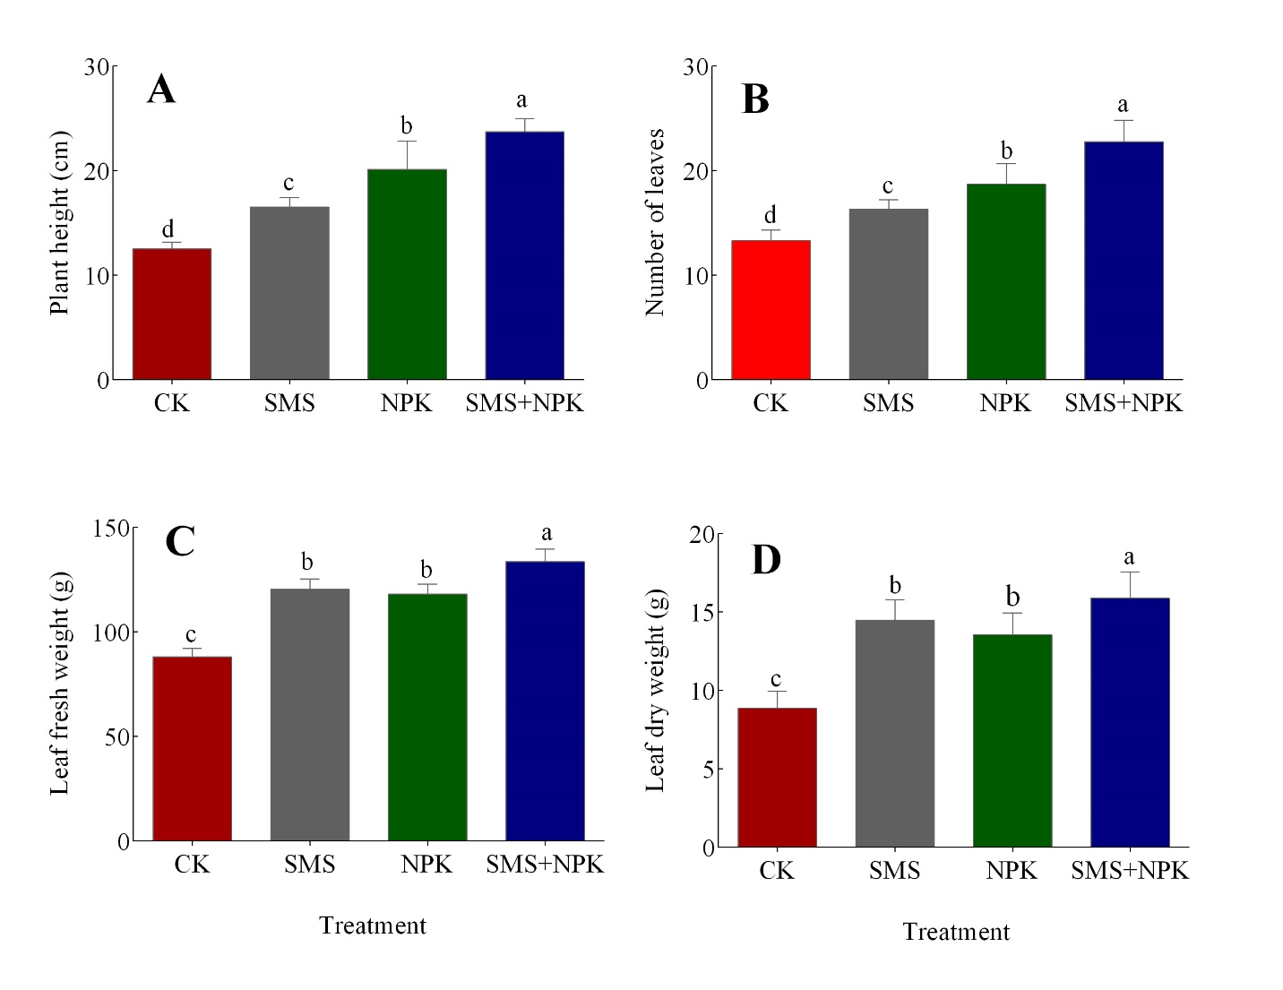

**Figure 1.** Impact of NPK and SMS on lettuce's (A) plant height, (B) leaf count, (C) fresh weight, and (D) dry weight. The data is displayed as mean ± SE. According to Duncan's multiple range test, different letters denote a significant difference (p < 0.05). CK stands for control treatment in the absence of a soil amendment.

Additionally, after applying SMS and NPK fertilizers, there was a significant (p<0.05) increase in root length, fresh root weight, and dry root weight. Root length, fresh root weight, and dried root weight increased by 44.9%, 63.1%, and 55.7%, respectively, as a result of SMS treatment compared to the control (Figure 2A-2C). Additionally, the administration of NPK led to increases in root length, fresh root weight, and dried root weight of 21.3%, 40.7%, and 34.4%, respectively, in comparison to the control. Furthermore, the treatment of SMS and NPK in combination (SMS + NPK) increased root length, fresh root weight, and dried root weight by 61.3%, 84.6%, and 91.8%, respectively, in comparison to the control (Figure 2A-2C).

The application of SMS and NPK fertilizers increased all the growth parameters (height, and weights) measured in the study. These results are in line with those of Alzain et al. (2023), who found that applying biofertilizer and NPK increased the sunflower's plant height, root length, fresh mass, and dry mass. The Kundu (2021) study found that the application of cowdung, either by itself or in conjunction with inorganic fertilizer, increased plant height, leaf count, and the fresh and dry weight of the roots. According to Zaman et al. (2017), the height of *Stevia rebaudiana* plants was affected by cowdung treatment and rose with higher dosages of cowdung. According to Amendola et al. (2017), applying compost all at once boosted the height of the grapevine crops. Based on these observations, it can be concluded that the use of organic manure enhances the growth and development of lettuce and leads to the highest growth parameters than the control. Therefore, when viewed holistically, the study suggests that the likelihood of increasing the height of lettuce plants is realised where the direct application of organic fertilizers including spent mushroom substrate (SMS) is deployed strictly or in combination with inorganic fertilizers (NPK).

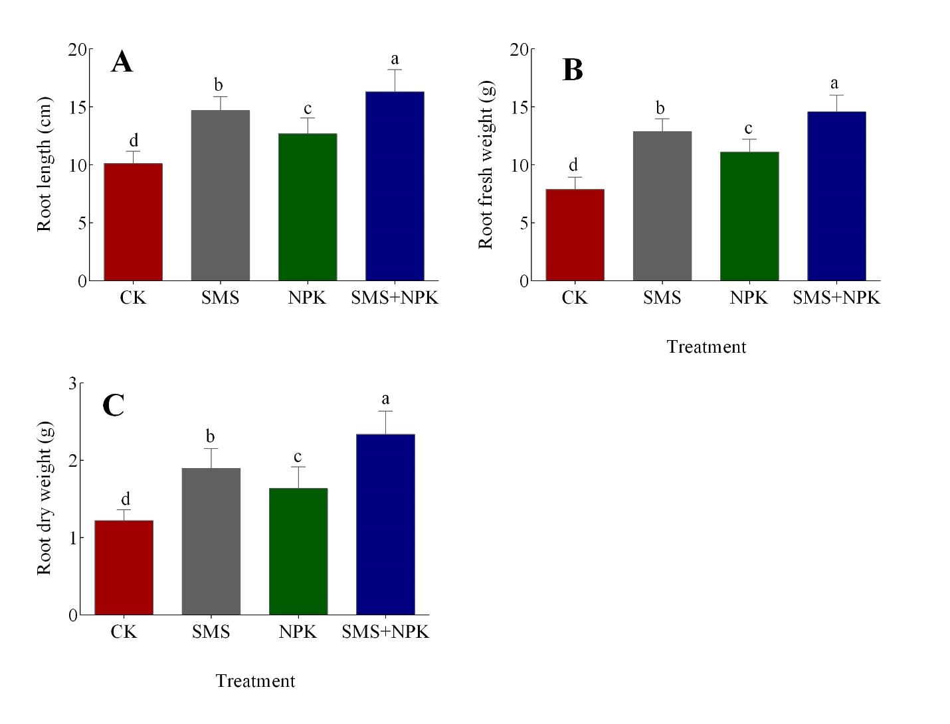

**Figure 2.** Impact of NPK and SMS on lettuce's (A) root length, (B) fresh weight, and (C) dry weight. The data is displayed as mean ± SE. According to Duncan's multiple range test, different letters denote a significant difference (p < 0.05). CK stands for control treatment in the absence of a soil amendment.

**3.2 Effect of SMS and NPK application on oxidants in roots of lettuce**

In response to SMS and NPK fertilizers application, lipid peroxidation (MDA) and hydrogen peroxide (H2O2) content in the lettuce roots significantly decreased. Spent mushroom substrate application reduced MDA and H2O2 content by 28.9% and 29.9%, respectively, compared to control (Figure 3). Again, applying NPK lowered MDA and H2O2 content by 11.1% and 12.8%, respectively, compared to control. However, the combined application of SMS and NPK (SMS + NPK) further declined MDA and H2O2 content by 39.6% and 42.6%, respectively, as compared to the control treatment (Figure 3A. B). The results show that MDA and H2O2 levels of lettuce root were higher in the control treatment than the soil amendments. Oxidants, also known as reactive oxygen species (ROS), include non-radical compounds like H2O2, free radicals like O₂⁻, and ROS (Ozougwu, 2016). These chemicals are produced as byproducts of metabolic processes including respiration and photosynthesis (Martemucci et al., 2022).

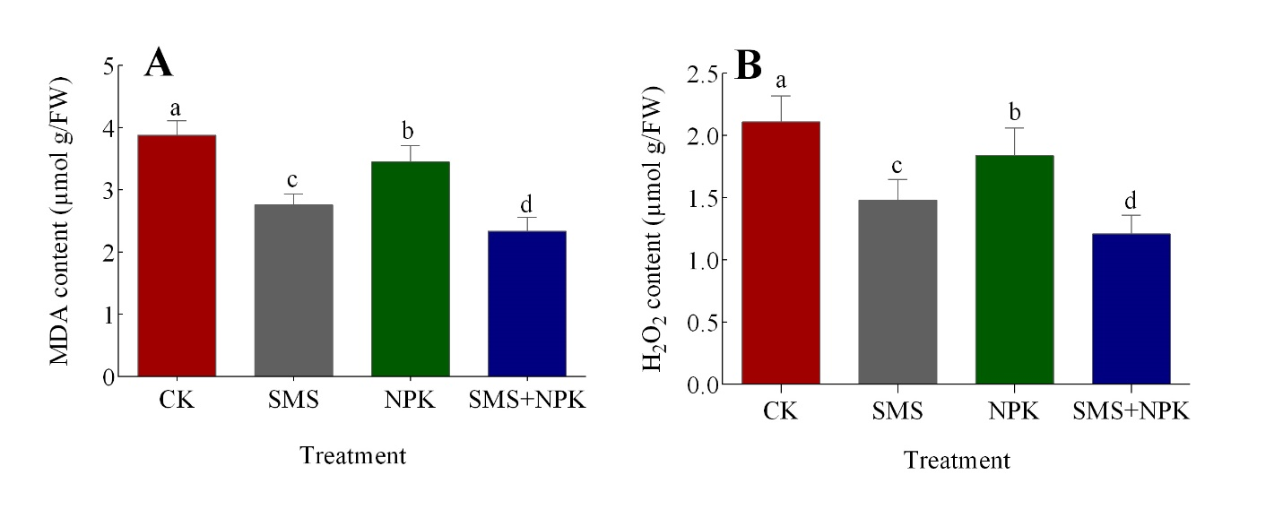

**Figure 3.** Impact of NPK and SMS on lettuce roots' (A) MDA and (B) H2O2 content. The data is displayed as mean ± SE. According to Duncan's multiple range test, different letters denote a significant difference (p < 0.05). CK stands for control treatment in the absence of a soil amendment.

**3.3 Effect of SMS and NPK application on antioxidants in roots**

The application of SMS and NPK fertilizers improved the antioxidant activity of lettuce plants under stress and inhibited reactive oxygen species (ROS) by increasing enzymes like SOD, CAT, and POD (Figure 4). In comparison to the control, the activities of SOD, CAT, and POD rose by 31.4%, 18.3%, and 29.3%, respectively, under NPK fertilizer treatment. Again, SMS treatment enhanced the activities of SOD, CAT, and POD by 44.4%, 31.6%, and 53.4%, respectively, compared to the control. However, when SMS and NPK fertilizers were applied together, SOD, CAT, and POD increased by 58.6%, 44.8%, and 82.7%, respectively, in comparison to the control. This implies that applying SMS and NPK fertilizers together gives the strongest protection, as evidenced by the greatest levels of enzyme activity.

In the present research, the fertilization treatment raised the activities of CAT, POD, and SOD in comparison to the control. The application of SMS or NPK alone reduced MDA and H2O2 levels in lettuce leaves due to promoting antioxidant enzyme activity. However, the combined application of SMS and NPK fertilizers further reduced MDA and H2O2 levels in lettuce leaves by increasing SOD, POD, and CAT activities. Plant defense mechanisms against biotic and abiotic stressors rely heavily on antioxidant enzymes. According to Mittler (2017), increased antioxidant enzyme activity results in potential and targeted ROS scavenging under various stressors. Fertilizing Chinese cabbage with organic fertilizer resulted in a considerable increase in SOD, POD, and CAT activities as well as a decrease in MDA and H2O2 buildup (Qiu et al., 2013). Additionally, Alzain et al. (2023) found that the activities of CAT, POD, and SOD were increased by the application of organic fertilizer. In a similar study, Shahkolaie et al. (2020) discovered that adding both organic and inorganic fertilizers to the soil considerably raised the activities of SOD and CAT in maize. Three types of protective enzymes with anti-oxidative properties are found in plants: SOD, POD, and CAT (Rajput et al., 2021). The superoxide anion may be quickly catalyzed into H2O2 and O2 by SOD, a crucial enzyme in the oxygen-scavenging mechanism (Davies and Dow, 1997). The two main enzymes that eliminate peroxide are POD and CAT (Sharma et al., 2019).

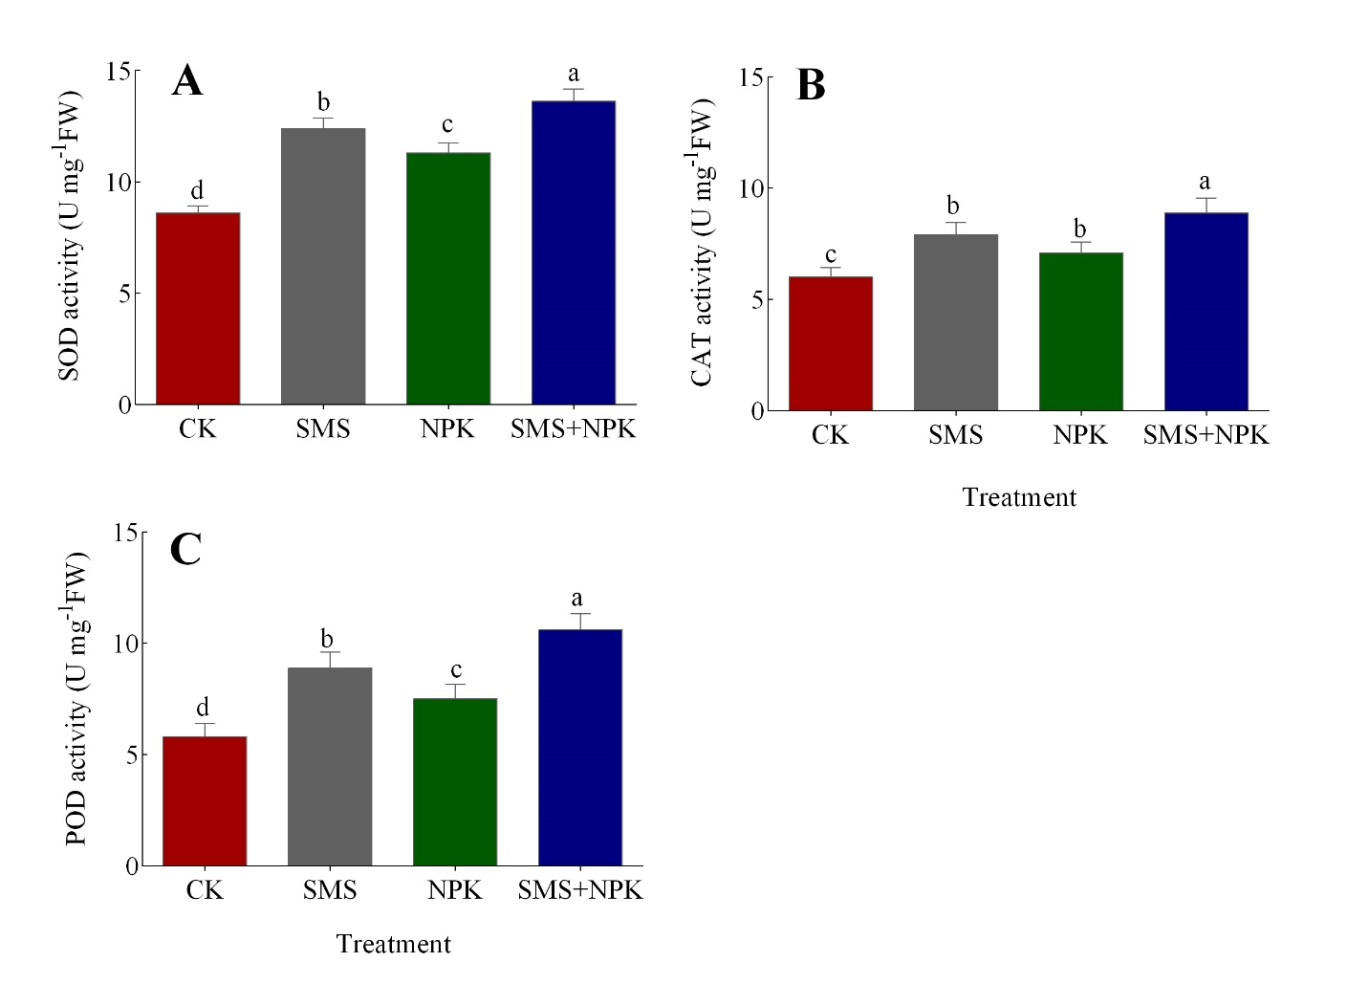

**Figure 4.** Impact of SMS and NPK on lettuce root (A) SOD and (B) CAT (C) activity. The data are shown as mean ± SE. According to Duncan's multiple range test, different letters denote a significant difference (p < 0.05). CK stands for control treatment in the absence of a soil amendment.

# 4. CONCLUSION

From the experiment it was shown that mean values of Lettuce plant growth and physiological attributes enhanced by using spent mushroom substrate (SMS) and NPK fertilizers either alone or in combination. When combined with the SMS and the NPK, the results were even better, proving that the use of organic and inorganic fertilizers supplement each other well. In addition, the present investigation also showed that there were increase in the oxidative stress markers and antioxidant enzyme activity due to the application of SMS and NPK fertilizers in lettuce. In detail, the combined application caused a synergistic effect in down regulating MDA and H2O2, which can be attributed to the lowered oxidative stress. This implies that these fertilizers not only encourage growth but also the immunological system of the plant against, biotic and abiotic stressors.

**COMPETING INTERESTS**

Authors have declared that no competing interests exist

**COMPETING INTERESTS DISCLAIMER:**

Authors have declared that they have no known competing financial interests OR non-financial interests OR personal relationships that could have appeared to influence the work reported in this paper.

# REFERENCES

Alzain, M. N., Loutfy, N., and Aboelkassem, A. (2023). Effects of Different Kinds of Fertilizers on the Vegetative Growth, Antioxidative Defense System and Mineral Properties of Sunflower Plants. Sustainability, 15(13), 10072. https://doi.org/10.3390/su151310072

Amedor, E. N. (2014). Effect of soil amendments on the quality of three commonly cultivated lettuce cultivars (Doctoral dissertation).

Amendola, C., Montagnoli, A., Terzaghi, M., Trupiano, D., Oliva, F., Baronti, S., ... and Scippa, G. S. (2017). Short-term effects of biochar on grapevine fine root dynamics and arbuscular mycorrhizae production. Agriculture, Ecosystems and Environment, 239, 236-245. https://doi.org/10.1016/j.agee.2017.01.025

Chang, B. V., Hsu, F. Y., and Liao, H. Y. (2014). Biodegradation of three tetracyclines in swine wastewater. Journal of Environmental Science and Health, Part B, 49(6), 449-455. https://doi.org/10.1080/03601234.2014.894784

Dey, M. D., Ahmed, M., Singh, R., Boruah, R., and Mukhopadhyay, R. (2017). Utilization of two agrowastes for adsorption and removal of methylene blue: kinetics and isotherm studies. Water Science and Technology, 75(5), 1138-1147. https://doi.org/10.2166/wst.2016.589

Grembi, J. A., Sick, B. A., and Brennan, R. A. (2016). Remediation of high-strength mine-impacted water with mixed organic substrates containing crab shell and spent mushroom compost. Journal of Environmental Engineering, 142(2), 04015075. https://doi.org/10.1061/(ASCE)EE.1943-7870.0001023

Huang, Z., Guan, H., Zheng, H., Wang, M., Xu, P., Dong, S., ... and Xiao, J. (2022). Novel liquid organic fertilizer: A potential way to effectively recycle spent mushroom substrate. Journal of Cleaner Production, 376, 134368. https://doi.org/10.1016/j.jclepro.2022.134368

Jayaraman, S., Yadav, B., Dalal, R. C., Naorem, A., Sinha, N. K., Rao, C. S., ... and Rao, A. S. (2024). Mushroom farming: A review focusing on soil health, nutritional security and environmental sustainability. Farming System, 2(3), 100098. https://doi.org/10.1016/j.farsys.2024.100098

Kamarudzaman, A. N., Adan, S. N. A. C., Hassan, Z., Wahab, M. A., Makhtar, S. M. Z., Seman, N. A. A., ... and Syafiuddin, A. (2022). Biosorption of copper (II) and iron (II) using spent mushroom compost as biosorbent. Biointerface Research in Applied Chemistry, 12, 7775-7786. https://doi.org/10.33263/BRIAC126.77757786

Kundu, M. (2021). Effects of organic and inorganic fertilizers on yield and antioxidant properties of lettuce grown in a rooftop garden (Doctoral dissertation, Department Of Agricultural Botany, Sher-E-Bangla Agricultural University, Dhaka, Bangladesh).

Martemucci, G., Costagliola, C., Mariano, M., D'andrea, L., Napolitano, P., and D'Alessandro, A. G. (2022). Free radical properties, source and targets, antioxidant consumption and health. Oxygen, 2(2), 48-78. https://doi.org/10.3390/oxygen2020006

Martínez-Ispizua, E., Calatayud, Á., Marsal, J. I., Cannata, C., Basile, F., Abdelkhalik, A., ... and Martínez-Cuenca, M. R. (2022). The nutritional quality potential of microgreens, baby leaves, and adult lettuce: an underexploited nutraceutical source. Foods, 11(3), 423. https://doi.org/10.3390/foods11030423

Mayans, B., Camacho-Arévalo, R., García-Delgado, C., Antón-Herrero, R., Escolástico, C., Segura, M. L., and Eymar, E. (2021). An assessment of Pleurotus ostreatus to remove sulfonamides, and its role as a biofilter based on its own spent mushroom substrate. Environmental Science and Pollution Research, 28, 7032-7042. https://doi.org/10.1007/s11356-020-11078-3

Mittler, R. (2017). ROS are good. Trends in Plant Science, 22(1), 11-19. https://doi.org/10.1016/j.tplants.2016.08.002

Mohd Hanafi, F. H., Rezania, S., Mat Taib, S., Md Din, M. F., Yamauchi, M., Sakamoto, M., ... and Ebrahimi, S. S. (2018). Environmentally sustainable applications of agro-based spent mushroom substrate (SMS): an overview. Journal of Material Cycles and Waste Management, 20, 1383-1396. https://doi.org/10.1007/s10163-018-0739-0

Mwangi, R. W., Mustafa, M., Kappel, N., Csambalik, L., and Szabó, A. (2024). Practical applications of spent mushroom compost in cultivation and disease control of selected vegetables species. Journal of Material Cycles and Waste Management, 1-16. https://doi.org/10.1007/s10163-024-01969-9

Othman, N. Z., Sarjuni, M. N. H., Rosli, M. A., Nadri, M. H., Yeng, L. H., Ying, O. P., and Sarmidi, M. R. (2020). Spent mushroom substrate as biofertilizer for agriculture application. Valorisation of Agro-industrial Residues-Volume I: Biological Approaches, 37-57. https://doi.org/10.1007/978-3-030-39137-9_2

Ozougwu, J. C. (2016). The role of reactive oxygen species and antioxidants in oxidative stress. International Journal of Research, 1(8), 1-8.

Papazlatani, C. V., Karas, P. A., Tucat, G., and Karpouzas, D. G. (2019). Expanding the use of biobeds: degradation and adsorption of pesticides contained in effluents from seed-coating, bulb disinfestation and fruit-packaging activities. Journal of Environmental Management, 248, 109221. https://doi.org/10.1016/j.jenvman.2019.06.122

Qaswar, M., Jing, H., Ahmed, W., Dongchu, L., Shujun, L., Lu, Z., ... and Huimin, Z. (2020). Yield sustainability, soil organic carbon sequestration and nutrients balance under long-term combined application of manure and inorganic fertilizers in acidic paddy soil. Soil and Tillage Research, 198, 104569. https://doi.org/10.1016/j.still.2019.104569

Qiu, X., Wang, Y., Hu, G., Wang, Q., Zhang, X., and Dong, Y. (2013). Effect of different fertilization modes on physiological characteristics, yield and quality of Chinese cabbage. Journal of Plant Nutrition, 36(6), 948-962. https://doi.org/10.1080/01904167.2012.759972

Rahi, D. K., Rahi, S., and Sharma, D. K. (2023). Spent Mushroom Substrate Perspectives and Applications. Bioprospects of Macrofungi, 31-44. https://doi.org/10.1201/9781003343806-4

Rahman, K. A., and Zhang, D. (2018). Effects of fertilizer broadcasting on the excessive use of inorganic fertilizers and environmental sustainability. Sustainability, 10(3), 759. https://doi.org/10.3390/su10030759

Rajavat, A. S., Mageshwaran, V., Bharadwaj, A., Tripathi, S., and Pandiyan, K. (2022). Spent mushroom waste: An emerging bio-fertilizer for improving soil health and plant productivity. In New and Future Developments in Microbial Biotechnology and Bioengineering (pp. 345-354). Elsevier. https://doi.org/10.1016/B978-0-323-85579-2.00010-1

Rajput, V. D., Harish, Singh, R. K., Verma, K. K., Sharma, L., Quiroz-Figueroa, F. R., ... and Mandzhieva, S. (2021). Recent developments in enzymatic antioxidant defense mechanism in plants with special reference to abiotic stress. Biology, 10(4), 267. https://doi.org/10.3390/biology10040267

Sadhu, M., Bhattacharya, P., Vithanage, M., and Sudhakar, P. P. (2021). Adsorptive removal of fluoride using biochar-A potential application in drinking water treatment. Separation and Purification Technology, 278, 119106. https://doi.org/10.1016/j.seppur.2021.119106

Shahkolaie, S. S., Baranimotlagh, M., Dordipour, E., and Khormali, F. (2020). Effects of inorganic and organic amendments on physiological parameters and antioxidant enzymes activities in Zea mays L. from a cadmium-contaminated calcareous soil. South African Journal of Botany, 128, 132-140. https://doi.org/10.1016/j.sajb.2019.10.007

Sharma, P., Jha, A. B., and Dubey, R. S. (2019). Oxidative stress and antioxidative defense system in plants growing under abiotic stresses. In Handbook of Plant and Crop Stress, Fourth Edition (pp. 93-136). CRC press. https://doi.org/10.1201/9781351104609-7

Toptas, A., Demierege, S., Mavioglu Ayan, E., and Yanik, J. (2014). Spent mushroom compost as biosorbent for dye biosorption. CLEAN-Soil, Air, Water, 42(12), 1721-1728. https://doi.org/10.1002/clen.201300657

Wang, H., Yang, Y., Yao, C., Feng, Y., Wang, H., Kong, Y., ... and Deng, G. (2024). The Correct Combination and Balance of Macronutrients Nitrogen, Phosphorus and Potassium Promote Plant Yield and Quality Through Enzymatic and Antioxidant Activities in Potato. Journal of Plant Growth Regulation, 1-19. https://doi.org/10.1007/s00344-024-11428-2