PROFILING OF HEAVY METALS, TOTAL PETROLEUM HYDROCARBON AND POLYCYCLIC AROMATIC HYDROCARBONS IN SOILS AROUND AUTOMOBILE WORKSHOPS IN PORT HARCOURT, NIGERIA

ABSTRACT
The primary aim of this research was to assess heavy metal, polycyclic aromatic hydrocarbon (PAHs), and total petroleum hydrocarbon (TPH) loading in soils around selected automobile workshops in Port Harcourt Metropolis and associated environmental risks. The study was carried out using Atomic Absorption Spectroscopy (AAS) and Gas Chromatography (GC FID). It focused on three active automobile workshop locations in Port Harcourt, Nigeria: AP Filling Station Mechanic Workshop, Y Junction Haruk Road Mechanic Workshop, and Rumuagholu Road Mechanic Workshop. From the results obtained, TPH concentrations at the three sites are 612.342 ppm at AP Filling Station, 901.145 ppm at Y Junction, Haruk Road, and 865.212 ppm at Rumuagholu Road exceeded the U.S. EPA's recommended range of 100 to 500 ppm, indicating significant petroleum contamination. Similarly, PAHs concentrations of 924.50 ppm, 543.50 ppm and 1211.11 ppm at the above respective sites were significantly above the U.S. EPA limit of 10 ppm, reflecting severe contamination. For heavy metals, Nickel, Vanadium, Copper, Chromium, Iron, Lead concentrations were far below their respective maximum regulatory limits. Remediation techniques like Detoxification by Chemical Reaction (DCR) Technology, phytoremediation and bioremediation should be explored to restore contaminated soil.
KEYWORDS; PAHs, TPH, EPI, DCR Technology, Heavy meals
- INTRODUCTION

Port Harcourt is a thriving metropolis that is a significant hub for industrial and commercial activities. A vital aspect of the local economy is automobile workshops which offer services such as vehicle maintenance and repair as well as parts sales. Environmental pollutants such as heavy metals, polycyclic aromatic hydrocarbons (PAHs), and total petroleum hydrocarbons (TPH), are massively discharged from these workshops from spent vehicular oils.
Heavy metals are metallic elements with high density, atomic weight, or atomic number greater than 5.0g/cm³. Typical examples are Chromium (Cr), Copper (Cu), Nickel (Ni), and Zinc (Zn) etc. Sources of heavy metal pollution in automobile workshops include activities such as metal scraping, improper disposal of batteries, and inadequate waste processing methods, which contribute to environmental contamination. Heavy metals are known for their ability to persist in the environment and cause harmful health effects, such as kidney and liver failure, respiratory disorders, and brain damage.
Polycyclic aromatic hydrocarbons (PAHs) is a class of organic compounds composed of multiple aromatic rings primarily resulting from incomplete combustion processes. Sources of polycyclic aromatic hydrocarbons (PAHs) in automobile workshops include the burning of waste materials, the use of spent engine oil, and emissions from exhaust, all of which release these hazardous compounds into the environment [1]. Due to their carcinogenic properties, PAHs pose significant health risks to humans [2][3][4][5].
Total petroleum hydrocarbon (TPH) is a term used for any mixture of hydrocarbons found in crude oil. These pollutants often result from leaks and spills of hydraulic fluids, lubricants, and other petroleum-based products commonly used in automobile workshops [6][7]. Elevated levels of total petroleum hydrocarbons (TPH) in soil can adversely affect soil structure, reduce oxygen and water infiltration, inhibit plant growth, and pose risks to groundwater quality [8].
Soil, also commonly referred to as earth or dirt, is a mixture of organic matter, minerals, gases, liquids, and organisms that together support the life of plants and soil organisms. Activities conducted in automobile workshops can lead to soil contamination in surrounding areas with pollutants such as heavy metals, polycyclic aromatic hydrocarbons (PAHs), and total petroleum hydrocarbons (TPH). There are reports over loading of underground water with the above mentioned pollutant. Assessing soil contamination levels is critical for understanding potential environmental impacts and risks to human health and ecosystems [9][10].
Automobile Workshops are established for servicing, maintaining, and rectifying any issue that arises in a vehicle. The workshops perform a variety of electrical and mechanical repairs, replace parts, and also handle bodywork and painting for newly launched vehicles. Activities in automobile workshops lead to the release of pollutants, including used motor oils, lubricants, petrol residues, and other hazardous materials, into the environment. Environmental contamination could be reduced by proper management [11] .
It is necessary to determine the levels of these contaminants within soil environmental media in order to evaluate human health risks and deduce potential impact on the environment (especially the ground water) as well. This study aims to provide valuable data on the concentration of these pollutants to support stakeholders, policymakers, and local authorities in developing remediation strategies and pollution control measures. My research team at various times have investigated the toxicity of PAHs and heavy metals in soils around Niger Delta using the total potency equivalent concentrations and noted that these petroleum products’ polluted soil could be point sources of underground water pollution through leaching [4] [5] . However, there are little data of above on the chosen and notorious locations.
The aim of this research is to ascertain the loading of Total petroleum hydrocarbons, Polycyclic aromatic hydrocarbons and heavy metals in soils of major auto mechanic workshops in Portharcourt metropolis using GC-FID and AAS as the case may be. The data will be useful to relevant authorities to correlate it with contamination of groundwater with petroleum related contaminants and help reduce health related diseases. The data will also immensely assist in determining the Environmental Performance Index (EPI) of the study area.

2.0 MATERIALS AND METHODS

Study Area
This study focuses on three active automobile workshop locations in Port Harcourt, Nigeria: AP Filling Station Mechanic Workshop, Y Junction Haruk Road, and Rumuagholu Road Mechanic Workshop. These sites were selected due to their high vehicle repair activity, which likely contributes to soil contamination by petroleum-based pollutants and heavy metals.
2.2 Sample Collection
Soil samples were collected from each specified site on November 1, 2024. The geographic coordinates for each collection point are as follows: AP Filling Station Mechanic Workshop, 4.8176° N, 7.0154° E; Y Junction, Haruk Road near: 4.8721° N, 7.0135° E and Rumuagholu Road Mechanic Workshop: 4.8545° N, 7.0019° E. Each sample was carefully collected and placed in a plastic bag immediately to maintain sample integrity and prevent contamination.
  - Material and Reagent
Gas Chromatography-Mass Spectrometer, Gas Chromatography-Flame Ionization Detector, Rotary Evaporator, Filter Paper, Measuring cylinder, Beakers, 100ml clean and dry conical flask, Hot plate, Weighing balance, 100 ml Volumetric Flask, Laboratory coat, Hand Gloves, Nose mask, Glass Funnel, 100ml plastic container, Wash bottle, Beakers, Fume Cupboard, Atomic Absorption Spectrophotometer, Concentrated Nitric acid, Concentrated Hydrochloric acid, PAH primary standards (Accu Standard), HPLC grade Dichloromethane, Acetone, Glass wool
2.4 Procedure for Analysis of TPH AND PAHs
Ten grams of each soil sample was weighed and placed in separate beakers. Afterwards 25 ml of 1 + 1 DCM and acetone was then added and the samples was placed each in a sonicator and sonicated for 20 minutes. The solvent phase were carefully extracted through a filter paper and concentrated using a rotary evaporator or water bath (for removal of DCM and acetone). Afterwards the samples were run in the gas chromatograph to determine the concentrations of each PAH and the carbon content.
2.5 Procedure for Analysis of Heavy metals by Digestion Method
A total volume of 20ml of HCl and HNO₃ in a 3:1 ratio was mixed to form an aqua regia solution. Then, 1 g of each of the soil samples were placed in separate conical flasks, labelling each flask accordingly. The samples were digested using in a fume cupboard with a hot plate until white fumes appeared. It was cooled after heating and 100 ml of distilled water was added for dilution. The diluted samples were filtered using a funnel and filter paper. 10 – 20 ml of the filtrate were taken and run for concentration of the required metal using the atomic absorption spectrophotometer.

3.0 RESULT AND DISCUSSION

3.1 RESULTS
The table below presents the results for three parameters—total petroleum hydrocarbons (TPH), polycyclic aromatic hydrocarbons (PAHs), and heavy metals—The study found significant soil contamination with polycyclic aromatic hydrocarbons (PAHs) and total petroleum hydrocarbons (TPH) at three automobile workshops in Port Harcourt.
S/N | Parameters | AP-FS Mechanic (ppm) | Y-Junction Mechanic (ppm) | Rumuagholu Road Mechanic (ppm) | Regulatory Limits  (ppm)
1 | PAHs | 924.50 | 543.50 | 1211.11 | 10
2 | TPH | 612.342 | 901.145 | 865.212 | 100-500
3 | Chromium | 0.155 | 0.120 | 0.100 | 1
4 | Iron | 7.232 | 5.311 | 5.020 | 50,000
5 | Lead | 0.331 | 0.322 | 0.412 | 85-400
6 | Vanadium | 0.034 | 0.051 | 0.410 | 129
7 | Nickel | 0.112 | 0.125 | 0.151 | 50
8 | Copper | 2.533 | 3.261 | 3.113 | 20-100
Table 1.0; Summary of Parameters from different soil locations and the regulatory limit

The results shown in Table 1.0, gives an overview of concentration of pollutants in soil samples from automobile workshops, with polycyclic aromatic hydrocarbons (PAHs) ranging from 543.50 ppm to 1211.11 ppm and total petroleum hydrocarbons (TPH) from 612.34 ppm to 901.15 ppm, both far exceeding recommended limits. In contrast, heavy metals, including Nickel (0.112 to 0.151 ppm), Vanadium (0.034 to0.140 ppm), Copper (2.533 to 3.261 ppm), Chromium (0.100 to 0.155 ppm), Lead (0.322 to 0.412 ppm), and Iron (5.020 to 7.232 ppm), were their respective maximum permissible safety limits.
Nickel (Ni) concentrations were 0.112 ppm in the soils AP Filling Station, 0.125 ppm in Y Junction Haruk Road, and 0.151 ppm in Rumuagholu Road auto mechanic workshops. These values are well below the US-EPA’s guideline of 50 ppm, suggesting that Nickel contamination is not a concern at these locations [12].
The result of the above table shows that Soil concentration of Vanadium was 0.034ppm in AP-FS, 0.051ppm in Y-junction and 0.410 in Rumuagholu Road which is significantly below Pennsylvania's updated permissible standard of 129 ppm, indicating no environmental concern based on these values [13].
The result on the above table equally shows that Soil concentration of Copper was 3.113 ppm at Rumuagholu Road, 3.261 ppm at Y Junction Haruk Road, and 2.531ppm at AP Filling Station. While these levels are within the safe range of 20-100 ppm [12], they do suggest some cumulative contamination from mechanical activities in the area.
The result on the above table shows that Soil concentration of Chromium (Cr) was 0.155ppm at AP-FS, 0.120ppm at Y-junction and 0.100ppm at Rumuagholu Road and they were below the 1ppm threshold for safe exposure recommended by WHO [14], indicating no significant Chromium contamination.
The result on the above table shows that Soil concentration of Lead (Pb) was low, with values of 0.331 ppm at AP-FS, 0.322ppm at Y-Junction, and 0.412ppm at Rumuagaholu Road, all well below the US-EPA’s threshold of 400 ppm, indicating minimal risk from lead contamination.
The results on the above table shows that Soil concentration of Iron (Fe), which are naturally abundant in soils, was 7.232ppm at AP-FS, 5.311ppm at Y-Junction and 5.020ppm at Rumuagaholu Road. There is no established regulatory standard for Iron in soils because it is abundant in soils and is an essential nutrient for both plants and microorganisms.
The concentration of PAHs in the soil samples from the three sites are 924.50 ppm at AP Filling Station, 543.50 ppm at Y Junction Haruk Road, and 1211.11 ppm at Rumuagholu Road, which significantly exceeded the 10ppm cumulative limit recommended by the U.S. EPA [12], indicating severe contamination likely linked to petroleum-based activities. A total of 17 PAHs were identified in the chromatogram as in figure 1. The results of the above table shows that concentration of TPH was 612.342 ppm at AP Filling Station, 901.145 ppm at Y Junction Haruk Road, and 865.212 ppm at Rumuagholu Road and they exceeded the recommended limit of 100-500pm set by the U.S. EPA indicating significant petroleum contamination [12] [13]. Figure 2 is the chromatogram of Soil TPH in AP auto mechanic workshop.
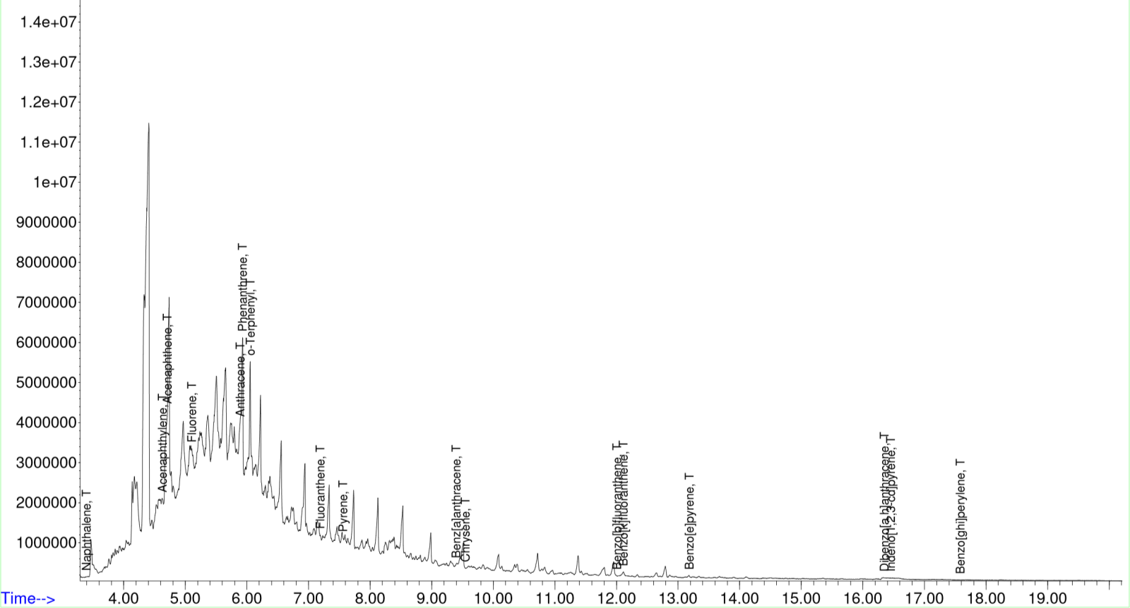
Figure 1. Chromatogram of PAHs for Location 1 (AP-FS)

Figure 2. Chromatogram of TPH for Location 1 (AP-FS)

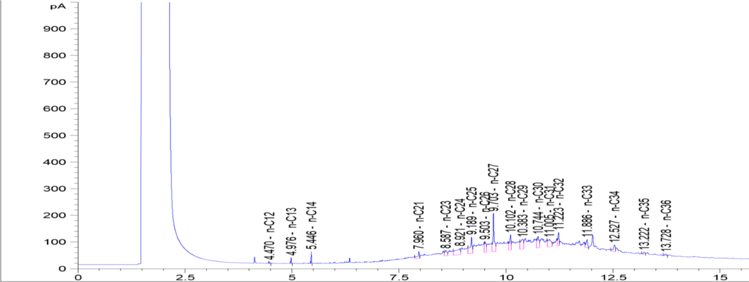

3.3 Discussion
The soil samples analysed from the AP Filling Station Mechanic Workshop, Y Junction Haruk Road, and Rumuagholu Road Mechanic Workshop show notable contamination levels by polycyclic aromatic hydrocarbons (PAHs), and total petroleum hydrocarbons (TPH) and no heavy metals contaminations. A comparison of these concentrations with the established guidelines from the World Health Organization (WHO) and the United States Environmental Protection Agency (US-EPA) indicates significant health concerns, particularly regarding PAHs and TPH.
In comparing the results with the environmental standards, it is evident that while the concentrations of heavy metals in the soil are largely within safe limits, the PAH and TPH concentrations pose significant environmental and health risks. The levels of PAHs are extremely high across all three sites, far surpassing the recommended limit, reflecting a severe contamination issue. This is particularly concerning given the carcinogenic nature of PAHs. Similarly, the TPH concentrations also exceeded the general soil guidelines for non-industrial areas, indicating substantial contamination that could lead to environmental degradation, including impacts on local flora, fauna, and potentially groundwater quality.
Given the high concentrations of PAHs and TPH, there is an increased risk to both human health and the environment. Prolonged exposure to high levels of PAHs can cause severe health effects, including cancer, respiratory problems, and skin irritations. TPH contamination, while not as immediately hazardous, can lead to soil and water contamination, affecting plant growth and the broader ecosystem. The presence of heavy metals at low levels does not pose an immediate risk but could accumulate over time with continuous exposure.
In summary, while the levels of heavy metals in the soil are largely within acceptable limits, the contamination from PAHs and TPH is a major concern. The results suggest that the mechanic workshops at the three sites are heavily impacted by industrial pollutants, which could have long-term health and environmental consequences if not properly managed.

3.4 Conclusion and Recommendations

The results show significant contamination of soil samples with polycyclic aromatic hydrocarbons (PAHs) and total petroleum hydrocarbons (TPH), with levels exceeding recommended environmental standards. Although concentrations of heavy metals, such as Nickel, Vanadium, Copper, Chromium, Lead, and Iron, were within acceptable limits, the elevated levels of PAHs and TPH present significant environmental and public health risks. These pollutants, primarily from petroleum-based activities, can degrade soil quality and potentially threaten groundwater quality. PAHs and TPH are mobile in the environment and can leach into groundwater, contaminating water sources that communities rely on for drinking and other essential uses. Given the elevated pollutant levels, it is crucial to implement effective pollution control measures, ensure proper waste disposal, and regularly monitor soil and water quality. Educating the community and workshop operators, along with promoting cleaner technologies, will be key to reducing future contamination and protecting both public health and the environment. Immediate actions are required to mitigate the risks posed by these pollutants and to protect the local ecosystem and water resources. Nigeria has ranked low over the years in the Environmental Performance Index (EPI) ratings and the soil and water quality are important indicators that are used to evaluate EPI. The following are recommended to mitigate the effects of above results on the very poor EPI ratings of Nigeria.
Implementation of Pollution Control Measures: Mechanic workshops should adopt pollution control practices, including the use of drip pans, spill containment systems, and regular maintenance of equipment to prevent leaks, thereby reducing PAH and TPH contamination. Regular monitoring of soil and water quality checks should be done for early detection of hazardous pollutants. Establishment of Proper Waste Disposal Systems: Workshops should implement proper waste management systems to safely dispose of petroleum-based products, such as oils and chemicals, ensuring compliance with national and international environmental standards. Environmental Education and Training: Local authorities should offer training on pollution prevention, waste management, and sustainable practices to mechanics and workshop operators, promoting environmentally responsible behaviour and reducing exposure to contaminants. Implementation of Remediation Strategies: Remediation techniques like DCR technology and bioremediation should be explored to restore contaminated soil. Stronger Enforcement of Environmental Regulations like enforcing stricter environmental regulations in industrial zones, conducting regular inspections and imposing penalties for non-compliance to ensure adherence to soil, water and air quality standards.

REFERENCES
- Okonkwo, U., & Igwo-Ezikpe, M. (2015). Sources of PAHs in automobile workshops. Environmental Chemistry Journal, 22(1), 128-135.
- Zhang, H., Fan, X., & Huang, Q. (2022). PAH pollution sources and risks. Journal of Environmental Research, 10(9), 345-358.
- Kumar, A., & Suri, R. (2023). Oil refining and PAH emissions. Energy and Fuels Journal, 22(4), 543-558.
- Iwuoha, G. N., Nwigoo, J., & Onojake, M. C. (2015) Determination of Total Potency Equivalent Concentration (Tpec) of Carcinogenic Polycyclic Aromatic Hydrocarbons (CPAHs) In Soils of Bodo-City. Journal of applied Science and Environmental Management 19 (3): 495-499. Doi.org/10.4314/jasem.v17i4.13
- Iwuoha, G.N., Achugo, D., Okorosaye-Orubite,Onwuachu, U., & Obuzor, G. (2016) Estimation Of Toxicity Equivalent Concentration (TEQ) Of Carcinogenic Polycyclic Aromatic Hydrocarbons In Soils From Idu Ekpeye Playground And University Of Portharcourt Car Parks. Scientia Africana. 15, ( 2): 33-41
- Adegbola, T., Shittu, T., & Adeniyi, K. (2016). Petroleum hydrocarbon pollution and environmental impacts. Environmental Management, 11(4), 89-97.
- Shittu, T., & Adeniyi, R. (2019). Environmental impacts of petroleum pollutants. Journal of Environmental and Public Health, 33(8), 245-259.
- Khan, M. A., Li, J., & Zhang, Z. (2018). Petroleum hydrocarbon effects on soil ecosystems. Soil Science and Environmental Health, 17(3), 312-319.
- Chen, Y., Zheng, M., & Feng, X. (2015). Cardiovascular toxicity of environmental contaminants. Toxicology and Applied Pharmacology, 112(3), 401-412.
- Wang, M., Li, Y., & Feng, J. (2016). Heavy metals in soils: Sources and health risks. International Journal of Environmental Science, 14(8), 487-495.
- White, C. A. (2018). Mitigating industrial pollution in urban areas. Environmental Policy and Health, 19(3), 231-240.
- USEPA (United States Environmental Protection Agency). (2019). Guidelines for soil contamination. Environmental Standards Report.
- USEPA (United States Environmental Protection Agency). (2023). Guidelines for soil contamination. Environmental Standards Report.
- WHO (World Health Organisation) (2021). Guidelines for soil contamination. Environmental Standards Report.

