Original Research Article
Estimation of Crop Evapotranspiration of Wheat using Remote Sensing & GIS Based Crop Coefficient

ABSTRACT -
Irrigation water management refers to the strategic planning and regulation of water applications to meet crop water requirements efficiently while minimizing water wastage, soil degradation, and nutrient loss. The FAO-56 bulletin is widely utilized for estimating agricultural water demand, relying on tabulated crop coefficients (Kc) to determine crop evapotranspiration (ETc). Since ETc is directly influenced by crop coefficient curves, traditional methods are based on point-specific Kc values.Multispectral vegetation indices (VIs) derived from remote sensing exhibit trends similar to crop coefficients (Kc), suggesting that VIs can serve as an alternative for estimating crop coefficients. The integration of VIs introduces a spatial dimension to Kc estimation, enabling precise assessment of spatial variability in water requirements.Therefore, the primary objective of the present study, "Estimation of Crop Evapotranspiration of Wheat Using Remote Sensing & GIS-Based Crop Coefficient" for the 2022–2023 crop year, is to identify the vegetation index that exhibits the strongest correlation with crop coefficients and is most suitable for rabi wheat.
The study was conducted in the Nashik district of North Maharashtra. Multi-date and multi-spectral images from the Sentinel-2A MIS sensor were utilized to generate multi-temporal vegetation indices (NDVI, NDWI, SAVI, and MSAVI2) for the 2022–2023 crop year. Agricultural acreage was estimated using a hybrid classification approach that combined K-means clustering with visual analysis of remote sensing data. The deviation between these estimates and the wheat acreage reported by the Department of Agriculture for 2022–2023 was found to be 3.83%.Multi-date vegetation index data for NDVI, NDWI, SAVI, and MSAVI2 were chronologically arranged for the 2022–2023 period based on crop growth stages in weekly intervals. To establish relationships with vegetation indices, weekly crop coefficients (Kc), as recommended by MPKV Rahuri, were utilized. Correlation analyses were performed using linear regression, and predictive models were developed accordingly.Among all the vegetation indices analyzed for the 2022–2023 wheat crop, the NDWI-Kc model demonstrated the highest predictive accuracy. The NDWI exhibited the strongest correlation with crop coefficients, with highly significant R² and D values of 0.9365 and 0.986, respectively. Additionally, it recorded the lowest values for percent deviation (PD), standard error (SE), and root mean square error (RMSE), at 3.34, 0.095, and 0.0891, respectively. Therefore, the NDWI-Kc model (Kc = 4.2302NDWI + 0.3716) can be effectively used to estimate spatial crop coefficients for wheat.

The NDWI-Kc model was employed to derive the weekly crop coefficients (Kc) for wheat, while the FAO Penman-Monteith method was utilized to estimate reference evapotranspiration (ETo). Subsequently, crop evapotranspiration (ETc) was calculated by multiplying the corresponding Kc values by ETo. The total estimated water requirement for wheat cultivation in the Nashik district was determined to be 397.13 mm. Consequently, the total water demand for wheat in the study area was estimated at 2,290.72 ha.cm, equivalent to 229.07 Mm3.
Due to minimal rainfall during the rabi season, the irrigation water requirement closely aligns with the total crop water demand in the region. The findings highlight the potential of multispectral vegetation indices in predicting spatial crop coefficients, thereby enabling accurate site-specific estimation of crop water demand. This approach facilitates precise irrigation water management, enhancing water use efficiency and contributing to substantial water conservation.

Keywords: Remote Sensing, Geographical Information System, crop coefficient, Vegetation indices, irrigation and drainage engineering
- INTRODUCTION
Worldwide, water is a dominant resource required for the daily sustenance and survival of human beings. Water is significant to facilitate livelihoods and economic growth, e.g. vital for the industrial and agricultural sector. Currently, irrigated agriculture is the main fresh water user, accounting for about 70% of the water from lakes, rivers and ground aquifers (CAI et al., 2002). Hence, it is crucial to develop methods or tools to quantify water use and availability (e.g. evapotranspiration) over large spatial scales in order to inform decision makers on sustainable utilization and management of this resource.
Evapotranspiration (ET) is a largest consumer of irrigated water, and measuring the amount of ET in a particular region gives water managers a useful tool for calculating water consumption. Because of the complicated interaction between the land surface, vegetation, and atmosphere, computing ET is one of the most difficult aspects of the hydrological cycle (Xu and Singh, 2005; Fang et al., 2012). To determine how much of the available energy is used in ET, water managers have traditionally employed reference ET and reference ET based crop coefficients (KC). The standard ET-based crop coefficient technique was created for ideal growing conditions, however it may neglect actual stressed crop conditions. Because the crop coefficient method is limited in its capacity to capture spatial variability, it can only provide very accurate results.
Irrigated water is limited and scarce in many areas of the world. Agriculture is the major consumer of fresh water (Heermann and Solomon, 2007; Gontia and Tiwari, 2010), but it is not necessarily used efficiently due to farmers’ supplying more water than is consumed by the crop. Thus, better estimation of irrigation water requirements is essential to use water efficiently so water is available for use in the future. A useful method for estimating crop water requirements is to multiply reference evapotranspiration (ET0) by a crop coefficient (KC). ET0 is estimated based on meteorological information (e.g. solar radiation, air temperature, wind, and air vapour pressure deficit) from a local weather station data. The FAO-56 Penman-Monteith equation has been advanced as the standard method for estimating ET0 (Allen et al., 1998).

2. MATERIALS AND METHODS
2.1 Study Area
A study has been chosen to investigate the issue and accessibility of meteorological data in the Nashik area of Maharashtra, India. Nashik, popularly referred to as the "Wine Capital," is a popular pilgrimage destination in Maharashtra. With a land area of 15,582 km², the district is located between latitudes 19035'N and 20050'N and longitudes 73016'E and 74056'E. In Nashik district the major part of the total geographical area is under agricultural use, the net sown area of the district is 7, 42,400 ha, the gross cropped area is 798.5 ha and the average cropping intensity is 107.5 percent, the forest area is 3, 20,668 ha, gross irrigated area is 4, 07,400 ha, irrigated through the tank, open wells, bore wells, canals, lift and micro-irrigation and other sources (Anonymous, 2016).
The soils in the district are classified as lateritic black soil, reddish-brown soil, coarse shallow reddish black soil, and medium light brownish black soil. In general, the soils are very fertile and suitable for growing cereal and pulses. The red soil is less common and is suitable for cultivation under heavy and consistent rainfall. The major Kharif crops of Nashik district are 18 Bajra, Paddy, Jowar, Cotton, Soyabean, Sugarcane, and Groundnut, while in rabi Wheat, Sorghum, and Gram. Horticultural crops like Mango, Pomegranate, and Grapes and vegetables like Brinjal, Cabbage, Onion, Cauliflower, Tomato, and Potato are cultivated in various parts of the district. Among spices Chillies, Coriander, Turmeric, Mustard Seeds, Ginger, Clove, Pepper, Garlic, and Cinnamon are cultivated (Anonymous, 2018)
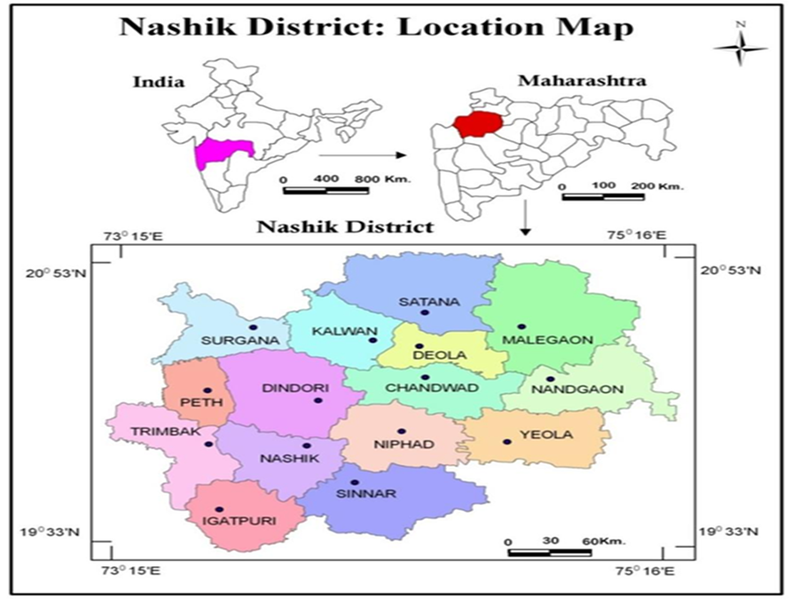
Fig. 1 Location Map of Study Area
2.2 Satellite Image Data-
Multi-date, multispectral satellite images from the Sentinel 2A satellite were downloaded from the Copernicus open-access hub website for a period of five months, ranging from November 2022 to March 2023. Two satellite images were downloaded for each month, except for March to capture the growth period of the wheat crop.
Table 1 Multi-date, Multispectral Sentinel 2A satellite data used for the study
Sr. no. | Satellite | Sensor | Date of Pass
1 | Sentinel 2A | MSI | 02-11-2022
2 | Sentinel 2A | MSI | 17-11-2022
3 | Sentinel 2A | MSI | 02-12-2022
4 | Sentinel 2A | MSI | 17-12-2022
5 | Sentinel 2A | MSI | 01-01-2023
6 | Sentinel 2A | MSI | 16-01-2023
7 | Sentinel 2A | MSI | 05-02-2023
8 | Sentinel 2A | MSI | 20-02-2023
9 | Sentinel 2A | MSI | 02-03-2023
10 | Sentinel 2A | MSI | 12-03-2023
11 | Sentinel 2A | MSI | 27-03-2023
2.3 Ancillary Data
The present study employed 1:50,000 scale topographical maps (toposheets) obtained from the Survey of India (SOI) as a reference for delineating the study area. These toposheets were utilized to digitize the administrative boundaries of the district under investigation. To generate the non-crop mask (NCM) for the study area, multiple data sources were integrated, including spatial information on water bodies, urban areas, forests, wastelands, and other non-crop features. This dataset facilitated the identification and delineation of regions within the study area that were not under agricultural cultivation.
2.4 Meteorological Data
The weekly meteorological data required for the study, including maximum air temperature, minimum air temperature, mean air temperature, maximum relative humidity, minimum relative humidity, bright sunshine hours, wind speed, and rainfall, were obtained from the Department of Agricultural Meteorology, Mahatma Phule Krishi Vidyapeeth, Rahuri, for the specified study period. Additionally, solar radiation data were sourced from the NASA website. (https://power.larc.nasa.gov).
2.5 The Digital Analysis
Digital analysis was carried out using Image processing and GIS software - ERDAS Imagine and ArcGIS. The methodology adopted for digital analysis is depicted in the flow chart (Fig.2)
Multidate Sentinel 2A
Collection of Satellite Data

Creating composite image

Vector map of the study area

Subset of the image

Unsupervised classification

Resultant classified image

Polygon vector layer
Extraction of Vis i.e. NDVI, NDWI, SAVI & MSAVI of wheat crop polygons

Creating layer stacks of VIS

Extraction temporal VI values of wheat
Temporal K_{c} value
Analyzing relationship between K_{c} & VIs

ET₀ by PM method
ET_{c}= ET₀ x K_{c} (Using best VI – Kc model)
Crop Acreage
Estimation of crop water demand

Fig. 2 Flow chart of the digital analysis
2.6 Collection of Ground Truth (GT) Data-
The ground truth (GT) work for crop locations was carried out from 6th to 11th January 2023 and 5th to 9th March 2023 in the study area.
2.7 Processing of Satellite Data for Vegetation Indices
Spectral vegetation indices (VIs) including the Normalized Difference Vegetation Index (NDVI), Normalized Difference Water Index (NDWI), Soil Adjusted Vegetation Index (SAVI) and Modified Soil Adjusted Vegetation Index (MSAVI2) were computed for each of the 11 pass dates listed in Table 1 to generate separate images for each vegetation index, the Model Builder Tool in ERDAS Imagine software was utilized. Furthermore, stacks of these index images were created using ERDAS Imagine software, combining the respective images for all vegetation indices.

Identification and Acreage Estimation of Wheat Crop.
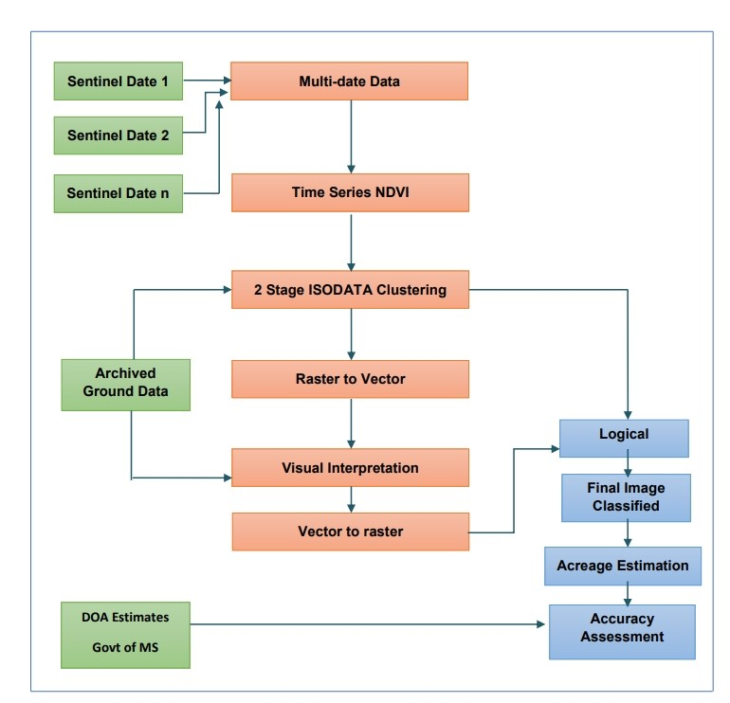
Fig.3 Flow diagram for acreage estimation
2.8 Establishing Relation between Vegetation Indices (VIs) and Crop Coefficients (Kc)
Using linear regression analysis, empirical correlations were established between the weekly wheat crop coefficients (Kc) proposed by Mahatma Phule Krishi Vidyapeeth, Rahuri (MPKV) and vegetation indices (VIs). The performance of the VI-Kc model was evaluated based on statistical metrics, including the coefficient of determination (R²), root mean square error (RMSE), Willmott's index of agreement (D), and percent deviation (PD).
2.9 Estimation of water requirement
Using weekly meteorological data, reference evapotranspiration (ETo) was estimated using the FAO Penman-Monteith method. The weekly crop coefficients (Kc) were derived from the best-performing VI-Kc model. Subsequently, the weekly crop water requirements (ETc) for wheat were determined as the product of reference evapotranspiration (ETo) and the vegetation index-based crop coefficient (Kc).

3. RESULTS AND DISCUSSION

3.1 Generation of Vegetation Indices Images
Sentinel-2A satellite data for the study area were acquired on 11 specific dates corresponding to different growth stages of the wheat crop. Key spectral bands were extracted and used to generate composite images through band combination. Image processing was conducted using ERDAS Imagine software, wherein vegetation index models were applied to derive four distinct vegetation indices: Normalized Difference Vegetation Index (NDVI), Normalized Difference Water Index (NDWI), Soil-Adjusted Vegetation Index (SAVI), and Modified Soil-Adjusted Vegetation Index (MSAVI2) for all eleven satellite overpass dates.
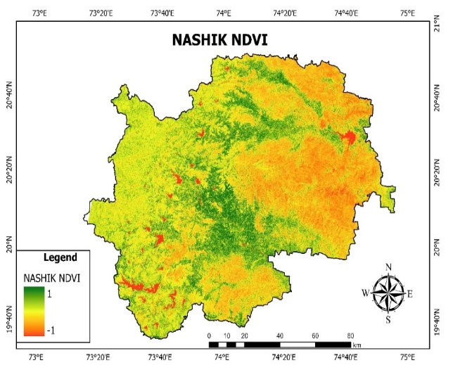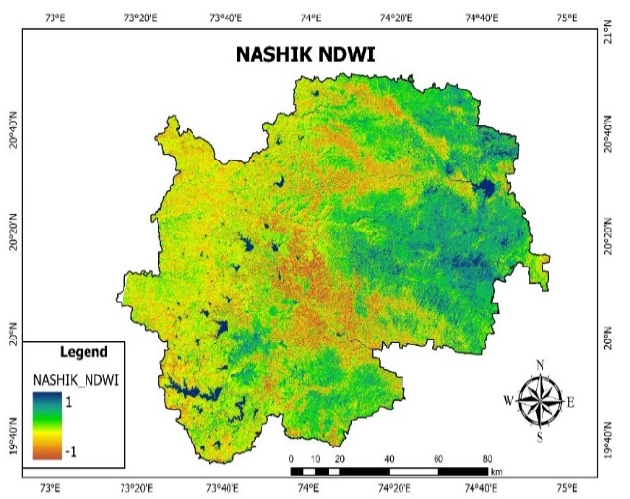
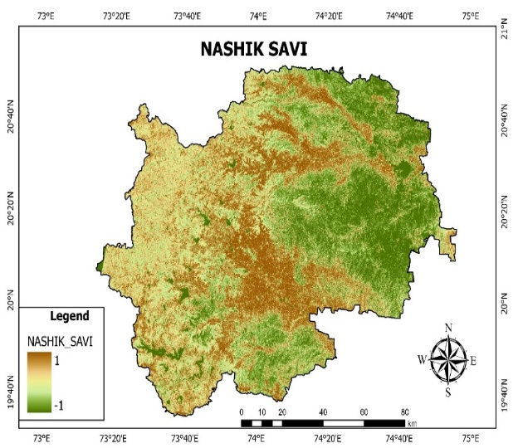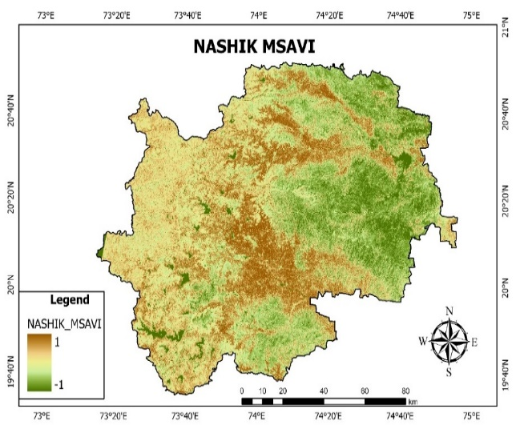
Fig. 4. Vegetation Indices Map of Study Area
Table 2- Average weekly values of vegetation indices of wheat
Weeks past Sowing | Vegetation Indices
Weeks past Sowing | NDVI | NDWI | SAVI | MSAVI 2
1 | 0.184 | 0.074 | 0.276 | 0.271
2 | 0.215 | 0.098 | 0.282 | 0.287
3 | 0.256 | 0.155 | 0.347 | 0.351
4 | 0.275 | 0.160 | 0.369 | 0.366
5 | 0.297 | 0.178 | 0.448 | 0.410
6 | 0.411 | 0.229 | 0.639 | 0.579
7 | 0.445 | 0.241 | 0.680 | 0.600
8 | 0.459 | 0.247 | 0.702 | 0.627
9 | 0.444 | 0.231 | 0.598 | 0.527
10 | 0.369 | 0.224 | 0.553 | 0.520
11 | 0.365 | 0.219 | 0.538 | 0.508
12 | 0.301 | 0.195 | 0.443 | 0.448
13 | 0.203 | 0.094 | 0.298 | 0.321
14 | 0.167 | 0.069 | 0.257 | 0.291
15 | 0.161 | 0.072 | 0.251 | 0.284
16 | 0.152 | 0.040 | 0.220 | 0.256
17 | 0.110 | -0.017 | 0.163 | 0.183

3.2 Identification and Acreage Estimation of Wheat Crop
The identification and estimation of wheat crop acreage were carried out using multi-date time series data from the Sentinel-2A satellite, employing a two-stage ISODATA clustering approach. This method facilitated the classification and delineation of wheat crop extent within the study area, enabling precise acreage estimation.
The wheat crop area was determined by multiplying the total number of wheat-classified pixels (1,955,308) by the spatial resolution of the satellite data (10 × 10 m) and converting the result into hectares. The estimated wheat acreage derived from the final classified image was 67,476.42 hectares. The classification accuracy was high, with most wheat pixels correctly identified. Additionally, linear features such as canals and roads were effectively classified as non-crop areas, enhancing classification reliability.
The remotely sensed wheat acreage estimation (67,476.42 ha) was compared to the actual reported area of 75,975.55 ha, as provided by the Department of Agriculture, indicating a 2.86% underestimation. Since wheat is an irrigated crop, variations in soil moisture influence its spectral reflectance, potentially affecting classification accuracy.
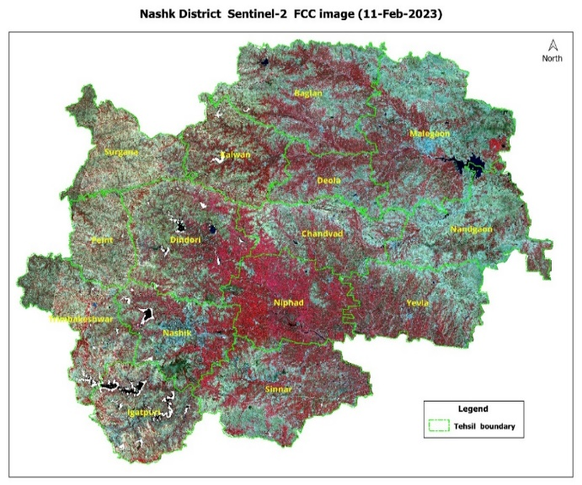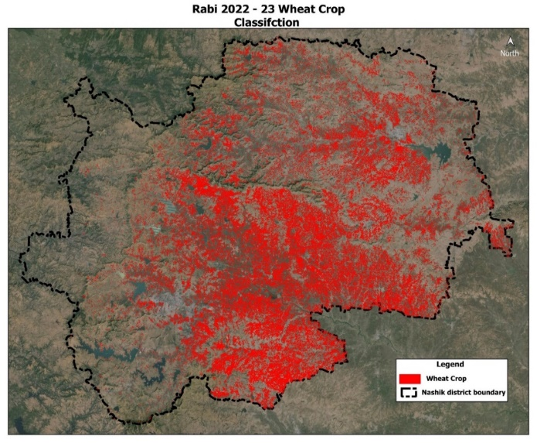
Fig 5 FCC Image of Study Area- Nashik District Fig 6 Classified image obtained by unsupervised classification
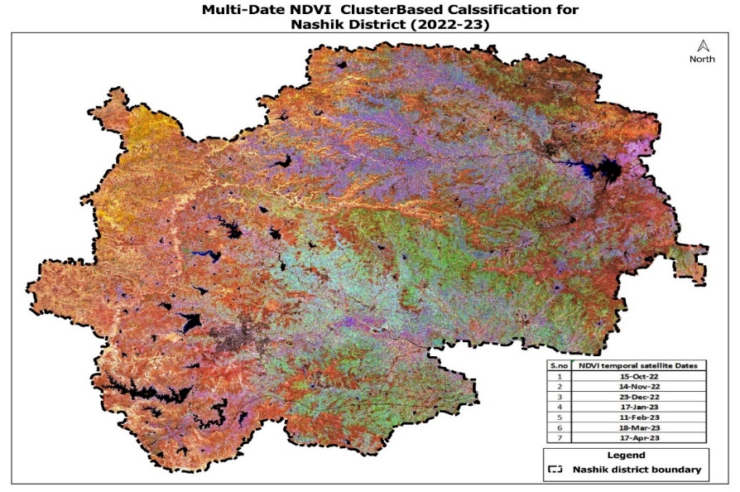
Fig 7 Final Classified image for 2022-23
3.3 Relationship between Crop Coefficients and VIs for Wheat.
The correlation analysis indicated that all vegetation indices exhibited strong associations with wheat crop coefficients, as evidenced by relatively high R² values. Among the indices examined, the NDWI-Kc model demonstrated the highest correlation, with an R² value of 0.934 and a Willmott Index of Agreement (D) of 0.986, signifying a robust relationship between NDWI and crop coefficients.
Moreover, the NDWI-Kc model outperformed other models, exhibiting the lowest values for standard error (SE), root mean square error (RMSE), and percent deviation (PD), recorded at 0.095, 0.0891, and 3.34, respectively. These results validate the superior predictive capability of the NDWI-Kc model for estimating wheat crop coefficients with high accuracy.
The NDVI-Kc and NDWI-Kc models demonstrated comparable performance, following the SAVI-Kc model. The NDVI-Kc model yielded an R² value of 0.8483, with SE, RMSE, PD, and D values of 0.116, 0.1090, 6.09, and 0.978, respectively. Similarly, the NDWI-Kc model achieved an R² value of 0.9365, along with SE, RMSE, PD, and D values of 0.095, 0.0891, 3.34, and 0.986, respectively.

Fig. 8 (a, b, c and d) Relationship of crop coefficients with Vegetation Indices for wheat crop
3.4 Reference evapotranspiration (ET_{o} mm) & Crop Evapotranspiration (ET_{c} mm) of wheat in Nashik District 2022-23
The reference crop evapotranspiration (ETo) for Nashik district was estimated using the FAO Penman-Monteith method, with the weekly values presented in Table 3. The NDWI vegetation index exhibited a strong correlation with wheat crop coefficients (Kc). Utilizing the linear regression equation derived from this correlation, the weekly crop coefficients for wheat were determined. Subsequently, crop evapotranspiration (ETc) was calculated by multiplying the reference evapotranspiration (ETo) with the corresponding crop coefficients (Kc), as detailed in Table 3. The total estimated crop evapotranspiration (ETc) for wheat was found to be 397.13 mm.
To quantify the water demand for wheat, the crop acreage obtained in Section 4.4 was multiplied by the corresponding total evapotranspiration (ETc) for each week. The resulting weekly water demands for wheat are presented in Table 4, with the total water demand estimated at 22,907,238.30 ha.cm or 229.07 Mm3. Notably, the week-wise water demand peaked during the mid-season stages, emphasizing the need for increased irrigation during these critical growth periods.
Table 3. The Total Estimated Crop Evapotranspiration (Et_{c}) For Wheat
MET Weeks | Weeks Past Sowing | ET_{o}(mm) | ET_{c}(mm)
45 | 1 | 3.11 | 15.54
46 | 2 | 2.96 | 16.32
47 | 3 | 2.75 | 19.83
48 | 4 | 2.71 | 19.94
49 | 5 | 2.49 | 19.71
50 | 6 | 2.61 | 24.46
51 | 7 | 2.97 | 28.91
52 | 8 | 3.06 | 30.40
1 | 9 | 2.90 | 27.38
2 | 10 | 2.81 | 25.92
3 | 11 | 3.61 | 32.89
4 | 12 | 3.77 | 31.68
5 | 13 | 4.44 | 23.94
6 | 14 | 4.81 | 22.57
7 | 15 | 4.94 | 23.15
8 | 16 | 5.75 | 21.72
9 | 17 | 6.08 | 12.77
Total |  |  | 397.13

Table 4 Crop water demand of wheat (m³) in Nashik district for wheat crop
Weeks Past Sowing | ET_{c} (mm) | Crop Acreage (ha) | Water Demand  (ha-cm) | Water Demand  (m³) | Water Demand  (mm3)
1 | 15.54 | 67476 | 1048442 | 1048442 | 1048442
2 | 16.32 | 67476 | 1101303 | 1101303 | 1101303
3 | 19.83 | 67476 | 1337880 | 1337880 | 1337880
4 | 19.94 | 67476 | 1345438 | 1345438 | 1345438
5 | 19.71 | 67476 | 1329763 | 1329763 | 1329763
6 | 24.46 | 67476 | 1650126 | 1650126 | 1650126
7 | 28.91 | 67476 | 1950866 | 1950866 | 1950866
8 | 30.40 | 67476 | 2051419 | 2051419 | 2051419
9 | 27.38 | 67476 | 1847358 | 1847358 | 1847358
10 | 25.92 | 67476 | 1749302 | 1749302 | 1749302
11 | 32.89 | 67476 | 2219286 | 2219286 | 2219286
12 | 31.68 | 67476 | 2137640 | 2137640 | 2137640
13 | 23.94 | 67476 | 1615328 | 1615328 | 1615328
14 | 22.57 | 67476 | 1523089 | 1523089 | 1523089
Total | 339.49 |  | 22907238 | 22907238 | 22907238
Total (Mm3) |  |  |  |  | 229.07

4. SUMMARY AND CONCLUSIONS
The research study was carried out in Nashik, a wheat-growing district in Maharashtra. To determine if four widely used vegetative indices-NDVI, NDWI, SAVI, and MSAVI 2 were needed for developing a relationship to crop coefficients. These indices were created by using digital processing techniques to sentinel 2A satellite images. The study's conclusions show that there is a constant pattern in the spectral profiles of wheat as shown by NDVI, NDWI, SAVI, and MSAVI 2. A two-stage hybrid classification approach was used to identify and estimate the acreage of the wheat crop. The results closely matched the actual statistics provided by the Department of Agriculture, Government of Maharashtra, with the wheat crop showing a variance of only 3.83%. Also, the estimations obtained from remote sensing were acquired significantly earlier than the Department of Agriculture's published statistics, providing an advantage in terms of early knowledge.
The study of four vegetation indices for wheat crop, namely NDVI, NDWI, SAVI, and MSAVI, shown that NDWI showed the greatest collaboration with the crop coefficient. Its R2 and D values were highly significant, at 0.9365 and 0.986, respectively. It also had the lowest PD, SE, and RMSE values-0.095, 0.0891, and 3.34, respectively. Thus, it is possible to calculate the geographical crop coefficients for wheat using the NDWI-Kc model (Kc = 4.2302NDWI + 0.3716).The NDWI-Kc model was utilized to derive the week-wise crop coefficients (Kc) for wheat, and the FAO Penman-Monteith method was used to estimate the reference evapotranspiration (ETo). After that, the crop evapotranspiration (ETc) was estimated by multiplying the corresponding Kc values by ETo. 397.13 mm of water was anticipated to be needed overall for the wheat crop in the Nashik district. Thus, it was determined that the study area's total water need for wheat was 22907238.307 ha.cm, or 229.07 Mm3. Because there is less rainfall during the rabi season, the amount of water required for irrigation nearly equals the amount needed for crops in the area.

Conclusions
The following conclusions are derived from the findings of the present study:
- All vegetation indices (VIs) exhibited patterns similar to crop coefficients (Kc). Conversely, phenological variations could be effectively monitored through temporal fluctuations in VIs. The probable date of planting can be inferred from distinct VI trends. The observed similarity between VI and Kc patterns suggests that Kc can be estimated using vegetation indices for wheat crops, thereby supporting the study’s hypothesis.
- The acreage estimation of wheat crops demonstrated high accuracy, with the estimated values closely aligning with actual measurements, exhibiting a percentage deviation of only 3.83%. This confirms that Remote Sensing and GIS techniques enable timely and precise crop acreage assessments.
- Among the vegetation indices analyzed, the Normalized Difference Water Index (NDWI) of wheat exhibited the strongest linear correlation with crop coefficients. Consequently, the developed VI-Kc relationships can be integrated into FAO-56 procedures as a viable alternative to conventional tabulated Kc values.
- The integration of Remote Sensing and GIS techniques can facilitate site-specific irrigation management by supplying water based on actual crop water demand. This approach is particularly beneficial in water-scarce conditions, allowing for optimized irrigation as a life-saving measure to prevent crop failure.
- A real-time expert system for precise irrigation scheduling can be established by integrating high-resolution remotely sensed data with automatic weather stations.

5. REFERENCES

Ahmad, F. 2012b. A review of remote sensing data change detection: Comparison of Faisalabad and Multan Districts, Punjab Province. Pakistan J. Geog. and Reg. Planning. 5(9): 236-251
Allen, R. G., M. Smith, L. S. Pereira, D. Raes and J. L. Wright. 2000. Revised FAO Procedures for Calculating Evapotranspiration: Irrigation and Drainage Paper No. 56 for testing in Idaho. In Proc. Watershed Management and Operations Management. June 20-24, Fort Coll ins, CO.
Anonymous 2022. Agricultural land and Water statistics of India. India Water Portal, https://www.indiawaterportal.org
Anonymous. 2021. Crop statistics. Department of Agriculture, Maharashtra. Website- www.krishi.maharshtra.gov.in
Anonymous. 2022. Crop statistics. Department of Agriculture, Maharashtra. Website- www.krishi.maharshtra.gov.in
Anonymous. 2022. Meteorological data. NASA Power Data. Websitewww.power.larc.nasa.gov.in
Dingre, S. K. and S. D. Gorantiwar. 2020. Determination of the water requirement and crop coefficient values of sugarcane by field water balance method in semiarid region. Agric. Water Manage, 1-8
Gontia, N. K. and K. N. Tiwari. 2010. Estimation of crop coefficient and evapotranspiration of wheat (Triticuum aerstivum) in an irrigation command using remote sensing and GIS. Water Res. Manag. 24:1399- 1414
Goswami, S. B., G.D. Bairagi, C. K. Sarat and S.K. Sharma. 2016. Evaluation of LISS-III And AWiFS Sensor data for Wheat Acreage estimation., Proc. of SPIE Vol. 9880: 1-10
Jha, A., A. S. Nain and R. Ranjan. 2013. Wheat Acreage Estimation Using Remote Sensing in Tarai Region of Uttarakhand. Soc. for Plant Res., Vol. 26 (2): 105-111
Kadam, S. A., S. D. Gorantiwar, S. D. Dahiwalkar and M. G. Shinde. 2019. Crop Evapotranspiration and Normalized Difference Vegetation Index relationship for Wheat crop. Agric. Res. J., 56 (2):336-339
Kamble, B., A. lrmak and K. Hubbard. 2013. Estimating Crop Coefficients Using Remote Sensing-Based Vegetation Index. Remote Sens., 5: 1588-1602
Kosle A. 2021. Vegetation indices-based crop coefficients to estimate evapotranspiration of wheat. M. Tech thesis (unpub.), Department of Irrigation and Drainage Engineering, Dr. PDKV, Akola.
Monteith, J. L. 1965. Evaporation and environment. p. 205-234. In G.E. Fogg (ed.) the state and movement of water in living organisms. In Proc. Symp. Soc. Exp. Bioi. Vol. 19. Academic Press, New York
MPKV. 2021. Krishi Darshani-2021. Directorate of Extension Education, Rahuri, Maharashtra.
Pimpale, A. R., P. B. Rajankar, S. B. Wadatkar, S. S. Wanjari and I. K. Ramteke 2015. Estimation of water requirement of wheat using multispectral vegetation indices. J. of Agromet, 17 (2): 208-212
Ray, S. S. and V. K. Dadhwal. 2001. Estimation of crop evapotranspiration of irrigation command area using remote sensing and GIS. Agric. Water Manage, 49: 239-249
Sharma, R., L. Pradhan, M. Kumari and P. Bhattacharya. 2021. Comparative Analysis of Different Vegetation Indices of Noida City using Landsat Data. Advances in Energy and Environment, Lecture Notes in Civil Engineering. pp: 209-221.
Singh, S. K., Dutta S. and Dharaiya N. 2016. Remote Sensing Indices for Crop Water Management. Inter. J. of Engg. Sci. & Res. Tech., ISSN: 2277-9655: 326-334
Wang, P., X. Li, J. Gong and C. Song. 2001. “Vegetation temperature condition index and its application for drought monitoring.” Inter. Geoscience and Remote Sens. Symposium, Sydney, Australia, 9·14 July, pp: 141-143
Zhang, H., Y. Lan, R. Lacey, W. C. Hoffmann and Y. Huang. 2009. Analysis of vegetation indices derived from aerial multispectral and ground hyperspectral data. Int. J. Agric. and Biol. Engg., 2(3):33-40

