Original Research Article

Prevalence of gastro intestinal parasites in sheep and goats and zoonotic helminths in Maekel region, Eritrea

ABSTRACT
Aim: To determine the prevalence of GIT parasites in sheep and goats and zoonotic helminths from slaughter house in the Maekel region, Eritrea.
Study design: The study involved firstly a cross-sectional screened 384 sheep and goats for GIT parasites from four study villages of Maekel region and a questionnaire survey on risk factors associated with GIT parasite infections. Secondly, retrospective data (2022,2023) on zoonotic helminths was also collected from slaughter house in Maekel region.
Place and duration of study: Maekel region of Eritrea between January 5,2024 to December 11,2024.
Methodology: A total of 384 feacal samples were collected from sheep and goats to determine the prevalence of gastrointestinal parasites. Fresh fecal samples were collected and transported to transported to National Animal and Plant health laboratory (NAPHL) in Eritrea, for analysis using floatation and sedimentation techniques for microscopic examination. Questionnaire survey was also carried out on 40 farmers to determine the risk factors associated with helminth infections in the region.
Results: Parasites have been isolated and identified with the occurrence of Hemonchus sp.(27.2%), Eimeria sp (19.79%), Cooperia sp. (15.9%), Strongylus sp. (11.9%), Monezia species (7.8%),Ascarisspecies(5.5%), Dictyocaylus filarial(5.2%), Paramphistomum cervi (5.2%), Osophagostomum colunibiamum (3.7%), Chabertia ovina (3.7%), Trichuris globulosa (3.4%), among others. The risk factors associated with GIT parasites included poor housing, mixed housing, sharing of water sources with other livestock, irregular deworming and low level knowledge. Zoonotic helminths of included by hydatid cysts, Strongyloides, Trchiuris, Ascaris, Paraphastumun, Dictyocaulus filarial, Haemonchus spp and Faciola spp.
Conclusion: Maekel region have had high prevalence of parasitic helminths in sheep and goats which negatively impact on the shoat’s production. Most importantly are the zoonotic NTDs including Echinococcosis, Strongyloides, Trchiuris, Ascaris, Paraphastumun, Dictyocaulus filarial, Haemonchus spp and Faciola spp which indicates that the animals could be reservoir hosts and play role of reinfection to humans.

Key words: Zoonotic NTDs, Sheep and goats, Gastrointestinal parasites, Risk factors

1.INTRODUCTION
Small ruminants are the most essential animals among small-scale farmers in the livestock production industries worldwide, in which they have a big impact on the ecological and economic sectors of agriculture. Sufficient production of small ruminants including the sheep and goats, support farmers as a means of generating income and important animal derived products (milk, meat, food security, manure, skin, medicine, gifts, hair) (Hailegebrael et al., 2017). Productivity in sheep and goats can be achieved through good hygiene management system, providing nutritional foods, applying efficient reproduction system involving good genetic makeup and seeking veterinary health services regularly. However, when these important procedures are not implemented, productivity of the animals are remained low due to the consequences of several factors like parasitic diseases that caused by different species of parasites (Olifan et al., 2020).
Gastrointestinal parasites are the most critical problems of livestock system in small ruminants’ production, especially in the tropical and subtropical regions where their prevalence’s of parasitic infections is very common due to different range of agro-ecological conditions. The conducive environmental conditions are important factors for the existence and development of diverse parasitic species and their interaction with their interrelated hosts (Ibn et al., 2022). Trematodes (like Paramphistomun spp, Fasciola spp), nematodes (like Strongyloide spp, Haemonchus spp, Ascaris spp.), cestodes (like Monezia spp), and Protozoans (like Cryptosporidium, Entamoeba and Eimeria spp) are among the most abundant parasites causing disease in these ruminants (Dogo et al.,2017). Gastrointestinal parasites in sheep and goats are associated with diverse adverse effects including, reduced reproduction rate, low weight, low quality of animal products and even death (Yafet et al., 2020, Solomon et al., 2021). Several of these parasites are also zoonotic. The zoonotic potential is also contributed by the complex interaction of animals, man and their environment which is sometimes pose a challenge to control (Andernice et al., 2021). From the previous studies, some of the integrated control measurements are proper practices on farming, good strategies on breeding, appropriate measurements on using biological controls, use of biotechnological techniques and chemical control (Toyin et al., 2020). As in the other parts of the world, in Eritrea also, sheep and goat are important sources of income among small-scale farmers. The main mode of transmission is through free range grazing where animals acquire infection in vegetation. Although some parasitological studies on sheep and goats have been carried out in Eritrea especially in the southern highland regions, most of these studies have focused only on estimating the distribution of GI parasites, thus prevalence’s of the parasite species and associated risk factors as well as the parasites present in the sheep and goats have not been studied. The main aim of the current study was therefore to determine the prevalence of gastro intestinal parasites in sheep and goats, associated risk factors and zoonotic helminths in Maekel region with the aim as help to guide control of the parasites. The outputs from the study could provide insights into better control measures put in place by the relevant authorities.

2.MATERIALS AND METHODS
2.1 Study area
The study was carried out in Maekel region of Eritrea (Figure 1), which is lies at elevation of 2,325 meters above sea level with north-south trending of high lands of Eritrea, which has about 483mm of rainy and 518mm of precipitation annually and average humidity of 51%. Due to its 2325mts altitude, temperatures are relatively mild and long rainy season extends from June until September as short rainy season occurs from March until May. Average about 60% of the region’s annual precipitation is seen during the months of July-August. In contrast, December to February are typically driest (Metrology units’ ministry of Agriculture Eritrea,2023). Therefore, studied was carried out in Maekel region by Selected the four villages (Adi Abieto, Adi Segudo, Kushet and Godaif-Sembel), in which the samples were collected from there randomly.
2.2 Study animals, Sample size and Study design
Study was conducted among 40 small-scale farmers who keep sheep and goats under traditional practice managements systems from four villages (Adi Abieto, Adi Segudo, Kushet and Godaif-Sembel) in Maekel region, Eritrea. Homesteads were selected randomly for sampling of the animals (sheep and goats). In this study, total sample of 384 animals (96 from each village) of both sheep and goats at different ages and sexes were used for assessing intestinal parasitic infections. Fecal samples were collected from both sheep and goats for the laboratory analysis of GI-parasites using microscopy techniques. In addition, sampling was also carried out in the slaughter house of Maekel region and retrospective data on zoonotic helminths in the past two years (2022,2023).
2.3 Sample collection and analysis
Fresh fecal samples of approximately 10 g was collected from the rectum of selected sheep and goats, using a gloved finger after wetting with water for lubrication. Collected samples were placed in plastic bottles of 30ml with suitable waterproof screw cap in order to keep the samples fresh. Sample bottles were labeled then transported in a cool box to the National Veterinary Parasitology Laboratory unit in Eritrea. The flotation technique was used to detect and identify eggs of nematodes, cestodes and protozoa parasites and sedimentation technique was used for detecting trematode parasites eggs as describe by Janina and Mathew, 2021.
2.4 Data management and statistical analysis
Data analysis was done using STATA version 12. One-Way Analysis of Variance (One-Way ANOVA) was used to compare the prevalence rates of GI-parasites among the villages. The P values for significance was set was set at 95%
3.RESULTS

3.1 Prevalence of gastrointestinal parasitic infections among sheep and goats in Maekel region, Eritrea
Overall the prevalence of GI-infections in sheep and goats in the whole Maekel region was 91.41%(351/ 384). There was no significant difference in the prevalence of parasites among the four villages (p = 0.69). However, there was a significant difference between the different species (p = 0.0001) with Haemonchus contortus (26%) being the most abundant while the Ostertagia circuncineta (0.5%) was the least common (Table 1). Among the parasites reported include Strongyloidess, Hemonchus, Eimeria spp among others (Table 1, Figure 2)
Table 1: Prevalence of GI-parasites in Maekel region, Eritrea.
Region |  | Adi-abeito (n=96) | Kushet (n=94) | Adi-segdo (n=97) | Sembel-Godaif  (n=97) | Overall prevalent rate (Maekel region) | ratio | p-value
Infection status | Positive | 91(94.79 %) | 87(92.55 %) | 88(90.72 %) | 85(87.63 %) | 351(91.41%) | t=40.827 | 0.0001
Gastrointestinal Parasite |  |  |  |  |  |  | Mean prevalence (%)
Haemonchus contortus |  | 54 (56.3%) | 23 (24.5%) | 16 (16.5%) | 11 (11.2%) | 104 (27.2%) | 26
Eimeria species |  | 28 (29%) | 21 (22.3%) | 11 (11.3%) | 16 (16.3%) | 76 (19.79%) | 19
Cooperia species |  | 22 (29.7%) | 17 (18.1%) | 9 (9.3%) | 13 (13.3%) | 61 (15.9%) | 15.25
Strongylus species |  | 14 (14.6%) | 9 (9.6%) | 10 (10.3%) | 13 (13.3%) | 46 (11.9%) | 11.5
Moniezia Benedini |  | 8 (8.3%) | 7 (7.5%) | 7 (7.2%) | 8 (8.2%) | 30 (7.8%) | 7.5
Ascaris species |  | 4 (4.2%) | 8 (8.5%) | 6 (6.2%) | 3 (3.1%) | 21 (5.5%) | 5.25
Trichuris globulosa |  | 3 (3.2%) | 0 (0%) | 5 (5.2%) | 5 (5.1%) | 13 (3.4%) | 3.25
Dictyocaylus filarial |  | 5 (5.3%) | 2 (2.1%) | 8 (8.3%) | 5 (5.1%) | 20 (5.2%) | 5
Osophagostomu Columbianum |  | 1 (1.1%) | 2 (2.1%) | 5 (5.2%) | 6 (6.1%) | 14 (3.7%) | 3.5
Paramphistomum cervix |  | 2 (2.1%) | 3 (3.2%) | 8 (8.3%) | 7 (7.1%) | 20 (5.2%) | 5
Bunostomum trigunocephelu |  | 2 (2.1%) | 0 (0%) | 0 (0%) | 6 (6.1%) | 8 (2.1%) | 2
Chabertia ovina |  | 2 (2.1%) | 0 (0%) | 7 (7.2%) | 5 (5.1%) | 14 (3.7%) | 3.5
Nematodirus species |  | 0 (0%) | 2 (2.1%) | 5 (5.2%) | 0 (0%) | 7 (1.8%) | 1.75
Ostertagia circuncineta |  | 0 (0%) | 2 (2.1%) | 0 (0%) | 0 (0%) | 2 (0.5%) | 0.5
Aggregated |  |  |  |  |  | 91.33%

Key: n= number of samples tested

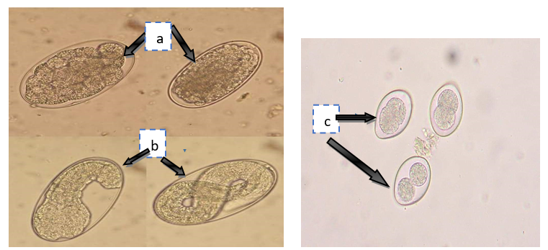
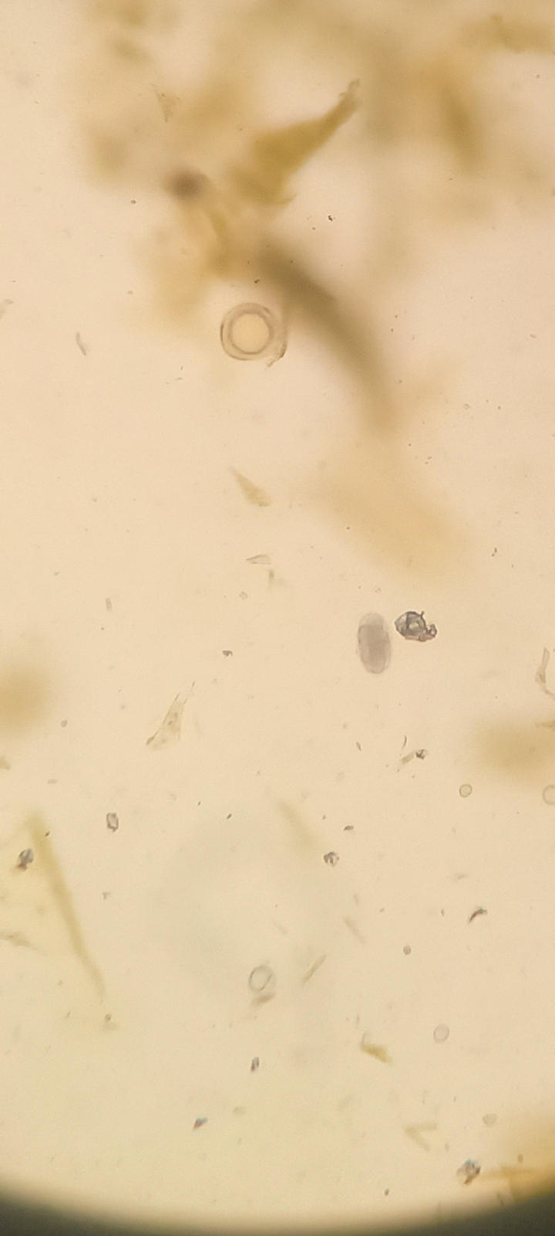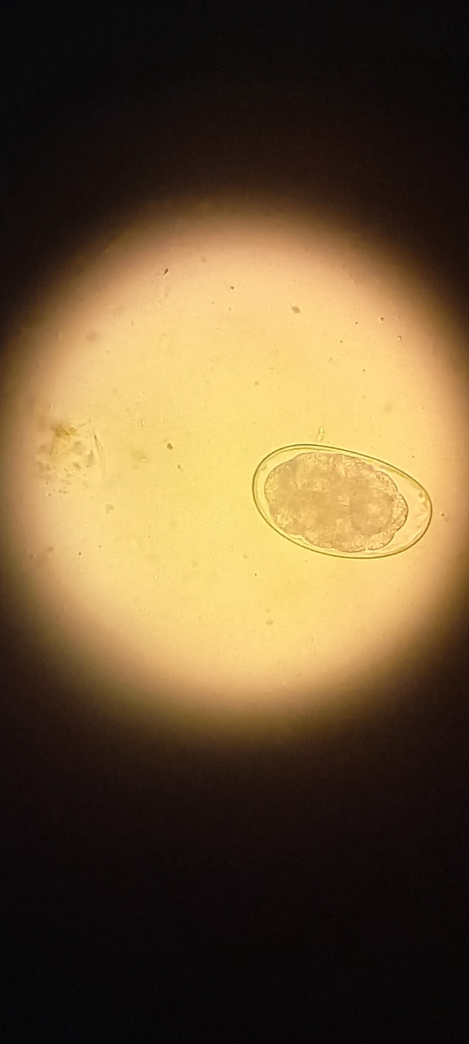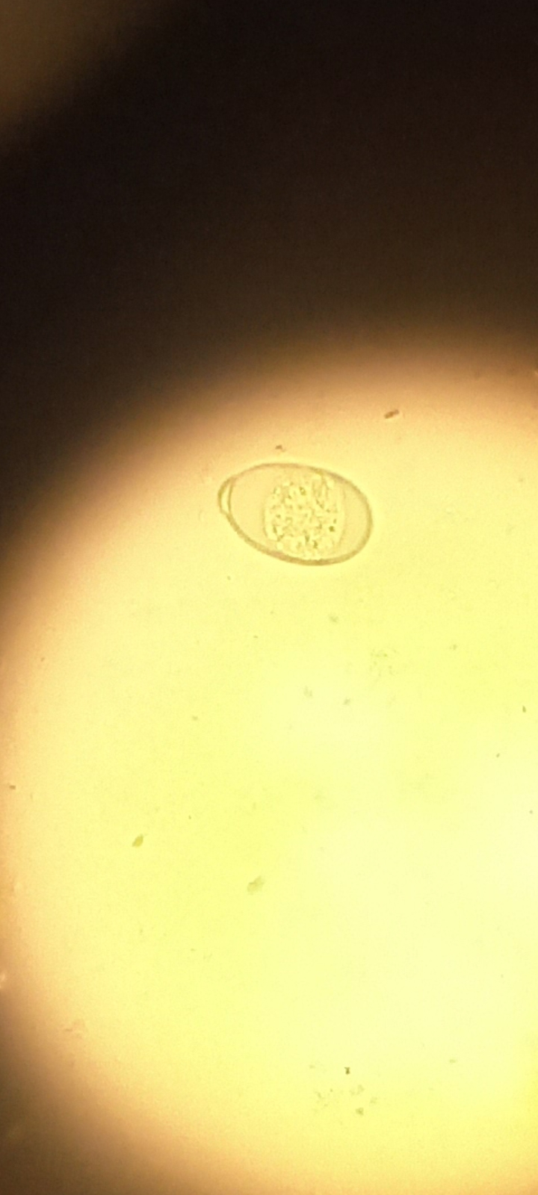
d
e
f
Figure 2: Different species of gastrointestinal parasites (a-f) detected during diagnosis a) Strongyl eggs spps b) Strongyloides eggs c) Eimeria d) Ascaris egg (X10) e) Haemonchus contortus of sheep (X40), f) Eimmeria spp (magnification X40)

3.2 Risk factors of gastrointestinal parasitic infections
Risk factors associated with helminth infections assessed included frequency of cleaning animal’s houses, water sources for the animals, knowledge of the farmers, checking parasites and deworming frequencies in relation to GI-parasites prevalence and explained as below.

3.2.1 Water sources
Only 2.5% out of the farmers provided drinking water in a designated area, where as 27.5% out of the participants did not avail water in a designated are for their animals. In addition, majority of the farmers (70 %) took their animal to dams for drinking (Figure 4).
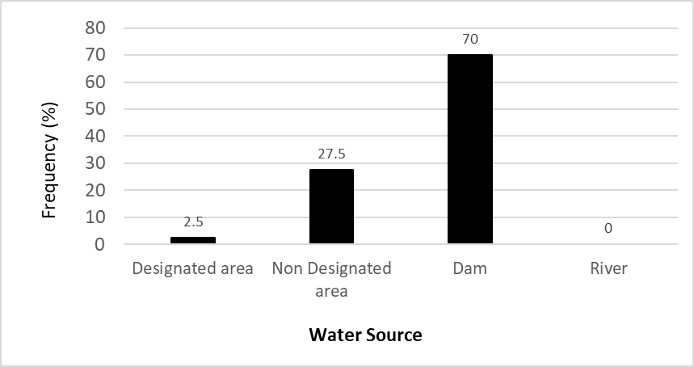

Figure 3: Sources of water for sheep and goats

3.2.2 Animal House cleaning frequency
Only 5.0% of the farmers cleaned their animal houses regularly (the regularity was some of them in days and others in weeks), while 27.5% out of the farmers were cleaning their animals’ houses daily. Again, the results indicated that, majority of the farmers (62.5%) were cleaning their animals’ houses weekly, as 2.5% out of the farmers were cleaning monthly and 2.5% confirmed that the farmers were cleaning their animal houses annually (Figure 4).
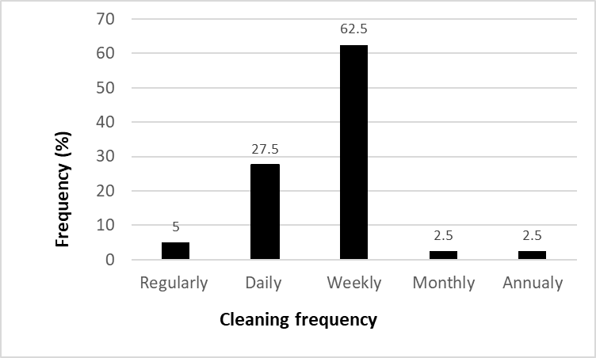
Figure 4: Cleaning frequency as a possible risk factor for parasite infections

3.2.3 Knowledge of gastro intestinal parasites by the farmers
Majority of the farmers (70.0%) had only elementary knowledge concerning GI-parasites, as 30% of these farmers had secondary level and none of the farmers from that area had beyond that level (Figure 5).

3.2.4 Frequency of deworming for sheep and goats by farmers
The analysis about frequency of deworming for sheep and goat by their owners showed that, only 5.0% of the farmers dewormed their sheep and goats every three months, 12.5% of them carried out this practice every six months. Many farmers (42.5%) dewormed their sheep and goats annually, 35.0% attested that deworming their sheep and goats irregularly while, 5.0% confirmed not conducting the deworming exercises at all (Figure 5).

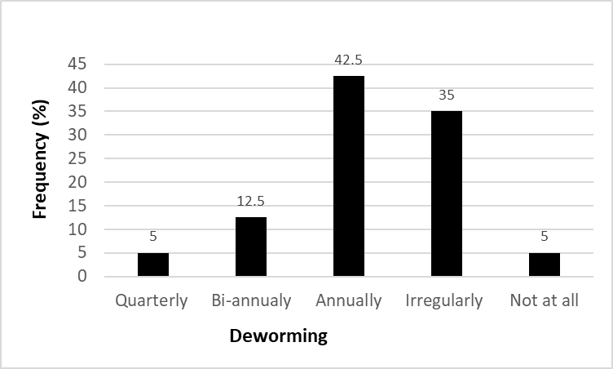
Figure 5: Frequency of deworming for sheep and goats by farmers

3.2.5 Other risk factors
The results indicated that, most of the farmers 57.5% provided housing for their animals (Figure 5). With regard to mixed housing, 32.5% of the farmers indicated that they had mixed housing with other livestock (Figure 5). In addition, majority of the farmers (97.5%) had earthen floor type of housing for their sheep and goats while only 2.5% had concrete floor type. Conversely, only as only 17.5% out of the farmers frequently screened their animals for GI-parasites hence most of them were not aware of the infection status of their livestock (Figure 6).
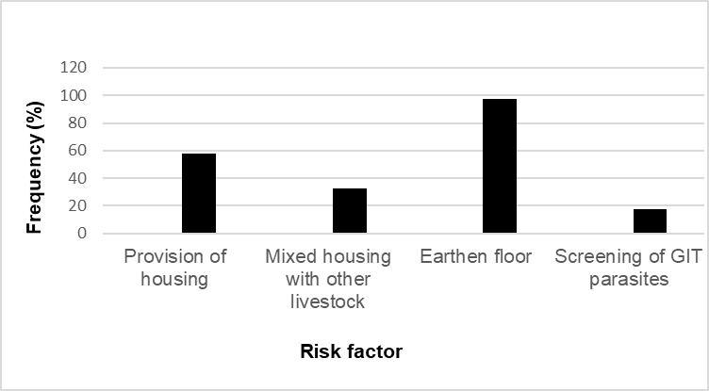
Figure 6: Other risk factors

3.4 Detection of zoonotic helminths from slaughter house of Maekel region, Eritrea
As the current prevalence’s of zoonotic helminths and assessment in caparison of the past two years (2022,2023 and half year of 2024) were carried out on sheep and goats by categorizing them in sexes and age groups. Currently samples collected from different organs (lung, liver and stomach) and the recorded data from the office were collected from the slaughterhouse of Maekel region, Eritrea. Different types of zoonotic helminths including hydatid cysts in lungs, paraphastumun in stomach, strongly, ascaris and Trichuris eggs species in small intestinal tract and dictyocaulus filarial in liver among the others were detected. The results of parasite infections were dominated by Strongloids, Ascaris, hydatid cysts, Haemonchus, Eimeria spp, among the others.
The result of parasite infection rates for male were 8.38% in 2022, 8.56% in 2023 and 12.96 % in 2024, while 11.42 % in 2022, 11.25 % in 2023 and 14.09 % in 2024 were the females’ parasitic infections. Based on age group demonstrations of 4-8 months, the infection rate was 8.99 % in 2022, 9.28 % in 2023 and 9.03 % in 2024, as in 1-3 months’ age group, the infection rate was 14.83 % in 2022, 11.79 % in 2023 and 14.04 % in 2024, while from 9 months up to 6 years’ age group, the rate of infection was 8.71 % in 2022, 9.07% in 2023 and 16.08 % in 2024 (Figure 7 and Table 2).
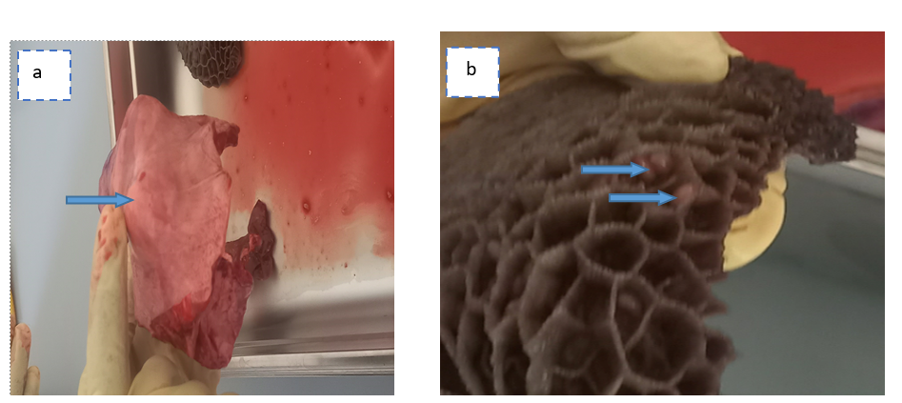
Figure 7: Organs of sheep and goats, which infected with zoonotic helminths. a) Hydatid cyst in lung of sheep (blue arrow), b) Paraphastumun egg from the stomach (reticulum) of sheep.

Table 2: Zoonotic helminths parasites recorded in slaughter house of Maekel region, Eritrea within 2022, 2023 and half year of 2024.
Years | Variables |  | Records |  |  | Parasites detected
Years | Category | Type | Slaughtered | Infected | (%)
Years | Category | Sheep and goats | 2,182 | 205 | 9.40 | hydatid cysts, Paraphastumun, Strongloids, Ascaris, Eimeria spp
2022(January-December) | Sex | Male | 1455 | 122 | 8.38 | Strongloids, Ascaris, hydatid cysts, Haemonchus
2022(January-December) | Sex | Female | 727 | 83 | 11.42 | Strongloid, Faciola spp,  Moniezia benedini
2022(January-December) | Age range | 1-3 months | 209 | 31 | 14.83 | hydatid cysts, Haemonchus, Paraphastumun
2022(January-December) | Age range | 4-8 months | 745 | 67 | 8.99 | Trichuris, Paraphastumun,  Dictyocaulus filarial, Ascaris
2022(January-December) | Age range | 9months-6years | 1228 | 107 | 8.71 | Hydatid cysts, Strongloid, Ascaris
2023(January-December) |  | Sheep and goats | 1,892 | 179 | 9.46 | Eimeria spp, Strongloid, Faciola spp, Ascaris, Paraphastumun, Haemonchus, Dictyocaulus filarial, hydatid cysts, Moniezia benedini
2023(January-December) | Sex | Male | 1261 | 108 | 8.56 | Strongloids, Ascaris, Faciola spp,
2023(January-December) | Sex | Female | 631 | 71 | 11.25 | Trichuris, Paraphastumun,  Dictyocaulus filarial
2023(January-December) | Age range | 1-3 months | 229 | 27 | 11.79 | Hydatid cysts, Haemonchus,  Eimeria spp, Strongloid
2023(January-December) | Age range | 4-8 months | 528 | 49 | 9.28 | Strongloid, Moniezia benedini
2023(January-December) | Age range | 9months-6years | 1135 | 103 | 9.07 | Faciola spp, Strongloid, Eimeria spp., Hydatid cysts, Strongloid
2024(January-May) |  | Sheep and goats | 743 | 98 | 13.19 | Eimeria spp, Strongloid, Faciola spp, Ascaris, Paraphastumun, Haemonchus, Dictyocaulus filarial
2024(January-May) | Sex | Male | 594 | 77 | 12.96 | Strongloids, Ascaris, Haemonchus
2024(January-May) | Sex | Female | 149 | 21 | 14.09 | Eimeria spp, Paraphastumun,  Dictyocaulus filarial
2024(January-May) | Age range | 1-3 months | 57 | 8 | 14.04 | Strongloid, Haemonchus, Trichuris
2024(January-May) | Age range | 4-8 months | 288 | 26 | 9.03 | Faciola spp, Moniezia benedini
2024(January-May) | Age range | 9months-6years | 398 | 64 | 16.08 | Ascaris, Strongloid, Paraphastumun, Eimeria spp, Dictyocaulus filarial

4.DISCUSIONS

4.1 Prevalence of GI-parasite infection in Maekel region, Eritrea
The most dominant species of the parasites being Haemonchus contortus (27.2%) while Ostertagia Circuncineta (0.5%) parasite was associated with the lowest prevalence. The aggregated prevalence (91.33 % was higher than previous study by Shimelis et al., 2021 (53%). The present study also indicated that female animals had higher prevalence than male ones similarly reported (Singh et al., 2017; Shimelis et al., 2021). Though other studies have reported the opposite (Takalani et al., 2020). Similarly, majority of the animals were positive with multiple parasites-co-infections.
Under natural situation, males and female sheep and goats have a higher chance of contamination if they were exposed to the same contaminated communal grazing pasture, but the differences in the variations in the infection rates between the two sexes are not clear. Male sheep and goats’ GI-parasites infection rate might be related to their behavioral characteristics (aggressiveness) and hormonal fluctuations during the breeding season (Maquivar et al, 2021). Previous studies have also reported significantly higher GI-parasitic infections in females as compared to male animals (Islam et al., 2017; Singh et al., 2017). Other studies have indicated that sheep and goats sex had a significant associated with GI-parasitic infections (Rahman et al., 2017; Dey et al., 2020). It is therefore, not clear why female sheep and goats would significantly have more infections when compared to the male animals yet all the animals are grazed in the same fields.

4.2 Risk factors associated with GI-parasitic infections in sheep and goats in the Maekel region, Eritrea
Housing sheep and goats in a good animal house is very important as this would help in confining livestock in an area where management systems can be well controlled. This would essentially help in disease control. The findings that majority of farmers in the present study had built good houses for their sheep and goats show some understanding in animal good management. Furthermore, it is well established that keeping so many different livestock species together would be a risk factor for infections (Hailegebrael et.al. 2017). It is established that when different species of animals live together, parasite infection rates become high (Solomon et al., 2021).
Providing clean drinking water to livestock is important for disease control and it was concerning that a number of sheep and goat farmers in the present study were providing their livestock with water sourced from dams and other undesignated water sources. Unclean water sources would be a risk factor for animal infections due to fecal contamination of water from contaminated environments (Abayomi et al., 2018). Thus, it is likely that, sheep and goats provided with water from these unclean sources could have been highly infected with parasites and this might be the reflection reported in the present disease prevalence.
Irregular cleaning of housing contributes to infections just like in cases of grazing livestock together in poor environments (Waktole et al., 2023). Likewise, livestock houses with earth floors could be harboring more parasites than concrete house floors in addition to the ease of cleaning the later (Solomon et al., 2021).
Farmers’ lack of awareness about disease control, prevention and treatment measures against parasitic infections is a likely factor to increased disease prevalence. Furthermore, upgrading farmer’s knowledge on livestock infection management systems can lead to effective disease control (Hafiz et al., 2021). Checking disease status in livestock can be important to inform on timely disease treatment and it was worrying to establish that some farmers were not checking their sheep and goats to establish their parasitic disease status (Dogo et al., 2017). Irregular deworming is a major risk factor to helminth infections and this could be due to lack of awareness and knowledge on good disease management systems in livestock farming though farmers who practice regular deworming controlled most helminths (Roshan et al., 2021). However, even though deworming of livestock is important, knowledge of good management system is very important as uncontrolled used drugs can lead to parasite resistance due to drug abuse (Hafiz et al., 2021).

4.3 Zoonotic helminths from slaughter house of Maekel region, Eritrea
Zoonotic parasites were dominated by Strongloides, Ascaris, hydatid cysts, Haemonchus, Fasciola and Eimeria species among the others. These are both helminths and one protozoa Eimeria though other studies have also reported several protozoan zoonoses in goats including Cryptosporidium and Giardia among others (Ikpe et al., 2022). Despite increase in infections over the perion no control measures were put in place. These animals therefore serve as reservoir hosts for most human helminths (Karshima et al., 2018)
This high infection of sheep and goats with zoonotic parasites is worrying because these animals form the most preferred source of meat for the local communities and there is a high possibility of these parasites being transmitted to humans and this could be the reason why these infections are highly prevalent in the study area (Kiani et al., 2021). Furthermore, transmission of parasites from animals to humans and vice versa would complicate disease control efforts especially in communities where meat may not be well cooked. This calls for community health education as well as mass drug administration in both affected animals and humans.

CONCLUSIONS
There were several GI-parasitic infections in sheep and goats in the Maekel region including Hemonchus sp ,Eimeria sp, Cooperia sp. Strongylus sp.,Monezia sp, Ascaris, Trichuris, Dictyocayls filarial, Osophagostomun colunibiamum(3.7%),Paramphistomumce vix(5.2%),Bunostomum trigunocephelum(2.1%),Chabertia ovina, Nematodirus, Ostertagia circuncineta. The risk factors associated with gastrointestinal parasitic infections included poor housing, mixed housing with other animals, dam or common water supply with other livestock, irregular deworming, poor knowledge of farmers on parasitic helminths. Several zoonotic parasites were reported from slaughter house including hydatid cysts, Strongyloides, Trichiuris, ASCARIS, Faciola sp, Paraphastumun, Dictyocaulus filarial, Haemonchus sp.

Data Availability Statement: The data presented in this study are available on request from the corresponding author.

CONSENT
All authors declare that, the study was permitted and authorized by the Ministry of Agriculture the state of Eritrea. The research work was further recognized by the concerned authorities in the Maekel region, Eritrea. Informed consent was obtained from the farmers following necessary explanation about the objectives of the study by the authors before sampling and administering the questionnaires (scanned letter in APPENDIX-I).
ETHICAL APPROVAL
The study was approved by Maekel administration state of Eritrea, in the reference number of 02/3/1245/24. All authors declare that, the participants were voluntary and informed of their right to withdraw at any time. Any information obtained from the participants were kept strictly confidential. During sampling, animals were restrained following standard procedures to minimize discomfort and ensure animal welfare. Again, Fecal samples were collected by trained animal health technicians and veterinary professionals while applying recommended precautions and safety procedures.
REFERENCES
Hailegebrael, B. Fikru, G. and Wossene, N. (2017). Preliminary study on small ruminant GIT helminthiasis in select arid and semi-arid pastoral and agro-pastoral areas of afar region- Ethiopia-Samara University, College of veterinary medicine. International Journal of Advanced Research in Biological Sciences, 4: 12.
Olifan, F. A., Duguma, M. T. and Fethu, L. (2020). Gastro intestinal parasites of sheep and goats in and around Gondar town, north West-Ethiopia. Haramaya University, college of veterinary medicine, Diredawa-Ethiopia. Biotechnology in Animal Husbandry, 36 (3): 371-380.
Ibn, I. A.R., Paintsil, I. F., and Makija, J. T. (2022). Gastrointestinal parasite infections in small ruminants relative to host sex, age and husbandry system under the guinea savannah vegetation. School of Veterinary Medicine, University for Development Studies, Nyankpala campus, Ghana. Biotechnology in Animal Husbandry, 38 (2): 139-155.
Dogo, G. I., Abraham1, Karaye, P., Gloria1, Patrobas, M.G.1, Galadima, M.3 and Gosomji, I.J. (2017). Prevalence of Gastrointestinal Parasites and their impact in Domestic animals in Vom, Nigeria. Department of Veterinary Parasitology and Entomology, University of Jos, Plateau State, Nigeria, Saudi Journal of Medical and Pharmaceutical Sciences,3(3) :211-216.
Solomon, G., Biruk, A., Hiwot, D., Tadiwos, A., Tesfaye, M., Mesfin, M., Asrat, A.and Barbara, W. (2021). Community-based approach for the control of gastrointestinal parasites under smallholder sheep farming systems. European union, Research program on livestock. International Livestock Research Institute (ILRI), Ethiopia, Component 2 of the HEARD project.
Andernice, S. Z., Lucas, F. D., Marta, S.M.A., Herakles, A. G., Daniel, M. A., Omar, A. E. and Antonio, F. M. (2021). Diversity and prevalence of intestinal parasites of zoonotic potential in animal hosts from different biomes in central region of Brazil. Faculty of Agricultural and Biological Sciences, University of Mato Grosso, Brazil, Annals of Parasitology, 67(1): 95–105.
Toyin, E. J. H., Lorraine, L., Karthik, P. R. S. and Gemma W. (2020). Recommendations for the Public Health Management of Gastrointestinal Infections ,2019. Public Health England and the Chartered Institute of Environmental Health, Sustainable Development Goals.
Yafet, K., Huruy, T., Ghimja, F., Yohana, K., Yafet, T., Asmerom, Y., and Biemnet, S. (2020). Assessment of prevalence and risk factors for intestinal parasites, malnutrition and anemia among schoolchildren in Ghindae, Eritrea. Department of Clinical Laboratory Science, College of Health Sciences, Asmara -Eritrea. Journal of Tropical Medicine, Article ID 4230260: 11.
Metrology unit staff, (2022). Annual work report on metrological records. Metrology unit, under Agricultural extension department. Public relations ministry of agriculture Eritrea, annual report magazine 2021.
Janina., M.-D. and Matthew, P. (2021). Evaluating methods for conducting fecal egg count reduction tests in sheep using McMaster technique, Mini-FLOTAC and pooled counts. Australian Wool Innovation Limited. Published by Australian Wool Innovation Limited, 6: 68.
Shimelis., D., Asmare, A. and Wudu, T. (2021). Epidemiology of gastrointestinal helminthiasis of small ruminants in selected sites of North Gondar zone, Northwest Ethiopia. University of Gondar, Faculty of Veterinary Medicine, Ethiop. Vet. J., 15 (2): 57-68.
Singh E., Kaur P., Singla, L. D. and Bal, M. S. (2017). Prevalence of gastrointestinal parasitism in small ruminants in western zone of Punjab. India. Vet World. 10(1):61–66.
Islam, M. S., Hossain, M. S., Dey, A. R., Alim, M. A., Akter, S. and Alam, M. Z. (2017). Epidemiology of gastrointestinal parasites of small ruminants in Mymensingh, Bangladesh. J Adv Veterinary Animal Research, 4 (4): 356–362.
Rahman, M. A., Labony, S. S., Dey, A. R. and Alam, M. Z. (2017). An epidemiological investigation of gastrointestinal parasites of small ruminants in Tangail, Bangladesh. J. Bangladesh Agricultural University, 15 (2): 255–259.
Waktole, T., Bersissa, K., Dinka, A., Anna, M., Cinzia, T. and Rudi, C. (2023). Epidemiology of Gastrointestinal Parasites of Cattle in Three Districts in Central Ethiopia. Department of Veterinary Science, School of Veterinary Medicine, Mamo Mezemir Campus, University of Ambo. Animals, 13: 285.
Abayomi, E. A., Temitope, T. S., Azonchi, A. H., Folakemi, O. K. and Dana’an, A. D. (2018). Parasitic contamination of some vegetables sold at two major markets in Jos-Nigeria. University of Sindh. Journal of Animal Sciences, 2(3): 01-09.
Hafiz, M. R., Muhammad, S. S., Asim, S., Haider, A., Abdu, Q., Mahvish, M., Muhammad, A. M., Zubaria, S. A. (2021). Sheep parasitism and its control by medicinal plants: A review. Section of Parasitology, Department of Pathobiology, College of Veterinary and Animal Sciences, Narowal, parasitologists united journal,2(14): 1687-7942.
Roshan, B. A., Rajendra, P. P, Mahendra, M., Tirth, R. G. (2021). Prevalence and risk factors of gastrointestinal parasites in the Chepangs in Nepal. Central Department of Zoology, Tribhuvan University, Kathmandu, Nepal, Annals of Parasitology 2021, 67(3), 387–405.
Takalani,J. M., Khathutshelo, A. N. and Bohani, M. Veterinary (2020). Prevalence of gastrointestinal parasites in communal goats from different ecological zones of South Africa. National Library of Medicine for Biotechnology information. Veterinary World-open Access and Peer Reviewed Journal, 15(10): 2442–2452.
Maquivar, M. G., Smith, S. M. and Busboom, J. R. (2021). Reproductive management of rams and ram lambs during the pre-breeding season in us sheep farms. Animals. 11(9):1–12.
Ikpe, R.T., Agbendeh, L.N., Akinsuyi, O.S. (2022). Prevalence study of zoonotic gastrointestinal parasitic infections in goats in Makurdi Metropolis, Nigeria. Department of Medical Microbiology and Parasitology, University of Ilorin, Nigeria, Journal of Zoonotic Diseases, 6 (1): 11-16.
Karshima SN, Maikai BV, Kwaga JKP. (2018). Helminths of veterinary and zoonotic importance in Nigerian ruminants: a 46-year meta-analysis (1970-2016) of their prevalence and distribution. Infect Dis Poverty. 7(1):52. doi: 10.1186/s40249-018-0438-z. PMID: 29807540; PMCID: PMC5972411.
Kiani, B., Budke, C.M., Shams Abadi, E. et al. (2021). Evaluation of zoonotic platyhelminthe infections identified in slaughtered livestock in Iran, 2015–2019. BMC Vet Res 17, 185 https://doi.org/10.1186/s12917-021-02888-9

