Review Article

The Role of Mulching in Sustainable Agriculture

Abstract: Over time, the rise in global temperatures caused by climate change has affected both energy consumption and water availability. To address these challenges, the development of eco-friendly farming methods is crucial for sustainable food production. Mulching can play a vital role by reducing soil evaporation, conserving moisture, regulating soil temperature, suppressing weed growth, and promoting microbial activity. The use of mulch offers several advantages, such as retaining soil moisture, improving soil nutrients, minimizing erosion, controlling weed growth in crops, and reducing pesticide, fertilizer, and heavy metal residues. This review compiles insights into how various types of mulches influence soil conditions and the growth, yield, and quality of plants. Inorganic mulches have shown greater benefits for soil health and crop productivity compared to organic mulches. However, organic mulches are more affordable, widely accessible, and environmentally sustainable. Effective mulch application, customized to specific climates, crop varieties, and farming practices, is crucial for optimizing yields. Future research should investigate how organic mulches affect microclimates, plant physiological processes, product quality, and economic feasibility.
Keywords: Organic mulch, Inorganic mulch, Mulch management, Landscapes establishment, Residual reduction of pesticides & chemicals, Soil health.
INTRODUCTION: The term "mulch" originates from the German word molsch, which means "easy to decay." The practice of mulching has been utilized in vegetable cultivation for centuries (Lightfoot 1994). It involves applying various types of materials on the soil surface to minimize moisture evaporation, control weed growth, and boost crop productivity (Nalayini 2007; Kader et al. 2019). Mulches can help decrease water runoff, improve soil absorption, and inhibit weed growth through shading while serving as a barrier against evapotranspiration (Rathore et al. 1998). Furthermore, mulching provides additional environmental advantages, such as regulating the temperatures of soil and plant roots, reducing nutrient loss, preventing soil erosion and compaction, and enhancing soil's physical characteristics (Ngouajio and McGiffen 2004; Lamont 2005). Interest in mulches surged in the late 1930s due to their effectiveness in altering conditions in agricultural, forestry, and horticultural settings. They can reduce the irrigation requirements for crops, and in some situations, may completely eliminate the need for irrigation (Ahmad et al., 2015; Kader et al., 2019; Iqbal et al., 2019; Ahmad et al., 2020).
Enhancing soil moisture retention remains a crucial objective in agriculture, especially in India. This is due to the limited and regulated water resources, coupled with the increasing water demands of agriculture driven by India's expanding population. As urban areas consume more water, farmers face a reduction in available water for their crops. To address these challenges, farmers are exploring innovative methods to retain more moisture in the soil. Mulch, a material applied to the soil, helps in conserving soil and water while boosting soil productivity. The term "mulch" refers to a "covering of soil." Mulching is an essential practice in agriculture, gardening, and landscaping that enhances crop health and the aesthetic quality of outdoor spaces. This technique involves applying a layer of organic or inorganic materials over the soil surface surrounding plants, which helps with moisture retention, temperature control, weed suppression, microbial activity, and soil fertility. By doing so, it creates a favourable microenvironment under the mulch that supports plant growth. Mulching has garnered significant interest due to its effectiveness in enhancing soil moisture and promoting optimal crop development. It acts as a barrier to weed growth, reduces evaporation, and preserves beneficial moisture levels in the soil. With increasing concerns about off-target chemical losses (Bhalekar et al., 2023; Mozzanini et al., 2023), mulching offers a practical solution for weed management, contributing to a more sustainable and weed-resistant agricultural system. A variety of materials, such as straw, plastic films, wood chips, and compost, can be utilized for mulching, with the selection based on factors like availability, cost, and the specific requirements of the crops.
The Significance of Mulching in Agriculture
In agricultural methods, mulching refers to the process of placing a layer of either organic or inorganic material on the soil around crops. This practice serves various essential roles.
- Enhancing Water Efficiency: Optimizing water use is vital in agriculture and can be achieved through mulching. By covering the soil surface with materials such as crop residue, paper, or polyethylene film, mulching helps retain soil moisture, manage weeds, lower soil temperature, and preserve soil health, ultimately improving soil fertility. It also increases moisture in the root zone and reduces soil temperature, creating a stable environment for seedlings compared to bare soil. Additionally, mulching boosts water infiltration, enhances soil structure and porosity, and minimizes evaporation and runoff (Osuiji, 2007).
- Weed Control: Mulches act as a physical barrier on the soil surface, preventing weed seeds from germinating and controlling their growth. Studies have shown that polythene and straw mulching are more effective in reducing weed populations compared to chemical treatments or unmulched soil. A combination of drip irrigation and sugarcane trash mulching has been found to be particularly effective, reducing weed growth by 95%, boosting crop yield by 53%, and conserving up to 44% of irrigation water compared to flood irrigation without mulching (Boomika et al., 2022).
- Regulating Soil Temperature: Mulching plays a crucial role in moderating soil temperature by preventing extreme fluctuations. It helps cool the soil during hot summer months and warms it during the colder winter season. Using wheat straw mulch can raise soil temperature by 2-3 degrees Celsius during the coldest part of winter (Sarolia and Bhardwaj, 2012). At night, mulching helps maintain warmer soil temperatures by absorbing the longwave radiation emitted by the soil, which slows the soil's cooling process (Lamont, 2005).
- Erosion Control: Mulching helps protect soil from erosion caused by wind, water, and traffic, which can lead to root stress and poor plant health. Even a thin layer of organic mulch can provide significant protection. For instance, applying straw mulch, fallen pine needles, or wood chips can reduce erosion and surface runoff. Using materials like bark or jute on compacted urban soils can improve soil structure and porosity. It’s advisable to apply mulch before compaction occurs, as reversing compaction is challenging. Proactive mulching safeguards soil integrity (Telkar et al., 2017).
- Improved Soil Health: The impact of organic mulching on nutrient levels depends on the type of mulch, soil chemistry, and the specific nutrients involved. Mulches with higher nitrogen content typically lead to increased yields. However, even low-nitrogen mulches like straw, sawdust, and bark can enhance soil fertility and plant nutrition (Telkar et al., 2017).
Plate 1 : Types of mulches 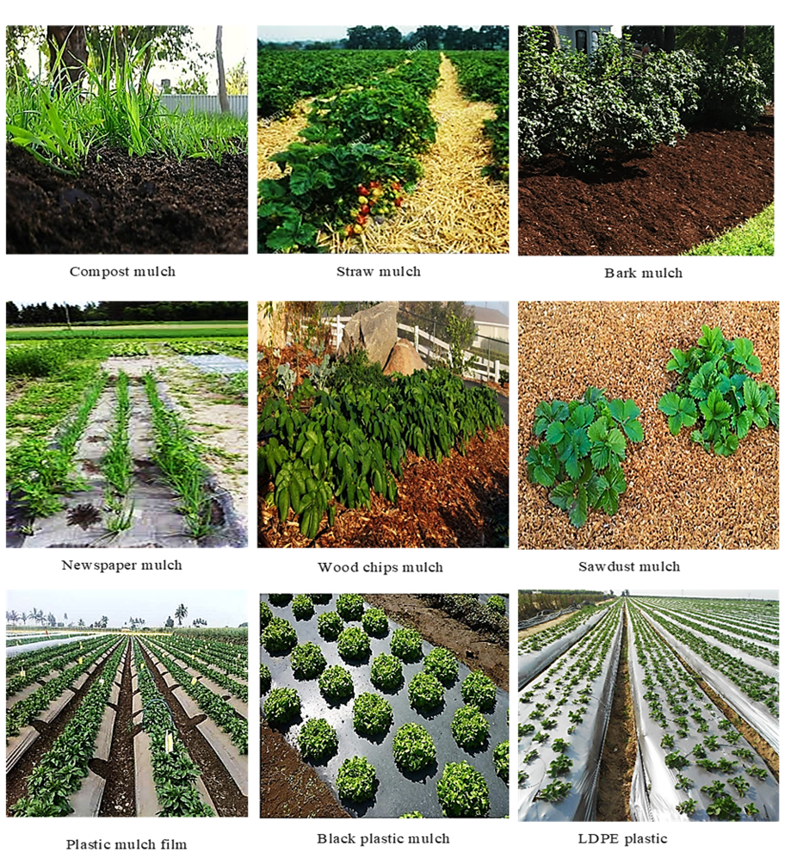
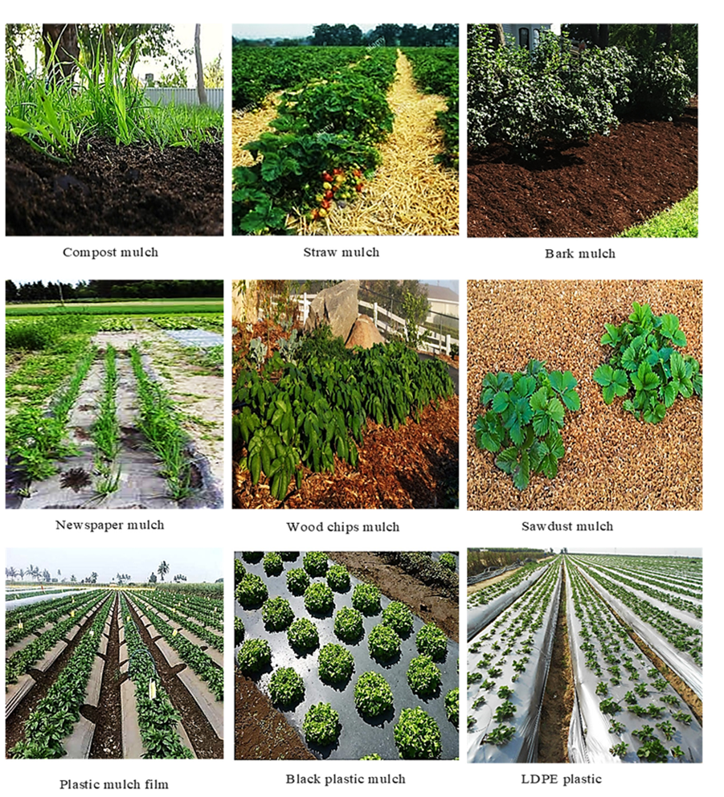

Organic Mulches
Organic mulches are made from materials sourced from plants or animals. For optimal effectiveness, they should be applied when crops germinate or when transplanting vegetable seedlings at a rate of 5 tons per hectare. These mulches play a crucial role in minimizing nitrate leaching, enhancing the physical properties of soil, boosting biological activity, regulating the nitrogen cycle, contributing organic matter, maintaining temperature, conserving moisture, and preventing soil erosion. However, using natural materials on growing crops can be labor-intensive and pose various challenges. Consequently, the adoption of organic mulch in horticultural production has been limited by cost and logistical issues, leading to only a small-scale commercial uptake (Wang et al., 2014).
Straw
After harvesting crops, leftover plant material such as straw becomes readily available for use. Straw mulch is lightweight, which facilitates easy application. In particular, paddy straw is commonly utilized as mulch in agricultural fields, as it improves the growing conditions for various crops. Nevertheless, there are some challenges associated with using straw as mulch. It needs to be replaced each year because of its high flammability and the presence of grain seeds, which can germinate and deplete soil nitrogen during decomposition (Goodman 2020).
Bark Mulches: Bark mulches are highly effective, as they retain moisture for longer periods, extending water availability to crops. They are commonly used in landscaping and for covering vegetation. However, due to their acidic nature, they are not suitable for vegetable fields. Conversely, they work well for covering pathways between planting beds (Kosterna 2014).
Wood Chips: Wood chips are made from processed wood and various tree species. Due to their high carbon-to-nitrogen (C) ratio, wood chip mulches may reduce the amount of nitrogen available in the soil for plants to absorb during their decomposition process (Bantle et al., 2014).
Compost: Compost is a highly effective mulch and soil enhancer that can be easily produced at home using various waste materials like leaves, straw, grass, and plant debris. Its use in agriculture has been a long-established practice. Compost enriches the soil by improving its characteristics and increasing its carbon content, which enhances water retention and overall soil health. However, because of its higher nitrogen content, compost is not ideal for vegetable fields as it can lead to increased weed growth.
Newspaper
Utilizing newspaper as mulch is a cost-effective strategy for weed control, as it helps prevent the germination of weed seeds from the previous season. The layers of newspaper decompose quickly in the soil, making it a more sustainable choice compared to plastic mulch, as it breaks down naturally over time, resulting in lower costs and reduced labour requirements.
Inorganic Mulches
Plastic mulch represents a popular form of inorganic mulch, frequently employed in commercial crop production. It is manufactured from materials like polyvinyl chloride (PVC) or polyethylene films. This type of mulch can elevate nighttime temperatures around plants during winter because of its ability to allow long-wave radiation to pass through. As a result, polyethylene film mulch is often recommended for the cultivation of horticultural crops. In the 1960s, various plastic films composed of different polymers were evaluated for mulching purposes. However, the differences in performance among flexible PVC, high-density polyethylene (HDPE), and low-density polyethylene (LDPE) were minimal. Currently, linear low-density polyethylene (LLDPE) is the preferred choice for plastic mulch due to its cost efficiency. The use of black plastic mulch film has also been increasing (Li, C et al., 2014).
Photodegradable or Biodegradable Mulches:An alternative approach to reduce waste generated by polyethylene mulches involves developing photodegradable or biodegradable options. Photodegradable mulch films have been tested intermittently for over two decades, but results have varied significantly, with some films decomposing prematurely (Greer and Dole 2003; Halley et al. 2001). Moreover, concerns have been raised about the ability of photodegradable mulches, made from petroleum-based materials, to completely break down into carbon dioxide and water (Zhang et al. 2008). Currently, biodegradable plastic mulches are produced from various polymers or additives that are widely accessible in global markets, providing comparable crop yields to low-density polyethylene (LDPE) mulches (Closas et al., 2017). In organic farming, this type of mulch contributes to reducing the reliance on agrochemicals (Briassoulis et al., 2018). According to Wang et al. (2015), each mulch type possesses unique characteristics. However, the selection of mulch material for soil incorporation is influenced by factors such as effectiveness and cost, local climate conditions, and the suitability of specific crops for growth.
Regular application of mulch can negatively affect soil efficiency, crop yield, contamination levels, and ecosystem functions, including food and water regulation, disease management, nitrogen cycling, oxygen production, as well as cultural and aesthetic values (Steinmetz et al., 2016).The impact of soil mulching on microorganisms and enzymatic activity has also been explored. Some research indicates that biodegradable mulches can enhance microbial and enzymatic activity in the soil, resulting in greater microbial abundance, respiration, and overall activity compared to polyethylene film mulch (Li et al., 2014). Introducing organic materials into agricultural soils has been shown to affect microbial metabolic processes and the complexity of their networks (Wang et al., 2019). As biodegradable plastic films break down, it is believed that microorganisms utilize the released monomers for growth, which leads to an increase in microbial biomass (Serrano et al., 2021).
Gravel or Pebbles: Gravel or pebble mulch is a durable option that enhances both the texture and aesthetic appeal of outdoor spaces. It is particularly popular in arid climates or xeriscapes, where conserving water is essential (Li et al., 2005). Gravel mulch allows rainwater to infiltrate the soil while effectively suppressing weed growth.
Landscape Fabric: Landscape fabric is a synthetic material designed to act as a weed barrier while allowing water and air to penetrate (Gabryś et al., 2021). Typically, it is laid on the soil surface before planting and covered with another layer of mulch, such as wood chips or gravel. This type of fabric is often preferred for vegetable gardens and perennial beds.
Rubber Mulch: Made from recycled tires, rubber mulch provides long-lasting weed suppression and moisture retention. It gives landscapes a unique appearance and is commonly used in playgrounds, walkways, and high-traffic areas.
Plastic Mulch: Plastic mulch is a common choice in commercial agriculture, particularly for vegetable cultivation. It helps retain moisture, control weeds, and regulate soil temperature (Yang et al., 2015). Available in various colors, with silver-black being the most widely used, plastic mulch is typically applied using specialized equipment for efficient installation.
Advantages of Mulching:
Moisture Retention: Mulching is highly effective in maintaining soil moisture compared to unmulched areas. By creating a protective layer between the soil and the atmosphere, mulch significantly reduces evaporation, helping the soil stay consistently moist (McMillen, 2013). Maintaining optimal soil moisture is crucial for supporting seedling emergence and growth, especially during the early to mid-season (Ramakrishna et al., 2006). This benefit is particularly vital in hot summer months or dry regions where water scarcity is a concern. With adequate moisture, plants can thrive and maintain healthy growth even in drought conditions.
Temperature Regulation: Mulch serves as a natural barrier that aids in regulating soil temperature and protects plant roots from extreme heat or cold (Pramanik et al., 2015). In warmer climates, mulch provides shade and cools the soil, reducing the risk of heat stress and root damage (Jabran & Jabran, 2019). Conversely, in cooler regions, mulch acts as an insulating layer that prevents the soil from freezing. By maintaining ideal soil temperatures, mulching creates a favourable environment for plant growth and development.
Weed Suppression: Weeds can pose a significant challenge in gardens and landscapes, competing with plants for nutrients, sunlight, and space. Mulching offers an effective method for suppressing weed growth. When applied correctly, mulch creates a barrier that inhibits weed seed germination and emergence from the soil (Khan et al., 2022). Additionally, mulch blocks sunlight, further impeding weed development. By minimizing weed competition, mulching ensures that plants can access essential resources and reduces the need for manual weeding.
Soil Fertility Improvement: Mulching plays a vital role in enhancing soil fertility by gradually decomposing and adding organic matter to the soil (Srikanth et al., 2023). Inorganic mulches can influence soil moisture levels and aeration, which can alter soil microbial communities and redox potential, thereby affecting phosphorus availability (Tiwari et al., 2014). Organic mulches such as compost, wood chips, or straw decompose over time, releasing key nutrients into the soil. These nutrients support plant growth and improve overall health. Furthermore, as mulch breaks down, it enhances soil structure, aeration, and water retention, creating an ideal environment for plants.
Disadvantages of Mulching:While mulching offers several benefits, it also has its drawbacks, including increased labor demands, higher transportation expenses, and difficulties associated with removal and disposal. Plastic mulch can lead to soil contamination by leaving behind fragments that directly contact the soil. Certain organic materials used for mulching, such as straw and grass, can contribute to weed growth and the leaching of acids.
Although mulched soil typically benefits from improved aeration and temperature, fostering increased microbial activity, it can also lead to heightened nitrification. Farmers often handle plastic film remnants by burning or burying them in the soil, which significantly contaminates the soil and negatively impacts crop growth.Moreover, the enhanced moisture retention from mulching can limit oxygen availability around the roots due to inadequate drainage. If mulch is applied too closely to the plant stem, the excess moisture may create an environment conducive to various microorganisms, pests, and diseases. Mulches containing seeds—such as hay, straw, and grass clippings—may also promote weed growth.
Inorganic mulches, with the exception of biodegradable plastic types, do not provide any nutrients to the soil as they do not decompose. Over time, inorganic mulches can break down under sunlight, and when applied over large areas, they can increase soil temperatures. Although rubber mulch is organic, it can be toxic and detrimental to both plants and the surrounding environment.
Case study
Table.1: Impact of Varying Mulching Levels on Maize Growth and Yield
Treatments | Growth parameters |  |  | Yield
 | Plant height at harvest (cm) | Dry matter(g/m²) | LAI (60DAS) | Grain yield
M₁:No mulching | 176.92 | 1264.70 | 2.96 | 5.23
M₂:Mulching@2.5 t/ha | 222.75 | 1557.58 | 3.59 | 6.84
M₃:Mulching@5 t/ha | 228.93 | 1597.86 | 3.68 | 7.00
SEM± | 5.89 | 40.72 | 0.09 | 0.15
LSD(P=0.05) | 23.75 | 164.18 | 0.36 | 0.60
In their experiment, Rout et al. (2022) demonstrated that mulching significantly affected growth parameters, including plant height, dry matter accumulation, and leaf area index (LAI). The highest measurements for plant height, dry matter accumulation, and LAI at 60 days after sowing (DAS) were recorded with straw mulching at a rate of 5 t/ha, showing values of 228.93 cm, 1597.86 g/m², and 3.68, respectively. These results were comparable to those obtained with straw mulching at 2.5 t/ha, which yielded plant height, dry matter accumulation, and LAI measurements of 222.7 cm, 1557.58 g/m², and 3.59, respectively.

Table.2: Impact of Various Mulching Techniques on Maize Yield and Yield Components
Treatment details | Plant height (cm) | No.of grains/cob | Grain yield t/ha | Harvest index
Weed check | 165.0 | 415.47 | 5.01 | 30.98
Manual hoeing | 214.0 | 465.15 | 5.79 | 31.49
Transparent plastic mulch | 215.7 | 445.23 | 6.67 | 33.00
Wheat straw mulch | 208.0 | 429.65 | 5.74 | 32.48
Rice straw mulch | 205.0 | 426.75 | 5.50 | 32.00
Saw dust mulch | 199.3 | 419.12 | 5.22 | 31.23
Tukey’s HSD | 11.91 | 8.46 | 0.004 | 0.48
Asif et al. (2020) conducted an experiment that showed how mulching can enhance weed management, soil carbon content, and the productivity of spring-planted maize (Zea mays L.). The results indicated that the application of plastic and wheat straw mulch led to increases of 30.76% and 26.06% in plant height, 7.16% and 3.41% in grain yield, 19.0% and 9.29% in biological yield, and 3.29% and 4.84% in harvest index, respectively, when compared to the control (weedy check). Additionally, the use of wheat straw mulch resulted in the highest levels of soil organic matter and carbon. These results suggest that wheat straw mulch not only boosts yield and soil organic matter but also enhances the overall productivity of maize.
References:
Ahmad, S.; Raza, M.A.S.; Saleem, M.F.; Zahra, S.S.; Khan, I.H.; Ali, M.; Shahid, A.M.; Iqbal, R.; Zaheer, M.S.2015. Mulching strategies for weeds control and water conservation in cotton. Journal Agriculture Biological Science.8: 299–306.
Ahmad S, Raza MAS, Saleem MF, Zaheer MS, Iqbal R, Haider I, Aslam MU, Ali M, Khan IH (2020). Significance of partial root zone drying and mulches for water saving and weed suppression in wheat. Journal of Animal Plant Science.30:154–162.
Bantle, A.Borken, W. Ellerbrock, R.H. Schulze, E.D.Weisser, W.W. Matzner, E. 2014.Quantity and quality of dissolved organic carbon released from coarse woody debris of different tree species in the early phase of decomposition. For. Ecological. Management 329: 287–294.
Bhalekar, D. G., Parray, R. A., Mani, I., Kushwaha, H., Khura, T. K., Sarkar, S. K., ... & Verma, M. K. (2023). Ultrasonic sensor-based automatic control volume sprayer for pesticides and growth regulators application in vineyards. Smart Agricultural Technology. 4, 100232.
Briassoulis, D.; Giannoulis, A. 2018.Evaluation of the functionality of bio-based plastic mulching films. Polymer Test. 67: 99–109.
Boomika R, Bhuvana B, Indianraj N.2022.Role of Mulching in Dryland Agriculture. Department of Agronomy, Thanthai Roever Institute of Agriculture and Rural Development, Perambalur, Tamil Nadu, India. International Journal of Advanced Research in Science, Communication.2(1):775-778.
Closas,M. L.; Costa, J.; Pelacho, A.M. 2017.Agronomic effects of biodegradable films on crop and field environment. In Soil Degradable Bioplastics for a Sustainable Modern Agriculture; Springer: Berlin/Heidelberg, Germany, 2017; 67–104. 45.
Gabryś, T., Fryczkowska, B., Grzybowska-Pietras, J. and Biniaś, D. (2021). Modification and properties of cellulose nonwoven fabric—multifunctional mulching material for agricultural applications. Materials, 14(15): 4335.
Goodman, B.A.2020. Utilization of waste straw and husks from rice production, A review. Journal Bioresources Bioproduction.5: 143–162. 30.
Jabran, K.& Jabran.K.(2019).Mulches for regulation of soil temperature. Role of Mulching in Pest Management and Agricultural Sustainability, 47-52.
Jabran, K., & Jabran, K. (2019). Mulches for regulation of soil temperature. Role of Mulching in Pest Management and
Agricultural Sustainability, 47-52.
Khan, B. A., Nijabat, A., Khan, M. I., Khan, I., Hashim, S., Nadeem, M. A., & Ikram, M. (2022). Implications of Mulching on
weed management in crops and vegetable. In Mulching in Agroecosystems: Plants, Soil & Environment (pp. 199-213).
Singapore: Springer Nature Singapore
Khan, B. A., Nijabat, A., Khan, M. I., Khan, I., Hashim, S., Nadeem, M. A., & Ikram, M. (2022). Implications of Mulching on weed management in crops and vegetable. In Mulching in Agroecosystems: Plants, Soil & Environment Singapore: Springer Nature Singapore. (pp. 199-213).
Kosterna, E.2014. Organic mulches in the vegetable cultivation (a review). Ecology Chemistry Engineering.21:481–492.
Lamont WJ (2005) Plastics: modifying the microclimate for the pro duction of vegetable crops. Horticulture Technology 15:477–481.
Li, X.Y., Shi, P.J., Liu, L.Y., Gao, S.Y., Wang, X.S. and Cheng, L.S.(2005). Influence of pebble size and cover on rainfall interception by gravel mulch. Journal of hydrology. 312(1-4), 70-78.
Li, C.; Moore-Kucera, J.; Lee, J.; Corbin, A.; Brodhagen, M.; Miles, C.2014. Inglis, D. Effects of biodegradable mulch on soil quality. Applied Soil Ecology. 79: 59–69.
Lightfoot DR (1994) Morphology and ecology of lithic-mulch agriculture. Geo. Review 25:172–185.
Lopez J, Gonzalez A, Fernandez JA, Banon S (2007) Behaviour of biodegradable films used for mulching in melon cultivation. In: Hanafi A, Schnitzler WH (eds) Proc. VIIIth IS on Protected Cultivation in Mild Winter Climates. Acta Horticulture.747: 125–130.
Mozzanini, E., Hoheisel, G. A., Grella, M., Bhalekar, D. G., Balsari, P., Gioelli, F., & Khot, L. R. (2023). Cleaning performance of a pneumatic-based SSCDS designed for crop protection in modern orchard systems. In 16th Workshop on Spray Application and Precision Technology in Fruit Growing (pp. 59-60). Jean-Paul Douzals and Marcel Wenneker.
McMillen, M.(2013). The effect of mulch type and thickness on the soil surface evaporation rate.California Polytechnic State University.
Osuiji GE.2007. Tillage and mulching effect on seed zone soil environment and cowpea seedling growth in humid tropics, in Soil Use and Management. 6(3):152-156
Pramanik, P., Bandyopadhyay, K. K., Bhaduri, D., Bhattacharyya, R., & Aggarwal, P. (2015). Effect of mulch on soil thermal regimes-a review. International Journal of Agriculture, Environment and Biotechnology. 8(3), 645-658.
Ramakrishna, A. Tam, H.M., Wani, S.P. and Long, T.D. 2006. Effect of mulch on soil temperature, moisture, weeds infestation and yield of groundnut in northern Vietnam. Field crop Research. 95: 115-125.
Rout., R.K. Mahapatra., A. Shankar, T., Adhikari., R., Panda., M. and Sial., A.K.2022. Growth and productivity of maize in response to straw mulch and nitrogen management. Crop Research 57 (3): 156-160.
Saikanth, D. R. K., Das, H., Kumar, V., & Pancholi, R. (2023). Application and Impacts of Mulch Installation Techniques on
Indian Horticulture: An In-depth Review. Int. J. Plant Soil Sci, 35(18), 2135-2147.
Saikanth, D. R. K., Das, H., Kumar, V., & Pancholi, R. (2023). Application and Impacts of Mulch Installation Techniques on Indian Horticulture: An In-depth Review. International Journal of Plant Soil Science.35(18), 2135-2147.
Serrano-Ruiz, H.; Martin-Closas, L.; Pelacho, A.M.2021. Biodegradable plastic mulches: Impact on the agricultural biotic environment. Science Total Environment. 750: 141228.
Sofy, M.; Mohamed, H.I.; Dawood, M.; Abu-Elsaoud, A.; Soliman, M.2021. Integrated usage of Trichoderma harzianum and biochar to ameliorate salt stress on spinach plants. Archealogical Agro Soil Science. 1949709.
Steinmetz, Z.; Wollmann, C.; Schaefer, M.; Buchmann, C.; David, J.; Tröger, J.; Muñoz, K.; Frör, O.; Schaumann, G.E.2016.Plastic mulching in agriculture. Trading short- term agronomic benefits for long-term soil degradation? Science Total Environment 550:690–705.
Serrano-Ruiz, H.; Martin-Closas, L.; Pelacho, A.M.2021. Biodegradable plastic mulches: Impact on the agricultural biotic environment. Science total Environment. 750:141228.
Tiwari, K.N., Kumar, M., Santosh, D.T., Singh, V.K., Maji, M.K., and Karan, A.K. 2014. Influence of drip irrigation and plastic mulch on yield of sapota(achraszapota) and soil nutrients. Irrigation Drainage System Engineering, 3(1): 116.
Telkar S, Kant K, Pratap, Shivendu SS. 2017.Effect of Mulching on Soil Moisture Conservation. Biomolecule report. ISSN:2456-8759.
Wang, S.J.; Tian, X.H.; Liu, T.; Lu, X.C.; You, D.H.; Li, S.2014. Irrigation, Straw, and Nitrogen Management Benefits Wheat Yield and Soil Properties in a Dryland Agro-Ecosystem. Agronomy Journal.106:2193–2201.
McMillen, M.(2013). The effect of mulch type and thickness on the soil surface evaporation rate.California Polytechnic State
University.
McMillen, M.(2013). The effect of mulch type and thickness on the soil surface evaporation rate.California Polytechnic State
Universit
Wang, Z.; Zhao, X.; Wu, P.; Chen, X.2015. Effects of water limitation on yield advantage and water use in wheat (Triticum aestivum L.) maize (Zea mays L.) strip intercropping. European Journal of Agronomy. 71:149–159.
Wang, B.; Wan, Y.; Wang, J.; Sun, J.; Huai, G.; Lv, C.; Cui, L.2019. Effect of biodegradable mulch film on peanut yield and soil physical and chemical properties in Southern Xinjiang, China. Journal Peanut Science. 48: 38–43.
Whittinghill, L.J.; Rowe, D.B.; Ngouajio, M.; Cregg, B.M.2016. Evaluation of nutrient management and mulching strategies for vegetable an extensive green roof. Agroecological Sustainable Food System. 40:297–318.
Zhang, X., Huang, G., Bian, X., Zhao, Q., 2013. Effects of nitrogen fertilization and root interaction on the agronomic traits of intercropped maize, and the quantity of microorganisms and activity of enzymes in the rhizosphere. Plant Soil. 368: 407–417.

