*Original Research Article*

Performance of Semi-Solid Set Sprinkler Irrigation System at Mkulazi Sugarcane Estate

.

ABSTRACT

|  |
| --- |
| The purpose of this study was to assess the efficacy of the semi-solid set sprinkler irrigation system at Mkulazi Sugarcane Estate in Tanzania's Kilosa District, Morogoro Region. Catch cans test experiments were carried out to evaluate the system efficiency in the sugarcane crop's specified zones and pressure measurements were taken at selected sprinkler lateral positions The distribution parameters Distribution Uniformity (DU) and Christiansen's Coefficient of Uniformity (CU) were computed. Furthermore, efficiency factors such as water application rate, Potential efficiency of the low quarter (PELQ), and delivery performance ratio (DPR) were calculated using the proper methods. According to the study's findings, the system's distribution uniformity, coefficient of uniformity, and Delivery Performance Ratio were 82%, 85%, and 0.93, respectively. These results showed that the overall performance of the sprinkler system was satisfactory. However, the tail parts of the sprinkler laterals experienced lower discharges due to clogging caused by deposited sediments. Proper filtration and regular flushing of the laterals was recommended to ensure a more uniform distribution and reduction of losses. |

*Keywords: Semi-solid set sprinkler, performance, uniformity, efficiency*

1. INTRODUCTION

As the effects of climate change continue to wreak havoc on agriculture causing water scarcity, modern irrigation technologies have been adopted to replace less efficient irrigation systems. These include sprinkler and drip systems, which have received a great attention as a common response to the limited water supply for reducing water use and achieving higher yields and profitability [1].

Sugar cane production in Tanzania is a crucial sector that heavily depends on irrigation to improve its productivity. According to Massawe and Kahamba [2], sugarcane production is a critical subsector of Tanzania's agricultural sector, accounting for around 35% of the total output of the food manufacturing industry. It is also a major employment, employing approximately 18,000 direct and 57,000 indirect workers. However, Tanzania still faces a significant deficit on sugar, as it currently produces 360,000 tonnes per year against the national demand of 440,000 tons per year. Among other initiatives, the Government has invested in development of sugar estates to bridge this gap. It is in this regard that among other implementations, Mkulazi Sugarcane Estate was initiated.

Mkulazi Sugar Estate (MSE) adopted sprinkler irrigation system as their mode of irrigation. Based on movement, sprinkler irrigation system can be classified as set-move, continuous move and solid-set irrigation system [3]. A solid-set sprinkler irrigation system has enough laterals and sprinklers covering the whole field, which are left permanent for the entire season[4]. However, the use of movable risers just enough to irrigate a portion of the field has been introduced to reduce the cost of installation of the solid-set irrigation system. This kind of modification is referred to as semi-solid set sprinkler irrigation system (SSSSIS) and is currently in use at MSE.

With the impending growing demand of water, irrigation designers have identified efficient use of water as a primary goal. Irrigation system’s type and design affects its efficiency [5]. According to Imrak *et al*., [6], the effectiveness of an irrigation system, the uniformity of water delivery, and the reaction of the crop to irrigation are the three general definitions of irrigation efficiency. These irrigation efficiency measurements have a variety of spatial and temporal dimensions and are interconnected.

Irrigation systems are initially designed to achieve high uniformity and effective irrigation, resulting in water and energy savings that improve farm profitability. However, with time, the systems are prone to operational and management-based setbacks that in return affect their performance. By virtue of this, performance evaluation has been a vital aspect of irrigation since man first began harnessing water to boost agricultural output [7].

Research conducted by Reuben *et al*., [8] found that poor centre pivot performance was among the causes of poor yields at Kagera Sugar Estate in Tanzania. [9] in Iran found significantly low uniformity coefficient and distribution uniformity values which were considered unacceptable and in return had an adverse effect on the crop yield. Additionally, in Tunisia, [10] reported that wind speeds greater than 4m/s had a significant impact on uniformity, regardless of spacing of the sprinklers. In Ethiopia, despite reporting uniformity coefficient values above 80%, Dinka [11] also found values above unity for adequacy of water delivery, denoting excess delivery of water.

According to [12], sprinkler irrigation system’s operation can be greatly improved by making simple changes such as changing operating pressures, nozzle sizes, riser heights, and water application durations; operating at different pressures at alternate irrigations; using alternate set sequencing; obtaining larger sized lateral pipes; and tipping risers along the edge of the field. All these require an in-depth analysis of measurements taken in the field while the system is operating under actual field conditions [13].

Despite adopting the semi-solid set sprinkler irrigation system, MSE has experienced varied setbacks in its system. During a preliminary field survey at MSE, it was pointed out that significant amount of water applied to the field was unaccounted for after an irrigation event through rain gauges set across the fields, with certain field blocks experience significantly lower operating pressure at the sprinklers. Additionally, it was noted that the water intakes had no filtration systems. The SSSSIS has gradually been preferred by sugarcane estates in Tanzania, even though no study has been conducted to ascertain its performance. It was therefore imperative to conduct a technical evaluation on the Sprinkler system at MSE to determine the pre-existing condition of the system in place and provide the necessary recommendations to the management.

2. material and methods

**2.1. Description of Study Area**

Mkulazi Sugarcane Estate is located at Magole Ward in Kilosa District, in the lowland plains of the Wami River basin, at an elevation of 360-385m above sea level. The landscape is almost flat, with very deep clay soils that show clear evidence of cracking and are classified as Fluvisol [14]. Kilosa district experiences bi-modal rainfall, with short rains from November to January and long rains from March to May. Rainfall in the southern flood plains ranges from 1000mm to 1400mm, while it ranges from 800 to 1100mm in the north. Kilosa's average annual temperature is 25°C, with temperatures ranging from 19°C in July to 30°C in March [15]. Mkulazi Sugarcane Estate obtains its irrigation water from the Wami and Mkundi rivers. The Estate farm covers a total area of 4,856ha whereby 1531ha is under Semi Solid Set Sprinkler Irrigation System(SSSSIS) while 1255ha is under furrow irrigation and the rest is still under development.

**Figure 1: Study Area Map**

**2.2. Semi-Solid Set Sprinkler Irrigation System**

This system is one in which laterals a permanently fixed throughout the season, while each lateral has only one sprinkler and riser that is moved along the lateral for each irrigation event. During irrigation, all the other sprinkler positions on the lateral are shut except the one operating. Blocks are divided into two, with each side having a manifold that connects to the laterals, and a hydrant located at the middle of the block.

**Table 1: Irrigation System Specifications at Mkulazi Sugarcane Estate**

|  |  |  |
| --- | --- | --- |
| **S/N** | **Features** | **Value** |
| 1 | Sprinkler Type | Semi-Solid Set Sprinkler Irrigation System |
| 1 | Field Block size | 25ha (500 by 500m) |
| 2 | Main pipe | 315mm |
| 3 | Submain pipe | 110mm |
| 4 | Manifold and Lateral pipes | 75mm |
| 5 | Hydrants per block | 1 |
| 6 | Laterals | 28 in each half of the block |
| 7 | Sprinkler positions per lateral | 14 |
| 8 | Sprinkler Manufacturer | NaandanJain |
| 9 | Sprinkler Name and Model | Acurain 5035 SD |
| 10 | Sprinkler Inlet connection | ¾ inch male threaded |
| 11 | Sprinkler volumetric flow rate | 1490l/h or 1.490m3/h |
| 12 | Sprinkler spacing | 18 by 18m |
| 13 | Wetted diameter | 28m |
| 14 | System operating pressure | 3 bars |
| 15 | Nozzle size | Dual nozzle 4.0*2.5mm Black |
| 16 | Riser height | 3.5m with tripod base and drag hose |

**2.3. Selection of Experimental Area**

The techniques by Merriam and Keller [12] and the American Society of Agricultural and Biological Engineers (ASABE) standard procedures were used to conduct the field evaluations. The field tests were carried out in 2023 on a 25ha sugarcane plantation plot during the dry season (July and August). The field measurements exercise was done throughout the day when normal irrigation was taking place. Six laterals (Laterals A1, B1 and C1 on one half and laterals A2, B2 and C2 on the other half) were purposively selected for the evaluation to represent the upper, middle and lower part of the selected block. On each lateral, 3 sprinkler positions were selected for the measurements. The sprinkler positions were also selected at the beginning, middle and end of the laterals.

**2.4. Data Collection and Analysis**

Catch cans of 11cm diameter were set up in a diagonal formation around a single sprinkler [11] as shown in Figure 2. The cans were raised by wooden pegs to avoid water splashing into the cans. Before any catch can test was done, pressure at the hydromatic valve that connects the lateral and the riser was measure as well as the sprinkler discharge to determine the actual precipitation. One-hour catch can test was conducted on every section in all selected sprinkler positions to determine Uniformity Coefficient(CU), Distribution Uniformity(DU) and Potential Efficiency of Lower Quarter( PELQ.

**Figure 2: Arrangement of catch-cans around sprinklers**

**2.5. Evaluation of Sprinkler Performance**

According to Eisenhauer *et al*., [16] water must be applied at the desired area, at the right rate and volume, and at the right time to meet management objectives. However, irrigation systems are not perfect and thus some places receive more water than others, while some is lost. These non-uniformities and inefficiencies are detrimental to the system’s primary objectives. Owing to this, several measurements are taken to determine the performance of the system and several developed relationships are used to quantify the performance.

**Table 2: Uniformity and Efficiency Measurements**

|  |  |  |
| --- | --- | --- |
| **Performance Indicator** | **Method** | **Standard/Design Value** |
| Coefficient of Uniformity (CU)  A measure of the average absolute deviation from the average irrigation amount using an array of catch cans. | $C_{u}=100\left[1.0-\frac{\sum{x}}{mn}\right]$*x* = absolute deviation of the individual observations from the mean (mm)  *m*=mean depth of observation (mm)  *n* = number of observations. | CU>84% is recommended for high value and field crops [12] |
| Distribution Uniformity (DU)  Indicates the uniformity of infiltration throughout the field [12] | $DU=\frac{D_{lq}}{D_{av}}×100$ Dlq=average weighted low quarter catch (mm)  Dav=average weighted system catch-cans (mm). | 75% and above is recommended [17] |
| Potential Efficiency of Low Quarter (PELQ) a measure of system performance attainable under reasonably good management when the desired irrigation is being applied. | $PELQ=\frac{D_{lq}}{D_{av}}×100$ Dlq = average low quarter depth caught (mm)  Dav = average depth of water applied (mm). | At least 90% is recommended  [18] |
| Sprinkler Operating Pressure | Pressure gauge measurements | Design Value by Manufacturer |
| Sprinkler Discharge Rate | $Discharge=\frac{Volume(l)}{Time(s)}$ | Design Value by Manufacturer |
| Delivery Performance Ratio | $DPR=\frac{QA}{QR}$ QA: Actual discharge  QR : Required discharge | 1 |

**2.6. Discharge Measurements**

Discharge was measured across the selected laterals at three (first, middle and end) selected riser positions. A flexible hose was connected to the sprinkler nozzles, and the sprinklers were run for water to fill a known volume of a 10 litre for a measured period.

Discharge measurements were determined using Equations 1 and 2 as used by [11]. The discharge from individual sprinkler was calculated using Equation 1. Then, the application rate (Ra) (Equation 2) was computed from the measured discharge and sprinkler spacing:

$Discharge=\frac{volume of water colected (l)}{time period (s)}$…………………………………...……………………...…………………(1)

$R_{a}=\frac{{3600}_{q}}{s_{l}×s_{m}}$……..………………………………...............................................................................................(2)

where Ra = application rate (mm/h), q = sprinkler discharge (l/s), Sl = sprinkler spacing across the lateral (m) and Sm = sprinkler spacing on the main line (m). In the case of the Mkulazi Sugarcane Estate Sm = Sl = 18 m.

**2.7. System Capacity Requirements**

$Q=N_{c×}N_{s}{×Q}_{s}$…………………………………………………………………………….………………………(3)

Equation 8 was used to determine the system requirements where: *Q* = system capacity (m3 /hr) *Nc* = the number of laterals operating per shift *Ns* = the number of sprinklers per lateral *Qs* = the sprinkler discharge (from the manufacturer’s tables/charts)

**2,8. Soil and Water Characteristics**

Soil and irrigation water test results from the beginning of the planting season were analysed to assess their effect on the irrigation system.

3. results and discussion

**3.1. System Capacity Requirements**

Table 7 presents results of the determination of sugarcane water and irrigation requirements at Mkulazi Sugarcane Estate. Using the weather parameters obtained from Ilonga Meteorological Station (Table 3), The output from CropWat software gives a maximum ETo of approximately 5.11 mm/day at peak demand. Annual crop water requirement (ETc) was 1511 mm with 781 mm of effective rainfall. Irrigation water requirement was high from the months of May to October at MSE, and at the same time, the Wami river flow rates are on a decline as shown in Figure 3. Due to this, total dependence on this source of water during this period is not appropriate since shortage of water could directly affect the growth of sugarcane. The estate therefore is currently exploring other sources which includes building dams and ponds in the farm from which water can be stored and used. Pousa *et al*., [19] proposed avoiding irrigation during low flow periods as one of the solutions to avoid water stress. In the case of sugarcane, this can be achieved through proper timing of planting that aligns the highest crop water requirement period to high river flow rate season and lower crop water requirements period to low flow rate season. Even though, sugarcane irrigation at MSE is supplementary to the rainfall in the area and thus only about half of the total water requirements by the crop is provided through irrigation (767mm) as shown in Table 7.

Table 4 shows the average monthly flow rates of Wami River obtained between the years 1950-2010 data. In reference to the system capacity at MSE, Wami River has adequate flow to comfortably provide irrigation water for sugarcane production throughout the year. However, recent trends as shown in Figure 3 show that for the first time since 1997, the flow rate in October 2022 were at the minimum flow trend (5.6m3/s) compared to the average October values (5.82m3/s) obtained from the long-term average data of 1950-2020, which could lead to dissatisfaction of irrigation requirements.

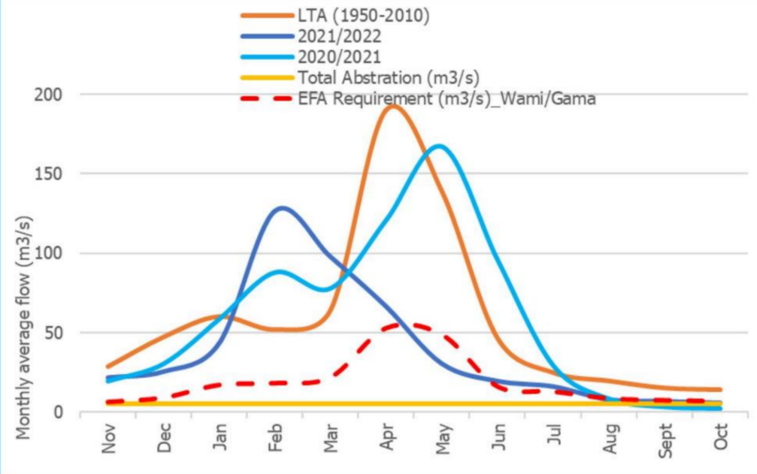

**Figure 3: Flow comparison for 2021/2022 and Long-Term Averages(LTA) for Wami River**

Source: URT,[20]

**Table 3: Average weather parameters obtained from 2003-2022 for Ilonga Meteorological Station, Tanzania**

|  |  |  |  |  |  |  |  |  |  |  |  |  |
| --- | --- | --- | --- | --- | --- | --- | --- | --- | --- | --- | --- | --- |
|  | **Nov** | **Dec** | **Jan** | **Feb** | **Mar** | **Apr** | **May** | **Jun** | **Jul** | **Aug** | **Sep** | **Oct** |
| **Max oC** | 29.4 | 29.7 | 29.1 | 28.9 | 28.2 | 26.5 | 25.6 | 24.9 | 24.4 | 25.3 | 26.8 | 28.3 |
| **Min oC** | 18.7 | 19.5 | 19.5 | 19.3 | 19.4 | 18.9 | 16.8 | 14.6 | 13.8 | 14.4 | 15.4 | 17.1 |
| **Wind (m/s)** | 2.2 | 1.6 | 1.2 | 1.3 | 1.5 | 2.1 | 2.2 | 2.3 | 2.4 | 2.5 | 2.6 | 2.6 |
| **R.H (%)** | 66.4 | 68.4 | 72.2 | 73 | 78.3 | 82.4 | 76.4 | 67.7 | 63.8 | 63.6 | 61.7 | 62.9 |
| **Rain (mm)** | 72.6 | 129.5 | 140.7 | 133.9 | 234.6 | 225.1 | 60.9 | 6.8 | 1.3 | 9.2 | 12.5 | 26.3 |
| **Sunshine (hours)** | 8.2 | 8 | 5.6 | 6.5 | 7 | 5.9 | 6.4 | 7 | 7 | 6.7 | 7.1 | 8.1 |

**Table 4: Average Long-Term Flow rates (1950-2010) for Wami River Measured at Dakawa Station (Source:** [21]

|  |  |  |  |  |  |  |  |  |  |  |  |  |  |
| --- | --- | --- | --- | --- | --- | --- | --- | --- | --- | --- | --- | --- | --- |
| **Month** | Nov | Dec | Jan | Feb | Mar | Apr | May | Jun | Jul | Aug | Sep | Oct | **Annual Average Flow**  **(m3/s)** |
| **Flow Rate (m3/s)** | 7.38 | 20.11 | 33.2 | 25.4 | 28.46 | 66.14 | 55.72 | 21.98 | 11.49 | 9.23 | 7.02 | 5.82 | **24.33** |

**3.2. Sprinkler Uniformity**

Results of uniformity indicators evaluated in the study area for sprinkler irrigation system are presented in Table 5. Christiansen’s Uniformity Coefficient (CU) values ranged from 72% to 92%. The distribution uniformity (DU) values ranged from 68% to 90%. The average CU was 85% and DU was 82% The values were within the recommended ranges of 84% and 75% respectively. The good uniformity of the sprinklers was related to the nature of operation of the semi-solid sprinkler system, in which despite having permanent laterals and sprinkler positions, only one sprinkler per lateral operates at each irrigation time, which causes a more stable pressure and a proper distribution pattern from the operating sprinkler.

The results obtained in this study for CU, DU and are similar to the findings from Topak et al, and Ahaneku [22, 23]. Referring to the recommendations set by Christiansen [24] and Merriam & Keller [12] the mean values of CU (85%) and DU (82%) resulted from the study fall in the desirable category; and that indicates a good performance of the irrigation system. A higher uniformity could be achieved with proper filtration to avoid accumulation of silt in the sprinkler laterals which in turn lowers the discharge of the sprinkler and hence the uniformity. The DU values indicated the degree of uniformity of water distribution over the irrigated region in the lower quarter (25%) and thus represent the amount of technical and administrative challenges associated with water distribution to irrigated areas[25]. The lower the value of DU, the greater the water loss and the difficulty in maintaining the irrigation system.

It was however noticeable that CU and DU values in the third sections of measurements in all selected laterals were relatively low as compared to the other sections. This was associated with observed accumulation of silt at the ends of the laterals after irrigation. Since there is only one outlet sprinkler at a time in a lateral, particles present in the system are carried and deposited at the ends of the laterals. Due to this, sprinklers operating around this area experience low pressures due to blockages, and hence low uniformity. As explained by Gurmu *et al*., [26] river sediment brought in with the irrigation water via intake structures is one of the sources of sedimentation in irrigation systems, which could be the case at Mkulazi Sugarcane Estate. These sediments cause adverse effects specifically on pumps and sprinkler nozzles, creates turbidity and impairs water distribution [27]. Although it is not feasible to prevent the sediments entering the irrigation system entirely, proper filtration at the intake can help alleviate this challenge.

The study also found out that towards the tail ends of the selected laterals, the discharge rates were significantly lower compared to the upper side as shown in Figure 4. Besides the obvious head losses along the lateral that cause pressure decreases towards the tail end [24], accumulation of sediments at the ends caused clogging and hence significantly low discharge, with some sprinkler positions experiencing complete blockage. Due to this, the upper side of the lateral receives enough depth for irrigation while the tail end is under irrigated. The nature of operation of the SSSSIS presents an opportunity to rectify this condition by increasing the irrigation time when the sprinklers are operating at the tail end of the lateral, and the time is gradually reduced accordingly to ensure that enough water is applied and there is no runoff, especially at the upper end.

**Table 5: CU and DU values at selected lateral points**

|  |  |  |  |  |
| --- | --- | --- | --- | --- |
| **Test Lateral** | **Area** | **Pressure**  **(bar)** | **CU**  **(%)** | **DU**  **(%)** |
| Lateral A1 | Upper | 3.1 | 89.52 | 92.20 |
|  | Middle | 3.0 | 92.33 | 87.99 |
|  | Tail | 2.9 | 84.62 | 76.60 |
| **Average** |  | **3.0** | **88.82** | **85.60** |
| Lateral B1 | Upper | 3.1 | 87.20 | 86.77 |
|  | Middle | 2.8 | 82.65 | 83.97 |
|  | Tail | 2.7 | 76.04 | 78.73 |
| **Average** |  | **2.9** | **81.96** | **83.16** |
| Lateral C1 | Upper | 2.9 | 89.77 | 88.00 |
|  | Middle | 2.8 | 92.30 | 87.90 |
|  | Tail | 2.7 | 72.34 | 70.43 |
| **Average** |  | **2.8** | **84.80** | **82.11** |
| Lateral A2 | Upper | 3.0 | 92.14 | 86.82 |
|  | Middle | 2.9 | 91.33 | 89.00 |
|  | Tail | 2.8 | 78.23 | 73.58 |
| **Average** |  | **2.9** | **87.23** | **83.13** |
| Lateral B2 | Upper | 3.1 | 89.09 | 84.67 |
|  | Middle | 2.8 | 83.98 | 87.55 |
|  | Tail | 2.7 | 78.02 | 72.13 |
| **Average** |  | **2.9** | **83.70** | **81.45** |
| Lateral C2 | Upper | 2.9 | 84.40 | 80.20 |
|  | Middle | 2.8 | 83.36 | 82.65 |
|  | Tail | 2.7 | 78.62 | 68.57 |
| **Average** |  | **2.8** | **82.13** | **77.14** |

**Table 6: Average PELQ and Discharge rates for selected test laterals**

|  |  |  |  |  |
| --- | --- | --- | --- | --- |
| **Test Lateral** | **Actual**  **Discharge**  **m3/h** | **Design**  **Discharge**  **m3/h** | **PELQ**  **%** | **DPR**  **%** |
| A1 | 1.416 | 1.49 | 83.4 | 95.03 |
| B1 | 1.404 | 1.49 | 81.8 | 94.23 |
| C1 | 1.344 | 1.49 | 82.2 | 90.20 |
| A2 | 1.405 | 1.49 | 75.2 | 94.30 |
| B2 | 1.404 | 1.49 | 85.8 | 94.23 |
| C2 | 1.344 | 1.49 | 79.1 | 90.20 |

**Table 7: Irrigation Water Requirements for sugarcane production at Mkulazi Sugarcane Estate**

|  |  |  |  |  |  |  |  |  |
| --- | --- | --- | --- | --- | --- | --- | --- | --- |
| **Month** |  | **Decade** | **Stage** | **Kc** | **ETc** | **ETc** | **Eff. rain** | **Irr. Req.** |
|  |  | **(10 days)** |  | **Coeff** | **mm/day** | **mm/dec** | **mm/dec** | **mm/dec** |
| Nov |  | 1 | Init | 0.4 | 2.03 | 20.3 | 17.1 | 3.2 |
| Nov |  | 2 | Init | 0.4 | 2.02 | 20.2 | 21.4 | 0 |
| Nov |  | 3 | Init | 0.4 | 1.98 | 19.8 | 25.7 | 0 |
| Dec |  | 1 | Deve | 0.47 | 2.3 | 23 | 30.9 | 0 |
| Dec |  | 2 | Deve | 0.61 | 2.89 | 28.9 | 35.7 | 0 |
| Dec |  | 3 | Deve | 0.75 | 3.37 | 37.1 | 35.9 | 1.2 |
| Jan |  | 1 | Deve | 0.89 | 3.72 | 37.2 | 35.9 | 1.3 |
| Jan |  | 2 | Deve | 1.02 | 3.99 | 39.9 | 36.8 | 3.1 |
| Jan |  | 3 | Mid | 1.16 | 4.66 | 51.3 | 36.2 | 15.1 |
| Feb |  | 1 | Mid | 1.2 | 5.02 | 50.2 | 34.1 | 16.1 |
| Feb |  | 2 | Mid | 1.2 | 5.11 | 51.1 | 33 | 18.2 |
| Feb |  | 3 | Mid | 1.2 | 5.09 | 40.7 | 38.3 | 2.5 |
| Mar |  | 1 | Mid | 1.2 | 5.07 | 50.7 | 45.6 | 5 |
| Mar |  | 2 | Mid | 1.2 | 5.04 | 50.4 | 50.9 | 0 |
| Mar |  | 3 | Mid | 1.2 | 4.79 | 52.7 | 49.9 | 2.8 |
| Apr |  | 1 | Mid | 1.2 | 4.54 | 45.4 | 51 | 0 |
| Apr |  | 2 | Mid | 1.2 | 4.29 | 42.9 | 52.1 | 0 |
| Apr |  | 3 | Mid | 1.2 | 4.26 | 42.6 | 40.8 | 1.8 |
| May |  | 1 | Mid | 1.2 | 4.23 | 42.3 | 27 | 15.4 |
| May |  | 2 | Mid | 1.2 | 4.2 | 42 | 16.4 | 25.6 |
| May |  | 3 | Mid | 1.2 | 4.25 | 46.8 | 11.7 | 35.1 |
| Jun |  | 1 | Mid | 1.2 | 4.31 | 43.1 | 6.3 | 36.8 |
| Jun |  | 2 | Mid | 1.2 | 4.36 | 43.6 | 0.2 | 43.3 |
| Jun |  | 3 | Mid | 1.2 | 4.41 | 44.1 | 0.3 | 43.8 |
| Jul |  | 1 | Mid | 1.2 | 4.47 | 44.7 | 0.6 | 44.1 |
| Jul |  | 2 | Mid | 1.2 | 4.52 | 45.2 | 0 | 45.2 |
| Jul |  | 3 | Late | 1.2 | 4.63 | 50.9 | 0.8 | 50.1 |
| Aug |  | 1 | Late | 1.16 | 4.6 | 46 | 2.3 | 43.7 |
| Aug |  | 2 | Late | 1.11 | 4.53 | 45.3 | 3.2 | 42 |
| Aug |  | 3 | Late | 1.06 | 4.53 | 49.8 | 3.5 | 46.3 |
| Sep |  | 1 | Late | 1.01 | 4.51 | 45.1 | 3.4 | 41.7 |
| Sep |  | 2 | Late | 0.97 | 4.49 | 44.9 | 3.6 | 41.3 |
| Sep |  | 3 | Late | 0.92 | 4.41 | 44.1 | 5.2 | 38.9 |
| Oct |  | 1 | Late | 0.87 | 4.32 | 43.2 | 6.2 | 37.1 |
| Oct |  | 2 | Late | 0.82 | 4.22 | 42.2 | 7.2 | 35 |
| Oct |  | 3 | Late | 0.77 | 3.94 | 43.4 | 11.9 | 31.4 |
| **TOTAL** |  |  |  |  |  | **1511.2** | **781.3** | **767** |

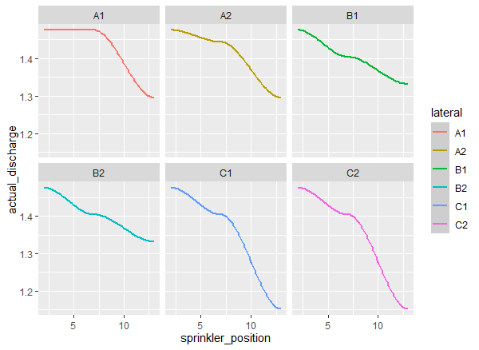

**Figure 4: Discharge rates along selected sprinkler laterals**

**3.3. Sprinkler Efficiency**

Table 6 displays the range of values for the Potential Efficiency of Low Quarter (PELQ), which spans from 64.8% to 72.2%. PELQ serves as a measure of how effectively irrigation is being implemented and how water is being distributed. Essentially, it reflects the quality of irrigation management. Lower PELQ values signalled issues with either the irrigation system's design or administrative processes in the field irrigation operation. These problems manifest as extended irrigation durations and application depths exceeding the required levels. Consequently, they resulted in increased water losses due to evaporation, surface runoff, and percolation[28]. The estimated PELQ values also pointed to deviations from the design specifications related to the arrangement and distribution of sprinklers, which are administrative challenges. These deviations lead to suboptimal irrigation scheduling, prompting operators to take measures to circumvent these issues. The average Delivery Performance Ratio( DPR) was 0.93, indicating a 93% efficiency of water delivery, while the 7% was associated to losses by wind drift and evaporation[29].

Figure 5 shows the relationship between the uniformity parameters measured as well as the catch can depth and actual sprinkler discharges. The results indicated a direct relationship between pressure and CU, DU, catch can depth and actual sprinkler discharges. Since sprinkler operating pressure affects sprinkler discharge rate and amount applied, it is generally accepted that the limit of discharge varied in different parts of laterals should not exceed 10% of average discharge. Pressure variation constraints shouldn't be more than 20% of the normal operating pressure to improve performance. Above this limit, more pressure variation would affect water distribution uniformity (DU), resulting in certain areas of the surface receiving more water than others.

|  |  |
| --- | --- |
| ***a)*** | ***b)*** |
| ***c)*** | ***d)*** |

**Figure 5: Relationship between pressure and other uniformity and efficiency parameters**

**Soil and Water Characteristics**

The physical soil properties are displayed in Table 8. The basic infiltration rate of the soil was 5.1mm/hr, which was acceptable as the selected sprinkler’s precipitation rate was 4.6mm/hr hence no chances of water loss due to runoff as the soil’s intake rate was higher than the application rate.

**Table 8: Physical Soil Properties**

|  |  |  |  |  |  |  |  |
| --- | --- | --- | --- | --- | --- | --- | --- |
| **Organic Matter**  **(%)** | **Bulk Density**  **g/cm3** | **Basic Infiltration Rate**  **(mm/hr)** | **Particle Size Distribution(%)** | | | | |
| **Sand** | **Coarse Silt** | **Fine Silt** | **Clay** | **Text Class** |
| 2.6 | 1.3 | 5.1 | 80 | 8 | 4 | 8 | Clay |

**Table 9: Irrigation Water Quality Parameters**

|  |  |  |
| --- | --- | --- |
| **Item** | **Actual Values** | **Recommended Values** |
| pH | 7.5 | 6-8 |
| Turbidity (Nephelometric Turbidity Units) (NTU) | 77 | <35 |
| EC (mS/m) | 0.3 |  |
| SAR | 5.1 | Up to 10 |
| TDS mg/L | 114.4 | <160 |
| TSS mg/L | 53 | 45 |

Selected soil and water properties were analysed to assess their effect on the irrigation system.

The water turbidity was 77 NTU which exceeds the turbidity standard of 35 NTU [30], which shows that the water is exposed to various pollutants hence the high turbidity. The Total Suspended Solids (TSS) was 53mg/L, slightly above the recommended value of 45mg/L [30]. Total Suspended Solids is an indicator of erosion and sediment transport, which in turn affects the production quality and effectiveness of irrigation systems. Long-term usage of irrigation water with high TSS values can cause irrigation systems to clog and reduce the quality of production because the water's particles can lead to microbial pollution and deposit on sugarcane leaves [31]. Whereas sprinkler irrigation systems do not require filtration in most cases as compared to drip irrigation, excessing accumulation of sediments carried with the irrigation water piles up and creates a clogging problem.

The absence of a filtration system at the intake at the Wami River enables sediments from the river to move into the system and are deposited at the ends of the sprinkler laterals. This is reflected by the low discharge rates at the ends of the laterals. Further observation showed that the location of the intake could one of the reasons for excessive accumulation of sediments in the system. The intake as shown in Figure 6 is located directly opposite the slow-moving side of River Wami, where deposition of sediments carried from upriver occurs.

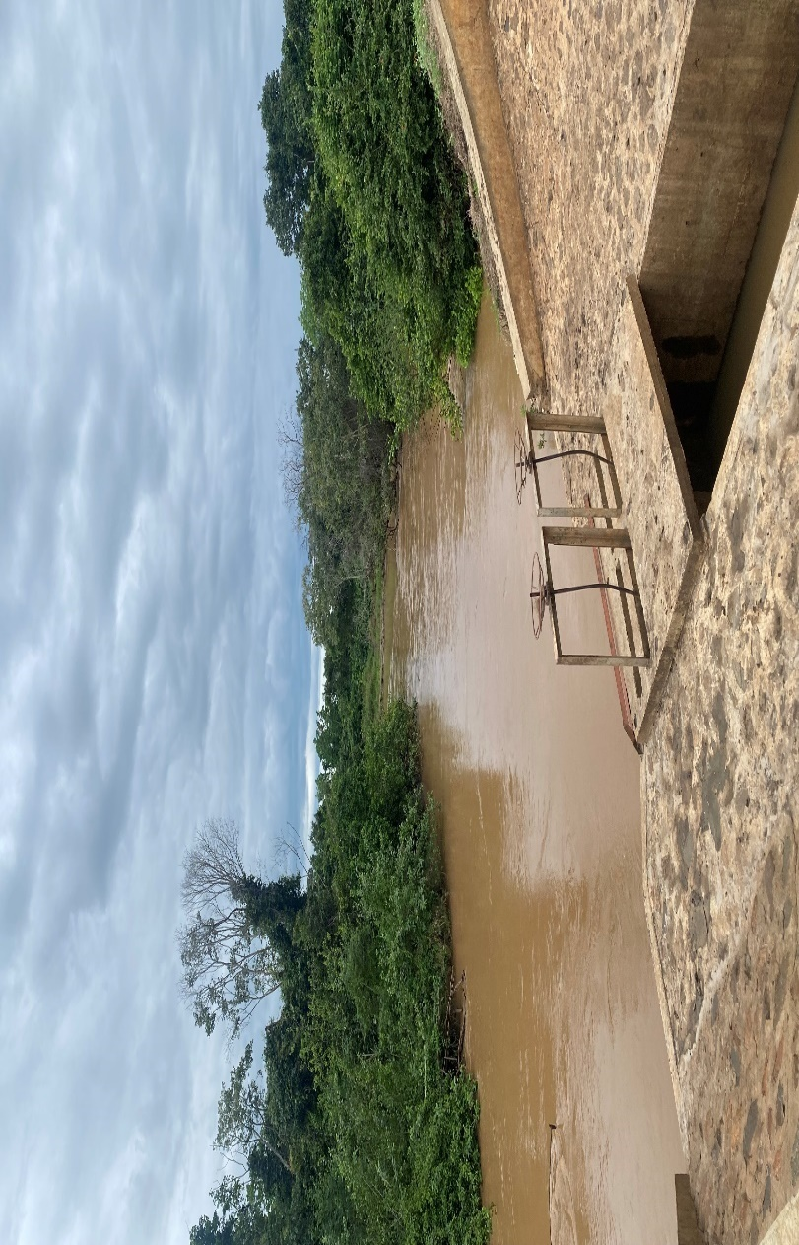

**Figure 6: Location of water intake at Wami River**

**4. CONCLUSION**

Solid set sprinkler irrigation system remains the most favourable system for sugarcane irrigation at MSE. The system has high uniformity levels of water application which means that the required depth of irrigation is achieved in most areas of the field. Besides the cost saving feature associated with acquiring less sprinklers, this system is easy to manage. Proper maintenance however should be adhered to ensure that the system operates according to its principal design. Proper filtration at the intake should be enhanced to minimize the amount of sediments that get into the system and are then deposited at the ends of the laterals. To control regular lateral blockage, the operators should ensure regular flushing of the laterals. A higher efficiency can also be achieved through proper management of the system.

5. References

1. Espinosa-tasón, J., Berbel, J., Gutiérrez-martín, C.: Energized water : Evolution of water-energy nexus in the Spanish irrigated agriculture , 1950 – 2017. Agric Water Manag. 233, 106073 (2020). https://doi.org/10.1016/j.agwat.2020.106073

2. Massawe, B.H.J., Kahamba, J.S.: SUGAR BOARD OF TANZANIA Phasing Out Plan for the Accompanying Measures Sugar Protocol. (2018)

3. Neelima, T.L., Das, A., Ramanjaneyulu, A.V.: Sprinkler Irrigation – An Asset in Water Scarce and Undulating Areas. (2018)

4. Kihupi, N.I.: Pressurized Irrigation: MSc Teaching Manual. In: Sokoine university of agriculture, Morogoro, Tanzania. pp. 1–18 (2009)

5. Heermann, D.F., Collins, F., Solomon, K.H.: Efficiency and Uniformity. Presented at the (2008)

6. Irmak, S., Odhiambo, L.O., Kranz, W.L., Eisenhauer, D.E.: DigitalCommons@University of Nebraska-Lincoln Irrigation Efficiency and Uniformity, and Crop Water Use Efficiency. (2011)

7. Bos, M.G., Murray-Rust, D.H., Merrey, D.J., Johnson, H.G., Snellen, W.B.: Methodologies for assessing performance of irrigation and drainage management. Irrigation and Drainage Systems. 7, 231–261 (1993). https://doi.org/10.1007/BF00881553

8. Reuben, P.M., Mahoo, H., Thadei, S.Y., Ernest, E.: Evaluation of the performance of Centre Pivot Sprinkler irrigation system and its effects on crop yield at Kagera , Tanzania. Second RUFORUM Biennial Meeting 20 - 24 September 2010, Entebbe, Uganda. 1323–1326 (2010)

9. Siosemarde, M., Byzedi, M.: Studding of Sprinkler Irrigation Uniformity. 574–575 (2012)

10. Yacoubi, S.: Assessing Sprinkler Irrigation Performance Using Field Evaluations at the Medjerda Lower Valley of Tunisia. Engineering. 04, 682–691 (2012). https://doi.org/10.4236/eng.2012.410087

11. Dinka, M.O.: Evaluating the Adequacy Performance of Sprinkler Irrigation Systems at Finchaa Sugar Cane Plantation, Eastern Wollega Zone (Ethiopia). Irrigation and Drainage. 65, 537–548 (2016). https://doi.org/10.1002/ird.2059

12. Merriam, J.L., Keller, J.: Farm irrigation system evaluation: A guide for management. 271 (1978)

13. Eisenhauer, D.E., Martin, D.L., Heeren, D.M., Hoffman, G.J.: Chapter 5 - Irrigation System. FAO Corporate Document Repository. (2021)

14. Msanya, B.M., Kaaya, A.K., Araki, S., Otsuka, H., Nyadzi, G.I., Studies, A.A.: Pedological characteristics, general fertility and calssification of some benchmark soils of Morogoro District, Tanzania. African Journal of Science and Technology. 4, 101–112 (2004). https://doi.org/10.4314/ajst.v4i2.15309

15. Karimuribo, E.D., Gallet, P.L., Ng’umbi, N.H., Matiko, M.K., Massawe, L.B., Mpanduji, D.G., Batamuzi, E.K.: Status and factors affecting milk quality along the milk value chain: a case of Kilosa district, Tanzania. Livestock Research for Rural Development. 273, (2015)

16. Dean E. Eisenhauer, Derrel L. Martin, Derek M. Heeren, Glenn J. Hoffman: Irrigation System  Performance. American Society of Agricultural and Biological Engineers. (2021)

17. Burt, C.M., Clemmens, A.J., Strelkoff, T.S., Solomon, K.H., Bliesner, R.D.: DigitalCommons @ University of Nebraska - Lincoln Irrigation Performance Measures : Efficiency and Uniformity. Published in Journal of Irrigation and Drainage Engineering. 123, 423–442 (1997)

18. Savva, A.P., Frenken, K.: Monitoring the Technical and Financial Performance of an Irrigation Scheme. (2002)

19. Pousa, R., Costa, M.H., Pimenta, F.M., Fontes, V.C., Castro, M.: Climate change and intense irrigation growth in Western Bahia, Brazil: The urgent need for hydroclimatic monitoring. Water (Switzerland). 11, (2019). https://doi.org/10.3390/w11050933

20. URT: Monthly Hydrological Bulletin, October 2022. , Morogoro (2022)

21. URT: The United Republic of Tanzania Ministry of Water. (2018)

22. Topak, R., Suheri, S., Ciftci, N., Acar, B.: Performance Evaluation of Sprinkler Irrigation in a Semi-arid Area, (2005)

23. Ahaneku, I.E.: Performance evaluation of portable sprinkler irrigation system in Ilorin, Nigeria. Indian Journal of Science and Technology 853. 3, 853–857 (2010)

24. Christiansen, J.E.: Irrigation by Sprinkling. University of California College of Agriculture Agricultural Experiment Station Berkeley, California. 1–126 (1942)

25. Al-Ghobari, H.M.: Effect of irrigation water quality on soil salinity and application uniformity under center pivot systems in arid region. Aust J Basic Appl Sci. 5, 72–80 (2011)

26. Gurmu, Z.A., Ritzema, H., de Fraiture, C., Ayana, M.: Sedimentation in small-scale irrigation schemes in Ethiopia: Its sources and management. International Journal of Sediment Research. 37, 576–588 (2022). https://doi.org/10.1016/J.IJSRC.2022.02.006

27. Brown, M.J., Carter, D.L., Bondurant, J.A.: Sediment in Irrigation and Drainage Waters and Sediment Inputs and Outputs for Two Large Tracts in Southern Idaho. J Environ Qual. 3, 347–351 (1974). https://doi.org/10.2134/jeq1974.00472425000300040010x

28. Misr, J., Ag, Eng: PERFORMANCE EVALUATION OF FLOPPY SPRINKLERS. (2009)

29. Ma-Lyse, N., Assiel, M.: Performance evaluation of sprinkler irrigation system in Matimba irrigation scheme of Rwanda Coast b Lecturer of irrigation engineering-Rwanda Polytechnic/IPRC Kigali, Civil engineering department. (2022)

30. Food and Agricultural Organization: Guidelines for Irrigation Water Quality. Ministry of Environment, Human Resource,  and Employment, Department of Environment. General Notice  No. 6/7 of/999. (1999)

31. Bortolini, L., Maucieri, C., Borin, M.: A tool for the evaluation of irrigation water quality in the arid and semi-arid regions. Agronomy. 8, (2018). https://doi.org/10.3390/agronomy8020023