***Original Research Article***

**Model Test Study on Failure Mode of Loess Slope under Different Water Head Heights**

**Abstract:** Groundwater is an important factor inducing slope instability, but there is limited research on the characteristics of deformation evolution and failure modes of loess slopes under the action of different water heads. Taking loess slopes as the research object, model experiments were conducted to record the slope instability failure process under different water heads and to analyze the crack evolution characteristics and failure modes. The experimental results show that as groundwater infiltrates, the wetting front develops from the rear to the front of the slope, and the slope gradually becomes saturated from the rear to the front and from the bottom to the top; the main deformation area of the slope occurs in the settlement at the top and the cracks on the slope surface; the direction of crack evolution develops from the front edge to the rear edge of the slope, and its development aggravates the deformation and failure of the slope; groundwater infiltration drives the soil particles in the slope body to accumulate from the rear to the front, weakening the cementation between soil particles, reducing its shear strength, and thus causing slope instability and failure. In the low water head state, the deformation and failure mode of the loess slope is: slope toe liquefaction → slope surface traction-type collapse → slow instability of the slope body. In the high water head state, the deformation and failure mode of the loess slope is: slope toe liquefaction → slope surface traction-type collapse → slope top settlement → overall sudden instability. The research results can provide theoretical reference for the construction and landslide disaster prevention of loess slopes under the action of different water heads.

**Keywords:** Water head height; Loess slope; Failure mode; Model test

**I. Introduction**

Loess in China is renowned worldwide for its complete stratification, significant thickness, wide distribution, and unique engineering properties. In a planar view, it spreads outwards from the "Central Loess Plateau," primarily composed of Shanxi, Shaanxi, and Gansu provinces (Xu et al., 2007). Due to the unique climatic conditions of the loess accumulation areas, the loess soil skeleton is mainly in point contact or point-surface contact, which gives the loess distinct columnar joints and a macroporous structure. This structure exhibits good engineering properties under arid conditions, but it is prone to damage such as subsidence, liquefaction, and seismic subsidence under the influence of water (Li, 2018). Due to the strong water sensitivity of loess, loess slopes are easily induced to landslides upon water infiltration (Zhang et al., 2011; Zhang et al., 2016). Research on loess slopes mainly focuses on the mechanisms of slope deformation and failure (Song et al., 2008; Zhang et al., 2019) and the mechanisms of instability (Zhang et al., 2017; Gao et al., 2016), with some scholars analyzing the micro-deformation and failure during the physical simulation of loess slopes (Cao et al., 2017) and the deformation and failure of supporting structures (Wei et al., 2018). Currently, the research methods for landslide failure modes mainly include field tests (Huang et al., 2007), numerical simulations (Wu et al., 1999), and model tests. Among these, model tests have irreplaceable advantages over in-situ tests and numerical simulations. Model tests are not only intuitive in experimental phenomena but can also comprehensively consider the boundary conditions of simulating in-situ tests, basically reflecting the mutual influence of various factors within and outside the landslide body. Liu et al. (2022) studied the infiltration and deformation mechanism of the high-fill slope of Malan loess and concluded that its deformation and sliding mode is progressive retreat-tension type sliding. Yu et al. (2022) studied the influence of the interface on the seepage characteristics and deformation failure of loess fill slopes through indoor rainfall model tests on loess fill slopes, revealing the failure mechanism of fill slopes under the influence of interface seepage. Slope deformation is closely related to water seepage, and the higher the moisture content, the greater the impact on slope stability (Guo, 2023; Tartaglia et al., 2023; Tong et al., 2023). Zhang et al. (2019) used centrifuge model tests to reveal the response characteristics of stress-strain and pore water pressure under rising groundwater conditions and the evolution of slope deformation. Orense et al. (2004) used indoor model tests to study the instability process of slopes under seepage conditions and analyzed the mechanism of slope instability based on sensor data. Beyabanaki et al. (2016) studied the comprehensive effects of groundwater, soil strength characteristics, and rainfall on the instability of landslides triggered by earthquakes, and the results showed that groundwater and soil strength characteristics are the main factors controlling landslide instability. Groundwater has already become one of the main causes of slope instability, which can induce a series of geological disasters such as collapses, landslides, and debris flows (Leng et al., 2018).

At present, due to insufficient research foundation, limited working means, and inadequate exploration, the key issues such as the deformation and failure characteristics and failure modes of loess slopes under different water head heights remain unclear. Based on this, this paper takes loess slopes as the research object and adopts the model test method to explore the failure modes of loess slopes under different water head heights. During the model test process, data acquisition instruments and sensors are used to collect data in real-time, and a three-dimensional laser scanner is utilized to conduct real-time monitoring of the deformation and failure of loess slopes during the seepage process. By combining the monitoring data, the deformation and failure evolution process of loess slopes under different water head heights is analyzed, and the failure modes of loess slopes are summarized.

**II. Model Test Equipment and Materials**

**2.1 Test Equipment**

The experimental setup utilizes an independently developed controllable water head testing system, primarily consisting of a model box, infiltration device, and measurement system. The model box measures 1.5 meters in length, 1 meter in width, and 1.2 meters in height, with transparent sides made of organic glass, connected by angle steel, and a non-permeable high-strength steel plate at the bottom. To observe the migration of the wetting front and the deformation of the slope, a grid is drawn on the left side of the organic glass of the model box, serving as a coordinate reference and control for benchmark points. Before the experiment begins, Vaseline is applied to the inside organic glass of the model box to reduce the boundary effect of the model box on the slope. The infiltration device mainly comprises a water tank, valves, water supply pipes, and a pressure gauge. The measurement system consists of volumetric water content sensors, pore water pressure sensors, data acquisition units, 3D laser scanners, and high-definition digital cameras.

**2.2 Experimental Materials**

The loess used in the experiment was sourced from Shaanxi. During the model test process, remolded loess was used, and compaction tests were conducted before the model test began. The analysis yielded the basic physical indicators of the loess (Table 1), where the maximum dry density and optimum moisture content of the loess were found to be 1.84g/cm³ and 13.38%, respectively, as shown in Figure 1.

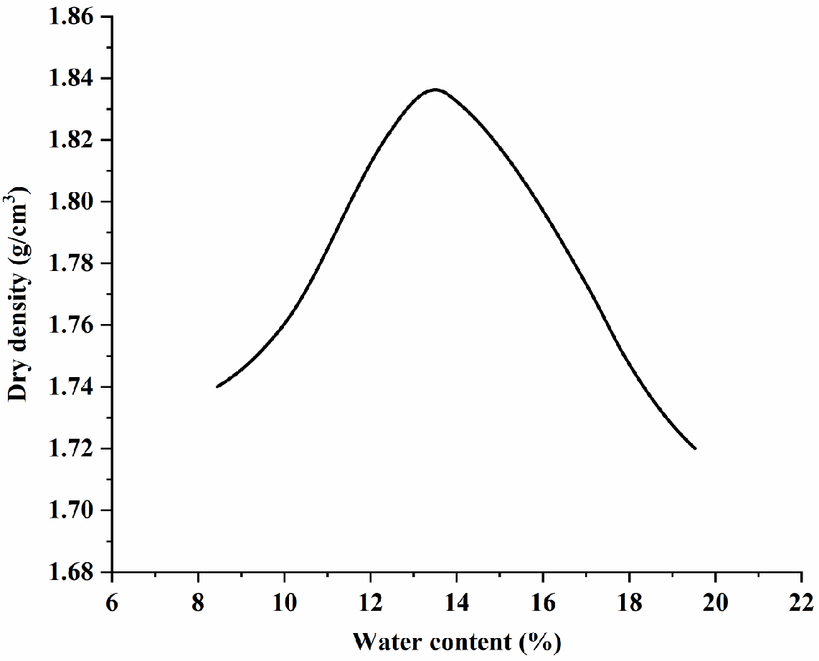

**Fig.1.Light compaction test curve of loess soil sample**

**Table 1. Basic physical indexes of loess**

|  |  |  |  |  |  |
| --- | --- | --- | --- | --- | --- |
| **Name of soil** | **Specific gravity**  ***Gs*** | **Liquid limit *ω*L（%）** | **Plastic limit *ω*P（%）** | **Plasticity index**  ***I*P** | **Permeability *k*（cm/s）** |
| **Silty clay** | **2.70** | **22.31** | **14.71** | **7.60** | **6.04×10-5** |

**III. Specific Test Plan**

Firstly, model making is conducted to simulate natural loess slopes. During the construction of the slope, each layer of soil is compacted as much as possible to ensure a compaction degree of 0.85, as shown in Figure 2a. The slope is constructed in layers, and before proceeding to the next layer after completing each layer, the surface of the soil layer is roughened to ensure full contact between the two layers of soil, making the loess slope soil as uniform as possible. Additionally, after completing each layer, a ring knife is used to take samples to measure the moisture content and density for calculating the compaction degree, ensuring that the compaction degree reaches the set value. After the construction is completed, the slope is cut according to the preset slope angle, and then a plastic film is laid on its surface for curing for 24 hours. After curing, two groups of loess slope model tests under different water head heights are carried out. The measurement system is started simultaneously with the beginning of the test, real-time data is collected, the slope deformation is monitored, and the deformation and failure characteristics and processes of the loess slope under different water head heights are compared and analyzed to explore and summarize the failure modes of the slope under different water head heights.

In terms of seepage pressure, since this experiment investigates the deformation and failure modes of loess slopes under different water head heights, two sets of infiltration conditions were set up, divided into low water head and high water head. The infiltration water pressures for the two sets of model tests were 0.02MPa and 0.06MPa, respectively. During the process of the two sets of model tests, the infiltration water pressure was the only variable, and the infiltration method was continuous infiltration until the loess slope ultimately failed as a whole. In terms of sensor embedding, this experiment used a total of 4 sensors, located on two cross-sections, with two pore water pressure sensors placed on one cross-section (Figure 2b) and two volumetric water content sensors placed on the other (Figure 2c). The distance between each sensor was greater than six times the diameter of the sensor, which met the embedding requirements, thus ensuring that the sensors were almost unaffected by each other (Figure 2d). In terms of vertical depth, there were two depths: the first depth was 40cm from the bottom of the slope, and the second depth was 80cm from the bottom of the slope. In terms of embedding location, care was taken to ensure that the sensors on the two cross-sections and at different depths corresponded spatially, ensuring that the data collected could be compared and analyzed to determine the changes in the seepage process within the slope. Once the experiment began, data collection needed to be synchronized, with a fixed collection frequency to monitor in real-time the changes within the slope caused by infiltration. In addition, a high-precision three-dimensional laser scanner was used to monitor the deformation of the slope and record it in real-time. Before the formal start of the model experiment, the equipment was checked again to ensure its normal operation, thus ensuring the effectiveness of the experiment.

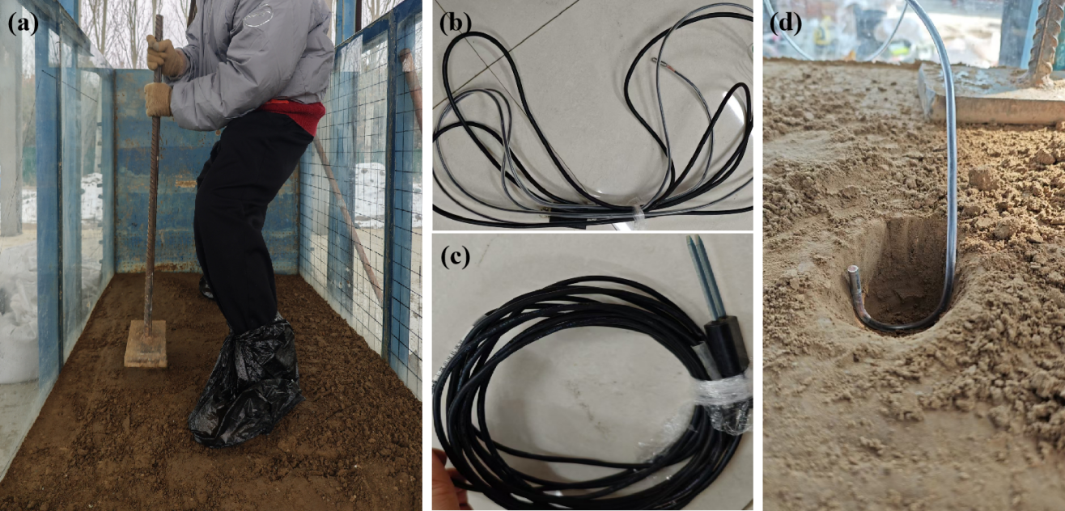

**Fig.2.Loess slope model production site. (a) Soil compaction; (b) Pore water pressure sensor; (c) Volumetric water content sensor; (d) Embedding of pore water pressure sensor**

**IV. Analysis of Loess Slope Deformation and Failure Modes**

Under the action of two different water heads, the loess slope will first experience the soil saturation stage. Subsequently, with the continuous infiltration of groundwater, the wetting front can be clearly observed to develop from the rear to the front of the slope, and the slope gradually saturates from back to front and from bottom to top. Under the action of low water head, the deformation and failure process of the loess slope can be divided into three stages: the slope toe liquefaction stage, the slope surface traction-type collapse stage, and the overall slow instability stage. Under the action of high water head, the deformation and failure mode of the slope can be divided into four stages: the slope toe liquefaction stage, the slope surface traction-type collapse stage, the slope top settlement stage, and the overall sudden instability stage.

During the liquefaction phase at the slope toe, due to the initial unsaturated state of the loess slope soil mass, the volumetric water content of the soil mass gradually increases at the beginning of infiltration, with some of the soil mass gradually becoming saturated, and the corresponding pore water pressure also gradually increasing. With the continuous infiltration of groundwater, the wetted area expands, and the seepage preferentially concentrates at the slope toe, causing the water content of the soil mass at this location to continuously increase, the soil mass gradually softens, and water can be clearly observed seeping out from the slope toe. During the saturation process of the slope toe soil mass, the shear strength of the soil mass decreases, the slope toe gradually transitions into a liquefied state and gradually develops towards the rear edge of the slope. In the second phase, the slope surface traction-type collapse phase, with the generation of liquefaction at the slope toe and the continuous infiltration of groundwater, an overhanging surface will be produced at the front edge of the slope, and under the influence of gravity, tensile cracks will develop on the slope surface, as shown in Figure 3a. The tensile cracks will gradually develop, showing longitudinal widening and lateral through-going phenomena, which in turn causes the loess slope surface to collapse, and then the front edge of the slope continues to develop towards the overhanging surface, further forming localized collapse, resulting in slope surface traction-type collapse. At the same time, various types of sensors buried also have timely changes in response. During the deformation failure, the volumetric water content sensor near the failure area will reach higher values, indicating that the water content of the soil mass in this area is continuously increasing, and the soil mass is changing from an unsaturated state to a saturated or nearly saturated state, resulting in plastic deformation in the sliding area. The monitoring results of the pore water pressure sensor show that with the continuous infiltration of groundwater, the pore water pressure within the loess slope soil mass continues to rise, and when the soil mass near the buried area of the pore water pressure sensor undergoes deformation failure, the pore water pressure value will decrease, which is caused by the release of internal pressure due to the blockage of the blockage in this area. The cracks generated during the deformation failure process provide preferential infiltration areas for seepage, thereby changing the seepage field within the slope body. With the continuous increase in the water content of the soil mass at the rear edge of the slope, the weight of the soil mass increases, the cementing action between the soil particles weakens, the effective stress of the soil mass weakens, the sliding force gradually becomes greater than the anti-sliding force, further causing localized collapse damage to the slope body.

For loess slopes under low water head conditions, the overall slope will slowly become unstable due to the further combined effects of seepage force and soil gravity. For loess slopes under high water head conditions, due to the relatively large infiltration pressure, traction-type collapse occurs on the slope surface, and more pronounced settlement phenomena appear at the slope top. During the infiltration process, the seepage force generated by the seepage action will bring the fine particles inside the slope body to the front edge of the slope, accompanied by the occurrence of swelling cracks, as shown in Figure 3b. In the second stage, with the collapse failure of the local soil mass, an overhanging surface is generated at the front edge of the slope. Under the combined effects of these two factors and the continuous increase in the weight of the slope body, settlement phenomena appear at the slope top. As the water accumulates inside the slope, the deformation and failure of the slope body accelerate, and the soil mass continuously moves towards the front edge of the slope, which in turn causes the overall sudden instability of the loess slope.

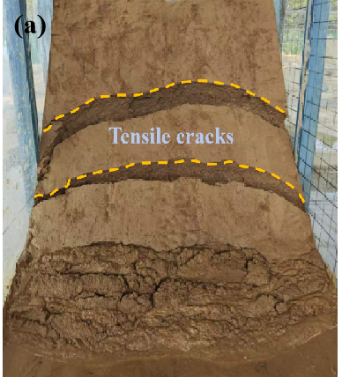 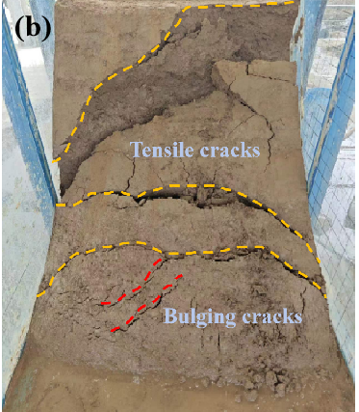

**Fig.3.Loess slope failure under different water head heights. (a) Low water head; (b) High water head.**

**V. Conclusion**

(1) With continuous groundwater infiltration, the wetting front develops progressively from the rear to the front of the slope, causing the slope to gradually saturate from back to front and from bottom to top. Moreover, the advancement speed of the wetting front is greater than the rising speed.

(2) The characteristics of loess slope crack evolution under different water head heights are as follows: the front edge of the slope is dominated by bulging cracks, which then gradually develop into tensile cracks towards the rear edge of the slope. The overall development direction is from the front edge to the rear edge of the slope, and the development of cracks aggravates the deformation and failure of the loess slope.

(3) The seepage action of groundwater drives the soil particles in the slope to accumulate from the rear to the front edge, weakening the cementation capacity between soil particles, reducing its shear strength, and thus causing slope instability and failure.

(4) Under low water head conditions, the deformation and failure mode of the loess slope is: liquefaction at the slope toe → traction-type collapse at the slope surface → slow instability of the slope body. Under high water head conditions, the deformation and failure mode of the loess slope is: liquefaction at the slope toe → traction-type collapse at the slope surface → settlement at the slope top → overall sudden instability.

**Disclaimer (Artificial Intelligence)**

The author hereby declares that no generative AI technologies, such as large language models (ChatGPT, COPILOT, etc.) and text-to-image generators, were used during the writing or editing of this manuscript.

**Conflict of interest**

The authors declare that there are no conflicts of interest.

**COMPETING INTERESTS DISCLAIMER**:

Authors have declared that they have no known competing financial interests OR non-financial interests OR personal relationships that could have appeared to influence the work reported in this paper.

**Reference:**

1. Xu Z, Lin Z, Zhang M. Loess and Loess Landslides in China[J]. Chinese Journal of Rock Mechanics and Engineering, 2007, (07): 1297-1312.
2. Li Tianlei. Mechanism of Loess Landslide Induced by Groundwater and Its Stability Analysis[D]. China University of Geosciences (Beijing), 2018.
3. Zhang M, Li T. Study on the triggering factors and formation mechanism of loess landslides[J]. Journal of Engineering Geology, 2011, 19(04): 530-540.
4. Zhang M, Hu W, Sun P, et al. Current research and prospects on the water sensitivity and water-induced loess landslides[J]. Journal of Earth Environment, 2016, 7(04): 323-334.
5. Song Y, Peng J, Zhang J. Analysis of deformation and failure mechanism of loess filling high slope[J]. Journal of Engineering Geology, 2008, (05): 620-624.
6. Zhang S, Pei X, Huang R, et al. Model test on rainfall infiltration characteristics and deformation and failure modes of loess slopes[J]. China Journal of Highway and Transport, 2019, 32(09): 32-41+50.
7. Zhang S, Pei X, Huang R, et al. Study on the instability mechanism of high filling loess supporting slopes induced by rainfall[J]. Journal of Engineering Geology, 2017, 25(04): 1094-1104.
8. Gao Yuequan. Study on the mechanism and control measures of high filling embankment landslides in loess areas[J]. Chinese Journal of Underground Space and Engineering, 2016, 12(S1): 393-399.
9. Cao Congwu, Xu Qiang, Qi Xing, et al. Deformation and failure characteristics of microstructure in loess slope during physical simulation process[J]. Science Technology and Engineering, 2017, 17(33): 225-231.
10. Wei K, Pei X, Zhang S, et al. Deformation characteristics of a loess high slope support structure based on IBIS-L[J]. Journal of Jilin University (Earth Science Edition), 2018, 48(05): 1556-1565.
11. Huang Runqiu. Large-scale landslides and their occurrence mechanisms in China since the 20th century[J]. Chinese Journal of Rock Mechanics and Engineering, 2007, (03): 433-454.
12. Wu H, Chen S, Pang Y. Parameter study on the effect of rainfall infiltration on the stability of unsaturated soil slopes[J]. Rock and Soil Mechanics, 1999, (01): 2-15.
13. Liu C, Feng J, Zhang Q, et al. Physical simulation of the seepage deformation mechanism of loess high embankment slopes[J]. Science Technology and Engineering, 2022, 22(19): 8218-8224.
14. Yu D, Huang Q, Kang X, et al. Study on the Model Test of Seepage Failure Mechanism of Loess Filling Slope Interface[J]. Hydrogeology and Engineering Geology, 2022, 49(05):119-128.
15. Guo Guanmiao. Study on the Slope Effect and Mechanical Influence of Soil Water Migration Spatial and Temporal Evolution in Loess High Fill Slopes[D]. Xi'an: Chang'an University, 2023.
16. Tartaglia M, Pirone M, Urciuoli G. A data-driven approach to assess the role of the groundwater conditions in triggering shallow landslides initiating with frictional failure. [J]. Landslides, 2023, 20(7): 1497-1517.
17. Tong D, Su A, Tan F, et al. Genetic mechanism of water-rich landslide considering antecedent rainfalls: a case study of Pingyikou landslide in three Gorges reservoir area. [J]. Journal of Earth Science, 2023: 1-14.
18. Zhang S, Pei X, Wang S, et al. Centrifuge model testing of a loess landslide induced by rising groundwater in Northwest China. [J]. Engineering geology, 2019, 259: 105170.
19. Orense RP, Shimoma S, Maeda K, et al. Instrumented model slope failure due to water
20. Seepage. [J]. Journal of Natural Disaster Science, 2004, 26(1): 15-26.
21. Beyabanaki SAR, Bagtzoglou AC, Anagnostou EN. Effects of groundwater table position, soil strength properties and rainfall on instability of earthquake-triggered landslides. [J]. Environmental Earth Sciences, 2016, 75: 1-13.
22. Leng, Yanqiu, et al. (2018). A fluidized landslide occurred in the Loess Plateau: A study on loess landslide in South Jingyang tableland. Engineering Geology 236:129-136.