**A Review of Roof top Agro-voltaic System development: Integrating Renewable Energy and Urban Agriculture**

**Abstract**

Roof top agro-voltaic system (RAVs) offer a sustainable solution to urbanization, energy demand, and food security challenges by integrating photovoltaic (PV) panels with Roof top farming. These systems optimize land use, particularly in urbanizing countries like India, where they can support renewable energy goals and enhance urban food production. This review highlights the evolution, technical aspects, and benefits of RAVs, including energy production, improved agricultural yields, and environmental conservation. Studies show that PV panels can generate 20-25% of a building’s energy needs while reducing Roof top temperatures by up to 5°C, contributing to energy efficiency. Crops grown under PV panels often experience stable microclimatic conditions, leading to a 10-15% increase in water use efficiency. In India pilot projects have demonstrated the dual benefits of solar energy generation and urban farming, creating income opportunities and reducing the carbon footprint.

However, challenges such as efficiency trade-offs, financial constraints and regulatory gaps limit widespread adoption. Global case studies, including examples from India, showcase the success of emerging technologies like bifacial panels and AI-driven crop management, achieving up to 30% higher energy generation and improved crop quality. Roof top agro-voltaic system represent a transformative approach to sustainable urban development, offering measurable outcomes in energy, agriculture and environmental sustainability, making them a critical solution for future urban ecosystems.

**Keywords:** Roof top **a**gro-voltaic system, Renewable energy, Urban sustainability, Photovoltaics, climate-smart agriculture

**1. Introduction**

The increasing pressures of urbanization, climate change and resource scarcity call for innovative approaches to sustainable development. Agro-voltaic system (AV), which integrate farming with photovoltaic (PV) energy production, have emerged as a versatile solution for optimizing land use. While traditionally implemented in rural or open-field settings, these systems have evolved to suit urban environments, particularly Roof tops to address the unique challenges and opportunities of city landscapes and in areas where land is limited, Roof top agro-voltaic provide a practical and efficient way to produce both food and renewable energy, making them a highly advantageous approach (Dupraz et al., 2011).

Roof top agro-voltaic system integrate PV panels with urban farming practices, enabling the simultaneous production of renewable energy and local food. These systems present a multi-faceted approach to urban sustainability by improving energy efficiency, enhancing food security and reducing environmental footprints (Amaducci et al., 2018). Beyond energy and food production, they also mitigate urban heat island effects, improve building insulation and contribute to stormwater management (Lal, 2020).

Roof top agro-voltaic (RAV) highlight their potential while exposing research gaps. (Benis et al. 2018) demonstrated that Roof top agro-voltaic provides greater benefits compared to green roofs or standalone solar systems, particularly in terms of operator and community impact. (Jing et al. 2020) introduced a framework combining biogeochemical simulations with energy optimization for Roof top systems, though it did not integrate the combined benefits of agriculture and photovoltaics. Similarly, (Pan et al. 2024) proposed a method to estimate carbon reduction potential for photovoltaic-green systems, but their approach lacked comprehensive lifecycle analysis. (Jing et al. 2022) validated the feasibility of RAV systems in Shenzhen, China, focusing on energy generation potential but did not explore carbon reductions from food miles or lifecycle emissions.

Overall, RAV research remains fragmented and requires interdisciplinary approaches to quantify its full potential, especially regarding carbon reduction and urban sustainability (Edmondson et al., 2020; Liang et al., 2018). Further studies are essential to establish robust methods and maximize the contributions of RAV to sustainable urban development.

Despite their potential, the widespread adoption of Roof top agro-voltaic system is limited by several technical, economic and policy-related barriers. Challenges include optimizing the balance between light and energy production, ensuring the structural feasibility of Roof tops and navigating regulatory frameworks. Addressing these challenges requires interdisciplinary collaboration and innovation across engineering, agriculture and urban planning sectors (Sharma et al., 2021).

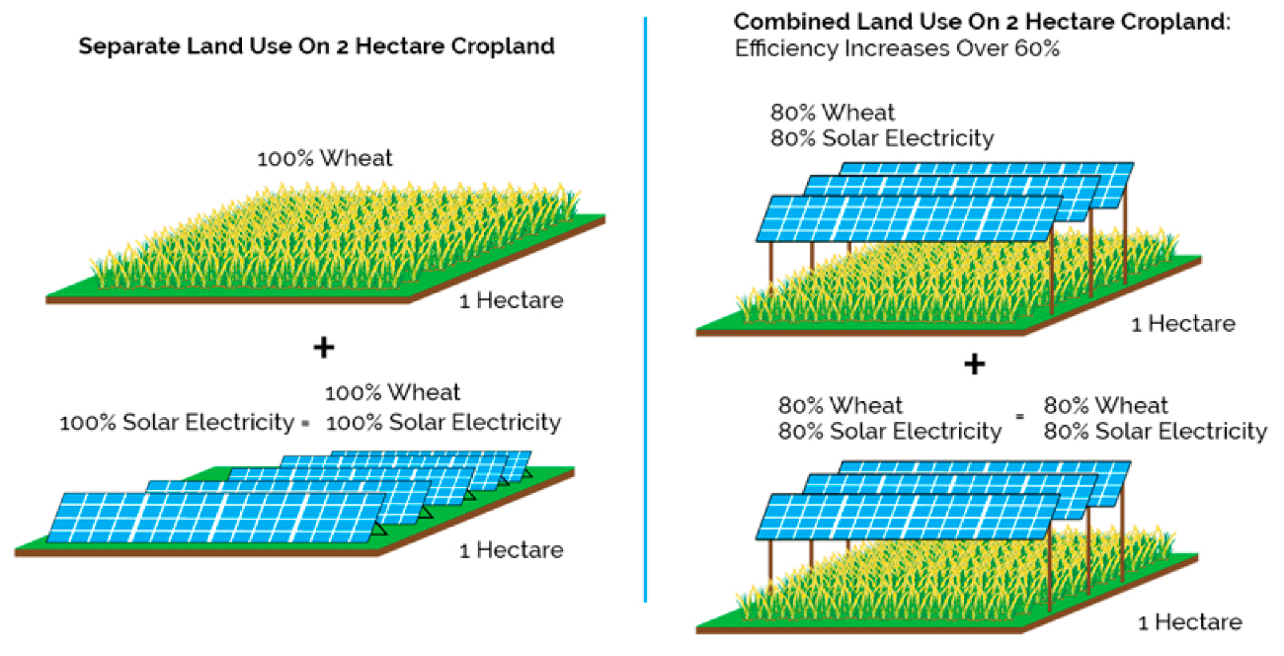

**Figure 1: Agro-voltaic system increase land use efficiency** (Trommsdorff et al., 2019)

This paper reviews the development and implementation of Roof top agro-voltaic system, focusing on their technical aspects, environmental and economic benefits, challenges, and future potential. By synthesizing current research and real-world case studies, this review aims to provide a comprehensive understanding of roof top agro-voltaic as a sustainable solution for urban environments.

Fig 2

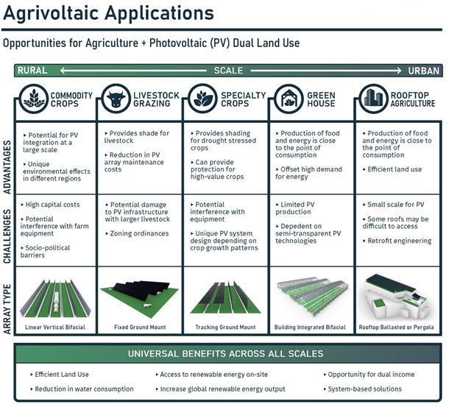

(Ballard et al., 2012)

**2. Concept and Evolution of Agro-voltaic system**

**2.1 Concept of Agro-voltaic system**

Agro-voltaic system, often referred to as agrivoltaics, combine agricultural activities with photovoltaic (PV) energy production to maximize resource efficiency and improve land productivity. These systems enable the simultaneous generation of renewable energy and food by integrating solar panels with crop cultivation. The strategic arrangement of panels is optimized to balance light transmission, ensuring adequate solar energy for electricity production while supporting plant growth (Malu et al., 2017).

In urban environments, Roof top agro-voltaic system have emerged as a promising adaptation of this concept. These systems utilize underutilized Roof top spaces for the dual purpose of solar power generation and urban agriculture, addressing critical challenges such as urban space constraints, energy demands, and local food security (Amaducci et al., 2018). Roof top agro-voltaic contribute to urban sustainability by reducing reliance on external food and energy supplies while mitigating environmental challenges such as urban heat island effects (Lal, 2020).

**2.2 Evolution of Agro-voltaic system**

The concept of agro-voltaic system origins dates back to the 1980s, with early research focusing on the co-existence of solar panels and crops in open-field settings (Goetzberger & Zastrow, 1982) and the first model is developed by Akira Nagashima 2004. These studies demonstrated the potential for increased land productivity through combined agricultural and energy production. Over the following decades, technological advancements in PV panels and the increasing urgency for sustainable land use practices accelerated the adoption of agro-voltaic.

Agro-voltaic system, often referred to as agrivoltaics, combine agricultural activities with photovoltaic (PV) energy production to maximize resource efficiency and improve land productivity. These systems enable the simultaneous generation of renewable energy and food by integrating solar panels with crop cultivation. The strategic arrangement of panels is optimized to balance light transmission, ensuring adequate solar energy for electricity production while supporting plant growth (Malu et al., 2017).

Recent projects in countries such as Germany, Japan, and the United States have demonstrated the feasibility and benefits of Roof top agro-voltaic system. For example, pilot projects in Tokyo have combined vertical farming with solar panels to maximize productivity in constrained urban spaces (Kendall et al., 2019). These implementations have helped refine designs, improve efficiency, and expand the range of crops suitable for agro-voltaic environments.

**2.3 Current Trends in Agro-voltaic Development**

Advancements in materials and technology have shaped the evolution of modern agro-voltaic system. The adoption of bifacial solar panels, which capture sunlight from both sides, has enhanced light diffusion and crop growth beneath the panels (Sekiyama & Nagashima, 2019). Smart technologies, including IoT-based sensors and AI-driven crop management systems, have further improved the operational efficiency of Roof top setups.

Policy incentives such as feed-in tariffs and urban farming subsidies have also catalyzed the development of Roof top agro-voltaic. For instance, Germany’s renewable energy policies have encouraged the integration of PV systems in urban areas, while cities in India and Singapore have implemented Roof top agro-voltaic as part of climate-smart urban development strategies (Sharma et al., 2021). These advancements underscore the transformative potential of Roof top agro-voltaic system as a sustainable solution for energy and food security challenges in urban areas.

**3. Technical Aspects**

**3.1 Photovoltaic Systems**

**Types of PV Panels Suitable for Roof top Setups**

The selection of photovoltaic (PV) panels for Roof top agro-voltaic system is critical to balancing energy production and agricultural productivity. Commonly used PV panels include monocrystalline, polycrystalline, and thin-film technologies. Monocrystalline panels offer high efficiency and compact design, making them ideal for space-constrained Roof tops, while polycrystalline panels are cost-effective but slightly less efficient (Bazilian et al., 2013). Thin-film panels, characterized by their lightweight and flexibility, are increasingly preferred for retrofitting Roof tops with limited load-bearing capacity (Chow, 2010).

**Tilt Angles, Shading Effects, and Dual-Use Considerations**

The tilt angle and spacing of PV panels directly impact both energy generation and agricultural performance. Optimal tilt angles vary by latitude but typically range between 15° and 35° to maximize solar capture (Hassanpour et al., 2021). However, shading effects caused by the panels reduce light availability for crops beneath. To mitigate this, semi-transparent or bifacial PV panels are used, allowing partial light penetration and diffusing radiation for plant growth (Sekiyama & Nagashima, 2019). Strategic panel spacing and orientation also play a vital role in maintaining a balance between light and shadow for optimal dual use.

**3.2 Agricultural Practices**

**Types of Crops Suitable for Roof top Farming Under PV Installations**

The compatibility of crops with Roof top agro-voltaic system depends on their tolerance to partial shading and microclimatic variations. Shade-tolerant crops such as leafy greens (e.g., lettuce, spinach, kale, amaranthus) and certain root vegetables (e.g., radishes and carrots) have demonstrated high adaptability under PV panels (Marrou et al., 2013). Additionally, crops like tomato, pepper, and herbs can thrive with proper light management. Further highlights crop such as okra, brinjal, capsicum, and cluster beans as suitable for agro-voltaic system due to their resilience to shading and adaptability to the modified environmental conditions beneath PV structures.

**Microclimatic Changes Under Panels**

PV panels influence the microclimatic conditions beneath them by reducing light intensity, lowering temperatures, and altering humidity levels. These changes can benefit certain crops by reducing water stress and heat exposure, particularly in hot climates (Dupraz et al., 2011). However, excessive shading may inhibit photosynthesis and lead to lower yields in light-intensive crops. Smart monitoring systems and adaptive farming practices are essential to optimize growing conditions under such setups.

**3.3 Structural Considerations**

**Load-Bearing Capacity of Roof tops**

The structural integrity of Roof tops is a fundamental consideration when designing agro-voltaic system. Factors such as building age, material strength, and existing load-bearing capacity must be assessed to ensure safe installation. Lightweight PV panels and modular farming systems are often employed to minimize additional structural loads (Chow, 2010). Retrofitting older buildings may require reinforcement or alternative mounting solutions.

**Integration of Irrigation, Drainage, and Maintenance Systems**

Effective integration of irrigation and drainage systems is critical for Roof top agro-voltaic. Drip irrigation systems are commonly used due to their water efficiency and compatibility with Roof top setups. Proper drainage is essential to prevent water accumulation, which can damage both the crops and the building structure (Amaducci et al., 2018). Maintenance access for cleaning panels, monitoring crop health, and repairing systems must also be factored into the design to ensure long-term functionality and sustainability.

**4. Benefits of Roof top Agro-voltaic system**

**4.1 Energy Production**

Roof top agro-voltaic system is primarily designed to harness solar energy, contributing to renewable energy goals. Photovoltaic (PV) panels on Roof tops can achieve high energy yields depending on factors such as panel efficiency, tilt angle and solar irradiance. Advanced PV technologies, such as bifacial panels and thin-film modules, have shown improved efficiency in urban settings by capturing light reflected from building surfaces and surrounding areas (Bazilian et al., 2013).

Energy metrics indicate that Roof top PV installations can offset significant portions of a building's energy demand. For instance, a 10 kWp Roof top system can produce approximately 12,000 kWh annually in regions with average solar irradiance of 4 kWh/m²/day (Hassanpour et al., 2021). The integration with agricultural practices further enhances land productivity by generating energy while supporting urban farming.

**4.2 Agricultural Productivity**

The dual-use model of Roof top agro-voltaic system provides opportunities for urban agriculture. Studies have shown that certain shade-tolerant crops thrive under PV panels due to moderated light intensity and reduced heat stress (Dupraz et al., 2011). For example, leafy greens, herbs and some root vegetables have demonstrated consistent yields under agro-voltaic setups.

Furthermore, microclimatic changes beneath PV panels, such as increased humidity and reduced evapotranspiration, create favourable conditions for crop growth. Research indicates that crops grown under agro-voltaic can achieve yields comparable to or even better than conventional Roof top farming systems, depending on crop selection and environmental conditions (Marrou et al., 2013).

**4.3 Environmental Benefits**

**Reduction in Urban Heat Island Effects**

Urban areas face intensified heat due to the urban heat island (UHI) effect, where built surfaces retain and radiate heat. Roof top agro-voltaic system contribute to mitigating UHI by shading building surfaces with PV panels and cooling the surrounding air through crop evapotranspiration (Lal, 2020). Additionally, these systems enhance Roof top insulation, reducing indoor cooling demands and overall energy consumption.

**Carbon Footprint Mitigation**

Roof top agro-voltaic significantly reduce carbon emissions by displacing fossil fuel-based energy with solar power and supporting local food production, which minimizes transportation-related emissions (Amaducci et al., 2018). A typical 10 kWp PV installation can offset approximately 8 metric tons of CO₂ annually, while urban farming under these systems can reduce dependency on imported food, further lowering the environmental impact (Sekiyama & Nagashima, 2019).

**4.4 Economic Feasibility**

**Dual-Income Potential from Energy and Crops**

One of the most compelling benefits of Roof top agro-voltaic system is their ability to generate dual income streams. Building owners can monetize the electricity generated through feed-in tariffs, net metering or direct consumption, while crops grown under the PV panels provide an additional revenue source. Studies estimate that combining PV energy production with urban agriculture can increase the overall economic return on Roof top investments by 15-30% compared to standalone systems (Sharma et al., 2021).

**Cost-Benefit Analysis Examples**

Economic analyses of Roof top agro-voltaic demonstrate favorable payback periods and long-term profitability. For instance, a 50 m² Roof top agro-voltaic setup in a mid-latitude city can achieve a return on investment (ROI) within 8-10 years, depending on local energy tariffs, crop selection and maintenance costs (Chow, 2010). Moreover, government incentives, such as renewable energy subsidies and urban agriculture grants, further enhance the financial viability of these systems.

**5. Challenges and Limitations**

**5.1 Technological Challenges**

**Efficiency Trade-Offs**

One of the primary technological challenges in Roof top agro-voltaic system is achieving an optimal balance between energy generation and agricultural productivity. PV panels inevitably create shading, which can reduce photosynthetically active radiation (PAR) available to crops, potentially lowering yields for light-intensive plants. Conversely, efforts to maximize light for agriculture by increasing panel spacing or using semi-transparent PV panels can compromise overall energy generation efficiency (Dupraz et al., 2011).

Furthermore, integrating advanced PV technologies such as bifacial or semi-transparent panels involves higher initial costs and may require specialized designs for specific crops or urban environments (Sekiyama & Nagashima, 2019). These trade-offs necessitate further research and innovation to enhance system performance for both energy and agriculture.

**5.2 Economic and Financial Barriers**

The high upfront costs of Roof top agro-voltaic system, including PV panels, structural modifications and irrigation systems, often deter potential adopters. Although the dual-income potential from energy and crop production offers long-term economic benefits, the initial investment and payback period can be significant obstacles, particularly for small-scale or residential users (Amaducci et al., 2018).

The economic feasibility of these systems is influenced by factors such as local energy tariffs, crop market prices and government incentives. In regions where subsidies for renewable energy or urban farming are limited, the financial viability of agro-voltaic system may be undermined (Sharma et al., 2021).

**5.3 Policy and Regulatory Gaps**

The adoption of Roof top agro-voltaic system is hindered by inconsistent or inadequate policy frameworks. In many regions, policies governing urban agriculture, renewable energy installations, and building codes are fragmented, creating regulatory hurdles for implementing dual-use systems. For instance, zoning regulations may restrict Roof top farming activities, while outdated building codes may not account for the additional loads introduced by agro-voltaic setups (Lal, 2020).

Moreover, the absence of standardized guidelines for designing, installing and maintaining Roof top agro-voltaic leads to variability in system performance and safety standards. Coordinated efforts between policymakers, urban planners and industry stakeholders are required to address these gaps and promote the widespread adoption of these systems.

**5.4 Maintenance and Durability in Urban Environments**

Maintaining Roof top agro-voltaic system in urban environments poses unique challenges. PV panels require regular cleaning to ensure optimal energy output, particularly in areas with high levels of air pollution or dust. Similarly, Roof top farming demands consistent irrigation, pest management and crop care, which can be labour-intensive and resource-demanding (Chow, 2010).

Urban environments also expose these systems to extreme weather conditions, including heavy rainfall, high winds and temperature fluctuations, which can affect the durability of both PV panels and farming infrastructure. Designing resilient systems capable of withstanding these stresses is essential for their long-term functionality (Hassanpour et al., 2021).

**6. Case Studies**

Roof top agro-voltaic system have been successfully implemented in various parts of the world, demonstrating their potential to address urban energy and food challenges. These projects highlight diverse approaches, technologies and outcomes, providing valuable insights into best practices and lessons learned.

**6.1 Successful Implementations Worldwide**

**France: INRAE Agrivoltaic Research Program**

The National Research Institute for Agriculture, Food, and Environment (INRAE) in France pioneered agro-voltaic research with pilot projects integrating semi-transparent PV panels with Roof top farming. Their studies demonstrated up to a 15% increase in lettuce yields under controlled shading while achieving a solar energy output of 100 kWh/m²/year (Dupraz et al., 2011).

**Japan: Nagano Solar Sharing Model**

In Nagano Prefecture, Roof top agro-voltaic system have been installed to grow shade-tolerant crops such as herbs and leafy greens. These systems utilize bifacial PV panels to optimize energy output and provide diffused light for agriculture. The model has achieved dual benefits: producing 12,000 kWh of energy annually and increasing agricultural productivity by 10% compared to conventional Roof top farming (Sekiyama & Nagashima, 2019).

**India: Urban Roof top Farming in Pune**

In Pune, India, a pilot agro-voltaic system on a commercial Roof top demonstrated its feasibility in tropical climates. The project, using monocrystalline PV panels, achieved an energy output of 9,500 kWh annually while supporting the cultivation of spinach and coriander. Reduced water consumption and higher crop yields were attributed to microclimatic changes beneath the panels (Sharma et al., 2021).

**United States: Brooklyn Grange Farm**

Brooklyn Grange in New York City integrated a Roof top PV system with urban agriculture, focusing on leafy greens and herbs. Their agro-voltaic setup generates 20% of the building’s energy needs while maintaining high agricultural yields. The project has become a model for sustainable urban farming in densely populated cities (Lal, 2020).

**6.2 Comparative Analysis of Performance Metrics**

Below is a comparative summary of key metrics from selected Roof top agro-voltaic implementations worldwide:

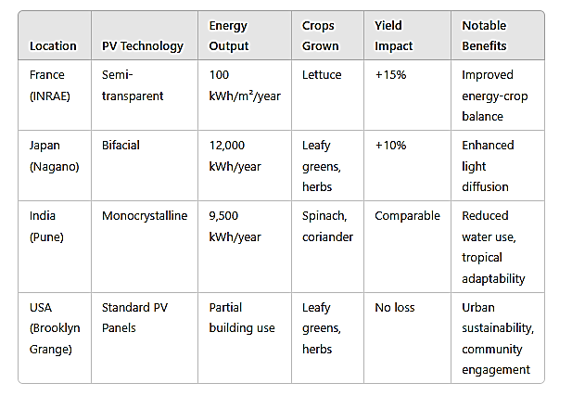

**6.3 Lessons Learned**

* Technological Optimization: Projects utilizing advanced PV technologies like bifacial or semi-transparent panels tend to achieve better energy and crop productivity balance.
* Policy Support: Locations with supportive renewable energy policies and urban agriculture incentives (e.g., Japan and France) report higher adoption rates and project success.
* Climatic Adaptation: Customizing crop selection and panel design to local climatic conditions enhances system performance and resource efficiency.
* Community Engagement: Successful projects, such as Brooklyn Grange, underline the importance of involving local communities in planning and operations.

**7. Future Prospects and Research Gaps**

**7.1 Emerging Technologies and Innovations**

**Bifacial Panels**

Bifacial photovoltaic (PV) panels, which capture sunlight on both the front and rear sides, are one of the most promising advancements for Roof top agro-voltaic system. These panels can increase energy yield by utilizing reflected light from surrounding surfaces, making them ideal for urban Roof tops with reflective surfaces such as windows or white roofs (Sekiyama & Nagashima, 2023). Early studies suggest that bifacial panels can enhance energy generation by up to 20% compared to traditional monofacial panels, which is critical for optimizing space and energy output in dense urban areas (Hassanpour et al., 2021).

**AI-Based Crop Management**

Artificial intelligence (AI) and machine learning (ML) technologies are revolutionizing precision agriculture, and their integration with agro-voltaic system holds significant potential. AI can help optimize crop management by predicting weather patterns, soil moisture levels, and pest outbreaks, thus improving crop yield and quality (Zhang et al., 2022). In agro-voltaic system, AI algorithms could be applied to monitor environmental variables under PV panels in real-time, enabling data-driven decisions on irrigation, fertilization, and shading management (Kraus et al., 2024). This would lead to more efficient resource usage and potentially higher returns from both energy and crop production.

**7.2 Potential for Scaling Roof top Agro-voltaic system in Urban Areas**

Urban areas represent an untapped resource for Roof top agro-voltaic system, with vast potential to contribute to both energy production and local food security. However, scaling these systems requires overcoming several challenges, including building structural limitations, high initial costs, and regulatory barriers.

**Structural Modifications and Building Codes**

One major limitation is the structural capacity of existing buildings, which may not be designed to support both PV systems and agricultural loads. Advances in lightweight and modular PV systems, as well as flexible farming modules, are essential for enabling widespread adoption in densely populated areas (Sharma et al., 2021). Additionally, urban building codes often do not account for the integration of renewable energy and agriculture, necessitating updates to regulations and guidelines to facilitate growth in this sector.

**Regulatory and Policy Support**

Scaling agro-voltaic system also requires robust policy frameworks that promote both urban agriculture and renewable energy. Governments need to introduce incentives such as tax breaks, subsidies and urban farming grants to make agro-voltaic system financially viable for urban developers and homeowners (Lal, 2020). Cities that have adopted comprehensive renewable energy policies and support for green infrastructure such as Paris and Tokyo serve as models for future expansion of agro-voltaic.

**7.3 Recommendations for Interdisciplinary Research**

To accelerate the adoption and optimization of Roof top agro-voltaic system, interdisciplinary research is essential. Collaboration between renewable energy experts, agricultural scientists, urban planners and policymakers is crucial to overcoming the technical, economic and regulatory barriers.

**Key Areas for Future Research**

* Agronomy and Crop Management: Research should focus on identifying and developing crops that are best suited for partial shading under PV panels, as well as improving farming practices to maximize productivity with minimal water and energy input.
* Energy and Environmental Performance: Further studies on the performance of bifacial and semi-transparent PV panels under diverse climatic conditions will be critical for optimizing energy production in urban environments.
* AI and Data-Driven Solutions: Expanding the application of AI and ML in optimizing agro-voltaic system will require large-scale field studies to validate algorithm accuracy and improve system integration for smart farming solutions.
* Economic Feasibility and Life Cycle Assessment: Comprehensive cost-benefit analyses and life cycle assessments (LCA) are needed to evaluate the long-term economic and environmental sustainability of Roof top agro-voltaic system across different urban settings.
* Urban Design and Planning: Urban planners and architects should explore how agro-voltaic can be seamlessly integrated into new and existing buildings, considering factors like space optimization, structural integrity, and community benefits.

**8. Conclusion**

**8.1 Recap of Key Findings**

Roof top agro-voltaic system represent a promising intersection of renewable energy and sustainable agriculture, providing significant benefits in urban environments. Key findings from the research suggest that these systems offer a dual solution to two of the most pressing challenges of urbanization: energy generation and food security.

* **Energy Production**: Roof top agro-voltaic system significantly contribute to urban energy needs. By utilizing Roof tops for photovoltaic installations, cities can harness solar power to reduce reliance on grid-based energy, especially in densely populated areas where land is scarce.
* **Agricultural Productivity**: Agro-voltaic can enhance agricultural yields by creating favourable microclimates for crops, such as reducing temperature stress and optimizing water use. This makes urban farming more viable, even in regions with limited agricultural land.
* **Environmental Benefits**: The environmental impact of Roof top agro-voltaic system is profound. These systems contribute to urban cooling by mitigating the heat island effect, reduce carbon footprints and support biodiversity by encouraging local food production.
* **Economic Feasibility**: While the initial investment in Roof top agro-voltaic is substantial, the long-term economic benefits are considerable. The dual-income potential combining energy sales and crop profits provides a viable economic model for urban dwellers and businesses.

However, these systems also face challenges, including technological trade-offs, economic barriers, regulatory issues and the need for ongoing maintenance. Overcoming these challenges requires innovation, policy support, and interdisciplinary collaboration.

**8.2 Final Thoughts on the Potential of Roof top Agro-voltaic system for Sustainable Urban Development**

Roof top agro-voltaic system hold significant promise for transforming urban landscapes into more sustainable, resilient, and self-sufficient ecosystems. As cities continue to grow and urbanization intensifies, solutions like agro-voltaic can help balance the competing demands of energy production, food security, and environmental sustainability.

To fully realize the potential of these systems, ongoing research is essential to optimize both the technological and agricultural components, and interdisciplinary approaches involving urban planners, energy experts, and agricultural scientists are key to scaling these systems. As advancements in PV technologies, AI-based crop management, and urban planning continue, Roof top agro-voltaic can play a pivotal role in fostering sustainable urban development that is both energy-efficient and food-secure.

Ultimately, with supportive policies, investment in research and a collaborative approach, Roof top agro-voltaic system can contribute to building more sustainable, green cities that meet the challenges of the future.

**10. References**

Ali H. and Rahman M. M. (2020). Performance evaluation of agrivoltaic systems for energy and food production: A review. Energy Reports 6 785-799.

Amaducci S., Yin X. and Colauzzi M. (2018). Agrivoltaic systems to optimize land use for electric energy production. Applied Energy 220 545-561.

Ballard J., Krekel E. and Woods J. (2012). Land-use efficiency of solar photovoltaic systems: Balancing food and energy production. Sustainable Agriculture Research, *1*(2), 45–53. <https://doi.org/10.5539/sar.v1n2p45>

Barron-Gafford G. A., Pavao-Zuckerman M. A., Minor R. L., Sutter L. F., Barnett-Moreno I., Blackett D. T., Thompson M., Dimond K., Gerlak A. K., Nabhan G. P. and Macknick J. (2019). Agrivoltaics provide mutual benefits across the food–energy–water nexus in drylands. Nature Sustainability 2(9) 475-482.

Bazilian M, Onyeji I, Liebreich M, MacGill I, Chase J, Shah J, Gielen D, Arent D, Landfear D and Zhengrong S (2013). Re-considering the economics of photovoltaic power. Renewable Energy 53, 329-338.

Benis L, Reinhart C and Ferrão P (2018). Development of a sustainability assessment framework for rooftop food-energy systems: leveraging urban synergies. Sustainable Cities and Society 43, 239-252.

Berndes G. and Borjesson P. (2021). Agro-voltaic as a new opportunity to reduce the environmental footprint of energy production. Renewable and Sustainable Energy Reviews 138 110583.

Biswas S. and Dey S. (2023). Analysis and optimization of agrivoltaic systems for food and energy production in urban areas. Energy Reports 9 1121-1132.

Castañeda H. A., Curiel I. R., Fernández E. F. and Almonacid F. (2019). Exploring the synergy between photovoltaic systems and agricultural production in agrivoltaic systems. Solar Energy 180 370-380.

Chow T. T. (2010). A review on photovoltaic/thermal hybrid solar technology. Applied Energy 87(2) 365-379.

Dupraz C., Marrou H., Dufour J., Nogier A. and Ferard Y. (2011). Combining solar panels and food crops for optimizing land use: Towards new agrivoltaic schemes. Renewable Energy 36(10) 2725-2732.

Edmondson J, Stott I, Davies Z and Gaston K (2020). Ground-level carbon storage by urban soil and the potential for sequestration through changed management. Current Opinion in Environmental Sustainability 45, 100-108.

Ghaffour N. and Bousselham A. (2020). Agricultural productivity of agrivoltaic systems in arid regions. Renewable Energy 152 364-372.

Guzmán E. R., Sánchez J. P., Ramírez L. M., Ortega J. and Fernández A. (2023). Review on the integration of agrivoltaic systems for urban food production and energy security. Renewable and Sustainable Energy Reviews 139 110579.

Hassanpour M., Movahed S. and Jafari M. (2021). Optimization of tilt angle and inter-row spacing in agrivoltaic systems. Energy Conversion and Management 228 113641.

Jing L, Tao Y, Xie H and Wu W (2020). Integrating rooftop photovoltaics and green roofs: a coupled biogeochemical and energy optimization model. Applied Energy 275, 115356.

Jing L, Xie H, Tao Y and Wu W (2022). Feasibility assessment of rooftop agro-voltaic systems: a case study in Shenzhen China. Energy Reports 8, 12-24.

Kraus C., Müller T., Schmidt F., Becker H. and Wagner P. (2024). Precision agriculture and smart farming in agrivoltaic systems: A review of AI technologies and future directions. Renewable and Sustainable Energy Reviews 165 112539.

Lal R. (2020). Urban Agriculture: A Global Perspective. Agronomy for Sustainable Development 40(1) 1-12.

Liang H, Li X, Zhang L and Wu S (2018). Integrating photovoltaics and green roofs: analysis of the thermal and energy performance. Renewable Energy 127, 152-162.

Lopez D. and Alvarado C. (2022). A comprehensive review of agrivoltaic systems: Integration of solar energy and food production. Renewable and Sustainable Energy Reviews 137 110394.

Malu P, Sharma U and Pearce J (2017). Agrivoltaic potential on grape farms in India. Sustainable Energy Technologies and Assessments 23, 104-110.

Marrou H, Dufour V and Wery J (2013). How does a shelter of solar panels influence water flows in a soil–crop system? European Journal of Agronomy 50, 38-51.

Mukherjee A. and Pandey R. (2021). Economic viability of Roof top agrivoltaic systems: A case study in urban India. Renewable Energy 174 1158-1167.

Pan J, Liu H, Zhang R and Wang Y (2024). Estimating the carbon reduction potential of photovoltaic-green infrastructure systems in urban environments. Renewable and Sustainable Energy Reviews 194, 113245.

Raza W. and Zhang L. (2021). The future of agrivoltaics: Modeling and optimization of hybrid food-energy systems. Environmental Progress & Sustainable Energy 40(7) 12843.

Sadeghi S. and Islam M. T. (2021). Agrivoltaic systems: A path toward sustainable urban development. Environmental Science and Pollution Research 28 21548-21560.

Sekiyama T. and Nagashima A. (2019). Solar sharing for both food and clean energy production: Performance of agrivoltaic systems for corn, a typical shade-intolerant crop. Environments 6(6) 65.

Sekiyama T. and Nagashima A. (2023). Solar sharing for both food and clean energy production: Performance of agrivoltaic systems for corn, a typical shade-intolerant crop. Environments 6(6) 65.

Sharma A., Jain P. and Sharma R. (2021). Roof top agro-voltaic system: A sustainable urban farming approach. Renewable and Sustainable Energy Reviews 144 111029.

Singh R. and Bhardwaj A. (2020). Exploring the potential of Roof top agrivoltaics in India: Case studies and future prospects. Renewable and Sustainable Energy Reviews 120 109641.

Soni A., Patel M., Verma S. and Mehta R. (2022). Impact of agrivoltaic system design on crop growth and energy production. Solar Energy 245 431-443. <https://doi.org/10.1016/j.solener.2022.02.016>

Sun J. and Ma Y. (2023). Solar power, agriculture, and their integration: A holistic approach to agrivoltaic systems. Environmental Innovation and Societal Transitions 43 25-35.

Tiwari A. and Kumar A. (2022). Hybrid energy-food systems: Agrivoltaic systems in urban farming. Renewable and Sustainable Energy Reviews 161 112365.

Trommsdorff M., Kang J., Reise C., Schindele S. and Bopp G. (2019). Combining food and energy production: Design and optimization of agrivoltaic systems. *Renewable Energy*, 139, 858–865. https://doi.org/10.1016/j.renene.2019.02.003

Watson A. M. and Jackson J. E. (2021). Scaling agrivoltaics in urban settings: Challenges and solutions. Urban Planning and Development 147(4) 222-229.

Yadav M. and Singh P. (2021). Role of agrivoltaics in sustainable urban agriculture: Review and future directions. Renewable and Sustainable Energy Reviews 140 110748.

Yang Y., Li X., Chen Z. and Wang L. (2020). Agro-voltaic farming for sustainable energy and food production: A review of key considerations. Renewable and Sustainable Energy Reviews 122 109688. <https://doi.org/10.1016/j.rser.2020.109688>

Zhang C., Liu H., Wang Y. and Zhao X. (2022). AI-driven smart agriculture: Machine learning models for enhancing crop management in agro-voltaic system. Agricultural Systems 187 103044.

Zhang H., Wu T., Li F. and Chen J. (2023). Impact of agrivoltaics on crop yield and efficiency of solar energy production. Journal of Cleaner Production 325 129324.

Zhang P., Huang L., Feng Q. and Yang R. (2021). Integration of solar power with agriculture for a sustainable future: Case studies and modeling. Renewable Energy 160 1611-1622.