*Case report*

Primary Pulmonary MALT Lymphoma: An Unusual Cause of Non-Resolving Pneumonia

**ABSTRACT**

Mucosa-associated lymphoid tissue (MALT) lymphoma is a rare type of extranodal, low-grade B-cell lymphoma. Pulmonary MALT lymphoma is particularly uncommon and typically progresses slowly. Patients often present with asymptomatic, chronic alveolar opacities detected on chest radiographs or exhibit non-specific respiratory symptoms. In this report, we discuss the case of a male patient in his late 60s who experienced a persistent cough for one years following a diagnosed episode of pneumonia. Chest radiography revealed large area of consolidation in the right lung, which was further confirmed by computed tomography (CT) showing extensive consolidation involving right upper, middle and lower lobes. Histopathological analysis of a transbronchial lung biopsy confirmed the diagnosis of MALT lymphoma. This case underscores the importance of considering MALT lymphoma as a potential diagnosis in patients with non-resolving lung consolidation.

**INTRODUCTION**

Primary pulmonary lymphoma is an exceptionally rare malignancy, comprising only 0.4% of all lymphomas. [1] Among these, mucosa-associated lymphoid tissue (MALT) lymphoma is a subtype of extranodal B-cell lymphoma that originates from the mucosal layers. While MALT lymphoma most commonly arises in the gastrointestinal tract, thyroid, and salivary glands, its occurrence in the lungs is extremely uncommon. Despite its rarity, primary pulmonary MALT lymphoma generally has a favorable prognosis. This case emphasizes the need for a high level of clinical suspicion for pulmonary MALT lymphoma when evaluating patients with non-resolving, slowly progressive lung consolidation.

**PRESENTATION OF CASE**

A 65-year-old gentleman, an ex-heavy smoker with a history of 34 pack-years, presented with a persistent non-productive cough of one month's duration. He had associated symptoms of appetite loss and weight loss but denied fever, hemoptysis, night sweats, chest pain, or lower limb edema. His medical history included hypertension, dyslipidemia, and chronic kidney disease. There was no family history of malignancy or known exposure to pulmonary tuberculosis. The patient was a former locomotive operator and he is a non-alcohol consumer. Further history revealed that one year ago, he had presented to a district clinic with fever and cough, where chest radiography reportedly showed right middle and lower zone opacities consistent with a lung infection. He was treated with antibiotics, which led to symptom improvement. However, no follow-up chest imaging was performed. Since then, he experienced intermittent, mild non-productive cough, which he considered insignificant.

On examination, he appeared thin with mild temporal wasting but was afebrile and normotensive. He was comfortable breathing room air without cyanosis. There was no clubbing, lymphadenopathy, or skin rash. Respiratory examination revealed reduced air entry in the right middle zone with bronchial breathing, increased vocal resonance, and dullness on percussion. Other systemic examinations were unremarkable.

Chest radiography showed persistent right upper, middle and lower zone consolidation. Laboratory tests revealed hypercalcemia and an elevated creatinine level, while the full blood count was within the normal range. Uric acid and lactate dehydrogenase levels were also normal, and infectious screening for Hepatitis B, Hepatitis C, HIV, and VDRL returned negative results. Sputum cultures and *Mycobacterium tuberculosis* testing also yielded negative results. A CT thorax revealed a large consolidated area involving the apical and posterior segments of the right upper lobe and the superior and medial segments of the right lower lobe, with air bronchograms and a CT angiogram sign. There were no endoluminal lesions, pleural effusions, or pericardial effusions. Spirometry was normal, and echocardiography showed normal left ventricular function with no cardiac thrombus.

Bronchoscopy biopsy was performed by pulmonologist due to the persistent consolidation. While the airways appeared normal, histopathological examination of the transbronchial lung biopsy confirmed low-grade B-cell non-Hodgkin lymphoma, consistent with extranodal marginal zone lymphoma of mucosa-associated lymphoid tissue (MALT lymphoma). Immunohistochemistry showed diffuse positivity for CD20 and BCL-2, with negative results for TTF-1, P40, CD56, CD3, CD5, CD23, BCL-6, Cyclin D1, and CD10. Bronchoalveolar lavage was negative for bacterial cultures, tuberculosis Genexpert, and *Mycobacterium tuberculosis* cultures.

The patient received a single 60 mg dose of intravenous pamidronate for hypercalcemia and completed a five-day course of azithromycin 500 mg once daily. Following consultation with a hematologist, he was prescribed oral prednisolone 1 mg/kg/day and allopurinol 300 mg once daily but discontinued treatment after a week due to facial puffiness, refusing further steroid therapy. He was subsequently followed up in the hematology clinic. Despite persistent right lung consolidation on imaging, he remained asymptomatic initially and declined active treatment. However, during a recent visit, he reported worsening cough, a 5-kg weight loss within a month, recurrent hypercalcemia, and new-onset thrombocytopenia. Chest radiography showed progression with bilateral lung infiltrates. Although further imaging and chemotherapy were recommended, the patient opted for corticosteroid therapy alone. He was started on prednisolone (1 mg/kg/day) with a gradual tapering regimen. Thrombocytopenia was attributed to lymphoma-related immune thrombocytopenic purpura. The underlying cause of hypercalcemia in this case was not further investigated to determine whether it was PTH-dependent (PTHD) or PTH-independent (PTHI). Additional diagnostic workup was not pursued, as the patient opted for best supportive care rather than further evaluation or treatment. Top of Form Bottom of Form

**DISCUSSION**

Pulmonary non-Hodgkin lymphoma (NHL) is an uncommon malignancy, with an annual incidence of approximately 1 in 313,000 cases, accounting for less than 1% of all NHLs. Among these, mucosa-associated lymphoid tissue (MALT) lymphoma represents over two-thirds of cases. [2] Lung B-cell lymphoma is the most prevalent type of primary pulmonary lymphoma, comprising 70–80% of cases. The median age of diagnosis is typically 50–60 years, with cases in individuals under 30 years of age being rare. Pulmonary MALT lymphoma is often associated with comorbid autoimmune or infectious conditions, including Sjögren’s syndrome, rheumatoid arthritis, dysgammaglobulinemia, amyloid deposits, collagen vascular diseases, *Helicobacter pylori* infection, and acquired immunodeficiency syndrome. [3]

MALT lymphoma exhibits diverse clinical manifestations depending on the site of involvement. Most patients present with localized disease, which generally has a favorable prognosis. About one-third of cases exhibit non-specific symptoms such as dyspnea, cough, chest pain, weight loss, fever, fatigue, night sweats, or hemoptysis. These non-specific features often lead to misdiagnoses, including viral or bacterial pneumonia, cancer, sarcoidosis, or tuberculosis. The disease is not associated with smoking or occupational exposure. Its indolent nature and non-specific presentation make the diagnosis challenging. [4]

Imaging findings in pulmonary MALT lymphoma are heterogeneous and often non-specific. Common findings include single or multiple lung nodules, ranging from 2 to 8 cm, typically located in the lower lobes, sometimes with air bronchograms. Cavitation is seen in larger nodules, and pleural effusion occurs in approximately 10% of cases. Hilar or mediastinal lymphadenopathy may provide diagnostic clues. Positron emission tomography-computed tomography (PET-CT) typically shows increased fluorodeoxyglucose (FDG) uptake proportional to tumor size. [5]

A definitive diagnosis requires histopathological examination of biopsy specimens obtained via minimally invasive techniques such as transbronchial biopsy or radiologically guided transthoracic core-needle biopsy. Histological findings often reveal lymphoepithelial proliferation with invasion of the bronchial epithelium. Immunohistochemical staining is crucial for accurate diagnosis. The classical immunophenotype of MALT lymphoma is positive for B-cell markers CD20, CD19, CD22, and CD79a, positive for Bcl-2, and negative for CD5, CD10, CD23, and cyclin D1. In approximately 50% of cases, aberrant CD43 co-expression in CD20+ B cells supports a lymphoma diagnosis. This immunophenotype helps exclude other small B-cell lymphomas such as chronic lymphocytic leukemia /small lymphocytic lymphoma (CLL/SLL), mantle cell lymphoma, low-grade follicular lymphoma and lymphoplasmacytic lymphoma (LPL).

Pulmonary MALT lymphoma generally follows an indolent course with a favorable prognosis. However, systemic dissemination or transformation into high-grade B-cell lymphoma can occur. The 5-year survival rate is approximately 90%, with a 10-year survival rate of 70%. [6] Management remains debated, with therapeutic options including surgery, radiotherapy, chemotherapy, or a "watch and wait" approach for asymptomatic patients. Treatment selection depends on factors such as tumor stage, site, and patient-specific considerations. Current 2023 NCCN guidelines recommend radiotherapy as first-line treatment for stage IIE disease and monoclonal antibodies like rituximab in selected cases, with a response rate of 70% but a recurrence rate of up to 36%. [7]

Hypercalcemia is a common finding in patients with cancer, with multiple underlying mechanisms contributing to its development. Different malignancies are often associated with distinct mechanisms of hypercalcemia. In NHL, hypercalcemia is most frequently attributed to elevated levels of parathyroid hormone-related protein (PTHrP) or 1,25-dihydroxyvitamin D. [8] Autoimmune thrombocytopenia is a well-recognized immune hematologic complication of NHL, which may precede the clinical presentation, occur concurrently, or develop later, either spontaneously or following treatment. [9] In the present case, the patient’s disease course was complicated by both hypercalcemia and thrombocytopenia, highlighting the complex interplay of metabolic and immune dysregulation in NHL.

**CONCLUSION**

In conclusion, pulmonary MALT lymphoma is a rare but indolent disease with a generally favorable prognosis. Timely recognition and accurate diagnosis are essential to ensure appropriate management. Further research is needed to establish optimal treatment strategies for this uncommon condition.

**ETHICS APPROVAL AND CONSENT TO PARTICIPATE**

Not applicable

**FIGURES**

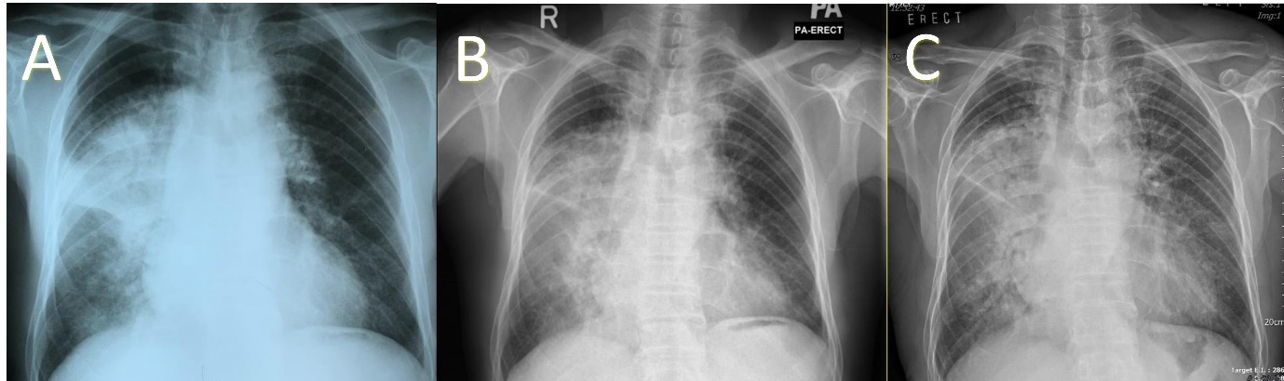

Figure 1: Posterior-Anterior (PA) Chest Radiographs (A and B) pre and post antibiotic treatment one year ago shows persistent air space opacities in the right upper and mid zones with air bronchograms. The sharp right horizontal fissure outline indicates that the opacities are predominantly in the right upper lobe. Also, there are subtle opacities in right lower zone with blurring of the medial right hemidiaphragm suggestive of lower lobe involvement as well. Posterior-Anterior (PA) Chest Radiographs C shows worsening bilateral lung infiltrations with air bronchograms.

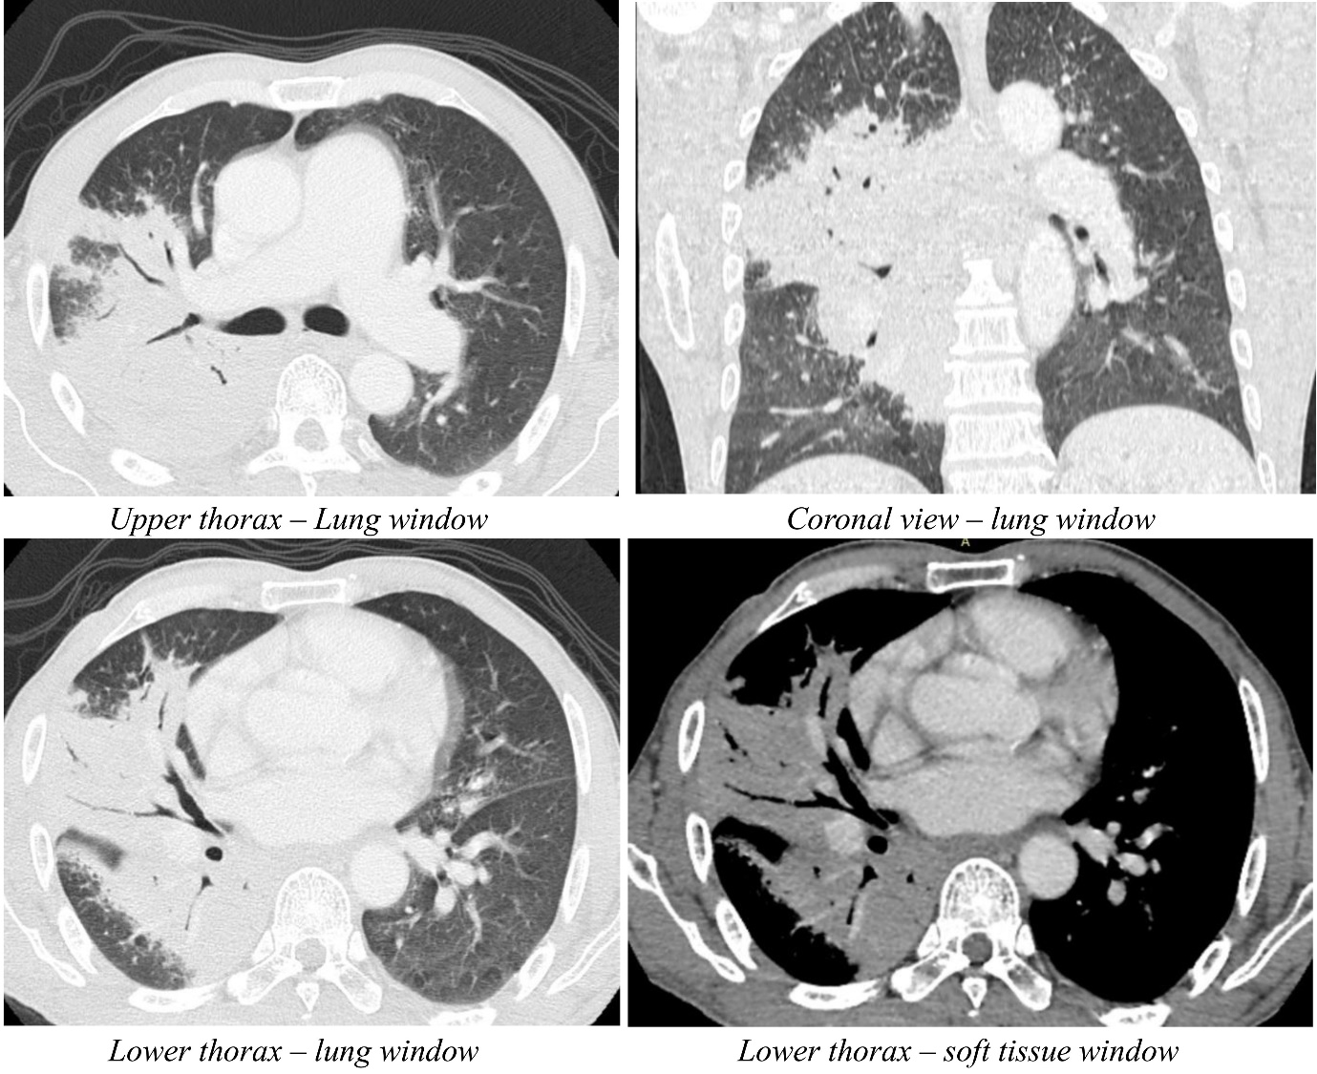

Figure 2: Contrast enhanced CT Thorax shows diffuse homogenous mass-like consolidations in the posterior segment of right upper lobe, lateral segment of right middle lobe, and anterior/medial basal segments of right lower lobe with associated air bronchograms. No endoluminal lesions, pleural effusion or mediastinal lymphadenopathies were detected.

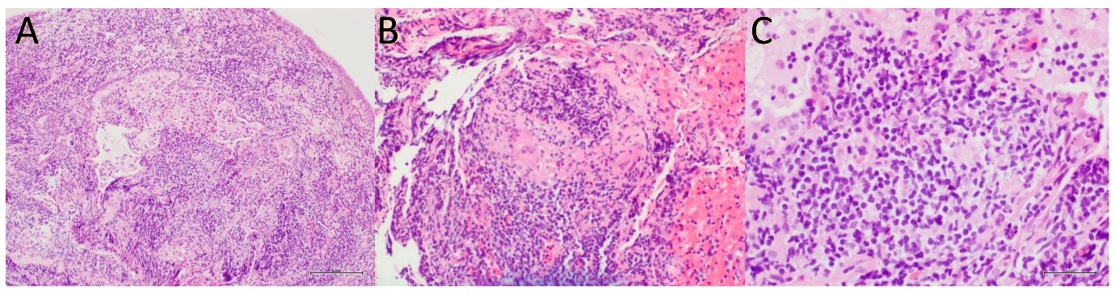

Figure 3A (100× magnification, haematoxylin and eosin stain) displays tissue fragments infiltrated by tumour cells, forming a diffuse infiltrate of small lymphoid cells. Figures 3B and 3C (200× and 400× magnification, haematoxylin and eosin stain) reveal monomorphic cells interspersed with scattered multinucleated giant cells, with mitotic figures being rare.

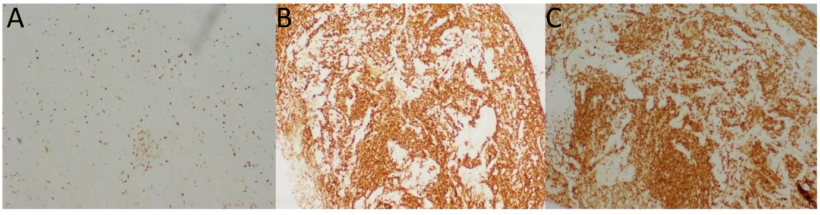

Figure 4A (Ki67, 100× magnification) demonstrates a low proliferative index. Figure 4B (CD20, 100× magnification) confirms CD20 positivity in tumour cells, while Figure 4C (BCL-2, 100× magnification) shows positive immunohistochemical staining for BCL-2. The tumour cells are negative for TTF-1, P40, CD56, CD3, CD5, CD23, BCL-6, Cyclin D1, and CD10.

**REFERENCES**

1. Parissis H. Forty Years Literature Review of Primary Lung Lymphoma. *Journal of Cardiothoracic Surgery* 2011;**6**. doi:10.1186/1749-8090-6-23
2. Cadavid JC, Wani AA. A 68-year-old woman with fever, atelectasis, and nodular endobronchial lesions. *Chest* 2011;**139**:208–11. doi:10.1378/chest.10-1404
3. Kelemen K, Rimsza LM, Craig FE. Primary pulmonary B-cell lymphoma. *Seminars in Diagnostic Pathology* 2020;**37**:259–67. doi:10.1053/j.semdp.2020.04.002
4. Shen H, Zhou Y. Clinical features and surgical treatment of primary pulmonary lymphoma: A retrospective study. *Frontiers in Oncology* 2022;**12**. doi:10.3389/fonc.2022.779395
5. O’Donnell PG, Jackson SA, Tung KT, *et al.* Radiological appearances of lymphomas arising from mucosa-associated lymphoid tissue (MALT) in the lung. *Clinical Radiology* 1998;**53**:258–63. doi:10.1016/s0009-9260(98)80123-2
6. Kurtin PJ, Myers JL, Adlakha H, *et al.* Pathologic and clinical features of primary pulmonary extranodal marginal zone B-cell lymphoma of malt type. *The American Journal of Surgical Pathology* 2001;**25**:997–1008. doi:10.1097/00000478-200108000-00003
7. Conconi A. Clinical activity of Rituximab in extranodal marginal zone B-cell lymphoma of malt type. *Blood* 2003;**102**:2741–5. doi:10.1182/blood-2002-11-3496
8. Stewart AF. Hypercalcemia associated with cancer. *New England Journal of Medicine* 2005;**352**:373–9. doi:10.1056/nejmcp042806
9. Hauswirth AW, Skrabs C, Schutzinger C, *et al.* Autoimmune thrombocytopenia in non-Hodgkin’s lymphomas. *Haematologica* 2008;**93**:447–50. doi:10.3324/haematol.11934