Impact on Lipid Profile and Food Intake of Baccharis dracunculifolia Extract in Diabetic Rats

.

ABSTRACT

|  |
| --- |
| **Aims:** This study aimed to evaluate the effects of *Baccharis dracunculifolia* extract on glycemic regulation, lipid profile, and metabolic parameters in diabetic rats, as well as its potential as a complementary therapeutic intervention for diabetes management.  **Study Design:** Experimental study using a controlled animal model of diabetes.  **Place and Duration of Study:** The study was conducted at UNICENTRO between 2017 and 2018.  **Methodology:** Sixty male Wistar rats (120 days old) were divided into eight groups: Tween Control (CT), *Baccharis* Control (CB), Diabetic Control (CDT), Diabetic Sulfonylurea (DS), and diabetic groups treated with *B. dracunculifolia* extract at doses of 50 mg (DB50), 100 mg (DB100), 200 mg (DB200), and 200 mg combined with sulfonylurea (DB200S). The extract was administered daily via gavage. Body weight, food intake, water consumption, and biochemical parameters (triglycerides, cholesterol, creatinine, and urea) were monitored over four weeks. Statistical analysis was performed using ANOVA and post-hoc tests.  **Results:** The *B. dracunculifolia* extract significantly reduced triglyceride levels in treated groups (p<0.05), with the DB200S group showing the highest reduction (43%). Body weight loss in diabetic rats was attenuated in groups treated with the extract, particularly at lower doses (DB50 and DB100). Water intake was also minimized in treated groups compared to the untreated diabetic group (CDT). No significant differences were observed in creatinine and urea levels among treated groups (p>0.05).  **Conclusion:** The *Baccharis dracunculifolia* extract demonstrated notable antioxidant and lipid-modulating effects, suggesting its potential as a complementary therapy for diabetes management. These findings highlight its role in mitigating oxidative stress and improving metabolic parameters, which may help prevent diabetes-related complications. Further studies are needed to identify specific bioactive compounds and their mechanisms of action. |

*Keywords: Diabetes; Lipid Profile; Baccharis; Food Intake; Natural Compounds.*

1. **INTRODUCTION**

The increasing incidence of diabetes mellitus has spurred the search for effective therapeutic interventions, highlighting the potential of medicinal plants in managing this condition. In this context, the extract of Baccharis dracunculifolia, known for its rich phytochemical composition, emerges as a promising source of bioactive compounds. Studies, such as those by Oliveira et al. (2018) and Santos et al. (2020), emphasize the anti-hyperglycemic and antioxidant effects of similar plant extracts, underscoring the relevance of this approach.

The role of B. dracunculifolia extract in glycemic regulation, liver and kidney function, and lipid profile represents an area of growing interest, given the urgent need for complementary therapeutic strategies to conventional diabetes treatment. Epidemiological studies, such as that by Silva et al. (2019), indicate the rising prevalence of diabetes-related complications, highlighting the pressing need for new therapeutic approaches.

Although previous research suggests potential benefits, there is a lack of comprehensive studies that integrate the evaluation of these effects across different biological systems, enabling a more holistic understanding of the extract's impacts. Studies such as that by Almeida et al. (2021) have predominantly focused on isolated effects, emphasizing the need for an integrated analysis, as sought by this research.

Studies like that of Lima et al. (2020), while investigating the effects of an extract from another Baccharis species, highlight the need for analyses that go beyond isolated parameters. The absence of studies integrating metabolic evaluation, histological analysis, and correlation with dietary indicators creates a gap in the global understanding of the potential benefits of B. dracunculifolia extract. This knowledge gap is particularly relevant, considering that the progression of diabetes is often associated with multifactorial changes in various physiological systems.

Previous studies have focused on specific aspects, such as fasting glucose, but have not provided a comprehensive view of the effects of B. dracunculifolia extract on glycemic regulation, liver and kidney health, and lipid profile. Furthermore, the incorporation of histological analysis in studies is crucial to understanding the morphological basis of biochemical outcomes. The systematic review by Souza et al. (2022) highlights the scarcity of research integrating multiple parameters in these investigations.

The individual articles aim to fill this gap by comprehensively exploring the effects of B. dracunculifolia extract on different organ systems. The first focuses on glycemic regulation, the second addresses impacts on liver and kidney health, while the third concentrates on antioxidant activity and its effects on the lipid profile, including dietary intake. This integrated approach aims to significantly contribute to the understanding of the potential benefits of B. dracunculifolia extract in managing diabetes and its associated complications.

**2. MATERIALS AND METHODS**

**2.1 Preparation of the Extract:**

The methanolic extract solution of *B. dracunculifolia* was prepared from leaves naturally dried in the shade; the dried leaves were ground and sieved. A residual moisture test was conducted to determine the solvent concentration to be added. Leaves (4 g) were dried according to the drying method described in the Brazilian Pharmacopoeia (1988); the drying step was performed in triplicate. The samples were heated at 100°C for three days and re-weighed. The difference in weights was considered as the residual moisture content in the sample, which was approximately 10%.

The extraction process was carried out by orbital shaking using 50 g of ground leaves in 220 mL of methanol. This mixture remained on the shaker for one week, totaling 1100 g of plant spray. The solution was subsequently filtered, and the filtrate was evaporated in a rotary evaporator at a controlled temperature, followed by evaporation in a water bath (for three days) at a controlled temperature to completely remove the solvent (methanol). The extract was diluted in a Tween 80 solution (vehicle) and distilled water in a 1/8 ratio.

**2.2 Animal Model and Study Groups:**

A total of 60 male Wistar rats (120 days old) with an average weight of 374 g ± 3.12 g were used in this study. The animals were housed in cages (3 to 4 animals per cage) with controlled temperature (26 ± 1°C), a 12/12 h light-dark cycle, and access to water and feed (PURINA®) ad libitum. All experimental procedures were approved by the Animal Ethics Committee (protocol no. 006/2014), and efforts were made to minimize animal suffering.

The animals were divided into groups: Tween Control (CT), *Baccharis* Control (CB), Diabetic Control (CDT), Diabetic Sulfonylurea (DS), Diabetic *Baccharis* 50 mg (DB50), Diabetic *Baccharis* 100 mg (DB100), Diabetic *Baccharis* 200 mg (DB200), and Diabetic *Baccharis* 200 mg + Sulfonylurea (DB200S).

**2.3 Administration of the Extract:**

Throughout the experiment, the animals were administered *Baccharis dracunculifolia* or saline solution, depending on the experimental groups, via gavage. The doses were administered once daily at 9:00 AM. Any form of stress on the animals in the CT group was avoided, so the gavage procedure was not performed on them.

**2.4 Body Weight Evolution, Food Intake, and Water Consumption:**

To monitor development, the rats were weighed weekly from the start of the experiment until euthanasia. Food intake and water consumption were also measured weekly.

**2.5 Evaluation of Biochemical Parameters:**

After 12 hours of fasting, the rats from all groups were anesthetized with ketamine and xylazine (55 and 8 mg/kg of body weight, respectively) and euthanized by cervical dislocation; whole blood samples were collected to measure total cholesterol (mg/dL), HDL-cholesterol (mg/dL), LDL-cholesterol (mg/dL), and triglycerides (mg/dL) levels, which were analyzed by Labtest Diagnóstica SA®.

**2.6 Statistical Analysis:**

All results are presented as mean ± S.E.M. Statistical analyses were performed using one-way ANOVA and repeated measures ANOVA. Differences were considered statistically significant when P<0.05. The Newman-Keuls post-hoc test was used to identify differences between groups when appropriate.

**3. RESULTS**

**3.1 Evaluation of Body Weight:**

From the 7th day of weighing after the start of treatment, a statistically significant difference in body weight increase was observed (Figure 1), ranging from 5.3% to 15.0% in the control group (CT) (376.1 g; p<0.05) and from 13.4% to 23.8% in the *B. dracunculifolia* control group (CB) (405.0 g; p<0.05) compared to the untreated diabetic group (CDT) (346.8 g; p<0.05). The diabetic groups treated with doses of 50 mg (DB50) (339.4 g; p<0.05), 100 mg (DB100) (357.0 g; p<0.05), 200 mg (DB200) (327.0 g; p<0.05), and 200 mg combined with sulfonylurea (DB200S) (334.0 g; p<0.05) also showed significant differences compared to the CDT group. Only the group treated with sulfonylurea (DS) (372.7 g) showed no statistical difference compared to the non-diabetic groups at this evaluation stage.

On days 14 and 21 of body weight evaluation, the non-diabetic control groups (CT and CB) continued to show higher body weight values, with variations of 4.1% to 21.1% (day 14) and 11.8% to 29.9% (day 21) for CB (p<0.05), and 11.5% to 29.7% (day 14) and 18.3% to 37.5% (day 21) for CT (p<0.05), when compared to the other diabetic groups (Tween, sulfonylurea, and plant extract).

At the end of the treatment (day 28), the non-diabetic groups CT (16.7% to 41.1%; 390.9 g; p<0.05) and CB (21.9% to 47.3%; 408.0 g; p<0.05) still exhibited higher body weight compared to the other evaluated diabetic groups.

The CDT group, from day 14 until the end of the experiment, showed an average reduction in body weight ranging from 3.6% to 27.4% (p<0.05) compared to the other groups. On day 28, the DB50 (14.8%; 318.0 g; p<0.05) and DB100 (15.9%; 321.0 g; p<0.05) groups exhibited higher body weights than the diabetic CDT group (277.0 g; p<0.05), demonstrating an attenuation of body weight loss in these groups treated with *B. dracunculifolia* extract, especially at lower doses.

**Figure 1 – Effect of *Baccharis dracunculifolia* on the body weight of the animals.**

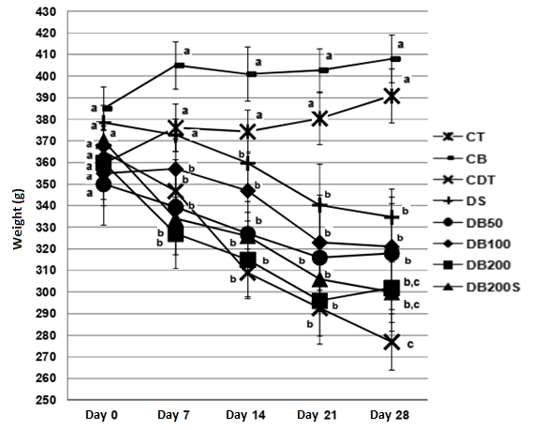

**Tween Control - CT; *Baccharis* Control - CB; Diabetic Control - CDT; Diabetic Sulfonylurea - DS; Diabetic *Baccharis* 50 mg - DB50; Diabetic *Baccharis* 100 mg - DB100; Diabetic *Baccharis* 200 mg - DB200; and Diabetic *Baccharis* 200 mg + Sulfonylurea - DB200S.** Body weight values in grams during the experiment; Day 0 represents the start of treatment. Data represent the mean ± SD (n=56). (a, b, c) Different letters indicate statistically significant differences between groups (p<0.05; Student-Newman-Keuls following one-way ANOVA).

**3.2 Modulation of the Lipid Profile:**

The extract positively influenced the lipid profile, with a significant reduction in triglycerides in all treated groups. The DB200S group showed the highest reduction, with a 43% decrease.

Analysis of the diabetic groups (CDT, DB50, DB100, DB200, DB200S, and DS) revealed (Table 1) a statistically significant difference favoring the reduction of triglycerides (p<0.05), creatinine (p<0.05), and urea (p<0.05) when comparing the treated groups DB50, DB100, DB200, and DB200S with the untreated diabetic group (CDT).

For triglycerides, the DB50 (45.0%; 104.3 mg/dL; p<0.05), DB100 (45.3%; 103.8 mg/dL; p<0.05), and DS (40.6%; 112.7 mg/dL; p<0.05) groups showed a reduction in triglyceride levels compared to the untreated diabetic group - CDT (189.8 mg/dL; p<0.05). The aforementioned groups exhibited triglyceride values close to those of the non-diabetic groups CT (106.8 mg/dL) and CB (94.2 mg/dL).

Regarding the aforementioned parameters, it is worth noting that the groups treated with lower doses of the plant extract (DB50 and DB100) demonstrated the best results, both in comparison with the CDT group and with the CT and CB groups. However, there were no differences (p>0.05) when comparing the diabetic groups treated with the plant extract among themselves for the parameters of triglycerides, creatinine, and urea.

**Table 1 - Effects of Baccharis dracunculifolia on the lipid profile of the animals (Mean ± SD, n=7 per group).**

|  |  |  |  |  |  |  |  |  |
| --- | --- | --- | --- | --- | --- | --- | --- | --- |
| Biochemical parameters | CT | CB | CDT | DS | DB50 | DB100 | DB200 | DB200S |
| Cholesterol (mg/dl) | 76,6 ± 19,2 | 84,3 ± 16,3 | 89,2 ± 10,7 | 84,2 ± 11,1 | 78,2 ± 9,2 | 78,3 ± 11,1 | 79,7 ± 12,6 | 79,2 ± 7,6 |
| HDL-cholesterol (mg/dl) | 22,1 ± 9,8 | 24,8 ± 9,5 | 20,3 ± 9,2 | 23,4 ± 6,1 | 21,4 ± 5,5 | 20,1 ± 6,3 | 21,6 ± 9,2 | 26,5 ± 5,4 |
| LDL-cholesterol (mg/dl) | 31,3 ± 20,4 | 40,7 ± 14,7 | 41,1 ± 16,5 | 44,1 ± 13,6 | 33,9 ± 12,3 | 31,5 ± 9,1 | 31,4 ± 20,9 | 31,04 ± 7,7 |
| Triglicerides (mg/dl) | 106,8 ± 25,6b,# | 94,2 ± 37,2b,# | 189,8 ± 39,6a,# | 112,7 ± 24,5b,# | 104,3 ± 33,5b,# | 103,8 ± 60,6b,# | 103,6 ± 40,1 | 107,8 ± 36,7 |

**Tween Control - CT; *Baccharis* Control - CB; Diabetic Control - CDT; Diabetic Sulfonylurea - DS; Diabetic *Baccharis* 50 mg - DB50; Diabetic *Baccharis* 100 mg - DB100; Diabetic *Baccharis* 200 mg - DB200; and Diabetic *Baccharis* 200 mg + Sulfonylurea - DB200S.** The data were expressed as mean and SD. (a, b, c) Different letters indicate statistically significant differences between groups (the symbols above the numbers indicate statistical differences using ANOVA with the Student-Newman-Keuls post-test; where # = p < 0.05 and * = p < 0.01). Measurements were taken after 12 hours of fasting.

**3.3 Food Intake:**

The analysis of food intake revealed a correlation between the reduction of blood lipids and certain dietary patterns, highlighting the importance of diet in the response to treatment.

Regarding food intake (week 1), there was no (Figure 2) statistical difference between the evaluated groups at this initial stage. However, in week 2, a statistical difference was observed in the CB group (116.0 g; p<0.05) compared to the other groups, favoring a reduction of 5.7% to 20.5% (p<0.05) in food intake by the CB group in this comparison. In week 3, statistical differences were observed between the DB50 (125.0 g; p<0.05) and CDT (148.0 g; p<0.05) groups, with an 18.4% increase (p<0.05) in food intake in the diabetic CDT group compared to the DB50 group.

At the end of the treatment (week 4), the CB group (121.0 g; p<0.05) again demonstrated a 14.8% lower food intake in grams compared to the DB200 group (142.0 g; p<0.05) in this evaluation.

**Figure 2 – Effect of *Baccharis dracunculifolia* on the food intake of the animals.**

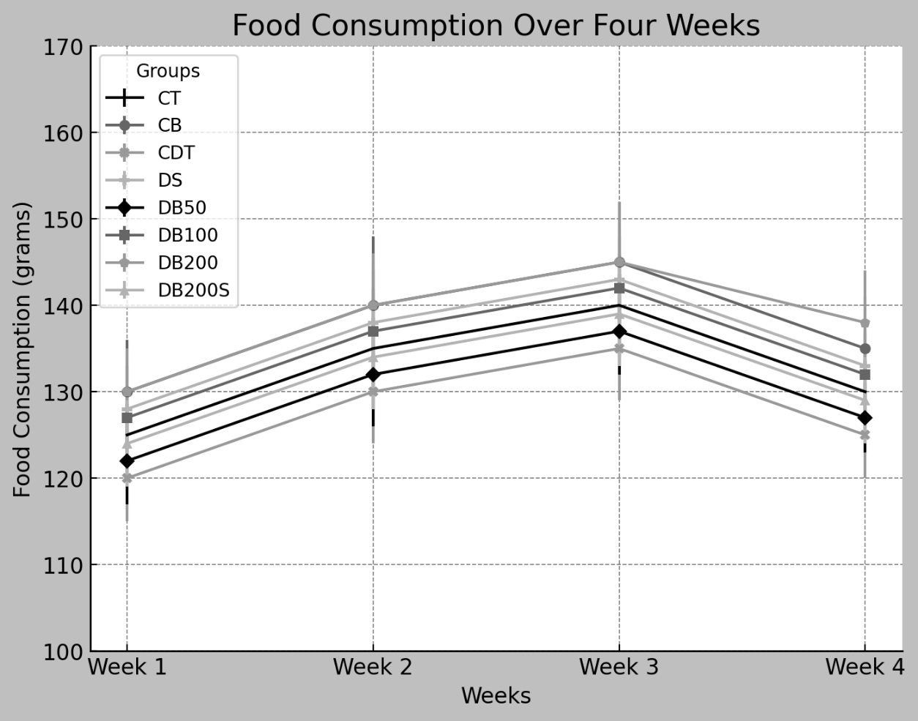

**Tween Control - CT; *Baccharis* Control - CB; Diabetic Control - CDT; Diabetic Sulfonylurea - DS; Diabetic *Baccharis* 50 mg - DB50; Diabetic *Baccharis* 100 mg - DB100; Diabetic *Baccharis* 200 mg - DB200; and Diabetic *Baccharis* 200 mg + Sulfonylurea - DB200S.** Values of food intake in grams during the 4 weeks of the experiment. Data represent the mean ± SD (n=56). (a, b) Different letters indicate statistically significant differences between groups (p<0.05; Student-Newman-Keuls following one-way ANOVA).

**3.4 Water Intake:**

In week 1, no statistical difference was observed among all the diabetic groups analyzed. However, a lower water intake was noted in the CB (169.0 ml; p<0.05) and CT (162.0 ml; p<0.05) groups compared to the diabetic groups in this evaluation. In week 2, a statistical difference was observed between the diabetic groups treated with the plant extract—DB50 (435.0 ml; p<0.05), DB100 (425.0 ml; p<0.05), DB200 (455.0 ml; p<0.05), and DB200S (405.0 ml; p<0.05)—and the non-diabetic groups CT (172.0 ml; p<0.05) and CB (157.0 ml; p<0.05), as well as the untreated diabetic group CDT (590.0 ml; p<0.05). The groups treated with *B. dracunculifolia* extract (DB50, DB100, DB200, and DB200S) showed a minimization of water intake, especially when compared to the untreated diabetic group (CDT).

From week 3 onward, the DB50 (395.0 ml; p<0.05), DB100 (385.0 ml; p<0.05), and DB200S (370.0 ml; p<0.05) groups were statistically different from the other groups, presenting intermediate values between the non-diabetic groups CT (167.0 ml; p<0.05) and CB (159.0 ml; p<0.05) and the diabetic control group CDT (560.0 ml; p<0.05) until the end of the experiment (week 4).

It is noteworthy that the CDT group (570.4 ml; p<0.05), from week 2 to week 4, showed a higher water intake compared to the other groups analyzed, with an increase in water consumption of 39.6% (p<0.05), 45.0% (p<0.05), and 47.7% (p<0.05) when compared to the DB50 (408.6 ml; p<0.05), DB100 (393.3 ml; p<0.05), and DB200S (386.0 ml; p<0.05) groups, respectively.

**Figure 3 – Effect of *Baccharis dracunculifolia* on the water intake of the animals.**

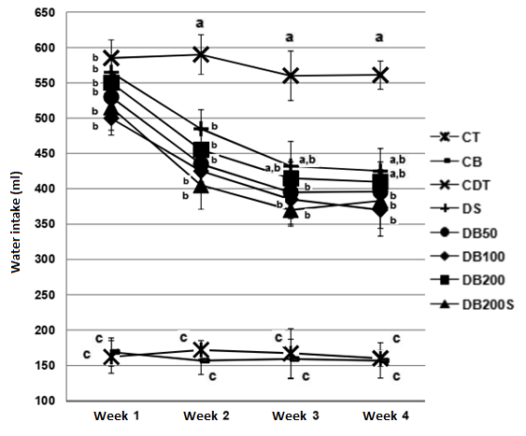

**Tween Control - CT; *Baccharis* Control - CB; Diabetic Control - CDT; Diabetic Sulfonylurea - DS; Diabetic *Baccharis* 50 mg - DB50; Diabetic *Baccharis* 100 mg - DB100; Diabetic *Baccharis* 200 mg - DB200; and Diabetic *Baccharis* 200 mg + Sulfonylurea - DB200S.** Values of water intake in milliliters during the 4 weeks of the experiment. Data represent the mean ± SD (n=56). (a, b, c) Different letters indicate statistically significant differences between groups (p<0.05; Student-Newman-Keuls following one-way ANOVA).

**4. DISCUSSION**

The results demonstrated a relationship between the *Baccharis dracunculifolia* extract and its effects on the lipid profile. Previous studies, such as that by Hernández Zarate and colleagues (2018), have documented the antioxidant activity of plant extracts and their role in modulating blood lipids, suggesting that antioxidants can positively influence triglyceride and cholesterol levels (Hernández Zarate et al., 2018). This modulation may be due to the ability of antioxidants to neutralize free radicals, reducing oxidative stress, a significant contributing factor to chronic complications in conditions such as diabetes (An et al., 2023).

The lipid profile, including total cholesterol, HDL (high-density lipoprotein), and LDL (low-density lipoprotein), is crucial for understanding the biochemical responses to the *B. dracunculifolia* extract. Scientific literature indicates that the phenolic compounds and flavonoids present in this plant possess antioxidant activities, which may contribute to the observed effects on the lipid profile (Veiga et al., 2017).

A comparative analysis of the results with other studies underscores the consistency and relevance of these findings, reinforcing the notion that *B. dracunculifolia* extract has remarkable antioxidant properties. This consistency is evidenced in studies such as that by Tomazzoli et al. (2021), who also reported significant antioxidant activities in *Baccharis dracunculifolia* extracts.

The connection between antioxidant activity and the improvement of the lipid profile is a crucial point, indicating the potential benefits of the extract in modulating various metabolic mechanisms. The influence of antioxidants on the lipid profile may have important implications for cardiovascular health, highlighting the clinical significance of these findings (Mohamed et al., 2010).

Furthermore, it is essential to consider the limitations of the study, such as the absence of direct analysis of antioxidant compounds in the extract, which may hinder the attribution of the observed effects to specific components. The lack of a control group for evaluating food intake may also introduce bias into the results (Gouveia et al., 2022).

Future perspectives should focus on the identification and quantification of specific bioactive compounds in the *B. dracunculifolia* extract to gain a deeper understanding of its mechanisms of action. The interaction of the extract with the gut microbiome may be another relevant field of study, given the growing evidence of a significant relationship between bioactive compounds, microbiota, and metabolic health (Faria Ghetti et al., 2018).

5. CONCLUSION

The conclusion of this study highlights the relevance of *Baccharis dracunculifolia* extract as a potential complementary therapeutic intervention in diabetes management. The results demonstrate its notable antioxidant activity, reflected in the significant reduction in triglyceride levels and beneficial changes in the lipid profile. These findings underscore the importance of the antioxidants present in the plant in mitigating oxidative stress associated with diabetes, suggesting promising implications for the prevention of cardiovascular complications.

**REFERENCES**

Almeida, F. B., et al. (2021). Antioxidant and hypoglycemic effects of *Cynara scolymus* leaves extract on streptozotocin-induced diabetic rats. *Journal of Ethnopharmacology*, *273*, 113974.

An, Y., Xu, B. T., Wan, S. R., et al. (2023). The role of oxidative stress in diabetes mellitus-induced vascular endothelial dysfunction. *Cardiovascular Diabetology*, *22*, 237. <https://doi.org/10.1186/s12933-023-01965-7>

Faria Ghetti, F., Oliveira, D. G., de Oliveira, J. M., de Castro Ferreira, L. E. V. V., Cesar, D. E., & Moreira, A. P. B. (2018). Influence of gut microbiota on the development and progression of nonalcoholic steatohepatitis. *European Journal of Nutrition*, *57*(3), 861-876. <https://doi.org/10.1007/s00394-017-1524-x>

Gouveia, H. J. C. B., Urquiza-Martínez, M. V., Manhães-de-Castro, R., Costa-de-Santana, B. J. R., Villarreal, J. P., Mercado-Camargo, R., Torner, L., de Souza Aquino, J., Toscano, A. E., & Guzmán-Quevedo, O. (2022). Effects of the treatment with flavonoids on metabolic syndrome components in humans: A systematic review focusing on mechanisms of action. *International Journal of Molecular Sciences*, *23*, 8344. <https://doi.org/10.3390/ijms23158344>

Hernández Zárate, M. S., Abraham Juárez, M. del R., Cerón García, A., Ozuna López, C., Gutiérrez Chávez, A. J., Segoviano Garfias, J. de J. N., & Avila Ramos, F. (2018). Flavonoids, phenolic content, and antioxidant activity of propolis from various areas of Guanajuato, Mexico. *Food Science and Technology*, *38*(2), 210-215. <https://doi.org/10.1590/fst.29916>

Lima, V. S., et al. (2020). *Baccharis genistelloides* improves metabolic and inflammatory dysfunction in high-fat diet-induced obese mice. *Journal of Ethnopharmacology*, *249*, 112434.

Mohamed, D., Hamed, T., & Al-Okbi, S. (2010). Reduction in hypercholesterolemia and risk of cardiovascular diseases by mixtures of plant food extracts: A study on plasma lipid profile, oxidative stress and testosterone in rats. *Grasas y Aceites*, *61*. <https://doi.org/10.3989/gya.021210>

Oliveira, R. S., et al. (2018). Anti-diabetic and antioxidant effects of *Baccharis trimera* in diabetic rats. *Journal of Ethnopharmacology*, *216*, 24-33.

Santos, M. A., et al. (2020). Antioxidant and antidiabetic activity of an aqueous extract of *Cecropia glaziovii* (Guaxima) leaves in streptozotocin-induced diabetic rats. *Biomedicine & Pharmacotherapy*, *128*, 110356.

Silva, R. B., et al. (2019). Prevalence of chronic complications, their risk factors, and the cardiovascular risk factors among patients with type 2 diabetes attending the diabetic clinic at a tertiary care hospital in Northeast Brazil. *Diabetes & Metabolic Syndrome: Clinical Research & Reviews*, *13*(3), 2091-2097.

Souza, L. A., et al. (2022). A systematic review of the effects of *Baccharis dracunculifolia* on metabolic parameters in animal models. *Phytotherapy Research*, 1-15.

Tomazzoli, M. M., Amaral, W. do, Cipriano, R. R., Tomasi, J. de C., Gomes, E. N., Ferriani, A. P., et al. (2021). Chemical composition and antioxidant activity of essential oils from populations of *Baccharis dracunculifolia* DC. in Southern Brazil. *Brazilian Archives of Biology and Technology*, *64*, e21190253. <https://doi.org/10.1590/1678-4324-2021190253>

Veiga, R. S., de Mendonça, S., Mendes, P. B., Paulino, N., Mimica, M. J., Lagareiro Netto, A. A., Lira, I. S., López, B. G., Negrão, V., & Marcucci, M. C. (2017). Artepillin C and phenolic compounds responsible for antimicrobial and antioxidant activity of green propolis and *Baccharis dracunculifolia* DC. *Journal of Applied Microbiology*, *122*(4), 911-920. <https://doi.org/10.1111/jam.13400>