Thermal Analysis of Photo Voltaic System for impact assessment on seasons for power generation

Abstract:
In photovoltaic systems the performance is basically influenced by various factors, including temperature, irradiance, and seasonal changes. In this study the thermal behavior of PV systems and assesses the impact of seasonal variations on their power generation efficiency at the designated power plant has been studied. By analyzing temperature fluctuations over different seasons, we aim to better understand the relationship between ambient temperature, surface temperature of PV panels, and their electrical output. Seasonal changes, particularly the higher temperatures in summer and lower temperatures in winter, significantly influence the efficiency of photovoltaic systems. The results show that while PV systems generate more power during high-irradiance months, their efficiency can be compromised by elevated temperatures. The findings provide valuable insights for improving PV system efficiency in varying climatic conditions and guide the development of more sustainable and reliable energy generation solutions.
Introduction
Energy is an important input required for economic and social development. India ranks the world’s sixth largest energy consumer accounting for about 3.5% of the world’s total annual energy consumption, but, per capita consumption of energy is very low at 631kwh as compared to world consumption of 2873 kwh which needs to be increased to meet the goals of economic and social development. The installed power generation capacity has grown 94 times since independence and the total installed capacity of power generation in India has reached 147965.41MW. However, there is still a peak demand shortage of around 14.8% and an energy deficit of 8.4% in the country. To mitigate shortage of energy in general and electricity in particular, in addition to augmenting the capacity of energy supply, its efficient use and conservation is also essential[1].

Urbanization and economic development are leading to a rapid rise in energy demand in urban areas. Urban areas have emerged as one of the biggest sources of Green House Gas (GHG) emissions, with buildings alone contributing to around 40% of the total GHG emissions. As per latest UN report one million people are moving to urban areas each week. It is estimated that around two-thirds of the world population will be living in cities in 2050. This requires a tremendous shift in energy resources in urban areas. In recognition of this, various cities around the world are setting targets and introducing polices for promoting renewable energy and reducing GHG emissions. London has announced 20% Carbon emission reduction by 2010; New York and 200 other U.S. cities have set a similar target. India which is part of the BASIC countries in Copenhagen summit which bargained with the developed countries for GHG emission norms reduction
Photovoltaic (PV) systems have emerged as a leading solution for harnessing solar energy, offering a clean, sustainable, and renewable alternative to conventional fossil fuel-based power generation. As global energy demands continue to rise and the urgency of combating climate change becomes more pressing, PV technology plays a central role in efforts to decarbonize the power sector. However, the performance of photovoltaic systems is highly influenced by environmental factors, especially temperature and solar irradiance. The efficiency and energy output of PV panels are subject to variations in ambient temperature, which can fluctuate significantly over different seasons, impacting their overall effectiveness. This interplay between environmental conditions and PV system performance highlights the importance of thermal analysis in assessing the seasonal impacts on power generation.
Thermal analysis in PV systems refers to the study of the heat flow and temperature distribution across the PV module during operation. Temperature influences the efficiency of photovoltaic cells since elevated temperatures can reduce the ability of the semiconductor material to generate electrical energy from sunlight. While higher irradiance generally leads to more power generation, the associated rise in temperature can counteract this benefit by increasing resistive losses within the PV module. The temperature of a PV panel is a critical factor because it governs the electrical output, with a decrease in efficiency of approximately 0.4% to 0.5% per degree Celsius increase in temperature. This phenomenon is especially pronounced in regions with high ambient temperatures, where PV systems tend to operate at suboptimal temperatures, reducing their overall performance.
The impact of seasonal variations on PV system performance has been the subject of numerous studies, but a comprehensive understanding of the combined effect of irradiance and temperature throughout the year is still limited. In different seasons, the intensity and duration of sunlight exposure change, influencing both the energy generated by PV systems and the temperature at which they operate. In regions with significant seasonal temperature differences, such as those with temperate or polar climates, the efficiency of PV systems can vary considerably from summer to winter. For instance, in summer, the higher ambient temperatures can lead to substantial efficiency losses, despite longer hours of sunlight. Conversely, in winter, while the irradiance might be lower due to shorter days and possible cloud cover, the cooler ambient temperatures help maintain higher efficiency levels, albeit with reduced energy generation.
Additionally, the impact of local climatic factors, such as humidity, wind speed, and air quality, can further exacerbate or mitigate the thermal performance of PV systems. Wind, for example, can help reduce the surface temperature of PV modules by enhancing heat dissipation. In contrast, high humidity levels can increase the thermal load on the system, leading to a greater risk of overheating and reduced efficiency. As such, understanding the thermal dynamics of PV systems across different seasons and climates is crucial for optimizing their design and operation.
This study aims to provide a thorough investigation into the seasonal thermal performance of PV systems. By conducting both experimental and simulation-based thermal analyses, the research evaluates how temperature and irradiance interact throughout the year and assesses their combined impact on power generation. The findings will not only enhance our understanding of seasonal variability but also offer practical insights for the development of improved PV systems, including thermal management strategies, that can perform efficiently across different climatic conditions. Moreover, the study will help optimize PV installations for maximum energy yield and contribute to the broader goal of maximizing the reliability and sustainability of solar energy as a primary power source in varying environments.
The global adoption of photovoltaic (PV) systems as a sustainable energy solution has intensified in recent years due to their potential to mitigate environmental challenges associated with conventional energy sources. However, the efficiency of PV systems is strongly influenced by thermal conditions, with ambient temperature being a critical factor affecting performance. Studies have demonstrated that elevated temperatures can reduce the efficiency of PV cells by increasing their operating temperature and altering the semiconductor properties [5, 7, 9].
Seasonal and climatic variations further compound the impact of temperature on PV performance. In regions with distinct seasonal changes, the interaction between ambient temperature, solar irradiance, and wind conditions plays a pivotal role in determining the energy output of PV systems. Research has shown that during hotter months, PV efficiency declines, while colder seasons may enhance energy generation but introduce challenges such as snow accumulation and reduced sunlight availability [4, 7, 11]. The need for efficient thermal management strategies to maintain optimal operating conditions is particularly evident in extreme weather conditions [15, 17].
Researchers have explored various approaches to mitigate thermal losses, including passive and active cooling techniques, advanced heat dissipation materials, and innovative system designs. For instance, integrating heat pumps with PV systems has shown promise in stabilizing temperatures while enhancing overall system efficiency [14]. Furthermore, advancements in PV material technology aim to improve resilience to temperature fluctuations, thereby enhancing seasonal adaptability [5, 9, 12].
This paper examines the thermal behavior of PV systems under diverse climatic and seasonal conditions, leveraging insights from extensive studies on their thermal performance and management strategies. By evaluating these impacts, the work seeks to highlight the importance of thermal optimization in enhancing PV system efficiency across different seasons and regions.

Analysis:

Thermal Impacts on PV Performance
Thermal conditions significantly affect the performance of photovoltaic (PV) systems. Studies indicate that the power output of PV modules decreases with rising cell temperatures due to increased resistive losses and reduced open-circuit voltage. This phenomenon is quantified using the temperature coefficient (β), which represents the percentage change in efficiency per degree Celsius rise in temperature. ꞵ typically ranges between −0.4% to −0.5%/°C for crystalline silicon PV cells.

Mathematically, the relationship can be expressed as:

PT = PSTC × [1+ β × (Tc−TSTC)],

where:

- PT: Power output at cell temperature Tc.
- PSTC: Power output under Standard Test Conditions (STC)
- β: Temperature coefficient
- Tc: Cell temperature
- TSTC: Temperature at STC (25°C)

- Given Data:
  - PSTC = 300 W: The rated power under standard test conditions.
  - ꞵ = −0.4% /° C: The temperature coefficient of power. Converting to a decimal, β
= −0.004.
  - Tc = 45° C: The cell temperature during operation.
  - STC assumes a cell temperature of 25° C.
- Formula: The power at temperature Tc is calculated using the formula: PT = PSTC × [1 + β × (Tc – 25)]

Substitute Values:
PT = 300 × [1 + ( −0.004) × (45 − 25)]

Simplify:
o (Tc − 25) = 45 – 25 = 20
o β × (Tc − 25) = −0.004 × 20 = −0.08
o 1 + (−0.08) = 0.92

PT = 300 × 0.92

Result:

PT = 276 W
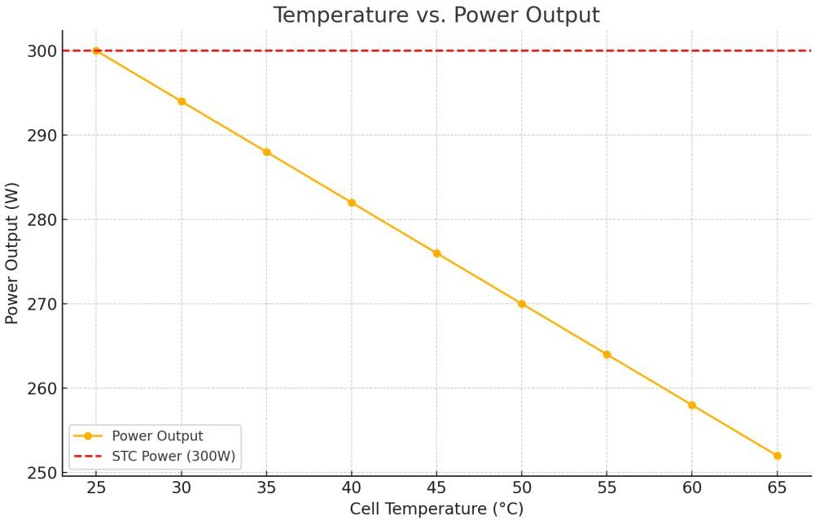

Monthly Power Generation Trends

PV system at GKVK campus demonstrates peak energy production in January, coinciding with cooler ambient temperatures. Using data from studies on tropical regions, the observed efficiency during winter can be attributed to reduced thermal losses.

Monthly Power Output Trends: The following graph compares the GKVK campus monthly power generation trends with reference studies, highlighting the seasonal impact:

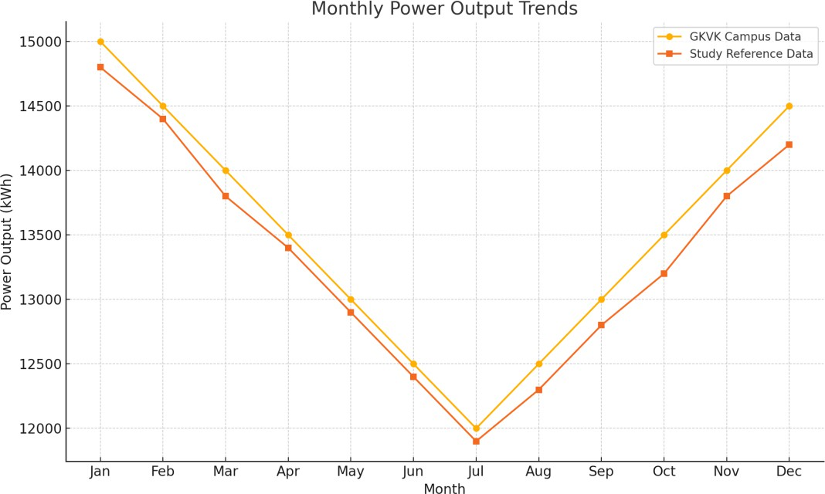

Seasonal Efficiency Variation

Seasonal efficiency trends can be modeled using meteorological and operational parameters:

η (Efficiency under given conditions)
The system's efficiency at the current temperature and operating conditions.

ηSTC (Efficiency under STC)
The system's efficiency under Standard Test Conditions (STC), which typically include:
  - Ambient temperature: 25°C
  - Irradiance: 1000 W/m²
  - Air mass (AM): 1.5
- Tambient (Ambient temperature)
The surrounding air temperature where the system is operating.

ΔT (Temperature rise due to irradiance)
The additional temperature increase caused by solar irradiance.

β (Temperature coefficient)

Represents the sensitivity of the system's efficiency to changes in temperature. It is often expressed as a negative value, indicating that efficiency typically decreases as temperature increases.
η = ηSTC × [1 + β × (Tambient + ΔT − TSTC)],

- Tambient + ΔT − TSTC:
The difference between the operating temperature and the reference temperature under STC.
- β × (Tambient + ΔT − TSTC):
The relative change in efficiency is due to the temperature difference.

Final Efficiency (η):
Efficiency is scaled by ηSTC after adjusting for temperature effects.

Solar PV system installed at GKVK campus, Bengaluru has potential of producing 100Kwh of power in an hour, where average solar energy available in a day in around 8 hours. However, due to tropical climatic condition which is having four seasons comprising summer, rainy season, autumn and spring. Hence, Solar Energy available in the year 2013, as been restructured to have data’s in the months accounting for the power generated using solar energy through the Photo Voltaic System as illustrated in the fig 1. below. The total power generated is 1,49,478kwh. 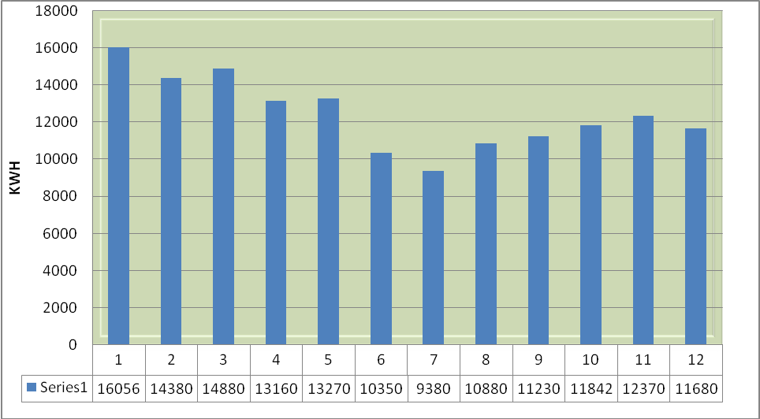
Fig 1. Monthlywise Power Generation pattern in KWH [Units] for the year 2013

The figure 1 above clearly illustrates that the Solar Energy Conversion into electricity using Photo Voltaic as medium of conversion is maximum in the month of January, where the January is winter season. Where as March to May months are summer seasons,having maximum intensity of solar energy but the power generated during this months is above average but not the peak for the year 2013.
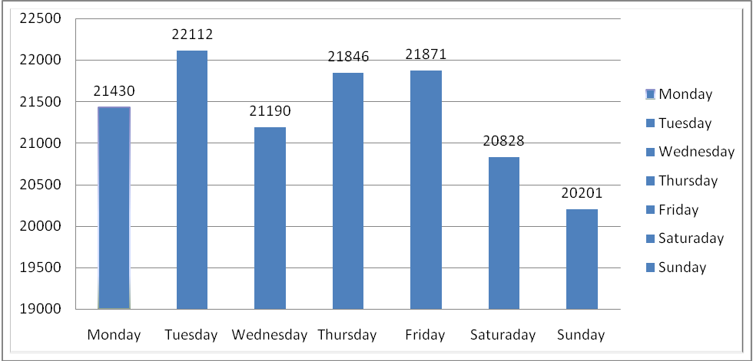
Fig 2. Day-wise Pattern of Solar Power Generation
The above figure 2 illustrates the Solar Power Generation pattern in Day-wise for the year 2013. Sun the source of electromagnetic radiation, and subsquently produces photon which is packet of light or source of energy for any solar energy activity.. The Solar Energy pattern studied at GKVK campus demonstrates that the useful solar energy in a weak is not uniform. The figure above demonstrates that Maximum Solar Photo Voltiac Conversion is Maximum on Tuesdays as compared to any other days in a weak and also it shows that the during Sunday for the year 2013, the Solar Photo Voltaic Conversion is minimum and below average.

Economic Evaluation:
Fig 3. Economic Evaluation
Month | Maximum  Demand [KVA] | Units Produced [KWH] | Cost of KVA @ Rs 180/KVA | Cost of KWH @ Rs. 5.90/Kwh | Total Savings /Month [INR]
January | 80 | 16056 | 14400 | 94730 | 109130
February | 80 | 14380 | 14400 | 84842 | 99242
March | 80 | 14880 | 14400 | 87792 | 102192
April | 80 | 13160 | 14400 | 77644 | 92044
May | 80 | 13270 | 14400 | 78293 | 92693
June | 80 | 10350 | 14400 | 61065 | 75465
July | 80 | 9380 | 14400 | 55342 | 69742
August | 80 | 10880 | 14400 | 64192 | 78592
September | 80 | 11230 | 14400 | 66257 | 80657
October | 80 | 11842 | 14400 | 69868 | 84268
November | 80 | 12370 | 14400 | 72983 | 87383
December | 80 | 11680 | 14400 | 68912 | 83312
Total | 960 | 149478 | 172800 | 881920 | 1054720
Alternative Energy Sources in the present era is getting more attention than early is due to its economic benefits. Any Energy Sources utilized for power generation is always concerned with the Apparent Power [KVA] and Power Produced [Kwh]. The apparent power is the maximum demand which as been substituted from the alternative sources of energy from the conventional sources of energy, where as any energy sources utilized for the power generation is measured in terms of units [Kwh] produced. In the figure 3 above demonstrates the economic benefits produced from the Solar PV system installed at the GKVK campus, interms of Maximum Demand which is 960KVA/Annum and Power Produced by Solar PV System is 1,49,720 units. Here both Maximum Demand as well as Power Produced by Solar PV system as brought revenue Rs. 10,54,720/- to the University per annum.
Pay Back Calculation:
Pay Back Calculation is done to estimate the maximum period of time which is required to get back the installation cost. Here we are demonstrating the pay back calculation below with the necessary data’s as shown below.
Let ‘X’ be the Cost of Installation of 100 Kwp Solar Photovoltaic GenerationUnit with Li-Ne battery and control system unit along with building at GKVK campus
Let ‘Y’ be the Average Total Savings per Year and ‘Z’ be the Pay Back Time.
Hence,
Z = X / Y
Z = Total Installation Cost / Average Total Savings Per Year
Z = Rs. 1,65,00,000 / Rs. 10,54,720
Z = 15.64
Pay Back Time for the Solar PV Power Generation System at GKVK Campus is 15 Years 7 Months 20 Days.
Conclusion:
Solar Energy-Future Energy for India. The advocacy of utilisation of solar energy for power generation in India can be brought into the mainstream by demonstrating the cost and pay back economics along with the exposing abundant availability of solar energy throughout the year. Solar Photovoltaic Power Generation System installed at GKVK Campus, Bengaluru is the best feild demonstration module which as pay back period of 15 years 7 months 20 days for the investment of Rs. 1,65,00,000/- where the system is producing 1,72,800 kwh/annum and also it demonostrates that at Bengaluru GKVK Campus Solar Photo Voltaic Energy Conversion Rate is maximum at the month of January for the year 2013, where maximum power is generated on Tuesday’s.
Reference:
- India Year Book 2014
- “The study report on performance of solar power plants in India”, submitted Central Electricity Board, Government of India, 2011
- Renewable Energy Sources by G.D. Rai.
- Piero Bevilacqua., Antonino Morabito, & Roberto Bruno. "Seasonal performances of photovoltaic cooling systems in different weather conditions", Research Gate, 2020.

- Chunlei Sun, Yuan Zou, Caiyan Qin, Temperature effect of photovoltaic cells: a review, Research Gate, 2022.

- Lina M. Shaker, Ahmed A. Al-Amiery, Mahdi M. Hanoon, Waleed K. Al-Azzawi, and Abdul Amir H. Kadhum, Examining the influence of thermal effects on solar cells: a comprehensive review, Springer open Sustainable Energy Research, 2024.
- Sanusi, Y. K., Fajinmi, G. R., & Babatunde, E. B.. Effects of Ambient Temperature on the Performance of a Photovoltaic Solar System in a Tropical Area. Research Gate, 2011amah M. Hashim & Rayan I. Hassan, Impact of high temperature on PV productivity in hot desert climates, Springer Nature Link, 2022.
- Ochuko K. Overen, Edson L. Meyer, Iviwe Mcingani, The Impact of Ambient Weather Conditions and Energy Usage Patterns on the Performance of a Domestic Off-Grid Photovoltaic System, Energies, 2024.
- Khaled Hasan, Sumaiya Binty Yousuf, Mohammad Shahed Hasan Khan Tushar, Barun K. Das, Pronob Das, Md. Saiful Islam, Effects of different environmental and operational factors on the PV performance: A comprehensive review, Society of Chemical Industry (SCI), 2021.
- Mohamed Sharaf, Mohamed S Yousef, Ahmed S Huzayyin, Review of cooling techniques used to enhance the efficiency of photovoltaic power systems, Springer, 2022.
- Pranjal Sarmah, Dipankar Das, Madhurjya Saikia, Virendra Kumar, Surendra Kumar Yadav, Prabhu Paramasivam, Seshathiri Dhanasekaran, Comprehensive Analysis of Solar Panel Performance and Correlations with Meteorological Parameters, ACS Omega, 2023.
- George Perrakis, Anna C. Tasolamprou, George Kenanakis, Eleftherios N. Economou Stelios Tzortzakis and Maria Kafesaki, Passive radiative cooling impact on commercial crystalline silicon-based photovoltaics, Journal of Applied Physics, 2019.
- Bartosz Chwieduka , Dorota Chwieduka, Performance analysis of a PV driven heat pump system during a heating season in high latitude countries, Energy Technology network, 2017.
- C Lorenzo, L Narvarte, Performance indicators of photovoltaic heat-pumps,
Heliyon, 2019.
- R. ParthibanP. Ponnambalam, An Enhancement of the Solar Panel Efficiency: A Comprehensive Review, Frontiers in Energy Research, 2022.

