Impact of Precursor Molar Concentration on the Structural and Optical Properties of ZnO Thin Films Synthesized by Ultrasonic Spray Pyrolysis

.

ABSTRACT

|  |
| --- |
| This study investigates the synthesis and characterization of zinc oxide (ZnO) thin films deposited on silicon substrates using the ultrasonic spray pyrolysis (USP) method at varying precursor molar concentrations (0.3 M, 0.4 M, and 0.5 M) of zinc acetate dihydrate (Zn(C₂H₃O₂)₂·2H₂O). The structural, morphological, and optical properties of the films were analyzed through X-ray diffraction (XRD), scanning electron microscopy (SEM), and photoluminescence (PL) measurements. XRD results showed an improvement in crystallinity with increased precursor concentration, with the highest intensity and sharpest peaks observed in the 0.5 M sample, indicating enhanced film quality. UV-Vis measurements showed a distinct absorption edge in the UV region, characteristic of ZnO’s wide band gap. PL spectra exhibited strong near-band-edge emissions, along with defect-related emissions linked to oxygen vacancies and zinc interstitials. Higher molar concentrations correlated with reduced defect luminescence, suggesting fewer vacancies and other defects, thus improving the overall optical performance of the ZnO films. These results demonstrate that precursor molar concentration plays a critical role in determining the structural and optical quality of ZnO thin films, supporting their potential for optoelectronic applications. |

***Keywords:*** *ZnO thin films, Ultrasonic spray pyrolysis (USP), Free electron-acceptor recombination, Defect photoluminescence, Zinc vacancies, Oxygen vacancies, Precursor molar ratio*

1. INTRODUCTION

Zinc oxide (ZnO) is a wide-bandgap semiconductor with a bandgap of approximately 3.37 eV at room temperature, making it an attractive material for applications in optoelectronic devices such as ultraviolet (UV) photodetectors, light-emitting diodes, and transparent conductive oxides [1, 2]. Due to its high exciton binding energy of around 60 meV, ZnO is capable of strong excitonic emissions even at room temperature, which enhances its utility in light-emitting applications [3, 4].

Several techniques, including sol-gel, chemical vapor deposition, and spray pyrolysis, have been developed to synthesize ZnO thin films with varying morphological and structural properties [5, 6]. Among these, the ultrasonic spray pyrolysis (USP) method has garnered attention due to its simplicity, cost-effectiveness, and capability for large-scale deposition with controlled film thickness and composition [7]. This method facilitates the fine control of precursor concentrations, allowing for adjustments that can significantly impact the quality of ZnO films in terms of crystal structure, defect density, and optical characteristics [8].

Defects in ZnO, such as oxygen vacancies (VO) and zinc interstitials (ZnI), are known to influence its optical and electronic properties [9]. These defects create localized states within the bandgap, leading to defect-related emissions in the visible range and affecting overall film quality. As shown in prior studies, increasing precursor concentration during deposition can enhance crystal quality by reducing defect densities, thus improving photoluminescent performance [10, 11].

This study aims to explore how varying precursor molar concentrations impact the structural and optical properties of ZnO thin films deposited using USP. By examining changes in crystallinity, morphology, and photoluminescence behavior across different molar concentrations, we provide insights into optimizing ZnO thin films for potential applications in optoelectronics.

2. material and methods

**2.1. Substrate Preparation**

Zinc oxide (ZnO) thin films were deposited on Si (100) substrates using the ultrasonic spray pyrolysis (USP) method. Prior to deposition, the silicon substrates were thoroughly cleaned to ensure the removal of impurities and to improve film adhesion. The cleaning process involved sequential immersion of the substrates in three solutions for 10 minutes each: hydrofluoric acid (HF), acetone, and ethanol. Hydrofluoric acid was used to remove the native oxide layer from the silicon surface, while acetone and ethanol were employed to eliminate organic residues. After the chemical cleaning steps, the substrates were rinsed with deionized (D.I.) water to remove any remaining impurities and organic solvents. This cleaning process is critical in promoting uniform ZnO thin film growth and ensuring good adhesion to the substrate.

**2.2. Solution Preparation**

Zinc acetate dihydrate (Zn(C₂H₃O₂)₂·2H₂O) was used as the zinc precursor for the deposition process. Three different molar concentrations of zinc acetate dihydrate were prepared: 0.3 M, 0.4 M, and 0.5 M. Each solution was prepared by dissolving the appropriate amount of zinc acetate in deionized water, ensuring complete dissolution to create a homogenous solution. These varying molar ratios were used to study the effect of precursor concentration on the structural and morphological properties of the ZnO thin films.

**2.3. Deposition Process**

The deposition of ZnO thin films was carried out using an ultrasonic nebulizer operating at a frequency of 1.7 MHz, which atomized the precursor solution into fine droplets. These droplets were carried by a stream of oxygen gas at a flow rate of 500 sccm (standard cubic centimeters per minute) into a reaction chamber. Oxygen was chosen as the carrier gas due to its role in facilitating the oxidation of zinc acetate during the pyrolysis process, leading to the formation of ZnO.

The silicon substrates were placed on a heated substrate holder, with the temperature maintained at 450 °C during the deposition process. This temperature was chosen to promote the decomposition of the zinc acetate precursor and the subsequent formation of ZnO thin films. The thickness of the deposited films was measured to be approximately 100 nm for all samples.

**2.4. Post-Deposition Annealing**

After the deposition process, the ZnO thin films were subjected to an annealing treatment to improve their crystallinity and eliminate any residual organic materials from the precursor. The annealing was performed in air at 550 °C for 15 minutes.

**2.5. Characterization Techniques**

The morphology and structure of the grown ZnO thin films were analyzed using a scanning electron microscope (SEM) to observe surface morphology, film uniformity, and grain size. Structural analysis was carried out using a Shimadzu X-ray diffractometer (XRD) with CuKα radiation. XRD measurements were conducted over a 2θ range from 30° to 45° to identify the crystallographic phases and determine the film orientation.

Optical reflectance and Photoluminescence: The optical properties of the ZnO thin films were measured using a UV/VIS spectrometer (MDR 12) in the wavelength range of 350 nm to 700 nm. The photoluminescence (PL) spectra were measured at room temperature to evaluate the optical emission characteristics.

3. results and discussion

3.1. sEm images

The top-view SEM image shows that the ZnO film has a uniform, tightly packed grain structure. The grains are small and mostly hexagonal in shape, which is typical for ZnO. The grains are evenly distributed across the surface, and no visible cracks or large defects are present in Figure 1a. The uniform grain distribution suggests that the ultrasonic spray pyrolysis method effectively deposited the ZnO film with a homogeneous surface morphology. From Fig. 1b the thickness of the sample was around 100 nm.

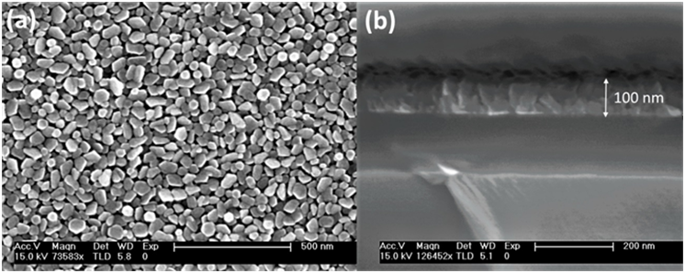

**Fig. 1. SEM images of the ZnO thin film for 0.5 molar ratios used for growth: (a) top view and (b) cross-sectional view, respectively.**

**3.2. Optical properties**

The ZnO thin films were grown on a Si substrate, and as a result, the optical properties were analyzed using the reflection spectrum rather than transmission. The optical band gap was determined using the Kubelka-Munk function: $F\left(R\right)=\frac{{(1-R)}^{2}}{R}$ where F(R) represents the diffuse reflectance. This function is proportional to the absorption coefficient and is commonly used to estimate the band gap in highly scattering samples. From the Tauc plot, the 0.5 M sample exhibits a peak at 3.21 eV, while the extrapolated optical band gap (Eg) is 3.277 eV (in Fig. 2b). The 60 meV difference between these values corresponds well with the free exciton binding energy in ZnO, suggesting that the observed feature is due to free exciton emission. This peak indicates enhanced excitonic effects, likely due to improved crystallinity and reduced defect density. In contrast, the 0.3 M sample lacks this excitonic peak, and the extrapolated band gap is 3.26 eV(in Fig.2a). Moreover, as seen in the inset reflection spectrum, defect-related absorption is evident in the 0.3 M sample, suggesting a higher density of defects.



**Fig. 2. Tauc plots of ZnO thin films grown at different precursor concentrations: (a) 0.3 M and (b) 0.5 M. The insets show the corresponding F(R) spectra.**

The photoluminescence (PL) measurements for ZnO thin films provide valuable insights into their optical properties, particularly their ability to emit light efficiently even at room temperature. ZnO exhibits strong near-band-edge emissions due to excitonic recombination, along with defect-related emissions, which are typically associated with oxygen vacancies or zinc interstitials. These defect emissions can influence the optical performance and provide information about the film’s crystallinity and quality. In Figure 3, the PL measurement results are presented for (a1) 0.3 M, (a2) 0.4 M, and (a3) 0.5 M molar ratios of ZnO thin films, respectively. In Figure 3a, the excitonic peaks for all ZnO thin film samples appear at the same position, around 379 nm. However, the peaks become sharper as the molar ratio increases, indicating improved crystal quality and reduced defect density with higher precursor concentrations. Meanwhile, noticeable defect-related luminescence was observed in all samples. The intensity of the defect emission decreases as the molar concentration increases. This suggests that higher concentrations of the precursor lead to fewer vacancies and other defects, improving the overall optical quality of the ZnO thin films [12, 13].

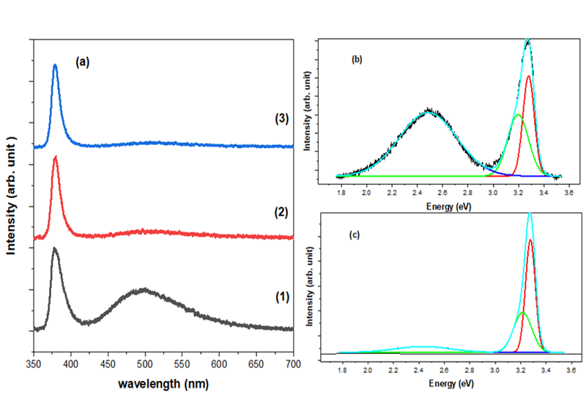

**Fig. 3. (a) Photoluminescence (PL) spectra of ZnO thin films for different precursor molar concentrations: (1) 0.3 M, (2) 0.4 M, and (3) 0.5 M. (b) Gaussian fitting for PL spectrum of 0.3 M ZnO thin film and (c) Gaussian fitting for PL spectrum of 0.5 M ZnO thin film.**

Using Gaussian fitting, as shown in Figure 3b, the PL data for the 0.3 M ZnO sample revealed three distinct peaks corresponding to excitonic and defect-related emissions [14]. In contrast, Figure 3c shows that the 0.5 M ZnO sample also exhibited three peaks with fewer defect-related emissions. The second peak (3.19 eV) for the 0.5 M sample, positioned 60 meV below the main excitonic peak, is consistent with emissions from free electron-acceptor recombination associated with zinc vacancies (VZn), a common defect in ZnO that forms shallow acceptor states [15]. The increased energy shift in the 0.3 M sample, showing a 70 meV separation, suggests a higher defect density, which enhances the binding energy of free electron-acceptor recombination due to a greater concentration of these vacancy defects. The defect-related peaks, particularly those associated with oxygen vacancies (VO), are significantly reduced in intensity for the 0.5 M sample, indicating a lower concentration of these defects at higher precursor molar ratios.

**3.3 Structural properties**

The X-ray diffraction (XRD) patterns for ZnO thin films deposited at different precursor concentrations reveal distinct trends in crystallinity and orientation. All samples in Fig. 4. display a prominent peak at approximately 2θ = 34.4°, corresponding to the (002) plane, indicating a strong c-axis orientation typical of hexagonal wurtzite ZnO [16]. The peak (102) intensity increases with higher molar concentration, with the 0.5 M sample showing the highest intensity and sharpest peak, suggesting enhanced crystallinity and larger grain sizes. The 0.3 M sample, with broader and less intense peaks, indicates smaller crystallite size and higher defect density. This improvement in crystallinity at higher concentrations is consistent with reduced defect-related emissions observed in photoluminescence measurements, likely due to a decrease in oxygen vacancies and other structural imperfections.



**Fig. 4. X-ray diffraction (XRD) patterns for ZnO thin films deposited with different molar concentrations of zinc precursor: (a) 0.3 M, (b) 0.4 M, and (c) 0.5 M.**

Table 1 presents the crystalline orientations, the full width at half maximum (FWHM) of the X-ray diffraction peaks for ZnO thin films shown in Figure 4. Also, it presents the ZnO nanocrystals sizes *D* determined from the X-ray diffraction patterns by using the Scherrer formula [17].

$D=\frac{Kλ}{β\cos{θ}}$ (1)

where K is a dimensionless shape factor with a value close to unity, $λ is$ the X-ray wavelength, $β$ is the FWHM of the diffraction peak in radians and θ  is the [Bragg](https://en.wikipedia.org/wiki/Bragg_diffraction) angle. It is seen from Table 1 that the average size of the ZnO nanocrystals is around 27 nm.

**Table 1**: The crystalline orientations

|  |  |  |  |  |  |  |  |
| --- | --- | --- | --- | --- | --- | --- | --- |
|  | hkl | 2ϴ | FWHM | λ (Å) | K | D (Å) | Davr (Å) |
| 0.3 M | [002] | 34.44275 | 0.37405 | 1.5406 | 0.9 | 222.3543 | 270.5 |
| [102] | 36.25247 | 0.29465 | 283.6967 |
| [112] | 43.74247 | 0.30775 | 278.1622 |
| 0.4 M | [002] | 34.39247 | 0.34649 | 240.0079 |
| [102] | 36.23011 | 0.26391 | 316.7212 |
| [112] | 43.80513 | 0.24989 | 342.6436 |
| 0.5 M | [002] | 34.34585 | 0.41655 | 199.6156 |
| [102] | 36.16541 | 0.36583 | 228.4408 |
| [112] | 43.82635 | 0.26496 | 323.1793 |

.

4. Conclusion

This study demonstrates that the precursor molar concentration significantly influences the structural and optical properties of ZnO thin films synthesized via ultrasonic spray pyrolysis (USP). X-ray diffraction (XRD) analysis confirmed that increasing the precursor concentration enhances the crystallinity with the 0.5 M sample showing the sharpest (002) and (102) peaks and highest intensity, indicating optimal crystal quality. Scanning electron microscopy (SEM) revealed uniform and well-packed grains, further supporting the improved structural integrity at higher concentrations.

Photoluminescence (PL) measurements indicated strong near-band-edge emissions across all samples, while defect-related luminescence, primarily associated with oxygen vacancies and zinc interstitials, decreased as the precursor concentration increased. The 0.5 M sample exhibited reduced defect emissions and sharper excitonic peaks, suggesting fewer vacancies and improved optical quality. The presence of free electron-acceptor recombination peak at lower energy shifts highlighted the impact of zinc vacancies, with energy separations indicating varying defect densities among the samples.

Overall, these findings confirm that optimizing the precursor molar concentration during USP deposition is crucial for enhancing the crystallinity, reducing defect density, and improving the optical properties of ZnO thin films. This research supports the potential application of high-quality ZnO thin films in optoelectronic devices, where minimal defect density and strong excitonic emissions are essential for performance.

**DISCLAIMER (ARTIFICIAL INTELLIGENCE)**

Author(s) hereby declare that NO generative AI technologies such as Large Language Models (ChatGPT, COPILOT, etc.) and text-to-image generators have been used during the writing or editing of this manuscript.

References

[1] B. K. Meyer et al., "Bound exciton and donor–acceptor pair recombinations in ZnO," Physica Status Solidi B, vol. 241, no. 2, pp. 231–260, 2004. DOI: 10.1002/pssb.200301962.

[2] A. Odedunmoye Y, T. Bello I, Adedokun O, K. Awodele M, O. Awodugba A. Morphological and Optical Characteristics of ZnO and F: ZnO Thin Films by a Sol-Gel Spin Coating Technique. Asian J. Phys. Chem. Sci. [Internet]. 2018 Jun. 14 [cited 2025 Jan. 30];6(2):1-11. Available from: <https://journalajopacs.com/index.php/AJOPACS/article/view/39>

[3] Ü. Özgür et al., "A comprehensive review of ZnO materials and devices," Journal of Applied Physics, vol. 98, no. 4, p. 041301, 2005. DOI: 10.1063/1.1992666.

[4] C. F. Klingshirn, ZnO: From Basics Towards Applications, Springer, 2010. DOI: 10.1007/978-3-642-10577-7.

[5] H. Morkoç and Ü. Özgür, ZnO: Fundamentals, Materials and Device Technology, Wiley, 2009. DOI: 10.1002/9783527628545.

[6] Z. L. Wang, "Zinc oxide nanostructures: Growth, properties and applications," Journal of Physics: Condensed Matter, vol. 16, no. 25, pp. R829–R858, 2004. DOI: 10.1088/0953-8984/16/25/R01.

[7] A. Umar et al., "Synthesis of ZnO nanostructures by spray pyrolysis method for dye-sensitized solar cells," Journal of Alloys and Compounds, vol. 509, no. 5, pp. 1776–1781, 2011. DOI: 10.1016/j.jallcom.2010.10.021.

[8] G. Korotcenkov, "Spray pyrolysis deposition method for metal oxide thin films," Current Opinion in Chemical Engineering, vol. 2, no. 2, pp. 179–185, 2013. DOI: 10.1016/j.coche.2013.02.001.

[9] M. R. Wagner et al., "Bound excitons in ZnO: Structural defect complexes versus shallow impurity centers," Physical Review B, vol. 84, p. 035313, 2011. DOI: 10.1103/PhysRevB.84.035313.

[10] J. W. Reynolds, "Optical and Structural Properties of ZnO Thin Films Grown on Silicon," Journal of Applied Physics, vol. 90, pp. 185–191, 2005. DOI: 10.1063/1.2896642.

[11] K. E. Knutsen et al., "Zinc vacancy and oxygen interstitial in ZnO revealed by sequential annealing and electron irradiation," Physical Review B, vol. 86, no. 12, p. 121203, 2012. DOI: 10.1103/PhysRevB.86.121203.

[12] B. K. Meyer et al., "Bound exciton and donor–acceptor pair recombinations in ZnO," Physica Status Solidi B, vol. 241, no. 2, pp. 231–260, 2004. DOI: 10.1002/pssb.200301962.

[13] D. C. Look, "Recent advances in ZnO materials and devices," Materials Science and Engineering: B, vol. 80, no. 1, pp. 383–387, 2001. DOI: 10.1016/S0921-5107(00)00604-8.

[14] C. F. Klingshirn, ZnO: From Basics Towards Applications, Springer, 2010. DOI: 10.1007/978-3-642-10577-7.

[15] Parchinskiy, P. B., Gazizulina, A. S., Yuldashev, Sh. U., Nebesniy, A. A., Arslanov, A. O., Nasirov, A. A., & Nusretov, R. A. (2022). Effect of the doping compensation on the photoluminescence spectra of ZnO doped by nitrogen. 2022 International Conference on Information Science and Communications Technologies (ICISCT), pp. 1-6. IEEE. DOI: 10.1109/ICISCT55600.2022.10146781.

[16] Arslanov, A. O., Yuldashev, S. U., Kwon, Y., & Il-Ho, A. (2024). Impact of sulfur concentration on the magnetic and electrical characteristics of ZnMnO thin films. East European Journal Of Physics, 4(284-288). <https://doi.org/10.26565/2312-4334-2024-4-30>

[17] R. Jenkins & R.I. Snyder, *Introduction to X-ray powder diffractometry*, John Wiley & Sons inc., 1996, p 89-91.