Fecal Carriage of Beta-Lactam-Resistant Escherichia Coli Through Pigeon Droppings (*Columba Palumbus)* in Lome, Togo

.

ABSTRACT

|  |
| --- |
| **Aims:** the study aimed to report the occurrence of ESBL-*Escherichia coli* from pigeons.  **Study design and Place and Duration of Study:** A total of 16 Samples were collected including eight from residential and eight from commercial pigeon houses from February to July 2024 in Lomé's Golfe district.  **Study design:** This forward-looking study took place from February to July 2024 in Lomé's Golfe district, Togo.  **Place and Duration of Study:** Four samples were collected monthly and per site over six months from four pigeon houses, namely two residential and two commercial pigeon houses.  **Methodology:** Freshly excreated droppings were collected and inoculated on-site directly into Mac Conkey Agar + 4mg/l of CTX (Cefotaxime) and Mac Conkey Agar + ERT 0,5mg/l of (Ertapenem) media, then into salted peptone water. After 24 h incubation at 37°C, the inoculums were reseeded onto Mac Conkey Agar + 4mg/l of CTX (Cefotaxime) and Mac Conkey Agar + ERT 0,5mg/l of (Ertapenem) media for a further 24 h incubation at 37°C. All colony types obtained on the seeded media were identified at the end of the different incubations using the API 20E gallery. Extended-spectrum beta-lactamase-producing *E coli* isolate were detected by antibiogram using the Kirby-Bauer method.  **Results:** Of the 96 samples taken, evenly distributed by type of loft, 52 (54.17%) contained ESBL *E. coli* isolate. No resistance to carbapenems was observed in any of the *E coli* isolate isolated. Over the study period, from the dry to the rainy season, was observed an increase in the carriage of *E coli* ESBL in commercial and domestic pigeons, reflecting more frequent dissemination of *E coli* ESBL isolate as compared to the rainy season than during the dry season.  **Conclusion:** pigeons are a reservoir for transferring multi-resistant *E coli* isolate to humans. |

***Keywords:*** *faecal carriage, E coli*, ESBL, *Columba palumbus*

1. INTRODUCTION

Antibiotic resistance has developed at an alarming rate in recent years, to the point of becoming one of the greatest threats to public health and one of the main challenges for medicine in the 21st century (OECD, 2020). There is considerable concern about antibiotic resistance in bacteria from humans and farm animals, but the spread of resistance into wider ecosystems has received much less attention ([Livermore](https://journals.asm.org/doi/full/10.1128/aem.01446-10#core-R48) *et al*., 2001). Usually, isolates of the common intestinal bacterium *Escherichia coli* are examined to detect antibiotic resistance in populations of wild animals ([Wallace](https://journals.asm.org/doi/full/10.1128/aem.01446-10#core-R83) *et al*., 1997; Literak I-M., 2010). Fecal isolates of *E. coli* resistant to antibiotics have been found at various prevalences in wild bird populations. In particular, bird populations sympatric to areas inhabited by people and areas with a high density of livestock were colonized with antibiotic-resistant *E. coli* strains possibly selected by the antibiotic practice in humans and domestic animal ( Literak I-M. *et al.,* 2010).

The expansion in pigeon meat production that has occurred in recent years warrants attention to its hygienic status (Jorge C. et al., 2019). *E coli* is a common bacterium in the intestinal tract of humans and animals. Most isolate of these bacteria are not pathogenic and are considered only as indicators of faecal contamination. However, between 10% and 15% of *E coli* isolate are pathogenic and can cause a wide range of food- and water-borne illnesses (Jorge C. et al., 2019). The presence of potentially zoonotic bacteria in migratory and non-migratory wild birds is of public health importance. Various pathogenic bacterial species have been isolated from wild birds. Migrating and non-migrating wild birds or general wild animals could therefore serve as reservoirs of resistant bacteria and genetic factors of antimicrobial resistance ([Dolejska](https://pmc.ncbi.nlm.nih.gov/articles/PMC4323292/" \l "B13)*[et al.](https://pmc.ncbi.nlm.nih.gov/articles/PMC4323292/" \l "B13)*[, 2009](https://pmc.ncbi.nlm.nih.gov/articles/PMC4323292/" \l "B13); [Cole *et al.*, 2005](https://pmc.ncbi.nlm.nih.gov/articles/PMC4323292/#B12); Mohammed Y-S. *et al.,* 2014). Direct contact with species that transfer multi-resistant bacteria to humans provides a biological mechanism for the increase of antibiotic-resistant genes in human populations, making antibacterial therapy difficult or impossible in humans. the study aimed to report the occurrence of ESBL-E. coli from pigeons.

2. material and methods

**2.1 Sampling**

A systematic sampling method was adopted. A series of four (04) samples was taken monthly over a 6-month period from four (04) dovecote in greater lome region: residential dovecote in Amadahome and Kegue commercial dovecote in Bè and Gbossimé markets. Samples were taken using sterile swabs from freshly excreted droppings.

**2.2 Microbiological tests**

**2.2.1 Isolation and identification**

Freshly emitted droppings were collected, inoculated on site directly into Mac Conkey Agar + 4mg/l of CTX (Cefotaxime) and Mac Conkey Agar + ERT 0,5mg/l of (Ertapenem), then inoculated into salted peptone water. After 24 h incubation at 37°C, the inoculums were reseeded Mac Conkey Agar + 4mg/l of CTX (Cefotaxime) and Mac Conkey Agar + ERT 0,5mg/l of (Ertapenem) for a further 24 h incubation at 37°C. (Megan E J., *et al*.,2020) At the end of the different incubations, all colony types obtained on the seeded media were identified using the API 20E gallery. Extended-spectrum beta-lactamase-producing *E coli* isolate were detected by antibiogram using the Kirby-Bauer method (Bauer A-W. *et al*., 1959)

**2.2.2 Antibiotic susceptibility testing**

Antibiograms were performed according to CASFM -EUCAST (Antibiogram Committee of the French Microbiology Society - European Committee on Antimicrobial Susceptibility Testing) recommendations, October 2022 version, using the Kirby-Bauer method. However, only the following antibiotic discs were tested to confirm the production of extended-spectrum betalactamases by these isolate via champagne cork image research according to the recommendations of the EUCAST standard used: Amoxicillin-clavulanic acid (AMC; 30µg), Ampicillin (AMP; 10µg), Ceftazidime (CAZ; 30µg), Cefotaxime (CTX; 30µg), Cefoxitin (FOX; 30 μg), Cefepim (FEP, 30µg), Imipenem (IPM; 10µg), Aztreonam (ATM; 30µg), Ertapenem (ERT; 05µg), Temocillin (TEM; 30µg), Ciprofloxacin (CIP, 05µg); Levoflocxacin (LEV, 05µg); Gentamicin (GEN, 10µg) and Amikacin (AK,30µg).

3. results and discussion

**3.1 Prevalence rate of samples positive for *E coli* producing broad-spectrum beta-lactamase enzymes**

**96 samples were collected, 48 per type of loft. A total of 54.17% of samples positive for ESBL *E coli* were obtained. Indeed, commercial pigeon lofts showed a slightly higher prevalence rate of samples positive for *E coli* producing broad-spectrum beta-lactamase enzymes than that of residential lofts, i.e** 29.16% compared to 25.00% **respectively. However, no carbapenem-resistant species** of *E coli* were observed. The table 1 below illustrates these results.

In total 96 samples were collected, 48 per type of loft. A total of 54.17% (n=52) of samples were positive for cefotaxim-resistant E. coli. A total of 96 samples were collected, 48 for each type of loft. 54.17% (n=52) of samples were positive for cefotaxime-resistant E. coli, and 43.75% (n=42) were positive for ESBL E. coli. Commercial pigeon lofts had a slightly higher prevalence of positive samples for E. coli ESBL than residential pigeon lofts, 22.91% (n=22) versus 20.83% (n=20), respectively. However, no carbapenem-resistant E. coli isolates were detected. Table 1 illustrates these results.

**Table 1.** **Positivity rate of beta-lactam-resistant *E coli* by site**

|  |  |  |
| --- | --- | --- |
|  | **dovecote** | |
| **Total number of beta-lactam-resistant E. coli obtained** | 42 | |
| **Total number of samples collected** | 96 | |
| **beta-lactam-resistant E. coli positivity rate obtained** | 43,75% | |
| **Type of dovecotes** | **Commercial** | **Residential** |
| **Total number of Beta-lactam-resistant E. coli positivity by site** | 22 | 20 |
| **Beta-lactam-resistant E. coli positivity rate by type of site** | 22,91% | 20,83% |

Compared with international studies, very low rates of ESBL-producing *E coli* in pigeons have been reported in France (1.4%) (Aires-de-Sousa M., 2020), Brazil (2.8%) (Ngaiganam E-P., 2019), Bangladesh (4.7%) (Cunha M-P-V., 2019) and Algeria (6.5%) (Loucif L., 2022). This variation may reflect differences in dietary habits or immune status (Vogt N-A, Stevens C-P-G., 2020).

Our results are similar to those of Rahman et al. in 2023, who obtained a rate of 22% for ESBL *Escherichia coli* in their study of extended-spectrum beta-lactamase in *E. coli* isolated from animals in Bangladesh (Rahman et al., 2023).

These results are consistent with those of Rahman et al. 2023 These authors worked on Extended-spectrum beta-lactamase in E coli isolated from humans, animals, and environments in Bangladesh: A One Health perspective systematic review and meta-analysis. In the animal sector, they obtained a prevalence of 22% for E coli ESBL and no resistance to carbapenems (Rahman A., 2023).

**3.2 Antibiotic Susceptibility Testing**

We observed 100%(n=52) resistance for the discs of cefotaxime confirming the production of betalactamases by these bacteria under the present study. However, this rate is 52% for Cefepime, which is a fourth-generation cephalosporin.

The antibiogram results presented in the figure below reveal a resistance rate of 100% (n=52) to ampicillin, cefotaxime and aztreonam, followed by 96.15% for ceftazidime. A rate ranging from 76% to 86% for cefepime, cefoxitin and temocillin discs, as well as the fluoroquinolones tested and gentamicin.100% sensitivity has been reported for imipenem and amikacin. In general, except for carbapenems, resistance rates of 80% (p ≤ 0,5) were observed for beta-lactams and fluoroquinolones. These results are better than those of Musa et *al.,* 2023 who found a resistance rate of 17% (p≤0,5) to fluoroquinolones and 16% to third-generation cephalosporins in avian isolates from Umbria (Italy).

Also, we observed the presence of champagne cork images in 80% of cases, indicating a presence of extended-spectrum beta-lactamase-producing E coli in pigeon droppings. These confirm the effective production of the betalactamases enzyme by the *E coli* isolate isolated directly from the above-mentioned selective media and described in the methodology. the absence of a champagne cork image indicates cephalosporinase production, confirmed by cefoxitin resistance. Also a low resistance is observed for ertapenem. The absence of resistance to carbapenems observed in the antibiogram confirms the absence of obtaining isolate resistant to carbapenems. These results are consistent with those of Rahman *et al*., 2023. The figure 1 illustrates the results of the antibiotic sensitivity test.

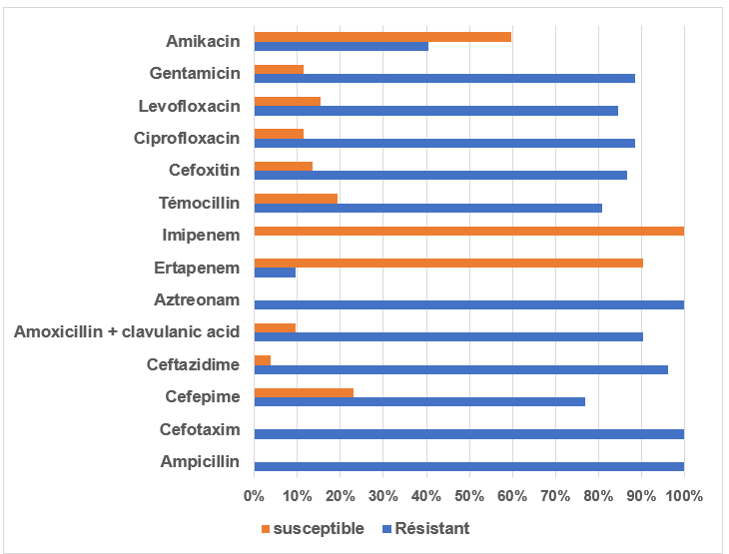

**Fig.1. Result of Antibiotic Susceptibility Testing**

**3.3 Monthly distribution of ESBL *E coli* isolate**

In order to have an idea of the evolution of the pigeon carrying rate, we have analyzed the ESBL *E coli* carrying rate by site and by month. The figure below shows these results.

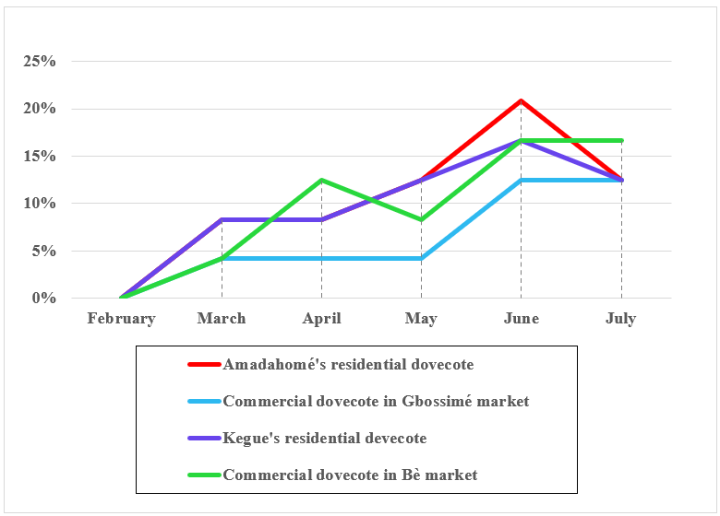

**Fig. 2. Monthly distribution of ESBL *E coli* isolate by site in pigeons**

we observed an increase in the rate of *E coli* ESBL in pigeon feces, depending on whether the loft was residential or commercial, until June, followed by a slight decrease in July. Given that the first three months of the study period constituted the dry season and the last three months the rainy season, we could say that the fecal carriage rate of ESBL *E coli* would increase during the rainy season. Factors related to water, sanitation and hygiene (WASH) are important factors in the transmission of extended-spectrum β-lactamase (ESBL)-producing E coli, with contaminated water and/or inappropriate infrastructure being the likely mode of acquisition. (Sammarro M *et al*.,2023) These watering places are often where birds, and therefore pigeons, quench their thirst. So, we could explain this increase by the acquisition of resistance due to exposure to the antibiotics used in their treatment.

**4. CONCLUSION**

This study stipulates the carriage of E coli ESBL in pigeons at a significant rate of 20%. From this, we can deduce that pigeons are a reservoir of multi-resistant bacteria such as E. coli BLSE. Thus, pigeons may contribute to spreading multi-resistant bacteria in the Greater Lomé Region as they travel in the wild.

Consent

All authors declare that ‘written informed consent was obtained from the patient (or other approved parties) for publication of this study and accompanying images. A copy of the written consent is available for review by the Editorial office/Chief Editor/Editorial Board members of this journal."

Ethical approval

“All authors hereby declare that "Principles of laboratory animal care" (NIH publication No. 85-23, revised 1985) were followed, as well as specific national laws where applicable. All experiments have been examined and approved by the appropriate ethics committee”

**Disclaimer (Artificial intelligence)**

Option 1:

Author(s) hereby declare that NO generative AI technologies such as Large Language Models (ChatGPT, COPILOT, etc.) and text-to-image generators have been used during the writing or editing of this manuscript.

Option 2:

Author(s) hereby declare that generative AI technologies such as Large Language Models, etc. have been used during the writing or editing of manuscripts. This explanation will include the name, version, model, and source of the generative AI technology and as well as all input prompts provided to the generative AI technology

Details of the AI usage are given below:

1.

2.

3.

References

1. Aires-de-Sousa M., Fournier C., Lopes E., de Lencastre H., Nordmann P., Poirel L. (2020) High colonization rate and heterogeneity of ESBL and carbapenemase-producing *Enterobacteriaceae* isolated from gull feces in Lisbon, Portugal. *Microorganisms*, *8*, 1487.
2. Antimicrobial Resistance. Tackling the Burden in the European Union Organization for Economic Coordination and Development (OECD). (2020) Generalizability and comparability of prevalence estimates in the wild bird literature: Methodological and epidemiological considerations. *Animal Health Research Reviews*, *21*, 89–95.
3. Cunha M.P.V., Oliveira M.C.V., Oliveira M.G.X., Menão M-C, Knöbl T. (2019) CTX-M-producing *E coli* isolated from urban pigeons (*Columba livia domestica*) in Brazil. *Journal of Infection in Developing Countries*, *13*, 1052–1056.
4. EFSA; ECDC. The European Union summary report on antimicrobial resistance in zoonotic and indicator bacteria from humans, animals and food in 2017 (2019). *EFSA Journal*, *17*, e05598, 278.
5. Jorge C., Carlos A.C., Camino G.F., Rosa C. (2019) Microbial Load and Antibiotic Resistance Patterns of *E coli* and *Enterococcus faecalis* Isolates from the Meat of Wild and Domestic Pigeons. *Foods*, *8*(11), 536
6. Mohammed Y.S., Aly E.A. (2014) rôle of wild birds as carriers of multi-drug-resistant *E coli* and *Escherichia* *vulneris, Environmental Microbiology Brazilian Journal of Microbiology. 45 (4).*
7. Ngaiganam E.P., Pagnier I., Chaalal W., Leangapichart T., Chabou S., Rolain J.M., Diene S.M. (2019) Investigation of urban birds as source of β-lactamase-producing Gram-negative bacteria in Marseille city, France. *Acta Veterinaria Scandinavica*, *61*, 51.
8. Rahman A., Hassan J., Rahman M., & Saiful Islam M. (2023). Extended-spectrum bêta-lactamase in *E coli* isolated from humans, animals, and environments in Bangladesh: A One Health perspective systematic review and meta-analysis. *UC Davis*.
9. Loucif L., Chelaghma W., Bendjama E., Cherak Z., Khellaf M., Khemri A., Rolain J-M. (2022) Detection of *bla*OXA-48 and *mcr-1* genes in *E coli* isolates from pigeon (*Columba livia*) in Algeria. *Microorganisms*, *10*, 975.
10. Dolejska M, Bierosova B, Kohoutova L, Literak I, Cizek A. Antibiotic-resistant Salmonella and E coli isolates with integrons and extended-spectrum beta-lactamases in surface water and sympatric black-headed gulls. J Appl Microbiol. 2009;106:1941–1950. doi: 10.1111/j.1365-2672.2009.04155.x. [[DOI](https://doi.org/10.1111/j.1365-2672.2009.04155.x)] [[PubMed](https://pubmed.ncbi.nlm.nih.gov/19245407/)] [[Google Scholar](https://scholar.google.com/scholar_lookup?journal=J%20Appl%20Microbiol&title=Antibiotic-resistant%20Salmonella%20and%20Escherichia%20coli%20isolates%20with%20integrons%20and%20extended-spectrum%20beta-lactamases%20in%20surface%20water%20and%20sympatric%20black-headed%20gulls&author=M%20Dolejska&author=B%20Bierosova&author=L%20Kohoutova&author=I%20Literak&author=A%20Cizek&volume=106&publication_year=2009&pages=1941-1950&pmid=19245407&doi=10.1111/j.1365-2672.2009.04155.x&)]; Dolejska M, Bierosova B, Kohoutova L, Literak I, Cizek A (2009) Antibiotic-resistant Salmonella and E coli isolates with integrons and extended-spectrum beta-lactamases in surface water and sympatric black-headed gulls. J Appl Microbiol 106:1941–1950. [[DOI](https://doi.org/10.1111/j.1365-2672.2009.04155.x)] [[PubMed](https://pubmed.ncbi.nlm.nih.gov/19245407/)]
11. Bauer AW, Perry DM, Kirby WMM. 1959. Single-disk antibiotic-sensitivity testing of staphylococci: an analysis of technique and results. AMA Arch Intern Med 104:208–216. doi: 10.1001/archinte.1959.00270080034004. [[DOI](https://doi.org/10.1001/archinte.1959.00270080034004)] [[PubMed](https://pubmed.ncbi.nlm.nih.gov/13669774/)] [[Google Scholar](https://scholar.google.com/scholar_lookup?journal=AMA%20Arch%20Intern%20Med&title=Single-disk%20antibiotic-sensitivity%20testing%20of%20staphylococci:%20an%20analysis%20of%20technique%20and%20results&volume=104&publication_year=1959&pages=208-216&pmid=13669774&doi=10.1001/archinte.1959.00270080034004&)]
12. Cole D, Drum DJ, Stalknecht DE, White DG, Lee MD, Ayers S, Sobsey M, Maurer JJ. Free-living Canada geese and antimicrobial resistance. Emerg Infect Dis. 2005;11:935–938. doi: 10.3201/eid1106.040717. [[DOI](https://doi.org/10.3201/eid1106.040717)] [[PMC free article](https://pmc.ncbi.nlm.nih.gov/articles/PMC3367595/)] [[PubMed](https://pubmed.ncbi.nlm.nih.gov/15963291/)] [[Google Scholar](https://scholar.google.com/scholar_lookup?journal=Emerg%20Infect%20Dis&title=Free-living%20Canada%20geese%20and%20antimicrobial%20resistance&author=D%20Cole&author=DJ%20Drum&author=DE%20Stalknecht&author=DG%20White&author=MD%20Lee&volume=11&publication_year=2005&pages=935-938&pmid=15963291&doi=10.3201/eid1106.040717&)]; Cole D, Drum DJ, Stalknecht DE, White DG, Lee MD, Ayers S, Sobsey M, Maurer JJ (2005) Free-living Canada geese and antimicrobial resistance. Emerg Infect Dis 11:935–938. [[DOI](https://doi.org/10.3201/eid1106.040717)] [[PMC free article](https://pmc.ncbi.nlm.nih.gov/articles/PMC3367595/)] [[PubMed](https://pubmed.ncbi.nlm.nih.gov/15963291/)]
13. Vogt N.A.; Stevens, C.P.G.; Pearl, D.L.; Taboada, E.N.; Jardine, C.M. Generalizability and comparability of prevalence estimates in the wild bird literature: Methodological and epidemiological considerations. *Anim. Health Res. Rev.* **2020**, *21*, 89–95. [[**Google Scholar**](https://scholar.google.com/scholar_lookup?title=Generalizability+and+comparability+of+prevalence+estimates+in+the+wild+bird+literature:+Methodological+and+epidemiological+considerations&author=Vogt,+N.A.&author=Stevens,+C.P.G.&author=Pearl,+D.L.&author=Taboada,+E.N.&author=Jardine,+C.M.&publication_year=2020&journal=Anim.+Health+Res.+Rev.&volume=21&pages=89%E2%80%9395&doi=10.1017/S1466252320000043)] [**[CrossRef](https://doi.org/10.1017/S1466252320000043" \t "_blank)**]
14. Sammarro M, Rowlingson B, Cocker D, Chidziwisano K, Jacob ST, Kajumbula H, Mugisha L, Musoke D, Lester R, Morse T, Feasey N, Jewell C. Risk Factors, Temporal Dependence, and Seasonality of Human Extended-Spectrum β-Lactamases-Producing Escherichia coli and Klebsiella pneumoniae Colonization in Malawi: A Longitudinal Model-Based Approach. Clin Infect Dis. 2023 Jul 5;77(1):1-8. doi: 10.1093/cid/ciad117. PMID: 36869813; PMCID: PMC10320086.
15. Livermore, D. M., M. Warner, L. M. C. Hall, V. I. Enne, S. J. Projan, P. M. Dunman, S. L. Wooster, and G. Harrison. 2001. Antibiotic resistance in bacteria from magpies (*Pica pica*) and rabbits (*Oryctolagus cuniculus*) from west Wales. *Environ. Microbiol.*3**:**658-661.
16. Wallace, J. S., T. Cheasty, and K. Jones**.** 1997. Isolation of Vero cytotoxin-producing *Escherichia coli* O157 from wild birds. *J. Appl. Microbiol.*82**:**399-404.
17. Literak IDolejska M, Janoszowska D, Hrusakova J, Meissner W, Rzyska H, Bzoma S, Cizek A.2010.Antibiotic-Resistant Escherichia coli Bacteria, Including Strains with Genes Encoding the Extended-Spectrum Beta-Lactamase and QnrS, in Waterbirds on the Baltic Sea Coast of Poland. Appl Environ Microbiol76:.https://doi.org/10.1128/AEM.01446-10
18. Megan E. Jacob, Shivaramu Keelara, Awa Aidara-Kane, Jorge R. Matheu Alvarez, Paula J. Fedorka-Cray. Optimizing a Screening Protocol for Potential Extended-Spectrum β-Lactamase Escherichia coli on MacConkey Agar for Use in a Global Surveillance Program. Journal of Clinical Microbiology Aug 2020, 58 (9) e01039-19; DOI: 10.1128/JCM.01039-19
19. Musa, L.; Stefanetti, V.; Casagrande Proietti, P.; Grilli, G.; Gobbi, M.; Toppi, V.; Brustenga, L.; Magistrali, C.F.; Franciosini, M.P. Antimicrobial Susceptibility of Commensal *E. coli* Isolated from Wild Birds in Umbria (Central Italy). *Animals* **2023**, *13*, 1776. <https://doi.org/10.3390/ani13111776>
20. Nfongeh JF, Odonye n DD, Akhaneregbe P, Adibe OO, Fadayomi VK. Faecal Carriage of Escherichia coli 0157:H7 Serotype by Free-Ranged and Confined Small Domestic Ruminants within Cross River State, Nigeria. J. Adv. Microbiol. [Internet]. 2022 Jun. 22 [cited 2025 Feb. 4];22(9):31-9. Available from: https://journaljamb.com/index.php/JAMB/article/view/646