**Assessment of the antimicrobial properties of ultraviolet radiation application and different types of packaging during the storage of cocoa beans**

**ABSTRACT**

|  |
| --- |
| **Aims:** To assess ultraviolet radiation microbial deactivation and impact of different types of packaging during the storage of cocoa beans.  **Study design:** Quasi experimental design.  **Place and Duration of Study:** Department of Microbiology, Faculty of Science, University of Yaoundé 1, between January 2023 and May 2024.  **Methodology:** Dried cocoa beans were used for ultraviolet radiation of 743.6 µW/cm² during 0 to 50 minutes. The total bacteria count, *Enterobacteriaceae*, *Escherichia coli*, yeasts, and moulds were enumerated, and the detection of Salmonella was performed. On the other hand, dried cocoa beans were introduced on 5 different packaging, and stored across two seasons, for 180 days and their microbial content and humidity assessed.  **Results:** The study observed that ultraviolet radiation type C with an intensity of 743.6 µW/cm² for 50 minutes reduces total bacteria count (TBC) by 1.62 log CFU/g (98%) and fungal flora by 2.03 log CFU/g (99%). Time of exposure was a significant factor affecting the ultraviolet antimicrobial efficacy. Based on Weibull model adaptation to experimental data, moulds were more sensitive to these radiation (b=0.09) than total bacteria count (b=0.0012). Hermetic bags show the ability to reduce microbial proliferation during the rainy and drying seasons compared to microaerophilic bags and Jute bags. The Hermetic bags also show an ability to resist humidification compared to other packaging.  **Conclusion:** Ultraviolet radiation for 50 minutes and storage in hermetic packages of cocoa beans can be proposed as alternatives to the only jute bag storage commonly used today in the cocoa sector. |

**Keywords:** cocoa beans, ultraviolet radiation, airtight conditions, storage, humidity, total aerobic mesophilic flora, moulds.

1. **INTRODUCTION**

Cocoa tree is a shrub that grows in a hot and humid climate, where the average temperature is around 27°C. This shrub, scientifically named *Theobroma cacao L*., produces fruits known as cocoa pods when it reaches adulthood **(Shwan et Wheals, 2004)**. This shrub belongs to the *Malvaceae* family and grows preferably in tropical climates, at an altitude of about 300 meters, in conditions of high humidity and an annual rainfall of 2000 millimetres. These fruits contain seeds that, once fermented and dried, yield cocoa beans, that are used for many cocoa derived products.

The global production of cocoa, which is around 4.2 million tons, is carried out mainly by African countries that represent about 70% of the global production. Cocoa is predominantly cultivated in rural areas and accounts for 60% to 90% of famers income **(Voora *et al.,* 2019)**. Cameroon is the fifth world producer, but some cocoa beans are heavily criticised for the lack of control over the storage processes, resulting in a difference in quality between the end of drying and the delivery of cocoa beans to the industry **(Bagal *et al.,* 2013; Mathé *et al.,* 2023)**. This variation in quality among other factors always depends on the parameters of the dried beans and the atmospheric conditions of the storage warehouses.

Sometimes, the alteration of cocoa beans quality begins at the end of fermentation with the intervention of spore-forming bacteria and moulds **(Shawn and Wheals, 2004)** which, under the action of inappropriate drying, leads to the production of cocoa beans highly loaded with these microorganisms. Furthermore, this variation in the quality of cocoa beans is exacerbated by the use of jute bags, which do not reduce the humidification, infestation and microbial proliferation of cocoa beans in tropical climates **(Navarro, 2012)**. With respect to traditional handling of cocoa beans, it is advised today, to associate other physical treatments and appropriate packaging in order to assure a better cocoa bean quality.

Hence, in order to increase the post fermentation quality of cocoa beans, the impact of two operations was assessed, namely the use of UV treatment and different storage packaging [30]. In particular, the working hypothesis was that ultraviolet treatment would reduce the microbial load on cocoa beans and the use of an appropriate storage container can help maintain dry cocoa beans microbial and moisture qualities.

It is in this context that the general objective of this study is to evaluate the impact of ultraviolet treatments as well as specific packaging measures on the maintenance of some market qualities of cocoa beans.

1. **MATERIALS AND METHOD**

**2.1 Evaluation of ultraviolet treatment on the microbial quality of cocoa beans.**

The samples of dried cocoa beans of Forastero variety, ready for storage in warehouse and packaged in jute bags were collected from the cocoa enterprise SOCAM SC in Obala, Center Region of Cameroon. A specific treatment chamber was constructed in order to avoid room lamp interference. The UV lamp was placed at 53 cm from the samples, covered with aluminium foil to maximise exposure. The lamp was turned on in the chamber 30 minutes before the start of the experiment. The average intensity of the lamp (SANYI, ZHMZH germicidal UV light, 40W, E27) used was 743.6 µW/cm². This protocol was adapted from what proposed by **Lim and Harrison, 2016**. The exposure duration of samples in triplicate to the lamp were 0, 10, 20, 30, 40, and 50 minutes, corresponding respectively to doses of 0, 446.16; 892.32; 1338.48; 1784.64; 2230.8 mJ/cm². After exposure, the beans were analysed for their microbiological quality, taking into consideration the total bacteria count **(ISO 4833-1: 2013)**, the enumeration of *Escherichia coli* **(ISO 16649: 2001)**, moulds and yeasts **(AFNOR-NF V08-059)**, *Enterobacteriaceae* **(ISO 21528-2: 2017)**, and the detection of *Salmonella* by the *Salmonella* Precis Method **(Karlson, 2012)**.

**2.2 Evaluation of different types of packaging on the quality of cocoa beans.**

The samples of dried cocoa beans from the same origin as previously indicated, ready for storage in warehouse and packaged in jute bags were used. Five types of packaging containing 4 Kg of cocoa bean each were experimented and repeated three times: Jute Bags; Microaerophilic Jute Bags (cocoa beans are inserted in Jute Bags, and this one is once more introduced inside a plastic bags before applying a microaerophilic sealing); Microaerophilic Plastic Bags (cocoa beans are inserted in Plastic bags in Microaerophilic sealing; Hermetic Jute Bags (cocoa beans are inserted in Jute bags, before being introduced again inside a plastic bags, then an Hermetic sealing is applied) and Hermetic Plastic bags (cocoa beans are inserted in a plastic bags then an hermetic sealing is applied). The storage was carried out for a duration between 0 and 180 days at a mean room temperature of 24°C. After storage time, some cocoa beans were removed and the following analyses performed: total bacteria count **(ISO 4833-1: 2013)**, enumeration of *Escherichia coli* **(ISO 16649: 2001)**, moulds and yeasts **(AFNOR-NF V08-059)**, *Enterobacteriaceae* **(ISO 21528-2: 2017)**, detection of *Salmonella* by the *Salmonella* Precis Method **(Karlson, 2012)**, and measurement of the moisture content of the cocoa beans **(ISO 2451:2017).**

**2.3 Data statistical analysis**

Regarding microbial analysis, averages from 03 different analyses of each sample were compared using a one-factor ANOVA test at a significance level of less than 0.05. The averages of the data from the measurement of the number of decimal reductions (log(final count)/log(initial count))) of the microorganisms during the different ultraviolet treatments were adapted to the model of Weibull **(Peleg et Cole, 1998)** to determine the kinetic parameter b (speed parameter) and n (shape parameter). This analysis was performed using a nonlinear regression analysis with the STATISTICA 10.2 version software.

1. **RESULTS AND DISCUSSION**

**3.1 Evaluation of ultraviolet treatment on the microbial quality of cocoa beans.**

In cocoa beans were exposed to ultraviolet radiation for different length of time. It was observed that the initial samples levels of Enterobacteriaceae, *Escherichia coli*, and yeasts were estimated to be below the detection threshold. Moreover, Salmonella was found to be absent in 25 grams of these samples. Consequently, only Total bacteria count (TBC) and mould evolution following UV treatments were assessed.

Regarding the total bacteria count, increase in the length of exposure to ultraviolet radiation also increased the reduction in this microbial group. (Table 1).

**Table 1. Evolution of TBC during the exposure of beans to ultraviolet radiation and fitting parameters to the Weibull model, 1998.**

|  |  |  |
| --- | --- | --- |
|  |  | Number of decimal reduction (log CFU/g) |
|  | Processing time (minutes) |
| Expérimental data | 0 | 0.00 ± 0.00 **a** |
| 10 | -0.12 ± 0.06 **b** |
| 20 | -0.18 ± 0.06 **b** |
| 30 | -0.66 ± 0.02 **c** |
| 40 | -1.23 ± 0.00 **d** |
| 50 | -1.62 ± 0.05 **e** |
| Weibull Model | Speed parameter (b) | 0.0012 |
| Shape parameter (n) | 1.85 |
| R² | 0.98 |
| SSE | 0.12 |

*\*R² (coefficient of determination); SSE (sum of squares of errors); the significance threshold of the presented values (P = .049).*

The total bacteria count on initial samples (6.8 CFU/g). After 50 minutes of exposure, the TBC reduction obtained was -1.62 log CFU/g, representing about 97.6 % of the initial cell load. The Weibull model,adapted to the experimental data explained 98 % of the data variability. (Figure 1a). A shape parameter “n”greater than 1 indicates that at the initial phase of the treatment, these microorganisms were resistant to the treatment before, the deactivation started.

Regarding moulds contamination, the exposure of cocoa beans to ultraviolet light caused a reduction that started earlier than that of TBC and also increased with the length of the treatment. (Table 2).

**Table 2. Evolution of mould concentration during the exposure of beans to ultraviolet radiation and fitting parameters to the Weibull model, 1998.**

|  |  |  |
| --- | --- | --- |
|  |  | Number of decimal reduction (log CFU/g) |
|  | Processing time (minutes) |
| Expérimental data | 0 | 0.00 ± 0.00 **a** |
| 10 | -0.63 ± 0.02 **b** |
| 20 | -0.70 ± 0.01 **c** |
| 30 | -1.71 ± 0.05 **d** |
| 40 | -1.89 ± 0.02 **e** |
| 50 | -2.03 ± 0.02 **f** |
| Weibull Model | Speed parameter (b) | 0.09 |
| Shape parameter (n) | 0.82 |
| R² | 0.94 |
| SSE | 0.47 |

*\*R² (coefficient of determination); SSE (sum of squared errors); the significance threshold of the presented values (P = .049).*

The initial mould load in samples was an average of 4.6 Log CFU/g. The mould deactivation after an exposure of 50 minutes corresponded to a decimal reduction of 2.03 log CFU/g, representing about 99 % reduction of the initial mould load. The Weibull model adapted to the deactivation kinetics explained 94 % of the variability observed in this analysis. (Figure 1b). A significant fraction of mould was sensitive to ultraviolet treatments. This is noticeable with the shape parameter less than 1.

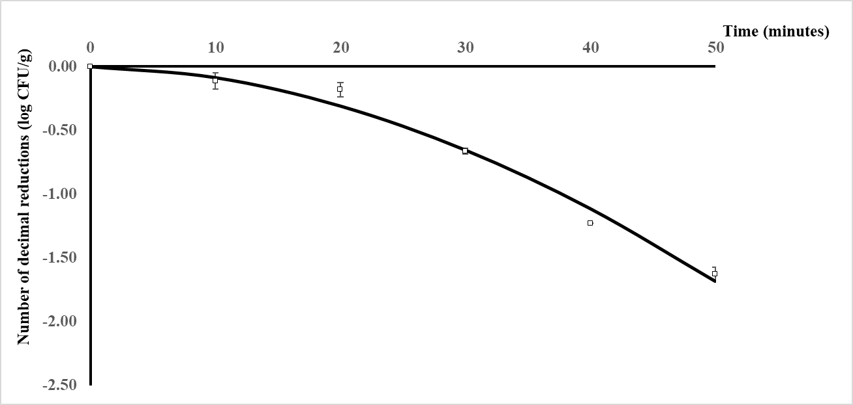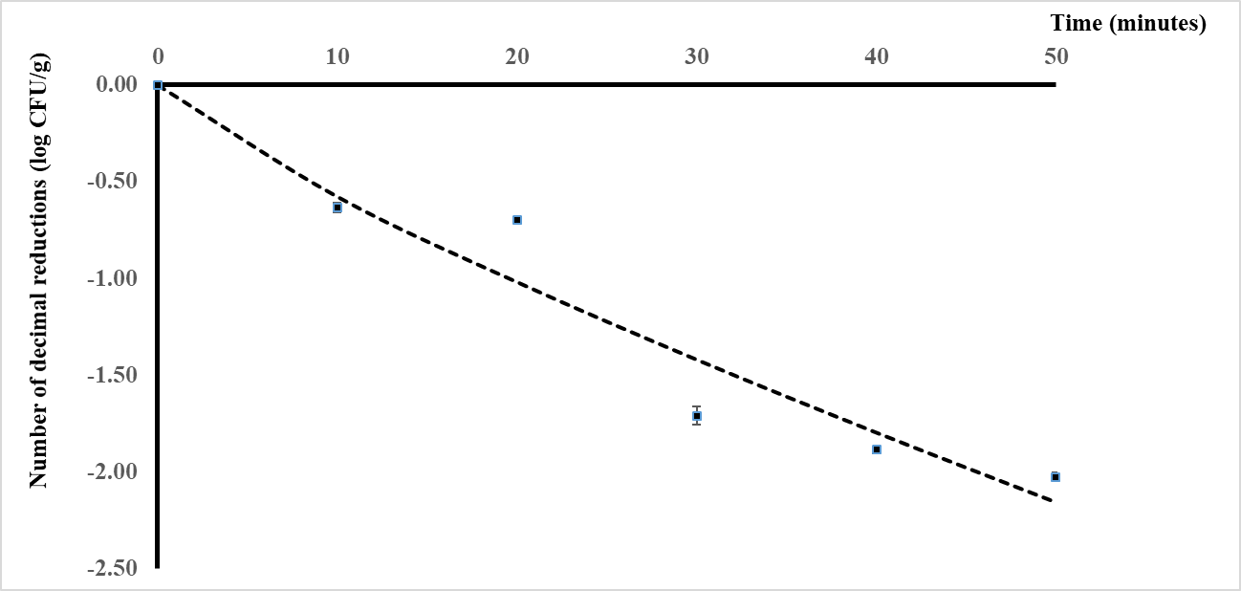

b

a

**Figure 1**: Decimal reduction kinetics of (a) total aerobic bacteria count (TBC) (White square "Fitted to the Weibull model" bold line) and (b) moulds (Black square "Fitted to the Weibull model" fine dashed line). during the exposure of cocoa beans to ultraviolet radiation

Mould and total bacteria count in initial samples without treatment had an average of 4.6 Log CFU/g and 6.8 Log CFU/g respectively. This observation is consistent with the observations made by **(Adeniyi *et al.,* 2011; Fagbohun *et al.,* 2011; Rahmadi and Fleet, 2008)**. This dominance of mould and total bacteria count (TBC), including spore-forming bacteria **(Rahmadi and Fleet, 2008)**, would be due to the presence of this flora on cocoa beans at the end of fermentation **(Gutiérrez, 2017)**. The last days of fermentation are driven by the action of mould and spore-forming bacteria which have the ability to resist low humidity percentages and activate forms of resistance **(Copetti *et al.,* 2014; De Moraes and Ferreira-Perei, 2024)**.

The results of the evaluation of ultraviolet treatments on the quality of cocoa beans show a low reduction of TBC (1.63 log CFU/g) and mould (2.02 log CFU/g). This low reduction in these florae could be due to colour of the food matrix. Indeed, light or white matrices reflect ultraviolet radiation. This reflection of radiation increases the incidence of ultraviolet rays on microorganisms present at the surface of the product **(Koutchma, 2019; Csapo *et al.,* 2019)**. Conversely, dark-coloured matrices (cocoa beans) absorb ultraviolet radiation, reducing the incidence of microorganisms on their surface **(Lopez-Malo and Palou, 2005)**. In addition, the presence of forms of resistance for mould and spore-forming bacteria on the surface of cocoa beans would be the origin of resistance to ultraviolet radiation **(Moeller *et al.,* 2011; Nicholson, 2018)**. The complex consisting of exosporium, spore tunic, cortex, and spore wall confers resistance to the ultraviolet radiation of the endospores. For mould, in addition to being able to activate forms of resistance (with the spore wall constituting a barrier to ultraviolet rays), they can synthesize melanin, providing them with resistance against ultraviolet radiation **(Onoda et al., 2024)**.

* 1. **Evaluation of different types of packaging on the quality of cocoa beans.**

Relevant to the impact of packaging on cocoa beans storage, the cocoa beans were subjected to five types of packaging for a duration ranging from 0 to 180 days over two seasons. Subsequently, an enumeration of the total bacteria counts (TBC), *Enterobacteriaceae, Escherichia coli*, yeasts and moulds, detection of *Salmonella*, and measurement of moisture were carried out. In the initial collected samples, *Enterobacteriaceae, Escherichia coli*, yeasts, *and Salmonella* were quantified below the detection thresholds.

* + 1. **The total bacteria count (TBC)**

Table 3 presents the evolution of the total bacteria count (TBC) of cocoa beans under the influence of different types of packaging during storage. The reduction in the TBC of cocoa beans during the dry season across all packaging types is observed.

**Table 3. Evolution of TBC during the storage of cocoa beans under the influence of different packaging.**

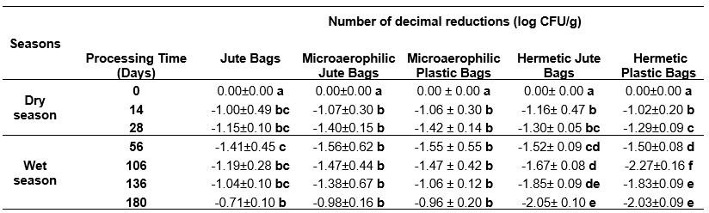

*\* In the same column, values followed by the same letter are statistically similar (P = .049).*

The results permit to observe a large amount of total bacteria count in initial samples was very high (average of 7.0 Log CFU/g). The reduction was more significant under microaerophilic conditions (1.20 log CFU/g and 1.18 log CFU/g, respectively for microaerophilic plastic bags and microaerophilic jute bags). This reduction in TBC is less significant for jute bags (0.93 log CFU/g). However, during the rainy season, the study observes an increase in the TBC of cocoa beans under microaerophilic conditions and jute bags. Under hermetic conditions, there was a reduction in the TBC of cocoa beans even during the rainy season (1.83 log CFU/g and 1.81 log CFU/g, respectively for hermetic jute bags and hermetic plastic bags after 180 days of storage).

* + 1. **Enumeration of moulds**

Regarding the presence of moulds of cocoa beans under different packaging material, (table 4) presents their variation during storage 180 days.

**Table 4. Evolution of mould during the storage of cocoa beans under the action of different types of packaging.**

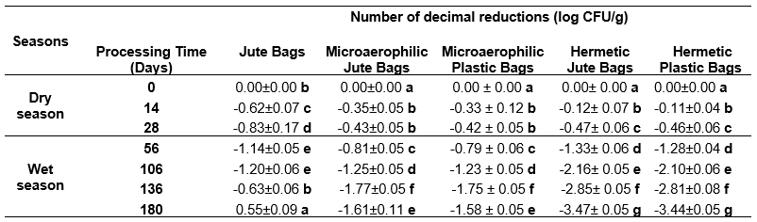

*\* In the same column, values followed by the same letter are statistically similar (P = .049).*

From the results, it can be observed that mould presence was very high in initial samples (average of 6.4 Log CFU/g). It was observed a reduction in cocoa bean moulds during the dry season in all packaging. This reduction was greater for microaerophilic conditions (0.81 Log CFU/g for jute bags). This reduction of moulds was less significant for packaging types and was around 0.41 log CFU/g. During the rainy season, the study observed a decrease in cocoa bean moulds for microaerophilic and hermetic conditions. This reduction was greater for hermetic conditions (3.44 Log CFU/g and 3.47 Log CFU/g for hermetic plastic bags and hermetic jute bags respectively, after 180 days of storage). Within the hermetic conditions, an increase in the moulds of the cocoa beans was observed even in the rainy season (0.55 Log CFU/g) for the jute bags after 180 days of storage.

**3.2.3 Humidity measurement of cocoa beans during storage in different conditions**

Table 5 indicates the evolution of the humidity of cocoa beans under the action of different types of packaging during storage. Moisture content of cocoa beans during the dry season in all packages reduced within time. This reduction was greater for hermetic conditions (6.33% and 6.37% respectively, for hermetic jute bags and hermetic plastic bags). This reduction in moisture was less significant for microaerophilic conditions (6.70% each). However, during the rainy season, the study observed an increase in the moisture content of cocoa beans for microaerophilic conditions and jute bags. This increase was greater for jute bags (8.77% after 180 days of storage). This increase was not very significant for microaerophilic conditions (7.53% each after 180 days of storage). Within the hermetic conditions, the study allows us to observe resistance to the increase of the humidity of the cocoa beans even in the rainy season (6.80% and 6.90% respectively, for the hermetic jute bags and the hermetic plastic bags after 180 days of storage.

**Table 5. Evolution of humidity during the storage of cocoa beans under the action of different types of packaging.**

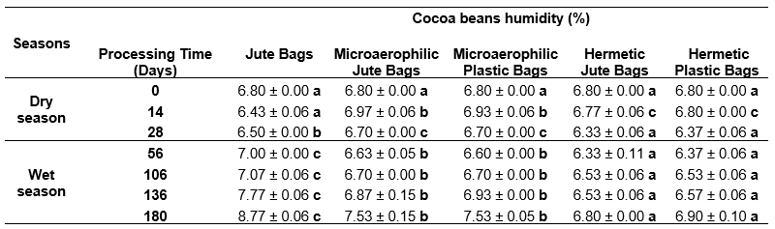

*\* In the same line, values ​​followed by the same letter are statistically similar (P= .049).*

The absence of *Enterobacteriaceae*, *Escherichia coli*, *Salmonella,* and yeasts below the quantifiable threshold in all initial samples analyzed. Has also been observed in some cses by other authors **(Stobinska *et al.,* 2006, Shwan et Wheals, 2004)**. In fact,these microorganisms require conditions in which water is present in significant proportions. However, cocoa beans, once dried, constitute a barrier to the proliferation of these microorganisms. Conversely, spore-forming bacteria and mould can activate forms of resistance (spores), allowing them to survive even under drying conditions **(Shwan et Wheals, 2004)**.

A reduction of the total bacteria count and moulds as a function of time for hermetic packaging was observed **(Jonfia-Essien *et al.,* 2008)**. Hermetic packaging limits access to oxygen inside the bags **(Villiers et al., 2010)**. Thus, the residual oxygen is transformed by microbial respiration into carbon dioxide. The reduction of the oxygen tension coupled with a significant presence of carbon dioxide is at the origin of the reduction of oxygen-dependent flora (TBC and moulds) (**Villiers et al., 2010)**.

Regarding the humidity impact during cocoa beans storage, it was observed a reduction of the humidity of the cocoa beans over time. This reduction of humidity is accompanied by a resistance to humidification of the cocoa beans during the humid period and for hermetic packaging. Indeed, hermetic packaging provides a physical barrier to water molecules suspended in the air **(Navarro, 2010)**. This impermeability capacity of these packages stabilizes the humidity of the cocoa beans during humid periods.

1. **CONCLUSION**

An approach aimed at exposing dried beans to ultraviolet radiation and introducing cocoa beans into specific packaging seems to be a stable, effective, and applicable solution that may help control the quality during storage. Ultraviolet radiation for 50 minutes and storage into hermetic packages of cocoa beans can be proposed as alternatives to the only jute bag storage commonly used today in the cocoa sector.

**Disclaimer (Artificial intelligence)**

Option 1:

Author(s) hereby declare that NO generative AI technologies such as Large Language Models (ChatGPT, COPILOT, etc.) and text-to-image generators have been used during the writing or editing of this manuscript.

Option 2:

Author(s) hereby declare that generative AI technologies such as Large Language Models, etc. have been used during the writing or editing of manuscripts. This explanation will include the name, version, model, and source of the generative AI technology and as well as all input prompts provided to the generative AI technology

Details of the AI usage are given below:

1.

2.

3.

**REFERENCES**

1. Schwan, R. F., & Wheals, A. E. (2004). The microbiology of cocoa fermentation and its role in chocolate quality. *Critical reviews in food science and nutrition*, *44*(4), 205-221.
2. Voora, V., Bermúdez, S., & Larrea, C. (2019). *Global market report: Cocoa* (p. 12). Winnipeg, MB, Canada: International Institute for Sustainable Development.
3. Mathé, S., Fouepe, F., Hansel, G., Sonfack, M., Temple, L., Abega Ndjana, J., ... & Brice, M. (2023). New challenges for innovation support services to improve cocoa quality and sustainability in Cameroon.
4. Bagal, M., Belletti, G., & Marescotti, A. (2013). Étude sur le potentiel de commercialisation du cacao du Cameroun en « Indication géographique ». *Rapport d’étude, Lausanne, REDD, Iram*, 26.
5. Navarro, S. (2012). *The use of modified and controlled atmospheres for the disinfestation of stored products.* Journal of Pest Science, *85*(3), 301-322.
6. Lim, W., & Harrison, M. A. (2016). Effectiveness of UV light as a means to reduce Salmonella contamination on tomatoes and food contact surfaces. *Food Control*, *66*, 166-173.
7. International Organization for Standardization (2013) ISO 4833- 2:2013/Cor.1:2014. *Microbiology of the Food Chain: Horizontal* *Method for the Enumeration of Microorganisms, Part 2: Colony Count at 30°C by the Surface Plating Technique*. 1st edition, Corrigendum1:2014. ISO, Geneva, Switzerland.
8. International Organization for Standardization (2001). ISO 16649-2:2001. *Microbiology of food and animal feeding stuffs - Horizontal method for the enumeration of beta-glucuronidase-positive Escherichia coli - Part 2: Colony-count technique at 44 degrees C using 5-bromo-4-chloro-3-indolyl beta-D-glucuronide*. 1st edition, ISO, Geneva, Switzerland.
9. French and European Standard Association (2002) AFNOR-NF V08-059. 2002. *Microbiology of Food Animal Feeding Stuffs - Enumeration of Yeasts and Moulds By Colony-Count Technique At 25°C.* AFNOR Edition, France
10. International Organization for Standardization (2017) ISO 21528- 2:2017. *Microbiology of the Food Chain: Horizontal Method for the* *Detection and Enumeration of Enterobacteriaceae, Part 2: Colony-Count Technique*. 2nd edition. ISO, Geneva, Switzerland.
11. Karlsson, D. (2012). *Evaluation of alternative analysis methods for Salmonella, yeast and mold for use in food business compared to reference methods* (Master's thesis, Chalmers University of Technology).
12. International Organization for Standardization (2017). ISO 2451:2017. Cocoa beans — Specification and quality requirements. 3rd edition, ISO, Geneva, Switzerland.
13. Peleg, M., & Cole, M. B. (1998). Reinterpretation of microbial survival curves. *Critical Reviews in Food Science*, *38*(5), 353-380.
14. Stobinska, H., Krysiak, W., Nebesny, E., & Kozanecka, E. (2006). Effects of convective roasting conditions on microbial safety of cocoa beans. *Acta Agrophysica*, *7*(1 [132]).
15. Adeniyi, D. O., Oyedokun, A. V., Adejobi, K. B., & Adenuga, O. O. (2011). Mycoflora associated with fermentation of cocoa beans in Nigeria. *Journal of Applied. Biosciences*, *39*, 2647-2651.
16. Fagbohun, E., Anibijuwon, I., Egbebi, O., & Lawal, O. (2011). Fungi associated with spoilage of dried cocoa beans during storage in Ekti State of Nigeria. *Journal of microbiology, biotechnology and food sciences*, *1*(2), 204-214.
17. Rahmadi, A., & Fleet, G. H. (2008). The occurrence of mycotoxigenic moulds in cocoa beans from Indonesia and Queensland, Australia. In *Proceeding of International Seminar on Food Science* (Vol. 1, pp. 1-18).
18. Gutiérrez, T. J. (2017). State‐of‐the‐art chocolate manufacture: A review. *Comprehensive Reviews in Food Science and Food Safety*, *16*(6), 1313-1344.
19. Copetti, M. V., Iamanaka, B. T., Pitt, J. I., & Taniwaki, M. H. (2014). Fungi and mycotoxins in cocoa: From farm to chocolate. *International journal of food microbiology*, *178*, 13-20.
20. De Moraes, D. C., & Ferreira-Pereira, A. (2024). Multidrug-Resistant Fungi. *Journal of Fungi*, *10*(10), 686.
21. Koutchma, T. (2019). *Ultraviolet light in food technology: principles and applications*. CRC press.
22. Csapó, J., Albert, C., Prokisch, J., & Sipos, P. (2019). Effect of UV light on food quality and safety.
23. Lopez-Malo, A., & Palou, E. (2005). Ultraviolet light and food preservation. *Novel food processing technologies*, 405-422.
24. Moeller, R., Schuerger, A. C., Reitz, G., & Nicholson, W. L. (2011). Impact of two DNA repair pathways, homologous recombination and non-homologous end joining, on bacterial spore inactivation under simulated martian environmental conditions. *Icarus*, *215*(1), 204-210.
25. Nicholson, W. L. (2018). Experimental evolution to explore adaptation of terrestrial bacteria to the Martian environment. *Molecular Mechanisms of Microbial Evolution*, 241-265.
26. Onoda, Y., Nagahashi, M., Yamashita, M., Fukushima, S., Aizawa, T., Yamauchi, S., ... & Takahashi, A. (2024). Accumulated melanin in moulds provides wavelength-dependent UV tolerance. *Photochemical & Photobiological Sciences*, *23*(9), 1791-1806.
27. Jonfia-Essien, W. A., Navarro, S., & Dator, J. V. (2008). Effectiveness of hermetic storage in insect control and quality preservation of cocoa beans in Ghana. In *Proceedings of Eight International Conference on Controlled Atmosphere and Fumigation in Stored Products, Chengdu, China* (pp. 21-26).
28. Villers, P., Navarro, S., & De Bruin, T. (2010). New applications of hermetic storage for grain storage and transport. In *Proc. 10th International Working Conference on Stored Product Protection* (pp. 446-452).
29. Navarro, S. (2010). *Commercial applications of oxygen depleted atmospheres for the preservation of food commodities. In* *Case Studies in Novel Food Processing Technologies* (pp. 321-350). Woodhead Publishing.
30. Madhumitha, B. and Muralidharan, N. P. (2021) “Effect of Ultraviolet Radiation on Pseudomonas Aeruginosa, Staphylococcus Aureus and Enterococcus”, Journal of Pharmaceutical Research International, 33(59A), pp. 116–123. doi: 10.9734/jpri/2021/v33i59A34255.