**EFFECT OF BIO-PRIMING ON SEED QUALITY PARAMETERS OF RICE (*Oryza sativa* L.)**

**ABSTRACT**

This study investigates the impact of bio-priming with *Azospirillum*, *Pseudomonas fluorescens,* Phosphorus solubilizing bacteria (PSB), and Potassium solubilizing bacteria (KSB) on seed quality parameters of rice (*Oryza sativa* L.). Bio-priming is a sustainable agricultural practice that involves the use of beneficial microorganisms to enhance plant growth. Standardization experiment was done using 35 treatments in laboratory using Completely Randomized Design (CRD).The best performed 10 treatments were selected for field study. The field experiment was conducted in Randomized Block Design (RBD). The harvested seeds were further subjected to quality tests in the laboratory using Completely Randomized Design (CRD). Among different treatments, *Azospirillum* bio-primedat 10% and 12 hours of soaking and *pseudomonas fluorescens* bio-primed at 20% and 12 hours of soaking showed significant results for germination percentage, seedling vigour index, field emergence, highest seedling length.

**Key words:** Bio-priming, *Azospirillum*, *Pseudomonas fluorescens,* Potassium solubilizing bacteria, Phosphorus solubilizing bacteria.

**INTRODUCTION**

Rice (*Oryza sativa* L.) is a cereal crop belonging to the family Poaceae. Being a tropical crop can be grown during the two distinct seasons (*kharif* and *rabi*) of the year provided that moisture is made available to the crop. In India, rice occupies second place in area, but it serves as the most important food source for Asian countries mainly in south-eastern parts where it is an economic crop for farmers and workers who grow it on millions of hectares throughout the region. Since rice provides 21% of energy and 5% of protein for human, its quantity and quality requires major attention.

In India paddy covers an area of 47.82 million hectares with a production of 137.83 million metric tonnes with a productivity of 4.32 metric tonnes per hectare whereas in Andhra Pradesh it covers 21.29 lakh hectares with a production of 126.30 lakh tonnes and productivity of 5932 kgs per hectare (Agricultural Statistics at a glance, 2023).

There are several problems in rice production like abiotic stress, disease incidence, poor seedling establishment and yield. To overcome these problems, bio-priming is an efficient technique which helps in successful establishment of seedling and getting higher yields by overcoming various stresses. Bio-priming is a technique which involves combination of seed hydration and inoculation of the seeds with beneficial micro-organisms. Bio-priming improves seed viability, germination, vigour indices, plant growth and also provides protection against diseases and finally enhances seed yield.

Hence it is necessary to adopt bio-priming which helps in getting higher yields. Bio-priming can be done by using different beneficial micro-organisms which helps in overcoming various adverse climatic conditions resulting in higher yields and quality.

Seed is the basic and most important input in agriculture. Good quality seed ensures germination and optimum crop stand establishment. Hence it is necessary to improve the quality of seeds.

Seed bio-priming can also be considered as a suitable alternative to seed treatment because the microbes multiply continuously, occupy the growing root surfaces, forms a biofilm around the roots and also protects the plants from soil borne plant pathogens throughout the crop-growth period (Singh *et al*., 2016).

Using bio-agents instead of chemical fertilizers can have a significant positive influence on both crop yield and soil health. Bio-agents contain beneficial microorganisms such as bacteria, fungi, and algae that promote nutrient uptake by plants and improve soil structure. Unlike chemical fertilizers, which can degrade soil quality over time and cause environmental pollution, bio-agents enhance soil fertility sustainably. These microorganisms contribute to the natural nutrient cycle, releasing essential nutrients gradually and reducing the risk of nutrient leaching. Additionally, the presence of beneficial microbes in the soil can suppress harmful pathogens and pests, leading to healthier crops. Inoculating seeds with Plant Growth-Promoting Rhizobacteria (PGPR) has emerged as an efficient and ecofriendly (environmentally responsible engineering) technique that boosts the resilience of food production and lessens its ecological impact over the past few decades (Guptha *et al*., 2015)

Hence it is necessary to adopt bio-priming which helps in getting higher yields. Bio-priming can be done by using different beneficial micro-organisms which helps in overcoming various adverse climatic conditions resulting in higher yields and quality. Among the array of bacteria employed in bio-priming, phosphorus-solubilizing bacteria (PSB), potassium-solubilizing bacteria (KSB), *Azospirillum*, and *Pseudomonas fluorescens* stand out for their remarkable contributions. PSB and KSB facilitate the release of essential nutrients, phosphorus, and potassium, respectively, making them readily available to plants. *Azospirillum* is known as non-symbiotic free living micro-organism. It can also promote growth by mechanisms of tolerance of abiotic stresses. *Pseudomonas fluorescens*, known for its bio control properties, helps suppress plant pathogens, thereby improving plant health. Together, these bacteria form a potent arsenal in bio-priming, fostering sustainable agriculture by boosting seed vigor, nutrient uptake, and disease resistance.

KSB can be a promising strategy to solubilize K from soil and convert it into accessible form for plants, bringing about advancement of plant development and limiting the use of K-fertilizers. Similarly PSB is one among the soil micro-organisms which play an important role in improving physical and chemical nature of the soil, adding organic matter, solubilizing the insoluble phosphate, increasing availability and improving the growth and yield (Ravikumar *et al.,* 2010).

Primed seeds usually exhibit an increased germination rate, uniformity and greater total germination percentage (Basra *et al*., 2005) and improved germination under sub-optimal conditions (Lin and Sung, 2001). (Pravisya *et al*., 2019) reported that Pseudomonas fluorescens priming alleviated drought stress tolerance through increased relative water content, osmolytes, and improved antioxidation mechanisms in okra.

**Materials and methods**

The present investigation was carried out to study the effect of bio-priming on seed quality parameters in paddy crop (*Oryza sativa* L.) during rabi season 2023-24 at wet land farm S.V. Agricultural college, Tirupati, Andhra Pradesh. The details of the materials used and and methods adopted during the course of investigation are presented here.

**Seed source**

The seeds of paddy BPT-5204 variety were procured from Agricultural Research Station, Nellore.

A preliminary experiment was carried out to standardize the optimum concentration of liquid biofertilizers and the duration of priming. Seeds of paddy (BPT-5204) variety were soaked either in water along with various concentrations (10, 15, 20 and 25%) of bio-agents *viz.,* *Azospirillum*, Phosphorous solubilizing bacteria and Potassium solubilizing bacteriaand *pseudomonas fluorescens* solutions for two different durations (12 and 24 hours) with 1:2 ratio of seed weight to priming solution. The best concentration and duration of seed priming of each of the liquid bio-fertilizers identified in the preliminary experiment were used in the subsequent experiments individually for seed bio-priming of paddy variety BPT- 5204.

The seeds of paddy variety BPT-5204 were soaked in respective bio-priming solutions in 1:2 seed weight to solution volume (w/v) ratio for 12 and 24 h. After soaking, the seeds were dried back to a safe moisture level (12 %) under shade at room temperature. The primed seed along with the unprimed seed (control) were used for both laboratory and field studies.

**Germination (%)**

On the final day of germination test, number of seedlings germinated in each replication were counted and the germination (%) was calculated and expressed in percentage as per the formula mentioned below

$$\text{Germination }\left(\text{\%}\right)=\frac{\text{Number of seeds germinated }}{\text{Total number of seeds }}\text{x100}$$

**Root length (cm)**

At the time of germination count, 10 normal seedlings were selected at random from each replication and used for measuring the root length of seedlings. Root length was measured from the point of attachment of seed to the tip of primary root.

**Shoot length (cm)**

The seedlings used for measuring root length were also used for measuring shoot length. The shoot length was measured from the point of attachment of seed to the tip of the leaf and the mean values were expressed in centimetre.

**Seedling dry weight (g/10 seedlings)**

Ten normal seedlings were placed in butter paper and dried in a hot air oven maintained at 70 ± 2ºc for 24 h. then the plants were removed and allowed to cool in a desiccator for 30 min before being weighed in an electronic balance. The average weight was calculated and expressed as dry weight of the plants in mg of seedlings (10) (ISTA, 2010).

**Seedling length (cm)**

The sum of root and shoot length of ten seedlings was calculated and their mean was expressed as seedling length in centimetres.

**Seed vigour index-I**

Seed vigour index I was computed by adopting the following formula as suggested by Abdul-Baki and Anderson (1973) and was expressed in whole number.

Seed vigour index-I = Germination (%) x Seedling length (cm)

**Seed vigour index-II**

Seed vigour index II was computed by adopting the following formula as suggested by Abdul-Baki and Anderson (1973) and was expressed in whole number.

Seed vigour index-II = Germination (%) x Seedling dry weight (g)

**Results and discussion**

**Germination Percentage**

Seed bio-priming showed a significant difference among different treatments for germination Percentage.

The mean germination percentage was ranged from 86.88 to 95.11 (%).The highest mean germination percentage 95.11 was observed with *Azospirillum* bio-primed at 10% concentration and 12 hours duration of soaking and the lowest mean germination percentage was noticed in control treatment (86.88) % with the overall general mean percentage of (90.65) %.

**Shoot length (cm)**

The shoot length was also significantly influenced by the concentration of different bio-agents, duration of soaking and its interaction.

The mean shoot length of seedling was ranged from 5.28 to 7.21 cm. the highest mean shoot length was observed with *Azospirillum* 7.21 cm bio-primed at 10% concentration and 12 hours duration of soaking and the lowest Mean shoot length 5.28 cm was noticed in control treatment with the overall general mean being 6.23 cm.

These are in accordance with Kumar and Panneerselvam (2012) that the inoculation of different strains of *Azospirillum* on paddy variety ADT-36 significantly increased shoot length than the control (untreated seeds) which may be due to the secretion of plant growth hormones by *Azospirillum***.**

**Table 1 Influence of bio-priming on germination percentage, seedling length and seedling vigour index-I**

|  |  |  |  |
| --- | --- | --- | --- |
| **Treatments** | **Germination percentage** | **Seedling length (cm)** | **Seedling vigour index-I** |
| **T1** | 86.88  (69.77) | 13.51 | 1176.71 |
| **T2** | 88.78  (71.43) | 14.14 | 1246.71 |
| **T3** | 95.11  (78.23) | 18.46 | 1737.52 |
| **T4** | 91.36  (73.91) | 18.12 | 1652.57 |
| **T5** | 90.60  (73.15) | 15.69 | 1418.90 |
| **T6** | 91.92  (74.49) | 16.01 | 1459.97 |
| **T7** | 89.02  (71.93) | 15.21 | 1361.85 |
| **T8** | 89.32  (71.93) | 15.80 | 1406.97 |
| **T9** | 91.94  (74.51) | 16.44 | 1495.11 |
| **T10** | 91.58  (74.13) | 17.45 | 1582.19 |
| **Mean** | 90.65  (73.20) | 16.08 | 1453.85 |
| **S Em±** | 1.021 | 0.102 | 15.85 |
| **CD (5%)** | 2.951 | 0.295 | 45.78 |
| **CV (%)** | 2.25 | 1.27 | 2.18 |

T1 - Control

T2 - Hydropriming @12 hours of soaking

T3 - *Azospirillum* @10% concentration and 12 hours of soaking

T4 - Azospirillum @10% concentration and 24 hours of soaking

T5 - PSB @10% concentration and 24 hours of soaking

T6 - PSB @25% concentration and 12 hours of soaking

T7 - KSB @15% concentration and 12 hours of soaking

T8 - KSB @25% concentration and 24 hours of soaking

T9 - *Pseudomonas fluorescens* @15% concentration and 12 hours of soaking

T10 - *Pseudomonas fluorescens* @20% concentration and 12 hours of s

|  |  |  |
| --- | --- | --- |
| **Treatments** | **Seedling vigour index-II** | **Electrical conductivity µS/cm** |
| **T1** | 9.84 | 45.70 |
| **T2** | 10.17 | 42.40 |
| **T3** | 11.17 | 40.70 |
| **T4** | 11.07 | 41.10 |
| **T5** | 10.48 | 40.10 |
| **T6** | 10.73 | 40.29 |
| **T7** | 10.14 | 38.90 |
| **T8** | 10.35 | 38.20 |
| **T9** | 10.79 | 39.60 |
| **T10** | 10.93 | 39.34 |
| **Mean** | 10.63 | 40.63 |
| **S Em±** | 0.149 | 0.479 |
| **CD (5%)** | 0.433 | 1.385 |
| **CV (%)** | 2.82 | 2.36 |

**Table 2 showing seedling vigour index-II and electrical conductivity**

T1 - Control

T2 - Hydropriming @12 hours of soaking

T3 - *Azospirillum* @10% concentration and 12 hours of soaking

T4 - Azospirillum @10% concentration and 24 hours of soaking

T5 - PSB @10% concentration and 24 hours of soaking

T6 - PSB @25% concentration and 12 hours of soaking

T7 - KSB @15% concentration and 12 hours of soaking

T8 - KSB @25% concentration and 24 hours of soaking

T9 - *Pseudomonas fluorescens* @15% concentration and 12 hours of soaking

T10 - *Pseudomonas fluorescens* @20% concentration and 12 hours of soaking

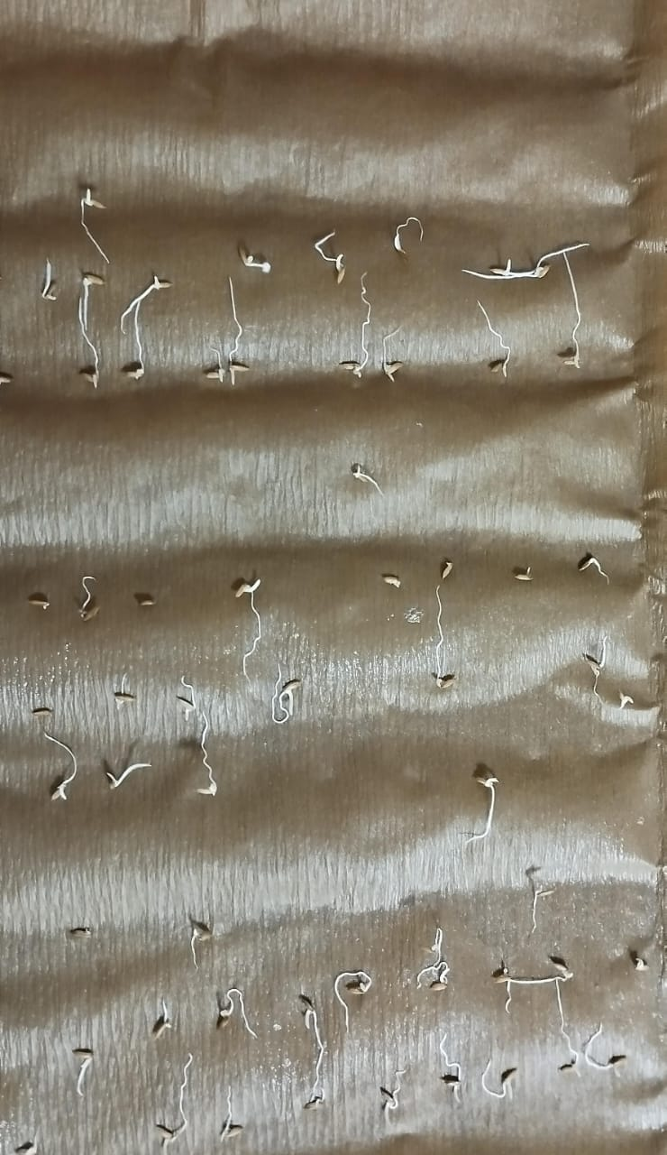

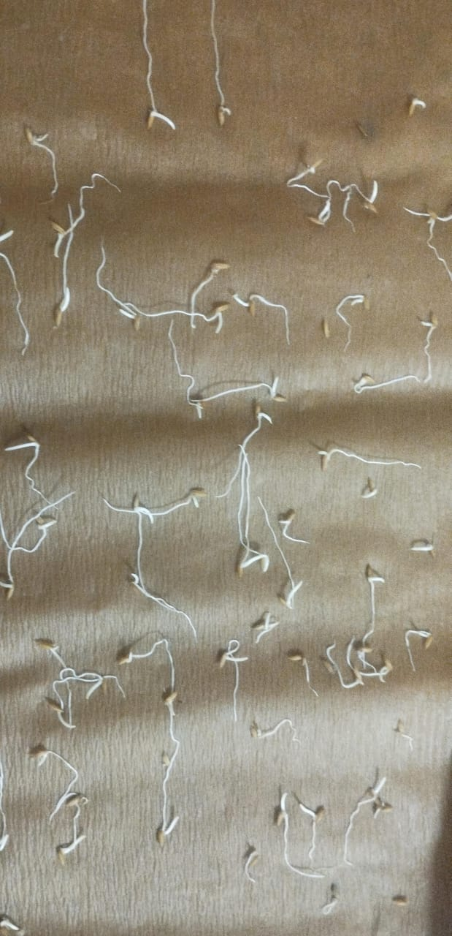

**Figure 1 showing difference in seedling length of controlled conditions and bioprimed with *Azospirillum* at 10% concentration and 12 hours duration of soaking.**

**Root length (cm)**

Root length was significantly influenced by the bio-agents of different concentration and their duration of soaking. The mean root length of seedlings were ranged from 8.24 cm to 11.20 cm. the highest mean root length was observed in seeds bio-primed with *Azospirillum* @10% concentration and 12 hours duration of soaking which is on par with mean root length of seeds bio-primed with *Azospirillum* @ 10% concentration and 24 hours duration of soaking (11.17) cm and the lowest mean root length was noticed in control treatment 8.24 cm with the overall general mean being 9.85 cm.

**Seedling length (cm)**

The length of the seedlings was significantly influenced by different treatments. The mean seedling length of different treatments were ranged from 13.15 to 18.46 (cm) and the highest mean seedling length was observed with *Azospirillum* bio-primed @10% concentration and 12 hours duration of soaking and the lowest mean seedling length was noticed in control treatment 13.15 cm with the overall general mean being 16.08 cm.

The results are in confirmation with Raja *et* al. (2017) where seeds soaked in equal volume of liquid microbial cultures viz., *Azospirillum* or Phosphobacteria @ 1:50 dilution for 18h and pigmented facultative methlotroph (PPFM) @ 1:100 dilution for 24 h recorded highest germination percentage (100% both) and seedling length ( 34.5 and 32.9 cm ) in Paddy.Theincreased germination percentage and high seedling length may be due to production of phytohormones and also due to colonizationof rhizosphere of the plants.

**Seed vigour index-I**

There was a significant difference observed among different treatments for seed vigour index-I. The mean seed vigour index was ranged from 1176.71 to 1737.52. the highest seed vigour index-I was observed with *Azospirillum* bio-primed at @10% concentration and 12 hours duration of soaking and the lowest was recorded in control 1176.71 with the overall general mean being 1453.85.

The results are in harmony with Revathi and Vanangamudi (2014) where seed biopriming with *Trichoderma viridae* @ 80 per cent for 6 h showed more seed vigour index when compared to control in maize and Pacome *et al.* (2013) reported that highest seed vigour index was obtained from seeds inoculated with a combination of *Pseudomonas fluorescens* and *Pseudomonas putida* followed by *Azospirillum lipoferum* in maize*.* The increased seed vigour may be due to production of defense enzymes, improved stress tolerance and increased germination, root and shoot length and production of phytohormones offered by bio agents.

**Seed vigour index-II**

There was a significant difference observed among different treatments for seed vigour index-II. The mean seed vigour index-II was ranged from 9.84 to 11.78. the highest mean seed vigour index-II was noticed with *Azospirillum* bio-primed @10% concentration and 12 hours duration of soaking and the lowest was recorded in control (9.84) with the overall general mean being 10.63.

**EC of seed leachates (µS cm-1)**

There was significant difference observed among different treatments for EC of seed leachates. The mean electrical conductivity of seed leachates was ranged from 38. 20 to 45. 70. the lowest mean EC (38.20) of seed leachates was observed with *Potassium solubilizing bacteria* bio-primed @25% concentration and 24 hours duration of soaking and the highest mean E.C. of seed leachates was noticed in control treatment (45.70) with the overall general mean being 40.63. Basra *et al*. (2003) reported that hydro-primed seeds had lesser electrical conductivity of seeds leachate even after several months of storage.

**CONCLUSIONS**

Seed bio-priming is an efficient method that combines both inoculation of (bio-agent) and hydration of seeds which helps in enhancing germination and good stand establishment of plants and increase in vigour of the seed.

The seeds of BPT-5204 were subjected for both hydropriming and bio-priming with different bio-agents like *Azospirillum*, *Pseudomonas fluorescens*, Potassium solubilizing bacteria, Phosphorus solubilizing bacteria @ different concentrations like 10%, 15%, 20%, 25%, and @ two durations 12 and 24 hours. The bio-primed seeds along with control were used for both field and laboratory studies.

The seed quality of harvested seeds revealed significant differences among different treatments and for different parameters. Among different treatments *Azospirillum* bio-primed@10% concentration and 12 hours duration of soaking recorded highest germination percentage (95.11), highest shoot length (7.21 cm), highest root length ( 11.20 cm), highest seedling length (18.46 cm), highest seed vigour index-I (1737.52), highest seed vigour index-II (11.78), highest protein content (8.97%), highest dry weight of seedlings ( 0.126 g). the lowest EC is observed in potassium solubilizing bacteria @25 % and 24 hours duration of soaking and highest field emergence was noticed in *Azospirillum* @10 % concentration and 24 hours duration of soaking.

**Based on the results obtained from the present study, the following conclusions can be drawn:**

(i) Among different treatments *Azospirillum* @10% concentration and 12 hours duration of soaking was found to be more effective treatment than other treatments.

(ii) There was no significant effect of bio-priming on moisture content of seeds.

Disclaimer (Artificial intelligence)

Option 1:

Author(s) hereby declare that NO generative AI technologies such as Large Language Models (ChatGPT, COPILOT, etc.) and text-to-image generators have been used during the writing or editing of this manuscript.

Option 2:

Author(s) hereby declare that generative AI technologies such as Large Language Models, etc. have been used during the writing or editing of manuscripts. This explanation will include the name, version, model, and source of the generative AI technology and as well as all input prompts provided to the generative AI technology

Details of the AI usage are given below:

1. Not used

2.

3.

**References**

Abdul-Baki, A.A and Anderson, J.D. 1973. Vigour determination in soybean seed by multiple criteria. *Crop Science*. 13: 630-633.

Basra, S. M. A., Farooq, M., and Khaliq, A., 2003, Comparative study of pre-sowing seed enhancement treatments in fine rice (*Oryza* sativaL.). *Pak. J. Life Soc. Sci.* 1(1):21-25.

Basra, S. M. A., M. Farooq, and Tavassum, R. (2005). Physiological and biochemical aspect of seeds vigor enhancement treatments in fine rice. Seed Science and Technology. 33: 623-628.

Gupta, G., Parihar, S., Ahirwar, N. K., Snehi, S. K and Singh, V. 2015. Plant Growth Promoting Rizobacteria (PGPR): current and future prospects for development of sustainable agriculture. *Journal Microbial Biochemistry Technology*. 7: 96–102.

[*https://fas.usda.gov*](https://fas.usda.gov)*.*

*https*://*desagri.gov.in/wp-content/uploads/2024/09/Agricultural-Statistics-at-a-Glance-2023*.

ISTA. 2010. International Rules for Seed Testing. Seed Science and Technology. Supplement Rules. 13: 209-355.

Kumar, R.S and Panneerselvam, A. 2012. Studies on the effect of different native strains of *Azospirillum* on paddy (*Oryza sativa* L.). *Journal of Microbiology and Biotechnology Res*earch. 2(6): 888-893.

Lin, J. M., and Sung, J. M. (2001). Pre- sowing treatments for improving emergence of bittergourd seedlings under optimal and sub-optimal temperatures. Seed Science and Technology, 29: 39-50.

Pacome, A.N., Emeric, K., Didagbe, O., Adjanohoun, A., Marcellin, Sikirou, R., Emma, W.G., Simeon, O.K and Moussa, L.B. 2013. Effect of different plant growth promoting rhizobacteria on maize seed germination and seedling development. *American Journal of Plant Sci*ences. 4: 1013-1021.

Pravisya, P., Jayaram, K.M and Yusuf, A. 2019. Biotic priming with Pseudomonas fluorescens induce drought stress tolerance in *Abelmoschus esculentus* (L.) Moench (Okra). *Physiology and Molecular Biology of Plants*. 25: 101-112.

Raja, K., Sivasubramaniam, K and Anandham, R. 2017. Manipulation of seed germination and vigour by bio-priming with liquid microbial cultures in paddy (*Oryza sativa* L.). *International Journal of Current Microbiology and Applied Sciences.* 6(10): 1612-1618.

Ravikumar, S., Shanthy, S., Kalaiarasi, A and Sumaya, S. 2010. Bioinoculation of halophilic phosphobacteria for raising vigorous seedlings of Rhizophora mucronata. *Archives of Applied Science Research*. 2(6): 261-266.

Revathi, R and Vanangamudi, K. 2014. Bio-priming of maize hybrid seeds with biocontrol agents for improving germination and vigour. *Madras Agricultural Journal.* 101 (13): 59-65.

Shivran, R.K., Rokadia, P and Kumar, R. 2012. Phosphorus and sulphur nutrition with P-solublizing bacterial inoculation enhanced the quality and yield of soybean (Cultivar JS-335). *Madras Agricultural Journal.* 99(13): 68–72

Singh, V., Upadhyay, R.S., Sarma, B.K. and Singh, H.B., 2016. Seed bio-priming with *Trichoderma asperellum* effectively modulate plant growth promotion in pea. *International Journal of Agriculture, Environment and Biotechnology*. 9(3): 361-365.