RESEARCH PAPER

A STUDY ON BUSINESS PERFORMANCE PARAMETERS OF GIRIJAN COOPERATIVE CORPORATION (GCC) IN HIGH ALTITUDE AND TRIBAL ZONE IN ANDHRA PRADESH

Abstract
Girijan Co-operative Corporation (GCC) majorly procures Minor Forest (MFNP), Agricultural produce (AP) and Horticultural Produce (HP) from the tribal farmers by paying them remunerative prices. The growth over the preceding years 2020-21 to 2021-22 was only 2.44 percent which shows rise over the previous year in a small whisker value . The divisons in HAT Zone contributing more in marketing when compared to other divisons in Andhra Pradesh. The value added products are marked with GCC brand which enhanced the trust of customers and captured the market share in sale of products. Tribal farmers expressed to resume the procurement for Adda leafs and Niger seed which are traditional crops and also opioned to supply of mini expellers for oil processing can on payment basis. Promoting digital marketing outlets for finished products with brand will give opportunity for customers to enjoy pure organic products and increase the growth of GCC business.
Keywords: Girijan Co-operative Corporation, tribal farmers, remunerative prices, market, brand,
1. Introduction
The majority of the population belongs to schedule tribe resides in hilly, terrain and dense forest areas where there is no proper market linkages. The incidence of poverty and unemployment is more in tribal population. The tribal people depend upon subsistence economy and adopt primitive technology which fits well with their ecological surroundings. Majority of people practices agriculture and they supplement their income by practicing hunting, fishing and selling minor forest produce (MFP) . Before 1950’s , middle man procures the good quality MFP in a lot from tribal farmers at low prices . The majority of margin on each product is taken by middleman, zamindars, Jagirdhars, contractors instead of tribe farmer. By considering the situation, Government of Composite Madras State had appointed a committee in 1952 to enquire into the problems of the tribals and to suggest remedial measures to improve their economic conditions. Further after a brief study by the government, Malayappan Committee has recommended the formation of multipurpose cooperative credit societies and marketing societies in the tribal areas with the objective of meeting the multiple and varied needs of the people. The following functions of marketing societies are to sell the MFNP surplus produce and essential commodities like oils ,Kerosene on behalf of hill tribes. Further, the cooperative market societies guarantee by the government to the central bank for advancing sufficient money to the societies. The second five year planning (1956-1961) in the field of agriculture, cottage industries and forest cooperatives. Besides the organisation of tribal development blocks, Governmnet of Andhra Pradesh developed a separate agency namely Girijan Co-operative Corporation (GCC) for marketing of agricultural produce in 1956 which inspired the states of Odisha, Bihar and Madhya Pradesh to set up the GCC in their states. Due to the Andhra Pradesh Re-organization Act 2014 , Girijan Cooperative Corporation (GCC) bifurcated between two states which have been included under Schedule-IX of the Act. Andhra Pradesh Girijan Cooperative Corporation Limited (GCC) for residuary Andhra Pradesh State and Telangana Girijan Cooperative Corporation Limited (GCC) for Telangana State under Societies Registration Act.
As a whole , the current main objectives of GCC are procurement of MFNP at remunerative prices from tribal farmers. The second most activity is distribution of essential commodities under Public distribution system . Further, involved in supply of other daily requirements , provision of Credit to tribal farmers for Seasonal agricultural operations . GCC also taken an effort for setting up industrial units , processing centres for value addition to the produce and to sell organic value added products to the consumers. raw coffee pooling, Marketing, , ration Card , distribution of LPG and Super Bazaars. By considering its important role in scheduled areas , an attempt has made to study the business activity , performance of GCC and perception of tribal farmers towards business activities of GCC.
2. Study area & Methodology
High altitude and Tribal Zone in Andhra Pradesh was chosen for study . The secondary data from 2016-17 to 2021-22 was collected from GCC Head office ,Vishakhaptanam. The primary data collected from local tribal farmers in Chinthapalli (23) , Araku valley (22), G.Madugula(23) and Paderu (22) in ASR district with sample size of 90 . The opinions of retail outlets from staff of Araku valley, Chinthapalli has been documented regarding market access and outreach to customers. Simple statistical techniques like percentage analysis, mean and Compound annual growth rate were used.

Figure (i) Pie chart showing the distribution of sample size of tribals in ASR District
2.1 Compound Annual Growth Rate (CAGR)
The exponential compound annual growth rates are estimated by using log linear functions on the time series data on performance parameters of GCC. The semi log exponential functional form is used to analyze the trend in growth rate, which is one of the appropriate functional forms to estimate the growth rate. That is, the growth rate is estimated by using the following semi log functional form:
logY_{t} = a + b_{t}............................. (1)
This equation (1) can be elaborated in details as:
Y_{t}= Y₀ (1+r)^{t}
Taking log on both sides, we get
Log Y_{t} = Log Y₀ + t Log (1+r)................. (ii)

Equation (ii) can be rewrite as
Y = a + bt............................. (iii)
Where, Y= Log Y_{t} ; a = Log Y₀ ; b= Log (1+r),
Y_{t}= Performance parameters (procurement , credit recovery & disbursement)
a= constant
b= Regression coefficient in a series
The annual compound growth rate (s) can be worked out by using:
Antilog (b) =Antilog (log (1+r)).
Antilog (b) =1+r and r = Antilog b-1
Therefore, Compound Annual Growth Rate which can be written as below:
CAGR (%) = r = (Antilog B-1) x100

2.2 Garrett Ranking
The perception by tribal farmers regarding the GCC activities were documented. Garrett ranking technique which identifies and ranks various parameters based on the calculated mean score., Garrtett’s formula for converting normal rank into percent was given by :
Percent Position = 100*(R_{ij}-0.5)/N_{j}
Where,
R_{ij} = rank given for i^{th} factor by j^{th} individual
N_{j} = number of factors ranked by j^{th} individual
The percent position of each rank is converted into scores referring to the table given by Garrett and Woodworth (1969).For each strategy, the scores of individuals respondents are added together and divided by the total number of the respondents for whom scores are added. These mean sores for all the factors are arranged in descending order, ranks are given and most important factors are identified.

3. Results and Discussions
3.1 Progress of Procurement activities by GCC in Scheduled areas in Andhra Pradesh
The increase in the growth rate of MFP & AP procurement during 2017-2022 as shown in Table 1 was 49.97 % which means the surplus produce by tribals are selling in GCC , DR Depots was of cash (2.55%) , super bazaars (1.39% ) which indicates market extended for processed products like sheekai, hair oil and soaps etc. The petrol bunk (25.96%) and gas (20.58%). Further, increase in the growth rate in credit disbursement was 5.81% which indicates the loans disbursement is high where as RMD sales was 0.18%. The decrease in the growth rate in coffee procurement was -19.89% as many of the farmers are selling to alternative market channel like in companies, ITDA , traders and exporting to other states. It is observed that , the credit recovery was -1.81% which indicates irregular repayments by tribal farmers who have taken loans. As shown in Table 1 & Figure 1 , The total business turn over from sales of MFNP, AP and HP by GCC in 2021-22 was Rs. 68.01 crores in which highest share recorded by Seethampeta (54.33 crores) followed by Partvathipuram division (10.26 crores) as shown in figure 1.1 . It is noticed that, the credit disbursement is being stable as shown in figure 1.3 with Rs.1.32 crores in 2021-22 without much fluctuation with Rs.1.36 crores in previous year 2020-21 while the credit recovery from the tribal farmers has been decreasing over the years (Rs.1.13 crores) as shown in figure1.4 .
As per the table 2 , it is observed that, turn over for last 7 years , GCC revenue achievement against targets during 2018-19 & 2019-20 was shortfall with Rs. 177 & Rs. 148 crores respectively. The turnover the business comparing to preceding years was registered positively . The growth over the preceding years 2020-21 to 2021-22 was only 2.44 % ( figure 2 ) which is negative alarm for business activities. The slow growth may be due to pause of collection of MFNP produce by farmers during pandemic covid.
3.2 Purchase Price of Different Minor forest Products
The Minimum Support Price (MSP) for Minor has been extended to Tamarind, Mohwa Commodities in Andhra Pradesh since 2016. In tamarind seed, the procurement price by GCC has been reduced due to low quality is being sold by the tribal farmers. GCC couldn’t able to auction the poor quality product which is causing loss to GCC. With respective to Adda leaf, the item has been totally stopped for few years , as there is less adda leaf sold by tribal farmers to GCC and more adda leaf selling to local restaurants & hotels. Many tribal farmers opined that, the collection of leaf can be resumed by GCC. The procurement price of Naramamidi bark , marking nuts, Myrobalons,nuxvomica has been increased slightly with variation of Rs. 3 to 5 (Appendix 1) .

Table 1 : Turn over for last 6 years Achievement in Crores (Rs)
S.No | Performance Parameter | 2017 | 2018 | 2019 | 2020 | 2021 | 2022 | Mean | Growth rate %
1 | MFP & AP Procurement | 12.82 | 10.67 | 15.92 | 14.95 | 76.37 | 68.01 | 33.12 | 49.97
2 | Coffee Procurement | 3.50 | 8.77 | 6.81 | 5.21 | 1.35 | 2.41 | 4.67 | -19.89
3.1 | ECs - Cash | 21.96 | 17.00 | 15.53 | 15.20 | 36.43 | 16.66 | 20.46 | 2.55
3.2 | ECs - Credit | 2.00 | 2.34 | 1.44 | 1.04 | 0.49 | 0.94 | 1.37 | -22.16
 | Sub-Total of EC | 23.96 | 19.34 | 16.97 | 16.24 | 36.92 | 17.60 | 21.84 | 1.02
4.1 | DR Depots | 50.50 | 47.42 | 40.62 | 41.31 | 40.57 | 30.76 | 41.86 | -8.03
4.2 | Super Bazaar | 5.88 | 5.68 | 5.07 | 5.57 | 6.29 | 5.98 | 5.74 | 1.39
4.3 | Petrol Bunks | 68.88 | 124.90 | 158.54 | 167.40 | 210.76 | 250.43 | 163.48 | 25.96
4.4 | GAS | 10.13 | 16.02 | 19.84 | 19.96 | 23.33 | 29.94 | 19.87 | 20.58
4.5 | DRs - Credit | 45.82 | 45.48 | 53.90 | 57.83 | 19.51 | 35.07 | 42.94 | -10.30
 | Sub-Total of DR | 181.21 | 239.50 | 277.97 | 292.06 | 300.47 | 352.17 | 273.89 | 12.27
5.1 | Credit Disbursement | 0.58 | 2.88 | 1.20 | 1.34 | 1.36 | 1.32 | 1.45 | 5.81
5.4 | Credit Recovery | 0.79 | 3.29 | 0.84 | 1.51 | 1.20 | 1.13 | 1.46 | -1.81
5.5 | RMD Sales | 23.11 | 22.83 | 23.30 | 25.59 | 33.07 | 18.39 | 24.38 | 0.18
 | Grand Total (1+2+3+4+5) | 247.77 | 307.27 | 343.01 | 356.90 | 450.74 | 461.02 | 361.12 | 13.05
*The growth rate analysis compiled by author based on data availability from Girijan Co-operative Corporation, Head Office, Vishakhapatnam

Figure 1:Activity wise progress of GCC business during 2016-17 to 2021-22

Table 2: Table : Short fall & Growth of revenue over the previous period 2016-17 to 2021-22
(Rs in crores)
Year | Target | Achievement | Shortfall T-A | Progress of revenue over the previous years | Turnover of business over previous year  C-P/P *100  (%)
2016-17 | 307 | 247 | 60 | - | -
2017-18 | 317 | 307 | 10 | 60 | 24.29
2018-19 | 520 | 343 | 177 | 36 | 11.73
2019-20 | 504 | 356 | 148 | 13 | 3.79
2020-21 | 505 | 450 | 55 | 94 | 26.40
2021-22 | 510 | 461 | 49 | 11 | 2.44
*The growth rate analysis compiled by author based on data availability from Girijan Co-operative Corporation, Head Office, Vishakhapatnam

Figure 2: Achievement of Revenue by GCC during 2016-17 to 2021-22 (Rs in crore)

3.3 Division wise performance of GCC in Andhra Pradesh
As per the table 3 & figure 3 , the contribution of revenue from HAT zone is Rs. 442.51 and Rs. 18.51 crore from other zones which totally up to sum of Rs.461.02 crores. There are nine divisions in Andhra Pradesh. High altitude and Tribal Zone has 6 divisions namely Seethampeta, Parvathipyram, Paderu, Chinthapalli, R.Chodavaram and Chinthuru. The divisons in HAT Zone contributing more when compared to other divisons in Andhra Pradesh. The total accumulated amount was 442.51 crores during 2021-22. The divisons like Paderu (104.45 crore) & Chinthapalli (97.85 crore) was collecting high revenue due to the existence of indigenous tribal farmers with prime dependence on forest produce. There is a positive percentage growth in the business over the previous years in Parvathipuram (12.10%) , Paderu(15.30%) , Chinthapalli (13.74%), Chinthur (5.49%), Srisailam (3.63%) while there is negative growth registered in Seethampeta (-8.57%), Rampachodavaram(-2.47%),Tirupati (-57.14%) and Vishakhaptnam(-53.04%).
Table 3 : Divison wise growth in the business during 2016-17 to 2021-22 in crores
S.No | Division | 2016-17 | 2017-18 | 2018-19 | 2019-20 | 2020-21 | 2021-22 | Growth %to previous year (2020-21& 2021-22)
1 | Seethampeta | 11.56 | 10.55 | 12.41 | 14.13 | 69.72 | 63.74 | -8.57%
2 | Parvathipuram | 22.09 | 23.53 | 26.46 | 42.79 | 47.26 | 52.98 | 12.10%
3 | Paderu | 59.50 | 77.35 | 84.41 | 73.03 | 90.64 | 104.45 | 15.30%
4 | Chintapalli | 50.35 | 78.00 | 79.13 | 81.28 | 86.04 | 97.85 | 13.74%
5 | R Chodavaram | 73.41 | 91.46 | 82.96 | 80.59 | 79.86 | 77.89 | -2.47%
6 | Chinthuru | - | - | 28.13 | 35.21 | 43.23 | 45.60 | 5.49%
 | Total | 216.91 | 280.89 | 313.52 | 327.03 | 416.75 | 442.51
7 | Tirupathi | 8.46 | 6.90 | 7.75 | 6.08 | 6.04 | 2.59 | -57.14%
8 | Srisailam | 6.72 | 4.53 | 6.21 | 6.77 | 4.94 | 5.12 | 3.63%
9 | Visakhapatnam | 15.68 | 14.94 | 15.54 | 17.06 | 23.01 | 10.81 | -53.04%
 | Total | 30.86 | 26.38 | 29.50 | 29.90 | 33.99 | 18.51
 | Total of HAT & Other zones | 247.77 | 307.27 | 343.01 | 356.94 | 450.74 | 461.02 | 2.29%

Figure 3: Share of turnover in GCC Business in HAT Zone in Andhra Pradesh

Figure 4: Growth in business across divisions in Andhra Pradesh during 2016 to 2022
3.4 GCC helping hand to Coffee farmers in HAT Zone through Coffee Project
The price offered by GCC for coffee per kilogram is slightly increased over the years as shown in the table 4 . The Parchment coffee has highest demand . The price per Kg as of 2021-22 is Rs. 270 against Rs.155 during the year 2015-16. The price of Cherry is Rs. 69.71 during 2015-16 and increased by twice price during 2021-22 with Rs.135. The price of Robust is stable all the years with range of Rs.60 to 67. Though the procurement activity from tribal farmers was stable by GCC but there is slight decline observed from 2019-20. The negative growth rate in procurement was observed for all three types of Coffee noticed with -28.68% for Parchment, Cherry (-32.39%) and Robust (-32.14). The pandemic attack of Covid is one of the reason for decline of sale of coffee produce by farmers to GCC branch as expressed by farmers. Most of the tribal farmers pooling a coffee lot and selling to traders for middleman for urgent requirement of cash. As shown in Table 5 , the cumulative sale value from 2015-16 to 2021-22 was Rs. 3771.48 lakh which indicates the positive sign . Nearly 14990 tribal farmers have been benefitted from this procurement activity.

Table 4 : Procurement of coffee during 2015-16 to 2021-22 (Metric Tonnes)
Year | Parchment |  | Cherry |  | Robust cherry |  | Total Quantity
Year | (Qty in MTs) | Price  (Per Kg) | (Qty in MTs) | Price  (Per Kg) | (Qty in MTs) | Price  (Per Kg) | (in MTs)
2015-16 | 166.11 | 155.78 | 1237.84 | 69.71 | 0.00 | 0.00 | 1403.95
2016-17 | 145.70 | 151.07 | 170.99 | 81.72 | 13.35 | 60.62 | 330.04
2017-18 | 203.34 | 139.68 | 672.76 | 78.12 | 2.52 | 60.62 | 878.62
2018-19 | 187.46 | 130.00 | 867.19 | 63.30 | 10.26 | 67.77 | 1064.91
2019-20 | 42.00 | 156.92 | 145.22 | 67.93 | 13.30 | 66.80 | 200.52
2020-21 | 9.75 | 255.00 | 131.30 | 112.00 | 64.49 | 67.00 | 205.54
2021-22 | 72.75 | 270.00 | 63.78 | 135.00 | 0.12 | 60.00 | 136.65
Total | 827.12 |  | 3289.08 |  | 104.04 |  | 4220.24
CAGR% | -28.68 |  | -32.39 |  | -32.14 |  | -28.55

Table 5 : Sale Value of Coffee (Rs in Lakh)
Year | Parchment | Cherry | Robust | Total sale value
2015-16 | 258.77 | 862.90 | - | 1121.66
2016-17 | 220.12 | 139.73 | 8.09 | 367.94
2017-18 | 284.03 | 525.56 | 1.53 | 811.12
2018-19 | 243.70 | 548.93 | 6.95 | 799.59
2019-20 | 65.91 | 98.65 | 8.88 | 173.45
2020-21 | 24.86 | 147.06 | 43.21 | 215.12
2021-22 | 196.43 | 86.10 | 0.07 | 282.61
Total | 1293.81 | 2408.93 | 68.74 | 3771.48
Percentage(%) | 34.31 | 63.87 | 1.82 | 100.00

3.5 SWOT analysis of Girijan Cooperative Corporation
The primary survey to the local tribal areas in ASR district gave a insight on the functioning of GCC and the tribals expectation from GCC. The SWOT has done to understand the structure of corporation. Procurement of Produce starts from December to March/April. From April to November the activities like recovery of loans, collection and distribution are done by staff of GCC. The GCC procures the items from tribals and it send to godowns. From the godowns , the produce are tender to highest bid. After the achieved target in procurement by staff, it will be channelized to company. Range officer /DFO is authorised for permit I (Godowns to tender) & Permit II (Tender to Company). The processing units which are near to ASR district are in Araku Valley, Vizianagaram and Rajamahendravaram
Table 6: SWOT analysis of Girijan Cooperative Corporation
 | Strengths | Weakness
Internal Factors  (Strengths & Weakness ) | The sub divisional offices are located at tribal and forest areas which enable a direct contact between tribal producers and GCC | Insufficient godowns and infrastructure to store bulk produce.  Problem in sale of produce
Internal Factors  (Strengths & Weakness ) | Retail market outlets have captured the eyes of customers. The products are being sold at reliable price & high quality. | Focus in procurement of only MFP/HP/AP
Internal Factors  (Strengths & Weakness ) | The products are marked with brand GCC which enhanced the trust of customers. | The low purchase price of MFP produce from tribals compared to market price will reduce the growth of the business in long run .
Internal Factors  (Strengths & Weakness ) | GCC supported by state and central governments. The MSP is fixed by TRIFED and state government. GCC Head Division chairman will be headed by officers in rank of IAS/IFS which ensures transparency in marketing activities. | Not assure in achieve target procurements even after regularly visiting villages and procuring produce through vehicles by GCC staff
External Factors  (Opportunities & threats) | Opportunities | Threats
External Factors  (Opportunities & threats) | GCC procuring items from individual/ FPOs/SHGs thereby contributing the region specific development in market aspects. | Some of tribals selling low quality produce (tamarind) to GCC
External Factors  (Opportunities & threats) | It eradicated the intervention of middleman. | Emerging of fast phase local markets as competation to GCC
External Factors  (Opportunities & threats) | Engaging of local tribals in contractual works will empowering the people. | Some tribals couldn’t able to return the loan in time which is a loss to GCC
External Factors  (Opportunities & threats) | Value addition of MFP fetches high prices for products | Storage of produce for long time in godown gets damage due to rat attack and moulds
External Factors  (Opportunities & threats) | Promoting digital marketing outlets for MFP /AP/HP produce will give opportunity for customers to enjoy pure organic products

3.6 Suggestions by farmers towards GCC activities: The 90 sample farmers have been interviewed through individual and focused group discussions. The sample size farmers were only small and marginal tribal farmers. As shown in Table 7 , Majority of farmers expressed their positive gratitude towards GCC activities. Few suggestions are documented and analysed through garattee ranking technique. Majority of the farmers with mean value 78 expressed (that more local storage godown need to established in favour of tribal farmers until the product reach to sale point. Some farmers (mean value 65 ) with opined that reorganise the price of commodities according to market price . About average of 62 persons expressed that, the village youth can be act as licensed middle man by GCC during procurement which creates direct employment . Further, few of tribals expressed that resuming the procurement for adda leafs and niger seed which are famously known for tribal traditional crops. As the value addition augmented the price of product, the tribals expressed to supply of mini expellers for oil processing can be offered by GCC on payment basis . As the many of the tribals don’t have cash on hand , they opined to extend the duration of loan payment period.
Table 7: Suggestions by tribal farmers towards activities of GCC
Parameters | Garatte Percent | Garatte Score | Mean score | Rank
Rise in procurement price of commodities | 25 | 63 | 65 | 2
Adding of Adda leaf & Niger seed in the list of procurement | 58.33 | 46 | 55 | 4
Encouraging local Youth employment in co-operation G | 41.66 | 54 | 62 | 3
Supply of mini oil expeller to tribal farmers should initiate | 75 | 37 | 51 | 5
Duration of repayment period of loan should increased | 91.66 | 23 | 45 | 6
Local storage godown should be provided by GCC in villages for tentative storage of MFP until sale | 8.33 | 77 | 78 | 1

Figure 5: Mean Score value of Suggestions expressed by Tribal Farmers in ASR district

4.Conclusion and Policy Implication
Girijan Co-operative Corporation (GCC) played a major role in welfare of tribal farmers in scheduled areas. It helps the tribals by direct procuring Minor forest produce, coffee beans , disbursing of credits and essential commodities at reliable prices. It is an historical break in creating a marketing activities in scheduled areas especially in High Altitude and tribal Zone. The divisions in HAT Zone contributing more when compared to other divisions in Andhra Pradesh. The total accumulated amount was 442.51 crores during 2021-22. The divisions like Paderu (104.45 crore) & Chinthapalli (97.85 crore) was collecting high revenue due to the existence of indigenous tribal farmers with prime dependence on forest produce. Despite of its important existence in hilly and slope areas, many of the farmers diverting their products to urban sale points. Therefore, it is necessary to GCC to reorganise and hike the prices of the products.
5. Acknowledgment
The research work is carried out in RARS ,Chinthapalli during the year 2023-2024 as part of first author’s State level Technical Programme which is non plan. The authors are thankful to Head office, GCC Vishakhapatnam in providing secondary data which enable to draw conclusions needed for research work.

6.Competing Interests Disclaimer:
Authors have declared that they have no known competing financial interests or non-financial interests or personal relationships that could have appeared to influence the work reported in this paper.

Disclaimer (Artificial intelligence)
Author(s) hereby declare that NO generative AI technologies such as Large Language Models (ChatGPT, COPILOT, etc.) and text-to-image generators have been used during the writing or editing of this manuscript.
7. References
Chinnadurai, M., Varadharaj, S., & Chitra, R. (2018). Production, marketing and value chain of tamarind in India. In Tamarind science and technology1 (1) ,116-132
Lakshmi, V. V., & Paul, M. M. (2019). Socio-economic conditions of tribal communities in Telangana and Andhra Pradesh–A review. Acta Scientific Agriculture, 3(8), 104-109.
Mehta, A. K. (1998). Administrative Responsiveness and Competitiveness: Gum Karaya Case. Indian Journal of Public Administration, 44(2), 157-165.
Johnson, T. S., Agarwal, R. K., & Agarwal, A. (2013). Non-timber forest products as a source of livelihood option for forest dwellers: role of society, herbal industries and government agencies. Current Science, 104(4), 440-443.
Kumar, C. S., Kumar, K., Paul, K., Gopal, P. V., & Rao, V. S. (2023). Determinants of prices of minor forest produce (MFP) in high altitude and Tribal (HAT) zone of Andhra Pradesh.
Naik, K. T., & Kumar, G. V. PERFORMANCE OF GIRIJAN COOPERATIVE CORPORATION LIMITED IN ANDHRA PRADESH: SOME ISSUES. Globalisation-Agricultural Development of tribes issues and challenges
Ravikumar, J., & Dhanraj, S. (2020). Role of Girijan Co-operative Corporation in Procurement of Agricultural Produce from the tribal farmers In Tribal areas of Telangana State-A Study. PalArch's Journal of Archaeology of Egypt/Egyptology, 17(7), 8947-8955.
Ravikumar, J., Dhanraj, S., & Bandaru, R. K. (2021). Digital Marketing of Andhra Pradesh Girijan Co-Operative Corporation Ltd. Products: Opportunities and Challenges. Pacific Business Review International, 14(5).
Sravan Kumar, G. (2011). Marketing Of Minor Forest Produce In Tribal Areas By Girijan Co-Operative Corporation In Visakhapatnam District Of Andhra Pradesh (Doctoral Dissertation, Acharya Ng Ranga Agricultural University).
Sankar, O. S. S. (2018). Climate Dimensions in Girijan Cooperative Corporation Ltd., Visakhapatnam. International Journal of Multidisciplinary Educational Research, 7(2), 188.
Teki, S. (2017). Role of Indigenous Eco‐Friendly Technologies and Microfinance for Forest‐Living Communities’ Livelihoods: Case Study of Andhra Pradesh, India. Sustainable Development, 25(1), 1-10.

.

Appendix 1
Purchase Price of commodities by GCC
 | Commodity | 2020-21 | 2021-22 | 2022-23 | 2023-24
I | MFP items
1 | Tamarind Seed | 36.00 | 36.00 | 32.40 | 32.40
2 | Deseeded Tamarind | 63.00 | 63.00 | 63.00 | 63.00
3 | Pungam Seed | 22.00 | 22.00 | 22.00 | 22.00
4 | Mohwa Seed | 29.00 | 29.00 | 29.00 | 29.00
5 | Gum Karaya | 114.00 | 114.00 | 114.00 | 114.00
II | Other MFP items
1 | Naramamidi bark | 22.00 | 20.00 | 18.00 | 20.00
2 | Cleaning Nuts | 45.00 | 50.00 | 50.00 | 50.00
3 | Sheekakai | 50.00 | 55.00 | 55.00 | 40.00
4 | Dry Amla | 55.00 | 60.00 | 60.00 | 60.00
5 | Soap nuts | 25.00 | 35.00 | 45.00 | 50.00
6 | Marking nuts | 10.00 | 12.00 | 12.00 | 18.00
7 | Myrobalans | 12.00 | 15.00 | 15.00 | 18.00
8 | Nuxvomica | 52.00 | 55.00 | 55.00 | 60.00
9 | Tanikayalu | 15.00 | 15.00 | 15.00 | 15.00
10 | Maredugaddalu | 350.00 | 400.00 | 500.00 | 400.00
11 | Bee wax | 150.00 | 160.00 | 160.00 | 160.00
12 | Gum Oilbanum Gr.I | 110.00 | 110.00 | 110.00 | 110.00
13 | Gum Oilbanum Gr.2 | 70.00 | 70.00 | 70.00 | 70.00
14 | Gatchakayalu | 40.00 | 45.00 | 45.00 | 45.00
15 | Tamarind Seed | 10.00 | 10.00 | 10.00 | 10.00
16 | Flower tamarind | 85.00 | 85.00 | 85.00 | 85.00
17 | Hill broom Gr.1 | 35.00 | 35.00 | 35.00 | 35.00
18 | Hill broom Gr.2 | 30.00 | 35.00 | 35.00 | 30.00
19 | Hill broom Gr.3 | 25.00 | 25.00 | 25.00 | 25.00
20 | Rock bee honey | 170.00 | 170.00 | 200.00 | 200.00
21 | Apiary honey | 150.00 | 150.00 | 150.00 | 150.00
22 | R.S.Roots
III | Agricultural Produce
1 | Rajmah White |  |  |  | 90.00
2 | Rajmah Red |  |  |  | 75.00
3 | Ragi |  |  |  | 22.00
4 | Cuttings |  |  |  | 40.00
5 | Annato seed |  |  |  | 80.00
6 | Black gram |  |  |  | 55.00
Source: Collected from Divisions of GCC office in Koyyuru & Chinthapalli Mandal of HAT Zone

Photographs during Survey
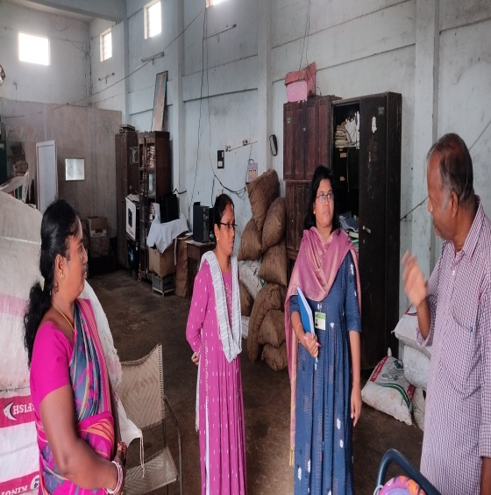  Collecting information from GCC Godown Office, Chinthapalli | 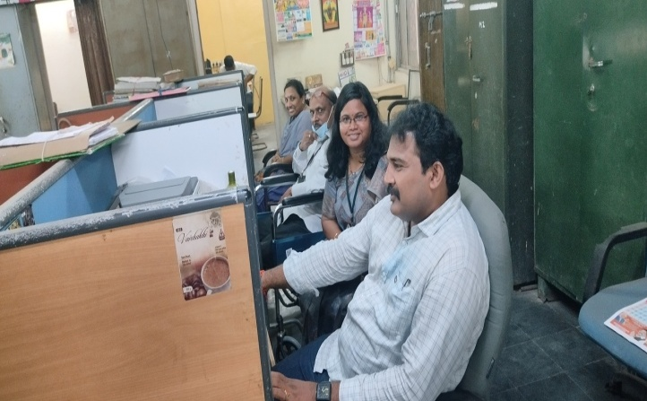  Collecting secondary data required for analysis from GCC Head Office, Vishakhapatnam
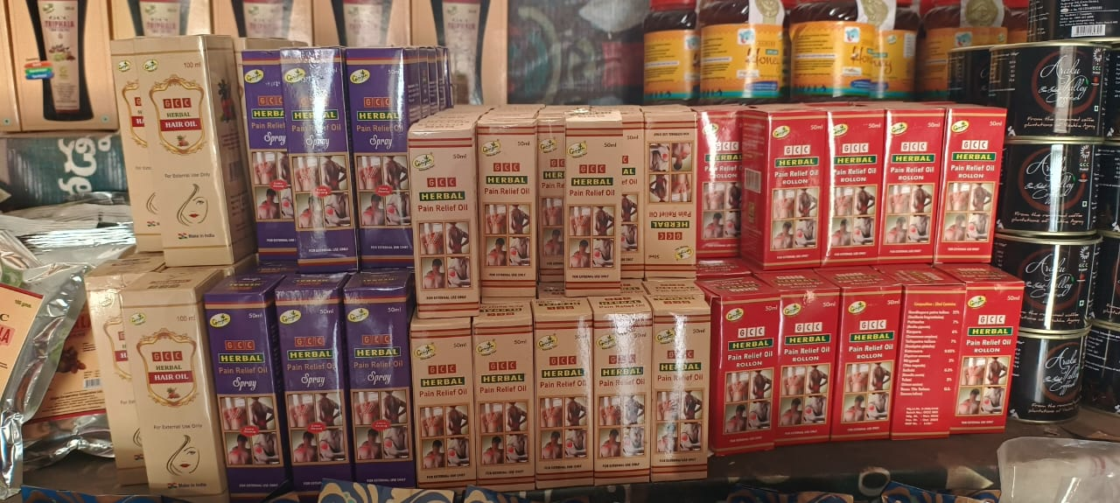  GCC brand on Value added MFP products in Retail outlet | 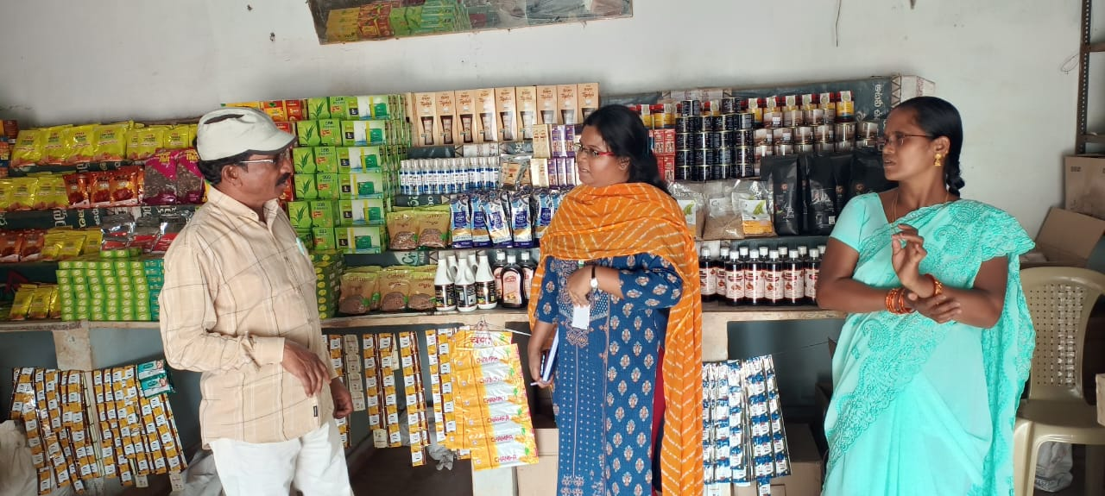  Collecting information in Retail market outlet, Araku Valley

