**Concentration of uranium in groundwater and its health effects around the Indira Gandhi Super Thermal Power Project in Jharli, Haryana (India).**

**Original research article**

**Abstract**

Contamination of uranium in ground water is topic of concern now a days across the world as the ground water is the primary source in rural and urban parts of India. Burning coal in thermal power projects is one of the several actions that might discharge uranium into the environment. These efforts unintentionally raised the Technically Enhanced Natural Radioactivity (TENR) levels of natural radionuclides and their radiation levels in the surroundings. The most significant sources of electricity produced are thermal power projects. But the environmental effects of these industrial operations cause questions. This study examines the uranium concentration in groundwater around the Power Plant and its health effects on nearby populations. High uranium content in drinking water can seriously compromise your health. This is so because uranium is radioactive and can cause nephrotoxicity and higher cancer risk. Groundwater samples were gathered and examined within a 0 to 4 kilometer range from many locations surrounding the water plant. Finding the degree of Uranium contamination is the aim of the project and LED fluorimetery technique is used. In terms of radiation and chemistry as well, uranium is a well-known dangerous element. The USEPA labeled uranium a carcinogen in 1991 and urged that drinking water should contain no uranium. With an average of 47.59 µg/L, the uranium content ranged from 2.64 to 201.9 µg/L. Average of 1.18 Bq/L, the activity concentration (Ac) ranged from 0.06 to 5.07 Bq/L. The average LADD range of 0.05/4.00 µg/kg/day was observed. The findings of this study helps in assessing public health and radiological risks and mainly asseses water quality with major implications towards environmental health. The study helps in evaluation of contamination risks including health risks like kidney damage and cancer.

**Keywords:** Uranium, LED fluorimeter, E.C.R., groundwater, LADD, chemical risks.

**1. Introduction**

A naturally occurring radioactive material, uranium can find several routes of seeping into ground. Public health is seriously threatened when the uranium concentration in groundwater exceeds the allowed limits. Uranium denser than lead by seventy percent. The isotope composition of uranium in nature is exactly that of uranium-238 (99.2739-99.2752%). Exceptionally low Uranium-234 (0.050-0.0059%) and Uranium-235 (0.7198-0.7202%) concentrations. The UN Scientific Committee on the Effects of Atomic Radiation (UNSCEAR) reports a range of 300 µg kg -1 to 11.7 mg kg -1 for soil uranium content. For a 70-kg male, uranium intake averages 2.6 µg daily, with one-third coming from drinking water (ATSDR, 1999). By (USEPA 2012; W.H.O 2011) Long-term uranium contamination of drinking water can lead to a range of health issues, particularly with regard to the kidneys. Studies on drinking water high in uranium have linked a higher risk of kidney damage, chronic kidney disease, and perhaps other health problems. Children, pregnant women, and people with renal issues prior to uranium exposure are more likely to suffer harmful consequences from the element. WHO and USEPA set a 30 ppb maximum contamination level (MCL).

Research by ( W.H.O. 1998; R.Jakhu et al., 2016) Chemical toxicity hazards are more severe than radiological ones. According to L.Domingo et al., 1995) Uranium metal is clearly bad for our bodies, especially for our kidneys. Water and other meals are the main ways one consumes uranium. Uranium often accumulates in the kidneys, liver, and bones (P.Kurttio et al., 2005) following intake. About 66% of the uranium the body absorbs passes right away through urine. The residual uranium is distributed and accumulates in soft tissues ( M.E. Wrenn et al., 1985), kidneys (12–25%), and bones (10–15%). Apart from that, uranium contamination can change the ecological balance, therefore affecting agricultural output and aquatic life. Eating food products polluted with uranium could seriously endanger human health since uranium can build up in the food chain.

Comprehensive assessments of groundwater quality must be conducted, especially in areas where thermal plants and industrial complexes can be sources of uranium pollution. To protect humans and the environment from uranium-contaminated groundwater, monitoring, remediation, and public awareness campaigns are essential. This study estimates chemical and radioactive dangers around the Indira Gandhi Super Thermal Power Project within 0–4 km. These findings can inform local management methods and laws.

**2.Study Area**

Indira Gandhi Super Thermal Power Project is in Jhajjar, Haryana. Jharli hamlet to the north and Khanpur Khurd to the south border the plant. Fig. 1 shows the project site between 28°28'43"N and 76°22'31". APCPL is a joint venture. NTPC Ltd., 25% HPGCL, and 25% IPGCL control half of it. Registered as a private limited company by the Central Government of India, Delhi, and Haryana on December 21, 2006. In Haryana's Jhajjar District, APCPL built the coal-based Indira Gandhi Super Thermal Power Project (IGSTPP) near Jharli Village. A 3x 500MW power plant is being built in Stage I. all three of the units have been commissioned at present. In Haryana, it has the largest thermal capacity plant.

Generation of energy from this facility is mostly dependent on The area boasts alluvial deposits that influence groundwater flow and quality, therefore impacting the hydrological characteristics. Commonly found in the Indo-Gangetic Plains, the geology of the area is essentially composed of sedimentary rocks, sandstones, shales, and clays. Both the spread of groundwater and the likelihood of pollution from industrial activities depend on these formations. Understanding the geological background is essential to assess the environmental impact of the power plant, particularly with relation to the quality of the groundwater and the likely migration of heavy elements such as uranium.

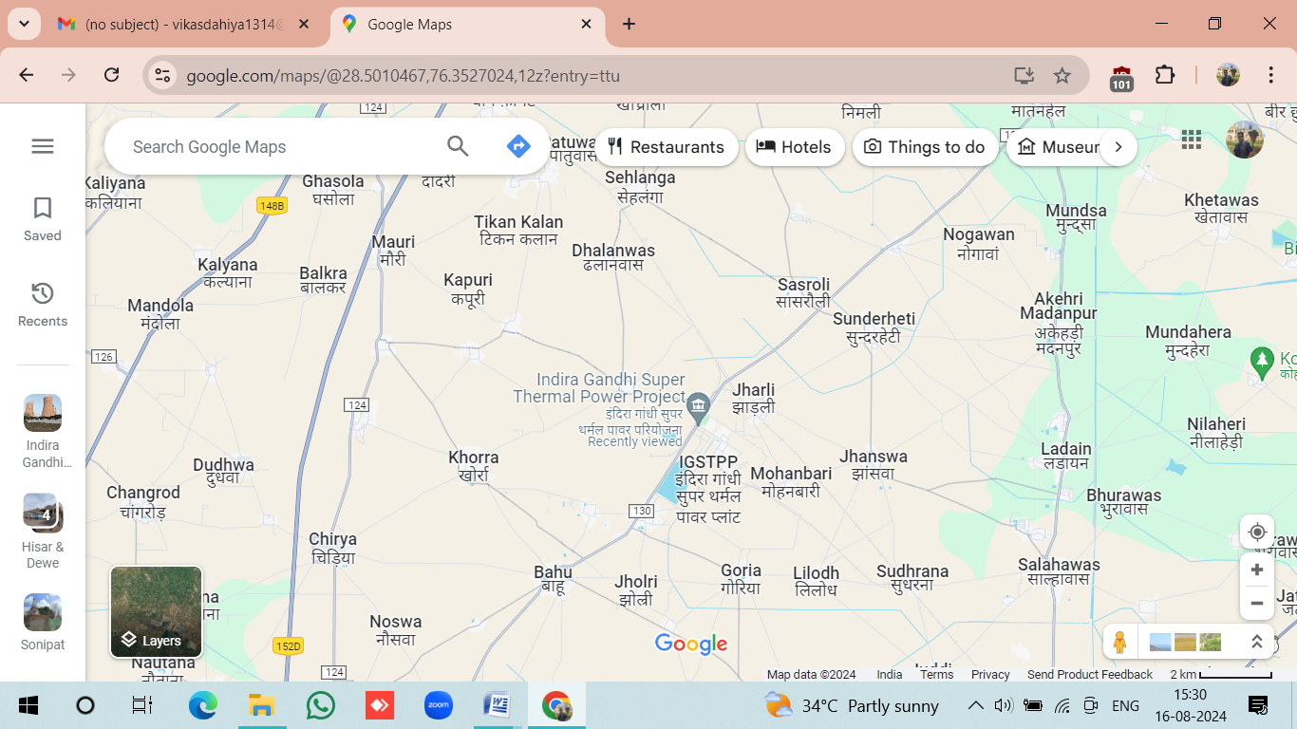

Figure 1.Haryana's Indira Gandhi Super Thermal Power Project

**3. Experimental Techniques**

**3.1 Sampling**

Hand pumps, canals, tubewells, bowlis, and wells were sampled. Water samples were carefully collected in polyethylene bottles pre washed with distilled water to avoid contamination. Uranium, pH, and TDS were measured after filtering with 0.45 micron paper. Within 3 days of sampling TDS were measured and analyzed for uranium content. All samples were collect during the month of May, 2024 and analyzed.

**3.2 Estimation of Uranium concentration**

The LED Fluorimeter is used to identify and count luminous compounds, including uranium. It is detected and measured after using light emitting diodes as the excitation source to produce light at a designated wavelength, hence activating the fluorescent species.

Quantifying uranium is most sensitive and efficient with a detection limit of 0.5 µg/L to 1000 µg/L with an accuracy of ±10% or 0.05 µg/L. Kumar et al. (2016) report better reproducibility than ±5%. ICP-MS achieved precisions of ±5% RSD and similar degrees of accuracy (Rani et al., 2013). Using an LED fluorimeter (Quantalase LF-2a), figure 2 displays the estimated uranium concentration of the gathered water samples. Varied uranium complexes had varied fluorescence yields, thus Fluren was added to the sample to combine them. Fluren (Fluorescence Enhancing Reagent) an inorganic reagent was added to convert all the complexes into a single form. Using an ultra-low fluorescence fused silica cuvette, a 6 ml sample with 10% Fluren was analyzed for Uranium in the fluorimeter.

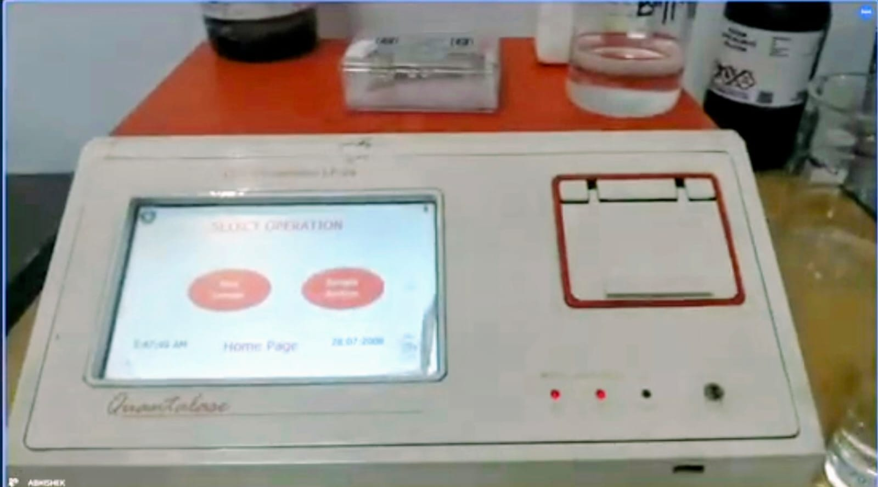

**Figure 2.** LED Fluorimeter (Quantalase LF-2a).

**3.3 Health Risk Assesment**

This research predicts lifelong average daily dosage and excess cancer risk (ECR).Uranium-generated ionizing radiation causes excess cancer risk, while chemicals produce LADD. Chemical toxicity, not radioactivity, is uranium's biggest health risk.

**3.3.1 Estimation of Excess Cancer Risk**

Radiological risk—Extra cancer risk—assessed using these calculations( EPA 2000).

Ground Water Excess Cancer Risk = Uranium Concentration x Risk Factor (Per Bq/L) (1)

Uranium value (μg/L) x conversion factor (0.025 Bq/L) Bq/L Uranium Concentration.

Risk factor is calculated by multiplying risk coefficient (Bq-1) by water intake rate (L/day) and exposure period (days).

The risk coefficients for death and morbidity were 1.19 and 1.84 x 10-9 Bq-1. Daily water consumption was 1.38 liters; exposure was 25,509 days. Death and morbidity risk factors were 4.19 and 6.48 x 10-5, respectively. The variation in cancer mortality and morbidity was 2.51 x 10-6 to 1.96 x 10-4 and 4.27 x 10-6 to 3.03 x 10-3.

**3.3.2 Estimation of Life Time Average Daily Dose**

Any material's chemical toxicity risk can be determined by LADD (Lifetime Average Daily Dose). By( W.H.O. 1998) for estimation, use these formulas

LADD = Ci x IR x EF x LEBW x AT (μg/kg/Day) (2)

Assume 1.38 L/Day ingested rate (IR). For equation (2), Ci represents the concentration of U in groundwater (μg/L). EF is exposure frequency—days/year—365 days. LE 69.89 years means years of life expectancy. BW is 70 kg. Average time is 25509 days( W.H.O. 1998). A chemical toxicity risk (LADD) range of 0.05-4.00 μg/kg/day was observed.

4**. Results**

Table 1 lists computed radiological risks and chemical hazards as well as concentration of Uranium for every water sample. LED Fluorimeter (Quantalase LF-2a) analysis of the samples With mean value 47.59 µg/L and activity concentration (Ac) in the range (0.06 – 5.07) Bq/L with mean value 1.18 Bq/L and life time average daily dose (LADD) in the range 0.05 – 4, the concentration of Uranium varied from (2.64 – 202.9) µg/L.

Of the 15 samples, 7 (47%) were determined to be less than 15 µg/L—the WHO 2004 acceptable limit( W.H.O. 2004). Four (27%) showed levels below 30 µg/L, the USEPA limit (USEPA 2012). Four out of 15 samples (26%) exceeded the allowable amount of 60 µg/L defined by AERB, DAE (P.K.Ghosh et al., 2007). Pie chart

s in fig 3 show samples of various concentrations.

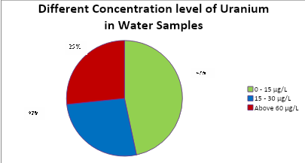

Figure 3. Pie Chart of different concentration of Uranium

| **Table – 1**  **Concentration of Uranium, computed radiological and chemical hazards per water sample around Indira Gandhi Super Thermal Power Project (Jharli) India** | | | | | | | | | | |
| --- | --- | --- | --- | --- | --- | --- | --- | --- | --- | --- |
| **Sr No** | **Label of Sample** | **GPS Location** | | **Conc. of U**  **(**µg/L) | **Ac**  **(Bq/L)** | **R**  **Mortality** | **R**  **Morbility** | **ECR**  **Mortality** | **ECR**  **Morbility** | **LADD**  **(**µg/kg/day) |
| **Latitude** | **Longitude** |
|  | S-1 | 28°29'44.9"N | 76°21'42.1"E | 94.46 | 2.36 | 4.19 E-05 | 6.48 E-05 | 9.88 E-05 | 1.52 E-04 | 1.86 |
|  | S-2 | 28°30'36.3"N | 76°22'15.1"E | 6.619 | 0.16 | 4.19 E-05 | 6.48 E-05 | 6.70 E-06 | 1.03 E-05 | 0.13 |
|  | S-3 | 28°30'48.1"N | 76°21'32.2"E | 14.24 | 0.35 | 4.19 E-05 | 6.48 E-05 | 1.46 E-05 | 2.27 E-04 | 0.28 |
|  | S-4 | 28°29'34.4"N | 76°21'35.6"E | 187.2 | 4.68 | 4.19 E-05 | 6.48 E-05 | 1.96 E-04 | 3.03 E-03 | 3.69 |
|  | S-5 | 28°31'05.6"N | 76°21'57.6"E | 6.56 | 0.16 | 4.19 E-05 | 6.48 E-05 | 6.70 E-06 | 1.03 E-05 | 0.13 |
|  | S-6 | 28°29'54.7"N | 76°21'10.6"E | 21.42 | 0.53 | 4.19 E-05 | 6.48 E-05 | 2.22 E-05 | 3.43 E-05 | 0.42 |
|  | S-7 | 28°30'03.4"N | 76°20'53.7"E | 12.48 | 0.31 | 4.19 E-05 | 6.48 E-05 | 1.29 E-05 | 2.00 E-05 | 0.25 |
|  | S-8 | 28°28'21.6"N | 76°20'19.6"E | 17.64 | 0.44 | 4.19 E-05 | 6.48 E-05 | 1.84 E-05 | 2.85 E-05 | 0.35 |
|  | S-9 | 28°28'39.5"N | 76°24'12.2"E | 24.43 | 0.61 | 4.19 E-05 | 6.48 E-05 | 2.55 E-05 | 3.95 E-05 | 0.48 |
|  | S-10 | 28°27'46.6"N | 76°22'40.6"E | 27.61 | 0.69 | 4.19 E-05 | 6.48 E-05 | 2.89 E-05 | 4.47 E-05 | 0.54 |
|  | S-11 | 28°29'56.0"N | 76°23'04.3"E | 86.32 | 2.15 | 4.19 E-05 | 6.48 E-05 | 9.00 E-05 | 1.39 E-04 | 1.70 |
|  | S-12 | 28°28'28.2"N | 76°21'22.4"E | 202.9 | 5.07 | 4.19 E-05 | 6.48 E-05 | 2.12 E-04 | 3.29 E-04 | 4.00 |
|  | S-13 | 28°27'45.9"N | 76°21'30.3"E | 2.96 | 0.07 | 4.19 E-05 | 6.48 E-05 | 2.93 E-06 | 4.53 E-06 | 0.06 |
|  | S-14 | 28°29'27.9"N | 76°22'47.7"E | 2.64 | 0.06 | 4.19 E-05 | 6.48 E-05 | 2.51 E-06 | 4.27 E-06 | 0.05 |
|  | S-15 | 28°30'31.8"N | 76°22'30.5"E | 6.26 | 0.15 | 4.19 E-05 | 6.48 E-05 | 6.28 E-06 | 9.71 E-06 | 0.12 |

Concentration of Uranium varying in the range 2.64 μg/L to 202.9 μg/L is shown by the fig 4 below:

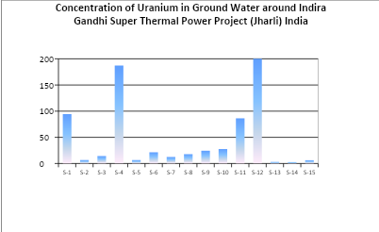

Figure 4. Concentration of Uranium in μg/L in different water samples

**5. Discussion**

The results of this study are compared to Uranium levels in water samples from different countries in Table 2:

| **Table 2:**  Uranium Concentration in Drinking Water Samples From Different Countries | | | | |
| --- | --- | --- | --- | --- |
| **Sr No** | **Country** | **Basic Source** | Uranium Concentration (μg/L) | **Reference** |
| 1 | Amazonas (Brazil) | Groundwater | 0.01 – 1.36 | [M.L.D. et al., 2015] |
| 2 | Southwestern Sinai (Egypt) | Groundwater | 328 - 560 | [H.A.S. et al., 2013] |
| 3 | Northern Greece | Groundwater | 0.01 – 10 | [I..A.Katsoyiannis et al., 2007] |
| 4 | Russia | Groundwater | >477 | [O.L. Gaskova et al., 2013] |
| 5 | Ulaanbaatar (Mongolia) | Groundwater | <0.01 –57 | [J.Nriagu et al., 2012] |
| 6 | Switzerland | Groundwater | 0.05 – 92.02 | [E. Stalder et al., 2012] |

**6. Conclusion**

Uranium concentration in water samples near the Indira Gandhi Super Thermal Power Project ranges from 2.64 to 202.9 μg/L, ranging from 0 to 4 k. Out of 15 water samples, 74% were below 30 μg/L, meeting WHO, USEPA, and AERB acceptable limits. However, 26% of samples (4/15) had Uranium concentrations above 30 μg/L. Uranium concentration averages 47.59 μg/L, Activity concentration is 0.06–5.07 Bq/L, averaging 1.18. Death and morbidity rates for hiv ranged from 2.51 x 10-6 to 1.96 x 10-4 and 4.27 to 3.03 x 10-3. Chemical toxicity risk (LADD) ranged from 0.05 to 4.00 μg/kg/day.

The present investigation demonstrates that 74% of samples are within permitted levels, hence there is no health risk to study region residents, while 26% are unfit for drinking.

**Acknowledgement**

Authors sincerely acknowledge the Director, NIT Jallandhar for providing all necessary lab facilities for experimental work and residents of study region near the plant for their support in field work.

**Disclaimer (Artificial Intelligence)**

Authors hereby declare that No generative AI technologies such as Large Language Models ( ChatGPT, COPILOT etc) and text-to- image generator have been used during writing or editing of this manuscript.

**6. References**

[1] EPA.(2000) National Primary Drinking Water Regulations- Radionuclides-Final Rule. *Federal Register*, **65(236)**, 76708- 76753.

[2] E. Stalder, A. Blanc, M. Haldimann, V. Dudler.(2012). Occurrence of uranium in Swiss drinking water. *Chemosphere*, 86**(6)**, 672–679.<https://doi.org/10.1016/j.chemosphere.2011.11.022>

[3] H.A.S. Aly and F.M. Ragab.(2013). Effect of Ground Water Chemistry and Surrounding Rocks on Radionuclides Distributions and their Environmental Hazard in Southwestern Sinai, Egypt. *J Environ Anal Toxicol.,* 3**(3)**, 172.

[4] I.A. Katsoyiannis , S.J. Hug , A. Ammann, A. Zikoudi, C. Hatziliontos.(2007). Arsenic speciation and uranium concentrations in drinking water supply wells in Northern Greece: Correlations with redox indicative parameters and implications for groundwater treatment. *Sci Total Environ,* **383**, 128–140. DOI: [10.1016/j.scitotenv.2007.04.035](https://doi.org/10.1016/j.scitotenv.2007.04.035)

[5] J. Nriagu, Dong-Ha Nam, T. A. Ayanwola, H. Dinh, E. Erdenechimeg, C. Ochir , T. A. Bolormaa.(2012). High levels of uranium in groundwater of Ulaanbaatar, Mongolia. *Sci Total Environ,* **414**, 722–726. DOI: [10.1016/j.scitotenv.2011.11.037](https://doi.org/10.1016/j.scitotenv.2011.11.037)

[6] .L. Domingo.(1995). Prevention by chelating agents of metal- induced development toxicity. *ReprodToxicol*, **9(2)**, 105–113. <https://doi.org/10.1016/0890-6238(94)00060-3>

[7] M.E. Wrenn, P.W. Durbin, B. Howard, J.(1985). Lipsztein, J. Rundo, E.T. Still, and D.L. Willis. Metabolism of Ingested U and Ra. *Health Phys*, **48(5)**, 601-633.  DOI: [10.1097/00004032-198505000-00004](https://doi.org/10.1097/00004032-198505000-00004)

[8] M.L.D. Silva, D.M. Bonotto.(2015). Uranium isotopes in groundwater occurring at Amazonas State, Brazil. *. Appl. Radiat. Isot.,* **97**, 24–33. DOI: [10.1016/j.apradiso.2014.12.012](https://doi.org/10.1016/j.apradiso.2014.12.012)

[9] O.L. Gaskova, A.E. Boguslavsky.(2013). Groundwater geochemistry near the storage sites of low-level radioactive waste: Implications for uranium migration. *Procedia Earth and Planetary Science*, **7,** 288 – 291.

[10] P.Kurttio, H. Komulainen, A. Leino, L. Salonen, A. Auvinen, and H. Saha.(2005). Bone as a Possible Target of Chemical Toxicity of Natural Uranium in Drinking Water. *Environ Health Perspect*, **113(1)**, 68-72. <https://doi.org/10.1289/ehp.7475>

[11] P.K. Ghosh, S. Bhattacharya, S. Bhattacharya, N. Chodankar,(2007). *Radiological Safety in Uranium Mining and Milling.* AERB, India. 24-28.

[12] R.Jakhu, R. Mehra, H.M. Mittal.(2016). Exposure assessment of natural uranium from drinking water. *Environ. Sci.: Processes Impacts*, **18(12)**, 1540–1549. <https://doi.org/10.1039/C6EM00514D>

[13] USEPA. (2012). *Drinking Water Standards and Health* Advisories. Washington DC U.S.A., EPA 822-S-12-001.

[14] W.H.O.,(1998). Guidelines *for drinking water quality*, World Health Organization, Geneva Switzerland, 72-80.

[15] W.H.O., (1998). Guidelines *for drinking water quality*, World Health Organization, Geneva Switzerland, 72-80. ISBN 978 92 4 154815 1

[16] W.H.O.,(2004). Guidelines for Drinking Water Quality. World Health Organization, Geneva Switzerland, 454-456. **ISBN:**978-92-4-154995-0

[17] W.H.O.,(2011). *Guidelines for drinking water quality*, World Health Organization, Geneva Switzerland, 241-252.

[18] Quantalase Enterprises Pvt Ltd. Indore, India. Available from: <https://quantalase.in/>

[19] D.P.S. Rathore. Historical Development and Potentiality of LED-fluorimeter. Research & Reviews : Journal of Physics. 2024; 13(01):14-21.

* [20] May 2017 [Journal of Radiation and Nuclear Applications](https://www.researchgate.net/journal/Journal-of-Radiation-and-Nuclear-Applications-2536-9539?_tp=eyJjb250ZXh0Ijp7ImZpcnN0UGFnZSI6InB1YmxpY2F0aW9uIiwicGFnZSI6InB1YmxpY2F0aW9uIn19) 2(67):67-73 DOI:[10.18576/jrna/020205](http://dx.doi.org/10.18576/jrna/020205)

**[21]** Environmental impacts of Indian coal thermal power plants and associated human health risk to the nearby residential communities: A potential review <https://doi.org/10.1016/j.chemosphere.2023.140103>

# [22] Uranium in groundwater in parts of India and world: A comprehensive review of sources, impact to the environment and human health, analytical techniques, and mitigation technologies. https://doi.org/10.1016/j.geogeo.2022.100043