***Review Article***

**A REVIEW ON MEDICATED CHEWING GUM**

**ABSTRACT**

According to the European Pharmacopoeia, Medicated chewing gum (MCG) is a non-dissolving intraoral medicine dosage form that can be used locally to treat oral disorders or systemically after being absorbed through the buccal mucosa or from the gastrointestinal tract. It can be used locally or systemically to administer drugs orally. Significant advancements in technology and research pertaining to the oral medicine administration route have been made in recent years. Because of its capacity to increase patient compliance in both pediatric and elderly patients as well as the general public, medicated chewing gum has drawn attention from all around the world this year. The manufactured product is evaluated for a number of qualities, such as colour, stickiness, hardness, and in vitro drug release. Chewing gum can be used as a transportable method of oral medicine administration, both locally and systemically. International dentistry associations, authorities, and federations have validated the benefits of sugar-free chewing gum for the mouth and teeth. Caries and gingivitis can be prevented by combining sugar-free chewing gum with floss, fluoride toothpaste, and interdental cleaners.

**Key words**

Chewing gum, oral health, buccal mucosa, systemic effects

**INTRODUCTION**

In 1924, the first medicated chewing gum was released under the Aspergum brand of United States. A new medicine delivery method called medicated chewing gum (MCG) uses an elasticgelatine basis combined with binding agents, sweeteners, and active medicinal ingredients.MCG is designed to treat mouth diseases locally or to be absorbed systematically by the oral cavity's mucosa. MCG is a solid or semisolid dosage form composed of

Single or more active pharmaceutical components that are either insoluble or soluble in water mixed with a lipophilic base [1]. Chewable dosage forms, such as chewing gum and chewable tablets, are made to be mechanically processed in the mouth to improve the  dissolving and/or disintegration of medications.

Since chewing gums are taken orally and the oral route of drug administration is the most popular among patients and doctors because of its numerous advantages, they are considered to be a comfortable oral mucosal medication delivery method in recent years. Chewing gum has been used to deliver nicotine as a smoking cessation intervention.[2]

**Definition**

A MCG is form of solid dose with one or more active pharmacological ingredients, medicated chewing gum is a solid, single-dose product that is intended to be chewed for a predetermined period of time in order to deliver the medication. The oral cavity is the site of absorption for many medications [3].

**Advantages of Chewing Gum**

1. You can use chewing gum anywhere, at any time, and without water.
2. When swallowed, MCG decreases the chance of overdose.
3. The product has good stability since the inserted medicinal ingredients are shielded from light, air, and water.
4. High levels of acceptance among kids and teens.
5. **Dental Caries:** Chewing gum formulations frequently aim to prevent and treat oral illness.
6. **Systemic Therapy:**

(a)Muscle aches, headaches, and minor discomfort can all be effectively treated.

(b)Give Up Smoking Clinical trials have been conducted on nicotine, lobeline, and silver acetate-containing chewing gum formulations as smoking cessation aids.[4]

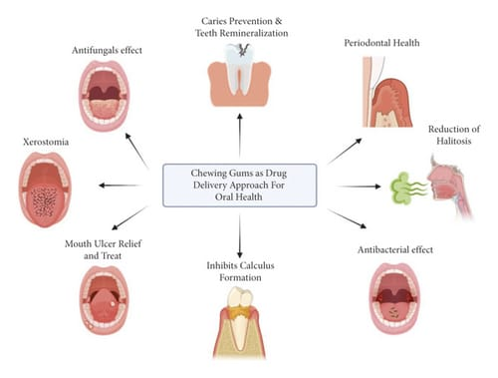

**Figure no.1:** MCG for oral health

**Disadvantages of chewing gum**

* Speed and chewing style affect medication release. The way the patient chews the MCG formulation greatly affects how much medication is released from the MCGs.Compared to all chewing speeds, a single chew per second produced a noticeably greater release of nicotine from the cigarette gum.
* MCG retains and contacts the oral mucosa for a longer period of time. The medication is progressively released into saliva when it is chewed.
* The inclusion of sorbitol in certain formulations may also result in flatulence, gastric ulcers, and stomach irritation from constant salivary swallowing.
* Artificial sweeteners can cause allergic responses.
* The risk that young toddlers could choke after ingesting gum. [5]

**Absorption of drug across the oral mucosa**

Oral medication formulations enter the mouth through the oral cavity, however their contact with the oral mucosa is brief. At about 100 cm2, the overall area available for medication absorption is very small. A speedy initiation of action and quick achievement of high blood levels are made possible by the mouth cavity's abundant supply of lymphatics and blood arteries. Oral dose formulations frequently have the same bioavailability as their intravenous counterparts, therefore aseptic preparation is not necessary. A medication must dissolve in saliva in order to be absorbed orally. In the absence of a particular delivery method that facilitates contact with the mucosa, very hydrophobic compounds are likely to be swallowed whole and will not dissolve sufficiently.[6]

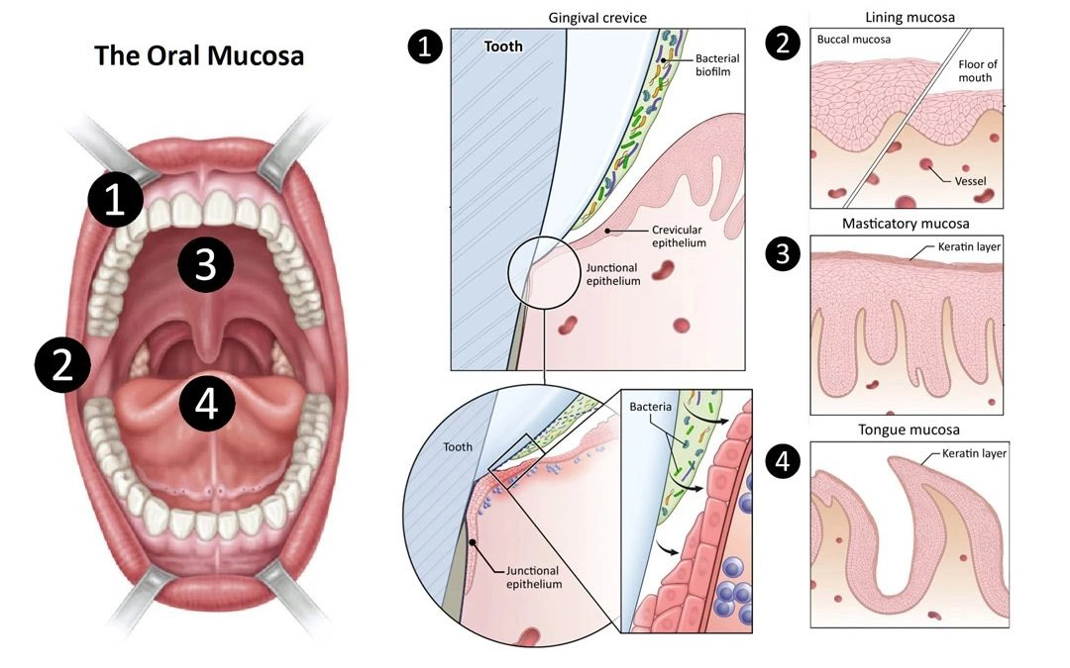 **Figure no.2:** Oral mucosa

**Optimal criteria for drug profile**

1. The medication must not possess any unpleasant flavour, as this can impact how consistently patients adhere to the treatment.

2. The size of the particles in the medication should be maintained below roughly 100 micrometers to prevent an undesirable gritty sensation while chewing.[7]

**The drug's physical and chemical characteristics include:**

* High salivary solubility
* PH-independent solubility
* Tasteless patient-related factors
* Non-carcinogenic
* Non-toxic to the oro mucosa and salivary duct
* Not likely to promote decay of teeth or discolour the oral mucosa
* Not likely to alter the rate of salivary flow;

**MCG Manufacturing Processes:**

There are primarily three ways to manufacture MCG, as listed below:

1. Conventional or Traditional Method (melting)

2. The Method of Cooling, Grinding, and Tableting

3. Direct Compression

**1. Conventional or Traditional Method (Melting)**

The traditional method involves cutting the bark of the sapodilla tree to remove the chicle, which is then burned over an open flame to eliminate any remaining moisture it is put into wooden molds, formed into blocks, then dried with hot air before being melted and softened once it reaches a consistency like to chunky toffee.

The mixture is then moved to a kettle blender, where it is gradually supplemented with corn syrup, active substances, bulking agents, sweeteners (such powdered sugar), and other excipients, such as fruity flavours. Next, a thin, broad ribbon is formed out of the chewing gum. To stop adherence, a thin layer of finely powdered sugar is applied during this stage. After that, the gum is kept in the refrigerator for two days to guarantee adequate curing. It is then finally chopped to the appropriate size.[8]

**2.The Method of Cooling, Grinding, and Tableting**

This method involves melting the gum base in an oven first, then mixing it with the other chewing gum ingredients together. Either adding a coolant, like solid carbon dioxide, or submerging the apparatus in a cold liquid, such as liquid nitrogen, cools the mixture during the mixing stage until it forms into a hard, brittle mass.

This process makes it easier to ground the gum's ingredients into a thin powder for chewing gum. The main reason of the grinding procedure is challenging is that chewing gum particles have a tendency to stick to the grinding apparatus. By adding a grinding aid, such as maltodextrin or an alkaline metal phosphate, at a concentration of 2–8% by weight, this problem can be lessened. The gum powder is then mixed with additional excipients and active substances, such as vitamins, minerals, or herbal components. After that, this mixture is ground into granules that can be molded into different chewing gum products or compressed into tablets.



**Figure no.3:** Schematic representation of chewing gum manufacturing

**3.Direct compression method**

Chewing gum tablets are made using the direct compression technique, which uses specially prepared compactable gum components in powdered form. A sizable amount of inert soft thermoplastic elastomers, a mixture of polyols (such as sorbitol, xylitol, and mannitol), sugars, plasticizers, and anti-caking agents make up these co-processed gum bases, which are intended for direct compression. Health in Gum® compresses to create items that look like prescription tablets.

Compared to medicated chewing gum which is made using conventional techniques, these pills are harder and have a more brittle texture. Additionally, their impact on the release of active pharmaceutical ingredients (APIs) is noticeable. For example, nicotine gums produced via direct compression have a faster rate of release than Nicorette® made using traditional methods. HiG PWD-01, HiG PWD-03, and HiG PWD-04 are the three different grades of Health in Gum® that comprise 25%, 35%, and 30% gum base, respectively. The active molecules in these grades have a longer shelf life because of their lower moisture content.[9]

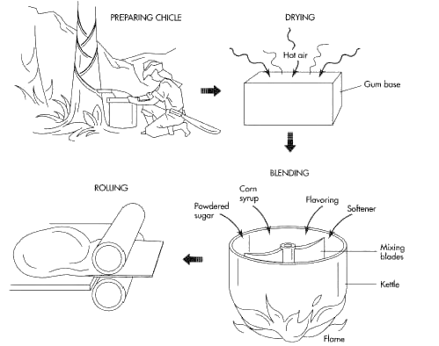 **Figure no.4:** Direct compression method

**Composition of medical chewing gum**

**Table No.1:** Water insoluble gum base – Plasticizer, Elastomers, Elastomeric solvents, Fillers.[10]

|  |  |  |
| --- | --- | --- |
| **INGREDIENTS** | **PURPOSE** | **EXAMPLE** |
| Plasticizers | To achieve a range of appealing textures and consistency characteristics. | Lanolin, palmitic acid, oleic acid, stearic acid, glycerine,  hydrogenated vegetable oils. |
| Elastomers | Offers flexibility and manages the gummy consistency. | Natural- chicle gum, nispero, ) Synthetic rubbers- (butadiene, styrene) |
| Fillers or texturisers | Provides texture | Caco3 |
| Mineral adjuvant | Enhance the ability to chew and offer a suitable size for the gum piece with a minimal dosage of medication. | Magnesium carbonate,  aluminium hydroxide, talc, aluminium silicate. |

**Table No.2:** Water soluble gum base- Sweeteners, Antioxidants, Softener and emulsifier, Colorants and whiteners, Flavouring agents, Bulking agent, compression adjuvant.[11,12]

|  |  |  |
| --- | --- | --- |
| **INGREDIENTS** | **PURPOSE** | **EXAMPLE** |
| Sweeteners | To achieve the intended level of sweetness in the product. | xylose, sucrose,  aspartame, alitame etc. |
| Anti oxidants | Prevents microbial growth | BHT, BHA,propyl gallate |
| Softeners and emulsifiers | These components are incorporated into the chewing gum to enhance its chewability and overall mouthfeel. | Glycerin, lecithin, tallow, hydrogenated tallow, mono/di/ tri glycerides |
| Colorants and whiteners | Enhances the formulation's tolerability and adds a calming colour. | Titanium dioxide, natural food colours and dyes suitable for food, drug and cosmetic applications |
| Flavouring agents | To increase consumer acceptance | Essential oils (citrus oil, fruit essences, peppermint oil, mint oil, clove oil) and synthetic or artificial Flavors |
| Bulking agents | This is utilized when a low-calorie gum is preferred. | Polydextrose, oligofructose, inulin, indigestible dextrin |
| Compression adjuvant | To ease the compression process | Silicon dioxide, magnesium stearate, calcium stearate, talc |

**EVALUATION OF MCG**

**Visual Appearance**

To assess the prepared MCG samples' flavour, consistency, coloration, texture, and clarity, a visual inspection was conducted.

**Thickness Measurement**

Each prepared gummy's mean thickness was measured using a digital vernier calliper (screw gauge in milliliter). [13]

**Weight Variation**

A computerized electronic balance was used to determine each prepared gummy's mass, and the average and standard deviation were then calculated for each gummy.

**Percentage Moisture Loss and Moisture Content**

After being weighed, each gummy was kept for three days in a desiccator with around one gram of anhydrous calcium chloride. The gummies were taken out of the desiccator and weighed once again after this time. The following formula was used to determine the moisture content and the percentage of moisture loss.

Percentage moisture loss = Initial weight – Final weight/Initial weight

Percentage moisture content = Initial weight – Final weight

**Hardness Test**

The Monsanto hardness tester was used to determine the forces needed to crush the gummy in order to determine its hardness.[14]

**Surface pH**

A digital pH meter is used to measure the gum's pH after it has been divided into four segments and submerged in 50 milliliters of distilled water for ten minutes.

**Drug Content**

50 mL of 0.1 N HCl solution was added to a beaker containing the gummy, and it was magnetically stirred for two hours. A UV-visible spectrophotometer was then used to determine the drug content after the solution had been filtered via Millipore filter paper. [15]

***In vitro* drug release study**

This examination is conducted utilizing an appropriate volume of 0.1 N HCl at a temperature of 37°C, with the dissolution apparatus type II operating at a rotation speed of 50 rpm. At specified time intervals, a sample is extracted from the jar and substituted with an equivalent volume of the dissolution medium after filtration. The sample is then analyzed at its maximum absorbance using a UV-visible spectrophotometer.[16]

**Table no.3:** Worldwide marketed chewing gums

|  |  |  |  |  |
| --- | --- | --- | --- | --- |
| Trade Mark | Active Ingredient | Uses | Manufacturer | Picture |
| Nicorette® | Nicotine | Smoking Cessation | GlaxoSmithkline | Nicorette Original Chewing Gum, 2 mg, 210 Pieces (Stop Smoking Aid ... |
| Nicotinelle® | Nicotine | Smoking Cessation | Novartis Consumer Health | Nicotinell Mint 4mg Medicated Chewing Gum - 96 Pieces |
| Chooz® | Calcium Carbonate | Stomach acid neutralization | Leosons Overseas Corporation, USA |  |
| Stay Alert® | Caffeine | Alertness | Stay Alert Safety Services, Inc | Stay Alert Caffeine Supplement, Cinnamon Chewing Gum - 5 ea, Nutrition ... |
| Fluorette® | Fluoride | Cariostatic | Fertin Pharma A/S | Köp Fluorette Mint, medicinskt tuggummi 0,25 mg 108 st på apotea.se |
| Vitaflo CHX® | Chlorhexidine | Preventing tooth decay | Fertin Pharma A/S |  |
| Travvel® | Dimenhydrinate | Motion sickness | Asta Medica | Travel-Gum 20 mg Travel Nausea Relief Chewing Gum 10pcs – My Dr. XM |

**Therapeutic Uses**

The primary focus of MCG formulation is the prevention and treatment of oral disorders. This gum is intended to provide a localized and long-lasting effect by releasing medication at a regulated rate over a prolonged period of time. As an additional measure for oral hygiene after meals and snacks, sugar-free MCG is used to promote dental health. MCG is also used in drug delivery systems for systemic effects, especially when the medicine is absorbed through the buccal cavity's mucosal lining. This reduces the possibility of gastrointestinal side effects while enabling quick and efficient therapy. Additionally, medications from MCG are absorbed faster than those from conventional pills, which results in immediate pain alleviation.[17]

**APPLICATIONS**

**Dental caries**

* The development of chewing gum formulations aims to prevent and treat oral diseases.
* By controlling the rate at which active chemicals are released, these formulations can guarantee a long-lasting local effect.
* Furthermore, they contribute to the restoration of the pH balance in dental plaque, thereby diminishing both the intensity and occurrence of dental caries.
* Fluoride-containing chewing gum has been shown to be successful in avoiding dental cavities in xerostomia patients of all ages.
* Additionally, chewing gum containing chlorhexidine helps treat diseases like gingivitis, periodontitis, and infections of the pharynx and mouth.
* It also serves to inhibit plaque formation.
* The formulation of chewing gum containing chlorhexidine offers several benefits, such as homogeneous dispersion throughout the oral cavity and less tooth discoloration.
* Furthermore, a chewing gum formulation can successfully conceal the disagreeable taste of chlorhexidine.[18]

**Systemic therapy**

* **Pain**

Muscle aches and headaches are among the mild discomforts that chewing gum may help to relieve.

* **Smoking cessation**

The formulation of chewing gum that incorporates nicotine and lobeline has undergone clinical testing as a supportive measure for individuals attempting to quit smoking. **-** [19]

**Obesity:**

* It has been shown that active ingredients including caffeine, guarana, and chromium are useful in the treatment of obesity. By improving blood glucose homeostasis, chromium in particular is said to reduce food cravings.

**Other indications**- For a number of ailments, including xerostomia, allergies, motion sickness, acidity, colds and coughs, diabetes, and anxiety, chewing gum may be a useful medication administration method.[20]

**Conclusion :**

Since self-administration is possible, medicated chewing gum is regarded as a good drug delivery strategy. When compared to other oral dose forms, it offers numerous benefits. Chewing releases the active pharmaceutical substance from the gums, which is then absorbed by the buccal mucosa. It is used to treat dental caries, local oral illnesses, elevated alertness, cognitive functions, and quitting smoking. It can be concluded that patients are beginning to embrace the use of chewing gum.

**COMPETING INTERESTS DISCLAIMER:**

Authors have declared that they have no known competing financial interests OR non-financial interests OR personal relationships that could have appeared to influence the work reported in this paper.

Disclaimer (Artificial intelligence)

Option 1:

Author(s) hereby declare that NO generative AI technologies such as Large Language Models (ChatGPT, COPILOT, etc.) and text-to-image generators have been used during the writing or editing of this manuscript.

REFERENCES :

1. Indhumathi. S, Siva Kuma r. K. A Review on Medicated Chewing Gum and its Role in Mouth Ulcers. Research J. Pharm. and Tech. 2020; 13(1): 481-484
2. Hattab FN. (2023)Chewing Gum for Oral and Dental Health: A Review. J Oral Health Comm Dent 2023;17(1):12–19.
3. Suvarna thube,(2024)A Review on: Formulation and Evaluation of Herbal Medicated Chewing Gum.DOI:10.23880/oajpr-16000312.
4. Nasseripour M, Newton JT, Warburton F, et al. A systematic review and meta-analysis of the role of sugar-free chewing gum on Streptococcus mutans. BMC Oral Health 2021;21(1):217. DOI: https://doi.org/10.1186/s12903-021-01517-z
5. Conway B, “Chewing Gum as a Drug Delivery System”, The Drug Delivery Companies, Report Autumn/Winter, 2003; 33-35.
6. Imfeld T. “Chewing gum--facts and fiction: a review of gum-chewing and oral health”. Crit Rev Oral Biol Med, 1999; 10(3):405-19
7. Squier C A. The permeability of oral mucosa, Critical reviews in oral biology and medicine, 2(1), 1991, 13-32.
8. Ezhumalai K et al. medicated chewing gum - a novel drug delivery for systematic and targeted drug delivery system, International Journal of Pharmacy and Technology, 3(1), 2011, 725-744.
9. Ritesh Kumar ,Pavitra solanki,medicated chewing gum –A Noveled drug delivery system : Anupdated review 10 july 2018
10. Athanikar N K, Gubler S A. Process for manufacturing a pharmaceutical chewing gum, US Patent, 98(4), 2004, 423-428.
11. Pedersen M, Rassing MR. Miconazole chewing gum as a drug delivery system: application of solid dispersion technique and lecithin, Drug Dev Ind Pharm 1990;16:2015-30
12. Christrup LL, Moeller N. Chewing gum as a drug delivery system-in vitro simulation of human mastication and influence of formulation upon the release of a water-soluble drug. Arch Pharm Chem Sci Ed 1986;14:30-6
13. Jacobsen J, Bjerregaard S, Pedersen M. Cyclodextrin inclusion complexes of antimycotics intended to act in the oral cavity-drug supersaturation, toxicity on TR146 cells and release from a delivery system. Eur J Phar Biopharm. 1999; 48(3): 217-224.
14. S. J. Daharwal, Rajendra K. Jangade, Veena Devi Thakur, Shikha Srivastava, Bhanu Pratap Sahu. Development and Characterization of Medicated Chewing Gum Containing Ambroxol HCl for Treatment of Bronchitis. Research J. Pharma. Dosage Forms and Tech. 2013; 5(5): 295-299.
15. Dhiraj A. Khairnar, Avinash B.Darekar, Ravindra B.Saudagar. Medicated Chewing Gum is an Excellent Drug Delivery System for Self Medication. Asian J. Pharm. Tech. 2016; V 6( 1): 24-30
16. Naik H, Gupta S. Medicated ChewingGums- Updated Review.IJPRD 2011; 2(8): 66-76
17. Doshi MM, Vasada SA, Joshi MD Herbal Cough Formulation And Process For Preparation. Patent Application Publication 2006;11(1):345-895.
18. Mehta F, Karti kayen C, Trivedi P. Formulation a nd character ization of medicated chewing gum delivery of diphenhydramine hydrochloride. Pharmacia Sin, 2011; 2: 182-93.
19. Banakar M, Moayedi S, Shamsoddin E, et al. Chewing gums as adrug delivery approach for oral health. Int J Dent 2022;20:9430988.DOI: https://doi.org/10.1155/2022/9430988.
20. American Dental Association (ADA). Chewing gum, 2023. <https://www.ada.org/resources/research/science-and-research-institute/> oral-health topics/chewing-gum.