**HERBAL SHAMPOO: A REVIEW ARTICLE**

**ABSTRACT**

Preparing and evaluating a herbal shampoo with an emphasis on the product's safety, effectiveness, and quality is the primary goal of the current study. Herbal shampoo is a natural hair care solution that is used to eliminate grime, dandruff, and grease as well as to encourage hair growth, strength, and blackness. Since shampoos are a common cosmetic item used in daily life, the shampoo industry has the most units sold of any hair care product. Consumers have occasionally experienced negative consequences as a result of synthetic detergents and preservatives. Incorporating natural extracts with similar functionality to their synthetic counterparts is a more extreme method of minimise the use of synthetic compounds. Shampoo is one of the most important beauty items since it helps clean the hair. Herbal shampoo is a cosmetic product similar to ordinary shampoo in that it uses traditional ayurvedic herbs to clean the hair and scalp. They are used to clean up environmental pollutants, dandruff, grease, and grime.

**KEYWORDS:**

Herbal shampoo powder, cleanser, hair care, hair detergent.

**DEFINITION**

A shampoo is a mixture of a surfactant (also known as a surface-active substance) in an appropriate form, such as a liquid, solid, or powder, that when used as directed will remove surface grime, filth, and debris from the hair shaft and scalp without having an unfavourable effect on the user. [1]

**INTRODUCTION**

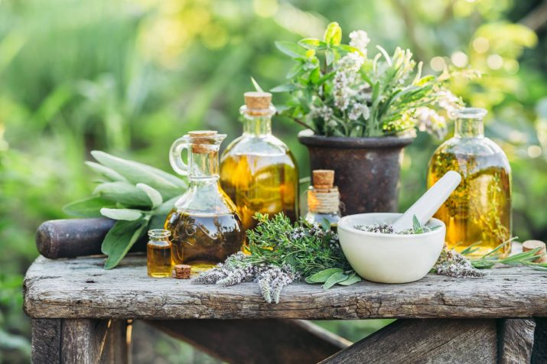“In our daily lives, shampoos are likely the most frequently used cosmetic products for cleaning our hair and scalp. A shampoo is essentially a detergent solution with appropriate additives for additional benefits such as improved hair conditioning, lubrication, medication”.[2] “There are many different types of shampoos available today, including synthetic, herbal, medicated, and non-medicated varieties, but consumers are becoming more and more interested in herbal shampoo because they think that because these products come from natural sources, they are risk-free and without side effects”.[3] “Synthetic surfactants are included in synthetic shampoos mainly for their cleansing and foaming characteristics, but lengthy consumption of these surfactants can produce eye and scalp irritation, hair loss, and hair dryness. We have natural herbal shampoos as an alternative to synthetic shampoo. However, creating cosmetic products with entirely natural ingredients is exceedingly challenging”.[4]

**Figure 1:: Herbal products**

“Numerous medicinal plants with possible benefits on hair have been used for centuries in shampoo formulations All worldwide. These therapeutic herbs can be used as extracts, powders, crude forms, or derivatives. It is challenging to create a shampoo with only one natural ingredient that is safer and softer than synthetic shampoo. It must also include considerable foaming, detergency, and solid content, similar to synthetic shampoo. As a result, we gave careful thought to developing a pure natural cleanser employing a time-tested method and commonly used plant material for washing hair”.[5]

**ANATOMY OF HAIR :**

Understanding the anatomy of hair is fundamental in comprehending the effects and benefits of herbal shampoos on hair health:

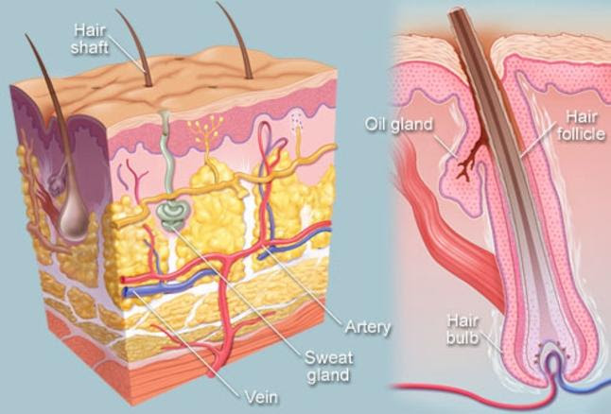**1.Hair Structure:** Hair is primarily composed of a protein called keratin, arranged in three layers: the cuticle, cortex, and medulla. The outermost layer, the cuticle, consists of overlapping scales that protect the inner layers and determine the hair's strength and shine. Herbal shampoos often target this layer, aiming to nourish and smoothen the cuticle for enhanced hair texture and appearance.

Figure : Hair Structure

**2.Scalp:** The scalp is the foundation of healthy hair growth. It contains hair follicles responsible for hair growth and sebaceous glands that produce natural oils (sebum) to moisturise and protect the hair. Herbal shampoos often focus on maintaining a balanced and healthy scalp environment, reducing excess oiliness or dryness while promoting optimal conditions for hair growth.

**3.Hair Growth Cycle:** Hair undergoes a growth cycle consisting of three phases: anagen (growth), catagen (transition), and telogen (resting). Herbal shampoos may impact this cycle by nourishing the scalp, potentially prolonging the growth phase and reducing hair fall during the resting phase.

**Anagen (growth phase):** It is the growing phase. This phase lasts for several years.

**Catagen (transitional phase):** During this phase the hair follicle shrinks and hair growth slows.

**Telogen (resting phase):** It is the resting phase where hair growth stops and new hair begins the growth phase, pushing the old hair out.

**Exogen phase:** Last phase of hair growth cycle where hair strand completely detaches from the scalp and sheds off.

**4. Hair Porosity:** “Porosity refers to the hair's ability to absorb and retain moisture. Herbal shampoos containing moisturising ingredients can aid in regulating hair porosity, preventing excessive loss of moisture and maintaining hair hydration levels. Understanding the intricacies of hair anatomy enables consumers to select herbal shampoos tailored to address specific aspects of hair health, promoting overall nourishment, strength, and vitality” [3].

**PHYSIOLOGY OF HAIR.**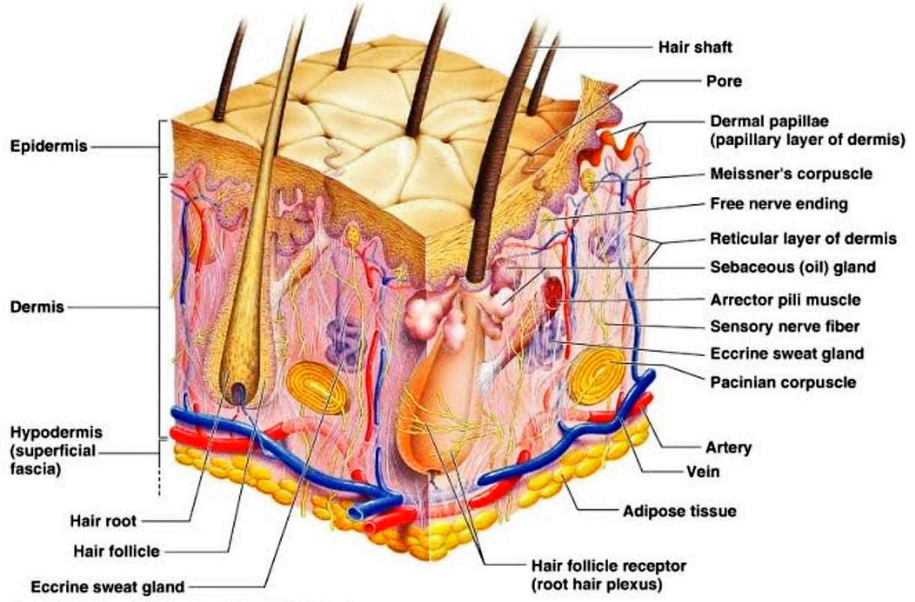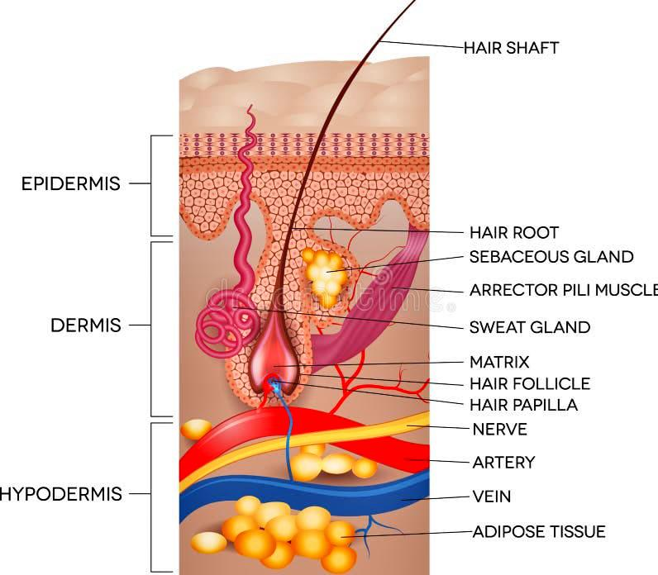

Figure : PHYSIOLOGY OF HAIR

**Hair growth cycle**: Hair development a continuous cyclic process and all mature follicles go through a growth cycle consisting of growth (anagen), regression (catagen), rest (telogen) and shedding (exogen) phases. The duration of the phase’s changes based on the location of the hair and also personal nutritional and hormonal status and a

**1.Anagen:** “The inception of anagen phase is presented by the onset of the mitotic activity in the secondary epithelial germ located between the club hair and dermal papilla in telogen hair follicle. The anagen is the active growth phase in which the follicle enlarges and takes the original shape and the hair fibre is produced. Almost hair cm2 on average with variable range of 175-300 hair cm². The rate of hair growth has been reported be varying with sites. Scalp and chin have highest rate of growth. The rate of growth of scalp hair is between 0.27-0.40 mm per day. The growth rate of axillary hair is nearly same. The growth rate for hair on surface is about 0.2 mm per day. Though the daily variations of temperature have no effect on the growth rate but the study indicate higher growth rate of beard in summer than winter. Also, there is one study report which indicated that the growth of scalp hair in women is faster than men. The growth rate of scalp hair is more in young and adults and declines in old age” [3].

85-90% of all scalp hairs are in anagen. Six portions of the anagen stage are demonstrated. Through the anagens I-V, hair stem cells proliferate, encloses the dermal papilla, grow downwards to the skin and begin to proliferate hair shaft and IRS, respectively.

“Subsequently, hair matrix melanocytes begin to develop pigment and the form of the hair shaft begins to arise: in anagen VI. Hair bulb and adjacent the dermal papilla formation is realized and the new hair shaft appears from the skin. This phase can last up to 6-8 years in hair follicles. Hair shaft synthesis and pigmentation only takes place in anagen. The degree of axial symmetry within the hair bulb determines the curvature of the final hair structure. Fiber length is often dependent on the duration of the anagen or actively growing phase of the follicle” [4].

The featured regulatory proteins in anagen phases are BMP, sonic hedgehog, several WNT proteins and receptors, Insulin like growth factor-1 (IGF-1), fibroblast tgrowth factor-7 hepatic growth factor (HGF), and vascular endothelial growth factor (VEGF) are thought to be important for anagen maintenance.

Figure 4: Parternership between scalp skin and its microbiome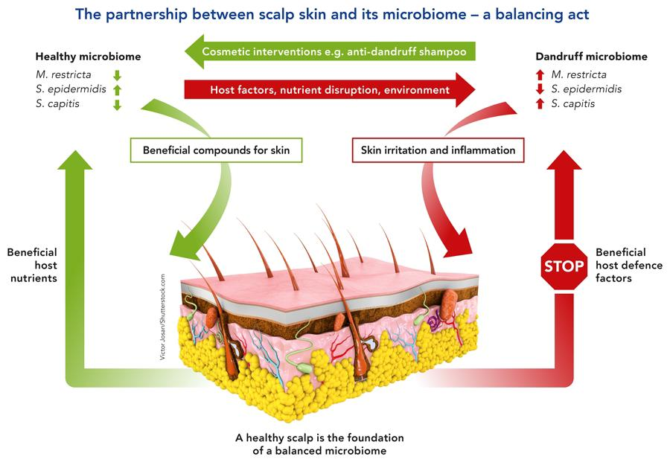

**2.Catagen**: “At the end of anagen, mitotic activity of the matrix cells is diminished and the follicle enters a highly controlled evolutionary phase known as catagen. Catagen lasts approximately 2 weeks in humans, regardless of the site and follicle type. During catagen the proximal of the hair shaft is keratinized and forms the club hair, whereas the distal part of the follicle is involutedly by apoptosis” [2].

Catagen phase is consisted of eight different stages. The first sign of catagen is the termination of melanogenesis in the hair bulb. Follicular epithelium, mesenchyme, neuroectodermal cells populations and also perifollicular vascular and neural systems demonstrates cyclic changes in differentiation and apoptosis. However, any apoptosis is occurred in dermal papilla due to the expression of suppressor bcl-2

“Catagen is a process of bulbar involution. The perifollicular sheath collapses and vitreous membrane thickens. Eventually, the lower hair follicle becomes reduced to an epithelial strand, bringing the dermal papilla into close proximity of the bulge. The epithelial strand begins to elongate and finally reaches to just below the insertion of pilar muscle. After the keratinization of the presumptive club hair, the epithelial strands begin to involute and shorten progressively followed by the papilla which condenses, moves upward and locates to rest below the bulge. The Column eventually reduces to a nipple and forms secondary hair germ below the club. The presence of hairless gene mutation contributes to the failure of dermal papilla migration toward the bulge area in catagen phase” [2].

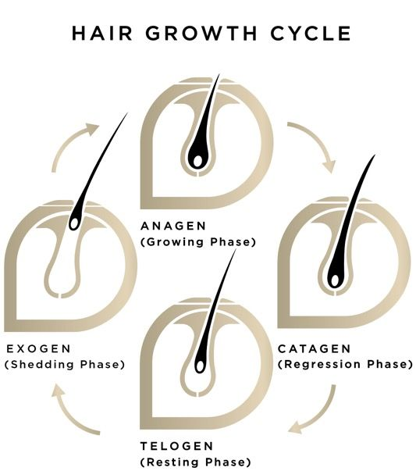**3.Telogen**: “The telogen stage is defined as the duration between the completion of follicular regression and the onset of the next anagen phase. Telogen stage lasts for 2-3 months. Approximately 10-15% of all hair is in telogen stage. During the telogen stage, the hair shaft is transformed to club hair and finally shed. The follicle remains in this stage until the hair germ which is responsive to anagen initiating signals from the dermal papilla, starts to show enhanced proliferative and transcriptional activity in late telogen, leading to the initiation of anagen. Telogen is one of the main targets of hair cycle which is influenced by several modulator agents like androgens, prolactin, ACTH, retinoids and thyroid hormones. Germ cells of telogen follicles also express bicuculine and FGF-5. The bone morphogenicprotein-4(BMP-4) as a growth factor plays an essential role in suppressing follicular growth and differentiation at telogen stage. The macro-environment surrounding the hair follicle also takes part in regulating cycle transitions. Telogen with a hair germ that is responsive to anagen-initiation signals and capable of entering a new anagen phase” [5].

Figure Hair growth cycle

**4.Exogen**: “There is less interest for the mechanism of the hair shedding but from the patient’s perspective it is probably the most important part of the hair growth. It is not unusual for human telogen hairs to be retained from more than one follicular cycle and this suggest that anagen and exogen phases are independent. The shedding period is believed to be an active process and independent of telogen and anagen thus this distinct shedding phase is named exogen. All body hairs undergo a similar life cycle, although is extent, the duration of its phases and the length of individual shafts vary between different body areas and between individuals, depending on genetic programming, gene, age and health status” [6].

**HAIR PROBLEM** :

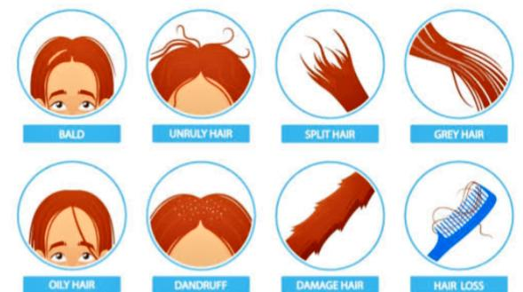Hair problems encompass a wide range of conditions that affect the scalp and hair strands, often necessitating specialised care and treatment:

**Fig 6 : Different Hair problems**

**1.Dandruff:** A common issue characterised by flaking of the scalp, caused by various factors such as dry skin, yeast overgrowth, or sensitivity to hair care products. Herbal shampoos with antifungal or soothing ingredients like tea tree oil or aloe vera can help alleviate dandruff.

**2.Hair Loss:** Hair loss or alopecia can result from genetics, hormonal changes, stress, or medical conditions. Herbal shampoos targeting hair loss often contain ingredients like saw palmetto or biotin, aiming to strengthen hair follicles and minimise hair fall.

**3.Dryness and Frizz:** Dry, frizzy hair occurs due to a lack of moisture and damage to the hair cuticle. Herbal shampoos with hydrating components like coconut oil or shea butter can restore moisture and smoothen the hair shaft.

**4.Oily Scalp:** Excessive oil production on the scalp leads to greasy, flat-looking hair. Herbal shampoos formulated with clarifying ingredients like citrus extracts or witch hazel can regulate oil production without stripping the scalp of its natural oils.

**5.Scalp Irritation:** Conditions like scalp psoriasis, eczema, or sensitivity to certain ingredients in hair products can cause itching, redness, or inflammation. Herbal shampoos with gentle, calming ingredients like chamomile or calendula aim to soothe and alleviate scalp irritation. Choosing the right herbal shampoo tailored to address specific hair concerns is crucial in effectively managing and resolving these hair problems, promoting healthier and more resilient hair and scalp conditions

**HAIR CARE**

“Hair texture and shine are usually related to hair surface properties, on the other hand, the integrity of hair is due to the hair cortex . For this purpose, hair products that improve the structural integrity of hair fibers and increase tensile strength are available, along with products that increase hair volume, reduce frizz, improve hair manageability, and stimulate new hair growth Interestingly, modern cosmetic products are formulated to clean hair from detritus, and to restore and improve hair physiology. For example, intensive conditioning agents can temporarily replace the f-layer, improving the moisture retention in the cortex and rebuilding some of the reduced physical properties of hair. Therefore, the boost in hair shine is a key benefit of modern products” [7].

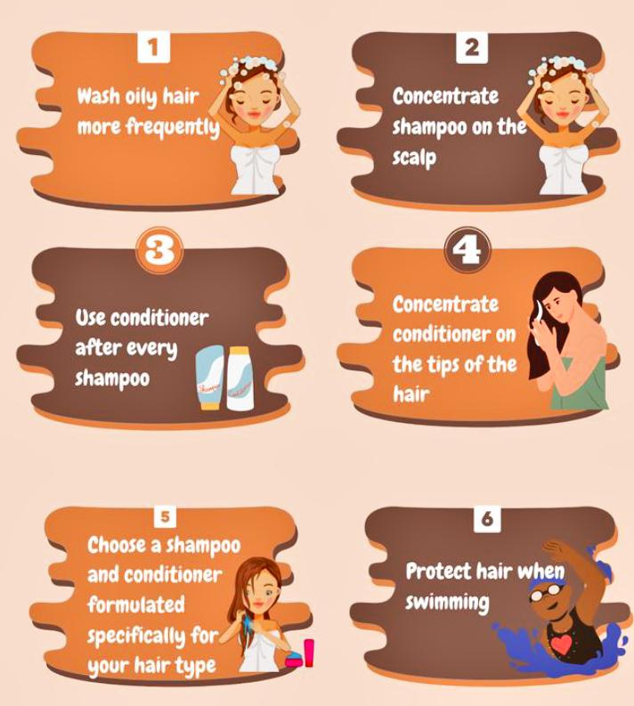**FIG 6 : HAIR CARE**

**HOW SHAMPOO WORKS**:

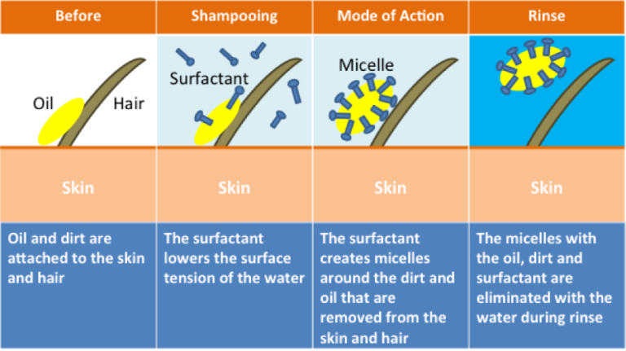Shampoo cleans by stripping sebum from the hair. Sebum is an oil secreted by hair follicles that is readily absorbed by the strands of hair, and forms a protective layer. Sebum protects the protein structure of hair from damage, but this protection comes at a cost. It tends to collect dirt, styling products and scalp flakes. Surfactants strip the sebum from the hair shafts and thereby remove the dirt attached to it. While both soaps and shampoos contain surfactants, soap bonds to oils with such affinity that it removes

Fig 8: Mechanism by which herbal shampoo works through a distinct category of surfactants

too much if used on hair. Shampoo uses a different class of surfactants balanced to avoid removing too much oil from the hair.

}The chemical mechanisms that underlie hair cleansing are similar to that of traditional soap. Undamaged hair has a hydrophobic surface to which skin lipids such as sebum stick, but water is initially repelled. The lipids donor comes off easily when the hair is rinsed with plain water. The anionic surfactants substantially reduce the interfacial surface tension and allow for the removal of the sebum from the hair shaft. The non-polar oily materials on the hair shaft are solubilised into the surfactant micelle structures of the shampoo and are removed during rinsing. There is also considerable removal through a surfactant and oil “roll up” off” [8].

**IDEAL PROPERTIES**

* It should fully and efficiently clean the hair of any dust or filth, excessive sebum or other fatty material, and loose corneal cells.
* It ought to be simple to remove with rinse water.
* It shouldn't cause any negative effects like eye or skin discomfort.
* It should provide a pleasant aroma to the hair.
* To give the hair a lustrous, smooth finish.
* Make a significant volume of foam.
* The hand shouldn't get dry and chapped as a result. It ought to successfully and totally eliminate dirt. [6,7,8]

**Benefits of herbal shampoo**

***Natural and Gentle***

1. Sulphate-free: Herbal shampoos are free from harsh sulphates, which can strip the hair of its natural oils.

2. Gentle cleansing: Herbal shampoos clean the hair and scalp without stripping them of their natural moisture.

***Promotes Healthy Hair and Scalp***

1. Nourishes the scalp: Herbal shampoos can help to nourish and soothe the scalp, reducing irritation and inflammation.

2. Strengthens hair roots: Herbal shampoos can help to strengthen hair roots, reducing hair fall and promoting healthy hair growth.

3. Improves hair texture: Herbal shampoos can help to improve the texture of the hair, making it soft, smooth, and manageable.

***Environmentally Friendly***

1*.* Biodegradable: Herbal shampoos are biodegradable and free from harsh chemicals that can harm the environment.

2. Cruelty-free: Herbal shampoos are often cruelty-free and vegan-friendly, making them a great choice for those who care about animal welfare.

**Customisable**

1.Tailored to hair type: Herbal shampoos can be tailored to specific hair types, such as dry, oily, or combination hair.

2. Address specific hair concerns: Herbal shampoos can be formulated to address specific hair concerns, such as dandruff, itchiness, or hair loss.

**Cost-Effective**

1. Long-term benefits: Herbal shampoos may be more expensive than conventional shampoos, but they offer long-term benefits for the hair and scalp.

2. Reduced need for styling products: Herbal shampoos can help to improve the health and appearance of the hair, reducing the need for styling products.

**ADVANTAGES**

* Pure and organic ingredients are used.
* These shampoos are free from side effects.
* No synthetic additives such as sodium lauryl sulphate.
* No animal testing.
* Skin friendly.
* These shampoos help in the strengthening the root which in turn helps in increasing the growth of hair. herbal shampoos also help in increasing the shine of hair therefore for one who suffers from dry and dull hair these herbal shampoos are beneficial.
* It enhances the roots and helps in the formation of new root which are soft then before.
* Herbal shampoos help in reducing the dandruff production in the scalp.
* They may be beneficial in reduction of hair fall

**DISADVANTAGES**

* Some herbs are sensitive to scalp. example: menthol.
* Natural products affect product uniformity and quality control.
* Sessional variation of plant constituents occurs.
* Less stable so, preservative should be added.
* Varying in consistency from batch to batch.
* Dry shampoo doesn’t clean hair.
* Skin allergies may be occurred. [9]

**CLASSIFICATION OF SHAMPOO**

1. Based on appearance.

* Powder shampoo
* Liquid shampoo or lotion shampoo
* Gel shampoo or solid shampoo
* Cream shampoo
* Oil shampoo
* Miscellaneous anti dandruff shampoo or medicated shampoo

2. Based on use or function.

* Conditioning shampoo
* Antidandruff shampoo
* Therapeutic shampoo
* Baby shampoo
* Balancing shampoo
* Clarifying shampoo

3. Based on origin:

* Herbal shampoo
* Egg shampoo

Evaluation of shampoos comprises the quality control tests including visual assessment and physiochemical controls such as ph, density and viscosity.[10]

***Table 1 Description of Herbal Shampoo ingredients .***

|  |  |  |  |  |  |
| --- | --- | --- | --- | --- | --- |
| Common Name | Botanical name | Parts used | Purpose | Category | Picture |
| Drumstick | Moringa Oliefera | Seed | Anti-dandruff, Anti-microbial | Core ingredient |  |
| Aloevera | Aloe Barbadensis | Pulp | Hair conditioner, control greasy hair | Smoothing agent |  |
| Hibiscus | Rosa Sinesis | Flowers | Improve overall health of hair and scalp | Conditioning agent |  |
| Shikakai | Acacia concinna | Fruits | Scalp health, lousy hair, hair conditioning | Antifungal, Nourish follicles, Curb dandruff |  |
| Ritha | Sapindusmukorossi | Fruits | Reduces frizz and adds shine,soften hairs | soapberry,  soapnut,  washnut,  aritha. |  |
| Sodium Lauryl Sulphate | Sodium dodecylsulfate | Powder | Cleanser, creates lather | Fat  Emulsifier,  Wetting  agent,  Detergent in  Cosmetics. |  |
| Methyl Cellulose | Hypromellose | Powder | Thickener and emulsifier | Thickening Agent, Stabilizing Agent. |  |
| Rose Water | Rosa damascena | Liquid | Hydration, improves low porosity hair | Flavoured water, Perfume agent |  |

***Formulation Of Herbal Shampoo***

|  |  |  |
| --- | --- | --- |
| S.No | Ingredients | Quantity |
| 1. | Drumstick | 10 gm |
| 2. | Alovera | 5 ml |
| 3. | Hibiscus | 4 ml |
| 4. | Shikakai | 8 gm |
| 5. | Ritha | 8 gm |
| 6. | Sodium Lauryl Sulphate | 6 gm |
| 7. | Methyl Cellulose | 1 gm |
| 8. | Rose Water | 10 ml |

***Method Of Preparation :***

1. Weighed all the ingredients according to the formulas.
2. Decoction of Drumstick, Aloevera, Hibiscus was prepared in one part of water.
3. Filter it by using muslin cloth, collect filtrate
4. Decoction of shikakai and Ritha was prepared in another part of water.
5. Filter it, by using muslin cloth, collect filtrate.
6. Mixed to each other of above filtrate with constant stirring.
7. Mixed to sodium lauryl sulphate in foaming.
8. Mixed to methyl cellulose as a thickening agent tom maintenance of consistency herbal shampoo of as per like semisolid mixtures.
9. Preservatives arts and & Rose water this perfume was add Lastly.

Table 2 : Ingredients Of Herbal Shampoo

***Evaluation Of Herbal Shampoo***

**Appearance** :-A shampoo like any other cosmetic preparation should have good.

**Appealing physical appearance**. The formulated and marketed shampoos were evaluated for physical characteristics such as colour, odour and transparency (Table 3). Our prepared shampoo was transparent, light green and had good odour. No significant difference was observed in terms of odour, transparency and foaming characteristics between commercial and formulated shampoo except for colour.

**Colour**: Black Brown, Dandruff Cleansing Shampoo

**PH**:- The pH of formulated shampoo was 6, falling within the ideal pH range for shampoo which is between 4.33 and 4.73. The formulated shampoo is acid balanced which is near to the skin PH. The pH of shampoo is important for improving and enhancing the qualities of hair, minimising irritation to the eyes and stabilising the ecological balance of the scalp. Mild acidity prevents swelling and promotes tightening of the scales, there by inducing shine.

**Viscosity**: The viscosity of shampoo plays an important role in determining its shelf life stability, the ease of flow on removal from packing and spreading on application to hair and product consistency in the package. The viscosity of formulated shampoo was found to be 50 millipoise which was good enough for its applicability.

**Foaming Stabilit**y-The stability of the foam was determined using cylinder shake

Method. About 50 ml of formulated shampoo (1%) solution was taken in a graduated cylinder of 250 ml capacity and shaken for 10 times vigorously. Foam stability was measured by recording the foam volume of shake test after 1 min and 4 min, respectively. The total foam volume was measured after 1 min of shaking. From the consumer point of view, foam stability is one of the important needs of a shampoo. Important parameter that was considered in the shampoo evaluation was determination of foaming stability. The foam volume produced by the formulated shampoo is above 50 ml. The prepared shampoo generates uniform, small sized, compact, denser, and stable foam. The foam volume remains same throughout the period of about 5 min showing that the generated foam by the shampoo has good stability.

**Surface Tension** :-Measurements were carried out with a 10% shampoo dilution in distilled water at room temperature. Thoroughly clean the stalagmometer using chronic acid and punitied water. Because surface tension is highly affected with grease or other lubricants.

**Wetting time:-** Wetting time was calculated by noting the time required by the canvas paper to sink completely. A canvas paper weighing 0.44 g was cut into a disc of diameter measuring 1-inch. Over the shampoo (1% v/v) surface, the canvas paper disc was kept and the time taken for the paper to sink was measured using the stopwatch.

**Cleaning action**: About 1 g of grease is spread on non-adsorbent cotton and kept in conical flask containing 1% shampoo solution. The conical flask is shaken for 1 hr in mechanical shaker. Cotton is collected, dried and weighed.

**Dirt dispersion:** Shampoo that causes the ink to concentrate in the foam is considered poor quality; the dirt should stay in water. Dirt that stays in the foam will be difficult to rinse away. It will redeposit on the hair. The estimated amount of ink in foam was light and so results indicate that prepared formulation is satisfactory.

**Solid contents (%)**: A Clean dry china dish was weighed and 4 grams of shampoo was added to it. The weight of dish and shampoo was noted. The exact weight of shampoo was calculated. Place the china dish with herbal shampoo on hot plate until the liquid portion was evaporated. The weight of shampoo (solids) after drying was calculated

**POWDER SHAMPOO**

**Description of powder shampoo ingredients**

**Table 3: Description of powder shampoo ingredients.**

|  |  |  |  |  |  |
| --- | --- | --- | --- | --- | --- |
| COMMON NAME | BOTANICAL NAME | PARTS USED | CATEGORY | PURPOSE | PICTURE |
| Shikakai | Acacia Concinna | Fruit pods,leaves | Natural foaming agent | Foam base and Anti-dandruff |  |
| Reetha | Sapindus Mukorossi | Dessicated fruit | Natural surfactant and cleanser | Hair nourishing and cleansing |  |
| Tulasi | Ocimum tenuiflorum | Dried leaves | Anti fading | Antibacterial |  |
| Amla | Phyllanthus emblica | Dried ripe fruits | Hair growth promoter | Hair health, scalp health |  |
| Neem | Azadirachta  indica | Neem leaves and extracts | Anti-dandruff | Improve greying of hair |  |
| Henna | Lawsonia  inermis | Dried leaves | Hair colourant | Conditioner |  |
| Harda | Terminalia  chebula | Dried ripe fruits | Anti-inflammatory, Anti-bacterial | Hair growth promoter |  |
| Bhringraj | Eclipta  prostrata | Entire herb | Hair growth promoter | Promote the hair health |  |

**Table4 : FORMULA OF HERBAL DRY SHAMPOO POWDER**

|  |  |
| --- | --- |
| **Ingredients** | **Quantity 100gm** |
| Shikakai | 15 gm |
| Reetha | 10 gm |
| Tulasi | 10 gm |
| Amla | 15 gm |
| Neem | 5 gm |
| Harda | 10 gm |
| Henna | 15 gm |
| Bhringraj | 5 gm |
| Black tea | 5 gm |
| Hibiscus flower | 10 gm |

**PREPARATION OF DRY SHAMPOO POWDER**

1. Drying

All the powder are in dry form and grinded.

1. Size reduction

The crude ingredients were collected and these ingredients were size reduced using driven mixer individually.

1. Sieving

Then this fine powder was passed through sieve no.:80 , to get the sufficient quantity of fine powder.

1. Weighing

All the required herbal powders for shampoo preparation were individually.

1. Mixing

All these fine ingredients were mixed throughly by mixer to form a homogeneous fine powder.

1. Packing and Labeling

Then it was packed and labeled suitably.

**EVALUATION OF HERBAL SHAMPOO**

**Organoleptic evaluation :**

Organoleptic evaluation on the parameters like colour, odour taste and texture was carried out. Colour and texture was evaluated by vision and touch sensation respectively. For taste and odour evaluation a team of five taste and odour sensitive persons was formed and random sampling was performed.

**General powder characteristics:**

General powder characteristics includes evaluation of those parameters which are going to affect the external properties (like flow properties, appearance, packaging criteria etc.) of the preparation, Characteristics evaluated under this section are powder form, particle size angle of repose and bulk density. Sample for all these evaluation were taken at three different level i.e. from top, middle and lower level. Particle size

Particle size is a parameter, which affect various properties like spreadability, grittiness etc., particle size was determined by sieving method by using I.P. Standard sieves by mechanical shaking for 10 min.

**Angle of repose**

It is defined as the maximum angle possible in between the surface of pile of powder to the horizontal flow.

Funnel method

Required quality of dried powder is taken in a funnel placed at a height of 6 cm from a horizontal base. The powder was allowed to flow to form a heap over the paper on the horizontal plane. The height and radius of the powder was noted and recorded the angle of repose (θ) can be calculated by using the formula.

Open - ended cylinder method

Required amount of dried powder is placed in a cylindrical tube open at both ends is placed on a horizontal surface.

Then the funnel should be raised to form a heap. The height and radius of the heap is noted and recorded. For the above two methods, the angle of repose (θ) can be calculated by using the formula.

θ = tan -1(h / r) Where,

θ – Angle of repose, h – Height of the heap, r – Radius of the base

**Bulk density**

Bulk Density is the ratio between the given mass of a powder and its bulk volume. Required amount of the powder is dried and filled in a 50 ml measuring cylinder up to 50 ml mark. Then the cylinder is dropped onto a hard wood surface from a height of 1 inch at 2 second intervals. The volume of the powder is measured. Then the powder is weighed.

This is repeated to get average values. The Bulk Density is calculated by using the below given formula.

Mass of the herbal powder shampoo

Bulk Density= Mass of the herbal powder shampoo

Volume of the herbal powder shampoo

**Tapped density**

The tapped density is an increased bulk density attained after mechanically tapping a container containing the powder sample. After observing the initial powder volume or mass, the measuring cylinder or vessel is mechanically tapped for 1 min and volume or mass readings are taken until little further volume or mass change was observed. It was expressed in grams per cubic centimeter (g/cm3).

**POLY HERBAL ANTI DANDRUFF SHAMPOO.**

Table 5: Description of Poly herbal anti dandruff shampoo ingredients

|  |  |  |  |  |  |
| --- | --- | --- | --- | --- | --- |
| Common name | Botanical name | Part used | Category | Purpose | Picture |
| Neem | Azadirachta indica A. Juss | Fresh Leaves | Antifungal/ Antibacterial | Improve greying of hair |  |
| Bhringraj | Eclipta alba (L.) Hassk | Powder of Leaves | Antifungal/ Antibacterial agent | Promote the hair health |  |
| Shikakai | Acacia concinna Linn | Leaves | Natural foaming agent | Scalp health, lousy hair, hair conditioning |  |
| Fenugreek | Trigonella foenum-graecum L. | Seeds | Anti dandruff | Reduce the premature greying of hair |  |
| Reetha | Sapindus trifoliatus linn | Seeds | Natural surfactant and cleanser | Hair nourishing and cleansing |  |
| Aloe Vera | Aloe barbadensis miller | Latex of Leaves | Smoothing agent | Hair conditioner, control greasy hair |  |
| Lemon Juice | Citrus limon (L.) Burm | Fresh Ripe Fruit Juice | Anti dandruff | Enhance hair shine, remove excess oil |  |
| Tulsi | Ocimum sanctum L | Fresh Leaves | Anti fading,  anti  scalp inflammation | Antibacterial |  |
| Orange | Citrus Linn. | Pericarp | Antibacterial | Reduce lousy hairs |  |
| Ginger | Zingiber officinale Roscoe | Rhizome | Hair promoter | Improve blood circulation |  |
| Curry Leaves | Murraya koenigii Linn. | Fresh Leaves | Hair strengthen | Shine & strong the hairs |  |
| Hibiscus | Hibiscus-sinensis L | Fresh Leaves. | Conditioning agent | Improve overall health of hair and scalp |  |

**Table 6 :FORMULATION Of POLY HERBAL ANTI DANDRUFF SHAMPOO**

|  |  |
| --- | --- |
| **Ingredients** | Quantity(100ml) |
| Herbal extract | 24ml |
| Sodium Lauryl Sulphate | 6gm |
| Guar gum | 1gm |
| NaCl (0.1M) | Q.s |
| Glycerin | 2ml |
| Vitamin E | 800mg |
| Lavender oil | 2 drops |
| Water | Q.s100ml |

**PREPARATION OF POLY HERBAL ANTI DANDRUFF SHAMPOO**

* The composition was made by simple decoction process.
* All the herbs were accurately weighed by using digital balance the used quantity is listed in Table 1.
* The crude herbs were collected and these ingredients were size reduced using hand driven mixer individually grinded into powder, fine powder was passed through sieve no.120 and separately mixed with 100ml distilled water and kept for boiling till water gets reduced to one quarter.
* After boiling, the extract was cooled at normal room temperature and then filtered with muslin cloth to get the final filtrate

**EVALUATION PARAMETERS FOR ANTI DANDRUFF SHAMPOO**

**1.PH**

10% v/v shampoo solution is prepared in distilled water and pH of this solution was measured with digital pH meter at room temperature 30-2°C

**2.Determination of percentage solids content**

A clean dry dish was weighed and added with 4 Grams of shampoo. The dish with shampoo was weighed. The exact weight of the shampoo was calculated. The dish with shampoo was placed on the hot plate until the liquid portion was evaporated. The weight after drying was calculated (10).

**3.Wetting time (sec)**

A cotton ball weighing of about 0.44gm was taken and added it to container containing shampoo Time taken for cotton to sink at bottom of the formulation was measured as wetting tune

**4.Viscosity**

The index of resistance to flow was determined using Brookfield viscometer DV-II Pro at room temperature Lc. 30+2°C with varying rpm and torque

**5.Surface tension measurement**

Dilute the shampoo using distilled water to fix 10% as concentration. Measurements were carried out using stalagnometer

**6.Foam formation/Foam stability**

Cylinder shake method Used. 50ml of 1% solution of shampoo is taken in graduated cylinder (1 ml in 100ml water), shake for ten minutes and record the foam produced after I minute. Record the stability of foam after 4-5 minutes+_2 for 48 hand examined for the appearance of inhibition zones around the wells. The diameters of the inhibition zones were measured from the images using digital antibiotic zone reader.

**7.Stability studies**

Stability studies were performed in accordance with KH guidelines for accelerated testing with required modifications. The sample taken formulation was taken and kept at room temperature (30 2°C) a well as refrigerator (4:2°C) for duration of one month The samples were tested for their physical appearance, PH, viscosity, cleaning action and foam stability.

**8.In-vitro anti-dandruff activity**

Well diffusion assay method was used. The anti-microbial efficiency of polyherbal anti dandruff Shampoo was examined against Malassezia furfur using an agar well diffusion assay method. 500µl fungal cell suspension was spread onto the Sabourand Dextrose Agar (SDA) plates and wells (mm diameter was made on the agar plates using a sterilized stainless steel cork borer). The wells were landed with 20µl of the respective shampoo. The plates were incubated at 35 °C

2. Address specific hair concerns: Herbal shampoos can be formulated to address specific hair concerns, such as dandruff, itchiness, or hair loss

**CONCLUSION**

The key to choosing the best shampoo is knowing your particular hair needs, which include your hair type, scalp health, and desired results. While washing is the primary function, modern shampoos usually provide additional benefits like hydration, volume, or color retention. For the best possible hair health and appearance, it is essential to select a shampoo that targets your unique hair issues for which the herbal shampoo is chosen which is suitable for almost all hair types and it leaves no side effects and less added artificial agents.

Disclaimer (Artificial intelligence)

Option 1:

Author(s) hereby declare that NO generative AI technologies such as Large Language Models (ChatGPT, COPILOT, etc.) and text-to-image generators have been used during the writing or editing of this manuscript.

Option 2:

Author(s) hereby declare that generative AI technologies such as Large Language Models, etc. have been used during the writing or editing of manuscripts. This explanation will include the name, version, model, and source of the generative AI technology and as well as all input prompts provided to the generative AI technology

Details of the AI usage are given below:

1.

2.

3.

**REFERENCES**

1. Mayank Signgh, piyush Yadav Memish kumar Maurya jaiswal, Nitin Yadav (2021), "A review on Cosmetic Product shampoo”, ijort vol. 9, (1) 2320- 2882
2. Nagajyothi N, Dhanalakshmi M, Thenmozhi S, Natarajan R, Rajendran NN. Formulation and evaluation of pitavastatin nanosuspension. Int J Pharm Life Sci 2014;5:3318-24.
3. Pal RS, Saraswat N, Wal P, WalA, Pal Y. Preparation and assessment of poly-herbal anti-dandruff formulation. Open Dermatol J 2020;14:22-7.
4. Al Badi K, Khan SA. Formulation, evaluation and comparison of the herbal shampoo with the commercial shampoos. Beni-Suef Univ J Basic Appl Sci 2014;3:301-5.
5. Mrs. K. Sravanthi, N. Kavitha, K. Sowmya, S. Nazneen, U. vaishnavi, CH, Anil (2021), “A review on formulation & evaluation of onvidandruff Shampoo”, ijpra vol.6 ,(3)2249-778
6. Balsam, S.M., Gershon S.D., Rieger, M. M. Sagarin, E & strianse, S. J, “Cosmetic science & Technology”. 2nd edition, Vol. 2, John Wiley India, New Delhi, 2008
7. Priya d, gaikwad, kamani v mulay, madhavee d borade. formulation and evaluation of herbal shampoo. ijsr.2018;9(3):29-31.
8. ashwini sukhdev pundkar* and sujata p. ingale ,world journal of pharmaceutical research, volume 9, issue 5, 901-911.
9. Aniket Pawar, Rakesh Pomnar, Mahesh Sawant Rohit Asher Komal suryawanshi,The formulation and evaluation of herbal shampoo 2022 IJCRT,Vol-10, Issue 7 July 2022.
10. Ali Heyamsaad, Rasolbazigha Kadhim. Formulation and development of herbal shampoo from Ziziphusspina leaves extract. International Journal of Research in Ayurveda and Pharmacy, 2011; 2(6): 1802-1806.
11. B.M. Mithal, R.N. Saha, Handbook of cosmetics, M.K. Jain for Vallabh Prakashan, first edition, 2000; 100-21.
12. Md. Rageed, Md. UsmanSullivan Ahmad, Sunil. P. Pawar, V.M. Sherry, Mohammed zuber shaik; Encyclopedia of healing plant; Stadium press (India) pvt. Ltd, 98
13. Maurya, Pawan, et al. "A Review Article on Herbal Shampoo." Journal of Emerging Technologies and Innovative Research 8.5  
    (2021): 366.
14. Arora, Pooja, Arun Nanda, and Maninder Karan. "Shampoos based on synthetic ingredients vis-a-vis shampoos based on herbal ingredients: a review."  
    International Journal of Pharmaceutical Sciences Review and Research 7.1 (2011):  
    41-46.
15. Bhagwan, Doifode Dilip, et al. "Scientific Review On: Formulation and Evaluation of Herbal Shampoo." International Research Journal of Modernization in Engineering Technology and Science 4.12  
    (2022): 1254-1256.
16. ﻿Nipurte, Disha S., Mahendra B. Datir, and S. Fulsundar Apeksha. "A Review on formulation and Evaluation of HerbalShampoo." World Journal of Pharmaceutical Research 11.3 (2022): 412-418.
17. Patel, I. M. R. A. N., and A. D. N. Y. A.  
    Talathi. "Use of traditional Indian herbs for the formulation of shampoo and their comparative analysis." International  
    Journal of Pharmacy and Pharmaceutical  
    Sciences 8.3 (2016): 28-32.
18. Arora, Rimjhim, Rathore Kamal Singh, and Bharakatiya Meenakshi. "Formulation and evaluation of herbal shampoo by extract of some plants." Pharm Chem J  
    6.4 (2019): 74-80.
19. ﻿﻿﻿Kushwaha, Ritik Kumar, and Shashikant Maury. "A REVIEW ON ANTI-DANDRUFF ACTIVITY OF HERBAL SHAMPOO." (2022).
20. <https://www.ijpsjournal.com/article/A+Review+on+Formulation+and+Evaluation+of+Herbal+Shampoo>
21. <https://rjtcsonline.com/AbstractView.aspx?PID=2020-11-1-1>
22. Sachin Dubey, Neelesh Nema, Nayak S. Preparation and evaluation of herbal shampoo powder. Ancient Science of Life 26(1); 2004: 38-44.
23. Sutar Manisha, Deshmukh Swati, Chavan Manisha, Singh Sonia. Preparation and evaluation of polyherbal shampoo powder. International Journal of Pharmacy and Biological sciences 392); 2013: 151-159.
24. Mohamed Halith S, Abirami A, Jaya prakash S, Chitra Karthikeyini, Kulathuran K, Mohamed Firthouse PU. Effect of *Ocimum sanctum*and *Azadiracta indica*on the formulation of antidandruff herbal shampoo powder. Scholars Research Library 1(2); 2009: 68-76.
25. Naresh Gorantla, Sai Prasad K, Thimma Reddy VT, Ragadeepika J, Hajarabi T, Hindustan Abdul Ahad. Formulation and evaluation of herbal shampoo containing chamomile, rose and orange peel. Pharma Research Library: International Journal of Medicine and Pharmaceutical Research 1(2); 2013: 192-197.
26. Jammao kaveri, Gaikwad vishal Shivaji. “A review on Herbal Shampoo”; ijcrt, vol-10, 23202882.